APPENDIX A

A.1 R410A heat pump modeling approach
This section describes the R410A modelling approach used to simulate the dynamic behavior of the baseline cycle, similar to the one described in section 2.2. Figure A.1 presents the Modelica model schematics of the R410A heat pump. The real system used a 4-way valve to reverse the operating mode, heating and cooling modes were split as it simplifies the model without affecting the final results. Table A.1 provides the characteristics and physical parameters of the main components.

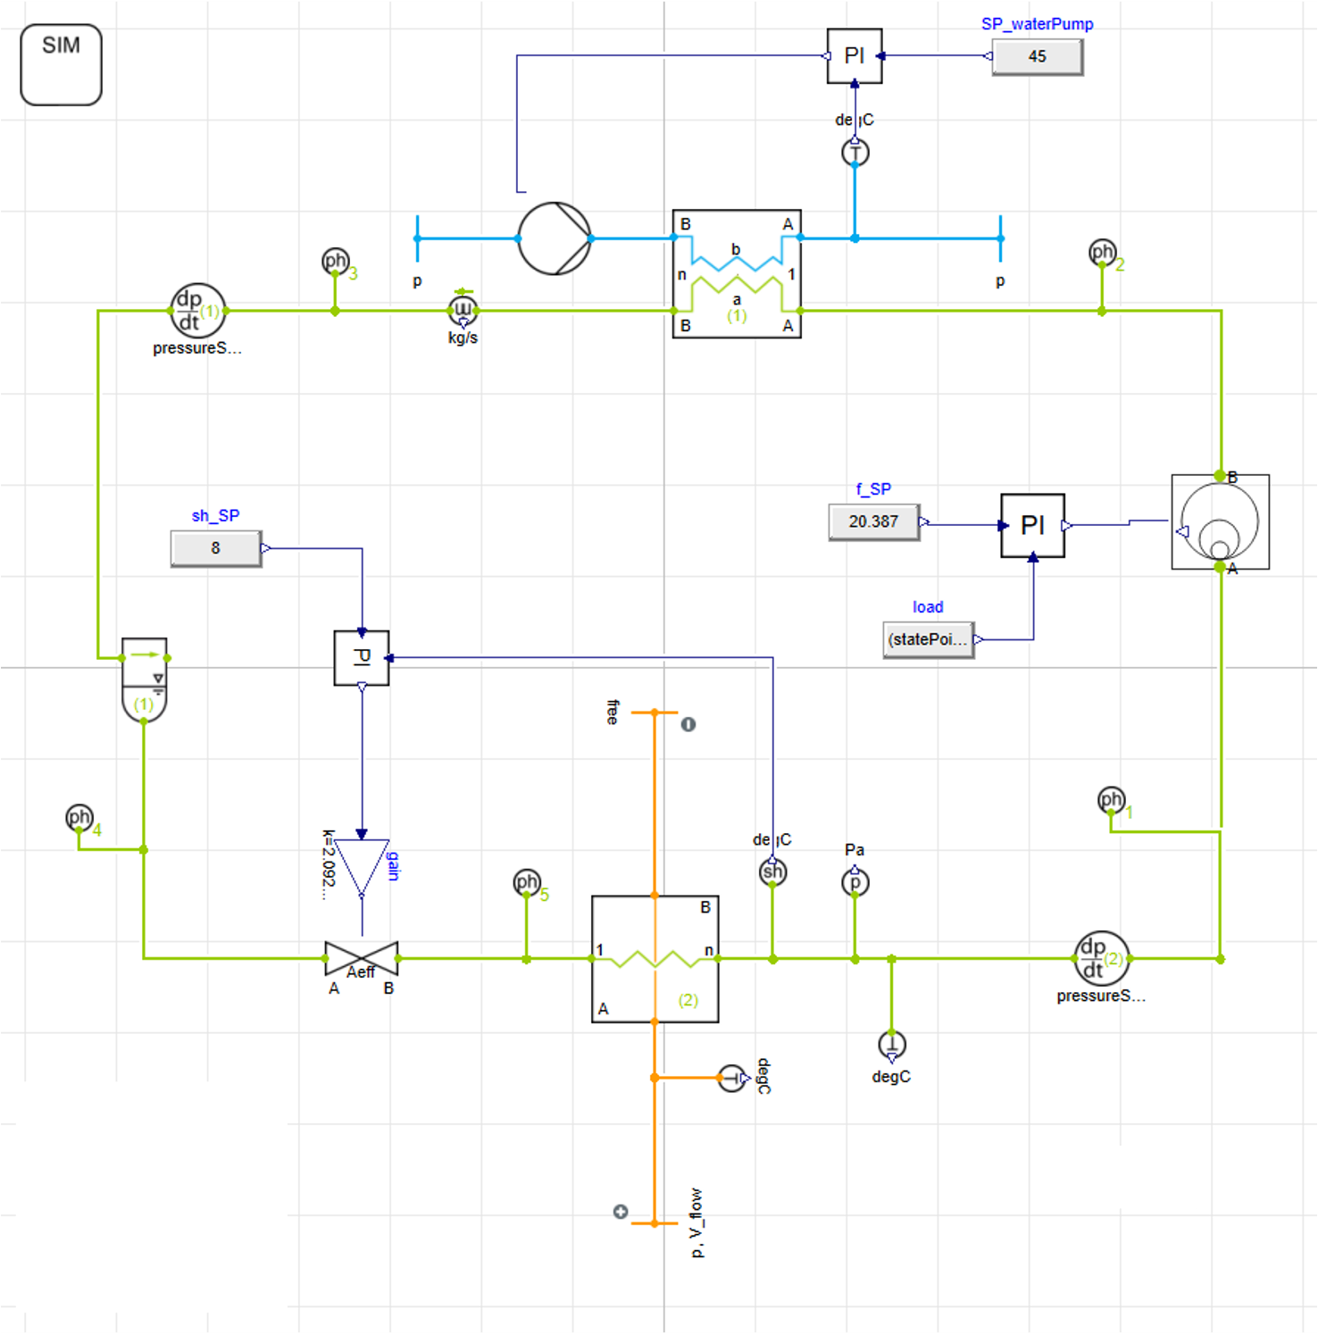 | 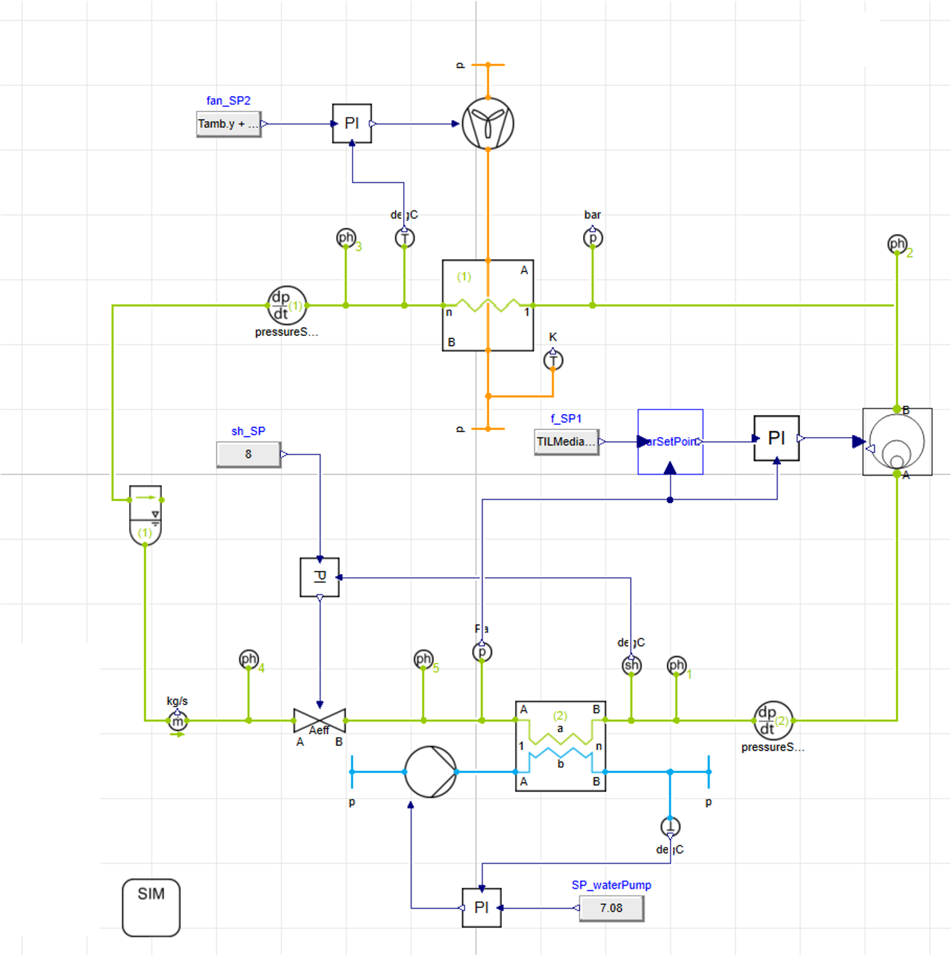
(a) | (b)

Figure A.1. Schematics of the R410A heat pump in (a) heating mode (b) cooling mode as implemented in Dymola.

Table A.1. Component parameters of the R410A heat pump.
Component name | R410A cycle
Compressor | Type: scroll semi-hermetic  Displacement: 88.4 cm³
Indoor heat exchanger | Type: plate  Material: steel  Heat transfer area: 1.48 m²  Size: 300 mm, 10 mm  Number of plates: 38
Outdoor heat exchanger | Fin-tube  Material: copper/aluminum  Heat transfer area: 74.8 m²  Outer tube diameter: 15.875mm  Size: 1250 mm, 750 mm, 15 mm
Expansion Valve | 480 steps
Receiver/accumulator | 4 l

A.1.1 Scroll compressor
The scroll compressor was modeled as a black box component. Its three principal outputs—mass flow rate, discharge temperature, and power consumption—were determined using polynomial correlations. The coefficients for these correlations, provided by the manufacturer [1], depended on condenser or evaporator temperature and compressor speed, as shown in Eq. A.1 and Table A.2 The manufacturer specifies the coefficients for these polynomials.
$$\left({\dot{m}}_{ref}, {T_{d},W}_{com} \right)=f\left(T_{ev},T_{c},N_{com}\right)$$ | (A.1)

Table A.2. Coefficients for the scroll compressor correlations A.1
N (Hz) | C1 | C2 | C3 | C4 | C5 | C6 | C7 | C8 | C9 | C10
Discharge temperature
25 | 7.602084 | -1.133017 | 1.969090 | -0.008548 | 0.034784 | -0.020422 | -0.000593 | 0.000967 | -0.000867 | 0.000314
30 | 6.773720 | -1.111801 | 2.051333 | -0.006753 | 0.035578 | -0.022460 | -0.000668 | 0.000870 | -0.000825 | 0.000316
35 | 7.018986 | -1.113057 | 2.055501 | -0.005424 | 0.035935 | -0.021919 | -0.000660 | 0.000775 | -0.000794 | 0.000299
40 | 9.734082 | -1.025395 | 1.910958 | -0.004938 | 0.031919 | -0.018387 | -0.000658 | 0.000723 | -0.000725 | 0.000263
45 | 13.304532 | -0.926958 | 1.707297 | -0.004942 | 0.027146 | -0.013582 | -0.000660 | 0.000696 | -0.000652 | 0.000218
50 | 16.693847 | -0.824204 | 1.517850 | -0.004990 | 0.022107 | -0.009191 | -0.000677 | 0.000682 | -0.000578 | 0.000177
55 | 19.642006 | -0.759641 | 1.358410 | -0.005347 | 0.018512 | -0.005506 | -0.000676 | 0.000678 | -0.000525 | 0.000142
60 | 22.315050 | -0.710305 | 1.216845 | -0.005801 | 0.015421 | -0.002248 | -0.000671 | 0.000682 | -0.000479 | 0.000111
65 | 24.708871 | -0.677125 | 1.093172 | -0.006279 | 0.012843 | 0.000587 | -0.000658 | 0.000690 | -0.000442 | 0.000084
70 | 26.824192 | -0.660452 | 0.986907 | -0.006666 | 0.010733 | 0.003022 | -0.000633 | 0.000698 | -0.000411 | 0.000061
Mass flow rate
25 | 0.059067 | 0.002046 | 0.000176 | 0.000028 | 0.000004 | -0.000005 | 0.000000204 | -0.000000022 | -0.000000096 | 0.000000004
30 | 0.071126 | 0.002503 | 0.000252 | 0.000035 | 0.000002 | -0.000007 | 0.000000248 | -0.000000042 | -0.000000066 | 0.000000036
35 | 0.083703 | 0.002941 | 0.000258 | 0.000041 | 0.000001 | -0.000008 | 0.000000294 | -0.000000044 | -0.000000052 | 0.000000041
40 | 0.096159 | 0.003375 | 0.000270 | 0.000047 | 0.000001 | -0.000008 | 0.000000340 | -0.000000045 | -0.000000042 | 0.000000046
45 | 0.108495 | 0.003805 | 0.000290 | 0.000053 | 0.0000003 | -0.000009 | 0.000000384 | -0.000000045 | -0.000000035 | 0.000000052
50 | 0.120396 | 0.004213 | 0.000345 | 0.000059 | 0.000001 | -0.000011 | 0.000000428 | -0.000000037 | -0.000000046 | 0.000000067
55 | 0.132454 | 0.004633 | 0.000382 | 0.000065 | 0.000001 | -0.000012 | 0.000000471 | -0.000000035 | -0.000000048 | 0.000000076
60 | 0.144394 | 0.005050 | 0.000424 | 0.000071 | 0.000002 | -0.000013 | 0.000000513 | -0.000000032 | -0.000000054 | 0.000000085
65 | 0.156215 | 0.005464 | 0.000474 | 0.000076 | 0.000003 | -0.000014 | 0.000000555 | -0.000000028 | -0.000000063 | 0.000000095
70 | 0.167918 | 0.005873 | 0.000530 | 0.000082 | 0.000004 | -0.000016 | 0.000000596 | -0.000000023 | -0.000000076 | 0.000000105
75 | 0.179503 | 0.006279 | 0.000592 | 0.000087 | 0.000005 | -0.000017 | 0.000000636 | -0.000000017 | -0.000000092 | 0.000000116
80 | 0.190969 | 0.006682 | 0.000661 | 0.000093 | 0.000006 | -0.000019 | 0.000000676 | -0.000000010 | -0.000000112 | 0.000000128
85 | 0.202316 | 0.007080 | 0.000737 | 0.000098 | 0.000008 | -0.000021 | 0.000000714 | -0.000000002 | -0.000000135 | 0.000000140
90 | 0.213546 | 0.007475 | 0.000819 | 0.000104 | 0.000010 | -0.000023 | 0.000000752 | 0.000000006 | -0.000000162 | 0.000000153
95 | 0.228556 | 0.007856 | 0.000433 | 0.000110 | 0.000015 | -0.000008 | 0.000000783 | -0.000000036 | -0.000000253 | -0.000000003
100 | 0.239741 | 0.008243 | 0.000505 | 0.000115 | 0.000018 | -0.000010 | 0.000000819 | -0.000000029 | -0.00000029 | 0.000000003
Compressor power
25 | 140.952 | -60.026 | 74.980 | -1.273 | 1.559 | -0.747 | -0.009344 | 0.013251 | -0.010682 | 0.013752
30 | 217.872 | -73.113 | 86.387 | -1.566 | 1.944 | -0.793 | -0.011760 | 0.018199 | -0.013215 | 0.014326
35 | 314.537 | -85.475 | 98.091 | -1.854 | 2.331 | -0.851 | -0.014134 | 0.023103 | -0.015922 | 0.014999
40 | 430.950 | -97.112 | 110.092 | -2.136 | 2.719 | -0.921 | -0.016466 | 0.027965 | -0.018803 | 0.015771
45 | 567.110 | -108.023 | 122.391 | -2.413 | 3.108 | -1.004 | -0.018756 | 0.032783 | -0.021860 | 0.016644
50 | 723.016 | -118.209 | 134.987 | -2.685 | 3.498 | -1.099 | -0.021005 | 0.037558 | -0.025091 | 0.017616
55 | 898.669 | -127.670 | 147.880 | -2.951 | 3.889 | -1.207 | -0.023211 | 0.042290 | -0.028498 | 0.018689
60 | 1094.069 | -136.406 | 161.071 | -3.211 | 4.281 | -1.327 | -0.025376 | 0.046978 | -0.032079 | 0.019861
65 | 1309.215 | -144.416 | 174.559 | -3.466 | 4.674 | -1.460 | -0.027498 | 0.051624 | -0.035835 | 0.021134
70 | 1544.109 | -151.701 | 188.344 | -3.716 | 5.068 | -1.605 | -0.029579 | 0.056226 | -0.039765 | 0.022506
75 | 1798.749 | -158.260 | 202.426 | -3.960 | 5.464 | -1.763 | -0.031618 | 0.060785 | -0.043871 | 0.023978
80 | 2073.136 | -164.094 | 216.806 | -4.199 | 5.860 | -1.933 | -0.033615 | 0.065300 | -0.048151 | 0.025550
85 | 2367.270 | -169.203 | 231.484 | -4.432 | 6.257 | -2.115 | -0.035570 | 0.069773 | -0.052606 | 0.027222
90 | 2681.150 | -173.587 | 246.458 | -4.660 | 6.656 | -2.310 | -0.037484 | 0.074202 | -0.057236 | 0.028994
95 | 3014.777 | -177.245 | 261.730 | -4.882 | 7.056 | -2.517 | -0.039355 | 0.078588 | -0.062041 | 0.030866
100 | 3368.151 | -180.178 | 277.299 | -5.099 | 7.456 | -2.736 | -0.041185 | 0.082930 | -0.067020 | 0.032838

A.1.2 Condenser/evaporator
The condenser and evaporator alternated between operating modes. In cooling mode, the outdoor heat exchanger (OHX) served as an evaporator. The indoor heat exchanger worked as a condenser. Table A.3 shows the main heat exchanger characteristics, secondary fluids, and system arrangement. In heating mode, these roles were reversed. To address non-linear variations in fluid properties, the heat exchangers were divided into control volumes. This followed the TIL suite package methodology. The indoor heat exchanger (IHX) was modeled with the TIL.HeatExchangers.Plate.VLEFluidLiquid.ParallelFlowHX component. R410A was used as the vapor-liquid equilibrium (VLE) fluid, and a 70 %/30 % water/ethylene glycol mixture was used as the secondary fluid. Table A.4 summarizes the heat transfer correlations from the TIL suite package [2] for both sides. The OHX was modeled with the TIL.HeatExchangers.FinAndTube.-MoistAirVLEFluidLiquid.ParallelFlowHX component with moist air as the secondary fluid. Further details on the modeling approach are available in [3].
Table A.3. Heat exchanger model characteristics of the R410A heat pump model.
Refrigerant | Heat exchanger | Mode | Secondary fluid | Arrangement
R410A | Condenser | Heating | Ethylene-glycol 30% | Counter-current
R410A | Condenser | Cooling | Air | Cross-flow
R410A | Evaporator | Heating | Air | Cross-flow
R410A | Evaporator | Cooling | Ethylene-glycol 30% | Co-current

Table A.4. Heat transfer correlations for R410A heat exchangers available in Dymola + TIL suite package 2025x [2].
Working fluid | Heat transfer
Single phase supercritical | Dittus-Boelter
Two phase evaporation | Shah/Chen
Single phase (IHX) | Dittus-Boelter/Gnielinski
Two phase condensation | Shah
Single phase water | Gnielinski
Moist air | Haaf

The rest of components were modelled as described in section 2, using Dymola and components available in TIL package. The electronic expansion valve was modeled as an isenthalpic throttle with similar approach as in section 2.2.3 controlled by a standard PI logic regulating the superheating in the evaporator. The accumulator was modeled using the TIL component.VLEFluid-Components.Separator in TIL Library, with a volume of 4 liters. Auxiliary components, such as pumps and fans to provide the secondary fluid flow rates, were modeled following TIL.LiquidComponents.Pumps.SimplePump and TIL.GasComponents.Fans.SimpleFan in TIL Library, like the approach described in section 2.2.4

APPENDIX B

B.1 R744 heat pump modeling approach

B.1.1 R744 reciprocating compressor
The coefficients presented in Table B.1 were obtained from the manufacturer [4].
Table B.1. Coefficients for the reciprocating compressor correlations in Eq.1.
Frequency (Hz) | C1 | C2 | C3 | C4
Volumetric efficiency
20 | -0.015373 | 0.181520 | -0.500880 | 1.256729
30 | -0.005692 | 0.062804 | -0.315758 | 1.311527
40 | -0.002343 | 0.040733 | -0.274834 | 1.298481
50 | -0.005763 | 0.068122 | -0.344341 | 1.348485
60 | -0.016545 | 0.174928 | -0.679059 | 1.664619
Isentropic efficiency
20 | -0.020238 | 0.197671 | -0.509725 | 1.040497
30 | -0.001047 | 0.004029 | -0.039762 | 0.781483
40 | 0.008700 | -0.076311 | 0.169762 | 0.626423
52 | 0.003435 | -0.030765 | 0.042698 | 0.730017
60 | -0.009420 | 0.091973 | -0.328854 | 1.065771

References
[1] Danfoss, A. S. "Coolselector®2." Danfoss A/S. https://www.danfoss.com/en-us/service-and-support/downloads/dcs/coolselector-2/ (accessed January 2026).
[2] GmbH, TLK-Thermo. "TIL-model library for components of thermal system." https://www.tlk-thermo.com/en/software/til-suite (accessed May 25, 2026).
[3] Hu, Bin, Li, Yaoyu, Cao, Feng, and Xing, Ziwen, "Extremum seeking control of COP optimization for air-source transcritical CO2 heat pump water heater system," Applied Energy, vol. 147, pp. 361-372, 6 2015, doi: 10.1016/j.apenergy.2015.03.010.
[4] Bock Gmb, H. "VAP for Stationary Applications." Bock GmbH. https://vap.bock.de/stationaryapplication/Pages/Index.aspx (accessed January 2026).

