Supplementary Methods

We developed a closed-cohort microsimulation model to estimate the impact of mandatory FOPL policies on obesity and mortality among U.S. adults. The model was adapted from the IMPACT NCD microsimulation framework, originally developed and validated for the population of England.¹² We simulated the U.S. adult population aged 30–89 years over a 22-year horizon (2022–2043), stratified by single year of age, sex, and socioeconomic status (SES) quintile. Policy implementation was modeled to begin in 2026. The study did not involve human participants and used only publicly available, de-identified secondary data sources; therefore, institutional review board approval was not required.

Individual-level data on BMI and dietary energy intake were obtained from the National Health and Nutrition Examination Survey (NHANES), pooling seven two-year cycles from 2007–2008 through 2019–2020. NHANES employs a complex, multistage probability sampling design representative of the civilian, non-institutionalized U.S. population. BMI was calculated from measured height and weight; total daily energy intake was calculated using the first 24-hour dietary recall. We restricted the analytic sample to adults aged 30–89 years with complete BMI data and non-missing examination sample weights. For dietary analyses, we further excluded individuals with implausible energy intake values (<500 or >5,000 kcal/day). Survey weights were adjusted for pooling across cycles by dividing by the number of cycles contributing to each observation. Socioeconomic status was operationalized using the family income-to-poverty ratio, a continuous measure comparing family income to the federal poverty level. Within each NHANES cycle, respondents were assigned to SES quintiles based on the survey-weighted cumulative distribution of income-to-poverty ratio.

Baseline population counts by single year of age and sex were obtained from the U.S. Census Bureau American Community Survey (ACS) 5-year estimates for 2022 (Table B01001). Age groups reported in the ACS were disaggregated to single-year ages, assuming a uniform distribution within each group. Population projections for 2023–2043 were derived by applying age-specific annual growth ratios from the Census Bureau 2023 National Population Projections to the 2022 ACS baseline. The distribution of the population across SES quintiles was estimated from household income brackets in ACS Table B19001, with cumulative income shares mapped to quintile boundaries. Growth rates were applied uniformly across SES quintiles in the absence of differential projection data.

Age-, sex-, and cause-specific mortality rates were obtained from the Centers for Disease Control and Prevention (CDC) Wide-ranging Online Data for Epidemiologic Research (WONDER) system, using the Underlying Cause of Death database for 1999–2020. Mortality was extracted for four categories: all causes; coronary heart disease (CHD; ICD-10 codes I20–I25); ischemic stroke (ICD-10 code I63); and hemorrhagic stroke (ICD-10 codes I60–I62). Mortality rates were computed as the ratio of death counts to the underlying population denominators provided by CDC WONDER, with standard errors derived from the Poisson variance of death counts.

To capture differential mortality by socioeconomic position, we estimated cause-specific SES gradients using a cross-sectional ecological approach. State-level age-standardized mortality rates by cause and sex were obtained from the Institute for Health Metrics and Evaluation (IHME) Global Burden of Disease (GBD) 2023 U.S. state-level results. States were assigned to income quintiles based on population-weighted median household income from the ACS 2020 (Table B19013). For each cause-by-sex stratum, the population-weighted mean mortality rate was computed within each state income quintile. SES gradient ratios were expressed relative to the middle quintile (Q3) as the reference group, following the approach of Chetty et al., who demonstrated substantial income-related differences in life expectancy in the United States.¹³ These ratios were applied as age-invariant multiplicative adjustments to baseline mortality rates across all age groups within each SES stratum, and were held constant over the simulation horizon.

The joint distribution of BMI and energy intake was modeled using generalized additive models for location, scale, and shape (GAMLSS), which allow all parameters of a specified probability distribution—not only the mean—to be modeled as smooth functions of covariates (Rigby and Stasinopoulos, Journal of the Royal Statistical Society: Series C, 2005). The distribution of BMI was modeled using the Sinh-Arcsinh (SHASH) family, a four-parameter distribution that flexibly accommodates the skewness and heavy tails characteristic of population BMI distributions. The location parameter (μ) was modeled as a function of penalized B-splines (P-splines) for calendar year and age, with categorical terms for sex and SES quintile. The scale parameter (σ) was modeled with P-splines for age and categorical effects for sex and SES. The shape parameters (ν and τ) were estimated as constants. Models were fitted using iteratively reweighted least squares with NHANES examination sample weights incorporated as analytic weights.

The distribution of daily energy intake from packaged food was modeled using the Box-Cox t (BCTo) family, a four-parameter distribution suitable for skewed, positive continuous outcomes. The location parameter was modeled as a function of P-splines for calendar year, age, and current BMI, with categorical terms for sex and SES quintile. The scale parameter included P-splines for age and a categorical effect for sex. Shape parameters were estimated as constants. Dietary recall sample weights were used as analytic weights.

Total daily energy intake was scaled to estimate the fraction attributable to packaged foods amenable to FOPL regulation. This multiplier (0.55) was derived as the product of two empirically estimated components: the proportion of daily calories consumed at home (0.69), based on NHANES What We Eat in America (WWEIA) data for 2015–2018; and the proportion of at-home grocery energy derived from packaged products (0.792), based on nationally representative food purchase data. The resulting estimate (0.69 × 0.792 ≈ 0.55) represents the share of total daily energy intake from packaged foods that could bear a front-of-package label. Sensitivity analyses varied this multiplier from 0.50 to 0.60.

Uncertainty in GAMLSS parameter estimates was quantified using a primary-sampling-unit (PSU) cluster bootstrap procedure that respects the complex survey design of NHANES. Within each survey stratum, PSUs were resampled with replacement, and all observations within sampled PSUs were included with appropriately rescaled weights. One hundred bootstrap replicates were generated, and the standard error for each distributional parameter at each point on the prediction grid (defined by year, age, sex, SES, and—for energy—BMI category) was computed as the standard deviation across replicates. These standard errors were propagated into the microsimulation via random perturbation of GAMLSS parameters at each Monte Carlo iteration, as described below.

The microsimulation tracks a synthetic population of individuals, each characterized by age, sex, SES quintile, BMI, energy intake, and vital status. The baseline population was initialized for the year 2022 using Census-derived population counts, with individuals sampled proportionally across age-sex-SES strata. Each simulation year, individuals age by one year, and those surviving beyond age 89 exit the model. New 30-year-old entrants are added annually according to projected population counts, maintaining an open entry, closed exit cohort structure. To manage computational burden, the population was downscaled by a factor of 1:500, with all results rescaled to national population levels for reporting.

At each simulation year, BMI and energy intake were assigned to individuals by sampling from the fitted GAMLSS distributions conditional on their demographic characteristics. To preserve within-individual rank ordering of BMI over time—reflecting the tracking of BMI across the life course—each individual was assigned a persistent standard normal quantile (z-score) at model entry, which was carried forward across all simulation years. BMI was obtained by inverting the SHASH cumulative distribution function at the individual’s fixed quantile, given the year- and age-updated distributional parameters. Energy intake was sampled from the BCTo distribution conditional on the individual’s current BMI. BMI values were constrained to the range 13–55 kg/m², and energy intake to 200–8,000 kcal/day.

To account for the delayed effects of decreased adiposity on cardiovascular mortality, a 6-year lag was applied between BMI exposure and mortality risk, consistent with the methodology of the Prospective Studies Collaboration.¹⁴ Each individual’s BMI history was stored, and the value from 6 years prior was used for mortality risk calculations. For individuals newly entering the model without sufficient BMI history, lagged BMI was imputed by back-projecting from their current BMI using age-, sex-, and SES-specific secular trends in log-BMI estimated from NHANES data. Sensitivity analyses evaluated lag periods of 4 and 8 years.

We modeled the health impact of five FOPL systems, each with a primary scenario and sensitivity variants, yielding 21 scenarios in total. Policy effects were parameterized based on evidence from a systematic review and network meta-analysis of color-coded and warning nutrition labeling schemes,⁸ supplemented by evidence from Chile’s national implementation. The five FOPL systems modeled were as follows:

- Modeled at 100% product coverage with a 6.5% reduction in energy purchased from packaged foods, reflecting combined consumer behavior change and industry reformulation. Sensitivity analyses examined 75% product coverage, reduced consumer response, reformulation-only effects, and combined reduced coverage with reformulation.
- Modeled at 51% product coverage (reflecting the proportion of products exceeding nutrient thresholds) with a 6.4% energy reduction. Sensitivity variants included temporal decay of the consumer response (5% annual attenuation) and partial compensation (75% of the effect retained).
- Modeled at 100% coverage. The primary scenario incorporated a net 0.5% increase in energy purchased, reflecting a potential “health halo” effect whereby consumers may overconsume products carrying favorable ratings. A sensitivity scenario removed the health halo assumption.
- Modeled with an 8.3% energy reduction based on observed effects from Chile’s national mandatory warning label policy. Scenarios included a two-phase implementation (reduced consumer response in years 1–2), reformulation-only effects, and a combined consumer plus reformulation scenario.
- Modeled with a 3.0% energy reduction reflecting the estimated effect of proposed U.S. Food and Drug Administration front-of-package labeling regulations. Sensitivity analyses examined combined coverage and reformulation effects.

All policy effects were applied as proportional reductions in daily energy intake from packaged foods beginning in 2026. Energy changes were converted to body weight changes using the validated mathematical model of Hall et al.,¹⁵ which estimates that a sustained change of 10 kcal/day results in an approximate 1 kg change in body weight at equilibrium. Sex-specific conversion coefficients were applied (men: 20.7 kg per MJ/day; women: 17.7 kg per MJ/day), with an equilibration adjustment factor of 1.5 to account for metabolic adaptation. The resulting weight change was converted to a BMI change using sex-specific mean heights from national anthropometric reference data (men: 175.6 cm; women: 161.6 cm).

Annual mortality probabilities were computed as a function of baseline cause-specific mortality rates and BMI-associated relative risks. Cause-specific relative risks per unit increase in BMI were obtained from the GBD 2019 comparative risk assessment.¹⁶ Excess BMI was defined as the difference between an individual’s lagged BMI and the theoretical minimum risk exposure level (TMREL) of 20.0 kg/m², expressed in units of 4.56 kg/m² (approximately one population standard deviation). Relative risks were age-specific for cardiovascular causes: for CHD, the relative risk per unit was 1.41 (ages 40–59), 1.23 (ages 60–69), and 1.12 (ages 70–89); for ischemic stroke, 1.34, 1.22, and 1.08 for the same age bands, respectively.

For non-cardiovascular causes, a binary relative risk of 1.136 was applied to individuals with obesity (BMI ≥30 kg/m²), based on estimates from the Global BMI Mortality Collaboration,¹⁷ which reported hazard ratios for all-cause mortality by BMI category in a meta-analysis of 239 prospective studies. Hemorrhagic stroke relative risks were set to 1.0 (null) in the primary analysis, with GBD 2019 point estimates evaluated in sensitivity analyses. The composite adjusted mortality rate for each individual was computed as the sum of cause-specific mortality rates, each multiplied by the corresponding BMI-associated relative risk. Annual survival probabilities were derived as p(death) = 1 − exp(−m_adjusted), assuming a piecewise constant hazard within each one-year interval. Deaths were assigned stochastically based on these probabilities.

The primary outcomes were cumulative deaths averted and life-years gained over the simulation horizon (2026–2043), comparing each policy scenario to a counterfactual baseline of no FOPL implementation. Deaths averted were computed as the difference in total deaths between the baseline and each policy scenario. Life-years gained were calculated by applying remaining life expectancy at each age of death, obtained from the CDC/National Center for Health Statistics (NCHS) period life table for 2020 (National Vital Statistics Reports, Volume 73, Number 1). Secondary outcomes included changes in obesity prevalence (defined as BMI ≥30 kg/m²) and the distribution of health impacts across SES quintiles.

Uncertainty in model outputs was quantified through 1,000 Monte Carlo iterations. At each iteration, GAMLSS distributional parameters were randomly perturbed by adding independent standard normal draws multiplied by bootstrap-derived standard errors, propagating exposure measurement uncertainty through the model. Stochastic variation in individual mortality events provided an additional source of variability. Results are reported as medians with 95% uncertainty intervals (UI), defined by the 2.5th and 97.5th percentiles of the distribution across Monte Carlo iterations. We conducted deterministic sensitivity analyses across seven methodological parameters: (1) BMI lag period (4 years and 8 years, versus the base case of 6 years); (2) packaged food energy fraction (0.50 and 0.60, versus 0.55); (3) SES mortality gradient magnitude (scaled by factors of 0.8 and 1.2); (4) inclusion versus exclusion of hemorrhagic stroke relative risks; (5) temporal decay of the consumer behavioral response (5% annual attenuation after policy implementation); (6) consumer compensation (partial offset of energy reduction, retaining 75% of the policy effect); and (7) two-phase policy implementation (attenuated consumer response in years 1–2 post-implementation). Results of sensitivity analyses are presented as tornado diagrams for selected focal scenarios.

All analyses were conducted in Python (version 3.11) and R (version 4.3). GAMLSS models were fitted using the gamlss package in R, called from Python via the rpy2 interface. The microsimulation engine was implemented in Python using NumPy for vectorized computation. Statistical figures were produced using ggplot2 in R. All statistical code is available at https://github.com/MilitPatel/microsimulation_US.
Supplementary Results
The baseline all-cause mortality was 1,170 per 100,000 person-years, with coronary heart disease contributing 131, ischemic stroke 6, and hemorrhagic stroke 13 per 100,000 person-years throughout the modeled simulation. Under the no-policy counterfactual, obesity prevalence followed a sustained upward trend over the simulation horizon. Meanwhile, all-cause mortality rates declined modestly over time, consistent with secular trends, yet gains were partially offset by rising obesity-attributable cardiovascular disease burden.
In addition to deaths averted, the traffic light labeling system (TLS) at full coverage yielded 11.0 million life-years gained [95% UI, 6.6–17.2 million], with a 5.91 percentage-point reduction in obesity prevalence by 2043 (Table 1; Figure 2). Additionally, the nutrient warning labels averted 392,000 deaths [95% UI, 212,500–645,500], while the FDA-proposed labeling system yielded 6.3 million life-years gained [95% UI, 3.7–10.1 million]. In short, these findings were broadly comparable in magnitude to those reported with the United Kingdom's population after accounting for the U.S.'s larger fivefold population difference.
The combined consumer behavior change and industry reformulation scenario for TLS averted 997,250 deaths [95% UI, 641,500–1,457,000] with 18.9 million life-years gained. Among the nutrient warning label variants, the combined consumer and reformulation scenario averted an estimated 823,500 deaths [95% UI, 542,000–1,210,500]. For the FDA-proposed system, the inclusion of reformulation effects increased the estimated deaths averted to 559,500 [95% UI, 354,500–827,500]. From the simulation, the least effective active intervention was the TLS scenario with a reduced product coverage (75%), which averted 260,500 deaths [95% UI, 143,000–460,000]. Nutri-Score at reduced coverage produced no significant effects [95% UI, −53,000 to 13,500].
Consistent with the 6-year BMI to mortality lag assumed in the model, annual deaths averted increased gradually from 2032 onward, which stabilized in later projection years. By 2043, the Chile-style warning label system averted approximately 44,500 deaths annually [95% UI, 24,500–71,500]. Meanwhile, the FDA-proposed system averted 28,500 annual deaths [95% UI, 14,500–48,000], compared with the 34,000 annually [95% UI, 17,000–60,000] for the Nutrient warning labels. Additionally, the annual trajectory showed no evidence of a plateau by the end of the project horizon, which suggests that the cumulative benefits may continue to accumulate beyond 2043.
Overall, men accounted for a disproportionate share of the mortality benefits across all of the FOPL scenarios, consistent with their higher baseline cardiovascular disease burden. Under the Chile-style warning label system, for instance, an estimated 366,500 deaths were averted among men [95% UI, 233,938–555,525]; meanwhile, an estimated 149,000 were averted among women [95% UI, 88,988–227,000], with a male-to-female ratio of 2.5 to 1. This pattern was also consistent across all of the scenarios. With men accounting for approximately 71% of the total deaths averted, these sex differences largely reflected the roughly twofold male excess in U.S. cardiovascular mortality at ages 30–89. Under the nutrient warning system, 282,750 deaths were averted among men [95% UI, 166,488–443,025] versus 113,500 among women [95% UI, 64,000–183,050]. For the FDA-proposed system, 235,500 male deaths [95% UI, 140,450–370,512] and 95,000 female deaths [95% UI, 54,000–154,512] were averted.
The gradient in life-years gained showed a similar pattern to deaths averted, with Q1 accumulating 26–28% more life-years than Q5 across systems. Absolute gains declined monotonically from Q1 through Q5 across all scenarios, indicating that mandatory FOPL policies would reduce existing socioeconomic inequalities in cardiovascular mortality.
Scaling the socioeconomic mortality gradient by factors of 0.8 and 1.2 produced negligible changes in results (<1%); similarly, including hemorrhagic stroke relative risks changed estimates by less than 1%, indicating that the results were robust to these assumptions. Among the policy-specific sensitivity parameters, the temporal decay of the consumer response (5% annual attenuation) reduced the nutrient warning estimate from 392,000 to 288,000 deaths averted (-27%). Meanwhile, the partial consumer compensation (75% effect retained) reduced the estimate to 293,500 (-25%). Overall, the combined decay and compensation scenario yielded 218,000 deaths averted (−44% relative to base), representing the most conservative plausible estimate for the nutrient warning system.
Across all 1,000 Monte Carlo iterations, the probabilistic distributions of deaths averted were right-skewed for effective interventions, with the median consistently below the mean. The 95% uncertainty intervals were wide, reflecting propagated uncertainty in exposure parameters and stochastic mortality assignment. Despite this uncertainty, the ranking of systems by effectiveness was preserved across the vast majority of iterations. The probability that Nutri-Score without reformulation would produce net health harm exceeded 50%, with the upper bound of its 95% uncertainty interval overlapping zero. Model validation confirmed that the simulated baseline obesity trajectory and BMI density closely matched NHANES observed values across the 2008–2019 period.
Supplementary Figures
Figure S1: Model validation against NHANES
A Simulated baseline (blue, 95% UI) vs NHANES weighted observed (orange) B Weighted observed vs simulated BMI, adults 30–89
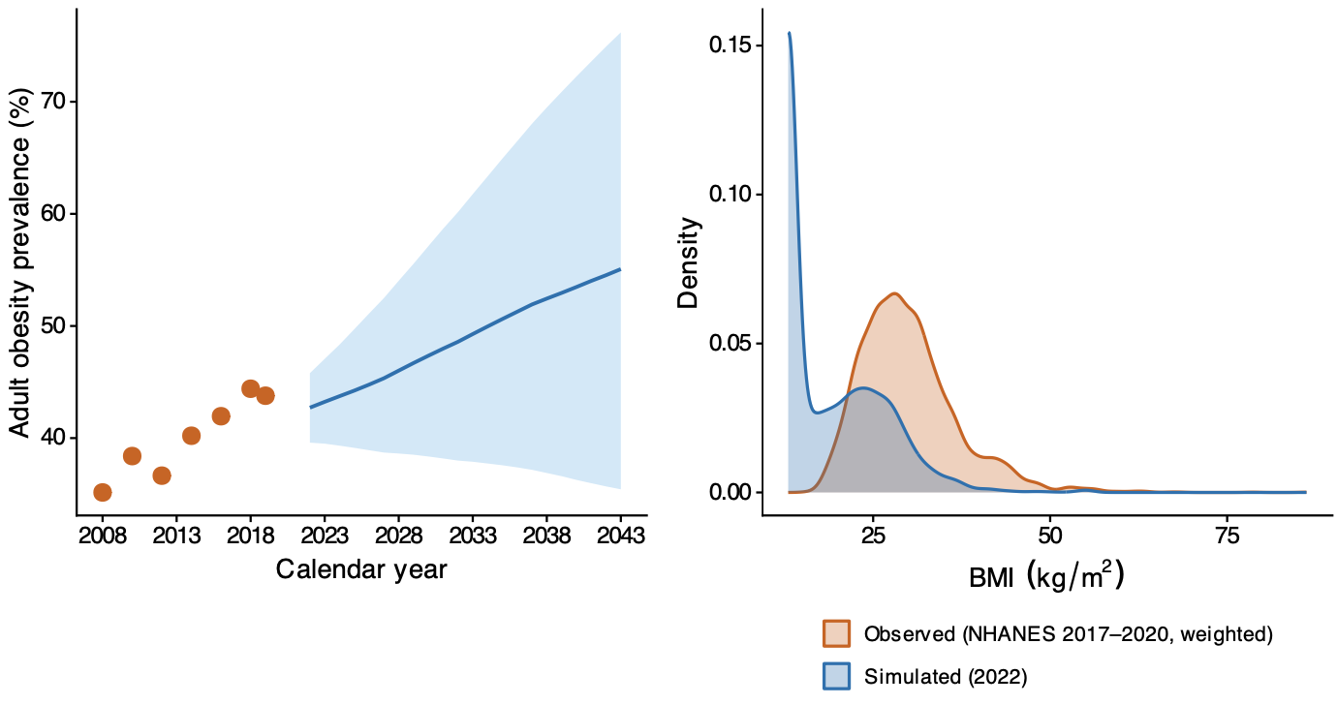(A) Simulated baseline trajectory (blue line, 95% UI shading) vs. NHANES cycle-weighted observed adult obesity prevalence (orange points, 2008–2019 cycle midpoints). (B) Simulated 2022 BMI density overlaid on the weighted NHANES 2017–2020 observed density.

Figure S2. Sex-stratified health impact, 2026–2043
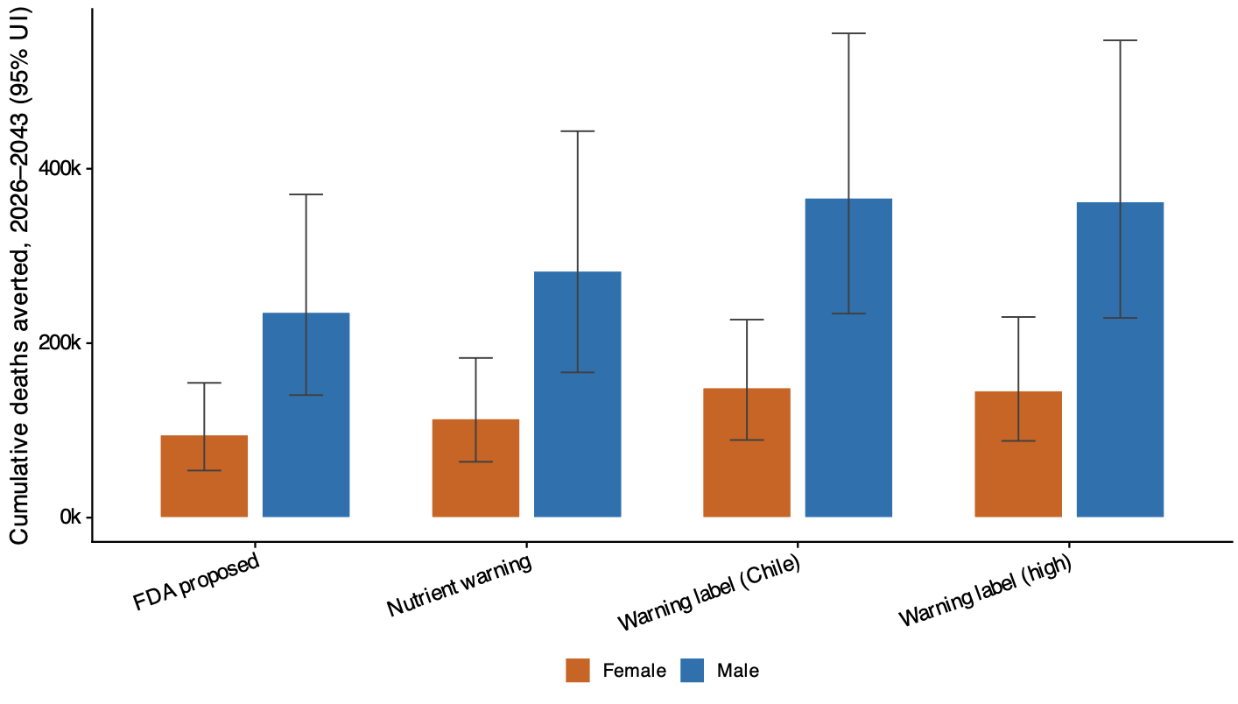

Figure S4: Iteration-level uncertainty distributions for four focal scenarios. 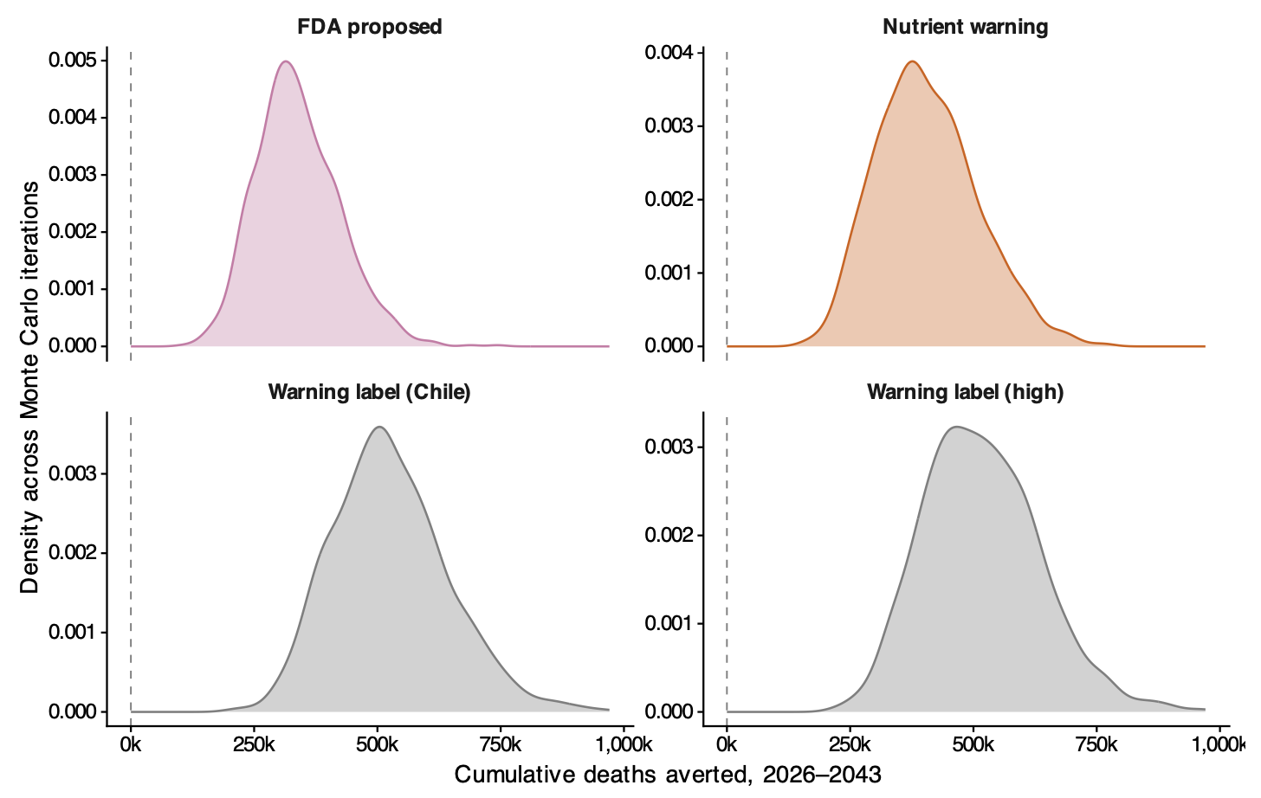1000 Monte Carlo iterations (seed 42). Dashed line at zero = no-effect reference.
Figure S5: Cumulative deaths averted trajectory, 2026–2043.
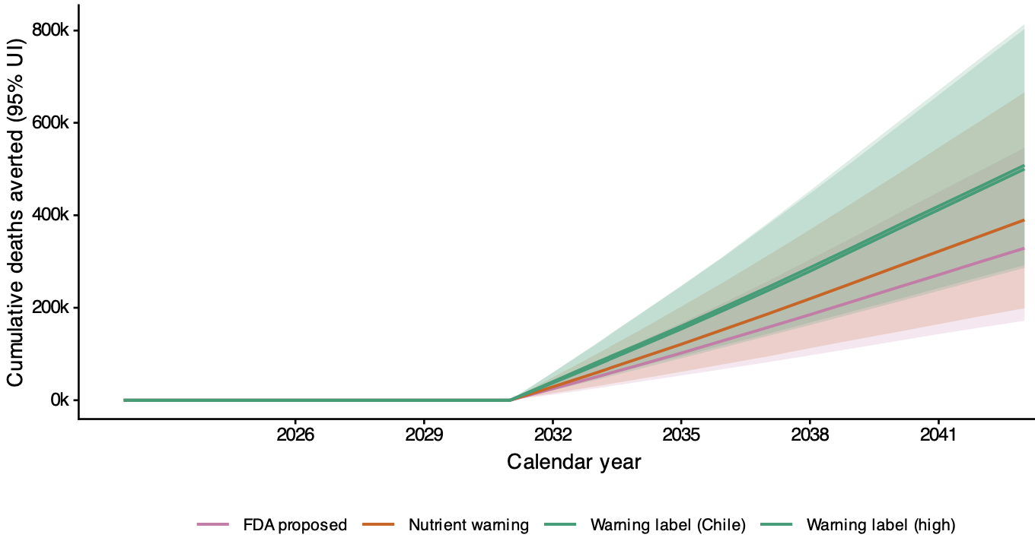
Running total of averted deaths from policy implementation, shaded 95% UI. Accumulation begins in 2032 after the 6-year BMI-to-mortality lag; all four scenarios show approximately linear gain thereafter.
Supplementary Tables
Table S1: Simulated baseline population characteristics, 2022. Demographic and behavioural values are NHANES 2017–2020 pooled survey- weighted estimates for adults aged 30–89; mortality rates are 2020 CDC WONDER national totals over the matching ICD-10 codes.
Characteristic | Value
Population
Simulated US adults aged 30-89 (2022) | 220,090,835
NHANES 2017-2020 pooled sample (unweighted n) | 9,963
Demographics (NHANES-weighted) | mean (SD)
Age, years | 53.5 (14.4)
Male, % | 47.9
Income quintile Q1 (lowest), % | 19.9
Income quintile Q2, % | 20.1
Income quintile Q3 (middle), % | 19.9
Income quintile Q4, % | 20.1
Income quintile Q5 (highest), % | 20.0
Body composition and dietary intake (NHANES-weighted) | mean (SD)
BMI, kg/m² | 30.1 (7.1)
Obesity (BMI ≥ 30), % | 44.1
Total energy intake, kcal/day | 2,148 (964)
Packaged-food energy intake (0.55x), kcal/day | 1,182 (530)
Baseline mortality rates (per 100,000 person-years, 2020 CDC WONDER)
All-cause | 1,170
Coronary heart disease (120-125) | 131
Ischemic stroke (163) | 6
Haemorrhagic stroke (160-162) | 13
Table S3: Sex-stratified cumulative deaths averted, 2026–2043

Scenario | Sex | Deaths averted (95% UI)
Nutrient warning | Male | 282,750 (166,488-443,025)
 | Female | 113,500 (64,000-183,050)
Warning label (Chile) | Male | 366,500 (233,938-555,525)
 | Female | 149,000 (88,988-227,000)
Warning label (high) | Male | 362,250 (228,975-547,525)
 | Female | 145,500 (87,988-230,025)
FDA proposed | Male | 235,500 (140,450-370,512)
 | Female | 95,000 (54,000-154,512)

Table S4: Income-quintile-stratified health impact, 2026–2043. Q1 = lowest-income quintile (highest baseline mortality).
Scenario | Income quintile | Deaths averted (95% UI) | Life-years gained (95% UI)
Nutrient warning | Q1 | 86,500 (50,500-137,012) | 1,693,625 (975,682-2,724,492)
 | Q2 | 81,000 (47,000-128,500) | 1,561,275 (880,748-2,491,465)
 | Q3 | 80,000 (47,488-130,512) | 1,542,749 (914,263-2,450,853)
 | Q4 | 77,500 (43,000-124,012) | 1,454,775 (811,271-2,356,501)
 | Q5 | 72,000 (40,500-115,525) | 1,337,700 (754,201-2,131,596)
Warning label (Chile) | Q1 | 113,000 (70,975-172,500) | 2,219,125 (1,409,416-3,419,295)
 | Q2 | 105,000 (66,988-158,500) | 2,037,299 (1,257,296-3,128,459)
 | Q3 | 105,000 (65,500-157,525) | 1,991,251 (1,251,448-3,082,573)
 | Q4 | 100,000 (61,000-156,512) | 1,881,301 (1,161,200-2,939,190)
 | Q5 | 92,500 (54,488-142,000) | 1,725,050 (1,030,992-2,627,104)
Warning label (high) | Q1 | 111,250 (68,488-168,512) | 2,191,450 (1,323,448-3,379,514)
 | Q2 | 104,500 (63,488-159,500) | 2,001,751 (1,217,684-3,093,442)
 | Q3 | 103,000 (63,000-156,500) | 1,969,450 (1,220,320-3,041,383)
 | Q4 | 99,500 (58,000-152,525) | 1,851,150 (1,129,685-2,844,307)
 | Q5 | 91,000 (54,488-141,012) | 1,688,948 (1,008,798-2,633,092)
FDA proposed | Q1 | 71,500 (41,500-115,500) | 1,417,399 (830,602-2,318,475)
 | Q2 | 66,500 (37,500-109,012) | 1,294,850 (747,120-2,087,553)
 | Q3 | 67,000 (38,500-106,000) | 1,282,376 (741,370-2,035,767)
 | Q4 | 65,000 (36,000-104,012) | 1,204,550 (703,801-1,955,661)
 | Q5 | 59,750 (33,500-97,012) | 1,115,250 (613,449-1,770,624)

Table S2: Complete scenario-level results (all 21 scenarios).
System | Scenario variant | Deaths averted (95% UI) | Life-years gained (95% UI) | Mean obesity, base (%) | Mean obesity, policy (%) | Δ (pp)
FDA proposed | FDA proposed (consumer + reformulation) | 559,500 (354,500-827,500) | 10,654,375 (6,986,094-16,093,199) | 48.8 | 42.9 | +5.69
 | FDA proposed (base) | 329,500 (189,000-528,500) | 6,262,501 (3,745,399-10,051,347) | 48.8 | 45.3 | +3.40
Nutri-Score | Nutri-Score (reformulation only) | 467,500 (309,500-659,000) | 8,926,724 (6,073,497-12,852,300) | 48.8 | 43.9 | +4.83
 | Nutri-Score (consumer + reformulation) | 410,500 (241,500-625,000) | 7,818,100 (4,702,653-12,028,848) | 48.8 | 44.6 | +4.19
 | Nutri-Score (reduced coverage) | -14,500 (-53,000-13,500) | -277,926 (-1,017,551-271,402) | 48.8 | 48.9 | -0.16
 | Nutri-Score (base) | -59,250 (-198,000-58,500) | -1,159,550 (-3,692,350-1,114,451) | 48.8 | 49.5 | -0.62
Nutrient warning | Nutrient warning (consumer + reformulation) | 823,500 (542,000-1,210,500) | 15,714,300 (10,512,948-23,297,951) | 48.8 | 40.2 | +8.49
 | Nutrient warning (reformulation only) | 467,500 (309,500-659,000) | 8,926,724 (6,073,497-12,852,300) | 48.8 | 43.9 | +4.83
 | Nutrient warning (base) | 392,000 (212,500-645,500) | 7,459,049 (4,174,349-12,315,449) | 48.8 | 44.7 | +3.98
Nutrient warning | Nutrient warning (compensation) | 293,500 (170,000-474,000) | 5,610,874 (3,288,701-8,982,603) | 48.8 | 45.7 | +3.01
 | Nutrient warning (temporal decay) | 288,000 (156,500-478,000) | 5,529,599 (3,072,950-9,266,450) | 48.8 | 46.0 | +2.66
 | Nutrient warning (temporal + compensation) | 218,000 (124,500-350,500) | 4,188,099 (2,429,800-7,014,751) | 48.8 | 46.8 | +2.00
Traffic light | Traffic light (consumer + reformulation) | 997,250 (641,500-1,457,000) | 18,926,623 (12,229,299-27,476,400) | 48.8 | 38.6 | +10.13
 | Traffic light (mandatory, high effect) | 747,500 (442,500-1,155,500) | 14,241,950 (8,840,398-22,467,500) | 48.8 | 41.0 | +7.59
 | Traffic light (base) | 580,750 (320,000-897,000) | 11,032,673 (6,565,898-17,169,152) | 48.8 | 42.7 | +5.91
 | Traffic light (reformulation only) | 467,500 (309,500-659,000) | 8,926,724 (6,073,497-12,852,300) | 48.8 | 43.9 | +4.83
 | Traffic light (reduced coverage) | 260,500 (143,000-460,000) | 5,005,951 (2,844,999-8,709,803) | 48.8 | 46.1 | +2.74
Warning label | Warning label (high effect) | 1,270,000 (768,500-1,959,000) | 24,237,702 (15,230,051-37,086,501) | 48.8 | 35.9 | +12.86
 | Warning label, two-phase (Chile) | 509,750 (316,500-782,000) | 9,800,676 (6,112,500-14,418,749) | 48.8 | 43.5 | +5.18
 | Warning label (base) | 500,250 (299,000-788,500) | 9,540,300 (5,872,550-15,091,100) | 48.8 | 43.4 | +5.11
 | Warning label (reformulation only) | 467,500 (309,500-659,000) | 8,926,724 (6,073,497-12,852,300) | 48.8 | 43.9 | +4.83
Table S5: Annual deaths averted by calendar year, focal scenarios, 2026–2043.
Year | FDA proposed (base) | Nutrient warning (base) | Warning label, two-phase (Chile) | Warning label (base)
2032 | 25,000 (12,000-41,500) | 29,000 (15,000-49,500) | 40,000 (24,500-60,000) | 37,500 (21,500-60,000)
2033 | 25,000 (13,500-41,500) | 30,000 (15,000-49,500) | 41,000 (25,000-60,500) | 38,000 (22,000-62,000)
2034 | 25,500 (14,000-42,000) | 31,000 (15,500-50,500) | 39,000 (23,000-63,000) | 39,000 (23,500-62,500)
2035 | 26,500 (14,000-42,000) | 31,000 (16,000-53,000) | 40,000 (22,500-63,000) | 39,500 (23,500-63,000)
2036 | 27,500 (14,000-44,000) | 32,500 (16,500-53,500) | 41,500 (24,500-64,500) | 41,000 (24,000-65,000)
2037 | 27,500 (14,500-45,500) | 32,500 (16,500-56,000) | 42,000 (23,500-67,500) | 41,500 (24,000-69,500)
2038 | 28,000 (15,000-48,000) | 33,500 (18,000-57,000) | 43,250 (25,000-68,500) | 42,500 (24,000-71,000)
2039 | 28,750 (15,000-47,500) | 34,000 (17,500-58,500) | 44,000 (24,500-69,500) | 44,500 (24,500-72,500)
2040 | 29,000 (15,500-49,500) | 34,500 (17,000-59,000) | 45,000 (24,500-72,000) | 44,500 (24,500-72,500)
2041 | 28,500 (15,500-49,000) | 34,000 (17,500-60,000) | 44,000 (25,500-71,500) | 44,000 (25,000-72,000)
2042 | 29,000 (14,500-47,500) | 34,000 (17,500-59,500) | 44,000 (25,000-72,000) | 44,000 (25,000-72,000)
2043 | 28,500 (14,500-48,000) | 34,000 (17,000-60,000) | 44,500 (24,500-71,500) | 44,000 (24,500-72,000)

