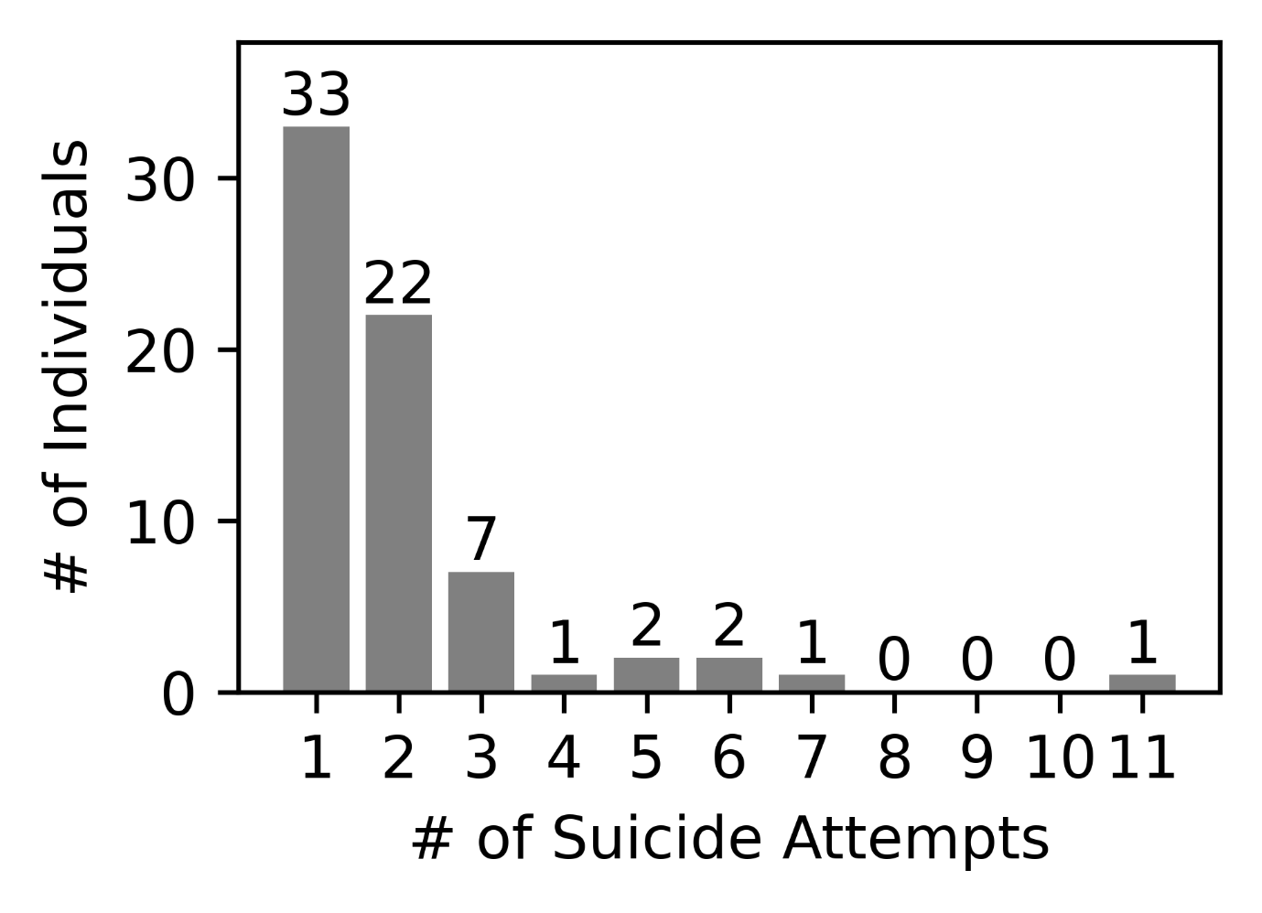Supplementary Figure 1. Distribution of the number of suicide attempts among suicide attempters in the discovery cohort.
Histogram showing the number of individuals (y axis) by the number of prior suicide attempts (x axis) for the 69 suicide attempters in the Korean discovery cohort.

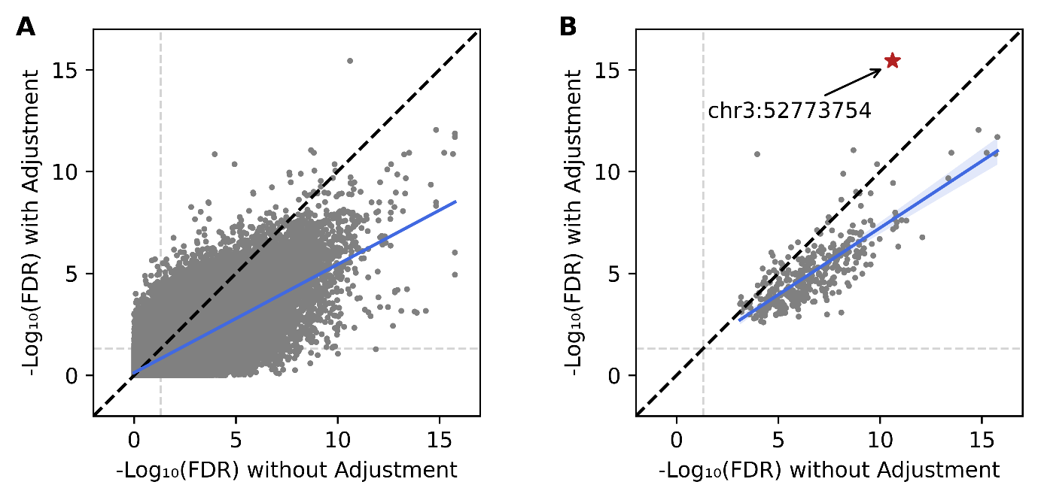

Supplementary Figure 2. Sensitivity analysis of differential methylation results to blood cell type composition adjustment.
Scatter plots comparing -log10(FDR) values from the weighted differential methylation analysis without (x axis) and with (y axis) adjustment for blood cell type proportions estimated by UXM deconvolution. The dashed diagonal line indicates equal significance under both models. (A) All input CpG sites. (B) The 365 selected CpG sites. The blue line represents the linear regression trend. The red star marks chr3:52773754 at the NEK4-ITIH1 locus.

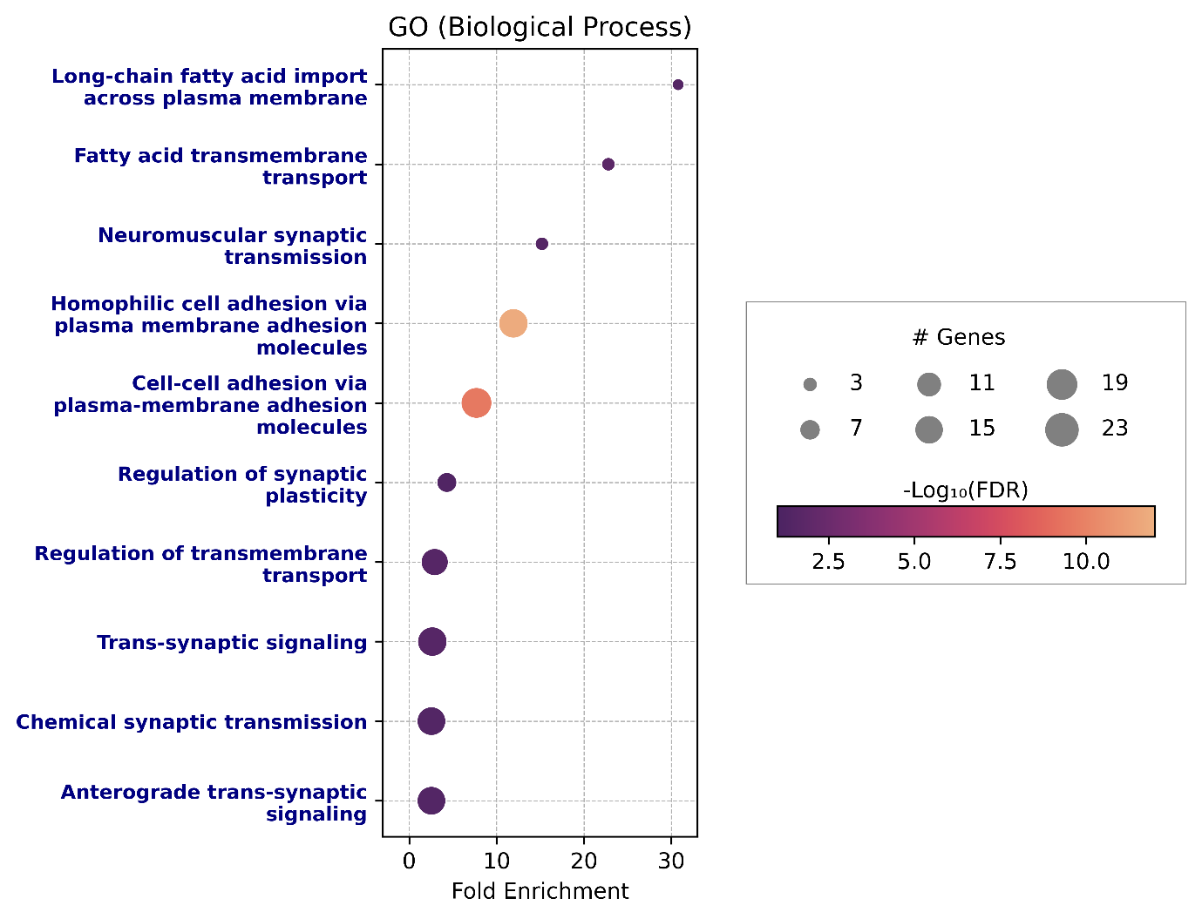

Supplementary Figure 3. Gene Ontology biological process enrichment analysis of the 365 suicidality-associated CpG sites.
GO biological process enrichment analysis of the 390 genes annotated to the 365 CpG sites. Dot size represents the number of genes in each term, and color indicates statistical significance (-log10 FDR). Terms reaching significance (FDR < 0.05) are labeled in blue.

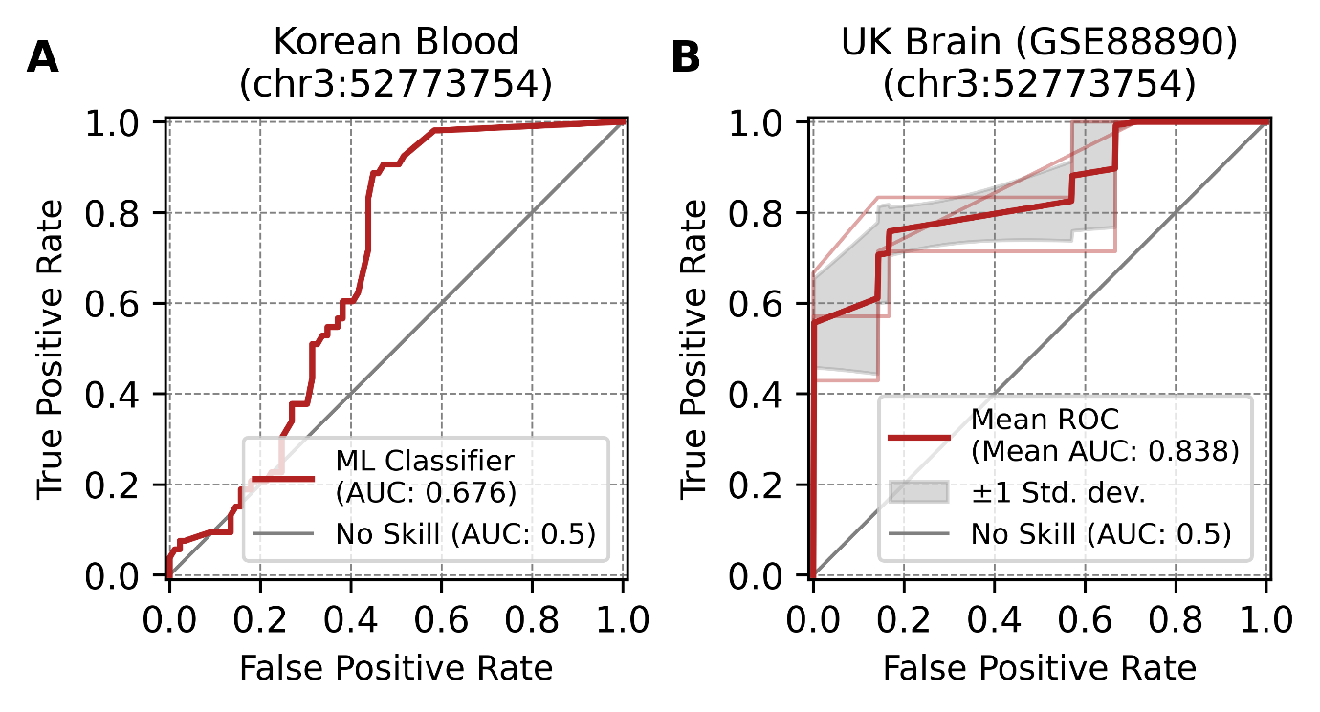

Supplementary Figure 4. Classification performance of the single CpG site chr3:52773754.
(A) ROC curve for the Korean blood validation cohort using chr3:52773754 alone, with the random forest model trained on the discovery set and tested on the independent validation cohort. (B) ROC curve for the UK postmortem brain tissue dataset (GSE88890; BA11) using chr3:52773754 alone, evaluated by 3-fold cross-validation. The red line indicates the mean ROC across folds, and the shaded area represents ±1 standard deviation.

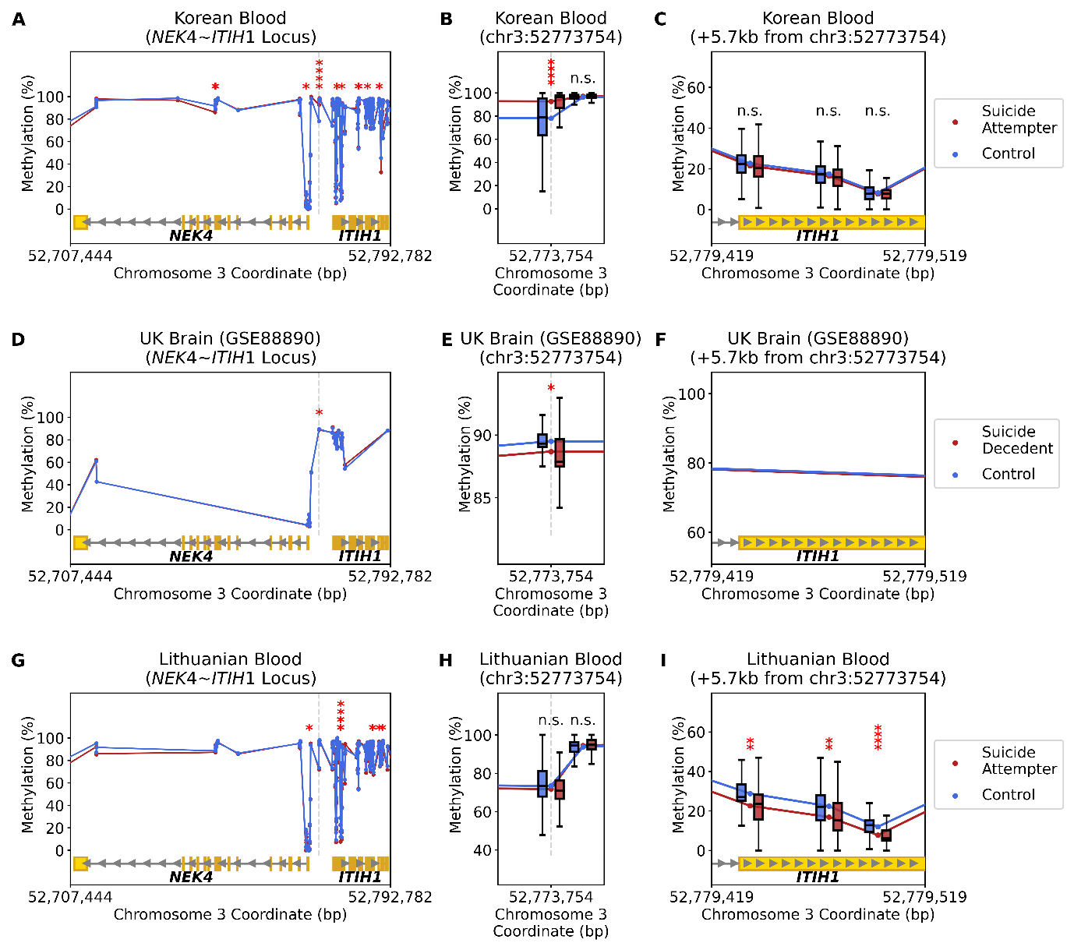

Supplementary Figure 5. Regional methylation profiles at the NEK4-ITIH1 locus across three validation cohorts.
(A-C) Korean blood cohort. (D-F) UK postmortem brain tissue (GSE88890; BA11). (G-I) Lithuanian blood cohort. In all panels, red indicates suicide attempters (or suicide decedents in the brain tissue dataset) and blue indicates controls. Gene structures are indicated at the bottom. The vertical dashed line marks the position of chr3:52773754. Asterisks above individual CpG sites indicate significant differences between groups by Wilcoxon rank-sum test (*: 0.01≤p<0.05; **: 0.001≤p<0.01; ***: 0.0001≤p<0.001; ****: p<0.0001) (A, D, G) Mean methylation levels across the NEK4 gene body through the ITIH1 gene body region (chr3:52,707,444-52,792,782). (B, E, H) Zoom-in of the region surrounding chr3:52773754, with boxplots showing the distribution of methylation values in each group. (C, F, I) Zoom-in of the ITIH1 gene body region approximately 5.7 kb downstream of chr3:52773754. This region was not assessable in (F) due to methylation array platform coverage.

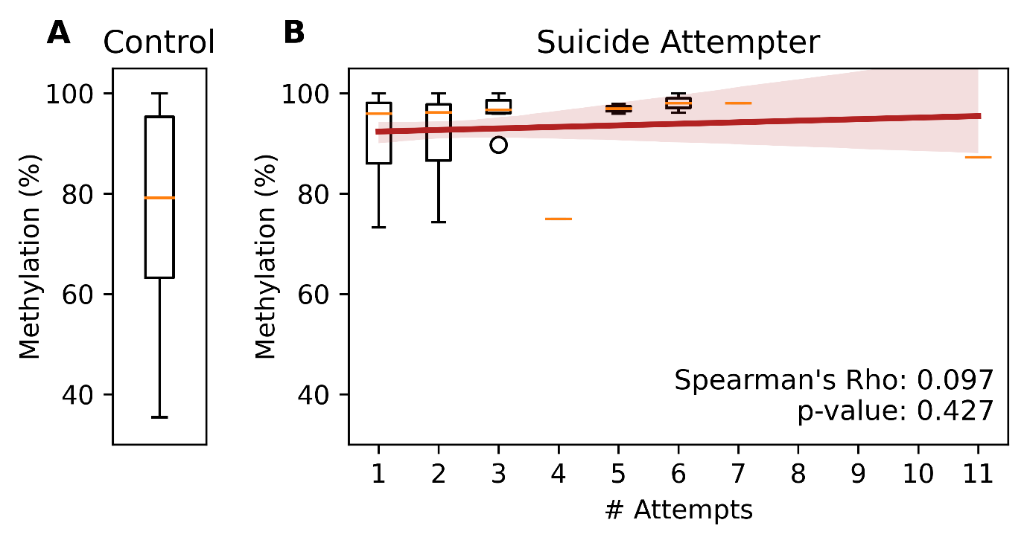

Supplementary Figure 6. Methylation levels at chr3:52773754 (NEK4-ITIH1) in the discovery cohort stratified by number of suicide attempts.
(A) Distribution of methylation values (%) at chr3:52773754 among controls (n = 207). (B) Methylation values among suicide attempters stratified by the number of prior suicide attempts, with individual boxplots for each attempt count. The red line indicates the linear trend across attempt frequencies, with shading representing the 95% confidence interval. Spearman's correlation coefficient and corresponding p-value are shown.

Supplementary Table 1. (separate file)
Summary of the weighted differential methylation analysis results from one thousand random samplings of all 365 CpG sites, along with the annotation of genes associated with each CpG site.

Supplementary Table 2. (separate file)
Summary of the gene enrichment results for genes associated with all 365 CpG sites. Only the terms with FDR < 0.2 are listed.

Supplementary Table 3. (separate file)
Summary of the Spearman correlation results between the number of suicide attempts and all 365 CpG sites within the suicide attempter group.

Supplementary Table 4. (separate file)
Baseline characteristics in this study. The following statistical methods were applied: (Sex: Fisher's exact test, Age: Wilcoxon ranksum test, Number of suicide attempts: Wilcoxon ranksum test). NA = Not Available;

