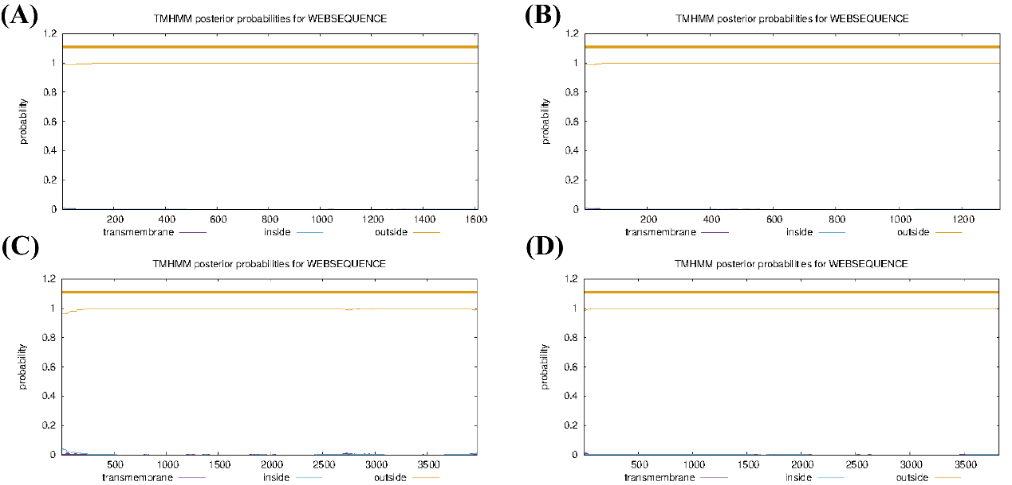
Figure 1 Analysis of RcDHD/SDHs transmembrane structure

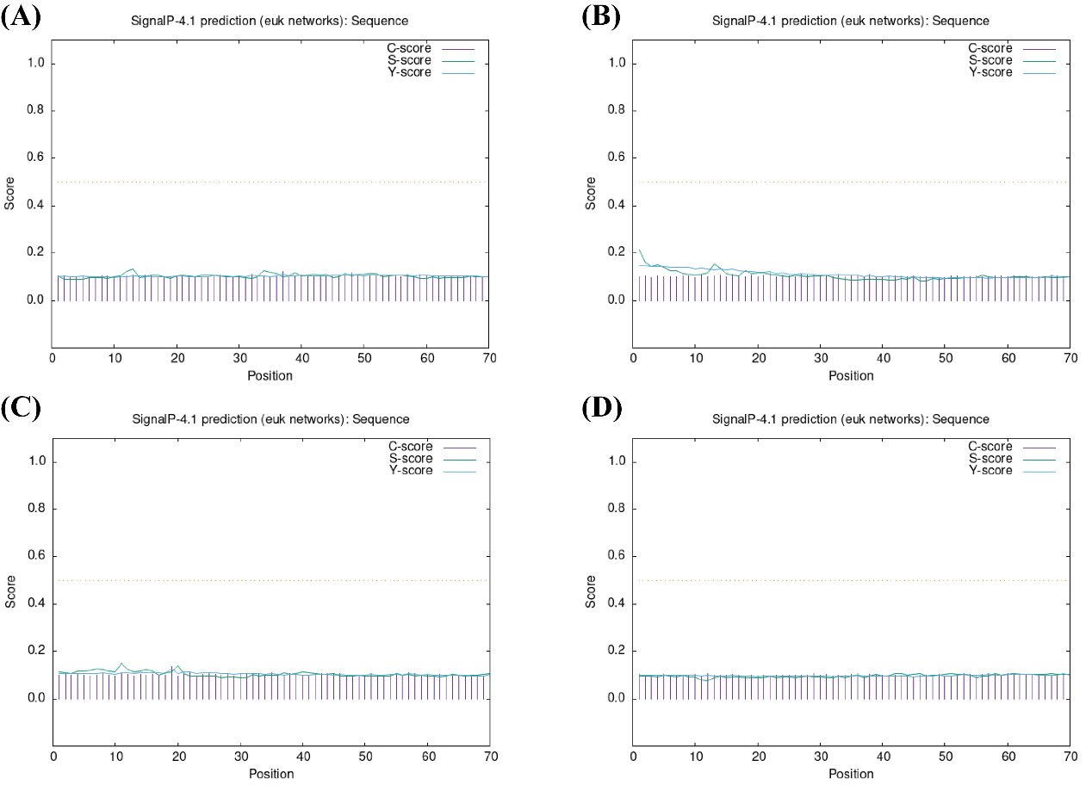
Figure 2 Prediction of signal peptides of RcDHD/SDHs

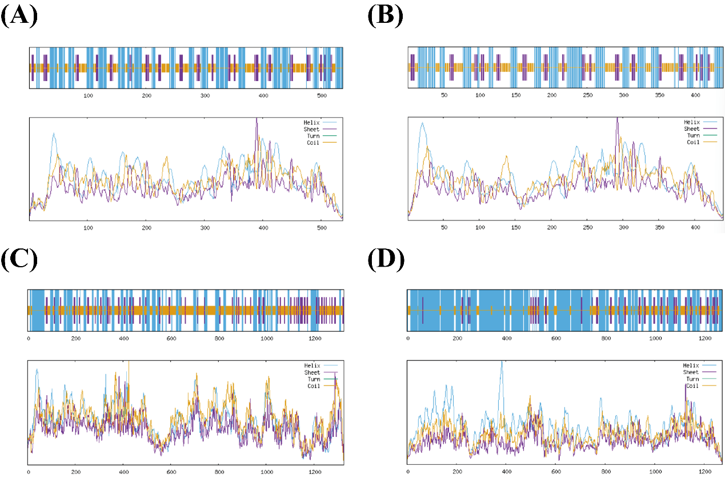
Figure 3 RcDHD/SDHs secondary structure prediction
Note：A：RcDHD/SDH1；B：RcDHD/SDH3；C：RcDHD/SDH3；D: RcDHD/SDH4

