Supplementary Information
Assessing the Osteoporosis Care Gap and Clinical Outcomes Following Fragility Hip Fractures in Saudi Arabia: Implications for Fracture Liaison Services
Fahad Alshahrani, Meshal Aljarallah, Mohammed Almohaya and Mussa Almalki
Aging Clinical and Experimental Research
Corresponding author: Fahad Alshahrani, fahad_alshahrani@yahoo.com

Outcome | Value
Total patients | 273
Mortality status known | 178
Deaths | 93
Mortality among patients with known status, n (%) | 93 (52.2)
30-day mortality, Kaplan–Meier estimate, % | 2.2%
1-year mortality, Kaplan–Meier estimate, % | 16.3%
5-year mortality, Kaplan–Meier estimate, % | 42%
Median survival, years (95% CI) | 6.1 (5.3–8.7)
Mean survival, years | 6.0
Maximum follow-up, years | 10.5
Table S1. Mortality outcomes summary. Mortality percentages among patients with known status are presented separately due to missing data.

Outcome | Value
Documented refracture, full cohort | 32/273 (11.7%)
Median time to refracture among dated events* | 1.38 years
IQR | 0.57–4.49
Documented refracture, untreated | 21/214 (9.8%)
Documented refracture, treated | 11/59 (18.6%)
p-value | 0.10
Table S2. Descriptive refracture outcomes according to documented post-fracture osteoporosis treatment.
*Time available in n = 14 patients.

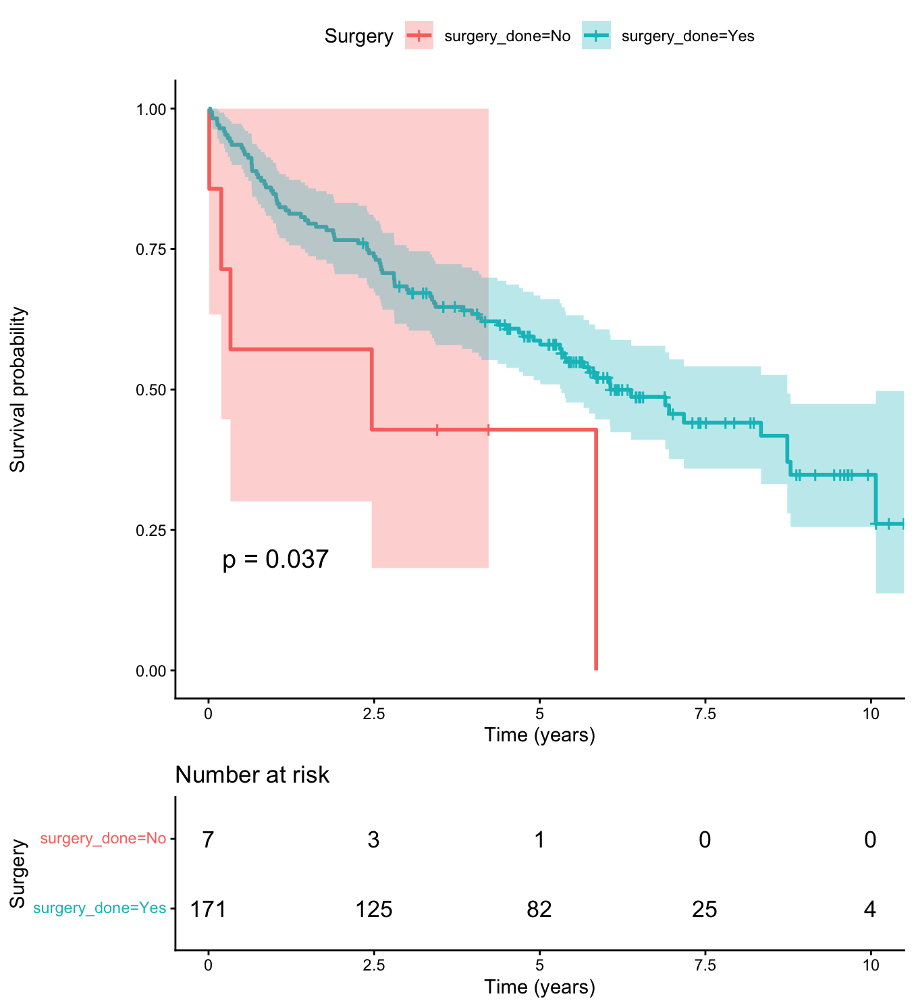
Figure S1. Kaplan–Meier survival by operative management in the mortality-analysis cohort. Interpret cautiously because the non-operative group was small and treatment selection was non-random.

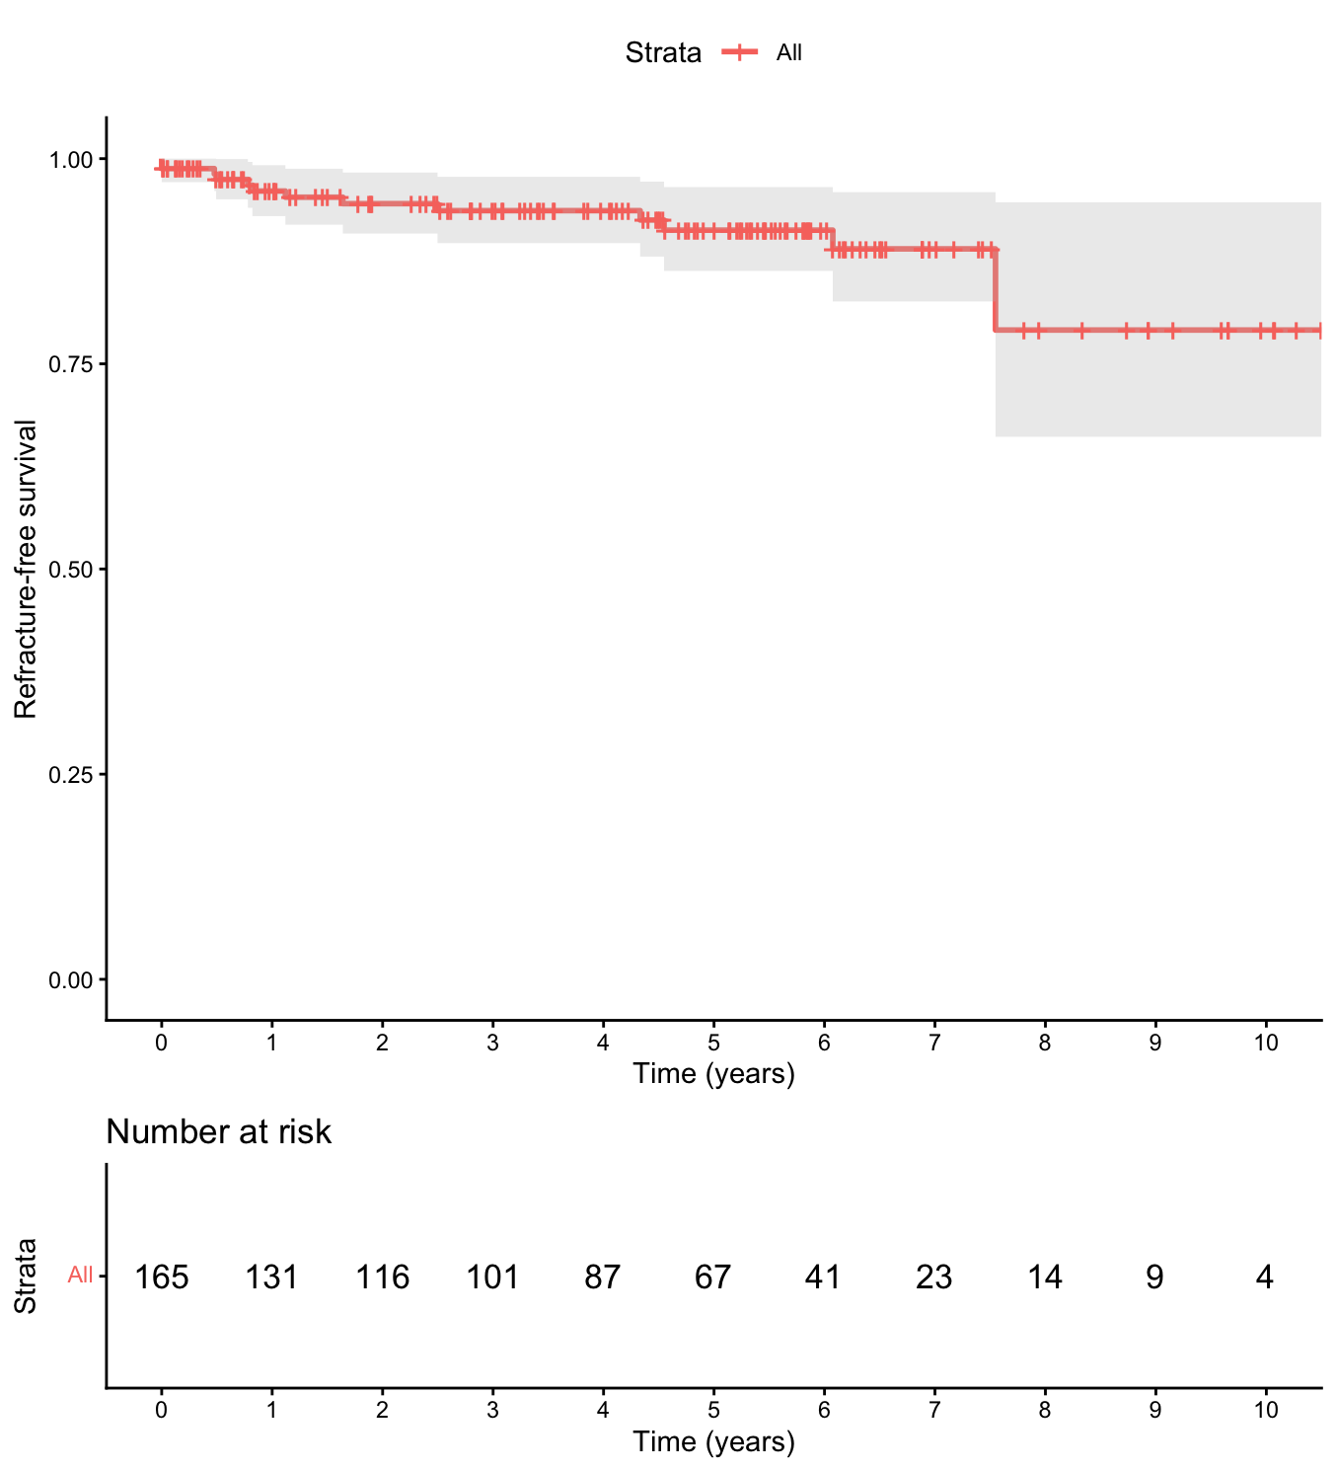
Figure S2. Exploratory Kaplan–Meier refracture-free survival among 165 patients with sufficient timing and follow-up data; 14 dated refracture events were included.

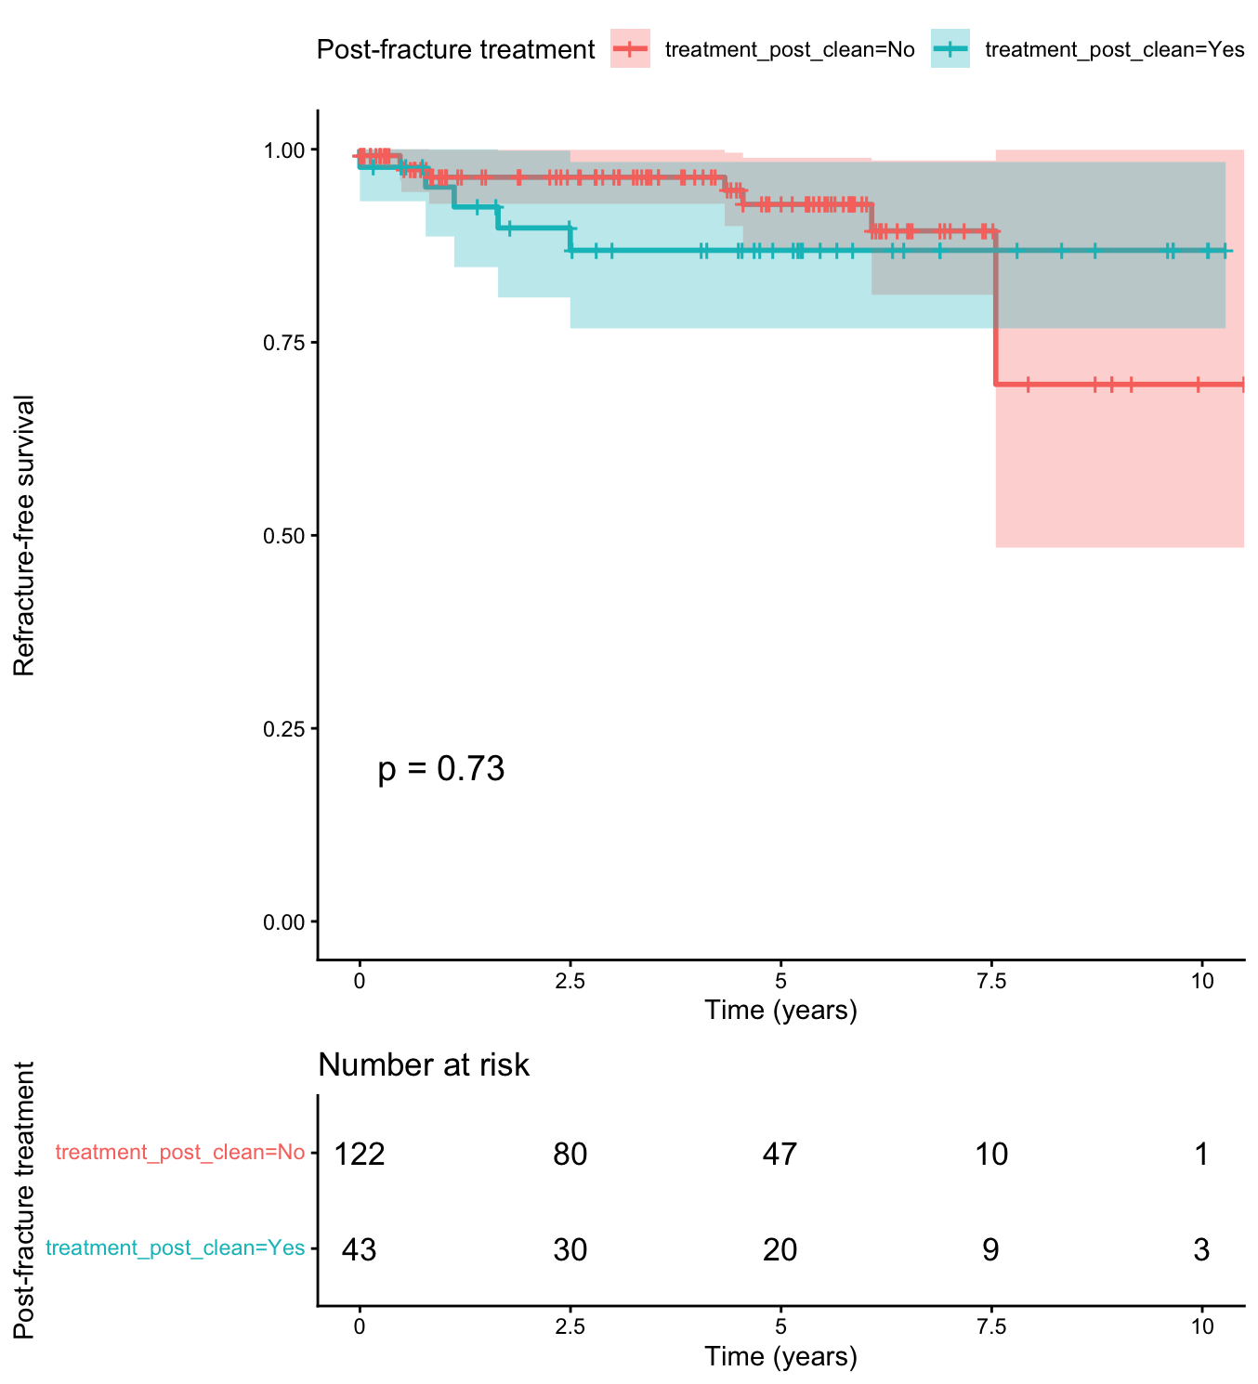
Figure S3. Exploratory refracture-free survival by documented post-fracture osteoporosis treatment (n = 165 at time zero: 122 untreated and 43 treated; log-rank p=0.73). Treatment timing was not modeled, and the comparison is susceptible to immortal-time bias and confounding by indication.

