Supplementary material

Supplement to:
Epidemiological changes in pediatric community-onset severe bacterial infections in France: A multicenter prospective study

Table of Content
List of the 12 participating centers 4
Figure S1 5
Figure S2 6
Figure S3 7
Figure S4 8
Table S1 9
Table S2 10
Table S3 11
Table S4 12
Table S5 13
Table S6 STROBE Checklist 14

List of the 12 participating centers
University hospital of Angers, University hospital of Bordeaux, University hospital of Brest, University hospital of Grenoble, University hospital of Lille, University hospital of Lyon, University hospital of Montpellier, University hospital of Nantes, Public hospitals of Paris (including Robert Debré university hospital, Armand Trousseau university hospital, and Necker university hospital), and University hospital of Saint-Etienne.

Figure S1
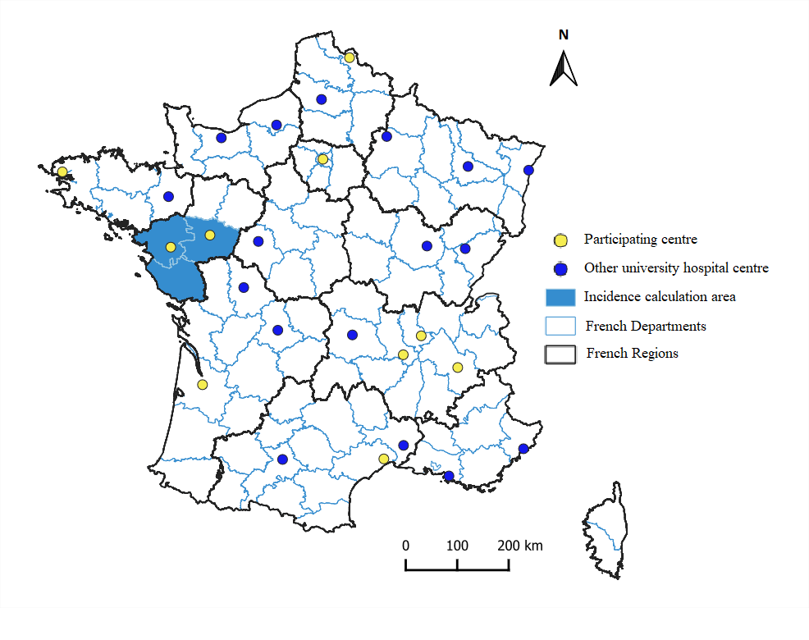
Figure S1. Geographical localisation of the participating centres and incidence calculation area for the 2015-2018 cohort

Figure S2
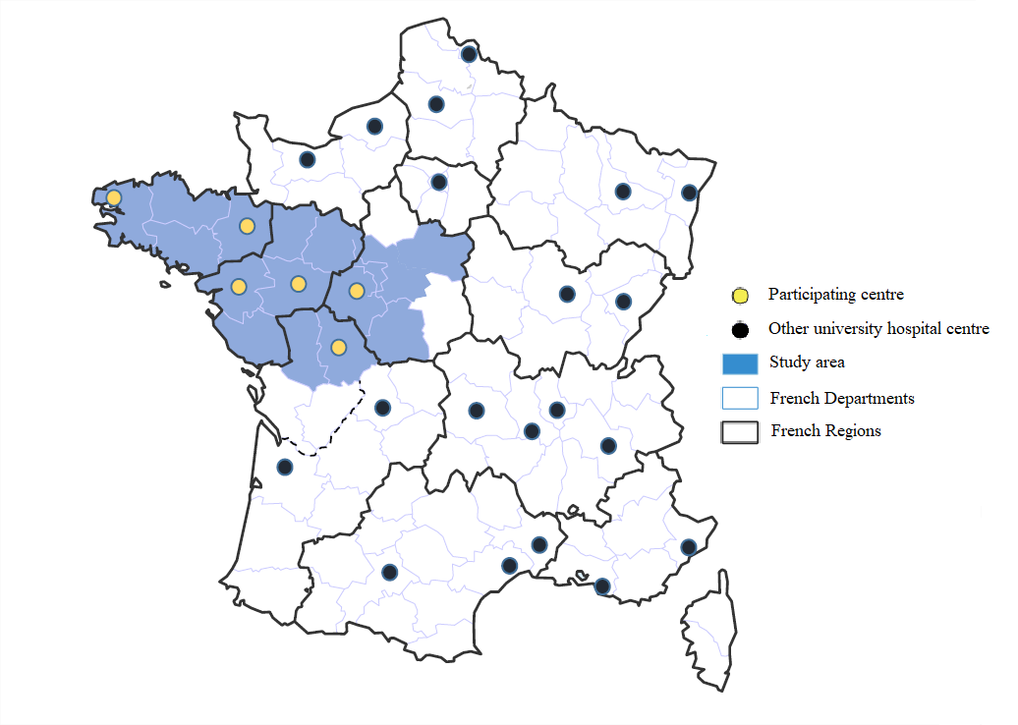
Figure S2. Geographical localisation of the participating centres for the 2009-2014 cohort.

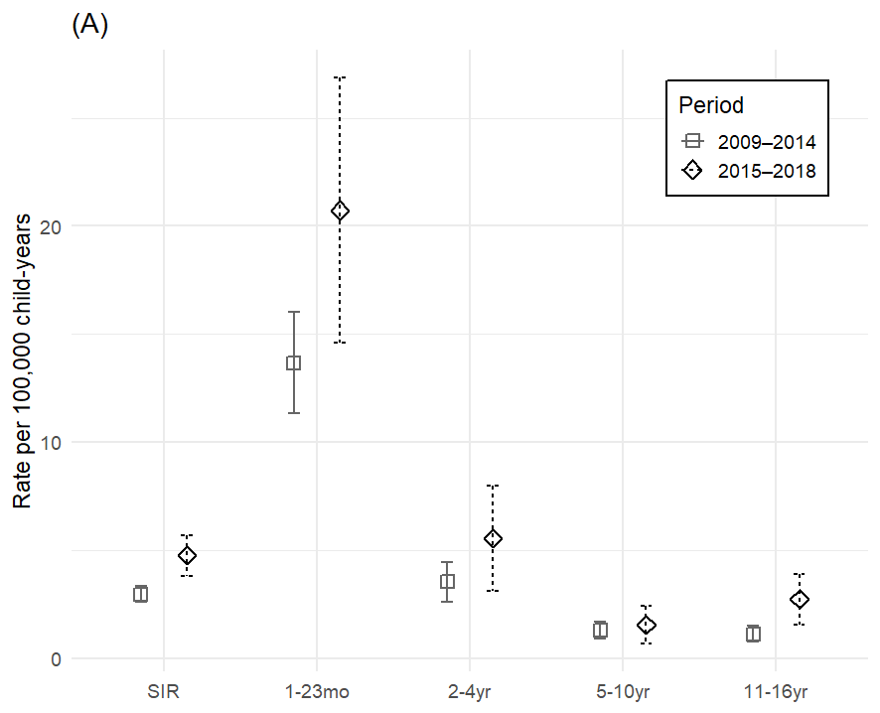
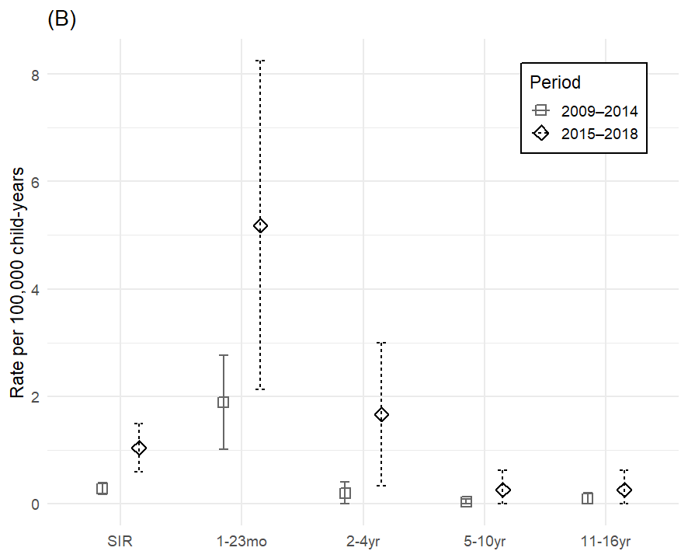
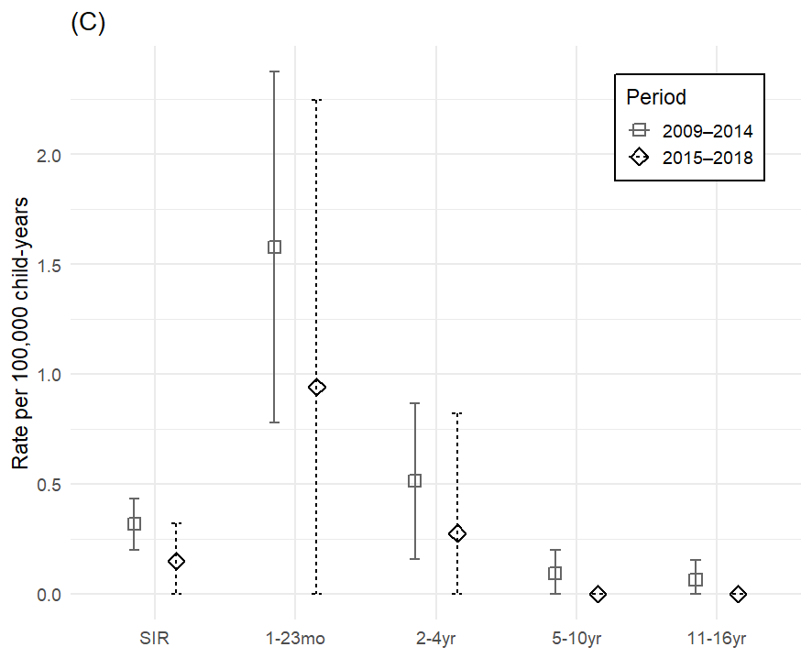
Figure S3
Figure S3. Evolution of incidence, disability and mortality rates of COSBIs according to the age group between 2009-2014 in western France and 2015-2018 in three administrative divisions (Loire-Atlantique, Vendée, and Maine-et-Loire)
(A) COSBIs Incidence rate, (B) Moderate-to-severe disability rate, (C) Mortality rate
COSBI: community-onset bacterial infection, SIR: age-standardized incidence rate

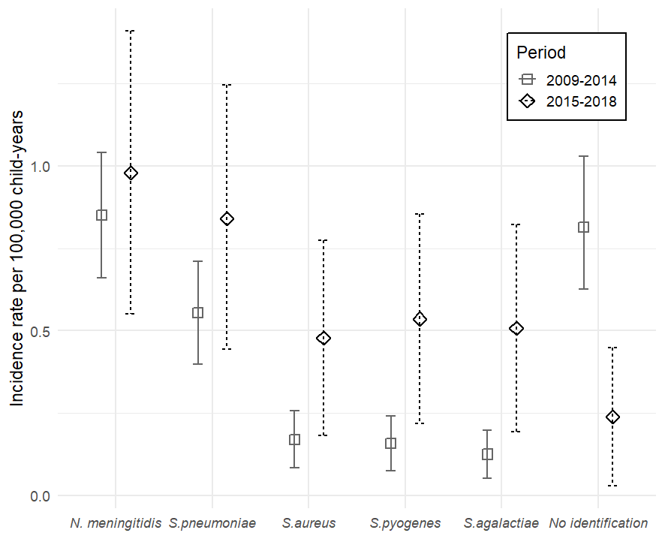
Figure S4
Figure S4. Age-standardized incidence rates (and 95% confidence intervals) of community-onset severe bacterial infections by identified bacteria during 2009–2014 in western France and 2015–2018 in three administrative divisions (Loire-Atlantique, Vendée, and Maine-et-Loire)

Table S1
Table S1. Microbiological findings
Bacterium, No. (%) | Total (n=493) | No or mild disability (n=391) | Moderate-to-severe disability (n=73) | Death (n=26)
Neisseria meningitidis | 94 (19) | 80 (20) | 11 (15) | 3 (10)
Streptococcus pneumoniae | 93 (19) | 65 (17) | 21 (29) | 6 (21)
Staphylococcus aureus | 54 (11) | 46 (12) | 6 (8) | 1 (4)
Streptococcus agalactiae | 43 (9) | 26 (7) | 12 (16) | 5 (19)
Streptococcus pyogenes | 38 (8) | 34 (9) | 3 (4) | 1 (4)
Escherichia coli | 38 (8) | 32 (8) | 4 (5) | 2 (8)
Other gram-negative bacilli | 27 (6) | 18 (5) | 4 (5) | 4 (15)
Other Streptococcus | 22 (5) | 15 (4) | 6 (8) | 1 (4)
Other bacteria | 19 (4) | 15 (4) | 3 (4) | 1 (4)
Haemophilus Influenzae | 10 (2) | 8 (2) | 2 (3) | 0
No identification | 55 (11) | 52 (13) | 1 (1) | 2 (8)

Table S2
Table S2. Detailled meningoccoccus and pneumococcus serotypes
Variable | No. (%)
Neisseria meningiditis | 94
Group B | 64 | (68)
Group C | 15 | (16)
W135 | 10 | (10)
Y | 3 | (3.2)
Unknown | 2 | (2.1 )
Streptococcus pneumoniae | 93
15 B/C | 8 | (8.6)
10A | 7 | (7.5)
15A | 6 | (6.5)
24F | 5 | (5.4)
33F | 5 | (5.4)
3 | 5 | (5.4)
22F | 4 | (4.3)
8 | 3 | (3.2)
12F | 3 | (3.2)
19A/F | 3 | (3.2)
23B | 3 | (3.2)
35B | 3 | (3.2)
Other serotype | 12 | (12.9)
Unknown | 26 | (28)
Pneumococcus serotype group (n=67)
13-valent PCV | 10 | (15)
15-valent PCV | 15 | (22)
20-valent PCV | 40 | (60)
95% CI : 95% confidence interval, PCV : pneumococcal conjugate vaccine

Table S3
Table S3. Comparison of incidence, disability, and mortality rates from community-onset severe bacterial infections between 2009-2014 and 2015-2018 (per 100,000 child-years)
Outcome | 2009-2014*  (95% CI) | 2015 - 2018**  (95% CI) | IRD  (95% CI)
Age-standardized incidence rate | 3.0 (2.6 - 3.3) | 4.8 (3.8 - 5.7) | 1.8 (0.8 to 2.8)
Crude incidence rates by age group
1 - 23 months | 13.7 (11.3 - 16.0) | 20.7 (14.6 - 26.9) | 7.1 (0.5 to 13.6)
2 - 4 years | 3.5 (2.7 - 4.5) | 5.5 (3.1 - 8.0) | 2.0 (-0.6 to 4.6)
5 - 10 years | 1.3 (0.9 - 1.7) | 1.6 (0.7 - 2.4) | 0.2 (-0.7 to 1.21)
11 - 16 years | 1.1 (0.7 - 1.5) | 2.7 (1.6 - 3.9) | 1.6 (0.4 to 2.8)
Age-standardized moderate-to-severe disability rate | 0.3 (0.2-0.4) | 1.0 (0.6-1.5) | 0.8 (0.3 to 1.2)
Crude disability rates by age group
1 - 23 months | 1.9 (1.0-2.8) | 5.2 (2.1-8.2) | 3.2 (0.1 to 6.5)
2 - 4 years | 0.2 (0 - 0.4) | 1.6 (0.3-3) | 1.5 (0.1 to 2.8)
5 - 10 years | 0.03 (0-0.1) | 0.3 (0-0.6) | 0.2 (-0.1 to 0.6)
11 - 16 years | 0.1 (0-0.2) | 0.3 (0-0.6) | 0.2 (-0.2 to 0.5)
Age-standardized mortality rate | 0.3 (0.2-0.4) | 0.2 (0-0.3) | -0.2 (-0.4 to 0.04)
Crude mortality rates by age group
1 - 23 months | 1.6 (0.8-2.4) | 0.9 (0-2.2) | -0.6 (-2.2 to 0.9)
2 - 4 years | 0.5 (0.2-0.9) | 0.2 (0.0-0.8) | -0.2 (-0.8 to 0.4)
5 - 10 years | 0.1 (0-0.2) | 0 | -0.1 (-0.2 to 0.01)
11 - 16 years | 0.1 (0- 0.2) | 0 | -0.1 (-0.2 to 0.02)
* Fifteen administrative divisions in western France
** Three administrative divisions (Loire-Atlantique, Vendée, Maine-et-Loire) of western France
95% CI: 95% confidence interval, IRD: incidence rate difference

Table S4
Table S4. Comparison of age-standardized incidence, disability, and mortality rates from community-onset severe bacterial infections between 2009-2014 and 2015-2018 in three administrative divisions (per 100,000 child-years)
Outcome | SIR (95% CI)  2009 - 2014* | SIR (95% CI)  2015 - 2018* | Rate difference  (95% CI)
COSBI incidence | 4.0 (3.3 - 4.8) | 4.8 (3.8 - 5.7) | 0.8 (-0.5 to 2.0)
Mortality | 0.4 (0.2 - 0.7) | 0.2 (0.0 - 0.3) | -0.3 (-0.6 to 0.04)
Moderate-to-severe disability | 0.3 (0.1 - 0.5) | 1.0 (0.6 - 1.5) | 0.7 (0.3 to 1.2)
* Three administrative divisions (Loire-Atlantique,Vendée, Maine-et-Loire)
COSBI: community-onset severe bacterial infection, SIR: age-standardized incidence rate, 95% CI: 95% confidence interval

Table S5

Table S5. Age-standardized community-onset severe bacterial infections incidence rates according to bacterial etiology during 2009-2014 and 2015-2018 (per 100,000 children-year)
Bacterium | SIR (95% CI)  2009 - 2014* | SIR (95% CI)  2015 - 2018** | IRD (95 %CI)
Neisseria meningitidis | 0.85 (0.7-1.0) | 1.0 (0.6-1.4) | 0.3 (-0.1 to 0.7)
Streptococcus pneumoniae | 0.6 (0.4-0.7) | 0.8 (0.4-1.2) | 0.1 (-0.3 to 0.6)
Staphylococcus aureus | 0.2 (0.1-0.3) | 0.5 (0.2-0.8) | 0.3 (0.0 to 0.6)
Streptococcus pyogenes | 0.2 (0.1-0.2) | 0.5 (0.2-0.8) | 0.4 (0.1 to 0.7)
Streptococcus agalactiae | 0.1 (0.1-0.2) | 0.5 (0.2-0.8) | 0.4 (0.1 to 0.7)
No positive identification | 0.8 (0.6-1.0) | 0.2 (0.0-0.4) | -0.6 (-0.9 to -0.3)
* Fifteen administrative divisions in western France
** Three administrative divisions (Loire-Atlantique, Vendée, Maine-et-Loire) in western France
SIR: age-standardized incidence rate; IRD: incidence rate difference, 95% CI: 95% confidence interval

Table S6 STROBE Checklist
STROBE Statement—Checklist of items that should be included in reports of cohort studies
 |  |  | Item No | Recommendation | Page No
Title and abstract |  |  | 1 | (a) Indicate the study’s design with a commonly used term in the title or the abstract
 |  |  | 1 | (b) Provide in the abstract an informative and balanced summary of what was done and what was found | 1-5
Introduction
Background/rationale |  |  | 2 | Explain the scientific background and rationale for the investigation being reported | 6
Objectives |  |  | 3 | State specific objectives, including any prespecified hypotheses | 7
Methods
Study design |  |  | 4 | Present key elements of study design early in the paper | 7
Setting |  |  | 5 | Describe the setting, locations, and relevant dates, including periods of recruitment, exposure, follow-up, and data collection | 7
Participants |  |  | 6 | (a) Give the eligibility criteria, and the sources and methods of selection of participants. Describe methods of follow-up | 7-8
 |  |  | 6 | (b) For matched studies, give matching criteria and number of exposed and unexposed
Variables |  |  | 7 | Clearly define all outcomes, exposures, predictors, potential confounders, and effect modifiers. Give diagnostic criteria, if applicable | 8
Data sources/ measurement |  |  | 8* | For each variable of interest, give sources of data and details of methods of assessment (measurement). Describe comparability of assessment methods if there is more than one group | 8
Bias |  |  | 9 | Describe any efforts to address potential sources of bias | 8-9
Study size |  |  | 10 | Explain how the study size was arrived at | 8
Quantitative variables |  |  | 11 | Explain how quantitative variables were handled in the analyses. If applicable, describe which groupings were chosen and why | 9
Statistical methods |  |  | 12 | (a) Describe all statistical methods, including those used to control for confounding | 9
 |  |  | 12 | (b) Describe any methods used to examine subgroups and interactions
 |  |  | 12 | (c) Explain how missing data were addressed
 |  |  | 12 | (d) If applicable, explain how loss to follow-up was addressed
 |  |  | 12 | (e) Describe any sensitivity analyses
Results
Participants |  |  | 13* | (a) Report numbers of individuals at each stage of study—eg numbers potentially eligible, examined for eligibility, confirmed eligible, included in the study, completing follow-up, and analysed | Fig 1
 |  |  | 13* | (b) Give reasons for non-participation at each stage
 |  |  | 13* | (c) Consider use of a flow diagram
Descriptive data |  |  | 14* | (a) Give characteristics of study participants (eg demographic, clinical, social) and information on exposures and potential confounders | Tables 1-2
 |  |  | 14* | (b) Indicate number of participants with missing data for each variable of interest
 |  |  | 14* | (c) Summarise follow-up time (eg, average and total amount)
Outcome data |  |  | 15* | Report numbers of outcome events or summary measures over time | 10-11
Main results |  |  | 16 | (a) Give unadjusted estimates and, if applicable, confounder-adjusted estimates and their precision (eg, 95% confidence interval). Make clear which confounders were adjusted for and why they were included | Table 3
 |  |  |  | (b) Report category boundaries when continuous variables were categorized | 11
 |  |  |  | (c) If relevant, consider translating estimates of relative risk into absolute risk for a meaningful time period | 11
Other analyses |  |  | 17 | Report other analyses done—eg analyses of subgroups and interactions, and sensitivity analyses | Table S1-S4
Discussion
Key results | 18 | Summarise key results with reference to study objectives |  |  | 12
Limitations | 19 | Discuss limitations of the study, taking into account sources of potential bias or imprecision. Discuss both direction and magnitude of any potential bias |  |  | 15-16
Interpretation | 20 | Give a cautious overall interpretation of results considering objectives, limitations, multiplicity of analyses, results from similar studies, and other relevant evidence |  |  | 15-16
Generalisability | 21 | Discuss the generalisability (external validity) of the study results |  |  | 16
Other information
Funding | 22 | Give the source of funding and the role of the funders for the present study and, if applicable, for the original study on which the present article is based |  |  | 2

