Appendices

Supplementary Note 1 to Section 2.4.4

The cleaning procedure processed each input SMILES string sequentially:
- Parsing: Input strings were converted to RDKit molecules (Chem.MolFromSmiles); entries failing to parse were discarded.
- Standardization: We applied a three-step standardization sequence: (i) neutralization using rdMolStandardize.Uncharger(), (ii) selection of the largest organic fragment using rdMolStandardize.LargestFragmentChooser(), and (iii) a second neutralization step to ensure the isolated fragment was uncharged.
- Property Filtering: Molecules were filtered to retain only those with an exact molecular weight between 180 Da and 900 Da. Additionally, we filtered out molecules containing atoms other than $\{\text{H, B, C, N, O, F, Si, P, S, Cl, Se, Br, I}\}$.
- Tautomer Canonicalization: Remaining structures were processed with rdMolStandardize.TautomerEnumerator().Canonicalize(mol) to resolve tautomeric ambiguity.
- Canonical Output: The standardized molecules were converted back to strings using Chem.MolToSmiles(mol, canonical=True, isomericSmiles=False), generating non-isomeric canonical SMILES.
- Validation: We performed a final validation by re-parsing the resulting canonical SMILES; any structure that failed this check was discarded to prevent downstream errors in modeling frameworks (e.g. Chemprop).

Supplementary Table 1: Chemical structure standardization
Category | Metric / filter description | PubChem | Novartis
Input data | Initial unique SMILES | 2,208,421 | 3,817,801
Quality filtering | Parsing failures (Invalid SMILES) | 0 | -348
Quality filtering | Standardization errors | 0 | -1
Quality filtering | MW filter (180–900 Da) | -17,303 | -72,550
Quality filtering | Forbidden atoms | -189 | -375
Quality filtering | Post-standardization validation failed | -12 | -10
Quality filtering | Subtotal: valid standardized structures | 2,190,917 | 3,744,517
Deduplication | Tautomer collapses (duplicates merged) | -182,944 | -105,968
Final dataset | Final unique canonical SMILES | 2,007,973 | 3,638,549

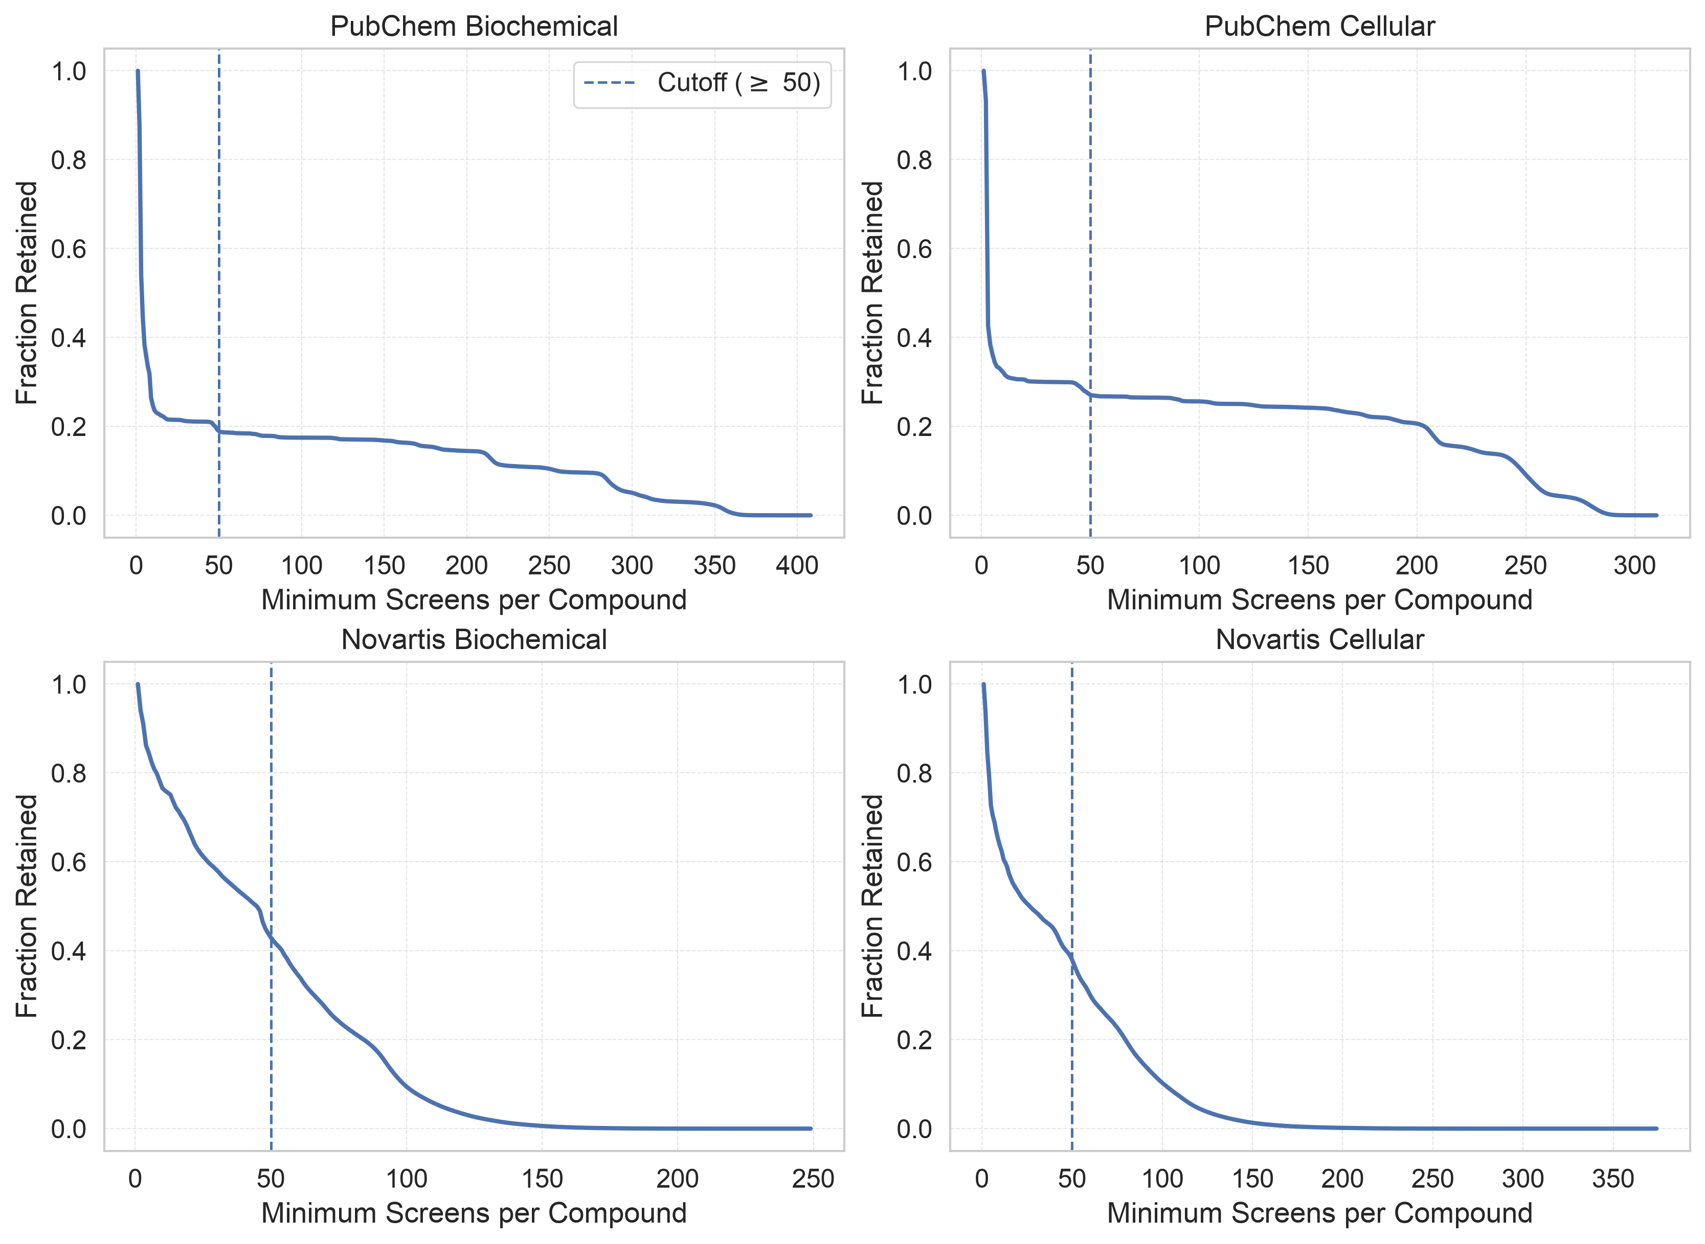

Supplementary Figure 1: Compound retention by screening frequency. The retained fraction of unique compounds is shown as the minimum required number of screened assays increases. The dashed line marks the cutoff used in this study. The threshold balances cohort size with the stability of EBHR estimates by excluding sparsely screened compounds.

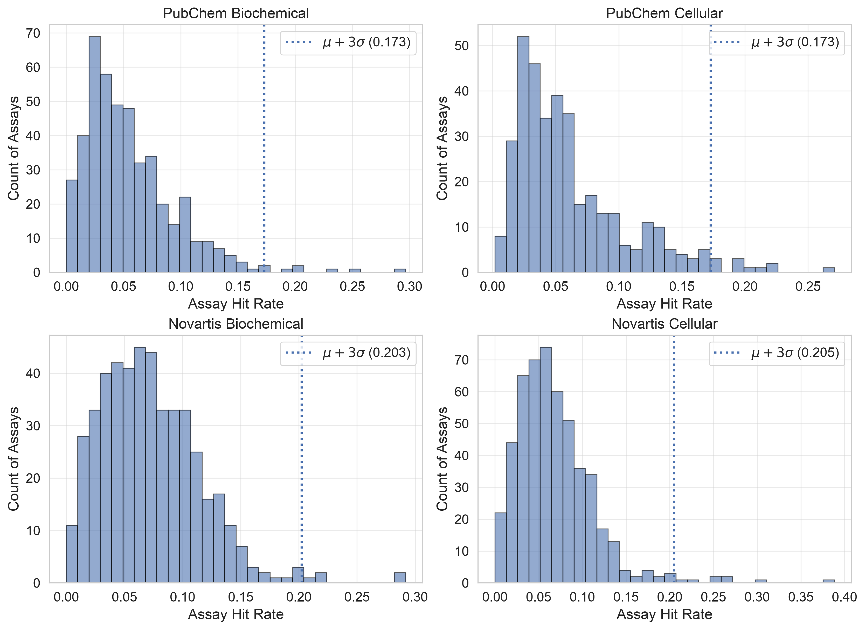
Supplementary Figure 2: Assay hit-rate distributions and outlier filtering. Histograms show R-score-derived assay hit rates for PubChem Biochemical, PubChem Cellular, Novartis Biochemical, and Novartis Cellular cohorts. The dotted line marks the cohort-specific mean plus three standard deviations. Assays at or above this threshold were excluded to limit the influence of extreme high-hit-rate assays.

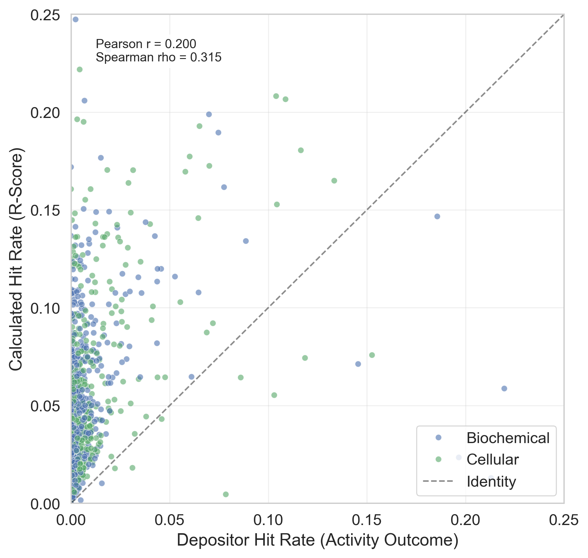
Supplementary Figure 3 (A): R-score and depositor-label assay hit rates. Each point represents a PubChem assay and is colored by assay format. The dashed line denotes identity. R-score-derived rates are generally higher than depositor-label rates, consistent with the more inclusive primary-screen definition.

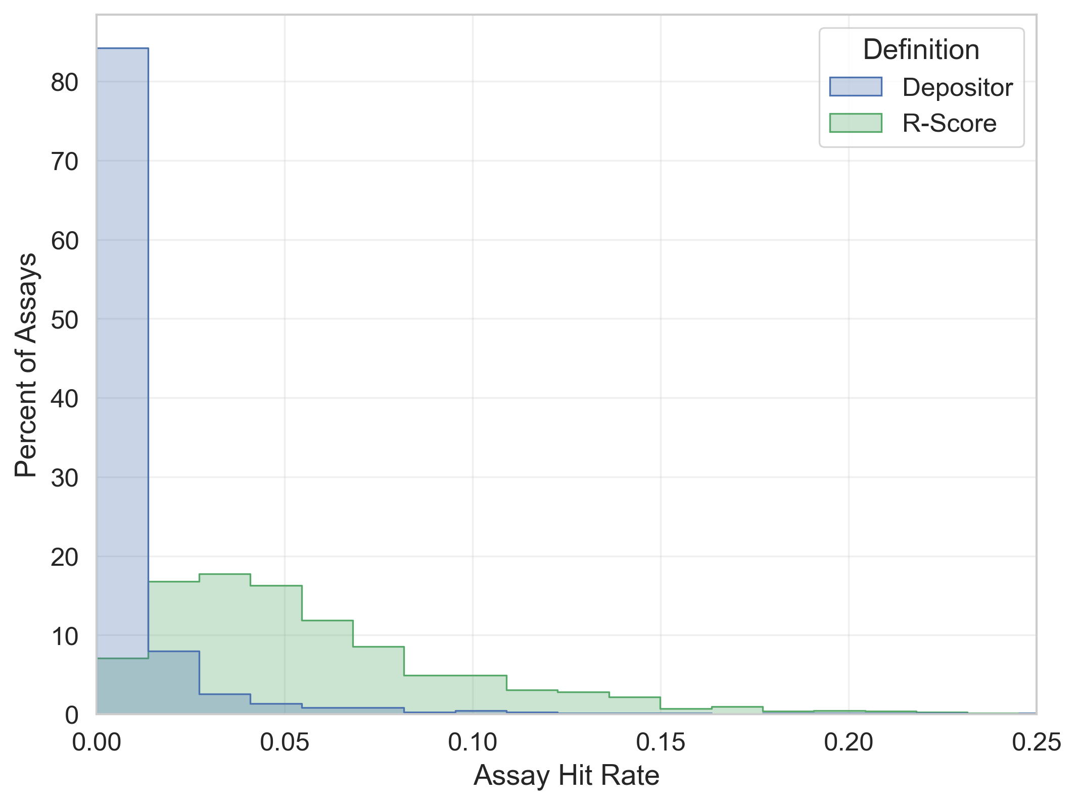
Supplementary Figure 3 (B): Distribution of assay hit rates by definition. Histograms compare depositor-label and R-score-derived assay hit rates across the PubChem assays included in the comparison.

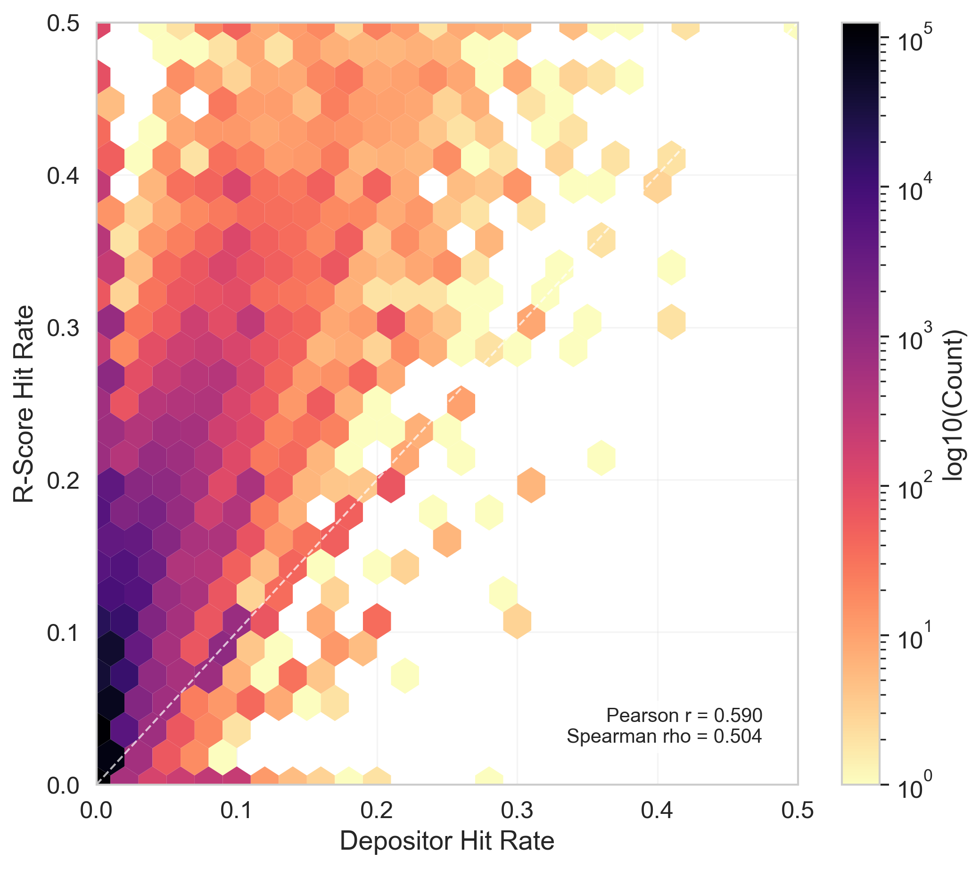
Supplementary Figure 4: Compound-level hit-rate comparison. The hexbin plot compares R-score-derived and depositor-label-derived compound hit rates in the PubChem cohort. Color indicates the logarithm of the compound count, and the dashed line denotes identity. The moderate positive association indicates that compounds with higher depositor-label-derived hit rates generally also have higher R-score-derived hit rates, although the R-score definition produces higher absolute values.

Supplementary results: restricted test sets

Supplementary Tables 2–5 report classification performance on restricted test sets after exclusion of gray-zone compounds. Metrics are means across five scaffold splits. “Baseline” denotes the threshold-specific binary classifier trained for the corresponding definition; Regression and Multi-Label denote the single continuous model evaluated against the same threshold-specific reference labels.

Supplementary Table 2: Performance on restricted test set (PubChem Biochemical)
Model | Baseline | Baseline | Multi-Label | Multi-Label | Regression | Regression
 | PR-AUC | ROC-AUC | PR-AUC | ROC-AUC | PR-AUC | ROC-AUC
Threshold
Top 1% | 0.791 ± 0.041 | 0.984 ± 0.002 | 0.911 ± 0.008 | 0.992 ± 0.002 | 0.895 ± 0.013 | 0.990 ± 0.002
Top 2% | 0.806 ± 0.021 | 0.978 ± 0.005 | 0.890 ± 0.014 | 0.987 ± 0.004 | 0.879 ± 0.013 | 0.984 ± 0.004
Top 5% | 0.794 ± 0.009 | 0.967 ± 0.002 | 0.857 ± 0.013 | 0.976 ± 0.004 | 0.846 ± 0.011 | 0.973 ± 0.004
Top 10% | 0.790 ± 0.014 | 0.949 ± 0.005 | 0.824 ± 0.010 | 0.958 ± 0.003 | 0.811 ± 0.008 | 0.953 ± 0.003
Top 20% | 0.747 ± 0.005 | 0.904 ± 0.002 | 0.776 ± 0.003 | 0.915 ± 0.001 | 0.762 ± 0.003 | 0.907 ± 0.002
Supplementary Table 3: Performance on restricted test set (PubChem Cellular)
Model | Baseline | Baseline | Multi-Label | Multi-Label | Regression | Regression
 | PR-AUC | ROC-AUC | PR-AUC | ROC-AUC | PR-AUC | ROC-AUC
Threshold
Top 1% | 0.523 ± 0.072 | 0.954 ± 0.012 | 0.717 ± 0.042 | 0.974 ± 0.008 | 0.717 ± 0.033 | 0.970 ± 0.006
Top 2% | 0.598 ± 0.044 | 0.952 ± 0.011 | 0.751 ± 0.018 | 0.973 ± 0.004 | 0.741 ± 0.020 | 0.970 ± 0.002
Top 5% | 0.687 ± 0.017 | 0.940 ± 0.004 | 0.778 ± 0.012 | 0.964 ± 0.002 | 0.754 ± 0.009 | 0.957 ± 0.002
Top 10% | 0.696 ± 0.009 | 0.922 ± 0.004 | 0.763 ± 0.008 | 0.943 ± 0.001 | 0.738 ± 0.006 | 0.933 ± 0.004
Top 20% | 0.695 ± 0.005 | 0.887 ± 0.001 | 0.740 ± 0.007 | 0.905 ± 0.002 | 0.719 ± 0.004 | 0.893 ± 0.002

Supplementary Table 4: Performance on restricted test set (Novartis Biochemical)
Model | Baseline | Baseline | Multi-Label | Multi-Label | Regression | Regression
 | PR-AUC | ROC-AUC | PR-AUC | ROC-AUC | PR-AUC | ROC-AUC
Threshold
Top 1% | 0.762 ± 0.042 | 0.979 ± 0.003 | 0.824 ± 0.028 | 0.981 ± 0.004 | 0.829 ± 0.029 | 0.981 ± 0.004
Top 2% | 0.794 ± 0.026 | 0.976 ± 0.002 | 0.830 ± 0.025 | 0.979 ± 0.003 | 0.835 ± 0.023 | 0.979 ± 0.004
Top 5% | 0.803 ± 0.011 | 0.965 ± 0.002 | 0.816 ± 0.015 | 0.969 ± 0.003 | 0.820 ± 0.014 | 0.968 ± 0.003
Top 10% | 0.788 ± 0.008 | 0.948 ± 0.002 | 0.792 ± 0.012 | 0.951 ± 0.003 | 0.794 ± 0.012 | 0.949 ± 0.003
Top 20% | 0.751 ± 0.009 | 0.905 ± 0.003 | 0.755 ± 0.010 | 0.910 ± 0.004 | 0.754 ± 0.009 | 0.907 ± 0.003

Supplementary Table 5: Performance on restricted test set (Novartis Cellular)
Model | Baseline | Baseline | Multi-Label | Multi-Label | Regression | Regression
 | PR-AUC | ROC-AUC | PR-AUC | ROC-AUC | PR-AUC | ROC-AUC
Threshold
Top 1% | 0.630 ± 0.066 | 0.968 ± 0.003 | 0.753 ± 0.029 | 0.977 ± 0.002 | 0.747 ± 0.028 | 0.973 ± 0.003
Top 2% | 0.686 ± 0.037 | 0.965 ± 0.003 | 0.768 ± 0.020 | 0.976 ± 0.002 | 0.764 ± 0.017 | 0.971 ± 0.002
Top 5% | 0.719 ± 0.016 | 0.954 ± 0.003 | 0.763 ± 0.011 | 0.964 ± 0.001 | 0.757 ± 0.008 | 0.959 ± 0.001
Top 10% | 0.730 ± 0.004 | 0.936 ± 0.001 | 0.749 ± 0.006 | 0.944 ± 0.002 | 0.743 ± 0.004 | 0.937 ± 0.001
Top 20% | 0.713 ± 0.003 | 0.894 ± 0.001 | 0.725 ± 0.005 | 0.900 ± 0.002 | 0.718 ± 0.003 | 0.893 ± 0.002

Supplementary results: full test sets

Supplementary Tables 6–9 report classification performance on the complete eligible test sets. For each frequent-hitter definition, the split-specific upper EBHR threshold was used to construct binary reference labels; all compounds below that threshold, including gray-zone compounds, were treated as negatives for PR-AUC and ROC-AUC calculation.

Supplementary Table 6: Performance on full test set (PubChem Biochemical)
Model | Baseline | Baseline | Multi-Label | Multi-Label | Regression | Regression
 | PR-AUC | ROC-AUC | PR-AUC | ROC-AUC | PR-AUC | ROC-AUC
Threshold
Top 1% | 0.401 ± 0.048 | 0.968 ± 0.002 | 0.564 ± 0.027 | 0.979 ± 0.002 | 0.556 ± 0.032 | 0.976 ± 0.003
Top 2% | 0.471 ± 0.034 | 0.959 ± 0.006 | 0.599 ± 0.015 | 0.969 ± 0.005 | 0.594 ± 0.019 | 0.966 ± 0.005
Top 5% | 0.567 ± 0.015 | 0.943 ± 0.003 | 0.660 ± 0.016 | 0.954 ± 0.005 | 0.650 ± 0.010 | 0.951 ± 0.005
Top 10% | 0.674 ± 0.018 | 0.929 ± 0.005 | 0.717 ± 0.015 | 0.939 ± 0.004 | 0.705 ± 0.009 | 0.934 ± 0.004
Top 20% | 0.747 ± 0.005 | 0.904 ± 0.002 | 0.776 ± 0.003 | 0.915 ± 0.001 | 0.762 ± 0.003 | 0.907 ± 0.002

Supplementary Table 7: Performance on full test set (PubChem Cellular)
Model | Baseline | Baseline | Multi-Label | Multi-Label | Regression | Regression
 | PR-AUC | ROC-AUC | PR-AUC | ROC-AUC | PR-AUC | ROC-AUC
Threshold
Top 1% | 0.248 ± 0.056 | 0.929 ± 0.014 | 0.339 ± 0.043 | 0.944 ± 0.010 | 0.361 ± 0.031 | 0.943 ± 0.008
Top 2% | 0.311 ± 0.034 | 0.922 ± 0.012 | 0.405 ± 0.025 | 0.943 ± 0.005 | 0.415 ± 0.020 | 0.942 ± 0.004
Top 5% | 0.482 ± 0.025 | 0.912 ± 0.005 | 0.555 ± 0.019 | 0.937 ± 0.002 | 0.541 ± 0.020 | 0.929 ± 0.003
Top 10% | 0.584 ± 0.012 | 0.899 ± 0.005 | 0.652 ± 0.007 | 0.922 ± 0.002 | 0.627 ± 0.009 | 0.911 ± 0.004
Top 20% | 0.695 ± 0.005 | 0.887 ± 0.001 | 0.740 ± 0.007 | 0.905 ± 0.002 | 0.719 ± 0.004 | 0.893 ± 0.002

Supplementary Table 8: Performance on full test set (Novartis Biochemical)
Model | Baseline | Baseline | Multi-Label | Multi-Label | Regression | Regression
 | PR-AUC | ROC-AUC | PR-AUC | ROC-AUC | PR-AUC | ROC-AUC
Threshold
Top 1% | 0.362 ± 0.047 | 0.960 ± 0.004 | 0.458 ± 0.037 | 0.962 ± 0.005 | 0.455 ± 0.028 | 0.961 ± 0.006
Top 2% | 0.461 ± 0.039 | 0.955 ± 0.003 | 0.536 ± 0.035 | 0.957 ± 0.005 | 0.538 ± 0.034 | 0.957 ± 0.005
Top 5% | 0.570 ± 0.023 | 0.941 ± 0.003 | 0.619 ± 0.020 | 0.945 ± 0.004 | 0.626 ± 0.019 | 0.944 ± 0.004
Top 10% | 0.670 ± 0.007 | 0.928 ± 0.002 | 0.684 ± 0.012 | 0.931 ± 0.003 | 0.688 ± 0.012 | 0.930 ± 0.003
Top 20% | 0.751 ± 0.009 | 0.905 ± 0.003 | 0.755 ± 0.010 | 0.910 ± 0.004 | 0.754 ± 0.009 | 0.907 ± 0.003

Supplementary Table 9: Performance on full test set (Novartis Cellular)
Model | Baseline | Baseline | Multi-Label | Multi-Label | Regression | Regression
 | PR-AUC | ROC-AUC | PR-AUC | ROC-AUC | PR-AUC | ROC-AUC
Threshold
Top 1% | 0.282 ± 0.054 | 0.947 ± 0.005 | 0.387 ± 0.056 | 0.955 ± 0.003 | 0.388 ± 0.053 | 0.950 ± 0.004
Top 2% | 0.370 ± 0.038 | 0.941 ± 0.004 | 0.463 ± 0.040 | 0.951 ± 0.003 | 0.471 ± 0.035 | 0.946 ± 0.003
Top 5% | 0.508 ± 0.017 | 0.927 ± 0.004 | 0.558 ± 0.020 | 0.937 ± 0.002 | 0.559 ± 0.018 | 0.932 ± 0.001
Top 10% | 0.614 ± 0.006 | 0.914 ± 0.002 | 0.638 ± 0.009 | 0.922 ± 0.002 | 0.635 ± 0.005 | 0.916 ± 0.001
Top 20% | 0.713 ± 0.003 | 0.894 ± 0.001 | 0.725 ± 0.005 | 0.900 ± 0.002 | 0.718 ± 0.003 | 0.893 ± 0.002

