Supplementary Materials

Full Search strategy
PUBMED
(((((radiation dosage) OR (radiation dosage[MeSH Terms])) OR (radiation dosage[Title/Abstract])) AND (breast cancer[MeSH Terms])
Filters applied: English, Humans

EMBASE
('breast cancer'/exp OR 'breast neoplasm*':ti,ab OR 'breast tumor':ti,ab) AND ('radiotherapy'/exp OR radiotherapy:ti,ab OR irradiation:ti,ab OR 'radiation dose':ti,ab) AND ('treatment outcome'/exp OR 'neoplasm recurrence':ti,ab OR 'tumor response':ti,ab OR survival:ti,ab OR 'overall survival':ti,ab OR 'progression free survival':ti,ab OR prognosis:ti,ab) AND ('clinical trial'/de OR 'cohort analysis'/de OR 'human'/de OR 'major clinical study'/de OR 'multicenter study'/de OR 'prospective study'/de OR 'randomized controlled trial'/de OR 'retrospective study'/de) AND 'radiotherapy'/lnk AND ('breast cancer'/dm OR 'breast carcinoma'/dm OR 'ductal breast carcinoma in situ'/dm OR 'metastatic breast cancer'/dm OR 'triple negative breast cancer'/dm) AND [humans]/lim AND [abstracts]/lim AND [embase]/lim AND 'article'/it AND [english]/lim AND [female]/lim

SCOPUS
( TITLE-ABS-KEY ( radiation dose ) AND ALL ( radiation dose ) AND TITLE-ABS-KEY ( radiation response ) AND ALL ( radiation response ) AND TITLE-ABS-KEY ( irradiation dose ) OR ALL ( irradiation dose ) ) AND TITLE-ABS-KEY ( breast neoplasms ) AND TITLE-ABS-KEY-AUTH ( breast neoplasms ) AND LANGUAGE ( english ) AND ( LIMIT-TO ( SUBJAREA , "MEDI" ) ) AND ( LIMIT-TO ( DOCTYPE , "ar" ) ) AND ( LIMIT-TO ( LANGUAGE , "English" ) )

Table 1. PRISMA Checklist
Section and Topic | Item # | Checklist item | Location where item is reported
TITLE
Title | 1 | Identify the report as a systematic review. | 1
ABSTRACT
Abstract | 2 | See the PRISMA 2020 for Abstracts checklist. | 7
INTRODUCTION
Rationale | 3 | Describe the rationale for the review in the context of existing knowledge. | 4-5
Objectives | 4 | Provide an explicit statement of the objective(s) or question(s) the review addresses. | 4-5
METHODS
Eligibility criteria | 5 | Specify the inclusion and exclusion criteria for the review and how studies were grouped for the syntheses. | 5-9
Information sources | 6 | Specify all databases, registers, websites, organisations, reference lists and other sources searched or consulted to identify studies. Specify the date when each source was last searched or consulted. | 5-9
Search strategy | 7 | Present the full search strategies for all databases, registers and websites, including any filters and limits used. | 5-6-7-supplementary
Selection process | 8 | Specify the methods used to decide whether a study met the inclusion criteria of the review, including how many reviewers screened each record and each report retrieved, whether they worked independently, and if applicable, details of automation tools used in the process. | 5-9
Data collection process | 9 | Specify the methods used to collect data from reports, including how many reviewers collected data from each report, whether they worked independently, any processes for obtaining or confirming data from study investigators, and if applicable, details of automation tools used in the process. | 5-9
Data items | 10a | List and define all outcomes for which data were sought. Specify whether all results that were compatible with each outcome domain in each study were sought (e.g. for all measures, time points, analyses), and if not, the methods used to decide which results to collect. | 5-9
Data items | 10b | List and define all other variables for which data were sought (e.g. participant and intervention characteristics, funding sources). Describe any assumptions made about any missing or unclear information. | 5-9
Study risk of bias assessment | 11 | Specify the methods used to assess risk of bias in the included studies, including details of the tool(s) used, how many reviewers assessed each study and whether they worked independently, and if applicable, details of automation tools used in the process. | 5-9- supplementary
Effect measures | 12 | Specify for each outcome the effect measure(s) (e.g. risk ratio, mean difference) used in the synthesis or presentation of results. | 6-9
Synthesis methods | 13a | Describe the processes used to decide which studies were eligible for each synthesis (e.g. tabulating the study intervention characteristics and comparing against the planned groups for each synthesis (item #5)). | 5-9
Synthesis methods | 13b | Describe any methods required to prepare the data for presentation or synthesis, such as handling of missing summary statistics, or data conversions. | 5-9
Synthesis methods | 13c | Describe any methods used to tabulate or visually display results of individual studies and syntheses. | 5-9
Synthesis methods | 13d | Describe any methods used to synthesize results and provide a rationale for the choice(s). If meta-analysis was performed, describe the model(s), method(s) to identify the presence and extent of statistical heterogeneity, and software package(s) used. | 5-9
Synthesis methods | 13e | Describe any methods used to explore possible causes of heterogeneity among study results (e.g. subgroup analysis, meta-regression). | 5-9
Synthesis methods | 13f | Describe any sensitivity analyses conducted to assess robustness of the synthesized results. | 5-9
Reporting bias assessment | 14 | Describe any methods used to assess risk of bias due to missing results in a synthesis (arising from reporting biases). | 7-9- supplementary
Certainty assessment | 15 | Describe any methods used to assess certainty (or confidence) in the body of evidence for an outcome. | 7-9- supplementary
RESULTS
Study selection | 16a | Describe the results of the search and selection process, from the number of records identified in the search to the number of studies included in the review, ideally using a flow diagram. | 12-14
Study selection | 16b | Cite studies that might appear to meet the inclusion criteria, but which were excluded, and explain why they were excluded. | 12-14
Study characteristics | 17 | Cite each included study and present its characteristics. | supplementary
Risk of bias in studies | 18 | Present assessments of risk of bias for each included study. | supplementary
Results of individual studies | 19 | For all outcomes, present, for each study: (a) summary statistics for each group (where appropriate) and (b) an effect estimate and its precision (e.g. confidence/credible interval), ideally using structured tables or plots. | 13-20
Results of syntheses | 20a | For each synthesis, briefly summarise the characteristics and risk of bias among contributing studies. | 13-20
Results of syntheses | 20b | Present results of all statistical syntheses conducted. If meta-analysis was done, present for each the summary estimate and its precision (e.g. confidence/credible interval) and measures of statistical heterogeneity. If comparing groups, describe the direction of the effect. | 13-20
Results of syntheses | 20c | Present results of all investigations of possible causes of heterogeneity among study results. | 13-20
Results of syntheses | 20d | Present results of all sensitivity analyses conducted to assess the robustness of the synthesized results. | 13-20
Reporting biases | 21 | Present assessments of risk of bias due to missing results (arising from reporting biases) for each synthesis assessed. | 23
Certainty of evidence | 22 | Present assessments of certainty (or confidence) in the body of evidence for each outcome assessed. | supplementary
DISCUSSION
Discussion | 23a | Provide a general interpretation of the results in the context of other evidence. | 21-23
Discussion | 23b | Discuss any limitations of the evidence included in the review. | 21-23
Discussion | 23c | Discuss any limitations of the review processes used. | 21-23
Discussion | 23d | Discuss implications of the results for practice, policy, and future research. | 21-23
OTHER INFORMATION
Registration and protocol | 24a | Provide registration information for the review, including register name and registration number, or state that the review was not registered. | 5
Registration and protocol | 24b | Indicate where the review protocol can be accessed, or state that a protocol was not prepared. | 5
Registration and protocol | 24c | Describe and explain any amendments to information provided at registration or in the protocol. | 5
Support | 25 | Describe sources of financial or non-financial support for the review, and the role of the funders or sponsors in the review. | 25
Competing interests | 26 | Declare any competing interests of review authors. | 1
Availability of data, code and other materials | 27 | Report which of the following are publicly available and where they can be found: template data collection forms; data extracted from included studies; data used for all analyses; analytic code; any other materials used in the review. | 6-7

Table 2. MOOSE Checklist

Supplementary Table 2. MOOSE (Meta-analyses Of Observational Studies in Epidemiology) Checklist.

Reporting Criteria | Reported (Yes/No) |  |  |  |  | Reported on Page No.
Reporting of Background
Problem definition |  | Yes |  |  |  |  | 3
Hypothesis statement |  | Yes |  |  |  |  | 3
Description of Study Outcome(s) |  | Yes |  |  |  |  | 3
Type of exposure or intervention used |  | Yes |  |  |  |  | 3
Type of study design used |  | Yes |  |  |  |  | 3
Study population |  | Yes |  |  |  |  | 5-6
Reporting of Search Strategy
Qualifications of searchers (eg, librarians  and investigators) | Yes |  |  |  |  | 5-6
Search strategy, including time period  included in the synthesis and keywords | Yes |  |  |  |  | 5-6
Effort to include all available studies,  including contact with authors | Yes
 |  |  |  |  |  |  | 5-6
Databases and registries searched |  | Yes |  |  |  |  | 5-6
Search software used, name and  version, including special features used (eg, explosion) | Yes |  |  |  |  | 5-6
Use of hand searching (eg, reference  lists of obtained articles) | Yes |  |  |  |  | 5-6
List of citations located and those  excluded, including justification | Yes |  |  |  |  | 6-suppl
Method for addressing articles  published in languages other than English | Yes |  |  |  |  | 5-6
Method of handling abstracts and  unpublished studies | Yes |  |  |  |  | 5-6
Description of any contact with authors |  | Yes |  |  |  |  | 5-6
Reporting of Methods
Description of relevance or appropriateness of studies assembled for  assessing the hypothesis to be tested | Yes |  |  |  |  | 5-6
Rationale for the selection and coding of data (eg, sound clinical principles or  convenience) | Yes |  |  |  |  | 5-6
Documentation of how data were classified and coded (eg, multiple raters,  blinding, and interrater reliability) | Yes |  |  |  |  | 5-6
Assessment of confounding (eg, comparability of cases and controls in  studies where appropriate | Yes |  |  |  |  | 5-6-7
Reporting Criteria | Reported (Yes/No) |  |  |  |  | Reported on Page No.
Assessment of study quality, including blinding of quality assessors; stratification or regression on possible  predictors of study results | Yes |  |  |  |  | 6-7-supp
Assessment of heterogeneity |  |  | Yes |  |  |  |  | 6-8
Description of statistical methods (eg,  complete description of fixed or random effects models, justification of whether the chosen models account for predictors of study results, dose-response models, or cumulative meta-analysis) in sufficient  detail to be replicated | Yes |  |  |  |  | 6-9
Provision of appropriate tables and  graphics | Yes |  |  |  |  | 14-21
Reporting of Results
Table giving descriptive information for  each study included | Yes |  |  |  |  | 14-21
Results of sensitivity testing (eg,  subgroup analysis) | Yes |  |  |  |  | 14-21
Indication of statistical uncertainty of  findings | Yes |  |  |  |  | 14-21
Reporting of Discussion
Quantitative assessment of bias (eg,  publication bias) | Yes |  |  |  |  | supp
Justification for exclusion (eg, exclusion  of non–English-language citations) | Yes |  |  |  |  | 21-suppl
Assessment of quality of included studies |  |  | Yes |  |  |  |  | suppl
Reporting of Conclusions
Consideration of alternative explanations  for observed results | Yes |  |  |  |  | 21-23
Generalization of the conclusions (ie, appropriate for the data presented and  within the domain of the literature review) | Yes |  |  |  |  | 21-23
Guidelines for future research |  |  | Yes |  |  |  |  | 21-23
Disclosure of funding source |  |  | Yes |  |  |  |  | 25

Supplementary Tables 3. Quality assessment for studies using the Newcastle–Ottawa Quality Assessment Scale: cohort studies and case-control studies

MODIFIED NEWCASTLE - OTTAWA QUALITY ASSESSMENT SCALE - COHORT STUDIES
Note: A study can be awarded a maximum of one star for each numbered item within the Selection and Outcome categories. A maximum of two stars can be given for Comparability

 | Selection |  |  |  | Compa-  rability | Outcome
Author | Representativeness | Selection | Ascertainment of exposure | Demonstration that outcome | Variables(s) | Assessment of outcome | Was follow‑up long enough | Adequacy of follow‑up | Overall
Abouegylah et al. 2019 | * | * | * | * | * | * | * |  | 7
Berlin et al. 2025 | * | * | * | ** | ** | * | * |  | 8
Chang et al. 2019 | * | * | * | * | ** | * | * |  | 8
Chen et al. 2023 | * |  | * | * | ** | * | * |  | 7
Erven et al. 2011 | * | * | * | * |  | * | * | * | 7
Honaryar et al. 2024 | * | * | * | * | ** | * | * | * | 9
Lai et al. 2024 | * |  | * | * | ** | * | * |  | 7
Marks et al. 2005 | * |  | * | * | ** | * | * | * | 8
Skyttä et al. 2015 | * |  | * | * |  | * | * | * | 6
Van den Bogaard et al. 2021 | * | * | * | * | ** | * | * | * | 9
Van den Bogaard et al. 2017 | * | * | * | * | ** | * | * | * | 9
Walker et al. 2019 | * |  | * | * | * | * | * | * | 7
Zureick et al. 2022 | * | * | * | * | * | * | * | * | 8

MODIFIED NEWCASTLE - OTTAWA QUALITY ASSESSMENT SCALE - CASE-CONTROL STUDIES
Note: A study can be awarded a maximum of one star for each numbered item within the Selection and Exposure categories. A maximum of two stars can be given for Comparability.

 | Selection |  |  |  | Comparability | Outcome
Author | Is the case definition adequate? | Representativeness of the cases | Selection of controls | Definition of controls | Comparability of cases and controls on the basis of the design or analysis | Ascertainment of exposure | Same method of ascertainment for cases and controls | Non-response rate | Overall
Baaken et al 2022 | * | * | * |  | ** | * | * |  | 8
Darby et al. 2013 | * | * | * | * | * | * | * | * | 9
Nilsson et al. 2012 | * | * | * | * | ** | * | * |  | 8

NOTE: For each study, a maximum of one star for each numbered item within the Selection and Exposure categories was awarded. A maximum of two stars was given for Comparability. The total number of stars earned (maximum score of 9) was a measure of study quality.
The Newcastle–Ottawa Scale (NOS) was used to assess the quality of the included studies. For case–control studies, stars are awarded within the Selection domain when the case definition is adequately validated, cases are representative, community controls are used, and controls have no history of the outcome. In the Comparability domain, one star is given if analyses are adjusted for breast cancer and an additional star if further confounders are controlled. In the Exposure domain, stars are assigned for secure ascertainment of exposure (e.g., medical or surgical records), blinded interviews, consistent methods of exposure assessment between cases and controls, and similar response rates. For cohort studies, the Selection domain awards stars when the exposed cohort is representative of the average population, the nonexposed cohort is drawn from the same community, exposure is ascertained from secure records or structured interviews, and the outcome is absent at baseline. In the Comparability domain, one star is given if analyses adjust for breast cancer and an additional star if further confounders are included. In the Outcome domain, stars are awarded for independent or record-based outcome assessment, sufficient length of follow-up, and adequate follow-up of the cohort. Higher numbers of stars indicate better methodological quality.

Table 4. Revised Cochrane risk-of-bias tool for randomized trials 2
RoB 2 - Risk of bias assessment
Responses underlined in green are potential markers for low risk of bias, and responses in red are potential markers for a risk of bias. Where questions relate only to signposts to other questions, no formatting is used.
Cao et al. 2024
Domain 1: Risk of bias arising from the randomization process
Signalling questions | Comments | Response options
1.1 Was the allocation sequence random? | Y  PY | Y / PY / PN / N / NI
1.2 Was the allocation sequence concealed until participants were enrolled and assigned to interventions? | Y  PY | Y / PY / PN / N / NI
1.3 Did baseline differences between intervention groups suggest a problem with the randomization process? | N | Y / PY / PN / N / NI
Risk-of-bias judgement | LOW | Low / High / Some concerns
Optional: What is the predicted direction of bias arising from the randomization process? | NA | NA / Favours experimental / Favours comparator / Towards null /Away from null / Unpredictable

Domain 2: Risk of bias due to deviations from the intended interventions (effect of assignment to intervention)
Signalling questions | Comments | Response options
2.1. Were participants aware of their assigned intervention during the trial? | Y  Y | Y / PY / PN / N / NI
2.2. Were carers and people delivering the interventions aware of participants' assigned intervention during the trial? | Y  Y | Y / PY / PN / N / NI
2.3. If Y/PY/NI to 2.1 or 2.2: Were there deviations from the intended intervention that arose because of the trial context? | PN | NA / Y / PY / PN / N / NI
2.4 If Y/PY to 2.3: Were these deviations likely to have affected the outcome? | Y | NA / Y / PY / PN / N / NI
2.5. If Y/PY/NI to 2.4: Were these deviations from intended intervention balanced between groups? | NA | NA / Y / PY / PN / N / NI
2.6 Was an appropriate analysis used to estimate the effect of assignment to intervention? | Y | Y / PY / PN / N / NI
2.7 If N/PN/NI to 2.6: Was there potential for a substantial impact (on the result) of the failure to analyse participants in the group to which they were randomized? | NA | NA / Y / PY / PN / N / NI
Risk-of-bias judgement | LOW | Low / High / Some concerns
Optional: What is the predicted direction of bias due to deviations from intended interventions? | NA | NA / Favours experimental / Favours comparator / Towards null /Away from null / Unpredictable

Domain 2: Risk of bias due to deviations from the intended interventions (effect of adhering to intervention)
Signalling questions | Comments | Response options
2.1. Were participants aware of their assigned intervention during the trial? | Y  Y | Y / PY / PN / N / NI
2.2. Were carers and people delivering the interventions aware of participants' assigned intervention during the trial? | Y  Y | Y / PY / PN / N / NI
2.3. [If applicable:] If Y/PY/NI to 2.1 or 2.2: Were important non-protocol interventions balanced across intervention groups? | PY | NA / Y / PY / PN / N / NI
2.4. [If applicable:] Were there failures in implementing the intervention that could have affected the outcome? | PN | NA / Y / PY / PN / N / NI
2.5. [If applicable:] Was there non-adherence to the assigned intervention regimen that could have affected participants’ outcomes? | N | NA / Y / PY / PN / N / NI
2.6. If N/PN/NI to 2.3, or Y/PY/NI to 2.4 or 2.5: Was an appropriate analysis used to estimate the effect of adhering to the intervention? | PY | NA / Y / PY / PN / N / NI
Risk-of-bias judgement | LOW | Low / High / Some concerns
Optional: What is the predicted direction of bias due to deviations from intended interventions? | NA | NA / Favours experimental / Favours comparator / Towards null /Away from null / Unpredictable

Domain 3: Missing outcome data
Signalling questions | Comments | Response options
3.1 Were data for this outcome available for all, or nearly all, participants randomized? | Y | Y / PY / PN / N / NI
3.2 If N/PN/NI to 3.1: Is there evidence that the result was not biased by missing outcome data? | NA | NA / Y / PY / PN / N
3.3 If N/PN to 3.2: Could missingness in the outcome depend on its true value? | NA  NA | NA / Y / PY / PN / N / NI
3.4 If Y/PY/NI to 3.3: Is it likely that missingness in the outcome depended on its true value? | NA  NA | NA / Y / PY / PN / N / NI
Risk-of-bias judgement | LOW | Low / High / Some concerns
Optional: What is the predicted direction of bias due to missing outcome data? | NA | NA / Favours experimental / Favours comparator / Towards null /Away from null / Unpredictable

Domain 4: Risk of bias in measurement of the outcome
Signalling questions | Comments | Response options
4.1 Was the method of measuring the outcome inappropriate? | N | Y / PY / PN / N / NI
4.2 Could measurement or ascertainment of the outcome have differed between intervention groups? | N | Y / PY / PN / N / NI
4.3 If N/PN/NI to 4.1 and 4.2: Were outcome assessors aware of the intervention received by study participants? | PY | NA / Y / PY / PN / N / NI
4.4 If Y/PY/NI to 4.3: Could assessment of the outcome have been influenced by knowledge of intervention received? | PN  PN | NA / Y / PY / PN / N / NI
4.5 If Y/PY/NI to 4.4: Is it likely that assessment of the outcome was influenced by knowledge of intervention received? | PN  PN | NA / Y / PY / PN / N / NI
Risk-of-bias judgement | LOW | Low / High / Some concerns
Optional: What is the predicted direction of bias in measurement of the outcome? | NA | NA / Favours experimental / Favours comparator / Towards null /Away from null / Unpredictable

Domain 5: Risk of bias in selection of the reported result
Signalling questions | Comments | Response options
5.1 Were the data that produced this result analysed in accordance with a pre-specified analysis plan that was finalized before unblinded outcome data were available for analysis? | PY | Y / PY / PN / N / NI
Is the numerical result being assessed likely to have been selected, on the basis of the results, from...
5.2. ... multiple eligible outcome measurements (e.g. scales, definitions, time points) within the outcome domain? | PN | Y / PY / PN / N / NI
5.3 ... multiple eligible analyses of the data? | PN | Y / PY / PN / N / NI
Risk-of-bias judgement | Some concern | Low / High / Some concerns
Optional: What is the predicted direction of bias due to selection of the reported result? | Unpredictable | NA / Favours experimental / Favours comparator / Towards null /Away from null / Unpredictable

Overall risk of bias
Risk-of-bias judgement | Some concern | Low / High / Some concerns
Optional: What is the overall predicted direction of bias for this outcome? | Unpredictable | NA / Favours experimental / Favours comparator / Towards null /Away from null / Unpredictable

Table 5. GRADE Assessment
Grading of Recommendations, Assessment, Development and Evaluation
Author | Risk of Bias | Inconsistency | Indirectness | Imprecision | Publication Bias | Overall
Abouegylah et al. 2019 | High | Not serious | Serious | Serious | Serious/suspected | Very low
Baaken et al 2022 | Moderate | Not serious | Serious | Serious | Serious/suspected | Low
Berlin et al. 2025 | Moderate | Not serious | Very serious | Serious | Serious/suspected | Very low
Cao et al. 2024 | Low | Not serious | Very serious | Very serious | Serious/suspected | Very low
Chang et al. 2019 | High | Not serious | Serious | Serious | Serious/suspected | Low
Chen et al. 2023 | High | Not serious | Very serious | Very serious | Serious/suspected | Very low
Darby et al. 2013 | Moderate | Not serious | Serious | Not serious | Possible | Moderate
Erven et al. 2011 | High | Not serious | Very serious | Very serious | Serious/suspected | Very low
Honaryar et al. 2024 | High | Not serious | Very serious | Very serious | Serious/suspected | Very low
Lai et al. 2024 | Moderate | Not serious | Serious | Not serious | Possible | Moderate
Marks et al. 2005 | High | Not serious | Very serious | Very serious | Serious/suspected | Very low
Nilsson et al. 2012 | High | Not serious | Serious | Serious | Serious/suspected | Low
Skyttä et al. 2015 | High | Not serious | Very serious | Very serious | Serious/suspected | Very low
Van den Bogaard et al. 2021 | Moderate | Not serious | Serious | Serious | Possible | Moderate
Van den Bogaard et al. 2017 | Moderate | Not serious | Serious | Serious | Possible | Moderate
Walker et al. 2019 | High | Not serious | Very serious | Very serious | Serious/suspected | Very low
Zureick et al. 2022 | Moderate | Not serious | Serious | Serious | Possible | Moderate

HEART MEAN DOSE
Supplementary Table 6. Casewise diagnostics
Casewise diagnostics evaluate individual study influence in meta-analysis by computing standardized residuals, leverage (Hat values), and global influence measures like DFFITS, Cook's distance, and covariance ratios.​
Leave-one-out (LOO) analyses refit the model after sequentially omitting each study, quantifying changes in key parameters (e.g., $τ$, $τ^{2}$, $Q_{e}$, pooled effect) to assess sensitivity to individual observations.​
Studies exceeding conventional thresholds (e.g., Cook's distance >1, |DFFITS| >1, |standardized residual| >2) are flagged as influential, guiding decisions on robustness or exclusion. Two records from Van den Bogaard et al. (2021) emerge as highly influential, with Cook's distances of 1.393 and 1.184 (both >1), DFFITS values of -0.683 and -0.476, and substantial LOO changes in the intercept (-0.674 and -0.534, respectively).​
LOO for these studies shows notable heterogeneity increases ($τ^{2}$ rising to 0.024–0.037 from near-zero baseline, per profile likelihood), high leverage (Hat 0.400–0.541), and elevated weights (40–54%), indicating their dominance in driving model fit.​
Zureick et al. (2022) shows minimal influence (Cook's distance 0.109, DFFITS 0.331, $τ^{2}=0$), confirming overall results' robustness except to the Van den Bogaard observations.
Casewise Diagnostics Table
 |  |  |  |  | Leave One Out |  |  |  |  | Difference in coefficients
Label | Standardized Residual | DFFITS | Cook's Distance | Covariance ratio | 𝜏 | 𝜏² | Qₑ | Hat | Weight | Intercept | Influential
Van den Bogaard et al. 2021 | -0.515 | -0.683 | 1.393 | 5.201 | 0.154 | 0.024 | 1.530 | 0.400 | 39.995 | -0.674 | Yes
Van den Bogaard et al. 2021 | -0.287 | -0.476 | 1.184 | 7.275 | 0.193 | 0.037 | 1.804 | 0.541 | 54.097 | -0.534 | Yes
Zureick et al. 2022 | 1.320 | 0.331 | 0.109 | 1.063 | 0.000 | 0.000 | 0.072 | 0.059 | 5.909 | 0.331

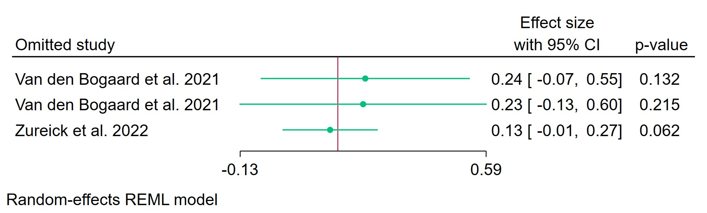
Figure 1. Leave-one-out sensitivity analysis for pooled effect size REML model.
Leave-one-out (LOO) analysis assesses meta-analysis robustness by iteratively excluding one study at a time and refitting the model to observe shifts in the pooled effect size, confidence interval, and heterogeneity. Omitting either Van den Bogaard et al. (2021) record shifts the pooled effect size leftward to 0.24 (95% CI: -0.07–0.55, p=0.132) with non-significance (p>0.05) and narrower CIs, indicating these studies drive the full-model significance and widen uncertainty.​ Excluding Zureick et al. (2022) yields a similar non-significant estimate (0.13, 95% CI: -0.01–0.27, p=0.62), suggesting limited individual influence from this study.
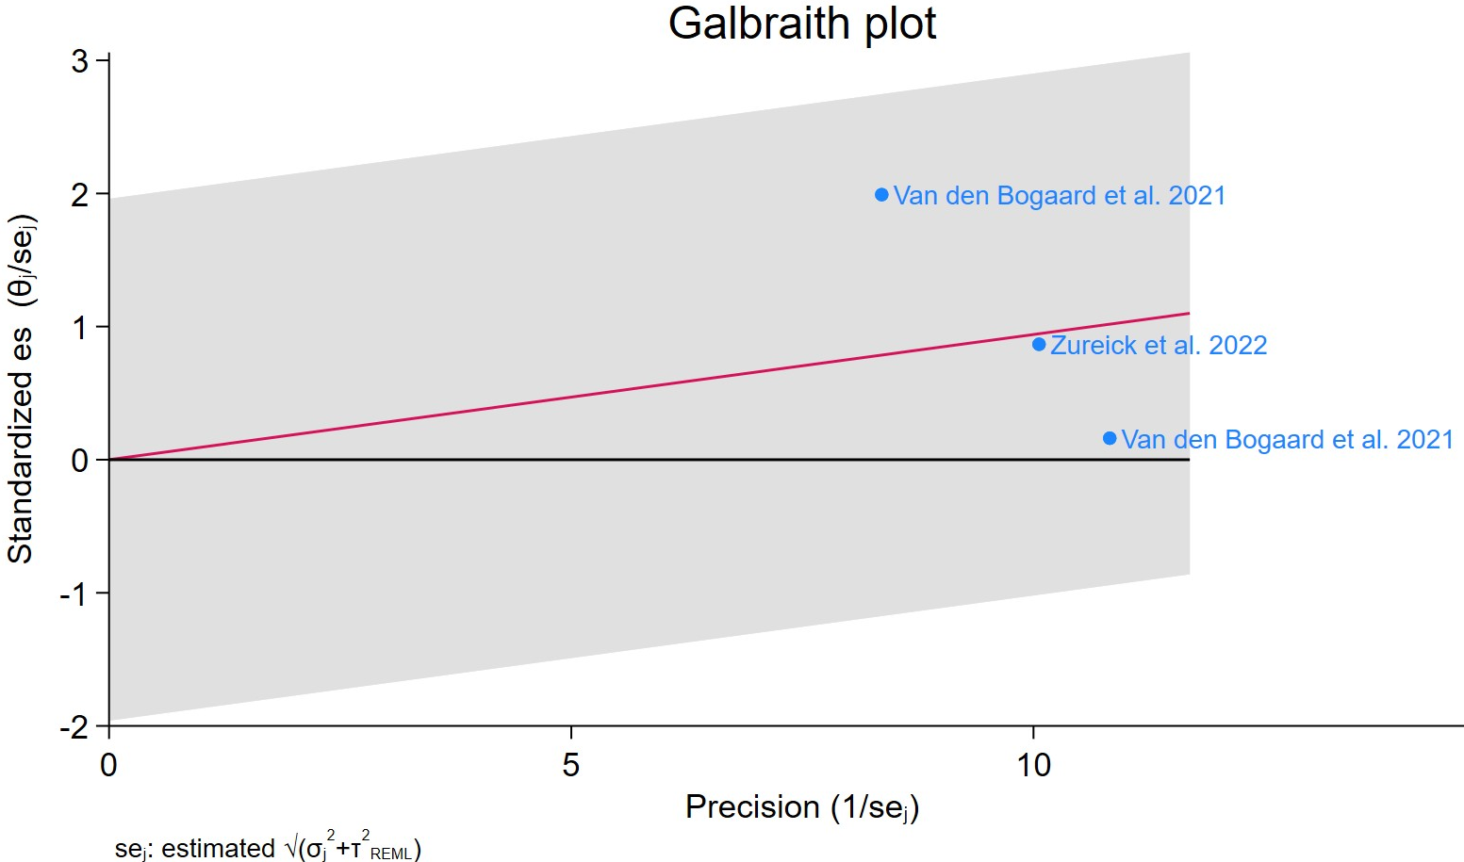
Figure 2. Galbraith plot – HEART MEAN DOSE
Each study is represented as a point, where the x-axis denotes the precision (defined as the inverse of the standard error), and the y-axis indicates the standardized effect size. The red regression line represents the overall summary effect estimated from the random-effects model, and the gray shaded area corresponds to the confidence interval at 95% around regression line. The horizontal black ––line at y = 0 corresponds to the line of no effect, serving as a reference.

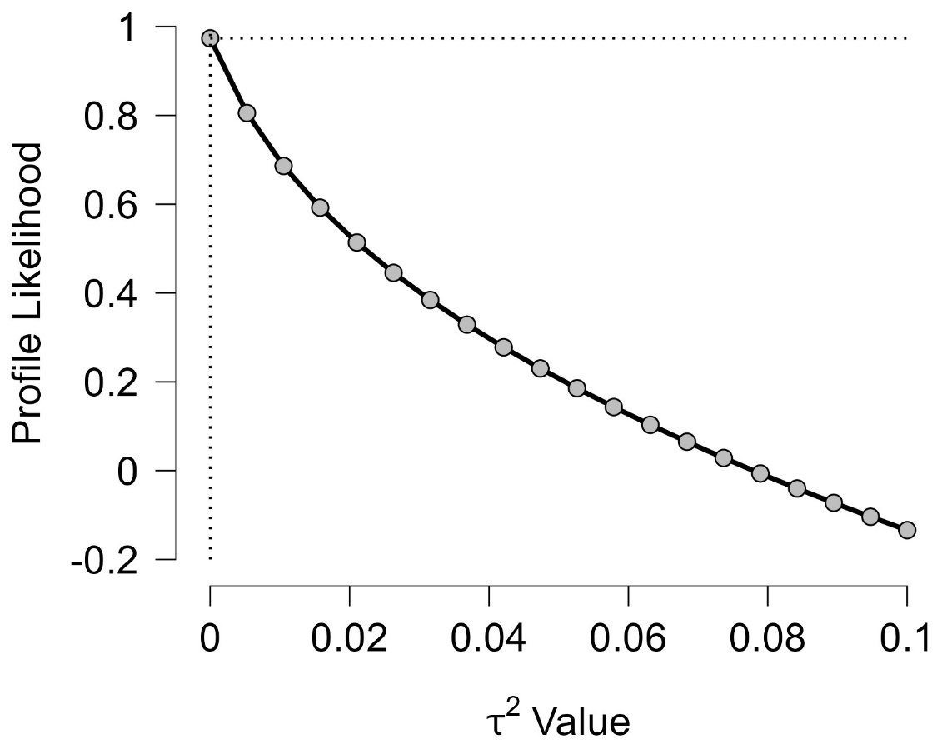
Figure 3. Profile Likelihood
The x-axis shows candidate values of the heterogeneity variance $τ^{2}$, and the y-axis shows the corresponding standardized profile likelihood, which has been scaled so that the maximum value equals 1 at $τ^{2}=0$. The monotonically decreasing curve indicates that the likelihood is highest at $τ^{2}=0$ and declines steadily as $τ^{2}$ increases up to 0.10, implying that data favour little to no between-study heterogeneity and provide progressively weaker support for larger heterogeneity variances.
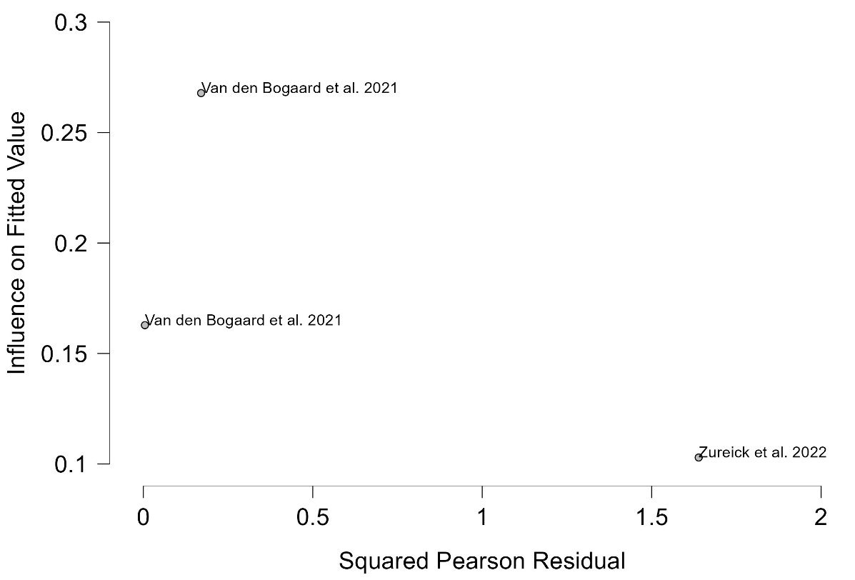
Figure 4. Baujat plot
The Baujat plot visualises each study's contribution to the Q-statistic for heterogeneity on the x-axis (squared Pearson residual) against its influence on the pooled effect on the y-axis (standardized squared difference in fixed-effects estimates with/without the study). Studies in the top-right quadrant drive both heterogeneity and effect variation, signalling candidates for sensitivity analysis; bottom-left points have minimal impact. Both Van den Bogaard et al. (2021) records exert a strong influence despite modest heterogeneity contributions (squared residuals <0.5), positioning them upper-left, suggesting leverage via precision/weight rather than discordance.​ Zureick et al. (2022) shows low influence and low residual, indicating conformity to the model without driving heterogeneity. ​Overall, low x-axis spread implies limited total heterogeneity (consistent with profile likelihood at $τ^{2}≈0$), with Van den Bogaard studies dominating via influence.

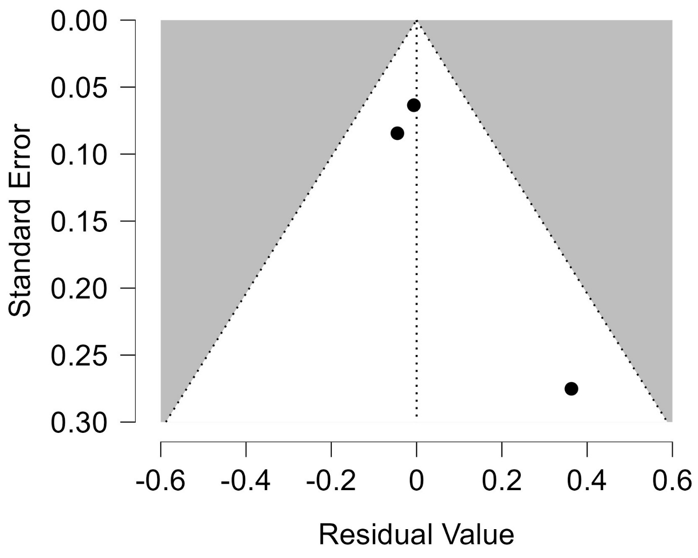
Figure 5. Funnel plot – HEART MEAN DOSE
Each blue dot represents a single study, plotted with its effect size on the x-axis and its standard error on the y-axis. The vertical red line represents the overall effect estimate derived from the random-effects model using restricted maximum likelihood (REML). The 95% confidence interval region, shown as gray diagonal lines, outlines the expected spread of studies in the absence of bias or between-study heterogeneity.

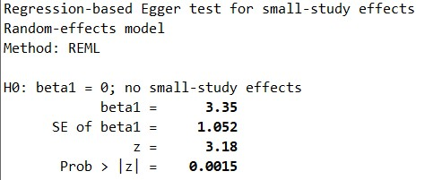

Figure 6. Regression-based Egger's test for small-study effects with REML model
Egger's regression test detects small-study effects (e.g., publication bias) by regressing standardized study effects (${\hat{θ}}_{j}/SE({\hat{θ}}_{j})$) on precision ($1/SE({\hat{θ}}_{j})$), testing if the intercept ($β_{0}$) equals zero under $H_{0}$: no asymmetry. Random-effects versions adjust for between-study variance $τ^{2}$, using marginal variances to mitigate bias in sparse data; p < 0.05 (or 0.10) suggests effects like selective reporting inflating smaller/precise studies. It complements funnel plots and potential inflation with high heterogeneity or ORs away from 1. The test yields $β_{1}=3.35$ (SE=1.052), z=3.18, p=0.0015 (<0.01), rejecting $H_{0}$ and indicating funnel asymmetry with small-study effects.​
Figure 7. Nonparametric trim-and-fill analysis for publication bias adjustment (random-effects REML model, linear estimator).
Trim-and-fill is a rank-based method to estimate and impute studies suppressed due to publication bias, "trimming" asymmetric extremes, mirroring to fill gaps, then re-estimating the pooled effect with observed + imputed studies. The linear estimator imputes effect sizes symmetrically; random-effects pooling (REML) accounts for $τ^{2}$; assesses bias impact but is conservative, sensitive to heterogeneity, and treats imputes as observed (underestimating uncertainty). If imputed-adjusted effect alters significance/inference, bias may inflate original estimate. Using linear estimator, suggesting no asymmetry, stable CI indicate low sensitivity to bias correction, consistent with borderline Egger signals.

LEFT ANTERIOR DISCENDENT ARTERY MEAN DOSE
Supplementary Table 7. Casewise diagnostics
Casewise diagnostics evaluate individual study influence in meta-analysis by computing standardized residuals, leverage (Hat values), and global influence measures like DFFITS, Cook's distance, and covariance ratios.​
Leave-one-out analyses refit the model after sequentially omitting each study, quantifying changes in key parameters (e.g., $τ$, $τ^{2}$, $Q_{e}$, pooled effect) to assess sensitivity to individual observations.​ Two records from Van den Bogaard et al. (2021) are flagged as influential: the first with a large positive standardized residual (2.098), DFFITS of 1.230 (>1 threshold), Cook's distance of 0.809, and LOO intercept shift of 1.656.
The second Van den Bogaard record shows a negative residual (-1.140), strong negative DFFITS (-0.940), and substantial LOO changes including $τ^{2}$ rising to 0.008 with intercept shift of -0.935.
Zureick et al. (2022) exhibits minimal influence (all diagnostics below thresholds), with LOO revealing increased heterogeneity ($τ^{2}=0.022$) and intercept change of -0.218 upon its removal.
Casewise Diagnostics Table
 |  |  |  |  | Leave One Out |  |  |  |  | Difference in coefficients
Label | Standardized Residual | DFFITS | Cook's Distance | Covariance ratio | 𝜏 | 𝜏² | Qₑ | Hat | Weight | Intercept | Influential
Van den Bogaard et al. 2021 | 2.098 | 1.230 | 0.809 | 0.340 | 0.040 | 0.002 | 2.820 | 0.242 | 24.24 | 1.656 | Yes
Van den Bogaard et al. 2021 | -1.140 | -0.940 | 0.827 | 1.605 | 0.088 | 0.008 | 3.049 | 0.407 | 40.65 | -0.935 | Yes
Zureick et al. 2022 | -0.145 | -0.216 | 0.110 | 3.546 | 0.148 | 0.022 | 8.001 | 0.351 | 35.11 | -0.218

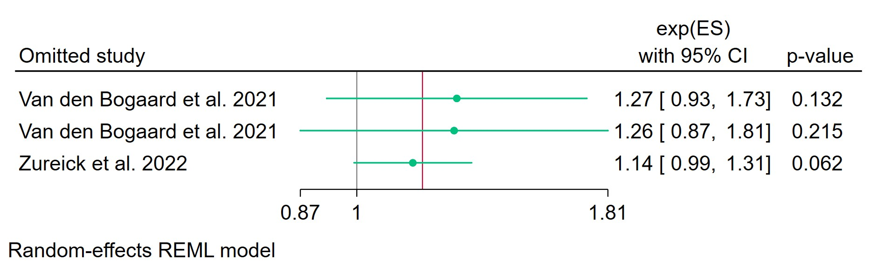
Figure 8. Leave-one-out sensitivity analysis for pooled effect size REML model.
Leave-one-out analysis assesses meta-analysis robustness by iteratively excluding one study at a time and refitting the model to observe shifts in the pooled effect size, confidence interval, and heterogeneity. Omitting Van den Bogaard et al. (2021) shifts the exp(ES) to 1.27 (95% CI: 0.93–1.73, p=0.132), borderline significant and narrower, while excluding Zureick et al. (2022) yields 1.14 (95% CI: 0.99–1.31, p=0.062), both non-significant at p<0.01.
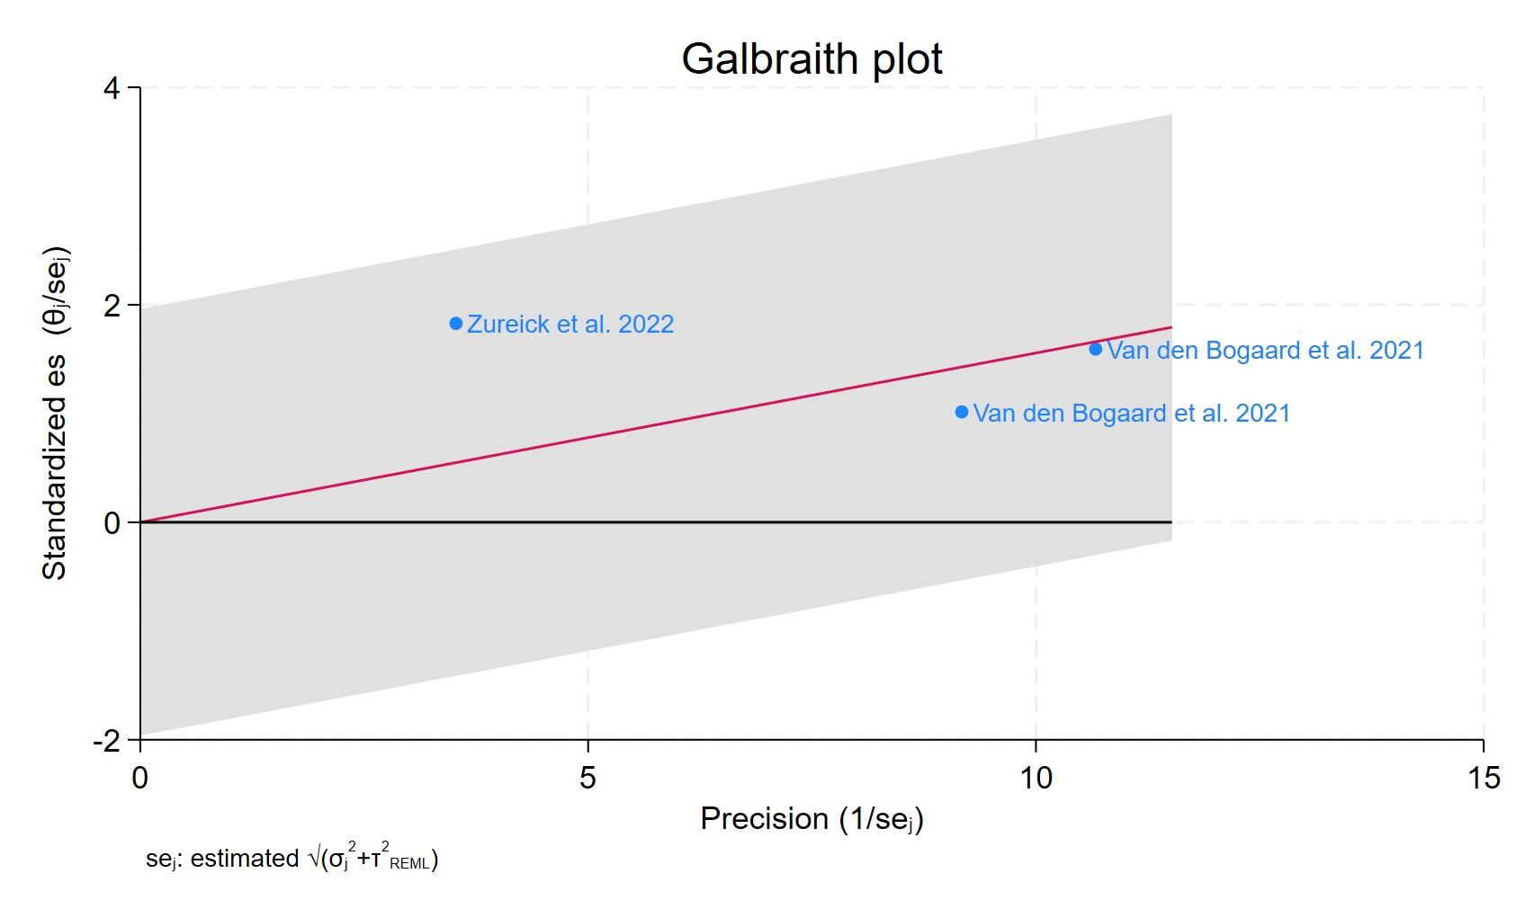
Figure 9. Galbraith plot - LAD MEAN DOSE
Each study is represented as a point, where the x-axis denotes the precision (defined as the inverse of the standard error), and the y-axis indicates the standardized effect size. The red regression line represents the overall summary effect estimated from the random-effects model, and the gray shaded area corresponds to the confidence interval at 95% around regression line. The horizontal black line at y = 0 corresponds to the line of no effect, serving as a reference.

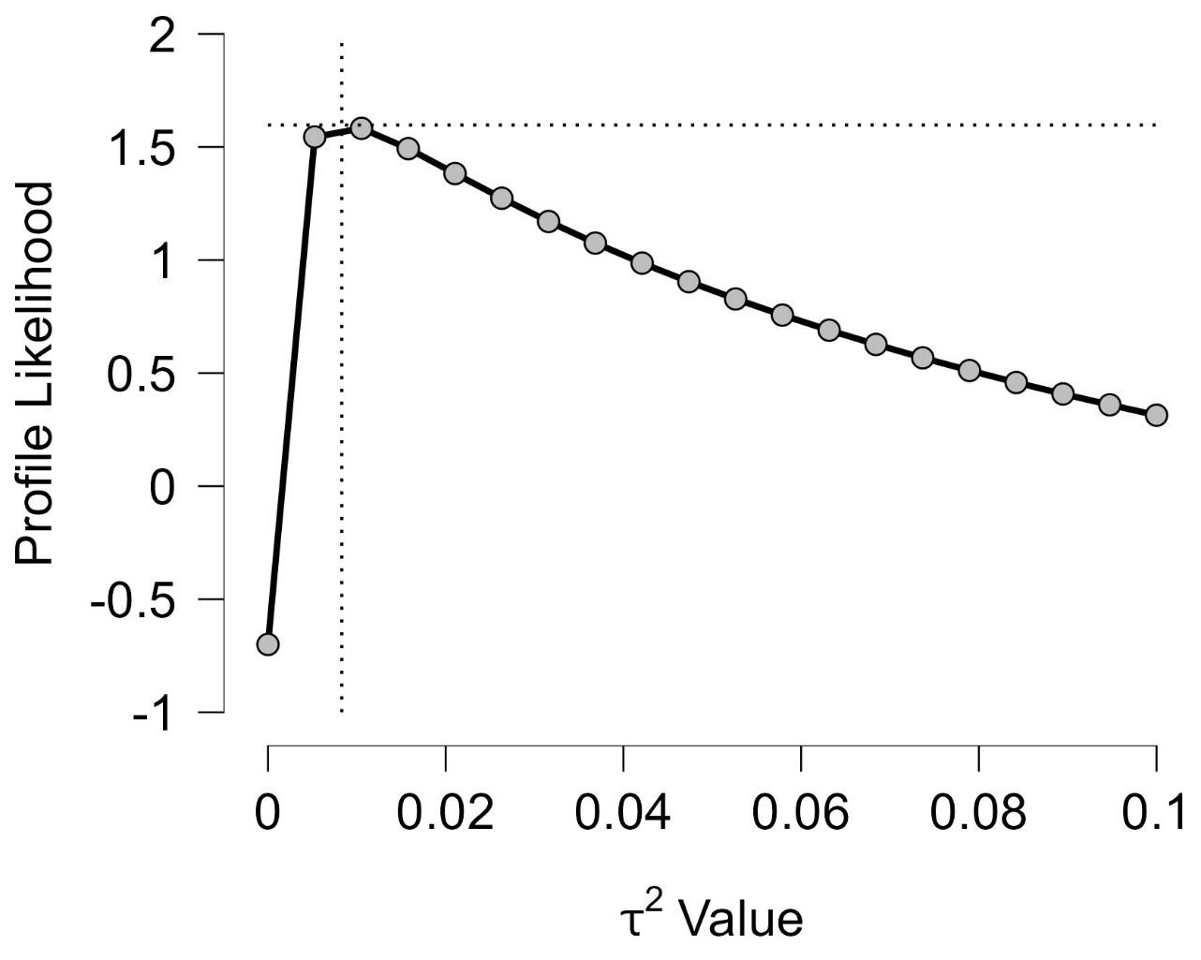
Figure 10. Profile Likelihood
The x-axis shows candidate values of the heterogeneity variance $τ^{2}$, and the y-axis shows the corresponding standardized profile likelihood, which has been scaled so that the maximum value equals 1 at $τ^{2}=0$.The maximum occurs at $τ^{2}=0$, where the profile likelihood reaches approximately 2 (likely on a rescaled log-likelihood scale), strongly supporting no between-study heterogeneity and favoring a fixed-effects model over random-effects. The curve drops sharply near zero before flattening gradually toward $τ^{2}=0.10$, suggesting the data provide strong evidence against small positive $τ^{2}$ values but weaker discrimination for larger ones; a 95% profile likelihood confidence interval for $τ^{2}$ would likely include zero and extend rightward.
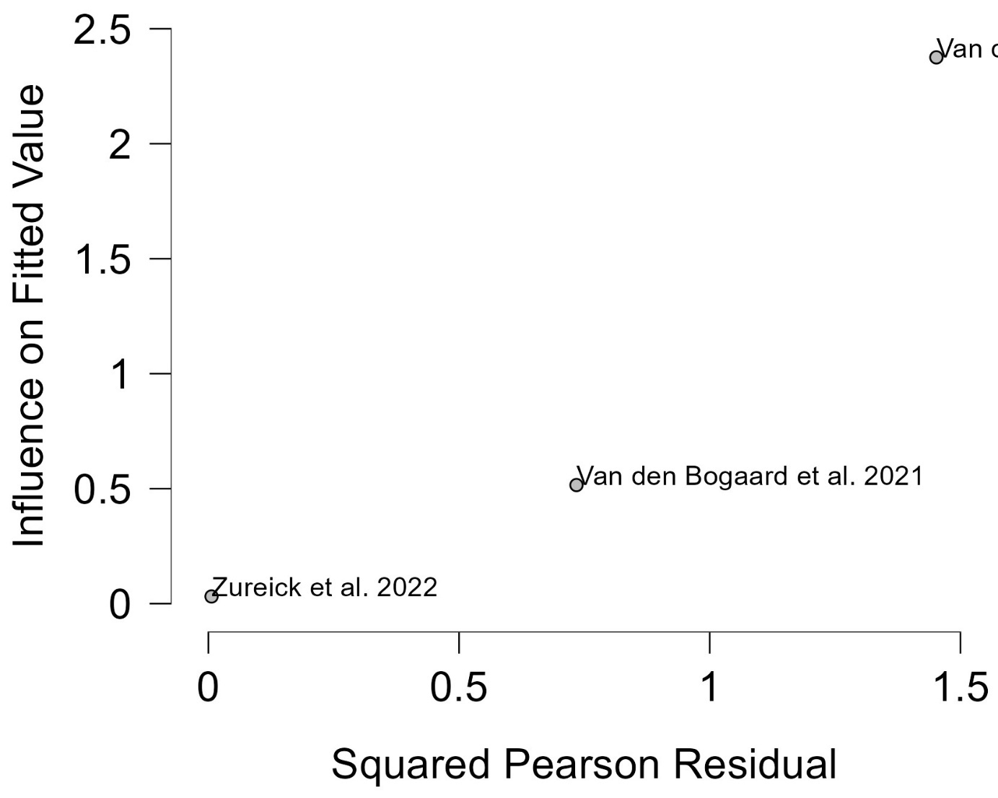
Figure 11. Baujat plot
The Baujat plot visualizes each study's contribution to the Q-statistic for heterogeneity on the x-axis (squared Pearson residual) against its influence on the pooled effect on the y-axis (standardized squared difference in fixed-effects estimates with/without the study). Studies in the top-right quadrant drive both heterogeneity and effect variation, signalling candidates for sensitivity analysis; bottom-left points have minimal impact. It aids outlier detection and heterogeneity exploration without refitting models, complementing LOO and casewise diagnostics in metafor or meta packages. Both Van den Bogaard et al. (2021) points show strong fitted influence (y-values ~1.0–2.5) but low residuals (x <0.5), placing them firmly in the upper-left quadrant, indicative of high-leverage studies that pull the pooled estimate without much discordance.​ Zureick et al. (2022) clusters low on both axes (bottom-left), confirming negligible contribution to heterogeneity or influence. The plot's compressed x-range reinforces minimal overall heterogeneity ($τ^{2}≈0$), with influence dominated by Van den Bogaard records.
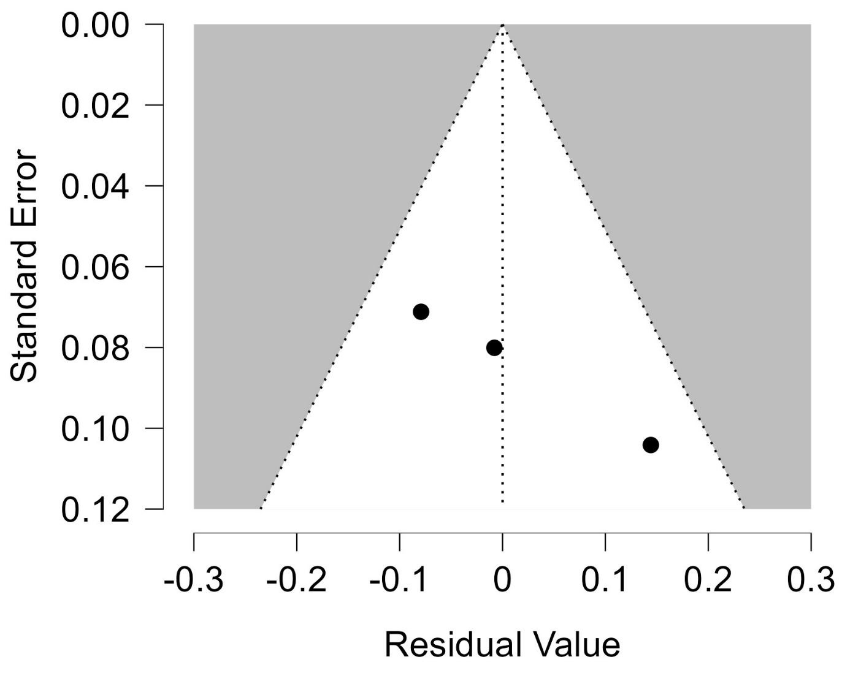
Figure 12. Funnel plot – LAD MEAN DOSE
Each blue dot represents a single study, plotted with its effect size on the x-axis and its standard error on the y-axis. The vertical red line represents the overall effect estimate derived from the random-effects model using restricted maximum likelihood (REML). The pseudo 95% confidence interval region, shown as gray diagonal lines, outlines the expected spread of studies in the absence of bias or between-study heterogeneity.

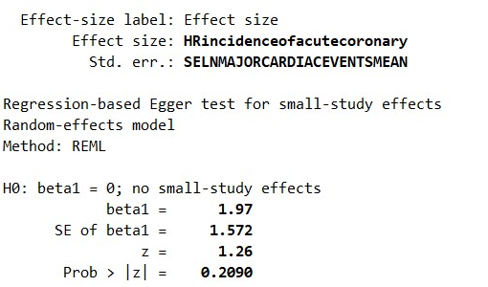
Figure 13. Regression-based Egger's test for small-study effects with REML model
Egger's regression test detects small-study effects (e.g., publication bias) by regressing standardized study effects (${\hat{θ}}_{j}/SE({\hat{θ}}_{j})$) on precision ($1/SE({\hat{θ}}_{j})$), testing if the intercept ($β_{0}$) equals zero under $H_{0}$: no asymmetry. Random-effects versions adjust for between-study variance $τ^{2}$, using marginal variances to mitigate bias in sparse data; p < 0.05 (or 0.10) suggests effects like selective reporting inflating smaller/precise studies. It complements funnel plots and potential inflation with high heterogeneity or ORs away from 1. The test reports $β_{1}=1.97$ (SE = 1.572), z = 1.26, p = 0.209, failing to reject $H_{0}$ (no small-study effects) at conventional levels.​ This non-significant result (Prob > |z| = 0.209) provides no evidence of funnel plot asymmetry or publication bias for this MACE-related HR outcome.​ Consistent with low heterogeneity from prior diagnostics, it supports the pooled estimate's credibility absent bias signals.

Figure 14. Nonparametric trim-and-fill analysis for publication bias adjustment (random-effects REML model, linear estimator).
Trim-and-fill is a rank-based method to estimate and impute studies suppressed due to publication bias, "trimming" asymmetric extremes, mirroring to fill gaps, then re-estimating the pooled effect with observed + imputed studies. The linear estimator imputes effect sizes symmetrically; random-effects pooling (REML) accounts for $τ^{2}$; assesses bias impact but is conservative, sensitive to heterogeneity, and treats imputes as observed (underestimating uncertainty). Results guide sensitivity: if imputed-adjusted effect alters significance/inference, bias may inflate original estimate. No studies imputed, indicating symmetric funnel plot with no evidence of missing left-side studies.​ Adjusted pooled REML estimate remains 1.168 (95% CI: 1.021–1.338), unchanged from observed, confirming robustness to hypothetical bias correction.​ This null adjustment, alongside non-significant Egger tests, supports absence of publication bias in this analysis.

CUMULATIVE INCIDENCE
Supplementary Table 8. Casewise diagnostics
Casewise diagnostics evaluate individual study influence in meta-analysis by computing standardized residuals, leverage (Hat values), and global influence measures like DFFITS, Cook's distance, and covariance ratios.​
Leave-one-out analyses refit the model after sequentially omitting each study, quantifying changes in key parameters (e.g., $τ$, $τ^{2}$, $Q_{e}$, pooled effect) to assess sensitivity to individual observations.​ Van den Bogaard et al. (2017) is highly influential, showing a standardized residual of 0.732, extreme DFFITS (2.765), Cook's distance (7.644), and leverage (Hat=0.934 with 93.4% weight), with LOO yielding zero heterogeneity ($τ^{2}=0$) and a massive intercept shift of 2.765.
Cao et al. (2024) has minimal impact across all metrics (e.g., Cook's distance 0.038, DFFITS -0.194), with negligible LOO changes including $τ^{2}=0$ and intercept shift of -0.194.
These results indicate the meta-analysis is dominated by Van den Bogaard et al. (2017), whose removal collapses heterogeneity to zero while drastically altering the pooled effect.
Casewise Diagnostics Table
 |  |  |  |  | Leave One Out |  |  |  |  | Difference in coefficients
Label | Standardized Residual | DFFITS | Cook's Distance | Covariance ratio | 𝜏 | 𝜏² | Qₑ | Hat | Weight | Intercept | Influential
Cao et al. 2024 | -0.732 | -0.194 | 0.038 | 1.070 | 0.000 | 0.000 | 0.000 | 0.066 | 6.551 | -0.194
Van den Bogaard et al. 2017 | 0.732 | 2.765 | 7.644 | 15.265 | 0.000 | 0.000 | 0.000 | 0.934 | 93.449 | 2.765 | Yes

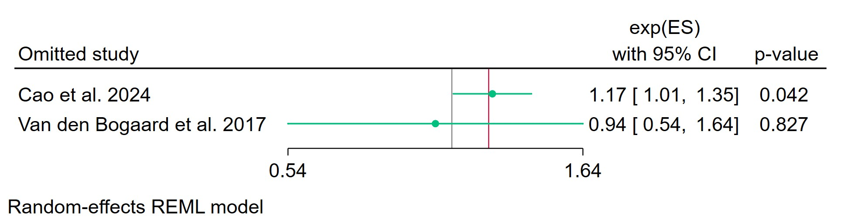
Figure 15. Leave-one-out sensitivity analysis for pooled effect size REML model.
Leave-one-out analysis assesses meta-analysis robustness by iteratively excluding one study at a time and refitting the model to observe shifts in the pooled effect size, confidence interval, and heterogeneity. Excluding Cao et al. (2024) increases exp(ES) to 1.17 (95% CI: 1.01–1.35, p=0.042), achieving borderline significance unlike the full model. Omitting Van den Bogaard et al. (2017) sharply reduces exp(ES) to 0.94 (95% CI: 0.54–1.64, p=0.827), non-significant and crossing null=1, highlighting this study's pivotal role in elevating the pooled ratio.​
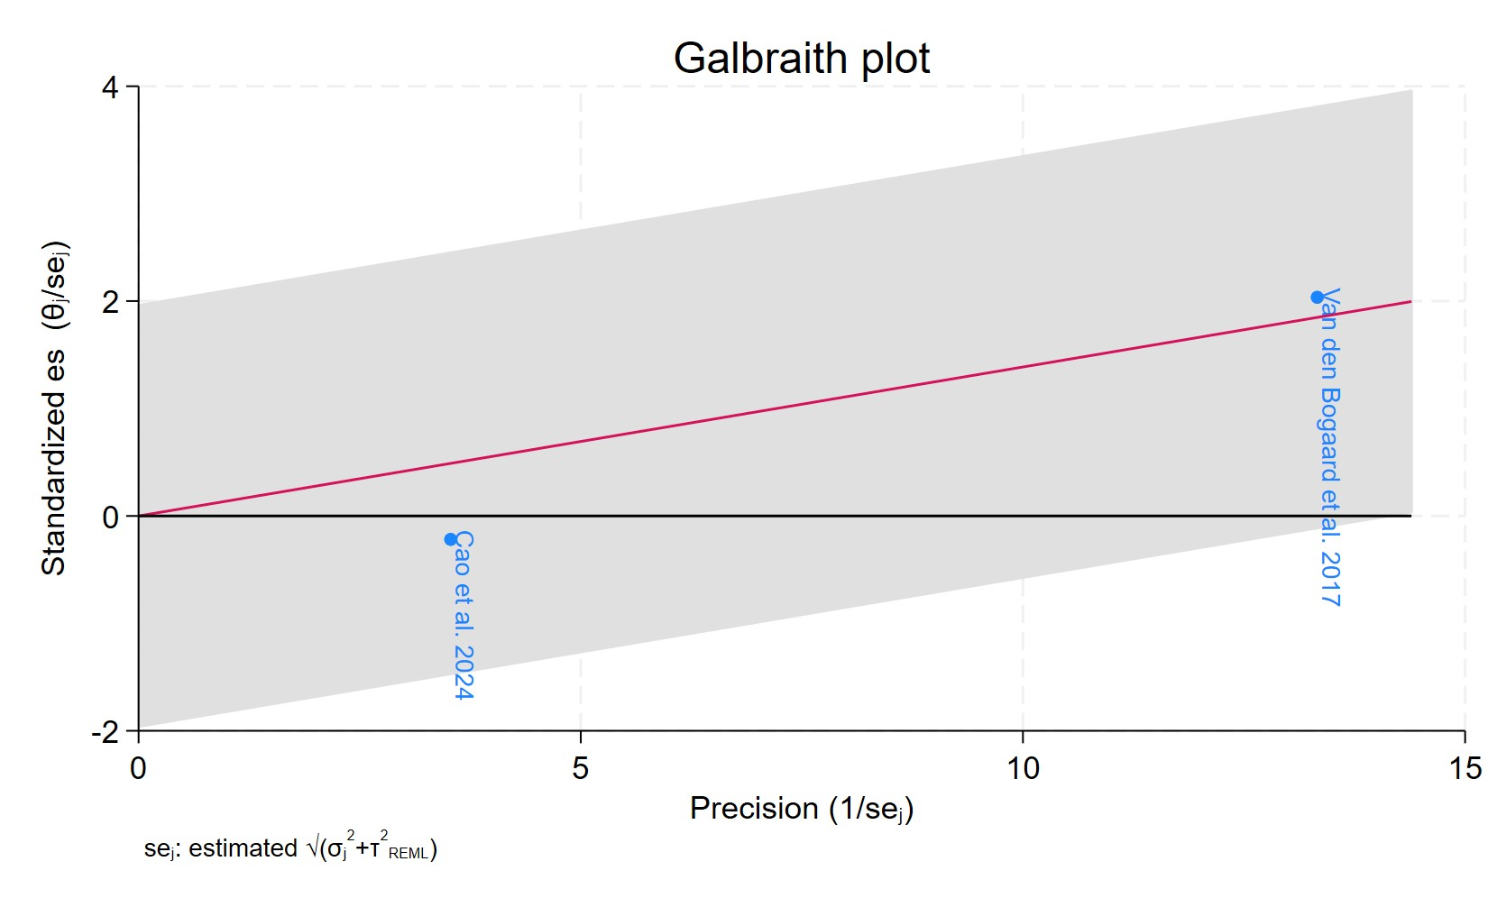
Figure 16. Galbraith plot – Cumulative Incidence
Each study is represented as a point, where the x-axis denotes the precision (defined as the inverse of the standard error), and the y-axis indicates the standardized effect size. The red regression line represents the overall summary effect estimated from the random-effects model, and the gray shaded area corresponds to the confidence interval at 95% around regression line. The horizontal black line at y = 0 corresponds to the line of no effect, serving as a reference.

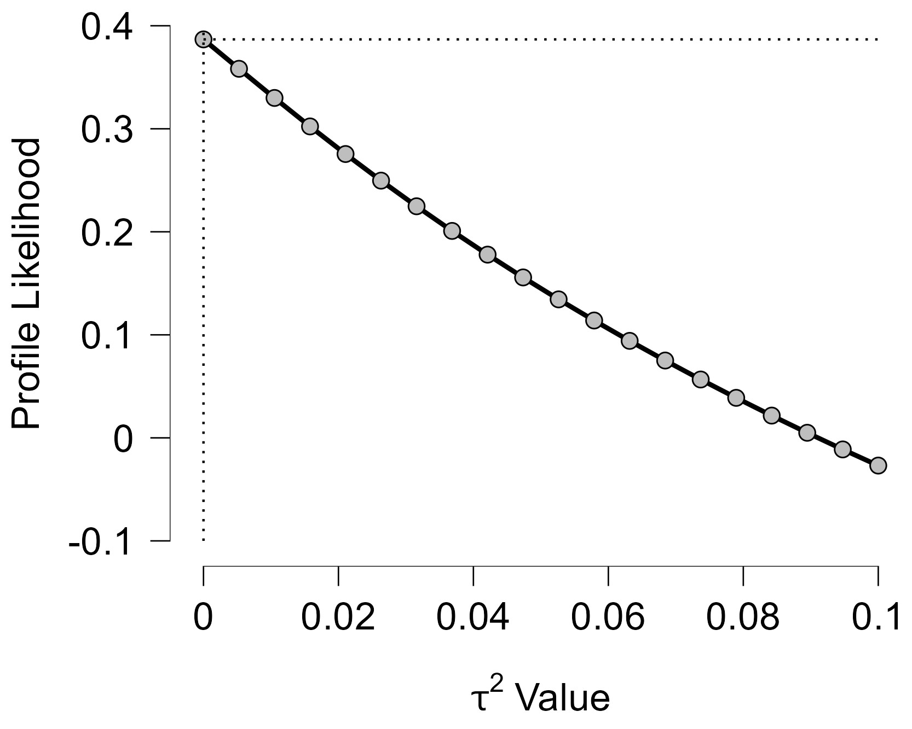
Figure 17. Profile Likelihood
The x-axis shows candidate values of the heterogeneity variance $τ^{2}$, and the y-axis shows the corresponding standardized profile likelihood, which has been scaled so that the maximum value equals 1 at $τ^{2}=0$.The peak at $τ^{2}=0$ and monotonic decline to near 0 at $τ^{2}=0.10$ confirm that the data strongly support zero heterogeneity, with the likelihood ratio test rejecting $τ^{2}>0$ decisively.
A plausible 95% profile CI for $τ^{2}$ spans from 0 to 0.04-0.06, underscoring minimal evidence for between-study variation.

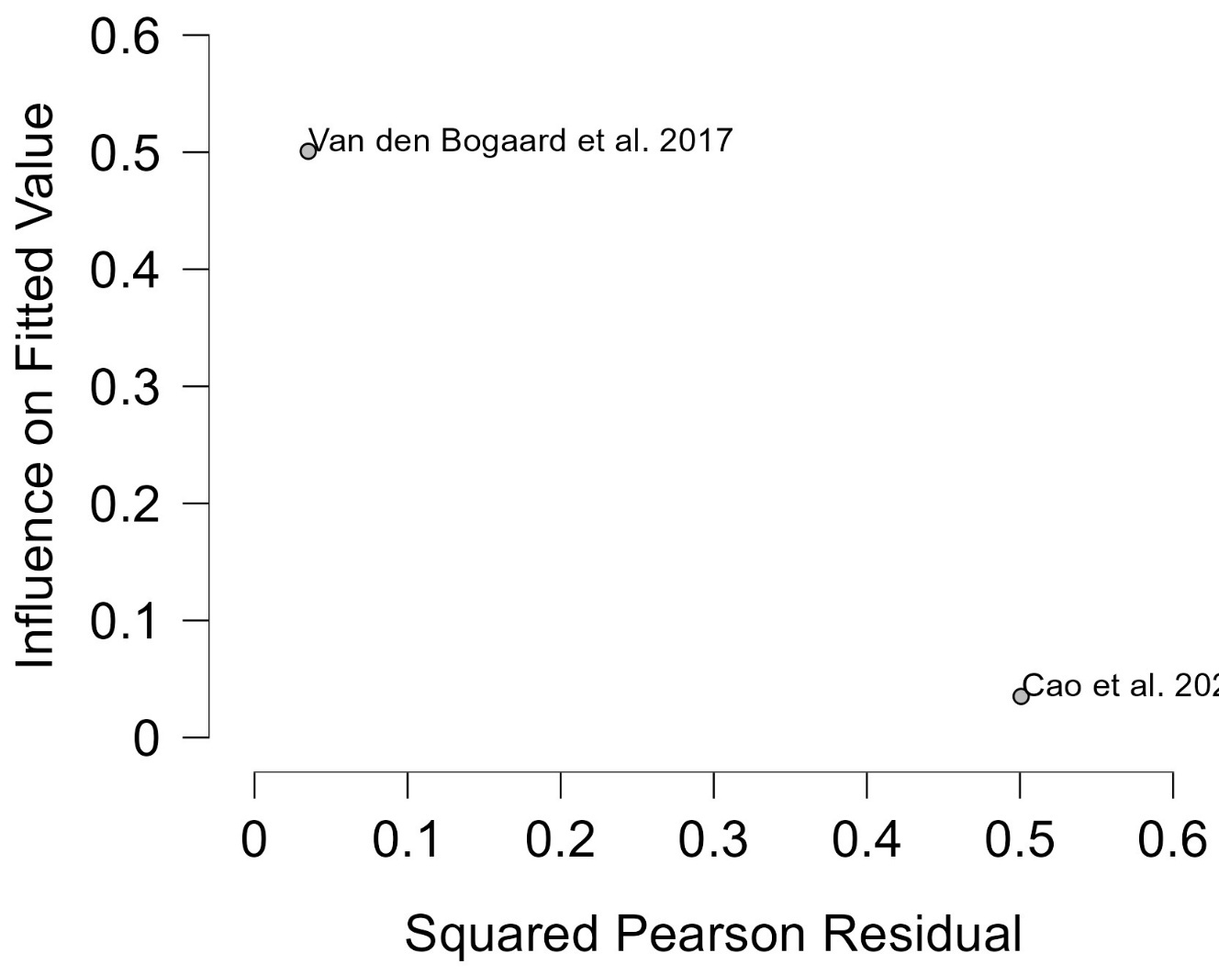
Figure 18. Baujat plot
The Baujat plot visualizes each study's contribution to the Q-statistic for heterogeneity on the x-axis (squared Pearson residual) against its influence on the pooled effect on the y-axis (standardized squared difference in fixed-effects estimates with/without the study). Studies in the top-right quadrant drive both heterogeneity and effect variation, signalling candidates for sensitivity analysis; bottom-left points have minimal impact. It aids outlier detection and heterogeneity exploration without refitting models, complementing LOO and casewise diagnostics in metafor or meta packages. Van den Bogaard et al. (2017) directs with high fitted influence (~0.5 y-value) and low residual contribution (<0.1 x), upper-left position confirming leverage-driven impact without discordance.
Cao et al. (2024) shows very low influence and residual (near origin), negligible overall role.
Constrained axes and clustered low residuals align with near-zero $τ^{2}$, where influence stems from study weights rather than variability.
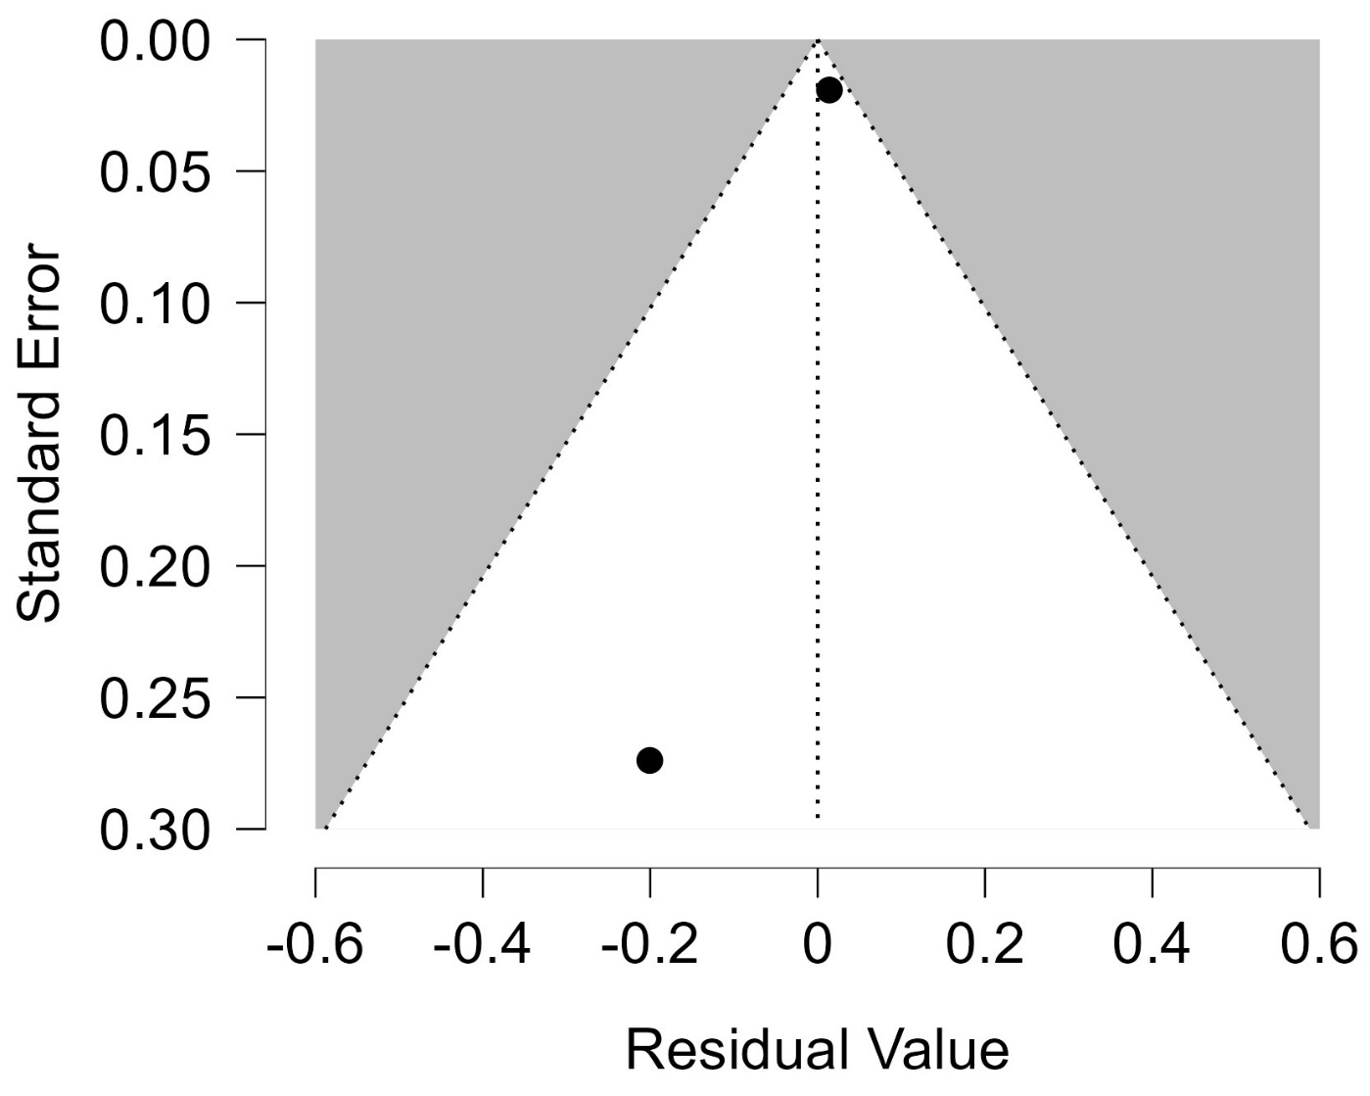
Figure 19. Funnel plot – CUMULATIVE INCIDENCE
Each blue dot represents a single study, plotted with its effect size on the x-axis and its standard error on the y-axis. The vertical red line represents the overall effect estimate derived from the random-effects model using restricted maximum likelihood (REML). The pseudo 95% confidence interval region, shown as gray diagonal lines, outlines the expected spread of studies in the absence of bias or between-study heterogeneity.

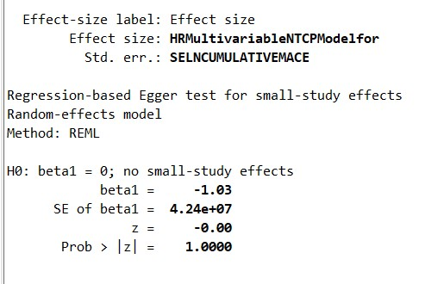
Figure 20. Regression-based Egger's test for small-study effects with REML model
Egger's regression test detects small-study effects (e.g., publication bias) by regressing standardized study effects (${\hat{θ}}_{j}/SE({\hat{θ}}_{j})$) on precision ($1/SE({\hat{θ}}_{j})$), testing if the intercept ($β_{0}$) equals zero under $H_{0}$: no asymmetry. Random-effects versions adjust for between-study variance $τ^{2}$, using marginal variances to mitigate bias in sparse data; p < 0.05 (or 0.10) suggests effects like selective reporting inflating smaller/precise studies. It complements funnel plots and potential inflation with high heterogeneity or ORs away from 1. The test shows $β_{1}=-1.03$ (SE = $4.24×{10}^{7}$), p = 1.000 (Prob > |z|).​This highly non-significant p-value provides no evidence against $H_{0}$, indicating symmetric funnel plot and absence of small-study effects or publication bias.​The large SE reflects sparse data/low power, aligning with prior non-significant bias tests and low heterogeneity findings.

Figure 21. Nonparametric trim-and-fill analysis for publication bias adjustment (random-effects REML model, linear estimator).
Trim-and-fill is a rank-based method to estimate and impute studies suppressed due to publication bias, "trimming" asymmetric extremes, mirroring to fill gaps, then re-estimating the pooled effect with observed + imputed studies. The linear estimator imputes effect sizes symmetrically; random-effects pooling (REML) accounts for $τ^{2}$; assesses bias impact but is conservative, sensitive to heterogeneity, and treats imputes as observed (underestimating uncertainty). Results guide sensitivity: if imputed-adjusted effect alters significance/inference, bias may inflate original estimate.

