Supporting Information for

Generative Diffusion Outperforms Quantile Mapping for Climate Downscaling Across Scales
Kaushik Muduchuru^{1*}, Amit Kumar Srivastava¹, Krishnagopal Halder¹, Manmeet Singh², Ivonne Anders³, Senthold Asseng⁴, Luis Alfredo Pires Barbosa¹, Kazi Jahidur Rahaman¹, Wenzhi Zeng^{5,6,7}, Thomas Gaiser⁸, Frank Ewert^{1,8}

¹Leibniz Centre for Agricultural Landscape Research (ZALF), Eberswalder Str. 84, 15374, Müncheberg, Germany
²Earth, Environmental and Atmospheric Sciences, Western Kentucky University, Bowling Green, KY, United States of America
³Deutsches Klimarechenzentrum GmbH (DKRZ), Datamanagement, Hamburg, 20156, Germany
⁴Technical University of Munich, Department of Life Science Engineering, Digital Agriculture, HEF World Agricultural Systems Center, Freising, 85354, Germany
⁵College of Agricultural Science and Engineering, Hohai University, Nanjing, 210098, China
⁶Key Laboratory of Agricultural Low-Altitude Technology Innovation and Integration, Ministry of Agriculture and Rural Affairs, Nanjing 211100, China
⁷Jiangsu Province Engineering Research Center for Agricultural Soil‒Water Efficient Utilization, Carbon Sequestration and Emission Reduction, Nanjing 211100, China
⁸Institute of Crop Science and Resource Conservation, University of Bonn, Bonn, 53111, Germany

S1. Rationale for the Dual-Stage Dataset Configuration
The choice of target datasets for the two-stage downscaling framework (CasCorrDiff) is guided by trade-offs among spatial coverage, data resolution, and the physical scales of the driving meteorological predictors. The Multi-Source Weather Observation (MSWX) dataset is selected as the intermediate 10 km target for two primary reasons. First, MSWX provides spatially continuous, high-resolution coverage across the entire European continent. Using a pan-European dataset in the first stage significantly increases the volume and diversity of training samples, enabling the diffusion model to learn robust, generalized representations of synoptic-to-mesoscale atmospheric features. Second, the upper-atmospheric and large-scale synoptic variables incorporated as predictors in Stage 1 operate primarily at these broader regional scales, making the 100 km to 10 km transition physically pertinent and well-constrained across the larger European domain. The German Weather Service (DWD) HYRAS dataset is used as the final 1-km target. While HYRAS offers an exceptional hyper-resolution grid ideal for capturing complex local topographies and microclimatic variability, its spatial extent is strictly limited to Germany. Transitioning directly from 100 km to 1 km over this restricted domain would drastically limit the model's training data and expose it to severe downscaling instabilities. By nesting the stages—leveraging the large-sample European-wide MSWX data at 10 km before refining locally to 1 km with HYRAS—the framework successfully balances large-scale statistical representation with localized hyper-resolution accuracy.

ERA5 Dataset
The ERA5 reanalysis provides global, hourly atmospheric data from 1950 onward. It combines observational records with numerical weather prediction models using advanced data assimilation techniques, producing a consistent, high-quality global dataset¹. For precipitation, ERA5 employs a 4D-Var assimilation system that integrates multiple observational sources, including gauge-adjusted radar data in selected regions. This work uses the period 1989-2024, during which ERA5 coincides with data availability of MSWX and DWD HYRAS datasets, providing sufficient samples for training, validation, and testing. Precipitation and daily mean, maximum, and minimum temperatures, solar radiation, and relative humidity from ERA5 fields, aggregated daily, are used as inputs for spatio-temporal downscaling. In addition, auxiliary variables, such as wind components, temperature, humidity, and geopotential height at multiple pressure levels, are included, as they have been shown to predict extreme events over Europe². We do not use the higher-resolution ERA5-Land precipitation product, as it is derived from ERA5 through an offline land surface model and therefore inherits many of the same underlying biases³. Although ERA5 precipitation is known to have limitations -including spatially heterogeneous performance, smoothing of local extremes due to its effective resolution, and difficulties in representing convective precipitation events -it remains one of the most widely used reference datasets in climate and environmental research⁴. For the first stage of the downscaling framework, ERA5 is linearly interpolated from their native resolution of approximately 31 km to a coarser 1° grid (~100 km) to emulate the input resolution of coarse-resolution climate model outputs.

MSWX Dataset
The MSWX dataset is used as the target for the first stage of the cascading downscaling model and also as input for the second stage. MSWX provides a global meteorological record of surface weather variables at 0.1° spatial resolution and daily temporal resolution, improving substantially upon ERA5’s native resolution⁵. Furthermore, MSWX addresses limitations of ERA5 by providing near-real-time updates with integrated forecast ensembles, enabling applications in both climate projection downscaling and near-term forecasting. High-resolution reference climatologies are incorporated for bias correction and improved representation in complex terrain, making MSWX particularly well-suited to bridging the gap between coarse reanalysis data and kilometer-scale observations.

HYRAS Dataset
The HYRAS dataset, developed by the Deutscher Wetterdienst (DWD), provides a long-term, high-resolution meteorological record for Germany, covering the period from 1951 to the present at a 1 km spatial resolution⁶. It includes daily fields of mean, minimum, and maximum near-surface air temperature, precipitation, solar radiation, and relative humidity. HYRAS uses a two-step interpolation approach to capture both large-scale atmospheric patterns and fine-scale terrain effects. First, a background climate field is constructed using nonlinear vertical temperature profiles. In a second step, spatial residuals are distributed using inverse-distance weighting. This interpolation is further refined by incorporating multidimensional distance metrics that account for elevation, distance to the coast, and urban heat island effects. Together, these components allow HYRAS to represent complex topographic influences and temperature inversions with high fidelity⁷. Due to its long temporal coverage and high spatial resolution, HYRAS is widely used in hydrological modelling, climate bias correction, and the analysis of historical climate variability. In particular, it plays an important role in studying climate extremes such as warming trends and heatwaves across Central Europe⁶.

GHCNd Observations
The Global Historical Climatology Network Daily⁸ (GHCNd) is a global archive of land-based weather station observations provided by NOAA’s National Centers for Environmental Information. The dataset is extensively quality-controlled and widely used for climate monitoring, model evaluation, and validation of satellite products, including within CMIP studies. In this work, GHCNd is used as an independent ground-truth dataset to evaluate the performance of the diffusion-based downscaling model and statistical bias-correction methods in reproducing spatiotemporal variability. It provides point-scale ground truth against which gridded model outputs can be assessed, enabling a more direct evaluation of local-scale performance and extreme-event representation. The dataset comprises approximately 118,000 global station time series, including over 800 stations in Germany. For evaluation, only stations with at least 80% completeness in their daily records are retained to ensure reliable and consistent performance assessment (Figure S1).

The disparity in daily mean temperatures (TAVG) coverage exists because it archives TAVG only when explicitly provided by source networks (Figure S1), rather than deriving them from the universally reported maximum (TMAX) and minimum (TMIN) fields⁸. This structural limitation is compounded across Europe because historical station networks traditionally calculated daily means using variable synoptic-hour combinations (such as the "Mannheim hours") rather than 24-hour averages, creating localized discrepancies⁹. Consequently, these varying regional calculations frequently cause TAVG anomalies to fail NCEI's rigid spatial consistency and cross-variable quality-control tests, leading to higher automated rejection rates than for raw physical extremes¹⁰.

Table S1. Summary of the input conditioning variables and corresponding target channels employed in the diffusion-based downscaling model to generate high-resolution climate fields from coarse-resolution atmospheric predictors and auxiliary geophysical information.
Model | Input Channels (Coarse Conditioning Parameters) | Target Channels
First Stage of the Diffusion Model: 100 km → 10 km | 1. Upper-Air Synoptic Fields (20 channels)  Source: ERA5 reanalysis (coarsened by factor 4 to ~100 km resolution)  Extracted at pressure levels: 200, 500, 700, 850 hPa  Variables (Abbreviation):  - Air Temperature (ta)  - Specific Humidity (hus)  - Zonal Wind (ua)  - Meridional Wind (va)  - Geopotential Height (zg)  2. Surface Meteorological Variables (6 channels)  Source: ERA5 reanalysis (coarsened by factor 4 to ~100 km resolution)  Variables:  - Total Precipitation (pr)  - Daily Maximum Temperature (tasmax)  - Daily Minimum Temperature (tasmin)  - Daily Mean Temperature (tas)  - Surface Downwelling Solar Radiation (rsds)  - Relative Humidity (hurs)  3. Static Variables (2 Channels; High Resolution at 10 km)  - Elevation (Source: GMTED)  - Land Sea Mask  ERA5: https://cds.climate.copernicus.eu/  MSWX: https://www.gloh2o.org/mswx/ | 1. Surface Meteorological Variables (6 channels)  Source: MSWX dataset (10 km resolution)  Variables:  - Total Precipitation (pr)  - Daily Maximum Temperature (tasmax)  - Daily Minimum Temperature (tasmin)  - Daily Mean Temperature (tas)  - Surface Downwelling Solar Radiation (rsds)  - Relative Humidity (hurs)
Second Stage of the Diffusion Model: 10 km →  1 km | 1. Surface Meteorological Variables (6 channels)  Source: MSWX reanalysis (10 km resolution)  Variables:  - Total Precipitation (pr)  - Daily Maximum Temperature (tasmax)  - Daily Minimum Temperature (tasmin)  - Daily Mean Temperature (tas)  - Surface Downwelling Solar Radiation (rsds)  - Relative Humidity (hurs)  2. Static Variables (2 Channels; High Resolution at 1 km)  - Elevation (Source: GMTED)  - Germany Mask  DWD: https://opendata.dwd.de/climate_environment/CDC/  GMTED: https://www.usgs.gov/coastal-changes-and-impacts/gmted2010 | 1. Surface Meteorological Variables (6 channels)  Source: DWD HYRAS dataset (1 km resolution)  Variables:  - Total Precipitation (pr)  - Daily Maximum Temperature (tasmax)  - Daily Minimum Temperature (tasmin)  - Daily Mean Temperature (tas)  - Surface Downwelling Solar Radiation (rsds)  - Relative Humidity (hurs)

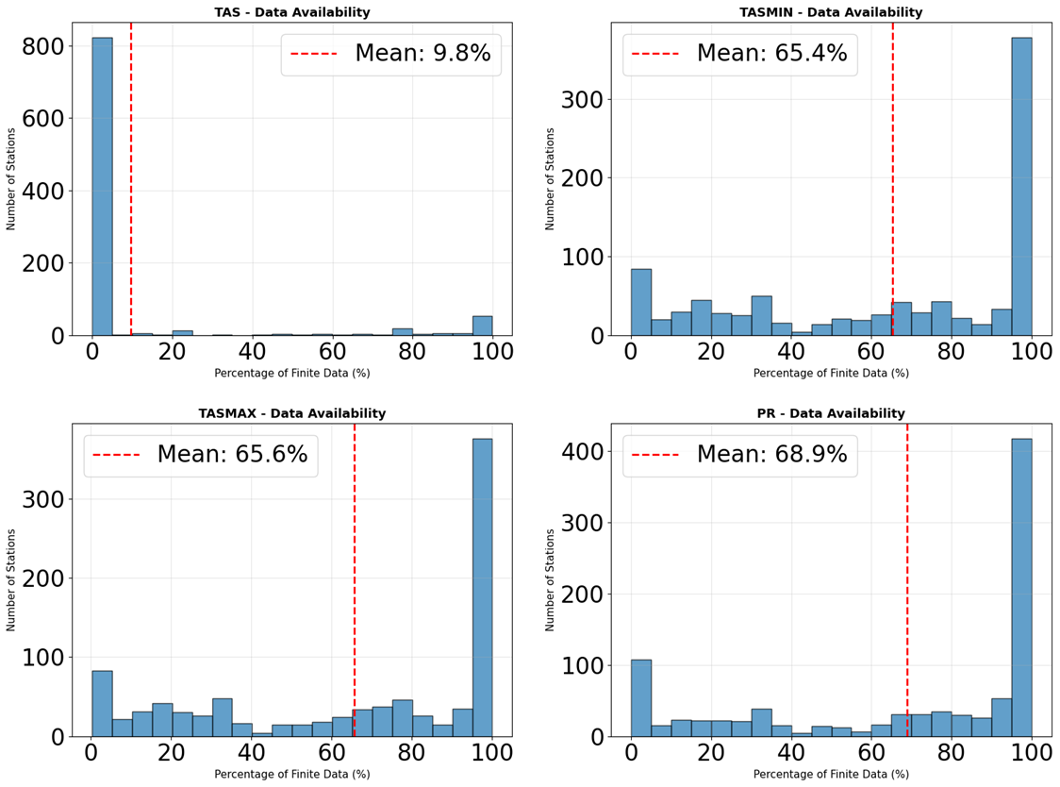
Figure S1: Distribution of stations by percentage of data availability (%) for Near-surface Air Temperature (TAS), minimum temperature (TASMIN), maximum temperature (TASMAX) and daily precipitation (PR) over Germany for the validation period (2020-2026).
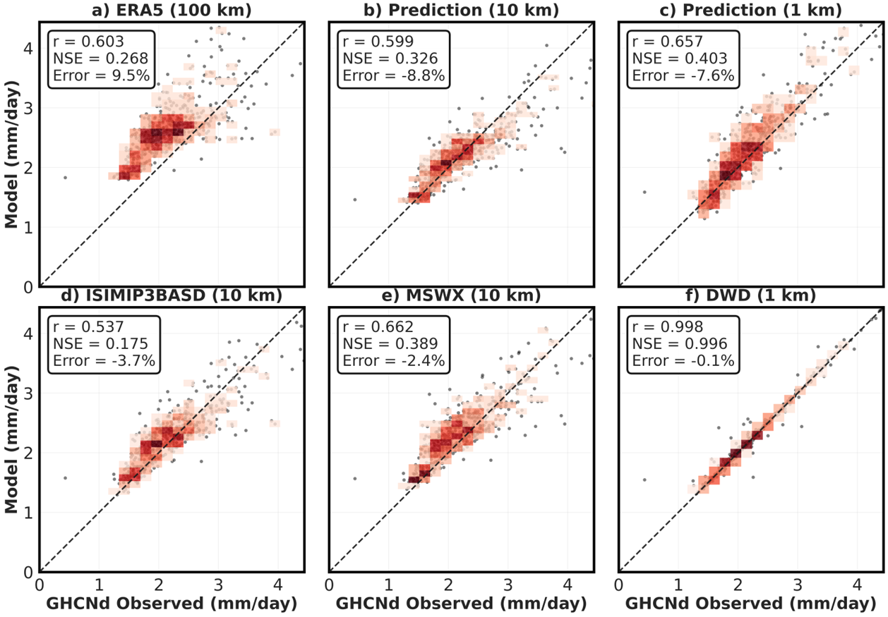
Figure S2: 2D density validation of modeled precipitation against station observations. Each panel compares station-averaged daily precipitation from the different models and datasets against GHCNd observations for 2020-2024 (552 stations). Gray points represent individual station mean values, while red density shading indicates regions with higher station concentrations (white = low density, red = high density). The black dashed line represents perfect 1:1 agreement. Performance metrics calculated on raw daily values are shown in each panel: Pearson correlation coefficient (r), coefficient of determination (R²), Nash-Sutcliffe Efficiency (NSE), and mean percent bias (Error). Models include: (a) ERA5 input at 100 km, (b) CasCorrDiff prediction at 10 km, (c) CasCorrDiff prediction at 1 km resolution, (d) ISIMIP3BASD bias-corrected ERA5 at 10 km, (e) MSWX target at 10 km resolution, and (f) DWD target at 1 km resolution.
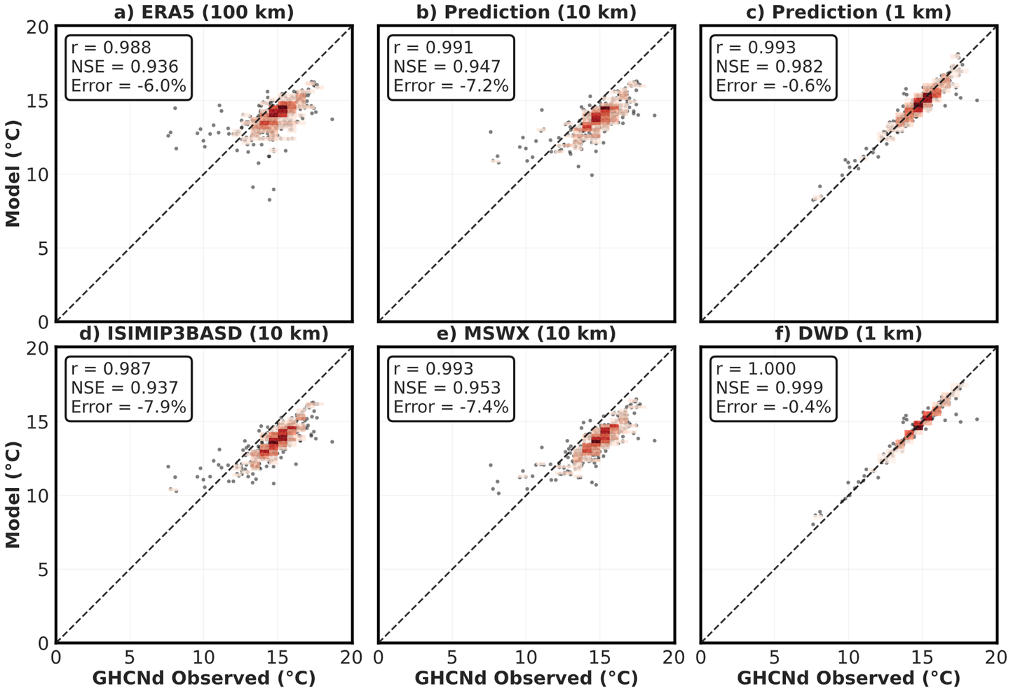
Figure S3:2D density validation of modeled daily maximum temperature against station observations. Same as Fig. S2 but compares station-average daily maximum temperature from the different models and datasets against GHCNd observations for 2020-2024 (552 stations).

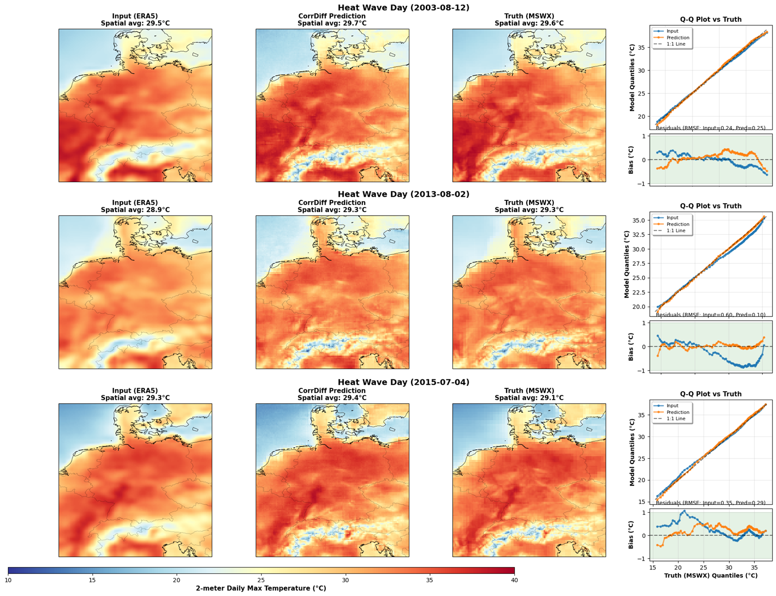
Figure S4: Spatial distribution of daily temperatures during heat wave peak days for the events on 12 August 2003, 2 August 2013, and 4 July 2015 (rows). Columns compare the coarse-resolution ECMWF ERA5 fields, the CasCorrDiff downscaled outputs, and the high-resolution reference dataset, MSWX. The fourth column presents Q–Q plots between the downscaled and reference datasets together with the corresponding quantile differences.

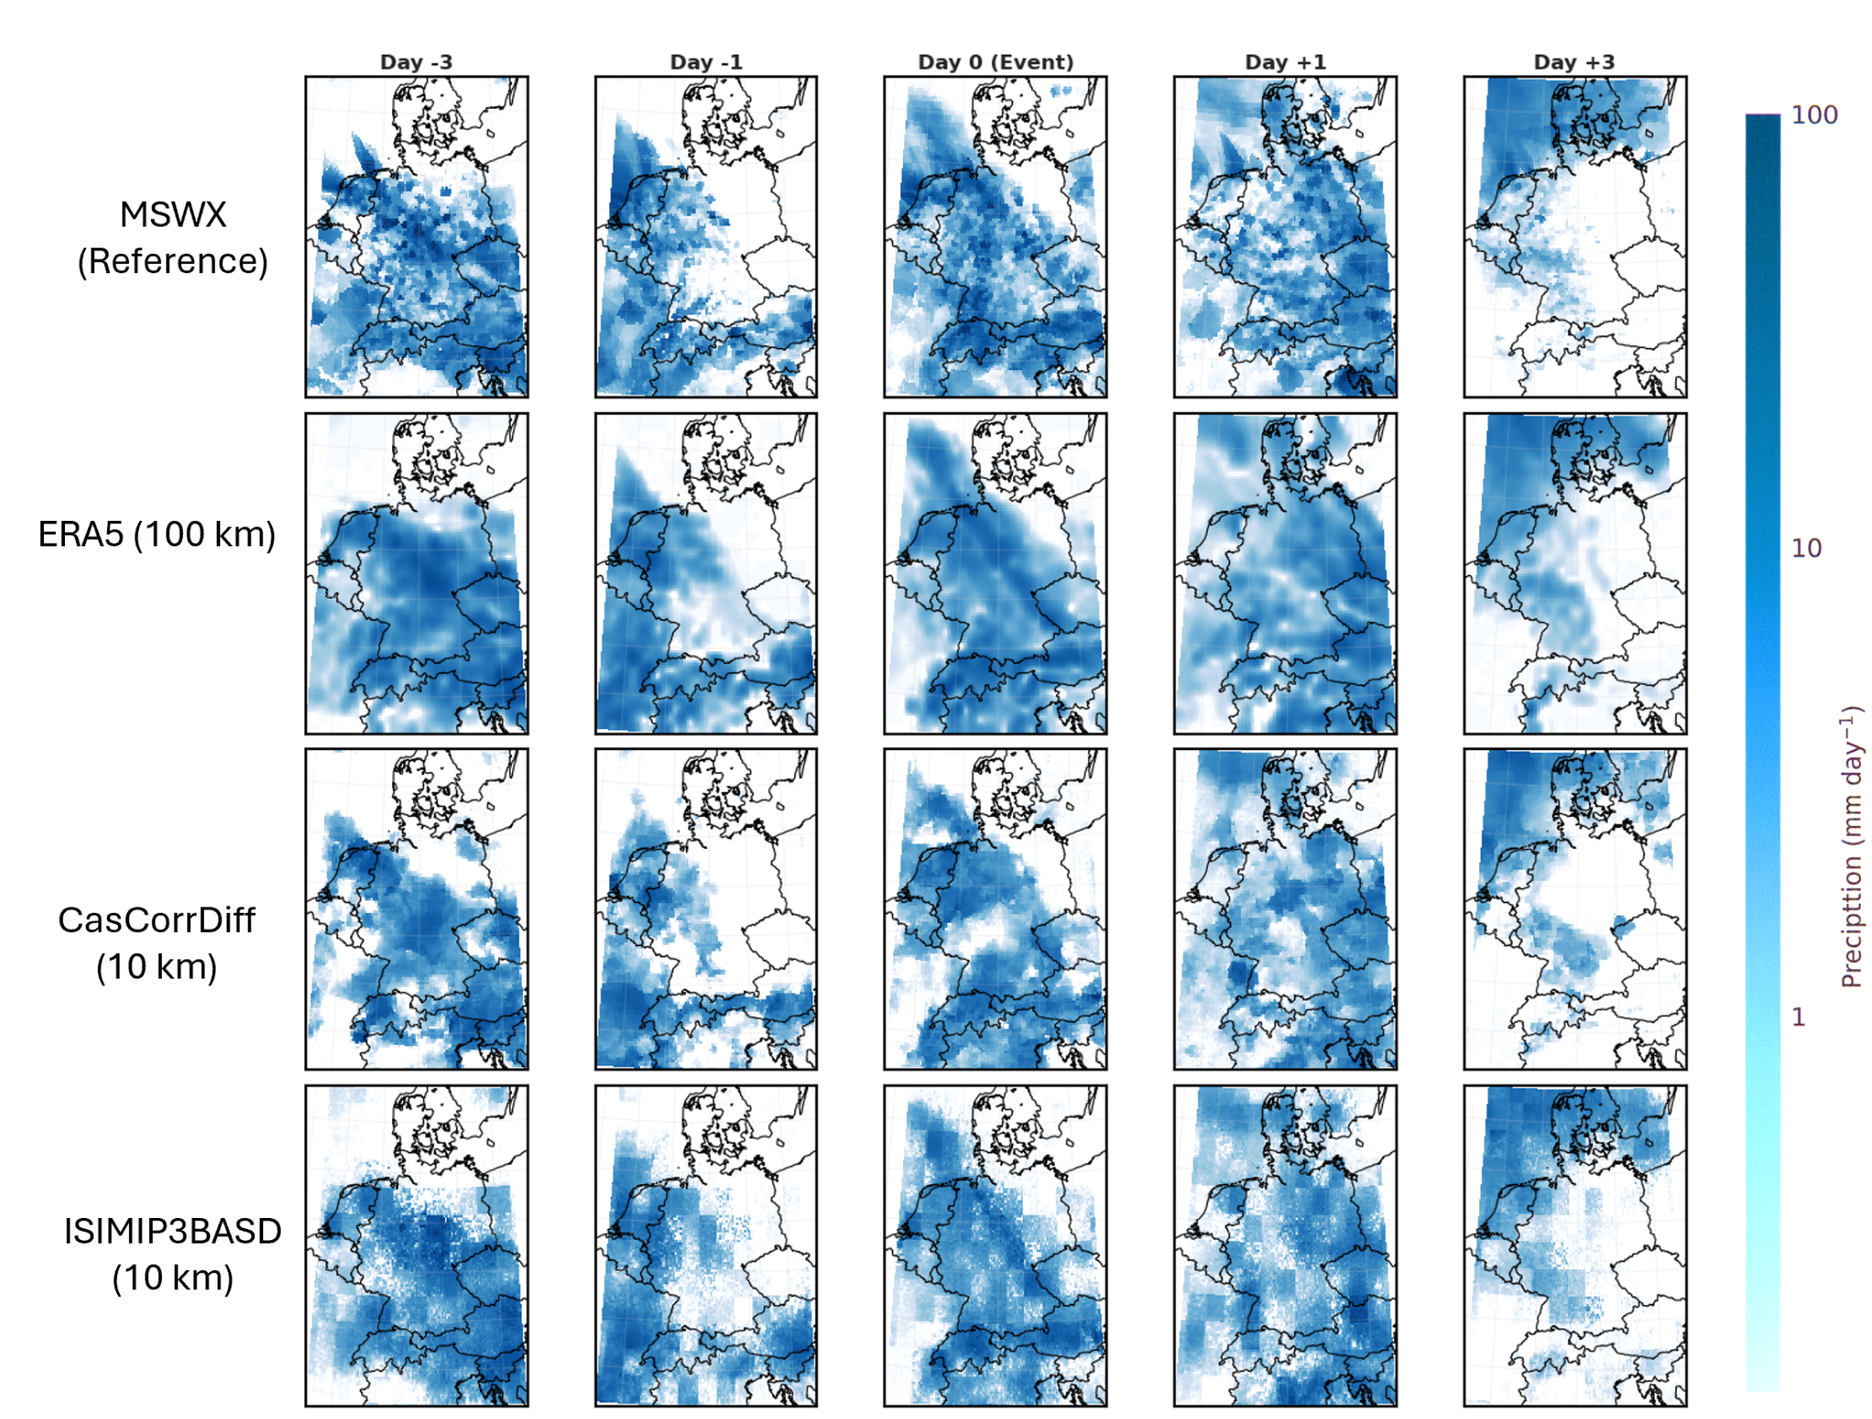
Figure S5: Spatial evolution of daily precipitation amount associated with a heavy precipitation event from day −3 to day +3 relative to the peak day (columns). Rows show the MSWX reference dataset, coarse-resolution ECMWF ERA5 fields at 100 km resolution, CasCorrDiff downscaled outputs at 10 km resolution, and ISIMIP3BASD outputs at 10 km resolution, illustrating the temporal and spatial progression of the event across datasets.
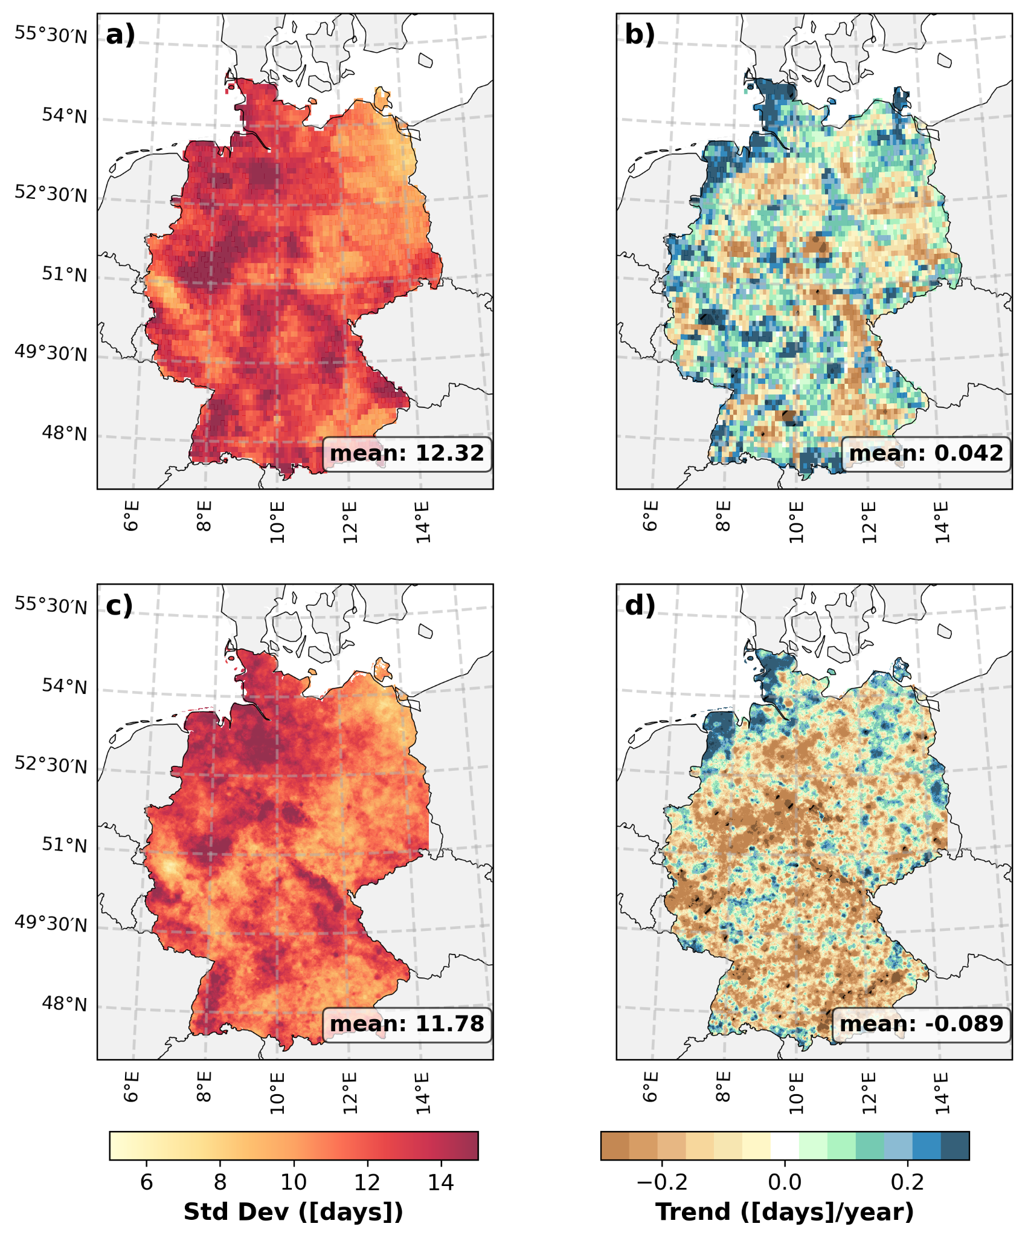
Figure S6: Spatial distribution of wet days variability and trends across Germany during 1989–2024. Panels (a) and (c) show the interannual standard deviation of wet days derived from the MSWX and HYRAS datasets, respectively, while panels (b) and (d) present the corresponding Mann–Kendall trends in wet days (days yr⁻¹). Hatched regions indicate statistically significant trends at the 95% confidence level (p < 0.05). The spatial mean value for each panel is shown in the bottom-right corner.
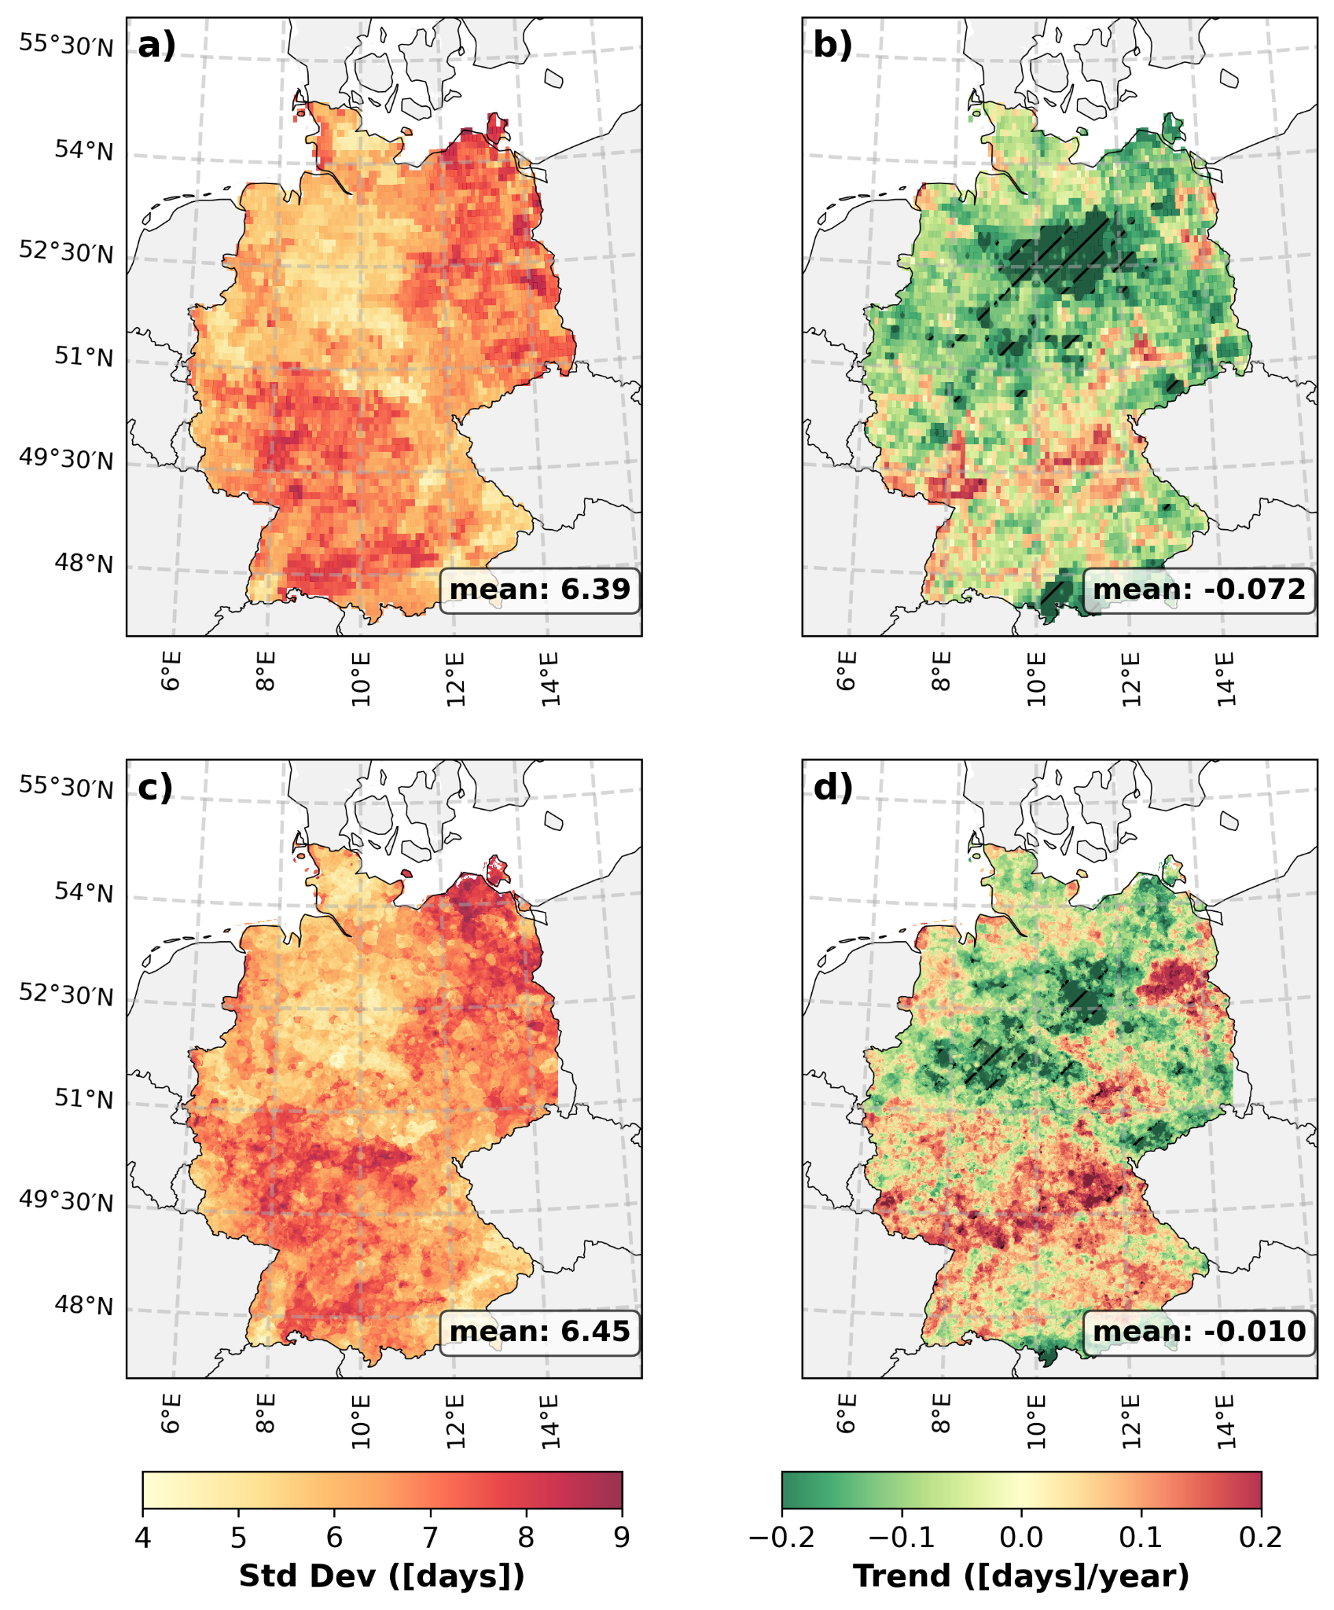
Figure S7: Spatial distribution of Consecutive Dry Days (CDD) variability and trends across Germany during 1989–2024. Panels (a) and (c) show the interannual standard deviation of CDD derived from the MSWX and HYRAS datasets, respectively, while panels (b) and (d) present the corresponding Mann–Kendall trends in CDD (days yr⁻¹). Hatched regions indicate statistically significant trends at the 95% confidence level (p < 0.05). The spatial mean value for each panel is shown in the bottom-right corner.

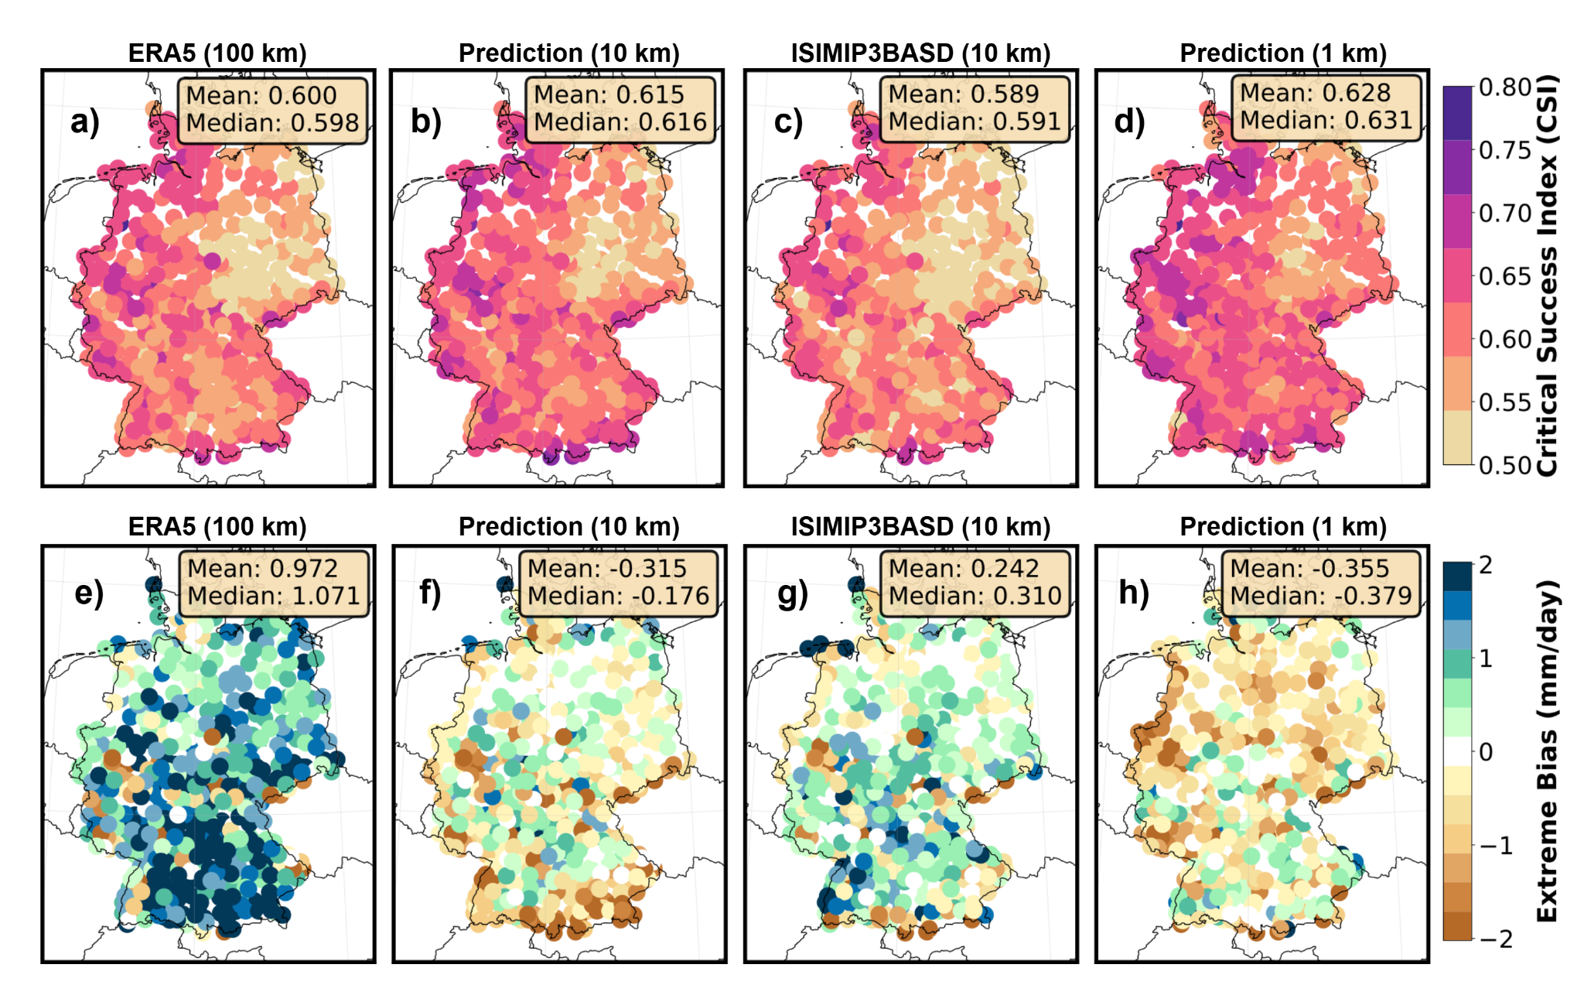Figure S8. Spatial distribution of temporal metrics for precipitation across station locations. (a-d) Critical Success Index (CSI) for wet-day detection (threshold: 1 mm day⁻¹), defined as CSI = hits / (hits + misses + false alarms), where values of 1 indicate perfect detection and 0 indicate complete failure. (e-h) Extreme precipitation bias, calculated as the difference between modelled and observed 90th percentile daily precipitation (mm day⁻¹) for ERA5 (100 km; a,e), CasCorrDiff Prediction (10 km; b,f), ISIMIP (10 km; c,g), and Prediction (1 km; ); positive (negative) values indicate overestimation (underestimation) of extreme events. Metrics are computed over the full evaluation period (2020–2024) using collocated GHCNd station observations.
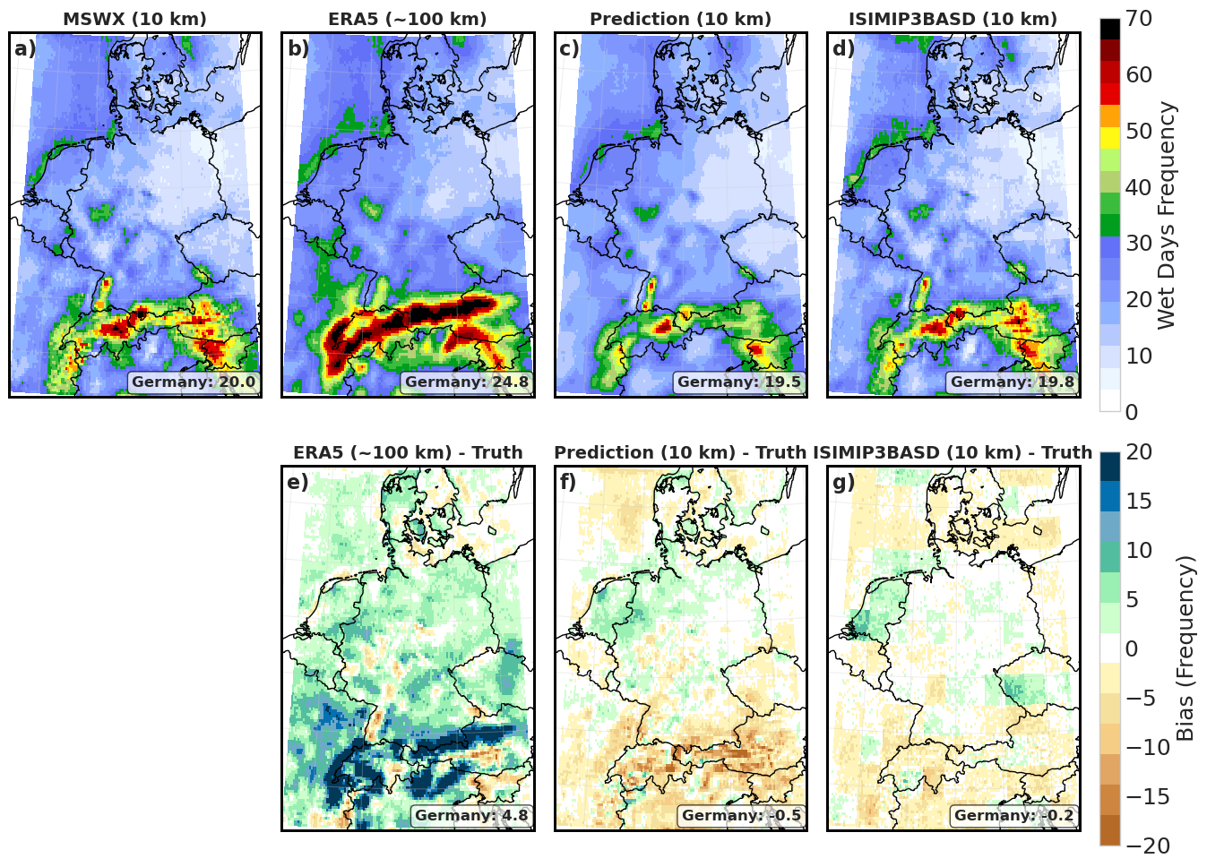 Figure S9. Spatial distribution of wet day frequency (precipitation > 3 mm/day) over Germany (2020–2024). The top row (a–d) presents the absolute frequency (%) for the MSWX reference, ERA5 reanalysis, CasCorrDiff prediction (10 km), and ISIMIP3BASD. The bottom row (e–g) illustrates the absolute bias of the model outputs relative to the MSWX reference. Area-weighted mean values for Germany are indicated in the bottom right of each panel.
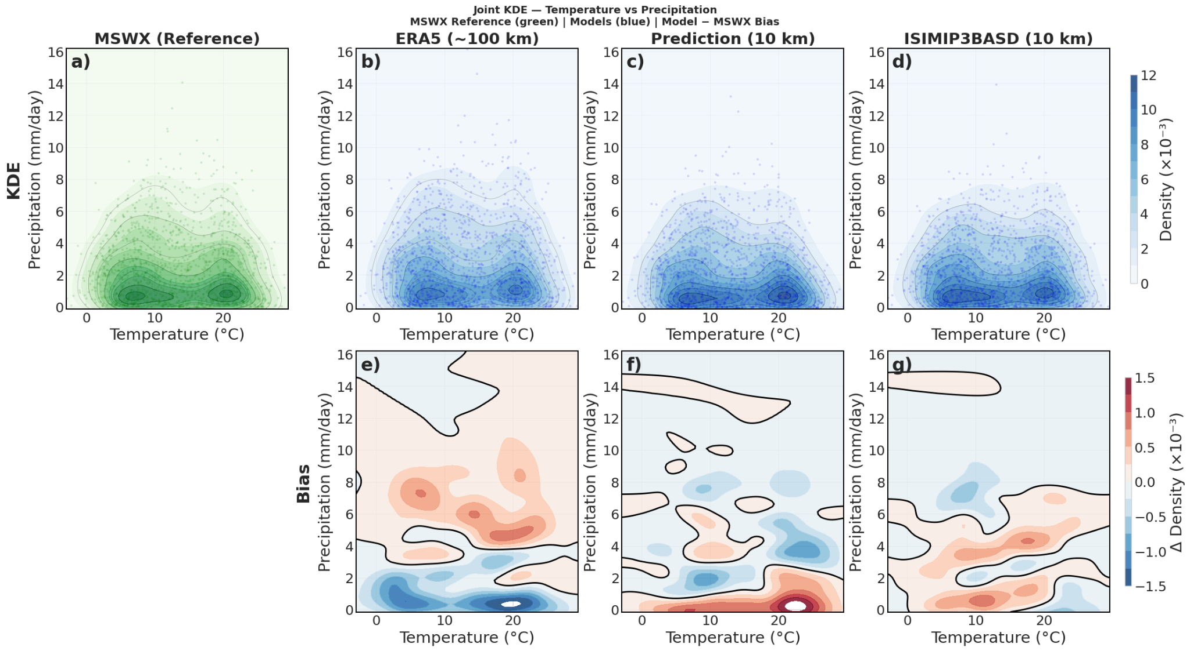
Figure S10: Joint kernel density estimation (KDE) of daily maximum temperature (°C) and precipitation (mm day⁻¹) over Germany (2020–2023). Top row (a–d): KDE contours for MSWX reference (green) and model predictions (blue) — ERA5 (~100 km), CasCorrDiff Prediction (10 km), and ISIMIP3BASD (10 km). Bottom row (e–g): Density bias (CasCorrDiff/ISIMIP3BASD − MSWX reference); the black contour marks the zero-bias line. Scatter points represent individual daily values. Density values are scaled by 10⁻³.
References
1. Hersbach, H. et al. The ERA5 global reanalysis. Q. J. R. Meteorol. Soc. 146, 1999–2049 (2020).
2. Shahi, N. K., Zolina, O. & Gulev, S. K. Large-Scale Drivers of Widespread Extreme Precipitation in Europe: Insights from High-Resolution Regional Climate Model Simulations. J. Hydrometeorol. 26, 221–238 (2025).
3. Muñoz-Sabater, J. et al. ERA5-Land: a state-of-the-art global reanalysis dataset for land applications. Earth Syst. Sci. Data 13, 4349–4383 (2021).
4. Rolle, M., Tamea, S. & Claps, P. Climate-driven trends in agricultural water requirement: an ERA5-based assessment at daily scale over 50 years. Environ. Res. Lett. 17, 044017 (2022).
5. Beck, H. E. et al. MSWX: Global 3-Hourly 0.1° Bias-Corrected Meteorological Data Including Near-Real-Time Updates and Forecast Ensembles. Bull. Am. Meteorol. Soc. 103, E710–E732 (2022).
6. Kaspar, F. et al. Monitoring of climate change in Germany – data, products and services of Germany’s National Climate Data Centre. Adv. Sci. Res. 10, 99–106 (2013).
7. Zink, M., Kumar, R., Cuntz, M. & Samaniego, L. A high-resolution dataset of water fluxes and states for Germany accounting for parametric uncertainty. Hydrol. Earth Syst. Sci. 21, 1769–1790 (2017).
8. Menne, M. J. et al. The Global Historical Climatology Network hourly (GHCNh) dataset. in vol. 105 446924 (2025).
9. Arguez, A. et al. NOAA’s 1981–2010 U.S. Climate Normals: An Overview. Bull. Am. Meteorol. Soc. 93, 1687–1697 (2012).
10. Durre, I., Menne, M. J., Gleason, B. E., Houston, T. G. & Vose, R. S. Comprehensive Automated Quality Assurance of Daily Surface Observations. J. Appl. Meteorol. Climatol. 49, 1615–1633 (2010).

