Supplementary Information

Fermented taro (poi) enhances intestinal barrier integrity, attenuates inflammatory signaling, and reshapes gut microbial metabolism
Lianger Dong^{a, b}, Yong Li^{a*}

ª Department of Human Nutrition, Food and Animal Science, University of Hawaii at Mānoa, 1955 East-West Road, AgSci 216, Honolulu, HI, USA
^{b} School of Life Sciences, Shanghai University, 99 Shangda Rd., Baoshan, Shanghai 200444, China

* Correspondence: liyong@hawaii.edu, Y.L.

Table S1 List of primers used for the qPCR amplification of target and reference genes in Caco-2 cells.
Function | Gene | Primer sequences | Reference
Pro-inflammatory | TNF-α | F: 5’- CCCAGGGACCTCTCTCTAATC -3’  R: 5’- ATGGGCTACAGGCTTGTCACT -3’ | 39
Pro-inflammatory | IL-6 | F: 5’- GCTGAAAAAGATGGATGCTTCC -3’  R: 5’- AACTCCAAAAGACCAGTGATGATTT -3’ | 39
Pro-inflammatory | IL-8 | F: 5’- AGAGTGATTGAGAGTGGACC -3’  R: 5’- ACTTCTCCACAACCCTCTG -3’ | 40
Anti-inflammatory | IL-10 | F: 5’- TCAGGGTGGCGACTCTAT -3’  R: 5’- TGGGCTTCTTCTAAATCGTTC -3’ | 41
Anti-inflammatory | TGF-β1 | F: 5’- GCTGCTGTGGCTACTGGTGC -3’  R: 5’- CATAGATTTCGTTGTGGGTTTC -3’ | 41
Anti-inflammatory | TLR2 | F: 5’- GGCCAGCAAATTACCTGTGTG -3’  R: 5’- AGGCGGACATCCTGAACCT -3’ | 39
Anti-inflammatory | IL-4 | F: 5’- TCATTTTCCCTCGGTTTCAG -3’  R: 5’- AGAACAGAGGGGGAAGCAGT -3’ | 41
Tight junction proteins | Claudin1 | F: 5’- ATGCAAAGATGTTTTGCCACAG -3’  R: 5’- TACAAATTCCCATTGCAGCCC -3’ | 42
Tight junction proteins | Occludin | F: 5’- TCACTTTTCCTGCGGTGACT -3’  R: 5’- GGGAACGTGGCCGATATAATG -3’ | 43
Tight junction proteins | ZO-1 | F: 5’- GCTGCCTCGAACCTCTACTC -3’  R: 5’- TTGCTCATAACTTCGCGGGT -3’ | 42
Lipid metabolism | PPARα | F: 5’- CTGGAAGC TTTGGCTTTACG -3’  R: 5’- TGTCCCCG CAGATTCTACAT -3’ | 44
Lipid metabolism | PPARβ | F: 5’- ACAGCATG CACTTCCTTCCA -3’  R: 5’- TCACATGC ATGAACACCGTA -3’ | 44
Lipid metabolism | PPARγ | F: 5’- GAGCCCAAGTTTGAGTTTGC -3’  R: 5’- CAGGGCTTGTAGCAGGTTGT -3’ | 44
Lipid metabolism | FIAF | F: 5’- CGTACCCTTCTCCACTTGGG -3’  R: 5’- GCTCTTGGCGCAGTTCTTG -3’ | 44
Lipid metabolism | SREBP-1 | F: 5’- ACCGCTCCTCCATCAATGAC -3’  R: 5’- CAGGCCGACACCAGATCCTTC-3’ | 45
Lipid metabolism | SREBP-2 | F: 5’- ATCGCTCCTCCATCAATGAC -3’  R: 5’- TCGATGCCCTTTAGAAGCTTG-3’ | 45
Lipid metabolism | NPC1L1 | F: 5’- TCTTCCCCTTCCTTGCCATT -3’  R: 5’- CGGCAGGGTAATTGTTGAGG -3’ | 46
Lipid metabolism | LXR | F-: 5’- AGACATCGCGGAGGTACAAC -3’  R-: 5’- GGCTCACCAGCTTCATTAGC -3’ | 46
Reference gene | GAPDH | F: 5’- AACGGATTTGGTCGTATTG -3’  R: 5’- GCTCCTGGAAGATGGTGAT -3’ | 47

MTT assay
Cytotoxicity was determined using the MTT assay. At confluence, Caco-2 cells were removed of cell medium and washed with fresh DMEM twice. The cells were then exposed to 100 μL of poi extracts at 5, 10, 20, 25, 50, 60, and 70% for 24 h. After incubation, the extract was discarded, the cells were washed twice with DMEM, and added with 100 μL of 0.5 mg/mL MTT solution (Invitrogen™, Thermo Fisher Scientific) After 4 h of incubation at 37°C, formazan crystals were dissolved in 100 μL dimethyl sulfoxide (Thermo Fisher Scientific) and absorbance was measured at 570 nm using a spectrophotometer (Bio-Rad, iMark, Hercules, CA, USA). Viability was expressed relative to untreated controls.
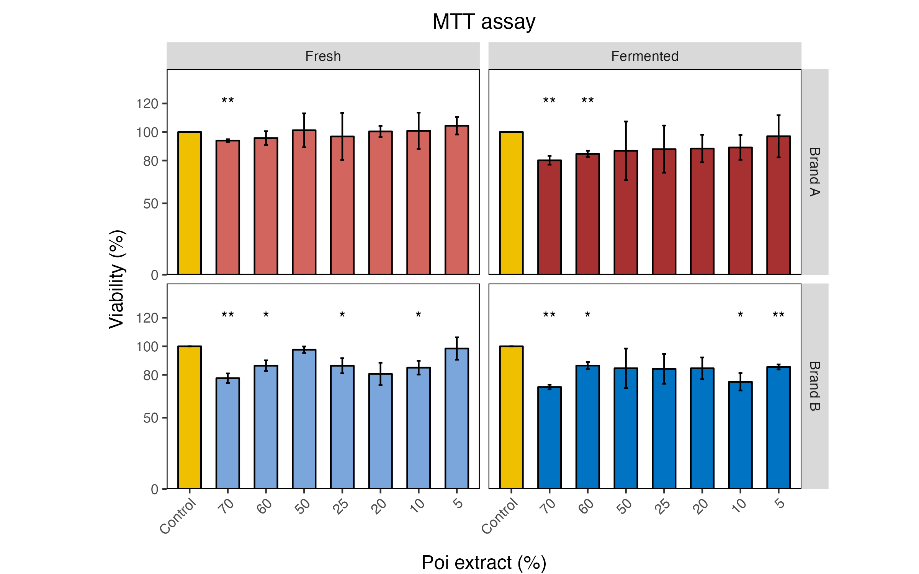
Figure.S1 Effects of 5, 10, 20, 25, 50, 60, and 70% of poi extract on Caco-2 cell viability evaluated by the 3-(4,5-Dimethylthiazol-2-yl)-2,5-diphenyltetrazolium bromide (MTT). Error bars are standard deviations (SD, n=3). Differences between groups were analyzed by ANOVA. “*” indicates significant differences between poi-treated cells to the control (100%; * P < 0.05; ** P < 0.01).
As shown in Fig. S1, a mild dose-dependent effect was observed in brand A groups, with a decrease in viability observed at concentrations of 60% and 70%, while cells treated with 70% fresh poi extract still achieved over 90% viability. Brand B groups showed a similar trend, with a few outliners which displayed viabilities over 80%. Seventy percent fresh and fermented brand B poi extracts resulted in the lowest Caco-2 cell viability values of 77% and 71%, respectively. The 50% concentration was chosen because no significant reduction in cell viability was observed in all treatments at this level.

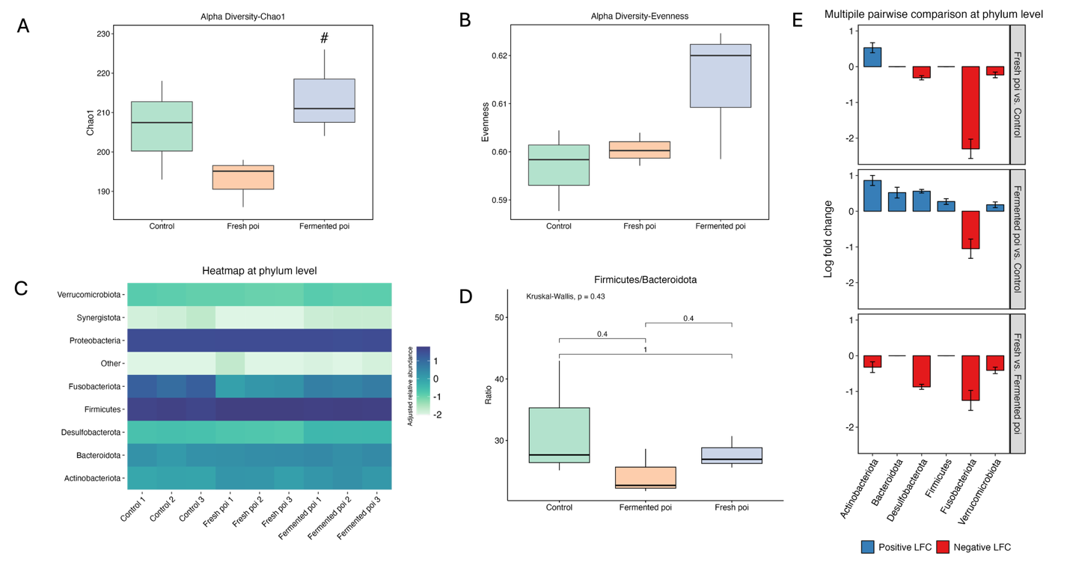
Figure. S2. Effects of fresh and fermented poi on gut microbiota structure at phylum level. (A) Alpha diversity of Chao1. (B) Alpha diversity of Evenness. (C) Heatmap of the taxa in each sample at phylum level. (D) Ratio of the relative abundance of Firmicutes to Bacteroidetes. (E) Differentially abundant phyla analyzed with ANCOM-BC2 multiple pairwise comparison. “#” indicates significant differences between fresh poi treatment and fermented poi treatment (p < 0.05).
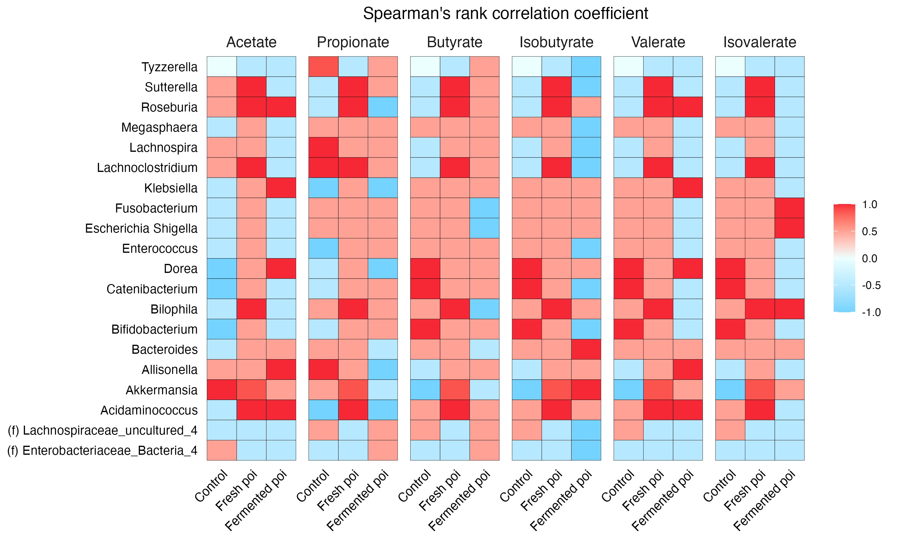
Figure. S3. Correlation analysis between top 20 differential genera and SCFAs using Spearman’s correlation coefficient. Red tiles mean positive correlation and blue tiles mean negative correlation.
Figure. S4. Questionnaire for screening fecal donors.

