Supplementary data
Supplementary Figure 1. Enkephalin is release from D2-expressing medium spiny neurons in the ASt.
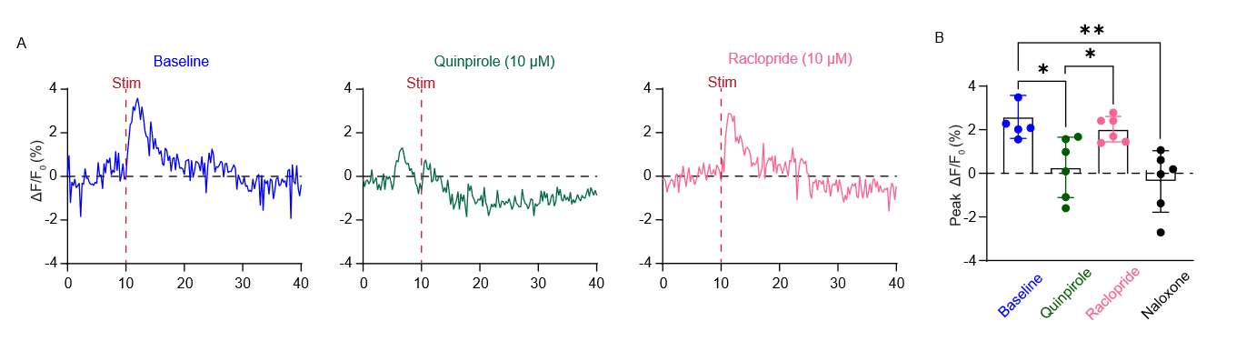
(A) Representative ΔF/F₀ δlight1.1 fluorescence responses evoked by optical stimulation of MGN terminals (100 pulses, 50 Hz) measured in the ASt under baseline conditions and during Quinpirole (10 μM) and Raclopride (10 μM) application. (B) Bar chart showing peak evoked ΔF/F₀ quantified as the average fluorescence during the first 8 imaging frames following optical stimulation in the ASt under baseline conditions and during quinpirole and raclopride application (two tailed paired Student’s t-test; baseline vs quinpirole, P = 0.01; quinpirole vs raclopride, P = 0.038; baseline vs naloxone, P = 0.009). Data represented as mean ± S.E.M with individual data points. * P < 0.05, **P < 0.01.

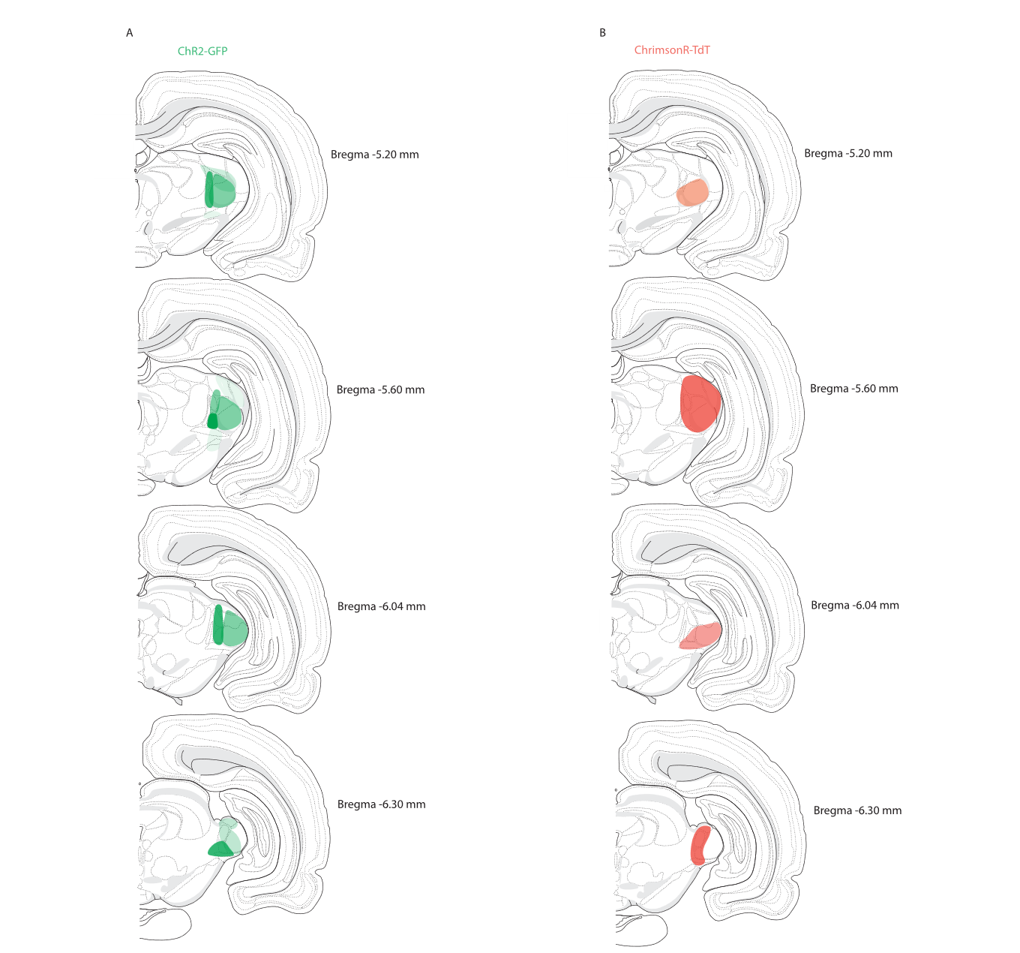
Supplementary Figure 2. Injection sites for ChR2-GFP and ChrimsonR-TdT in the MGN
(A-B) Summary of (A) ChR2-GFP and (B) ChrimsonR-tdT injection sites and fibre tip locations across animals all animals at different bregma coordinates. Dark colours indicate regions of high cell body expression.

Supplementary Figure 3. ASt enkephalinergic sends processes towards the LA

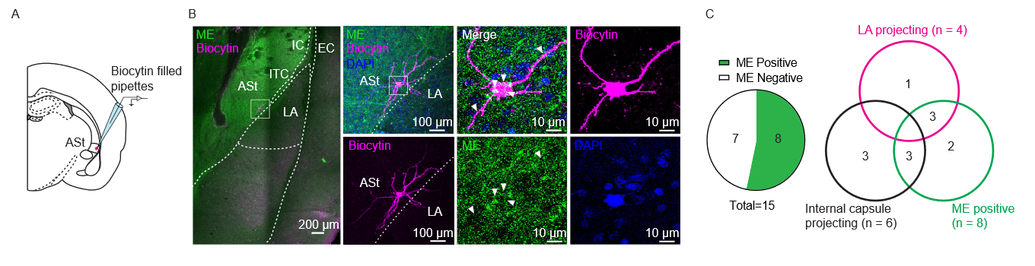
(A) Schematic diagram indicating recording locations for ASt MSNs. (B) Representative confocal images of met-enkephalin immunoreactivity (green) and biocytin-labelled MSN (purple). Representative image showing met-enkephalin immunoreactivity around the biocytin-labelled cell. Image of the boxed area reveals dendritic spines and co-localisation of biocytin with met-enkephalin. (C) Left: pie chart indicating 8/15 biocytin-filled neurones were met-enkephalin positive. Right: Venn diagram indicating the proportion of met-enkephalin positive neurones and their dendritic projection targets (4/15 terminating in the LA, 6/15 terminating at the ASt-LA border).

Supplementary Figure 4. PENK knockdown is specific to the injection site in the ASt
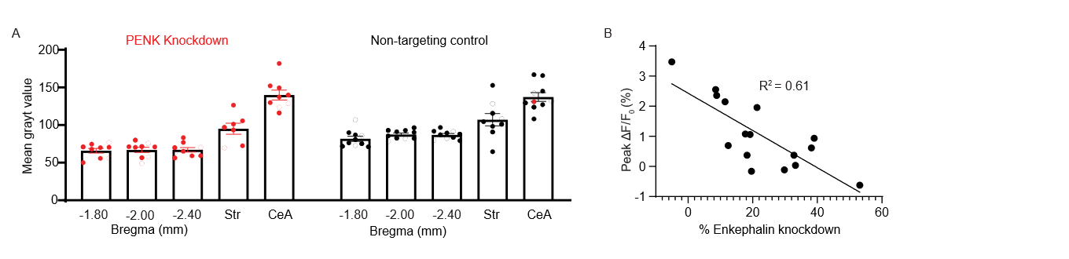
(A) Bar graph showing mean gray value of met-enkephalin immunoreactivity as measured in the ASt across the rostral-caudal range and in the striatum and CeA. (B) Correlation analysis between % of enkephalin knockdown and peak ΔF/F_{0.} (Linear regression, β = -0.06, 95% confidence interval -0.09 to -0.03, R² = 0.61)

Supplementary Figure 5. Functional connection from the VTA to ASt are sparse.

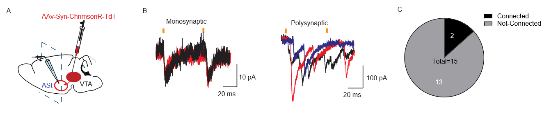
(A) Schematic diagram showing injection of ChrimsonR-TdT and recording site in the ASt. (B) Example traces showing oEPSC’s from putative ASt MSNs indicating a directly (left) and indirectly (right) connected cell. Black, red and blue traces indicate different stimulations episode from the same recording. Orange bars indicate optical stimulation points. (C) Pie chart showing number of connected verses non-connected cells. A total of 2 cells shown in (B) were connected out of 15 neurons recorded.

Supplementary Figure 6. Injections sites for ChrimsonR-TDT in the VTA
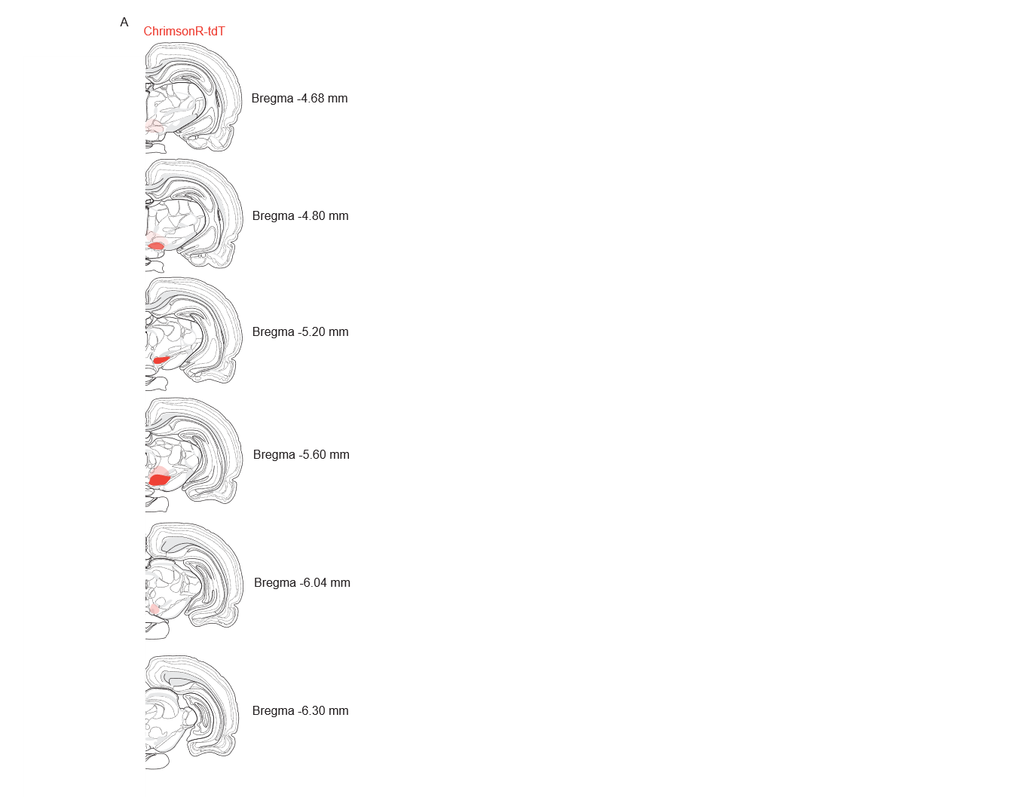
(A) Summary of ChrimsonR-tdT injection sites and fibre tip locations across animals all animals at different bregma coordinates in the VTA. Dark colours indicate regions of high cell body expression.

