Supplementary Materials

S1. Experimental grain size determination
The $d_{experiment}$ has been estimated by drawing the contours of over 250 Fper clusters by hand using ImageJ software spanning over different annealing times for each composition, then calculating the diameter of the circle of equal area as each cluster, and then fitting the results with a Gaussian distribution to obtain the average diameter (Fig. S1). The average diameters thus obtained are 2.36(22) µm and 2.27(20) µm for X_{Fper} = 0.30 and 0.18 respectively.

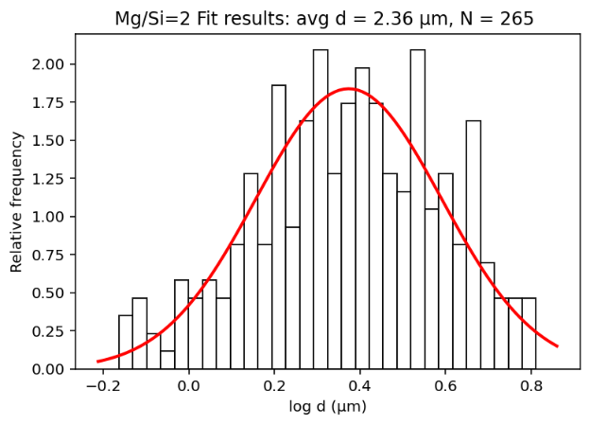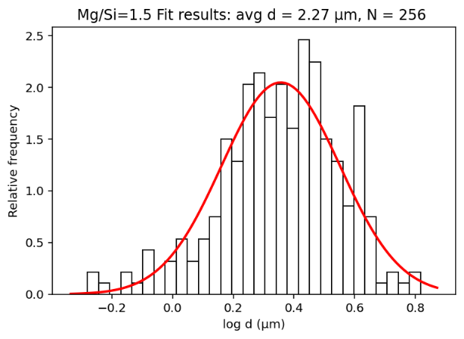
Fig. S1. The histogram of the log cluster size for the samples with X_{Fer} = 0.30 (top) and 0.18 (bottom). The numbers of clusters measured are 256 and 265 respectively, spanning over images taken after different annealing times ranging from 10 minutes to 48 hours. A Gaussian fit of the histogram against the logarithm of the grain size is also shown.
S2. Origin of Regime 1 vs Regime 2 in rounding of Fper clusters
To determine the origin of the two observed rounding regimes (faster Regime 1 and slower Regime 2) in our experiments (Fig.2), we employed a two-dimensional numerical model. In this model, we model the deformation of a viscous medium with an embedded inclusion of circular/elliptic shape due to the interfacial tension. Although no fluid flow occurs in our solid-solid interface, we use Marangoni flow-like partial differential equations as a numerical analogy to facilitate modelling. The ‘velocity field’ represents atomic transport along grain boundaries due to curvature through Coble creep and not the tangential gradient of surface tension as in classic Marangoni flow”. Solid state creep due to Coble creep is approximated via using constant viscosities $η_{h}$ and $η_{i}$ for host and inclusion respectively. Assuming an incompressible medium, conservation of mass and momentum are given by
$$∇⋅v = 0$$ | (18)
$$-∇p+ ∇⋅\left[η\left(x\right)\left(∇v+ ∇v^{T}\right)\right] = f_{ca}$$ | (19)
where $p$ and $v$ are pressure and velocity, respectively, $η\left(x\right)$ is the viscosity at a point $x$. $f_{ca}$ is the tensile force due to the interfacial energy. This force is given by the Young-Laplace equation, which can be reformulated as a volumetric force ¹ :
$f_{ca}= γκ\hat{n}δ(Γ,x)$ (20)
Where $γ$ is the interfacial energy per area and $κ$ the curvature. The delta function $δ(Γ,x)$ ensures that the interfacial tension only acts on the interface $Γ$. To include eq.(20) in finite element computations, we express it in terms of the Laplace-Beltrami operation $\underline{∆}$, which is defined as ²:
$$\underline{∆}f\left(x\right)=\underline{∇}⋅\left(\underline{∇}f\left(x\right)\right)$$
Where $\underline{∇}$ is the tangential gradient of the function f. The factor $κ\hat{n}$ in eq.(20) can then be expressed as ²:
$$κ\hat{n}=\underline{∆}{id}_{Γ}$$
Where ${id}_{Γ}$ is the identity mapping on $Γ$ ². Eq. (19) can thus be rewritten as:
$$-∇p+ ∇⋅\left[η\left(x\right)\left(∇v+ ∇v^{T}\right)\right]= γ\underline{∆}{id}_{Γ}δ(Γ,x)$$
As a next step, we non-dimensionalize these equations using the following characteristic scales
$η_{c}= η_{h}$, $L_{c}=2r,$ $τ_{c}= \frac{γ}{L_{c}}$
where we chose the characteristic viscosity $η_{c}$ to equal the viscosity of the host $η_{h}$, the characteristic length scale $L_{c}$ as the diameter of a circular inclusion and the characteristic stress as the pressure acting on an interface with curvature $L_{c}$. Based on these scales, we can also define a characteristic time scale $t_{c}$ as
$$t_{c}=\frac{η_{c}}{τ_{c}}=\frac{2η_{h}r}{γ}$$
With these scales, the governing equations become:
$$∇'⋅v' = 0$$ | (18)
$$-∇'p'+ ∇'⋅\left[η'\left(x\right)\left(∇v'+ ∇{v'}^{T}\right)\right]= \underline{∆'}{id}_{Γ}δ(Γ,x)$$ | (19)
Where ‘ indicates a non-dimensional quantity. Here, only the non-dimensional viscosity remains as a material parameter, which – in the case of our model setup – results in the viscosity of the host having a non-dimensional viscosity of 1. The non-dimensional viscosity of the inclusion then equals the viscosity contrast between host and inclusion.
To solve this system of equations, we apply a finite element method to discretize the governing equations. The curvature $κ$ is not explicitly computed, but the explicit calculation is transformed to the test function space by making use of the Laplace-Beltrami operator ².
To illustrate the effect of small-scale interface heterogeneities on the evolution of the perimeter due to the surface-induced rounding, we ran six different models, where we changed the aspect ratio and the amount of perturbation to the inclusion-host interface (Supplementary Information Fig. 1). The x- and y- coordinates of the host-inclusion interface were computed as:
$$x=cos α (a+a_{p}sin(n_{p}α))$$
$$y=sin α (b+b_{p}sin(n_{p}α))$$
Where a and b are the semi-major and semi-minor axes, respectively. $α$ is in the range from 0 to 360°. $a_{p}$ and $b_{p}$ are the respective perturbation amplitudes, and $n_{p}$ is the wave number of perturbation. In the simulations presented here, $b$ was set to 1, whereas $a$ was set to the respective value of the aspect ratio. In the simulations where the host-inclusion interface was perturbed, $n_{p}$ was set to 20 and $a_{p}$ and $b_{p}$ were set to 0.1$a$ and 0.1$b$, respectively. Two examples of the resulting initial model geometries are shown in Extended Data Fig. 5. The perimeter evolution of the respective models shows that the small-scale perturbations are smoothed at an early stage, thus resulting in a strong perimeter decrease.
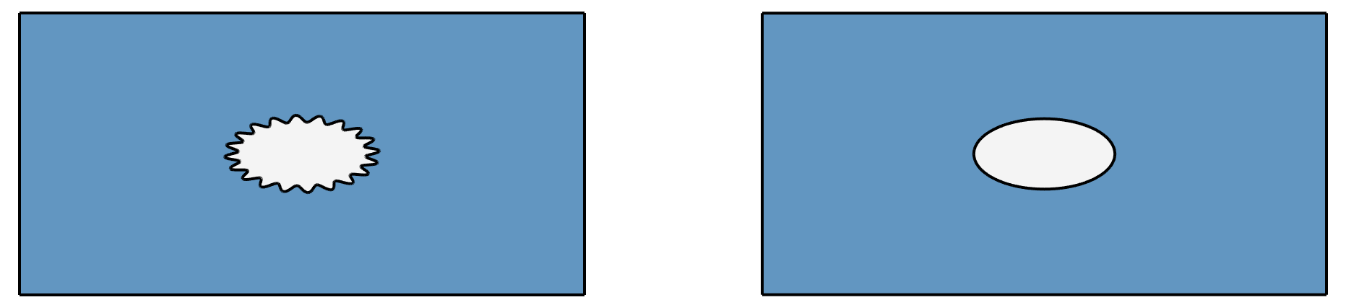
(B)
(A)
Fig. S2. The effect of the perturbed host-inclusion interface on the relative excess perimeter change. (A) The initial model geometry for an aspect ratio 2 with a sinusoidally perturbed (left) and unperturbed (right) host-inclusion interface. (B) The perimeter with time driven by surface tension is computed by a numerical model of solid state creep (see Methods for a description of the model). The perimeter is directly proportional to relative excess perimeter. The parameter a denotes the initial aspect ratio of the inclusion indicated by different colours. The solid and dashed curves correspond to the case where the inclusion-host interface is sinusoidally perturbed and unperturbed, respectively.
The boundary between Regime 1 (corresponding to jagged Bdm-Fper interface) and Regime 2 (corresponding to smooth Bdm-Fper interface) in Figs. 2 (A) and 2 (B) is determined visually. However, this does not impact the value of the coefficient of rounding rate $B$. In Fig. 2(A), for the surface annealing series (2.1) of X_{Fper} = 0.3 and T = 2000 K, the boundary is demarcated at 6 hours annealing time which gives $B$ = 0.0337 (8). For Fig.2(B), if the boundary between Regime 1 and 2 in the same series (2.1) is chosen at 1 hour annealing time, $B$ = 0.034 (5). Thus, as long as we choose any starting $\frac{p-p_{c} }{p_{c}}$ value well within Regime 2, the $B$ value is consistent.
References in Supplementary Materials
1. Peskin, C. S. Numerical analysis of blood flow in the heart. J. Comput. Phys. 25, 220–252 (1977).
2. Hysing, S. A new implicit surface tension implementation for interfacial flows. Int. J. Numer. Methods Fluids 51, 659–672 (2006).

