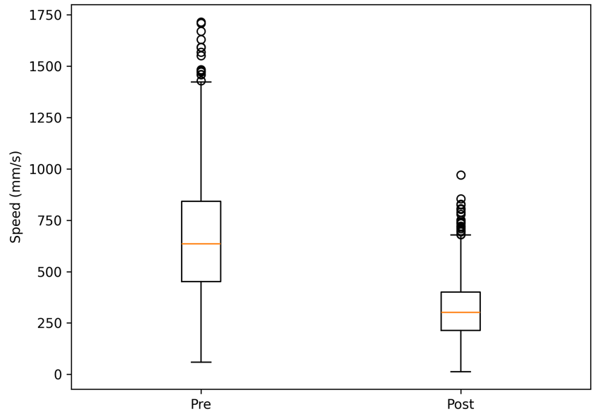
Supplementary figure S1. Distribution of task execution speed across intervention sessions.
Boxplot representation of movement speed in the artificial intelligence–assisted rehabilitation group (ARG) over time. A progressive increase in median speed and reduction in variability (interquartile range) are observed, suggesting enhanced motor performance consistency and stabilization of task execution with repeated training.

