Electronic Supplementary File (ESF)

Systems Biology of Gut Microbiome Dysbiosis in Major Depressive Disorder: Functional Microbial Networks Linked to Inflammation, Illness Severity, Recurrence, and Suicidal Behavior

Changyang Meng*, Jing Li*, Mengqi Niu*, Abbas F. Almulla, Yiping Luo, Andre F Carvalho, Annabel Maes, Yingqian Zhang**, Michael Maes**
* Co-joint first authors
** Co-corresponding authors

ESF, Table 1. Baseline demographic and clinical characteristics of the inpatients with major depression (MDD) and healthy controls (HC) included in this study.

Characteristics | HC (n=38) | MDD (n=102) | F / χ² | P
Age (years) | 35.9 (13.3) | 35.8 (12.4) | 0.003 | .955
Female gender, N (%) | 26 (68.4%) | 71 (69.6%) | 0.018 | .892
Education (years) | 14.3 (4.1) | 13.3 (3.4) | 1.903 | .170
BMI (z-score) | 0.29 (1.21) | -0.08 (0.96) | 3.533 | .062
Metabolic syndrome, N (%) | 11 (28.9%) | 20 (19.8%) | 1.333 | .248
OSOD (z-score) | -1.47 (0.26) | 0.46 (0.48) | 540.171 | <.001
Physiosomatic symptoms (z-score) | -1.31 (0.43) | 0.42 (0.63) | 236.071 | <.001
Current suicidal ideation (z-score) | -0.77 (0.27) | 0.19 (0.98) | 35.637 | <.001
ROI (z-score) | -1.05 (0.15) | 0.27 (0.85) | 90.423 | <.001
API | -1.60 (2.01) | 0.48 (1.73) | 36.654 | <.001
Note: Data is presented as Mean (SD) for continuous variables and n (%) for categorical variables. Group differences were evaluated using Analysis of Variance (F) for continuous data and Chi-square tests (χ²) for categorical data (gender and metabolic syndrome). Significant P values (<0.05) are bold. BMI, body mass index; OSOD, overall severity of depression; ROI, recurrence of illness; API, acute phase-inflammatory index.

ESF, Figure 1. Major gut microbiome compositional patterns in patients with major depressive disorder (MDD) and healthy controls (HC).
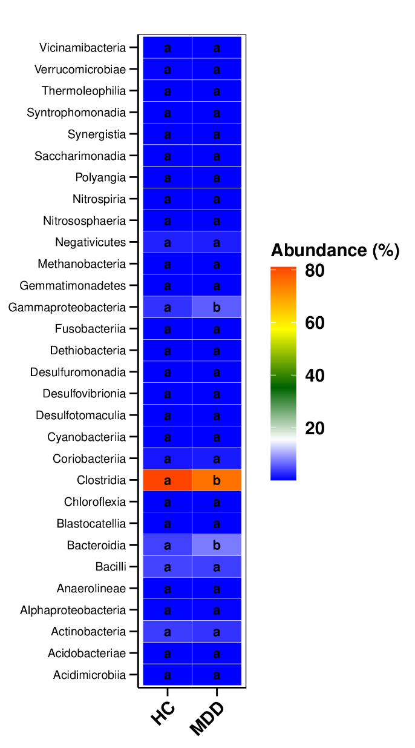
ESF, Figure 1A illustrates the relative abundance of the top 30 dominant bacterial classes in HC and MDD. As evidenced by identical letters (a), the majority of bacterial classes exhibit comparable abundances among groups, indicating that the gut microbiome's overall higher-level phylogenetic structure is relatively stable. Nevertheless, Gammaproteobacteria, Clostridia, and Bacteroidia exhibit substantial differences between MDD and controls.

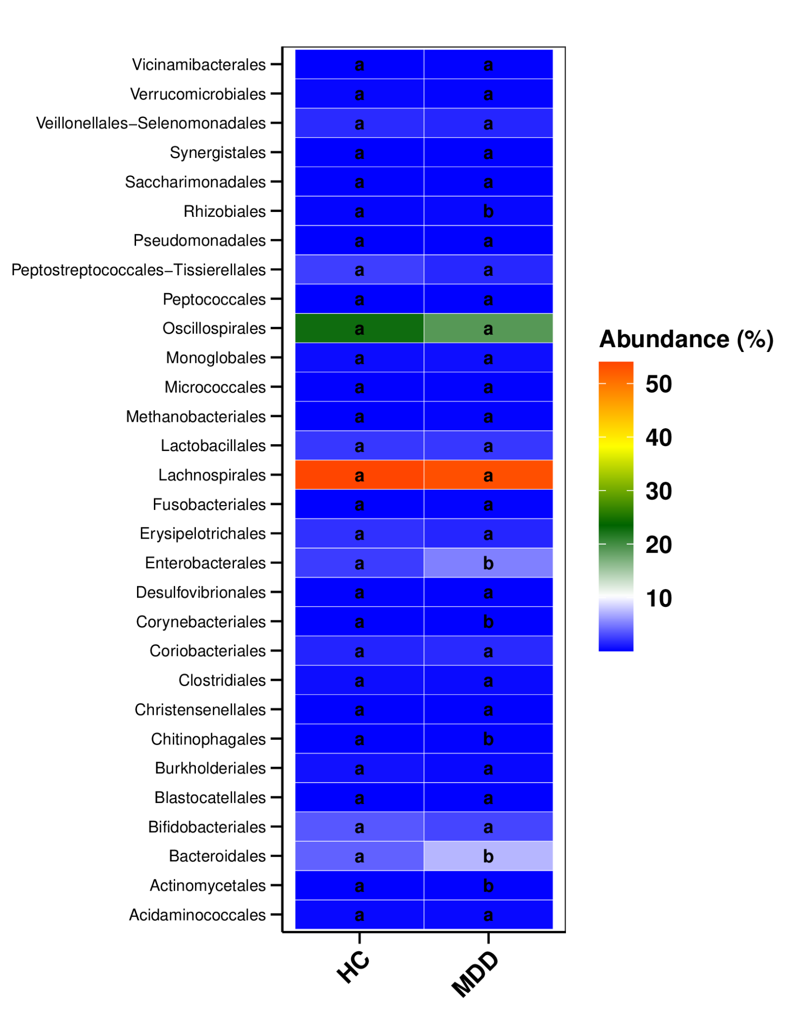
The relative abundance of the top 30 dominant bacterial orders in MDD and control subjects is depicted in ESF, Figure 1B. The majority of orders demonstrate comparable abundances among groups; however, Rhizobiales, Enterobacterales, Corynebacteriales, Chitinophagales, Bacteroidales, and Actinomycetales exhibit significant disparities between MDD and controls.

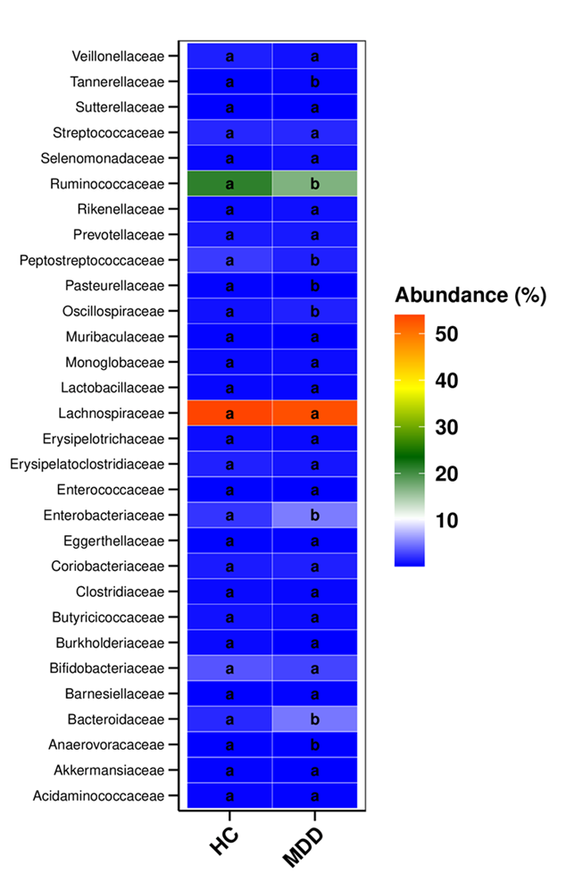
The relative abundance of dominant bacterial families is depicted in ESF, Figure 1C. The fundamental gut microbiota structure is suggested to be preserved by the similar abundances of most microbial families between groups. Nevertheless, there are families, such as Tannerellaceae, Ruminococcaceae, Peptostreptococcaceae, Pasteurellaceae, Oscillospiraceae, Enterobacteriaceae, Bacteroidaceae and Anaerovoracaceae, that exhibit significant differences between both groups.

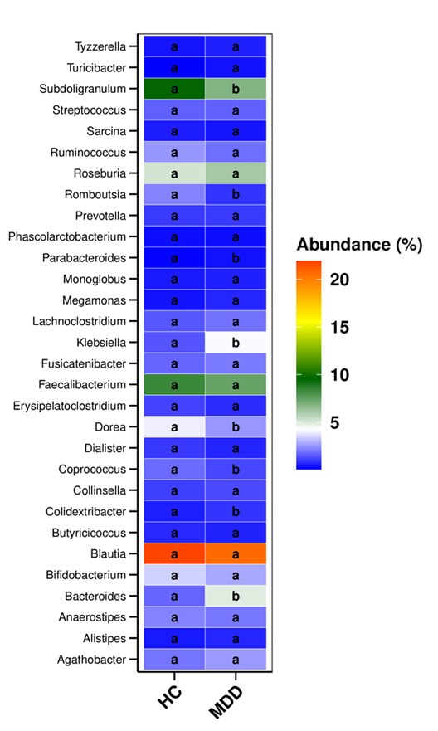
ESF, Figure 1D displays a heatmap depicting the relative abundance of dominant bacterial genera. The microbial composition is indicative of differences in genera such as Subdoligranulum, Romboutsia, Parabacteroides, Klebsiella, Dorea, Coprococcus, Colidextribacter, and Bacteroides. In contrast, the abundances of many genera, such as Blautia, Faecalibacterium, Bifidobacterium, Roseburia, and Ruminococcus, are comparable in both groups, suggesting the preservation of essential commensal bacteria.

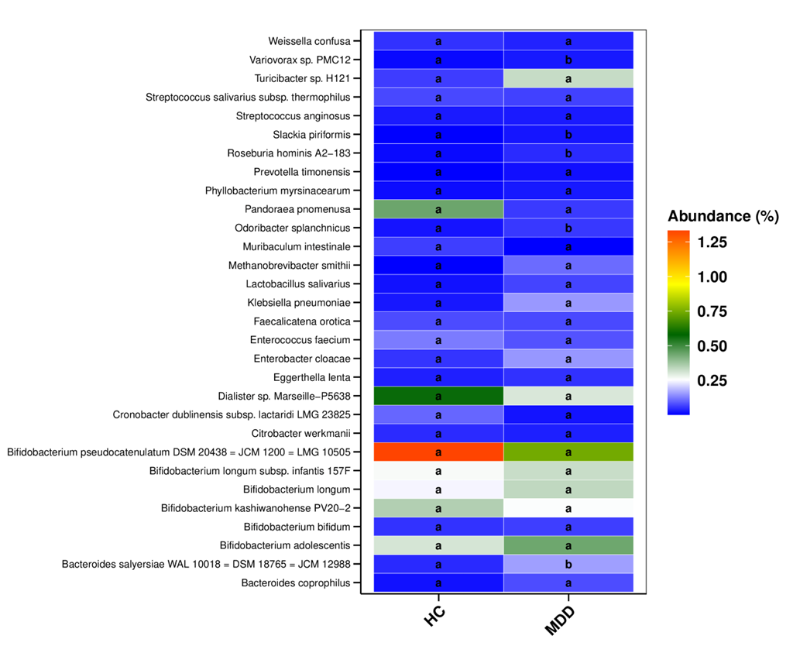
The relative abundance of dominant bacterial species is depicted in the heatmap in ESF, Figure 1E. The selective alterations at the species level are indicated by the differences in Variovorax sp. PMC12, Slackia piriformis, Roseburia hominis A2–183, Odoribacter splanchnicus, and Bacteroides salyersiae.

ESF, Figure 2. Phylogenetic cladogram
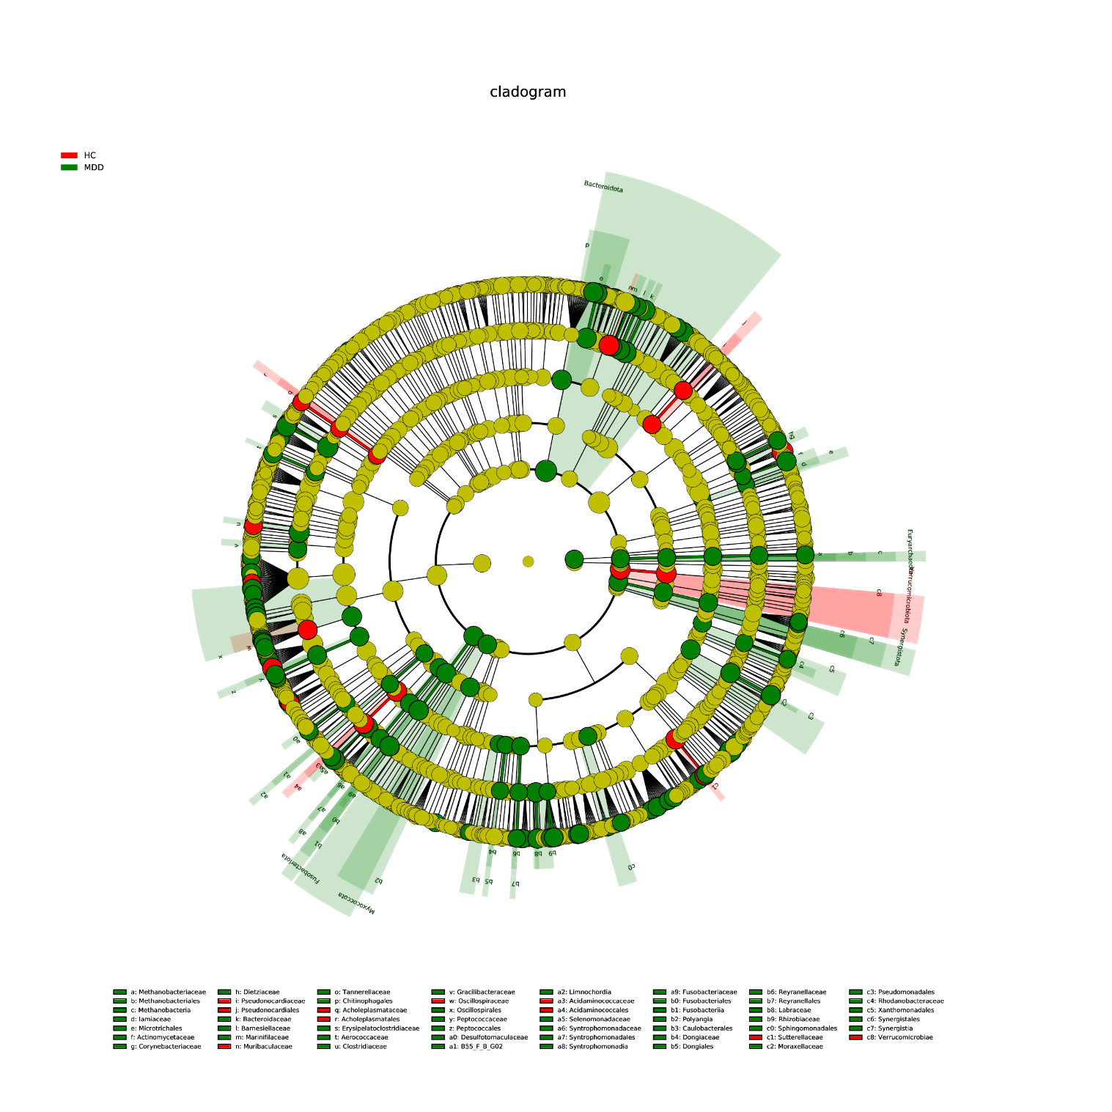
ESF, Figure 2 illustrates the LEfSe phylogenetic cladogram, which identifies bacterial taxa that are distinct between major depression (MDD) and healthy controls (HC). The cladogram illustrates the phylogenetic hierarchy of bacterial taxa, highlighting those that exhibit significant differences from phylum to lower taxonomic levels. Green nodes in the cladogram denote taxa that are enriched in MDD, whereas red nodes in the cladogram denote taxa that are enriched in HC, and yellow nodes represent taxa that do not exhibit any significant distinctions. In general, the figure demonstrates that microbial differences between groups are observed within specific phylogenetic branches rather than across the entire microbiome, indicating selective microbial shifts in MDD.
Several taxa belonging to the Bacteroidota lineage appear enriched in MDD, including branches within Bacteroidales → Tannerellaceae → Parabacteroides and related taxa: Bacteroidales → Bacteroidaceae → Bacteroides. Within Proteobacteria, enrichment is observed in branches belonging to Gammaproteobacteria → Pseudomonadales → Moraxellaceae; and Gammaproteobacteria → Pseudomonadales → Pseudomonadaceae. Additional MDD-associated lineages occur within Fusobacteriota → Fusobacteriales → Fusobacteriaceae; Synergistota → Synergistales → Synergistaceae. Some taxa enriched in controls occur within Firmicutes-related lineages, including branches of Lachnospirales / Oscillospirales; Clostridiaceae and related fermentative families; Coriobacteriaceae (Actinobacteria).

ESF, Figure 3. Microbial metabolic pathways. KEGG enrichment analysis.
Figure 3A. Tax4Fun results: KEGG, level 2

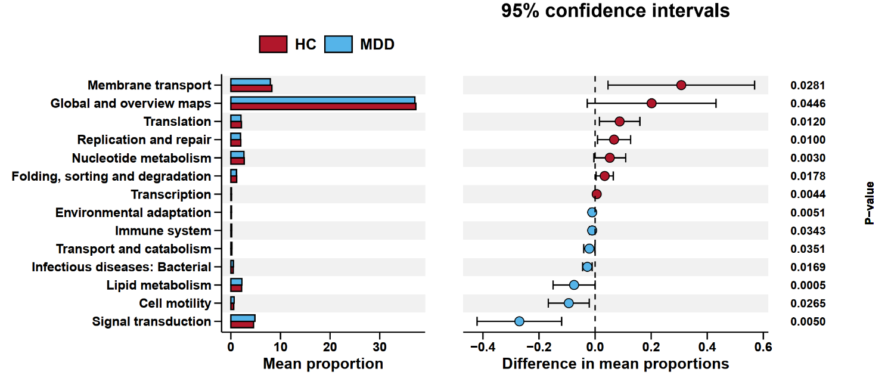

Wilcoxon rank-sum tests were employed to examine the differences in microbial metabolic pathway scores between MDD and HC using the Tax4Fun functional prediction at KEGG level 2 (ESF, Figure 3A). The controls exhibited a substantially higher level of microbial biosynthetic and cellular maintenance activity, as evidenced by the significantly higher pathways related to membrane transport, global metabolic overview maps, translation, replication and repair, nucleotide metabolism, folding/sorting/degradation, and transcription. Conversely, MDD exhibited a relatively high level of enrichment in pathways related to signal transduction, cell motility, lipid metabolism, bacterial infectious disease pathways, transport and catabolism, immune system processes, and environmental adaptation. This suggests that microbial stress responses, motility, and host–microbe interaction pathways were enhanced.

ESF, Figure 3B. Tax4Fun, KEGG level 3.
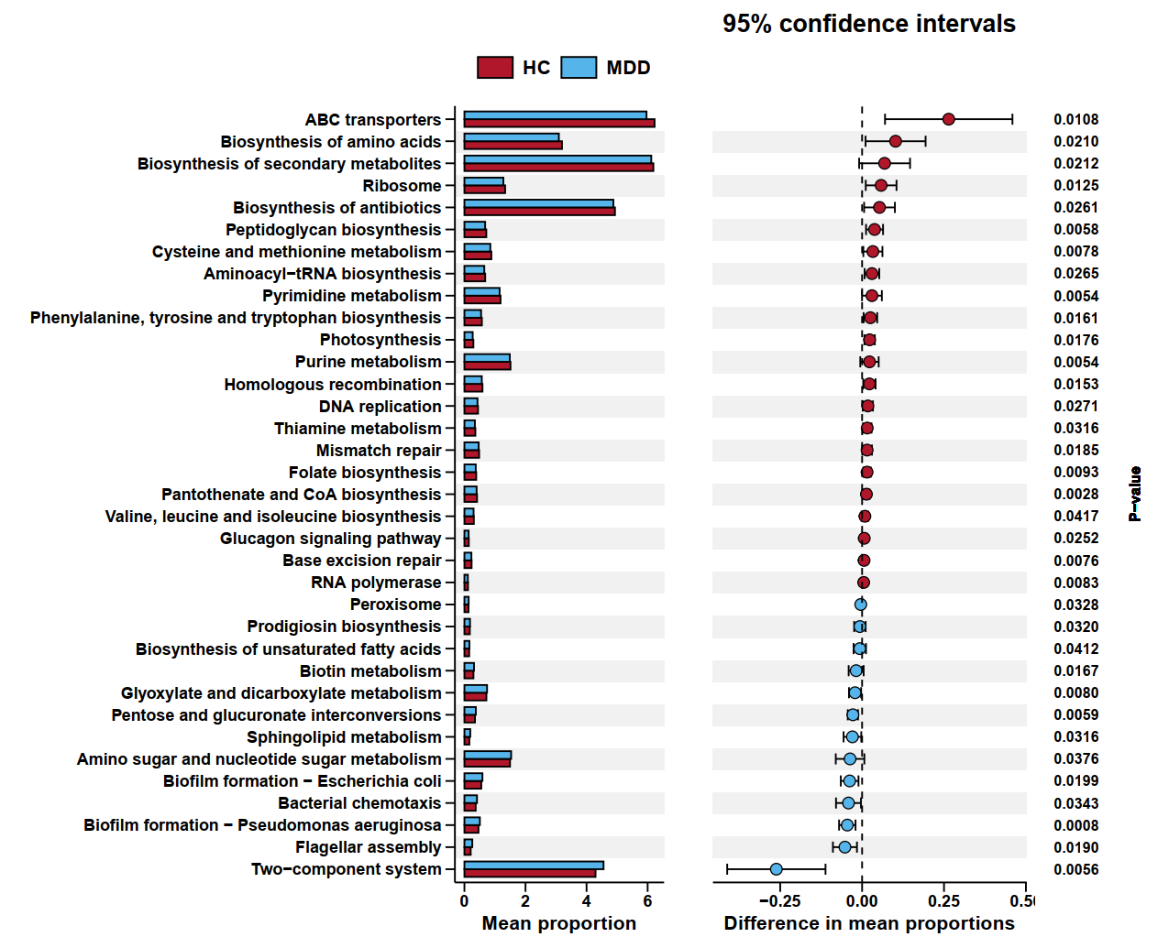

The functional prediction of Tax4Fun at KEGG level 3 (ESF, Figure 3B) identified differences in microbial metabolic pathways between MDD and controls. The latter exhibited substantially higher levels of pathways related to ABC transporters, biosynthesis of amino acids, secondary metabolite biosynthesis, pyrimidine metabolism, homologous recombination, and DNA replication, which suggests that the microbial biosynthetic and replication activity was more robust. On the other hand, MDD enriched pathways associated with two-component systems, flagellar assembly, bacterial chemotaxis, biofilm formation (e.g., Pseudomonas aeruginosa), amino sugar metabolism, glyoxylate metabolism, and pentose interconversions, indicating an increase in bacterial environmental sensing, motility, and host interaction functions. Furthermore, metabolic stress adaptation is suggested by the observed increases in glutathione metabolism and branched-chain amino acid metabolism.
Figure 4A. PICRUSt results: KEGG, level 2

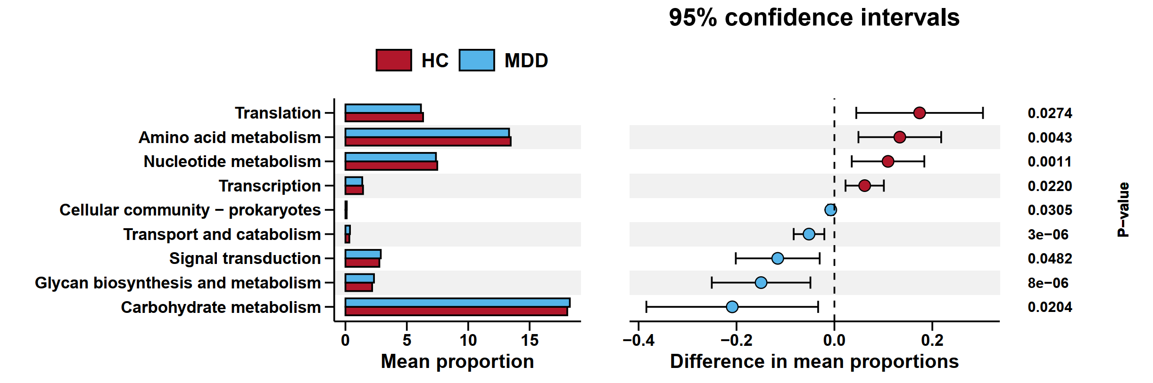

The PICRUSt functional prediction at KEGG level 2 (ESF, figure 4A) demonstrated significant differences in microbial functional pathways between MDD and HC. The pathways associated with translation, amino acid metabolism, nucleotide metabolism, and transcription were substantially elevated in HC, suggesting that there was a higher level of microbial biosynthetic and genetic processing. Conversely, MDD exhibited a relatively high level of enrichment in signal transduction, transport and catabolism, cellular community–prokaryotes, and glycan biosynthesis and metabolism. This may imply microbial environmental sensing, inter-bacterial interaction, and host–microbe interface processes. Furthermore, the metabolic pathways of microbial energy utilization were altered between the groups, as evidenced by the changes in carbohydrate metabolism.

Figure 4B. PICRUSt results: KEGG, level 3
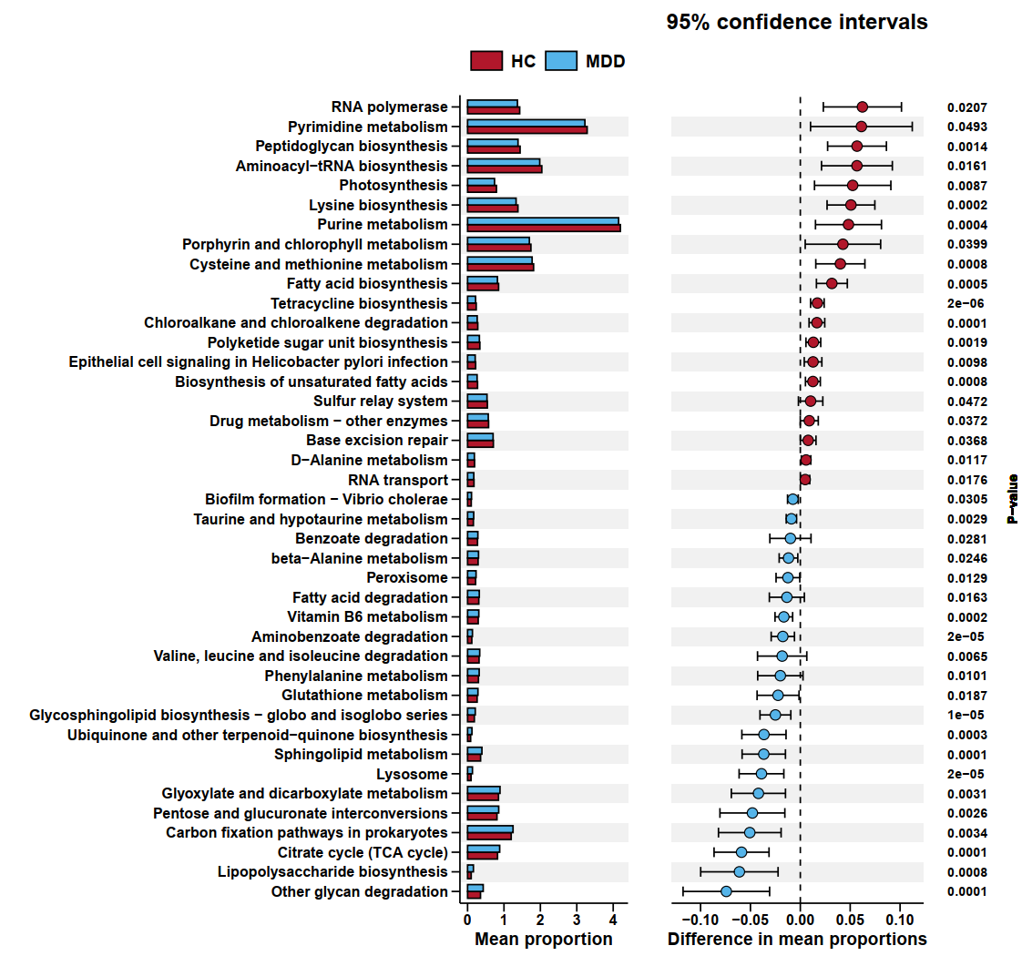
PICRUSt functional prediction at KEGG level 3 showed differences in metabolic pathways between MDD and HC. In the latter, pathways associated with RNA polymerase, pyrimidine metabolism, peptidoglycan biosynthesis, and aminoacyl-tRNA biosynthesis were significantly elevated the biosynthesis of unsaturated fatty acids, base excision repair, and alanine, aspartate, and glutamate metabolism were among the other pathways which were enriched in HC. These pathways suggest more robust metabolic maintenance processes and microbial replication. Conversely, MDD exhibited an enrichment of glyoxylate and dicarboxylate metabolism, pentose and glucuronate interconversions, carbon fixation pathways, lipopolysaccharide biosynthesis, and other glycan degradation, indicating an increase in microbial carbohydrate utilization and cell envelope remodeling.

