Supplementary information

Accounting for non-equivalence of carbon emissions and removals in meeting national net zero emissions targets in the United Kingdom

Contents
SI.1. UK TIMES carbon capture options 2
SI.2. Sectoral electricity and hydrogen use 4
SI.3. Direct air capture and fossil CCS 6
SI.4. Electricity and hydrogen production 7
References – SI only 10

UK TIMES carbon capture options
UK TIMES is a bottom up, technology rich model of the UK energy system. It is built using interconnected technologies and commodities which together describe supply chains for energy service demands (mobility, heat, etc.) in end use sectors.
In the context of meeting nationally legislated net zero emissions targets and 5-yearly carbon budgets¹, carbon dioxide removal (CDR) and fossil CCS technologies represent an important sub-group of technologies. Recent governmental analysis of carbon budget 7 stated that it was not possible to achieve net zero GHG emissions in 2050 without engineered removals, and described pathways with carbon capture, use and storage (CCUS) levels of 59-100 MtCO₂y⁻¹ by 2050².
Carbon capture options included in UK TIMES are shown in stylised form in Figure A. We distinguish between conventional CDR, which include well established methods deployed at scale around the world as part of countries’ LULUCF activities, from novel CDR, covering all other methods and generally associated with longer storage timescales but deployed at much smaller scales³. Where conventional CDR have averaged 2.2 GtCO₂y⁻¹ removals globally (2014-2023), novel CDR accounted for 2.04 MtCO₂ stored in 2025⁴. Note that Figure A combines Novel CDR and Carbon Capture and Storage (CCS) technologies for simplicity, creating a category sometimes referred to as engineered options.
Together, these carbon capture options feed either a Land or a Geological carbon sink:
- Afforestation, energy crops, changes in agricultural practice or soil remediation, affect soil carbon balances and are therefore linked to the land-sink. For afforestation and energy crops, the carbon accrued in above ground biomass that is removed either through crop harvesting or forest management does not accrue to the land sink. The woody biomass pellets are used in the wider energy system and could lead to accruals in the geological sink if used for bioenergy with carbon capture and storage (BECCS).
- Novel CDR and CCS technologies are spread across the electricity, hydrogen production, fuel and feedstock processing, and industrial sectors of the model. Their capture processes generate streams of CO₂ that can be used in synthetic fuel processes, or stored offshore on geological timescales.
The net carbon and energy balances of different novel CDR and CCS technologies account for the different feedstock fuels they use and their efficiencies of capture as part of the model’s consistent emissions accounting system (see main manuscript).
CDR and CCS options are part of the wider set of over 2000 technologies and 1000 commodities included in the UK TIMES whole energy system model.

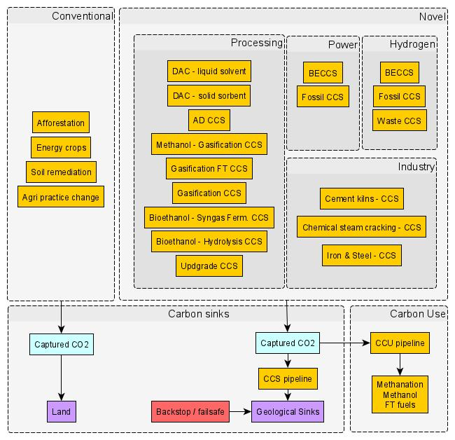
Figure A – Stylised and aggregated system map of existing carbon capture options included in the UK TIMES model. “Technology families” (yellow) represent groups of practices or processes that actively capture or mitigate CO₂ emissions. Land based options capture CO₂, accruing carbon to the land-sink, whereas technology-based systems including CCS and engineered CDR transfer CO₂ either to durable storage on geological timescales, or to possible uses in the fuel production supply chains of the UK TIMES model. Abbreviations above include: “AD” for anaerobic digestion, “Agri” for agricultural, “BECCS” for bioenergy with carbon capture and storage (denoted CCS), “DAC” for Direct Air Capture”, “Ferm” for fermentation.

Sectoral electricity and hydrogen use
Overall consumption of electricity and hydrogen across the energy system are shown below in Figure B. We choose to focus on these energy vectors as they represent the two most important means of fuel switching, reducing sectoral emissions at point of use and centralising efforts to decarbonise the system through changes to the power or hydrogen sectors. Panel a shows that electrification of buildings in the residential and service sectors as well as electricity use across industry are resilient choices across baseline and all GNZ scenarios.
Applying GNZ approaches of increasing levels of stringency has key implications for combined electricity and hydrogen system choices. Baseline uses of hydrogen in transport and both residential and service buildings decrease significantly as GNZ stringency increases, replaced instead by deeper electrification of heat and road transport. While overall hydrogen volumes decrease in GNZ futures, Cumulative approaches stand out as using similar levels as seen in baseline futures (191 TWh against 215 TWh). This suggests that hydrogen plays a strong transition role for hard to decarbonise sectors in the middle of the modelling period, where Strict and Progressive formulations either forgo fossil emissions (relying on fail-safe removals) or take responsibility for smaller though annually incremental shares.
In all GNZ cases, the production of hydrogen is seen to shift away from blue routes, dominant in the Baseline pathway, towards increased reliance on electrolysis. As a result, green hydrogen moves from representing 16% of production in 2050 (baseline) to 50-56% across GNZ alternatives.
Finally, panel a shows the levels of electricity required by direct air carbon capture and storage (DACCS) under Cumulative GNZ futures where it uses 64.2TWh electricity in 2050, 8% of all electricity consumption.

a
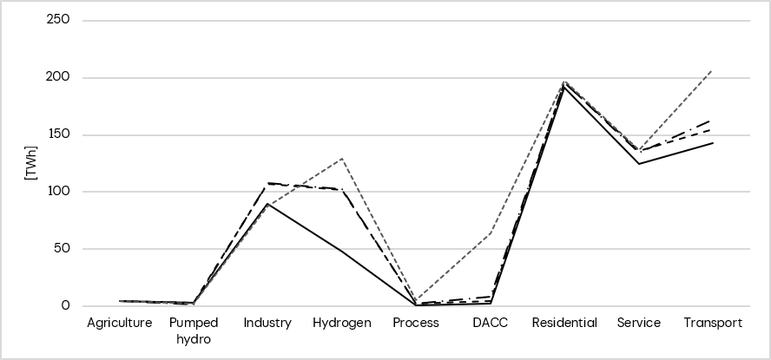
b
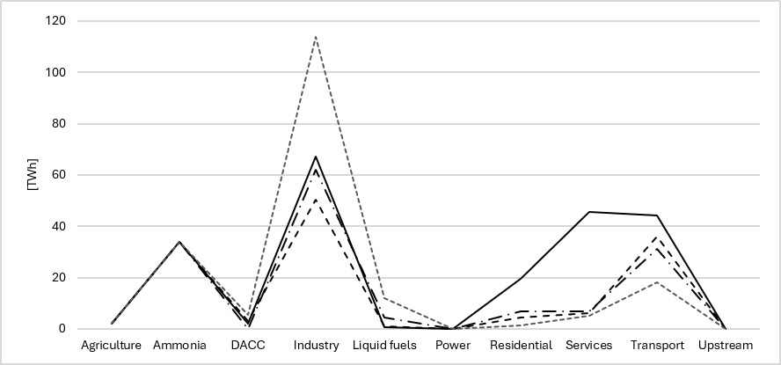
Figure B – Consumption of electricity (a) and hydrogen (b) per sector for Baseline and all GNZ scenarios. Data represent 2050 consumption in TWh, highlighting the changes between the Baseline and the different GNZ formulations. Sector choice is stylised to support an understanding of where the commodities are being used. Agriculture, Industry, Residential, Services and Transport are end-use sectors; all others are intermediate sectors. Note that Ammonia and Hydrogen (in (a)) should be understood as “production of […]”, and Pumped Hydro and DACC (in (a) and (b)) should be understood as “input to […]”.

Direct air capture and fossil CCS
Levels of carbon capture through both DACCS and fossil CCS (mitigation) across scenarios are shown below in Figure C. In line with current levels of development and demonstration in the UK and globally, these technologies are first made available to the model from 2030. Comparing panels a and b across scenarios highlights a shift away from mitigation options mirrored by an increase in DACCS use under GNZ scenarios compared to the baseline. This shift is resilient to sensitivity runs for most cases, with the exception of s2 which sees Cumulative formulations maintain their use of DACCS and seek to match it with mitigation, and progressive formulations favour larger volumes of mitigation earlier in the modelling period.
Panel a highlights the strong impact that GNZ conditions have on required levels of DACCS. All GNZ scenarios close to double baseline needs by 2050, sharing a common trajectory to 10-14 MtCO₂y⁻¹ in 2040 before cumulative futures show a markedly stronger growth to reach 84 MtCO₂y⁻¹ in 2050.
Under s1 and s2, the low availability of biomass or absence of BECCS from the GNZ consistently favour higher levels of DACCS alongside higher levels of mitigation. Under s3, the lower availability of TnS means trading off available offtake between its different uses and highlights a preference for DACCs over fossil CCS with 2050 (dotted coloured lines above (a) and below (b) reference solid lines)
a | 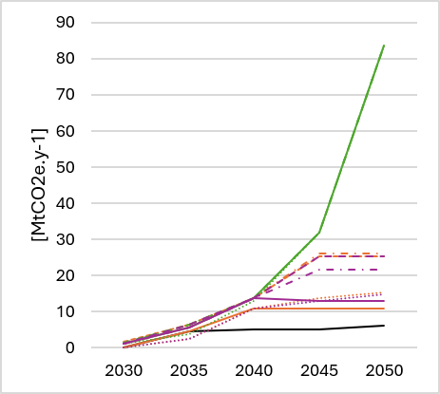 | b | 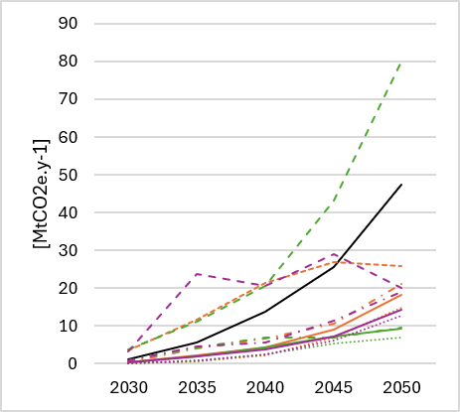
 | 
Figure C – Removals of CO₂ to geological storage from Direct Air Capture and Storage (a) and from fossil-based carbon capture and storage (mitigation) (b) over time across four scenario families and their sensitivities. Baseline, Strict-GNZ, Progressive-GNZ, and Cumulative-GNZ represented in four different colours, black, red, purple, and green respectively. Scenario sensitivities included as different forms of dashed line retaining the parent scenario colour. Sensitivity numbering refers to limited international biomass availability (s1), removal of BECCS from the GNZ formulation (s2), and delays in TnS availability (s3)

Electricity and hydrogen production
Levels of electricity and hydrogen production across scenarios are shown below in Figure D and Figure E respectively.
Baseline run results shown in “a” panels are relatively robust to sensitivity runs for both energy vectors. Electricity output increases by 7% under s3 between 2030 and 2040 compared to the reference case, where hydrogen output remains within a +13/-17 % range in 2050. Comparatively, the introduction of GNZ constraints has the potential to shift electricity generation by at least 10% and up to 27% in 2050 under strict / progressive and cumulative formulations respectively. More importantly, GNZ cases introduce this shift early in the modelling period, seeing departures from baseline trends in 2030 and 2035, requiring up to 40% larger annual electricity volumes. As shown in Figure D panel c, this increase is less demanding under a progressive implementation, giving the system time to ramp up systemic changes, including wider mitigation strategies, to support fossil emission balancing through durable storage.
Importantly, across both electricity and hydrogen futures, the introduction of sensitivities on the GNZ scenarios highlights their vulnerabilities to changes in national and global technology and feedstock supply chains. This is particularly true for panels c and d. Under s3, delays in TnS infrastructure cause electricity demands in a progressive GNZ to depart from baseline trends 5 years earlier, requiring 30% more output in 2030. Similarly, s3 and s2 reduce the cumulative case’s ability to recover all fossil emissions from the modelling period into durable storage, forcing the system to seek deeper electrification where possible, but also significantly increase the production of green hydrogen. This is reflected in Figure D panel c with the corresponding increases in hydrogen output, used to produce synthetic fuels to reduce residual emissions in the transportation sector.
Note that dynamics for panel b include the use fail-safe options for early compliance with the GNZ across both core and sensitivity scenarios – explaining the lower variability but showing the inability of the model to solve.

a | b
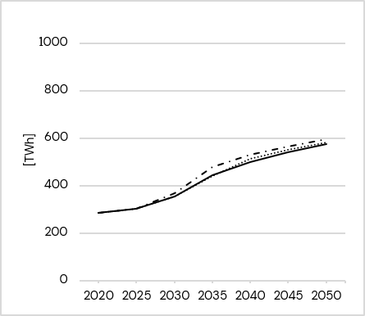 | 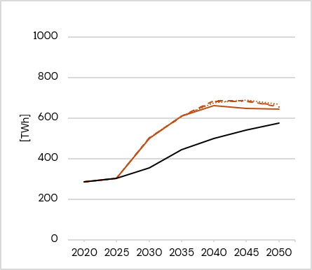
c | d
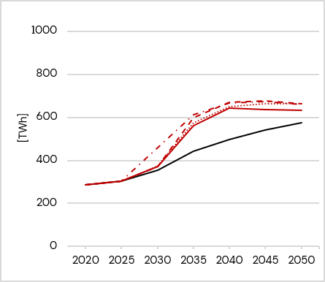 | 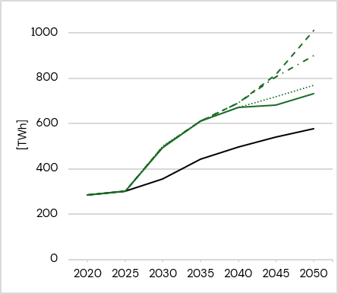


Figure D- Centralised production of electricity over time across four scenario families and their sensitivities. Baseline, Strict-GNZ, Progressive-GNZ, and Cumulative-GNZ in panels a, b, c, and d respectively. Scenario sensitivities are represented in each panel by different dashed lines retaining the colour of the parent scenario. The Baseline reference (black) is included in all panels. Sensitivity numbering refers to limited international biomass availability (s1), removal of BECCS from the GNZ formulation (s2), and delays in TnS availability (s3)

a | b
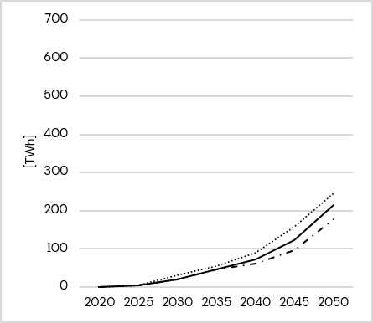 | 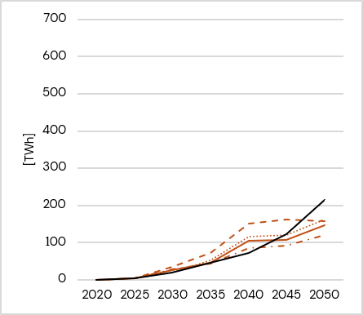
c | d
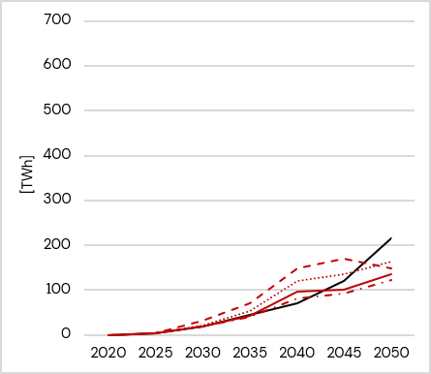 | 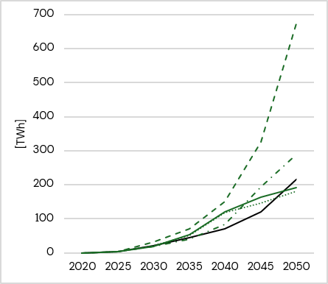
Figure E - Centralised production of hydrogen over time across four scenario families and their sensitivities. Baseline, Strict-GNZ, Progressive-GNZ, and Cumulative-GNZ in panels a, b, c, and d respectively. Scenario sensitivities are represented in each panel by different dashed lines retaining the colour of the parent scenario. The Baseline reference (black) is included in all panels. Sensitivity numbering refers to limited international biomass availability (s1), removal of BECCS from the GNZ formulation (s2), and delays in TnS availability (s3)

References – SI only
            - Climate Change Act 2008, c.27. Available at https://www.legislation.gov.uk/ukpga/2008/27/contents (accessed 04/08/2026).
            - DESNZ. Seventh Carbon Budget Impact Assessment. https://www.legislation.gov.uk/ukia/2026/100/pdfs/ukia_20260100_en.pdf (2026).
            - Geden, O., Gidden, M. J., Edwards, M. R., Cowie, A., Smith, S. M., Tenkhoff, L., Zakkour, P. Chapter 1: Introduction, in The State of Carbon Dioxide Removal 3rd Edition 2026 (eds. Edwards, M. R. et al.). DOI: https://doi.org/10.17605/OSF.IO/5K2SF (2026)
            - Smith, S. M., Grassi, G., Gupta, S., Schwingshackl, C., Harrington, K. J., Pilli, R., Rink, A. Chapter 7: Current levels of CDR, in The State of Carbon Dioxide Removal 3rd Edition 2026 (eds. Edwards, M. R. et al.). DOI: https://doi.org/10.17605/OSF.IO/VH7U6 (2026)

