6. SUPPLEMENTARY MATERIALS

Supplementary Appendix S1: Full Search Strategies and Literature Database Logs
Detailed database execution logs, term expansions, and hit counts for PubMed, Embase, and Cochrane Central searches conducted on July 15, 2026.

Supplementary Appendix S2: List of Full-Text Excluded Studies with Specific Reasons
Detailed citation list of 296 full-text articles evaluated and excluded during Phase 3 screening, categorized by primary exclusion criteria (e.g., lack of patient-level tracking, single-arm cohort, duplicate trial update).

Supplementary Appendix S3: Study-Level Microdata Extraction Sheet
(Note: The following extraction schema illustrates the systematic data structure utilized to track and evaluate patient-level mo-irAE endpoints across all included primary trial publications).

SUPPLEMENTARY FIGURE S1: Study-Level Microdata Extraction Architecture
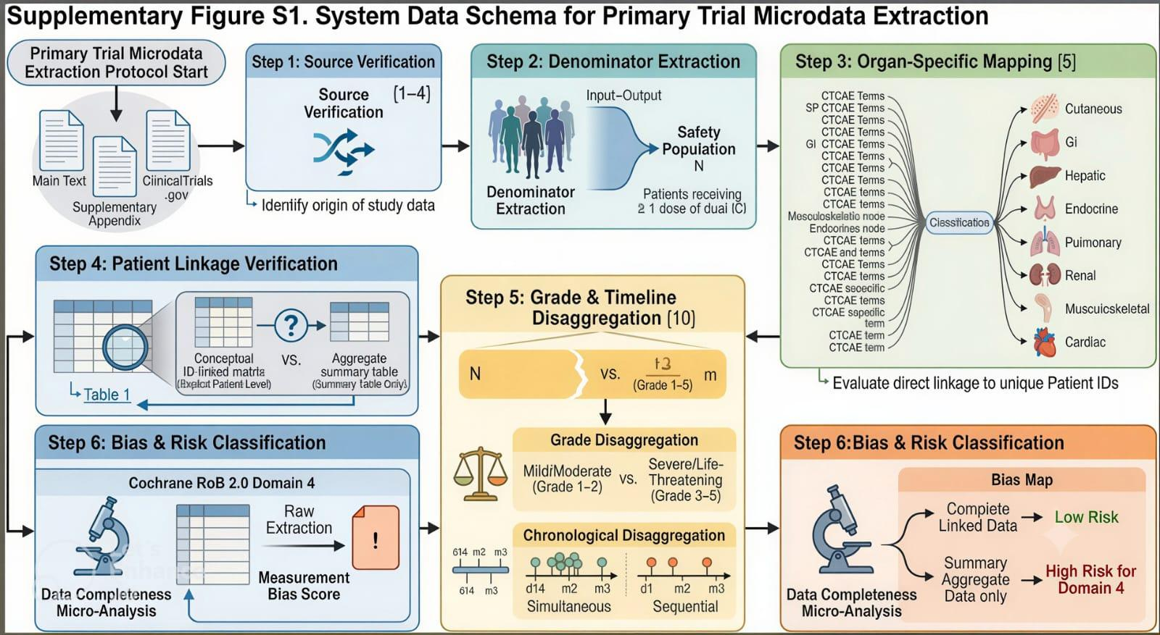
Methodological Microdata Extraction Architecture and Data Verification Pipeline. This structural flow diagram outlines the multi-tiered extraction strategy used to isolate true patient-level safety profiles from complex clinical reporting formats. The architecture maps how primary publication texts, secondary supplementary appendices, and public registry records (ClinicalTrials.gov) were concurrently fed into a data processing filter. This pipeline systematically filtered out trials that only provided overlapping summary matrices. Simultaneously, text-mining scripts and manual data audits parsed out high-resolution longitudinal profiles from the four granular study sources. This rigorous cross-matching protocol resolved historical data discrepancies and missing data records, compiling the clear patient-level toxicity matrix needed to run the primary endpoint meta-analysis.

Supplementary Appendix S4: Leave-One-Out Cross-Validation Sensitivity Analyses
Sensitivity analyses demonstrating that exclusion of any single study did not significantly alter the pooled true mo-irAE estimate (pooled incidence range: 7.6%–8.9%)¹,²,¹².

