Supplementary materials
Direct visualization of edge state in even-layer MnBi₂Te₄ at zero magnetic field

Weiyan Lin^{1†}, Yang Feng^{2†}, Yongchao Wang^{6†}, Zichen Lian³, Hao Li^{7,8}, Yang Wu^{8,9}, Chang Liu^{3,10}, Yihua Wang^{2,11}, Jinsong Zhang^{3,12}, Yayu Wang^{3,12}, Chui-Zhen Chen^{4,5}, Xiaodong Zhou^{1,14,15*} and Jian Shen^{1,2,13,14,15*}

¹Institute for Nanoelectronic Devices and Quantum Computing, Fudan University, Shanghai, China.
²State Key Laboratory of Surface Physics and Department of Physics, Fudan University, Shanghai, China.
³State Key Laboratory of Low Dimensional Quantum Physics, Department of Physics, Tsinghua University, Beijing, China.
⁴School of Physical Science and Technology, Soochow University, Suzhou, China
⁵Institute for Advanced Study, Soochow University, Suzhou, China
⁶Beijing Innovation Center for Future Chips, Tsinghua University, Beijing, China.
⁷School of Materials Science and Engineering, Tsinghua University, Beijing, China
⁸Tsinghua-Foxconn Nanotechnology Research Center, Department of Physics, Tsinghua University, Beijing, China.
⁹Department of Mechanical Engineering, Tsinghua University, Beijing, China.
¹⁰Beijing Academy of Quantum Information Science, Beijing, China
¹¹Shanghai Research Center for Quantum Sciences, Shanghai, China
¹²Frontier Science Center for Quantum Information, Beijing, China.
¹³Collaborative Innovation Center of Advanced Microstructures, Nanjing, China
¹⁴Zhangjiang Fudan International Innovation Center, Fudan University, Shanghai, China
¹⁵Shanghai Qi Zhi Institute, Shanghai, China

† These authors contributed equally to this work
* Emails: zhouxd@fudan.edu.cn, shenj5494@fudan.edu,.cn

Contents:

A: thickness determination of few-layer MnBi₂Te₄ devices
B: a complete gate voltage and field dependent transport characterization of 6-SL MnBi₂Te₄ (Device A)
C: bulk transport measurement of 6-SL MnBi₂Te₄ (Device A)
D: transport and sMIM results of one 7-SL MnBi₂Te₄
E: sMIM results of another 6-SL MnBi₂Te₄ (Device B)
F: crossover from three-dimensional (3D) to two-dimensional (2D) topological insulators

Figure S1 to S6

SI A: thickness determination of few-layer MnBi₂Te₄ devices

In this work, we fabricated and measured two 6-SL devices and one 7-SL device. The data shown in the main figures are from the first 6-SL device (Device A), and data of another 6-SL device (Device B) are displayed in this supplementary material. Also shown in the supplement is the transport and sMIM results of one 7-SL device. The exact thickness of MnBi₂Te₄ thin flakes is determined by checking its optical reflectance and following an empirical method we have obtained. Figure S1(a) displays an optical image of few-layer flakes of MnBi₂Te₄ cleaved onto SiO₂/Si substrate. Image was taken in reflection mode before PMMA coating and other fabrication process. We first determine the thickness of areas with different colors by Atomic Force Microscope (AFM, Bruker Innova). Number of SLs is labeled on selected flakes in Fig. S1(a). We then calculate the optical image contrast between substrate and selected flakes by extracting the RGB value from the selected flakes and substrate in the original optical image, and dividing the difference between them by the background of substrate. We plot such a contrast between substrate and flakes as a function of the number of SLs in Fig. S1(b). We have performed this AFM/optical measurement on multiple MnBi₂Te₄ devices, and the resultant data are all plotted in Fig. S1(b). We find a good one-to-one correspondence between the optical image contrast and the number of SLs. This relation serves as an empirical method for us to determine the thickness of MnBi₂Te₄ flake.

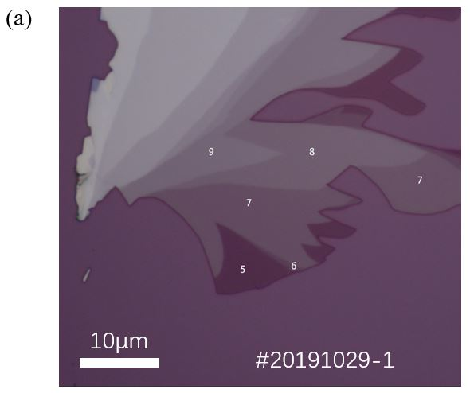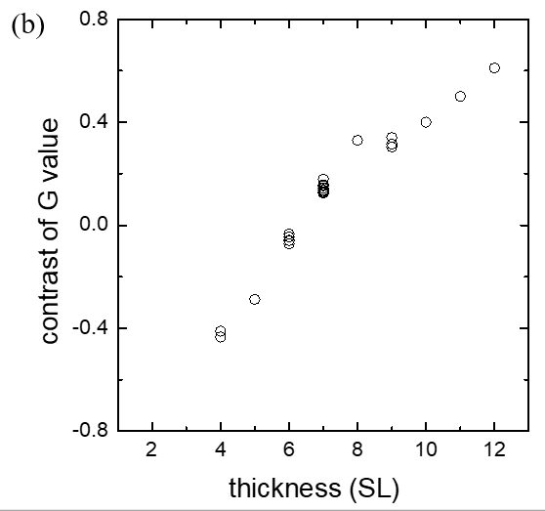

FIG S1 (a) Optical image of few-layer flakes of MnBi₂Te₄ cleaved onto SiO₂/Si substrate. Image was taken in reflection mode before PMMA coating and other fabrication process. Number of SLs is labeled on selected flakes as determined by AFM. Scale bar is 10 μm. (b) The optical image contrast as a function of the number of SLs.

SI B: a complete gate voltage and field dependent transport characterization of 6-SL MnBi₂Te₄ (Device A)
We provide a complete gate voltage and field dependent longitudinal resistivity $ρ_{xx}$ and Hall resistivity $ρ_{yx}$ of the 6-SL MnBi₂Te₄ device presented in the main text. This transport characterization clearly shows that a Chern insulator phase is realized when the magnetic field is larger than 6 T which shows a quantized Hall resistivity and a vanishing longitudinal resistivity. This Chern insulator phase is phase-transited into a C=0 insulating phase at low fields displaying a zero Hall plateau and a large longitudinal resistivity. Please note that the charge neutrality point (CNP) gating regime in transport (+25 V to +35 V) is slightly different from that of sMIM measurement (+10 V to +20 V). That is due to the sample’s aging effect which changed the actual doping level after a month-long transport experiment before sMIM measurement was taken.
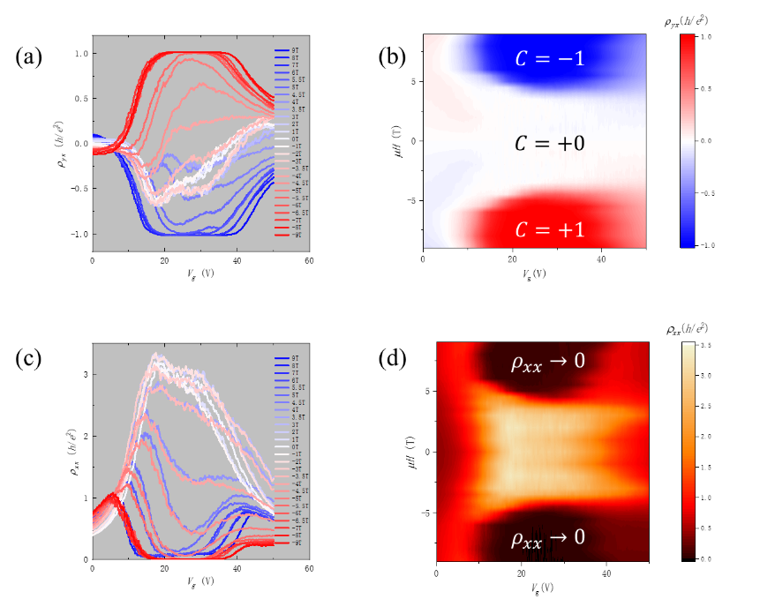

FIG S2 (a) Gate voltage and field dependent Hall resistivity $ρ_{yx}$ (b) The 2D color map of $ρ_{yx}\left(V_{g},μH\right)$ showing $C=±1$ and $C=0$ phase. (c) Gate voltage and field dependent longitudinal resistivity $ρ_{xx}$ . (d) The 2D color map of $ρ_{xx}\left(V_{g},μH\right)$.

SI C: bulk transport measurement of 6-SL MnBi₂Te₄ (Device A)
To confirm the insulator-metal transition (IMT) of the bulk as revealed by sMIM, we conduct a global transport measurement of Device A. As shown in the inset of Fig. S3(a), we run a current through a pair of electrodes on opposite site of the device while grounding all other electrodes. By this way, current mainly goes through the bulk which allows us to only probe the bulk resistance. Fig. S3(a) show a magnetic field dependent bulk resistance measurement taken at different temperatures. It reveals two IMT with a metallic state separating two insulating states at two ends. Fig. S3(c) and (d) are zoomed-in plots of such transition. The first one is an insulator-to-metal transition at around 4.0 T, while the second one is a metal-to-insulator transition at around 4.75 T. Fig. S3(b) is an Arrhenius plot of $σ_{bulk}$ as a function of $1/T$ under representative magnetic fields. By linearly fitting this plot, we get the energy gap of the thermally activated charge transport. We plot this gap as a function of magnetic field in Fig. 3(d) of the main text.
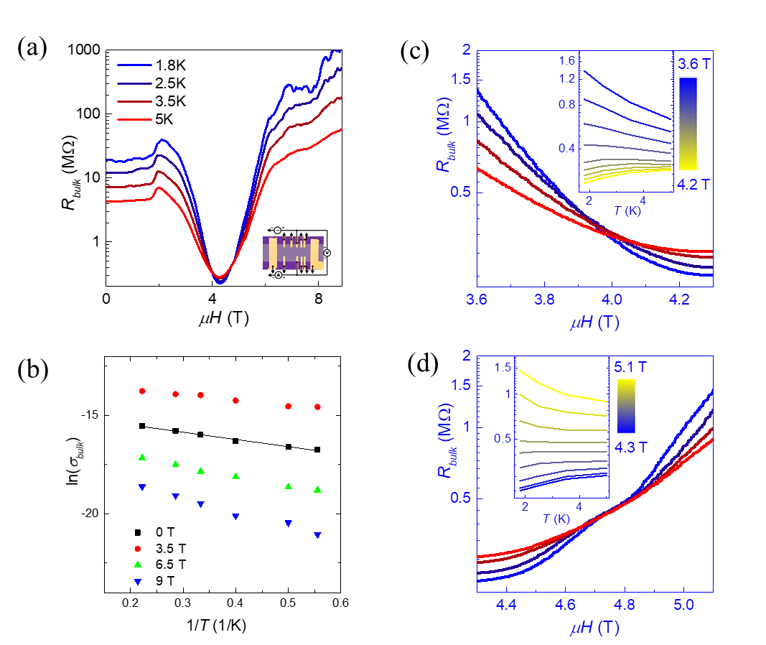

FIG S3 (a) The temperature and magnetic field dependent bulk resistance measurement of Device A shows two IMT during magnetic field sweeping. (b) The Arrhenius plot of $σ_{bulk}$ as a function of $1/T$ under representative magnetic fields. (c-d) The zoomed-in plots of IMT.

SI D: transport and sMIM results of one 7-SL MnBi₂Te₄
We show the transport and sMIM results of one 7-SL MnBi₂Te₄ device here to complement the 6-SL MnBi₂Te₄ experiment reported in the main text. Figure S4(a) is the optical image of this 7-SL MnBi₂Te₄ device. It has a uniform 7-SL layer thickness in the Hall bar region which allows us to characterize its transport property. It also has an area denoted by the yellow rectangle with both 6-SL and 7-SL layer thickness which is perfect for the sMIM imaging. Figure S4(b) shows the magnetic field dependent longitudinal resistivity $ρ_{xx}$ and Hall resistivity $ρ_{yx}$ when the applied gate $V_{g}$ is +30 V, close to its charge neutral point. When the magnetic field is larger than 6 T, the Hall resistivity $ρ_{yx}$ reaches a quantized Hall plateau while $ρ_{xx}$ is minimized signaling a Chern insulator phase. At low fields around zero, both $ρ_{xx}$ and $ρ_{yx}$ show a magnetic hysteresis between the up-sweep and down-sweep curves, indicating the existence of an uncompensated magnetization expected for such odd-layer MnBi₂Te₄. Figure S4(c) are gate voltage dependent sMIM images taken at zero magnetic field in the area with both 6-SL and 7-SL MnBi₂Te₄. As the gate is increased, one can see the emergence of an edge state in 6-SL MnBi₂Te₄ area, but the absence of such edge state in 7-SL MnBi₂Te₄ area due to the enhanced bulk conductivity in 7-SL MnBi₂Te₄.
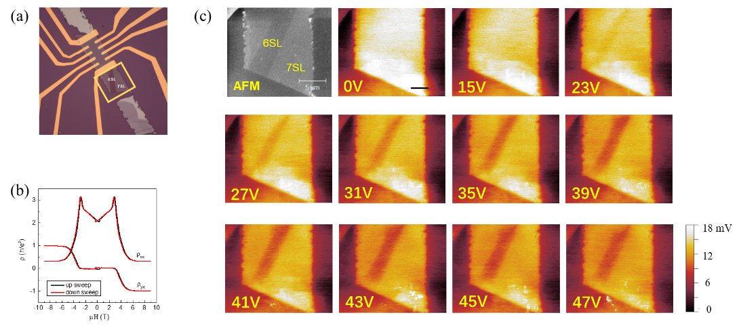
FIG S4 (a) The optical image of a 7-SL MnBi₂Te₄ device. (b) The magnetic field dependent $ρ_{xx}$ and $ρ_{yx}$. (c) The gate voltage dependent sMIM images at zero magnetic field. Scale bar is 4 μm for sMIM images.

SI E: sMIM results of another 6-SL MnBi₂Te₄ (Device B)
We have fabricated and measured two 6-SL MnBi₂Te₄ devices, denoted as Device A and B respectively. The data shown in the main text are all from Device A. Here we show sMIM results taken on Device B. Both gate voltage and magnetic field dependent sMIM images shown in Fig. S5 corroborate the major findings in this work. First, we directly visualize a topological edge state in the Chern insulator phase at high fields. Second, we uncover another edge state at zero magnetic field. Third, the field dependent sMIM measurement directly reveals an IMT of the bulk.
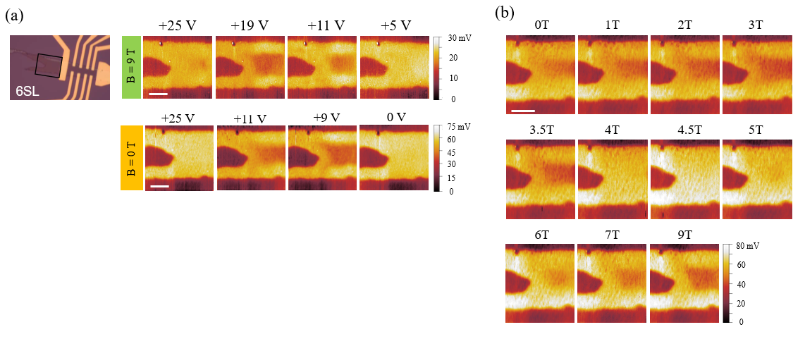
FIG S5 (a) Gate voltage dependent sMIM images of Device B measured at 9 T and 0 T. (b) Magnetic field dependent sMIM images measured at charge neutral point. Scale bar is 4 μm.

SI F: Crossover from three-dimensional (3D) to two-dimensional (2D) topological insulators
Following the Ref.¹ , we investigate the crossover behaviors from a three-dimensional (3D) topological insulator (TI) to a two-dimensional TI with reducing the layer thickness in z direction. In the following, we start from the 3D model Hamiltonian in the main text, replace $k_{z}→{-i∂}_{z}$ and solve eigenvalue problem of the infinite quantum well at $Γ$point ($k_{x}=k_{y}=0).$ In Fig. S6, the band gap $E_{g}$ at $Γ$point shows an oscillatory decay behavior with increasing layer thickness $N_{z}$. To be specific, there is a large trivial band gap for $N_{z}<4$, and it gradually closes with increasing $N_{z}$. Then the band gap reopens (e.g. at $N_{z}=6$) which leads to the antiferromagnetic quantum spin Hall phase discussed in main text. At last, the band gap decays quickly and becomes negligible when the sample thickness $N_{z}≥7$.
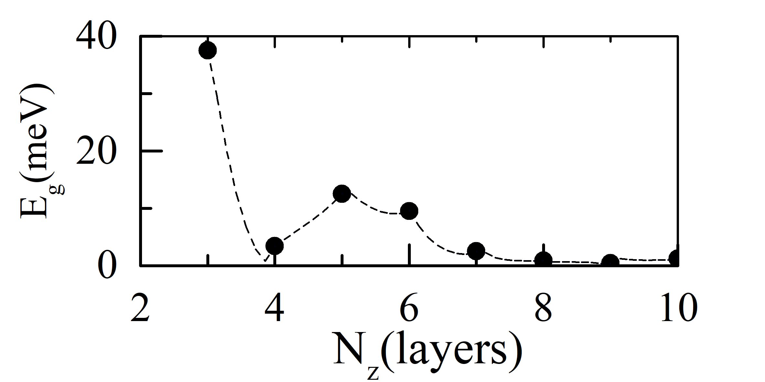
FIG. S6. The band gap $E_{g}$ at $Γ$point ($k_{x}=k_{y}=0)$ versus the number of SL layers $N_{z}$ in z direction. The model parameters are $M_{z}=0.04$eV, $A_{2}=2$eVÅ, $B_{2}=24$eVÅ² and $m_{0}= 0.116$eV with thickness $a_{z}=1.4$ nm for each SL layer.

Reference:

1 Liu, C. X. et al. Oscillatory crossover from two-dimensional to three-dimensional topological insulators. Phys. Rev. B 81, 041307, (2010).

