SUPPLEMENTARY DATA
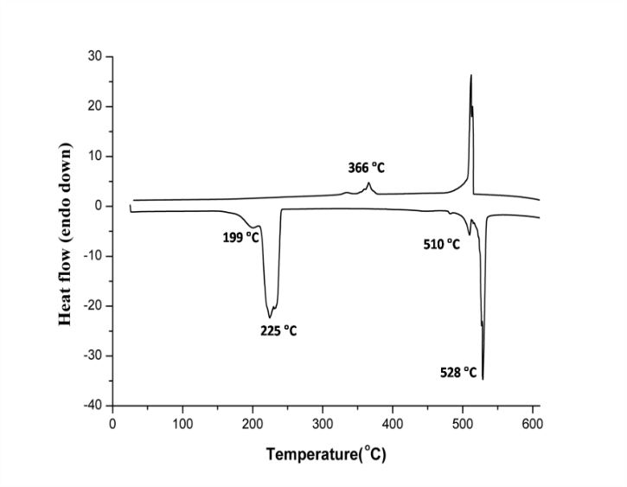
Figure S1: Differential scanning calorimetric thermogram of Na₂Cu(SO₄)₂.2H₂O.
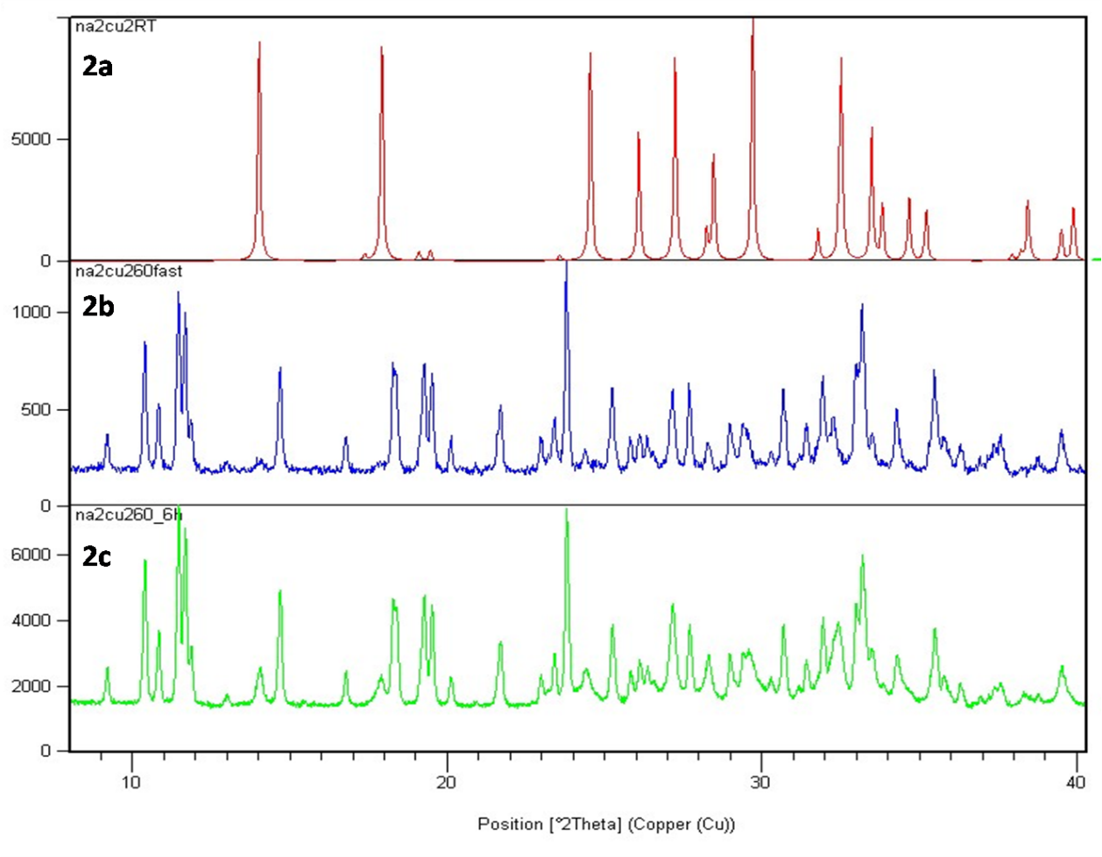
Figure S2: PXRD patterns for (a) Na₂Cu(SO₄)₂.2H₂O, (b) the anhydrous phase obtained just after heating above 260°C, and (c) indication of rehydration in a long p-XRD scan.
Report on P-XRD Data
- Refinement Results
R-Values
Rexp : 3.72 Rwp : 21.76 Rp : 14.79 GOF : 5.86
Rexp`: 15.12 Rwp`: 88.56 Rp` : 92.51 DW : 0.16

Quantitative Analysis - Rietveld
Phase 1 : ANC1_0m_a 100.000 %

Background
Chebychev polynomial, Coefficient 0 586.1738
1 -97.3156
2 -159.1205
3 113.7152
4 -37.21664
5 -3.702723
6 17.23036
7 16.51263
8 -18.98455
9 2.103443
10 16.70883

Instrument
Primary radius (mm) 250
Secondary radius (mm) 250
Linear PSD 2Th angular range (°) 2.74854
FDS angle (°) 0.3
Full Axial Convolution
Filament length (mm) 12
Sample length (mm) 15
Receiving Slit length (mm) 12
Primary Sollers (°) 2.5
Secondary Sollers (°) 2.5

Corrections
Specimen displacement -0.09466853
LP Factor 0
Absorption (1/cm) 8.70221

Structure 1
Phase name ANC1_0m_a
R-Bragg 16.785
Spacegroup C2/c
Scale 4.55988e-006
Cell Mass 4326.438
Cell Volume (Å^3) 2163.12829
Wt% - Rietveld 100.000
Double-Voigt|Approach
Cry size Lorentzian 297.1
k: 1 LVol-IB (nm) 189.132
k: 0.89 LVol-FWHM (nm) 264.409
Crystal Linear Absorption Coeff. (1/cm) 138.514
Crystal Density (g/cm^3) 3.321
PV_TCHZ peak type
U 0.1264258
V -0.02449122
W 0.001193819
Z 0
X 0.01
Y 0
Lattice parameters
a (Å) 17.2855546
b (Å) 9.3879652
c (Å) 14.3759432
beta (°) 111.9917

Site Np x y z Atom Occ Beq
Cu01 8 0.41255 0.25189 0.20240 Cu 1 0.912
Cu02 8 0.51438 0.52190 0.35962 Cu 1 0.923
Cu03 8 0.52337 -0.02056 0.15913 Cu 1 0.8819
S004 8 0.33872 -0.03366 0.13147 S 1 0.9135
S005 8 0.49088 0.75056 0.50821 S 1 0.7619
S006 8 0.33711 0.53815 0.21027 S 1 0.9112
Na07 8 0.17222 -0.27913 0.04715 Na 1 1.663
Na08 8 0.19732 0.24490 0.14528 Na 1 2.835
O009 4 0.50000 0.39365 0.25000 O 1 0.7343
O00A 4 0.50000 0.10778 0.25000 O 1 0.758
O00B 8 0.55288 0.83003 0.59066 O 1 1.142
O00C 8 0.40277 -0.05658 0.08667 O 1 1.39
O00D 8 0.43078 0.67543 0.54038 O 1 1.232
O00E 8 0.32050 0.38355 0.18927 O 1 1.524
O00F 8 0.53991 0.64788 0.47398 O 1 1.224
O00G 8 0.39303 0.55569 0.31748 O 1 1.453
O00H 8 0.32216 0.12186 0.13264 O 1 1.319
O00I 8 0.44266 0.84796 0.42578 O 1 1.232
O00J 8 0.37004 -0.08720 0.23579 O 1 1.461
O00K 8 0.25965 0.61176 0.19423 O 1 1.405
O00L 8 0.26350 -0.10522 0.06950 O 1 1.484

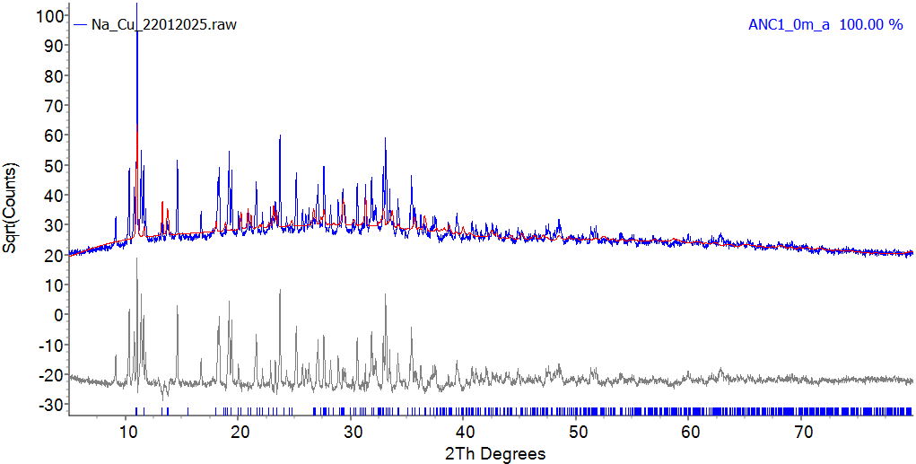
Figure S3. The Rietveld refined plot. Blue- Observed XRD pattern (Y_{obs}), Red- Calculated pattern (Y_{calc}), Grey- Difference profile (Y_{obs}- Y_{calc}).

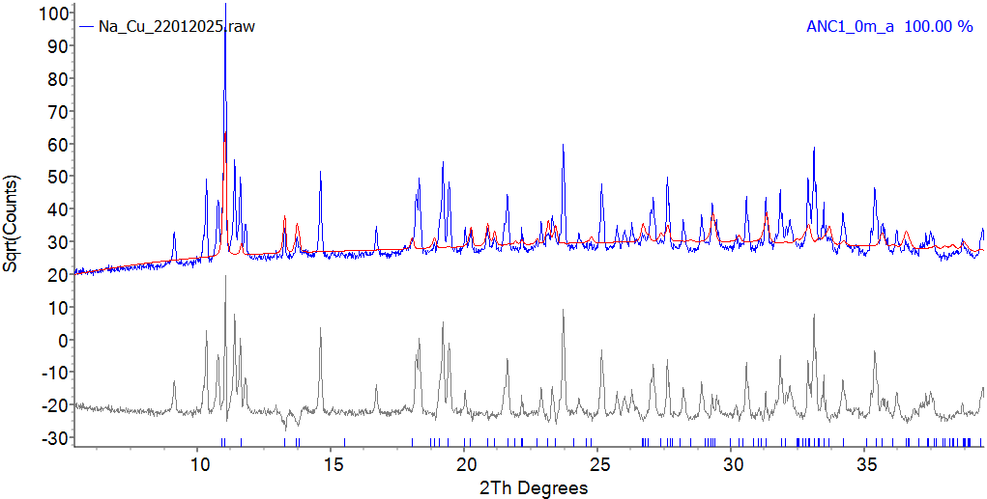
Figure S4. The same plot showed from 0°-40°.
Note: The At. fractional coordinates, ADPs, and occupancy parameters were not refined.
- Discussion
The PXRD pattern was compared with the simulated profile derived from previously obtained SCXRD data of the NaCuSO system (ANC1). It is evident from the plots above that some peaks from the calculated pattern align with the experimental data, while a significant number of unaccounted peaks remain, indicating the presence of impurity phases along with the desired Na₂Cu₃(SO₄)₃O phase.
File codes used for refining the crystal data:-
anc1_0m_a_mercury.xy- Simulated PXRD pattern from CIF.
hkl_fitted _cif.txt- Table of hkl, d-spacing and 2theta values of the fitted cif (cell parameters and a few other parameters refined for phase matching purposes)
Na_Cu_22012025.xy- Experimental PXRD data of your sample.
Na_Cu_22012025_fitted.txt- Fitted text file containing Yobs, Ycalc and Difference information.
Analysis software- TOPAS Version 6, marketed by Bruker.
STABILITY ANALYSIS OF THE FABRICATED ELECTRODE
Figure S5: The fabricated electrodes, A) Before, and B) After Electrochemical Studies
Scanning electron micrographs of the fabricated electrodes before and after electrochemical analysis were compared to check the structural stability. Micrographs exhibited a random distribution of irregular particles with some degree of agglomeration. The agglomeration may have happened during the high-temperature treatment over a prolonged period. Micrographs of the bare and the used electrodes have an almost similar appearance, which undeniably confirms the high structural stability of the fabricated electrode.
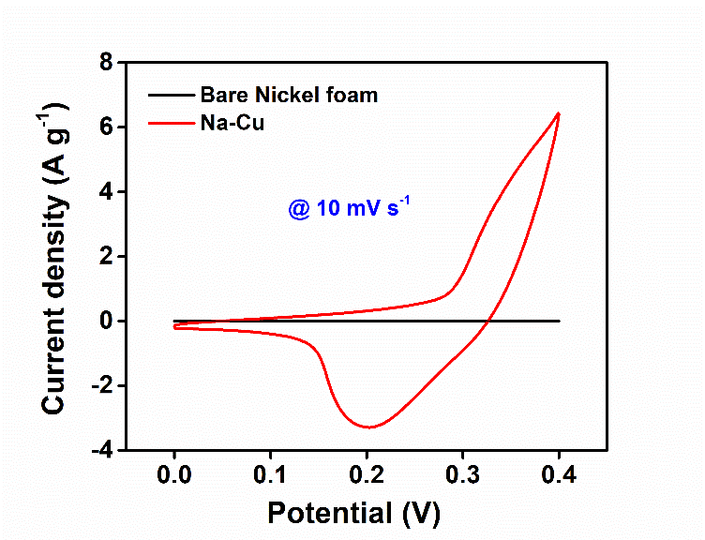
Figure S6: Cyclic voltammograms of Na-Cu and bare Ni foam at 10 mV s⁻¹.

Na₂Cu₃(SO₄)₃O as a Bifunctional Electrocatalyst Under Alkaline Conditions (Theoretical Investigation Insights – Literature Review)
Na₂Cu₃(SO₄)₃O features three crystallographically distinct Cu²⁺ sites exhibiting five-coordinate geometries, along with isolated OCu₄ tetrahedral units. These units have a central O²⁻ ion that is coordinated to four Cu²⁺ ions (Cu···Cu ≈ 2.8 Å). The structure also comprises three bridging SO₄²⁻ groups and open channels that accommodate free Na⁺ ions.
Under alkaline OER conditions (anodic potential ≥ 1.6 V vs RHE), surface Cu²⁺ centres in Cu-based electrocatalysts undergo electrochemical oxidation to form high-valent Cu³⁺ intermediates, which subsequently reconstruct into a surface CuOOH phase. Operando Cu L₃-edge X-ray absorption spectroscopy previously identified a reversible spectral feature at 932.6 eV, which emerged at 1.62 V vs RHE and became prominent during the OER at 1.75-1.8 V vs RHE.[1] DFT and operando spectroscopic studies have identified the bridge O* positions between two Cu³⁺ atoms in CuOOH as the active sites for OER. This was confirmed through operando modulation excitation X-ray absorption spectroscopy (ME-XAS), which detected a distinct Cu³⁺ fingerprint at 1.8 V vs RHE on a Cu thin-film electrode.[2] CuOOH is located within the stability region for OER in the Pourbaix stability region, with a calculated free energy of -208.68 kJ mol⁻¹. The OCu₄ structural units found in Na₂Cu₃(SO₄)₃O are considered a precursor motif capable of forming a CuOOH-like surface in situ under anodic conditions. Additionally, surface-adsorbed sulphate groups stabilise the *OOH intermediate through hydrogen bonding. This interaction reduces the energy gap between ΔG(*OH) - ΔG(*OOH) from the universal 3.2 eV to 2.65 eV, which corresponds to a theoretical minimum overpotential of 95 mV for optimal O adsorption strength.[3]
Under alkaline HER conditions (cathodic potentials), cathodic polarisation may induce local surface reconstruction, or oxygen-vacancy (Vₒ) formation within the residual Cu-O framework. Oxygen vacancies in metal oxide electrocatalysts are widely recognised as significant contributors to enhancing HER activity.[4] Vₒ-rich oxides show significantly improved intrinsic HER activity compared to their Vₒ-poor counterparts, as Vₒ dynamically promotes surface hydroxylation under alkaline HER conditions. DFT studies on oxygen-deficient transition-metal oxides indicate that Vₒ can modify the local electronic structure, facilitate H₂O adsorption and dissociation during the Volmer step.[5] DFT studies on related defective transition-metal oxides have demonstrated that local electronic perturbations can substantially accelerate the Volmer step. For instance, modification of NiO reduces the calculated water-dissociation barrier from 1.17 eV to 0.81 eV through charge redistribution and optimisation of hydrogen adsorption energetics.[6] DFT calculations on Cu₂O (111) revealed that coordinatively unsaturated Cu sites and oxygen vacancies serve as favourable centres for hydrogen adsorption.[7] Accordingly, Vₒ-adjacent Cu²⁺ sites represent a plausible HER-active ensemble.
The proposed active states are dependent on the potential and are effectively mutually exclusive under steady-state operating conditions. The CuOOH-like Cu³⁺ species are expected to form and remain stable only under anodic OER potentials. In contrast, oxygen-vacancy-containing Cu²⁺ environments are clearly more favourable under cathodic HER conditions. This potential-dependent surface evolution offers a plausible mechanistic framework for bifunctional electrocatalysis.
[1] L. Ostervold, R. Daneshpour, M. Facchinei, B. Tran, M. Wetherington, K. Alexopoulos, L. Greenlee, M.J. Janik, Identifying the Local Atomic Environment of the “Cu3+” State in Alkaline Electrochemical Systems, ACS Appl. Mater. Interfaces 15 (2023) 27878–27892. https://doi.org/10.1021/acsami.3c01852.
[2] P. Basera, Y. Zhao, A.T. Garcia-Esparza, F. Babbe, N. Bothra, J. Vinson, D. Sokaras, J. Yano, S.W. Boettcher, M. Bajdich, The Role of Cu3+ in the Oxygen Evolution Activity of Copper Oxides, J. Am. Chem. Soc. 147 (2025) 16070–16083. https://doi.org/10.1021/jacs.4c18147.
[3] J.N. Hausmann, P.W. Menezes, Effect of Surface-Adsorbed and Intercalated (Oxy)anions on the Oxygen Evolution Reaction, Angew. Chem. Int. Ed. 61 (2022) e202207279. https://doi.org/https://doi.org/10.1002/anie.202207279.
[4] K. Chen, V. Dao, S. Yadav, I.-H. Lee, Progress and perspective of transition metal layered double hydroxides with oxygen vacancies for enhancing water splitting applications: A review, J. Environ. Chem. Eng. 12 (2024) 113773. https://doi.org/https://doi.org/10.1016/j.jece.2024.113773.
[5] H. Zhang, L. Chen, F. Dong, Z. Lu, E. Lv, X. Dong, H. Li, Z. Yuan, X. Peng, S. Yang, J. Qiu, Z. Guo, Z. Wen, Dynamic transformation of active sites in energy and environmental catalysis, Energy Environ. Sci. 17 (2024) 6435–6481. https://doi.org/10.1039/d4ee02365j.
[6] T. Kou, M. Chen, F. Wu, T.J. Smart, S. Wang, Y. Wu, Y. Zhang, S. Li, S. Lall, Z. Zhang, Y.-S. Liu, J. Guo, G. Wang, Y. Ping, Y. Li, Carbon doping switching on the hydrogen adsorption activity of NiO for hydrogen evolution reaction, Nat. Commun. 11 (2020) 590. https://doi.org/10.1038/s41467-020-14462-2.
[7] M. Li, J. Zhang, Y. Zhang, G. Zhang, T. Wang, Density functional theory calculations of surface properties and H2 adsorption on the Cu2O (111) surface, Appl. Surf. Sci. 257 (2011) 10710–10714. https://doi.org/https://doi.org/10.1016/j.apsusc.2011.07.084.

