Dear editors and reviewers, thank you for opening this file. This file mainly contains the original Western blot strips and gels shown in the figures.
Folling is WB and gel in Fig.2
Folling is WB in Fig. 4.
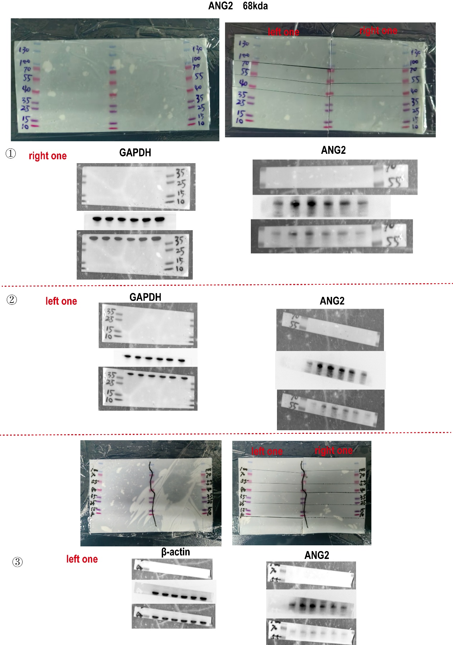
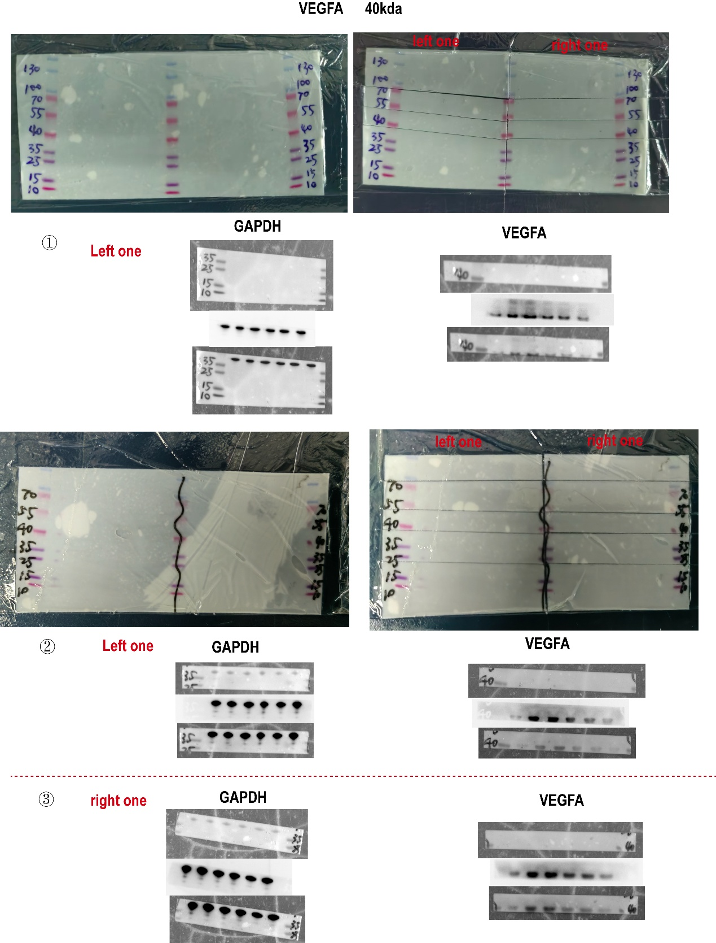

Folling is WB in Fig. 7.

Folling is WB in Fig. 9.

