A Triple-Action Nanoplatform for Retinal Neovascularization: Breaking Barriers, Blocking Angiogenesis and Fibrosis, and Restoring Mitophagy.

Menglei Wang^{1,2,3 †}, Meng Li^{1†}, Xiyuan Zhou^{1†}, Changhao Dong^{2,3}, Heyang Liu^{1,2}, Linglin Xia¹, Haitao Ran^{1,2,3*}, Minglan Wang^{1,2,3*}

¹Department of ophthalmology, The Second Affiliated Hospital of Chongqing Medical University, Chongqing 400010, China
²Department of Ultrasound, The Second Affiliated Hospital of Chongqing Medical University, Chongqing Key Laboratory of Ultrasound Molecular Imaging and Therapy
³Institute of Ultrasound Imaging, State Key Laboratory of Ultrasound in Medicine and Engineering, Chongqing Medical University, Chongqing 400010, China

†Menglei Wang, Meng Li and Xiyuan Zhou contributed equally to this work.

*Correspondence:
Haitao Ran: ranhaitao@cqmu.edu.cn
&
Minglan Wang: wangminglan0301@163.com

Fig. S1. Gating strategy for retinal microglia by flow cytometry. (A) Immune cells were gated. (B) Doublets were excluded. (C) CD11b⁺CD45⁺ cells were identified. (D) CD86⁺ cells were gated from the double-positive population. (E) CD206⁺ cells were gated from the double-positive population.

Fig. S2. Assessment of hepatic and renal function in mice via blood biochemical assays. (A) Serum concentrations of ALT. (B) Serum concentrations of AST. (C) Serum concentrations of sCr. (D) Serum concentrations of BUN. Data were displayed as MEAN±SD, n=3, *p<0.05, **p<0.01 and ***p<0.001.
Fig.S3. Assessment of systemic inflammatory responses in mice following administration of cRGD/siYAP/MEL. (A) White blood cell (WBC) counts in the blood. (B) Lymphocyte counts in the blood. (C) Monocyte counts in the blood. (D) Red blood cell (RBC) counts in the blood. Data were displayed as MEAN±SD, n=3, *p<0.05, **p<0.01 and ***p<0.001.

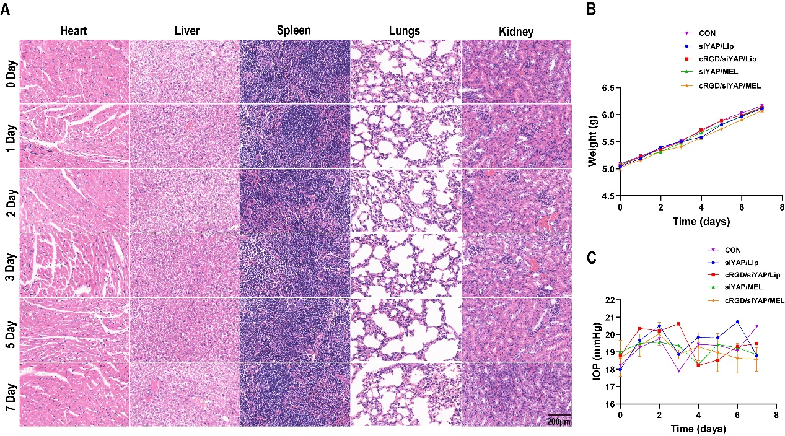
Fig.S4. Safety evaluation of mice following cRGD/siYAP/MEL treatment. (A) H&E staining of major organs in vivo. (B) Body weight changes after cRGD/siYAP/MEL treatment. (C) Intraocular pressure (IOP) changes after cRGD/siYAP/MEL treatment. Data were displayed as MEAN±SD, n=3.

Fig. S5. Changes in intraocular inflammatory cytokine levels in mice following cRGD/siYAP/MEL treatment. (A) TNF-α concentrations in the aqueous humor. (B) IL-6 concentrations in the aqueous humor. (C) IL-4 concentrations in the aqueous humor. (D) IL-10 concentrations in the aqueous humor. Data were displayed as MEAN±SD, n=3.

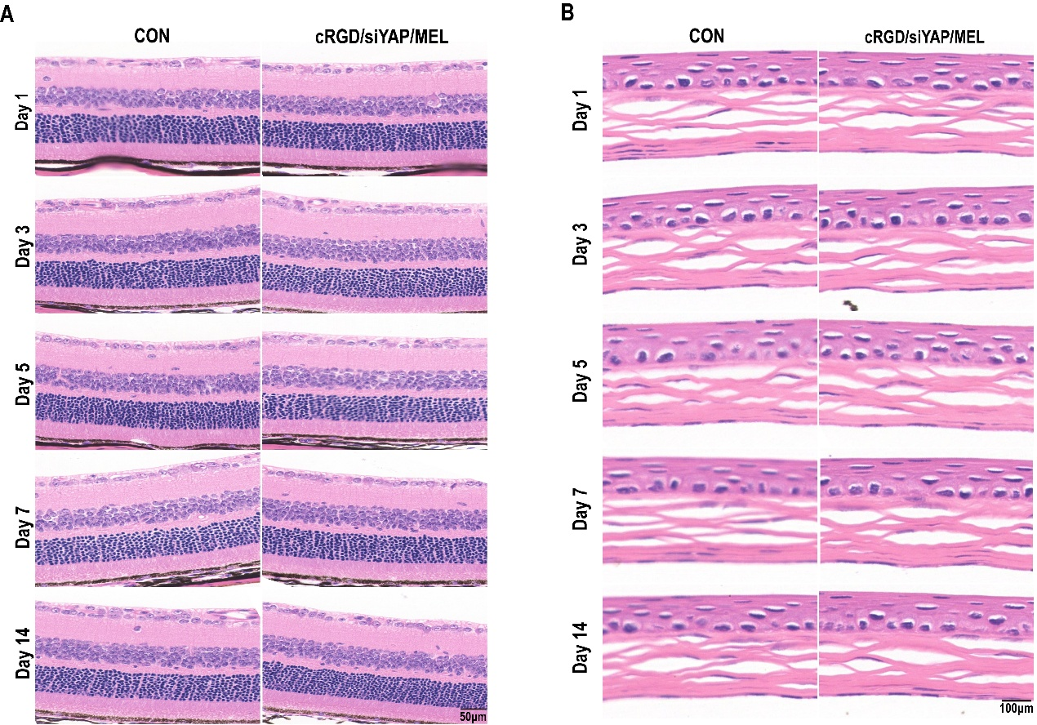
Fig. S6. Histomorphological assessment of ocular tissues in mice following cRGD/siYAP/MEL treatment. (A) H&E staining of the retina. (B) H&E staining of the cornea.

