Democratising global health research in rural Cambodia:
Youth-led co-creation of a community-driven research agenda

Co-created health promotion materials
Figure 1. Schematic diagram of the process of co-creation
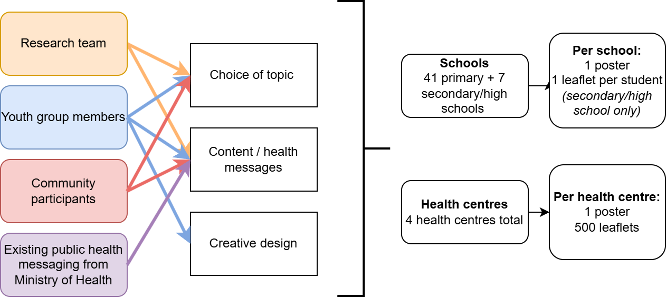

Figure 2. Health promotion leaflets in English
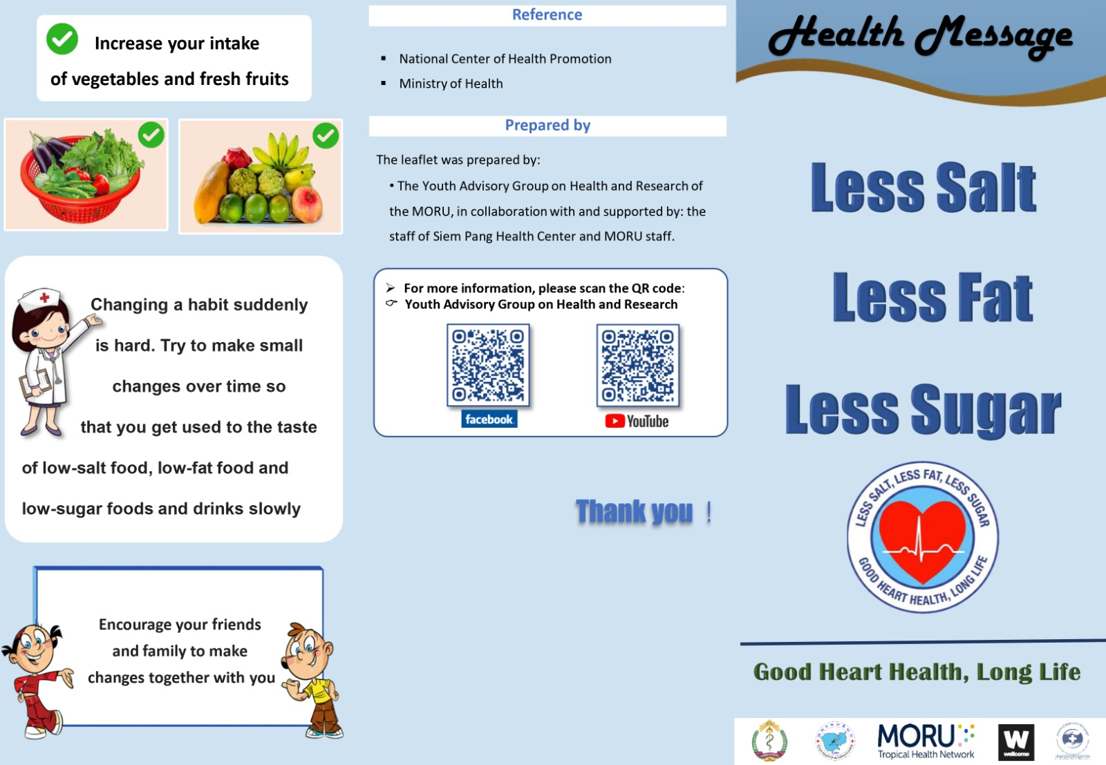

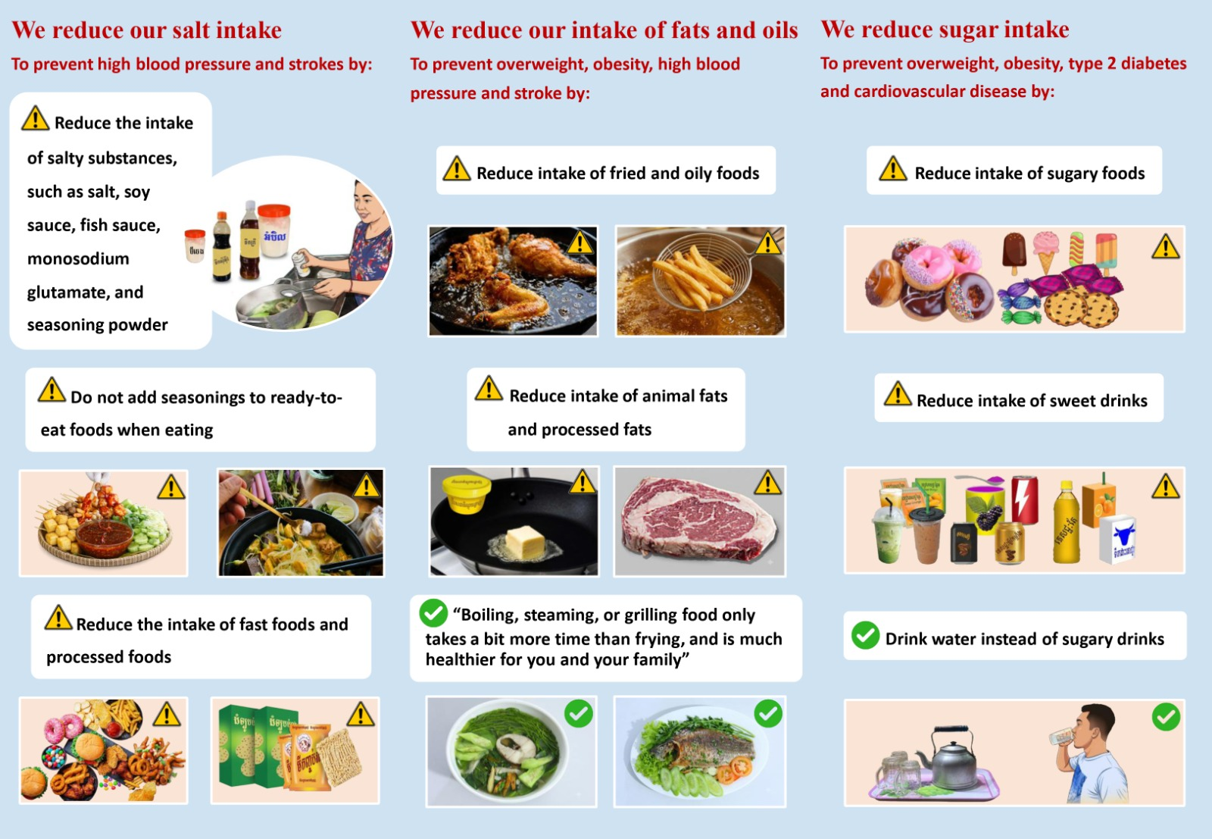

Figure 3. Health promotion leaflets in Khmer
