Supplementary Figures
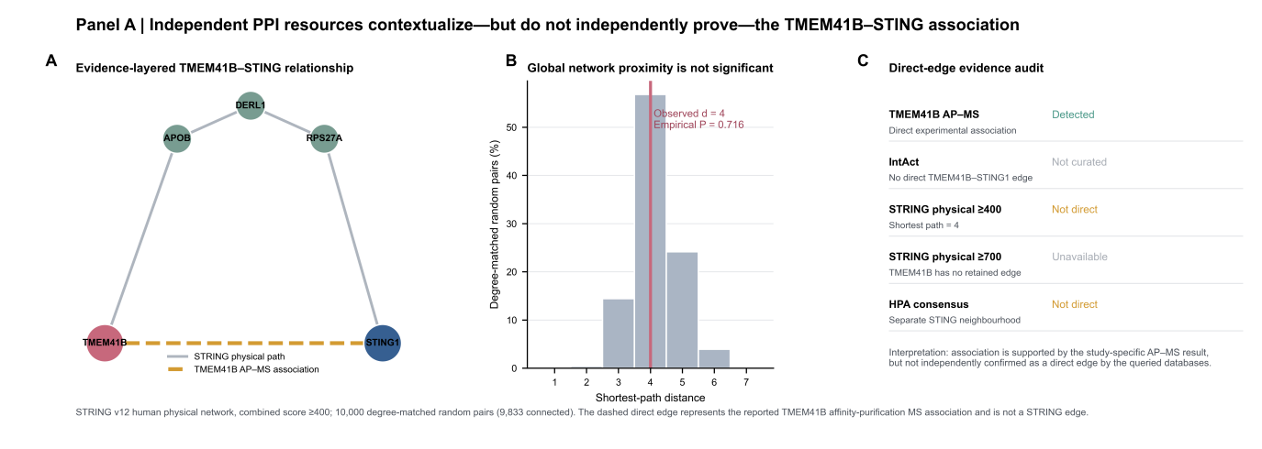
Supplementary Fig. 1 | Degree-matched protein-interaction network proximity. Local interaction evidence, shortest-path structure and degree-matched permutation test assessing whether TMEM41B is unusually close to STING1 in the complete STRING physical interactome (empirical P = 0.716).
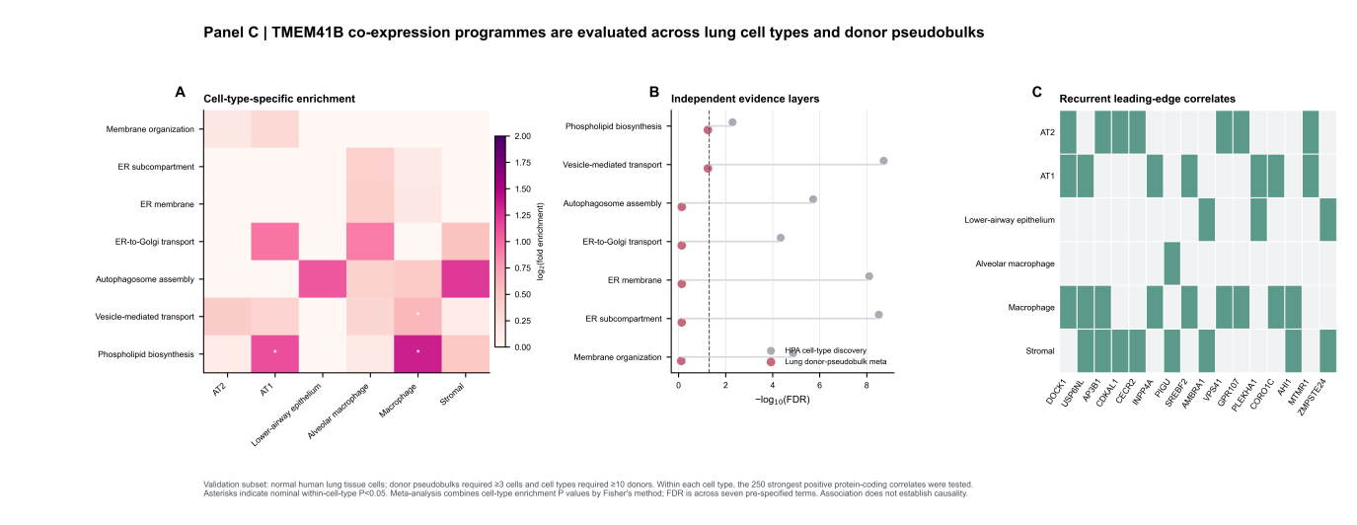
Supplementary Fig. 2 | Cell-type-resolved co-expression meta-analysis. Cell-type-specific TMEM41B correlations, pathway enrichment and cross-lineage meta-analysis showing context-dependent membrane and lipid associations.
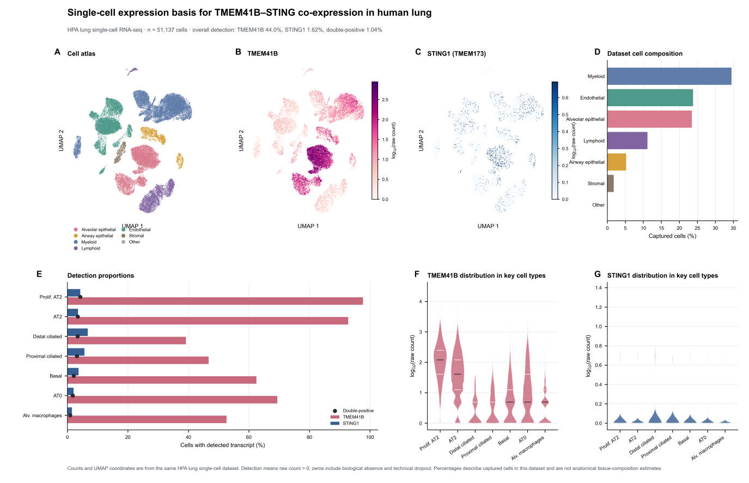
Supplementary Fig. 3 | Single-cell expression basis. Lung single-cell UMAP, cell composition, detection rates and violin plots defining the cellular contexts in which TMEM41B and TMEM173 can be jointly detected.
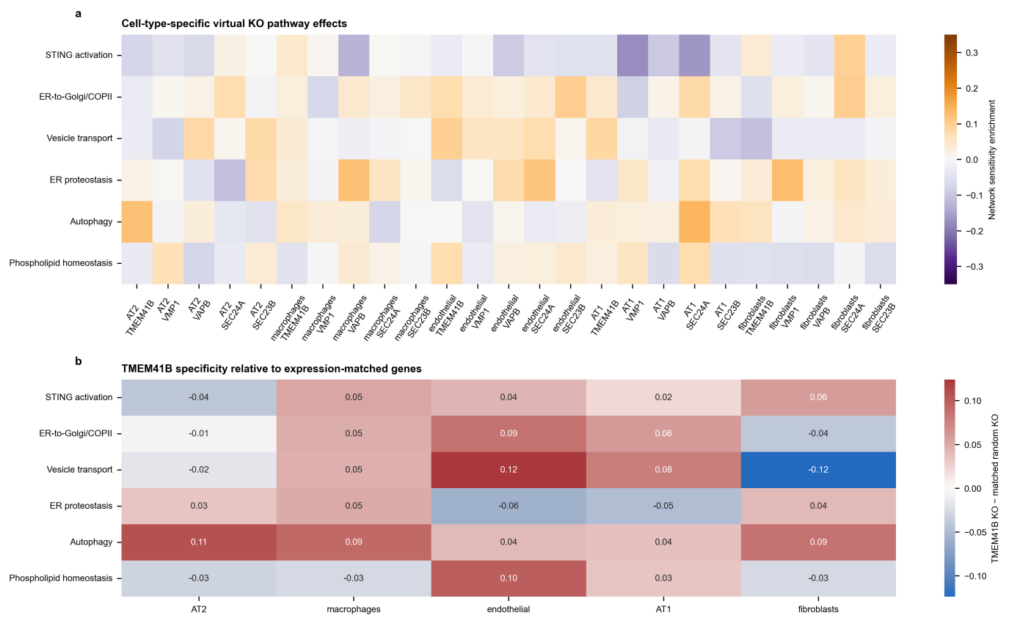
Supplementary Fig. 4 | Cell-type-matched virtual-knockout controls. Cell-type-resolved TMEM41B virtual knockout compared with VMP1, VAPB, SEC24A, SEC23B and expression-, detection- and dispersion-matched random-gene controls.
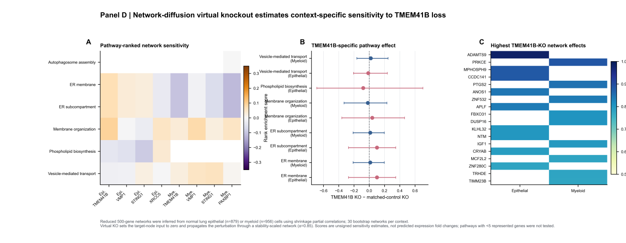
Supplementary Fig. 5 | Initial pooled-nuclei network-diffusion virtual knockout. Initial network-diffusion perturbation analysis, retained for transparency and superseded for inference by the donor-replicated ensemble analysis in Fig. 4.
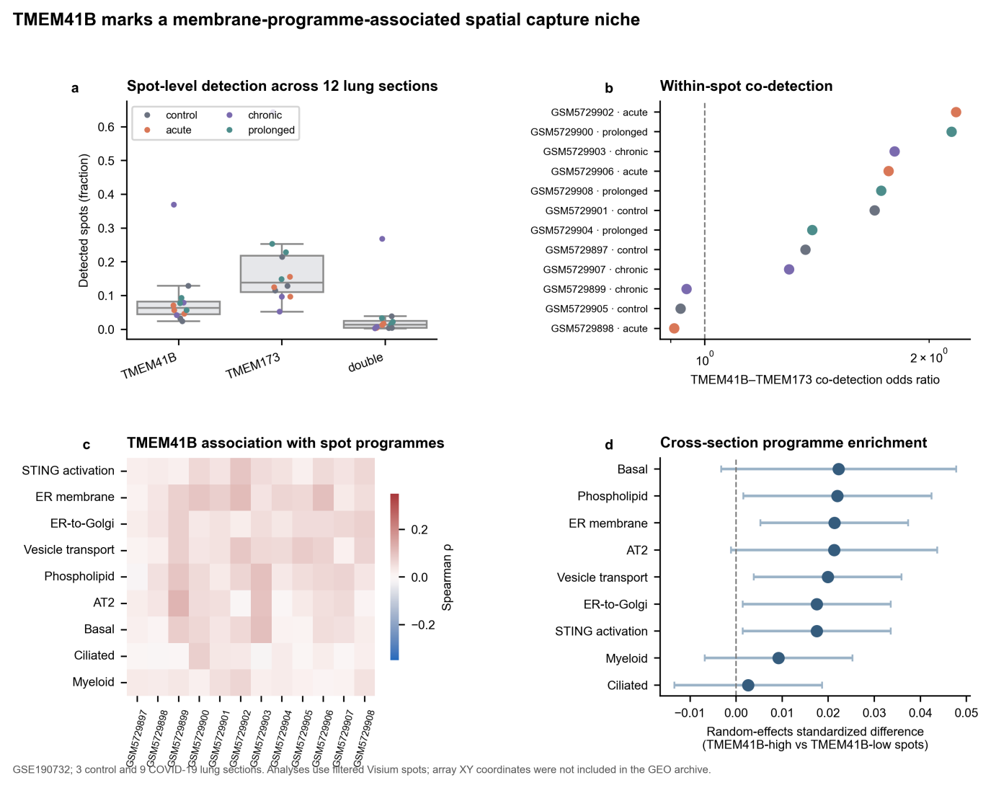
Supplementary Fig. 6 | Visium spot-level spatial ecology. Detection rates, TMEM41B–TMEM173 joint-detection odds ratios, within-section pathway correlations and random-effects comparison of TMEM41B-high versus TMEM41B-low spots across 12 lung sections. This stage preceded recovery of array coordinates and is superseded for inference by Supplementary Figs 7–8.
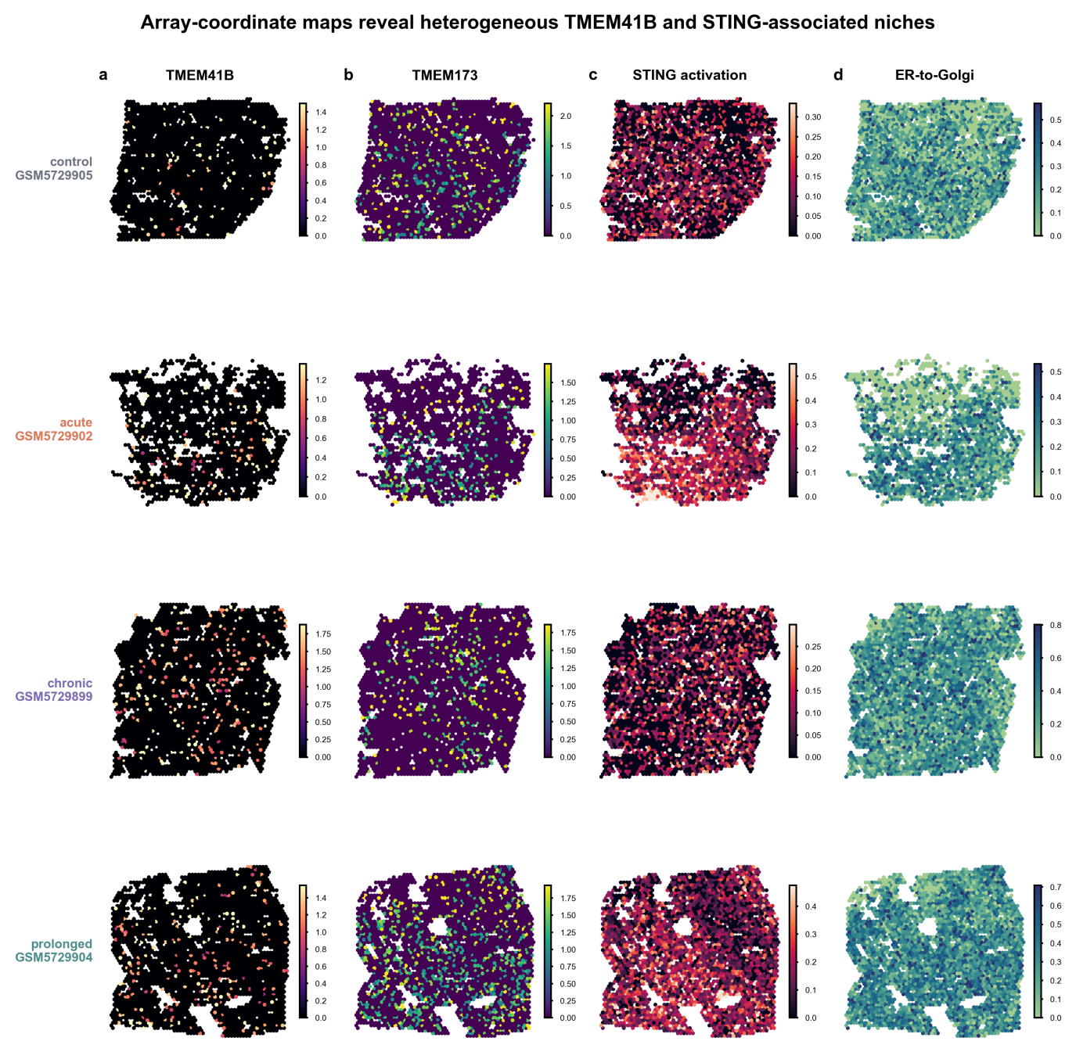
Supplementary Fig. 7 | Restored Visium array-coordinate maps. Representative array-coordinate maps of TMEM41B, TMEM173, STING activation and ER-to-Golgi programmes after restoration of official Visium V1 barcode coordinates. Coordinates are array-relative and are not pixel-registered to the immunofluorescence images.
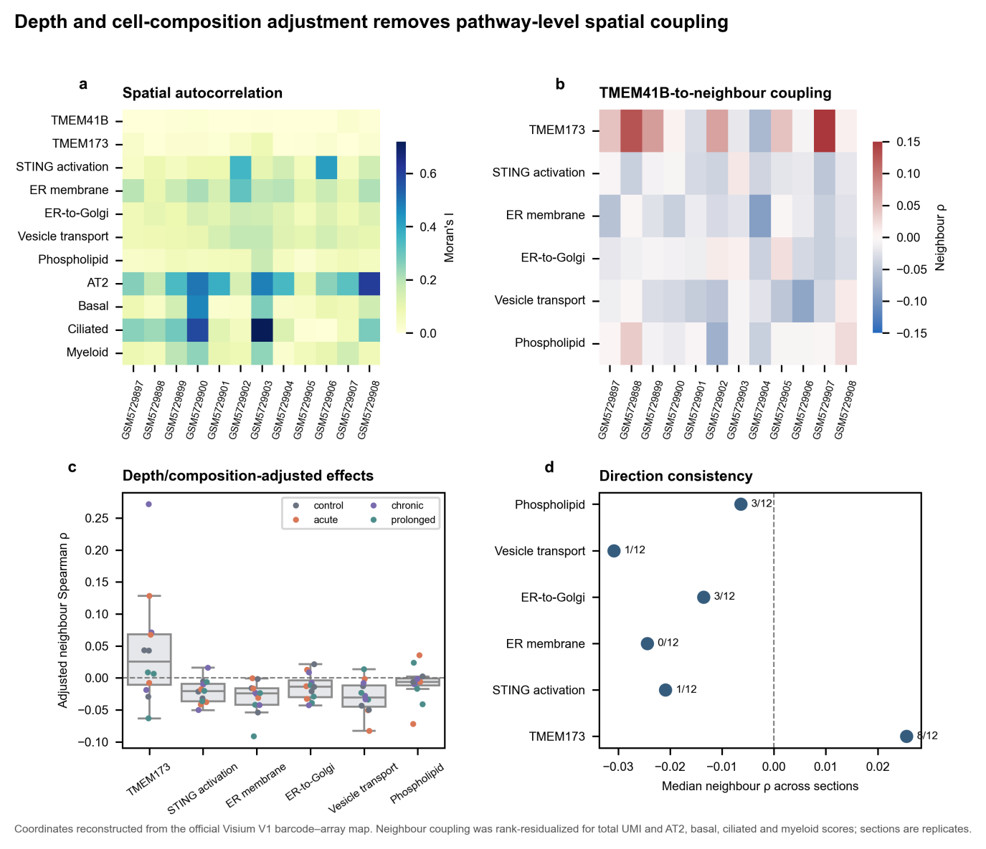
Supplementary Fig. 8 | Spatial autocorrelation and adjusted neighbourhood statistics. Moran's I and composition-adjusted spatial-lag correlations. Initially positive associations were largely removed after adjustment for sequencing depth and local cell composition; TMEM173 retained only a weak, non-significant trend (median ρ = 0.026; 8 of 12 sections positive; P = 0.388).
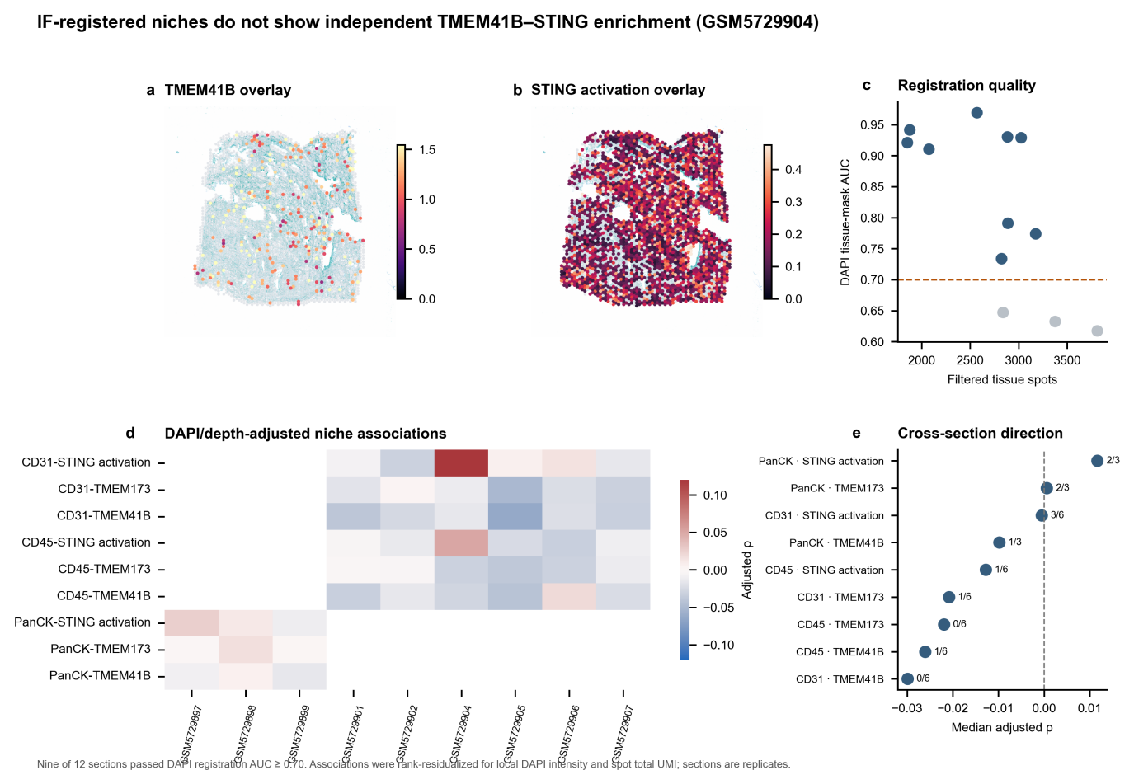
Supplementary Fig. 9 | Registered imaging–spatial niches. Fiducial-based registration quality control and adjusted CD45-, CD31- and PanCK-niche associations; no stable positive TMEM41B–STING enrichment was detected in any tissue niche.
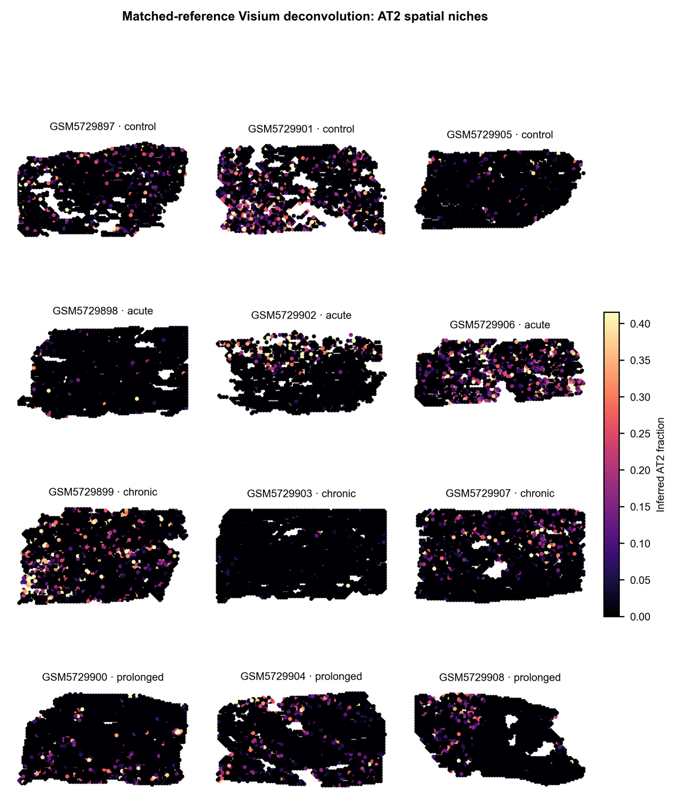
Supplementary Fig. 10 | AT2 deconvolution spatial maps. Section-level spatial maps of inferred AT2 abundance derived from the matched GSE198864 single-nucleus reference.
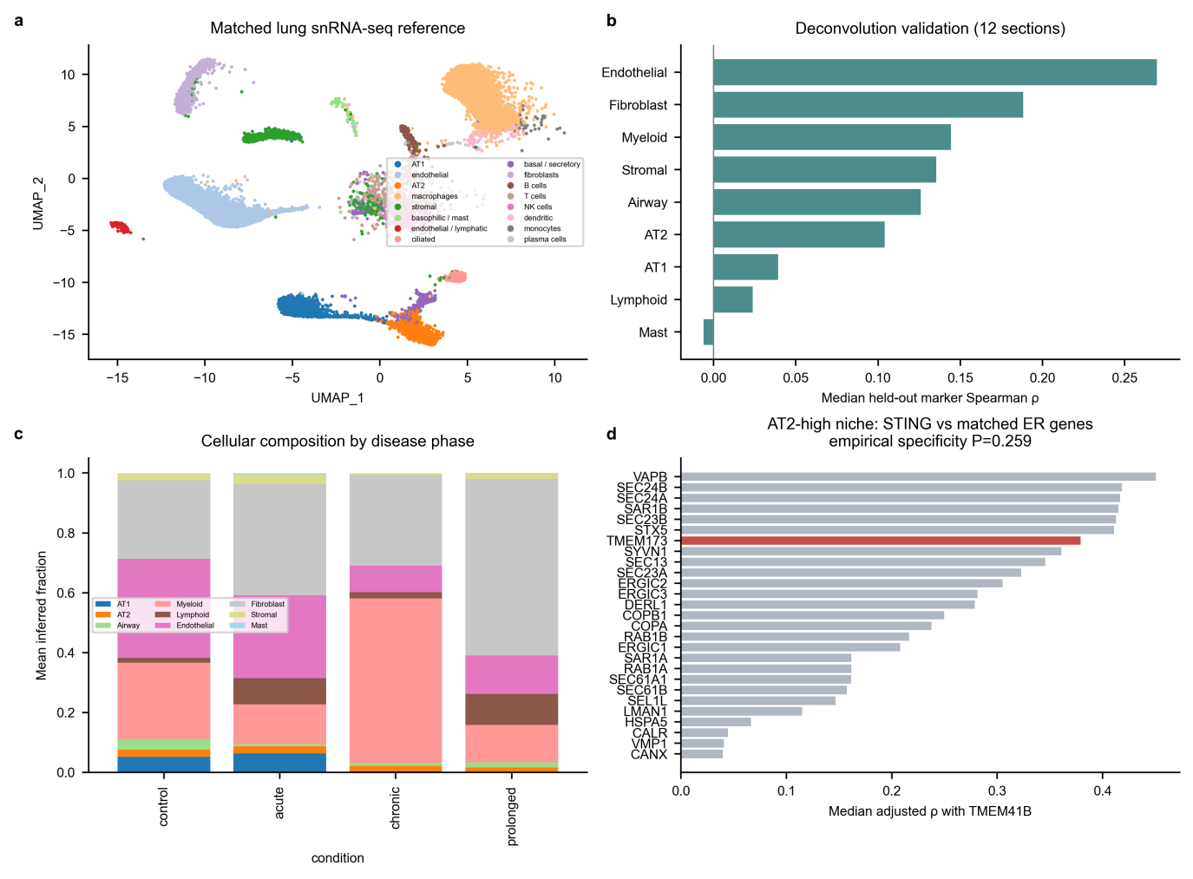
Supplementary Fig. 11 | Matched-reference deconvolution and AT2-niche specificity. Matched single-nucleus reference validation, Visium deconvolution and adjusted analysis of TMEM41B–TMEM173 relationships in AT2-high niches, with 25 ER/ERGIC/COPII genes as a specificity control (P = 0.259).
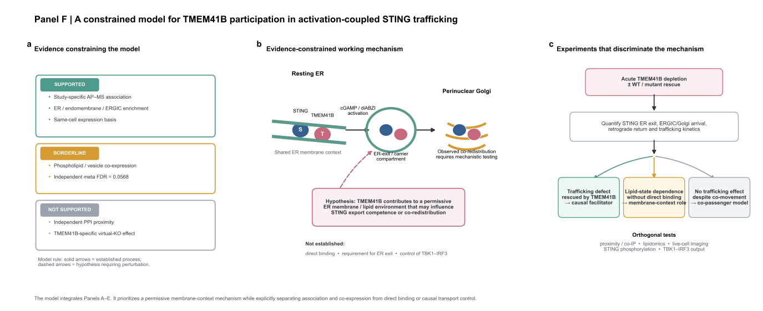
Supplementary Fig. 12 | Evidence-constrained working model. Data-driven working model separating the supported ER/early-secretory-pathway context from STING-specific causal claims that remain unverified by the computational analyses.

