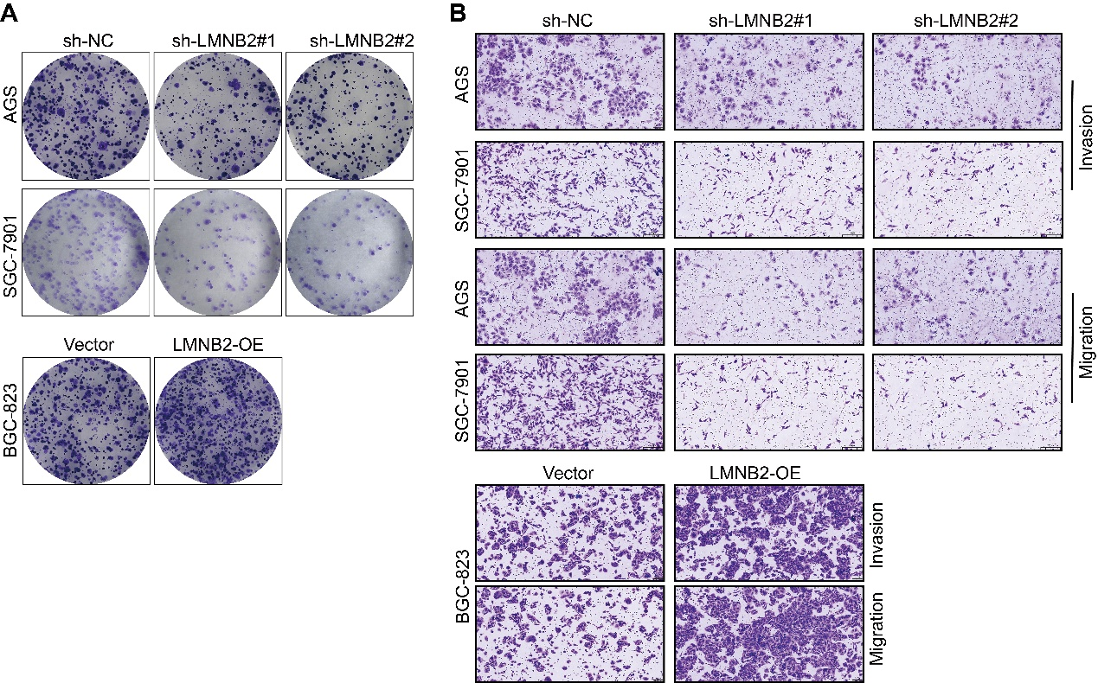
Supplementary Fig. S1 Effects of LMNB2 overexpression on clonogenicity and motility in gastric cancer cells. (A) Colony formation assays were performed to evaluate clonogenic capacity in BGC-823 cells following LMNB2 overexpression (LMNB2-OE). (B) Transwell assays were conducted to assess cell migration and invasion upon LMNB2 overexpression.

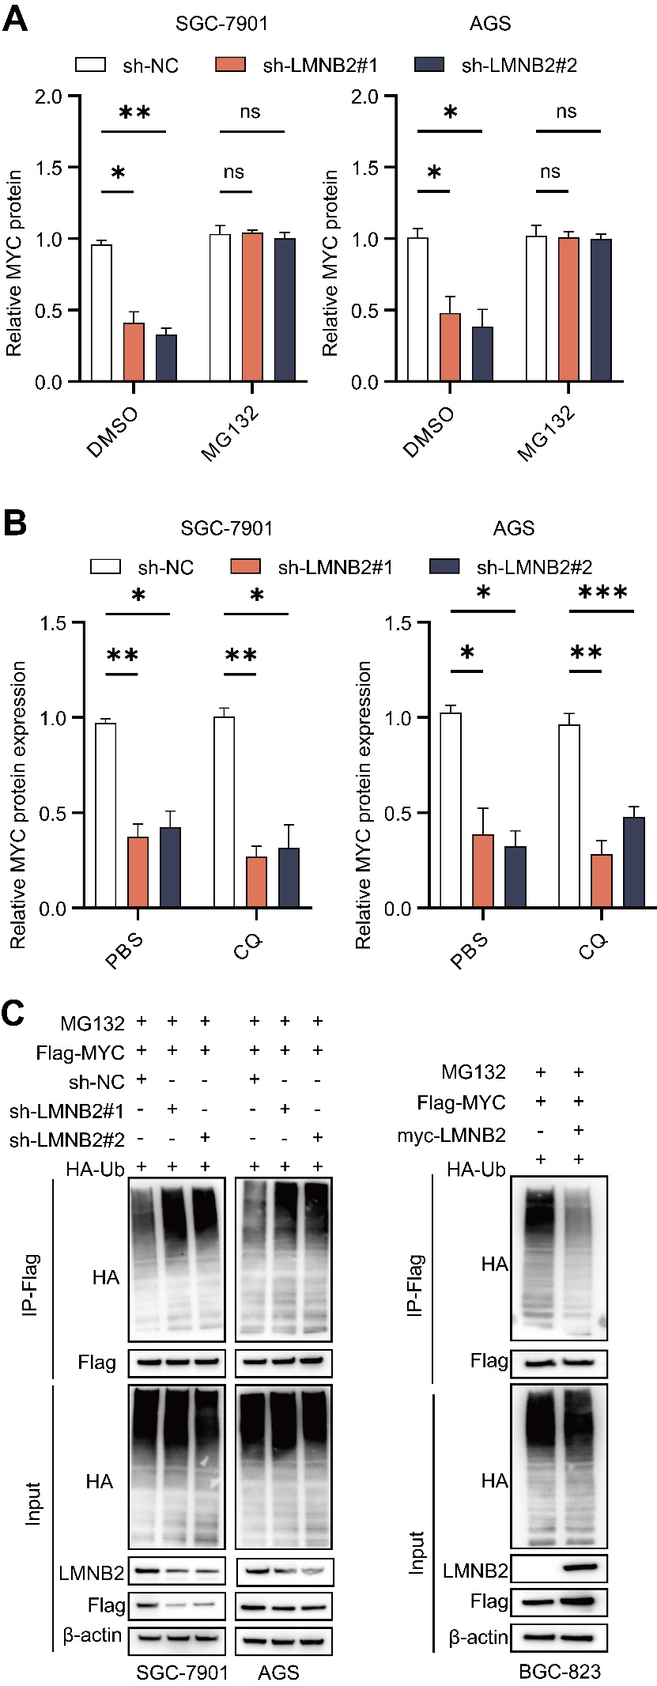
Supplementary Fig. S2 LMNB2 regulates MYC degradation and ubiquitination in gastric cancer cells. (A) Quantification of MYC protein expression in SGC-7901 and AGS cells following LMNB2 knockdown with or without MG132 treatment. (B) Quantification of MYC protein expression in SGC-7901 and AGS cells following LMNB2 knockdown with or without chloroquine (CQ) treatment. (C) Ubiquitination assays showing MYC ubiquitination levels in SGC-7901 and AGS cells following LMNB2 knockdown, and in BGC-823 cells following LMNB2 overexpression. Cells were treated with MG132 prior to harvesting. LMNB2 recruits USP37 to stabilize MYC by removing K48-linked ubiquitination.
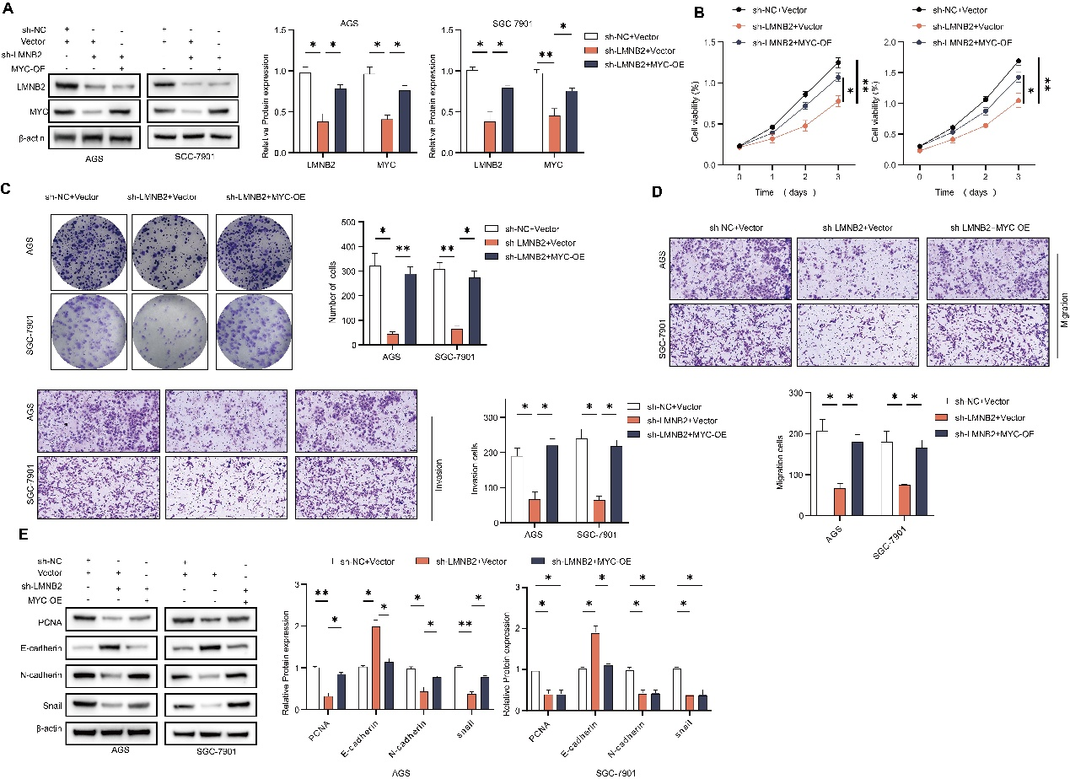
Supplementary Figure S3. MYC overexpression rescues proliferation, migration, invasion, and EMT marker expression suppressed by LMNB2 knockdown.
- Western blot analysis of LMNB2 and MYC expression following MYC overexpression in LMNB2-knockdown AGS and SGC-7901 cells. (B) CCK-8 assays evaluating cell viability over 3 days. (C) Colony formation assays. (D) Transwell migration and invasion assays. (E) Western blot analysis of PCNA and EMT-related markers (E-cadherin, N-cadherin, Snail). *p < 0.05; **p < 0.01; ***p < 0.001. n=3.

