Supplementary Material
This file contains supplementary methods, 11 supplementary tables, and 8 supplementary figures for the manuscript. Individual figure files are also supplied separately when required by the submission system.

Supplementary Methods
Supplementary analyses included lagged generalised estimating equation (GEE) models, generalised additive model (GAM) nonlinearity checks, latent growth curve models, carry-forward definitions, subgroup and interaction analyses, and latent class growth analysis/group-based trajectory modelling (LCGA/GBTM). Primary models were unweighted complete-case models. Longitudinal inverse-probability weights were not applied because validated attrition weights for the outcome-specific risk sets were not available in the released analytic files.
Abbreviations: ADL, activities of daily living; APP, average posterior probability; CMR, cardiometabolic-renal; GAM, generalised additive model; GBTM, group-based trajectory modelling; GEE, generalised estimating equation; IADL, instrumental activities of daily living; LCGA, latent class growth analysis.

Table S1. Operational definitions of rule-based CMR burden change patterns
Pattern | Operational definition
Low-stable burden | Maximum score ≤1 and mean score <1
Increasing burden | 2018 score minus 2011 score ≥1 and individual slope >0
Decreasing burden | 2018 score minus 2011 score ≤-1 and individual slope <0
Persistent/fluctuating moderate-high burden | Mean score ≥2 or high-burden waves ≥50%
Intermediate-stable burden | Remaining classifiable participants
Note: High burden was defined as a CMR burden score ≥2.

Table S2. Main analysis sample flow and event counts
Item | N
Five-wave complete participants | 10927
Participants with valid 2011-2018 burden pattern | 10556
Eligible for incident functional impairment | 7296
Incident functional impairment events | 1601
Eligible for incident ADL impairment | 8588
Incident ADL impairment events | 1481
Eligible for incident IADL impairment | 8010
Incident IADL impairment events | 1233

Table S3. Distribution of five-wave CMR burden classifications
Classification | N | Proportion | Percent (%)
Low-stable burden | 5745 | 0.53 | 52.60
Intermediate-stable burden | 1635 | 0.15 | 15.00
Increasing burden | 1884 | 0.17 | 17.20
Decreasing burden | 519 | 0.05 | 4.70
Persistent/fluctuating moderate-high burden | 773 | 0.07 | 7.10
Not classified | 371 | 0.03 | 3.40

Table S4. Latent growth curve model fit indices
Measure | Value
CFI | 0.96
TLI | 0.95
RMSEA | 0.14
SRMR | 0.05
AIC | 84677.08
BIC | 84742.77

Table S5. Lagged GAM nonlinearity tests
Outcome | Smooth term | edf | Statistic | p | N | Events
Functional impairment | s(Prior-wave CMR burden) | 1.00 | 539.76 | <0.001 | 34578 | 10843
Functional impairment | s(survey year) | 2.91 | 230.80 | <0.001 | 34578 | 10843
ADL impairment | s(Prior-wave CMR burden) | 1.29 | 465.78 | <0.001 | 34483 | 7308
ADL impairment | s(survey year) | 2.96 | 289.02 | <0.001 | 34483 | 7308
IADL impairment | s(Prior-wave CMR burden) | 1.02 | 394.65 | <0.001 | 34577 | 8089
IADL impairment | s(survey year) | 2.58 | 172.17 | <0.001 | 34577 | 8089

Table S6. Interaction tests for mean CMR burden score
Outcome | Exposure | Modifier | Model | N | Events | P for interaction
Incident functional impairment | Mean CMR burden score | Sex | Model 4 | 5808 | 1289 | 0.45
Incident functional impairment | Mean CMR burden score | Age group | Model 4 | 5808 | 1289 | 0.46
Incident functional impairment | Mean CMR burden score | Depressive symptoms | Model 4 | 5808 | 1289 | 0.91
Incident functional impairment | Mean CMR burden score | Non-CMR disease burden | Model 4 | 5808 | 1289 | 0.60

Table S7. Global interaction tests for CMR burden patterns
Outcome | Exposure | Modifier | Model | N | Events | P for interaction
Incident functional impairment | CMR burden pattern | Sex | Model 4 | 5657 | 1252 | 0.28
Incident functional impairment | CMR burden pattern | Age group | Model 4 | 5657 | 1252 | 0.85
Incident functional impairment | CMR burden pattern | Depressive symptoms | Model 4 | 5657 | 1252 | 0.52
Incident functional impairment | CMR burden pattern | Non-CMR disease burden | Model 4 | 5657 | 1252 | 0.02

Table S8. LCGA/GBTM candidate model fit indices
Number of classes | Convergence code | Log likelihood | AIC | BIC | Entropy | Minimum class N | Minimum class proportion | Mean APP
1 | 1 | −42648.96 | 85305.92 | 85334.98 |  | 10556 | 1.00
2 | 1 | −41038.78 | 82091.56 | 82142.41 | 0.78 | 1533 | 0.15 | 0.94
3 | 1 | −41038.78 | 82097.56 | 82170.20 | 0.39 | 1536 | 0.15 | 0.69
4 | 1 | −41038.78 | 82103.56 | 82198.00 | 0.25 | 1861 | 0.18 | 0.52
5 | 2 | −41038.78 | 82109.56 | 82225.79 | 0.19 | 2001 | 0.19 | 0.40

Table S9. Selected LCGA/GBTM class distribution
Trajectory class | N | Percent (%) | Mean burden overall | Mean burden in 2011 | Mean burden in 2018 | Change, 2011–2018
Class 1 | 9023 | 85.48 | 0.66 | 0.62 | 0.62 | -0.002
Class 2 | 1533 | 14.52 | 1.65 | 1.01 | 2.51 | 1.51

Table S10. Selected LCGA/GBTM posterior probability summary
Trajectory class | Raw class | Class order | N | Mean assigned posterior probability | Median assigned posterior probability | Minimum assigned posterior probability
Class 1 | 1 | 1 | 9023 | 0.96 | 1.00 | 0.55
Class 2 | 2 | 2 | 1533 | 0.84 | 0.91 | 0.50

Table S11. Attrition diagnostics by five-wave completion status
Five-wave completion status | N | Mean baseline age, years | SD of baseline age | Baseline ADL impairment, proportion | Baseline IADL impairment, proportion
No | 6781 | 60.96 | 11.62 | 0.20 | 0.25
Yes | 10927 | 57.61 | 8.95 | 0.15 | 0.19

Figure S1. Mean CMR burden across five CHARLS waves by the rule-based 2011–2018 change pattern.
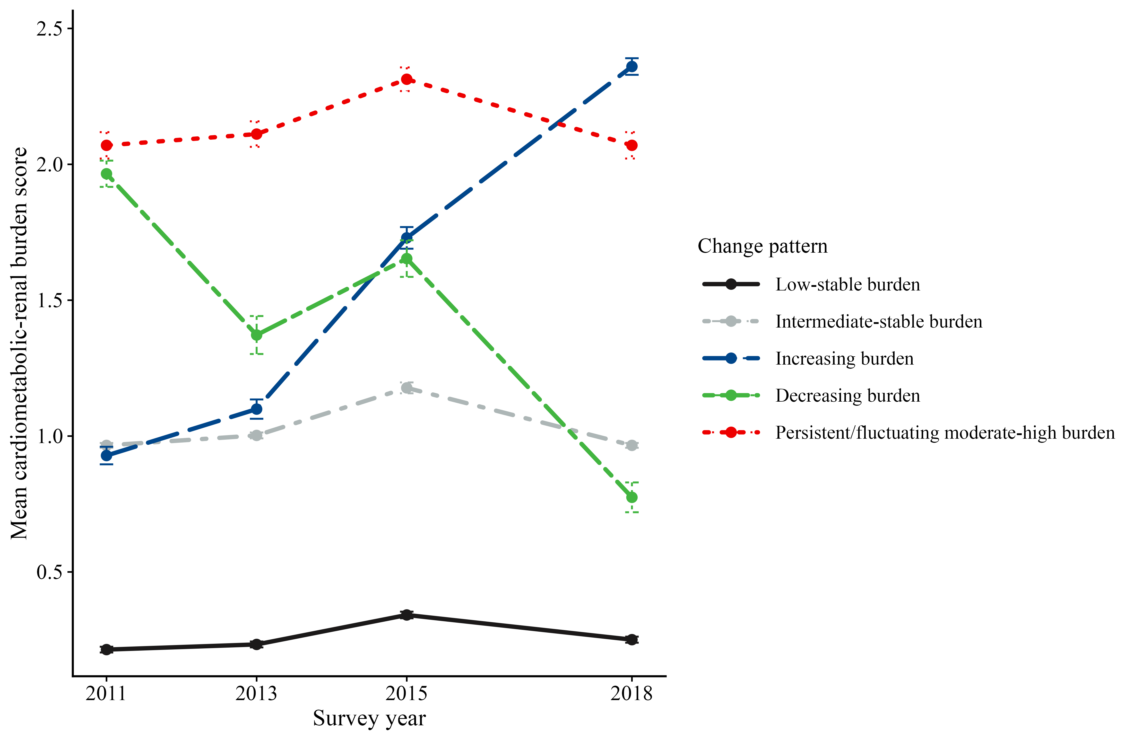

Figure S2. Lagged GEE associations of prior-wave CMR burden with next-wave functional impairment.

Figure S3. Associations of latent growth factors with incident functional impairment.

Figure S4. Carry-forward sensitivity analysis of CMR burden change patterns.

Figure S5. Carry-forward sensitivity analysis of cumulative CMR burden.

Figure S6. Subgroup associations of mean CMR burden with incident functional impairment.

Figure S7. LCGA/GBTM CMR burden trajectories from 2011 to 2018.
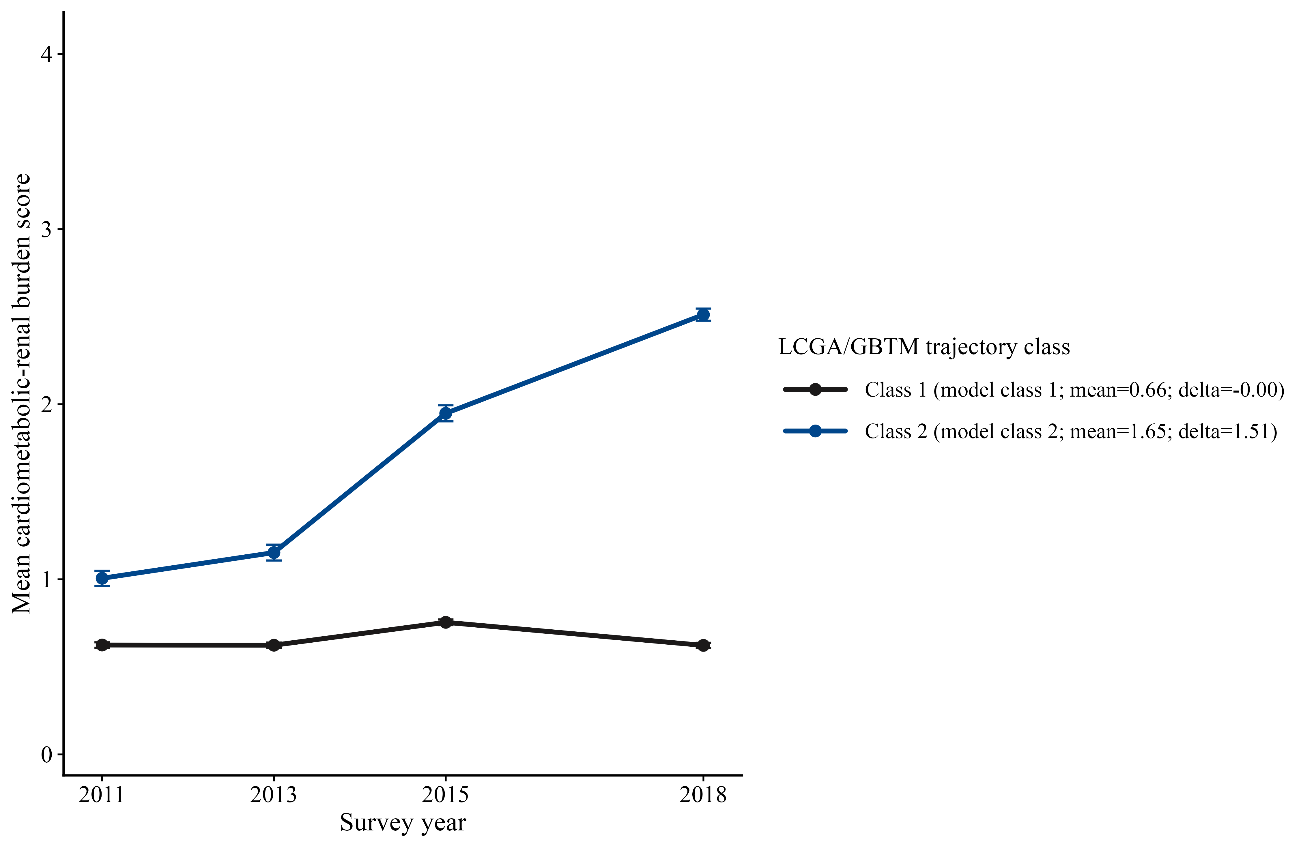

Figure S8. Associations of LCGA/GBTM trajectory class with incident functional impairment.

