Supplementary information
Biodegradable microplastic type and maize-straw addition shape soil CO₂ emissions: links to dissolved organic matter turnover and microbial carbon allocation
Hongcheng Bai¹, Yan Li², Peili Lu³
¹School of Architecture and Civil Engineering, Chengdu University, Chengdu, Sichuan, 610106, China
²State Key Laboratory of Soil and Sustainable Agriculture, Institute of Soil Science, Chinese Academy of Sciences, Nanjing 211135, China
³Department of Environmental Science, Chongqing University, China, 400045
Contents
Figures S1–S8
Tables S1–S4
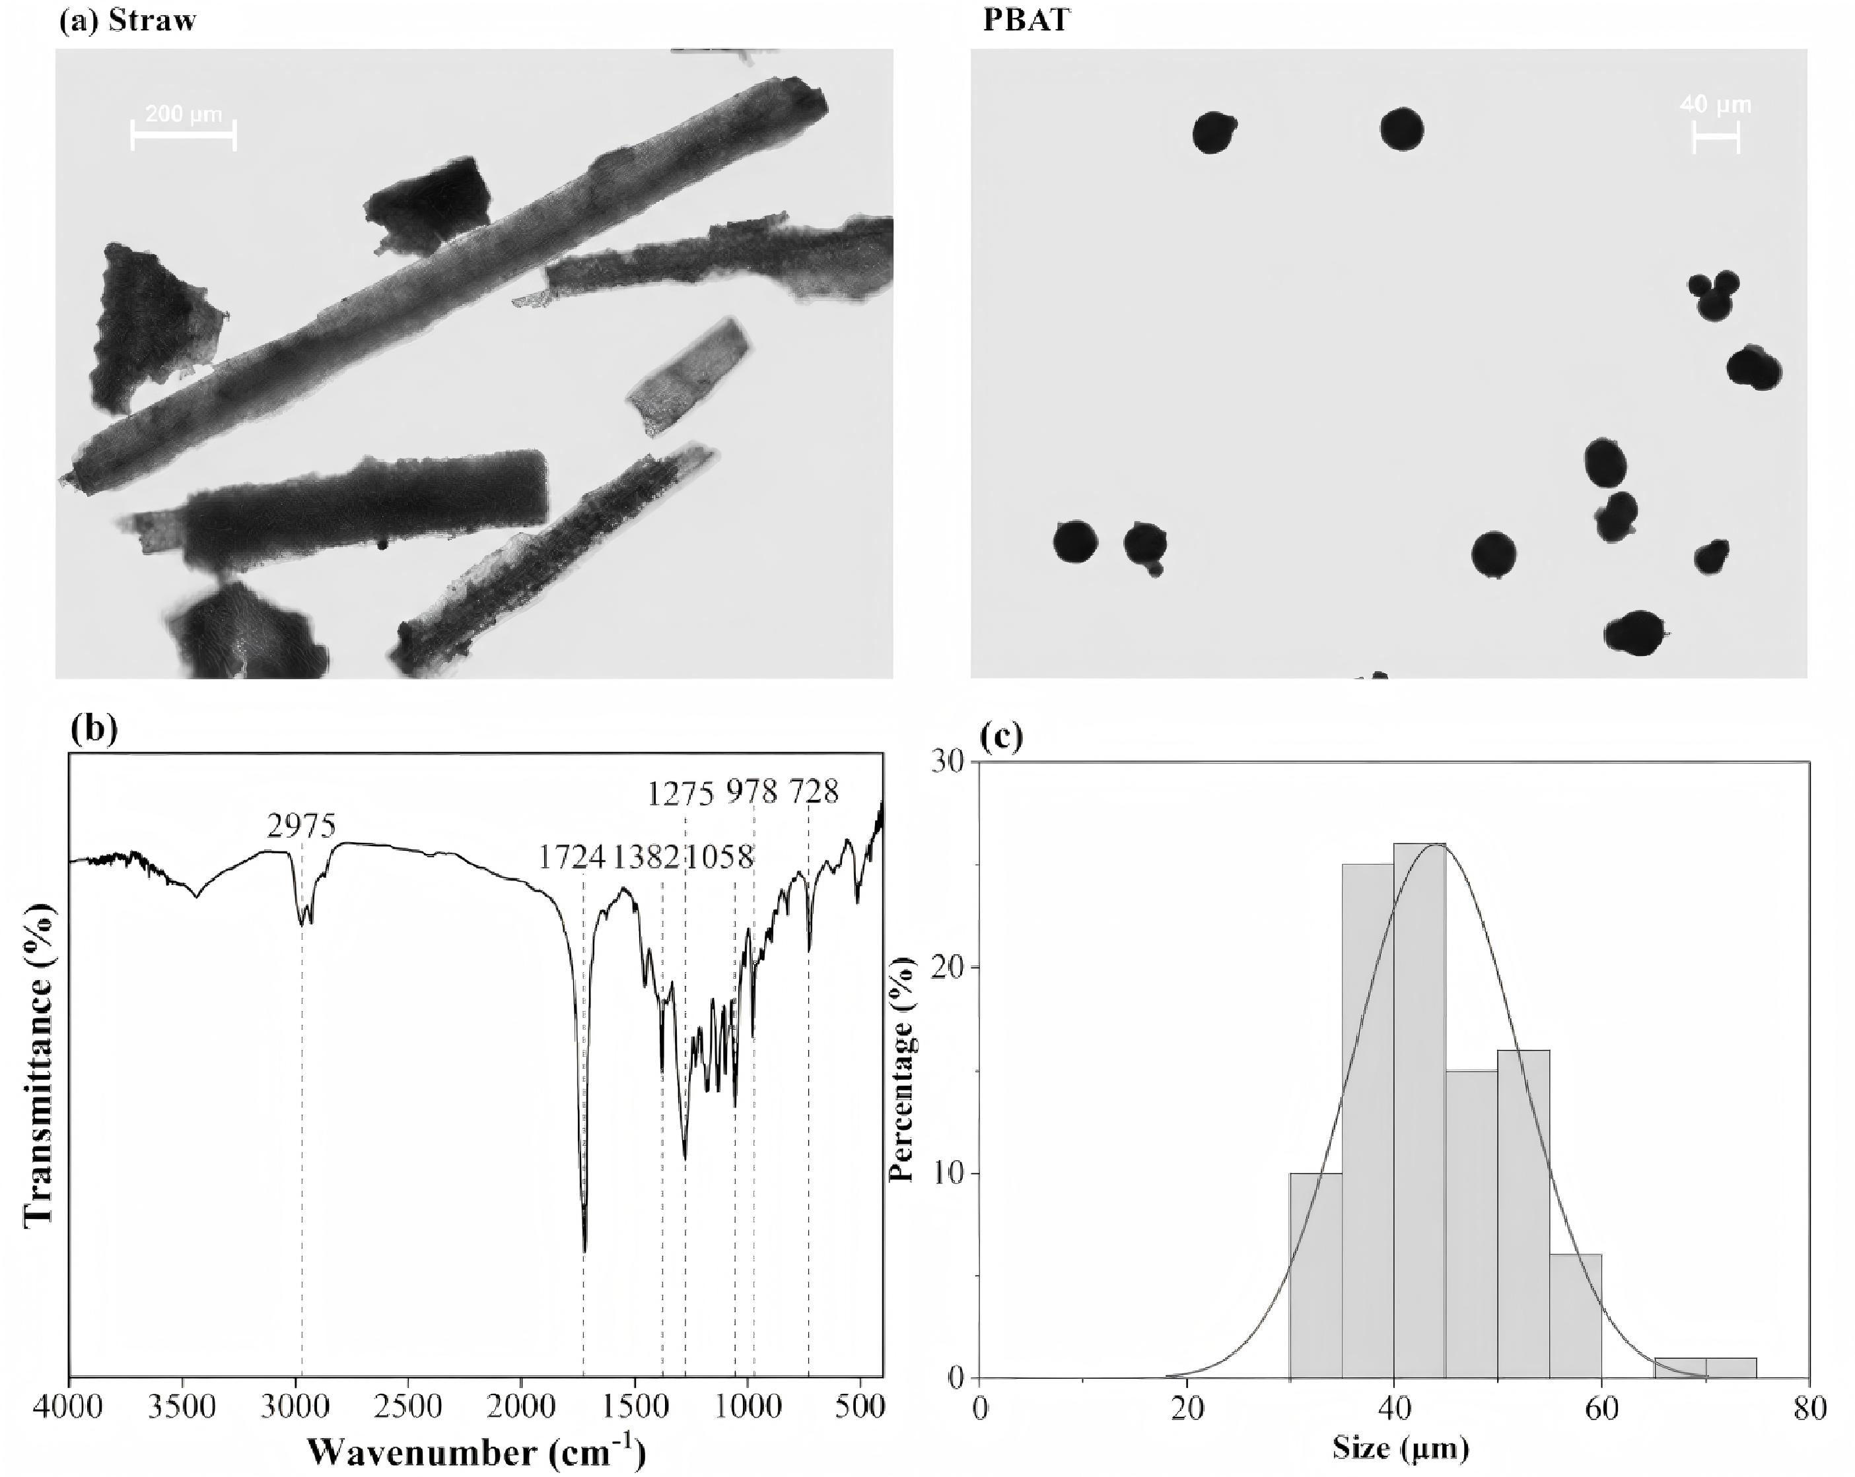
Fig. S1. Initial characterization of maize straw and PBAT. (a) Microscopic images of maize straw and PBAT; (b) FTIR spectrum of PBAT; and (c) PBAT particle-size distribution
Fig. S2. Power-function relationship between soil dissolved organic carbon (DOC) and CO₂ emission rate across treatments and sampling dates. The fitted relationship, coefficient of determination and significance level are shown in the artwork.
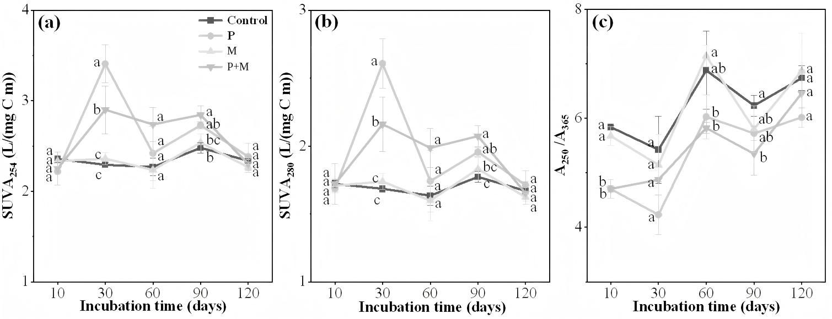
Fig. S3. Temporal changes in DOM optical indices: (a) SUVA₂₅₄, (b) SUVA₂₈₀ and (c) A₂₅₀/A₃₆₅. Control, P, S and SP correspond to CK, P, M and P+M, respectively. Values are means ± SD (n = 3); different lowercase letters at the same sampling time denote p < 0.05.
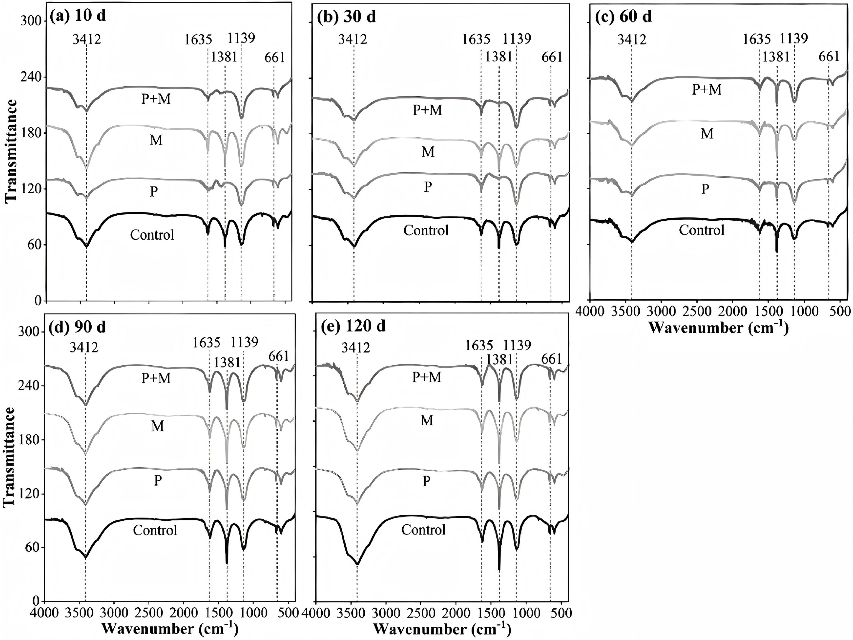
Fig. S4. FTIR spectra of soil DOM after 10, 30, 60, 90 and 120 d of incubation.CK, unamended soil; P, soil amended with 1% PBAT; M, soil amended with 1% maize straw; and P+M, Annotated bands are centered at 3412, 1635, 1381, 1139 and 661 cm⁻¹.
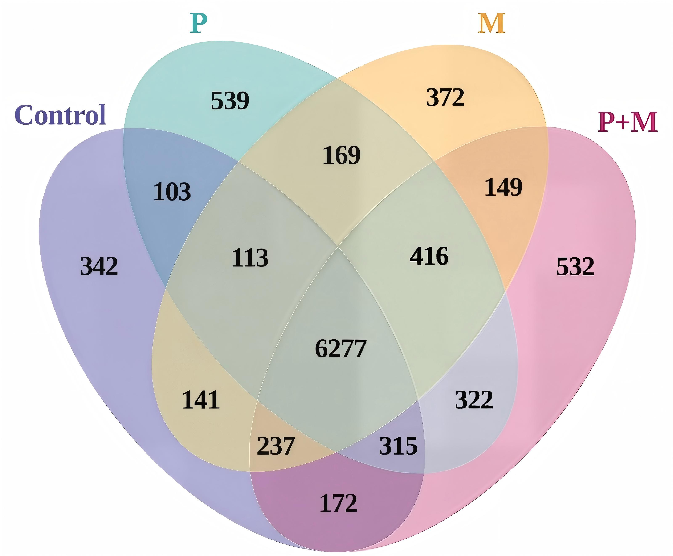
Fig. S5. Venn diagrams showing the numbers of assigned DOM molecular formulae shared within and between treatments at day 10.
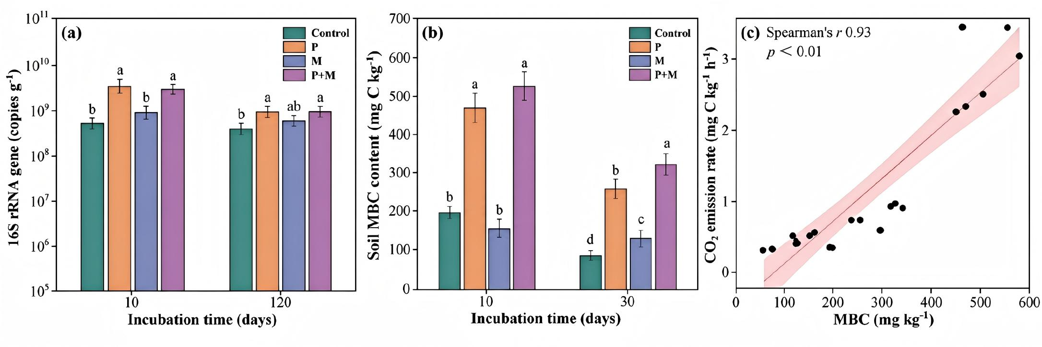
Fig. S6. (a) Absolute abundance of the bacterial 16S rRNA gene, (b) microbial biomass carbon (MBC) on days 10 and 30, and (c) association between MBC and CO₂ emission rate. Values are means ± SD (n = 3); different lowercase letters at the same sampling time denote p < 0.05.
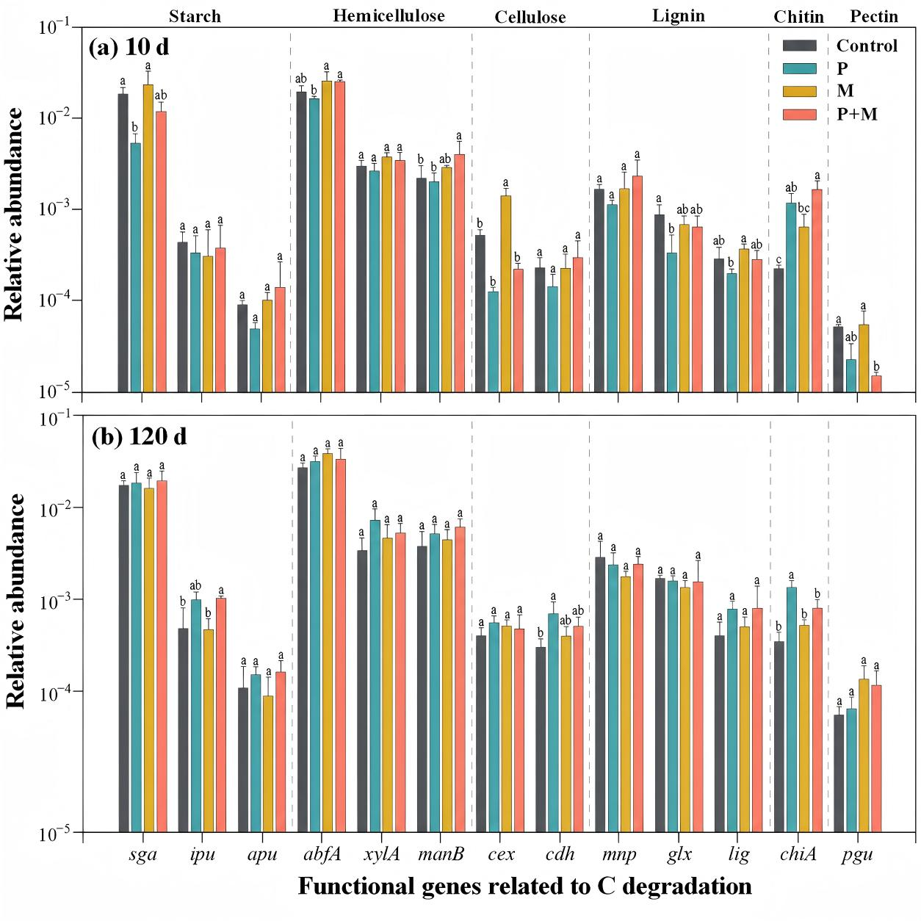
Fig. S7. Abundances of selected C-degradation genes normalized to bacterial 16S rRNA gene abundance on days 10 and 120. Values are means ± SD (n = 3); different lowercase letters within a sampling time or gene category denote p < 0.05.
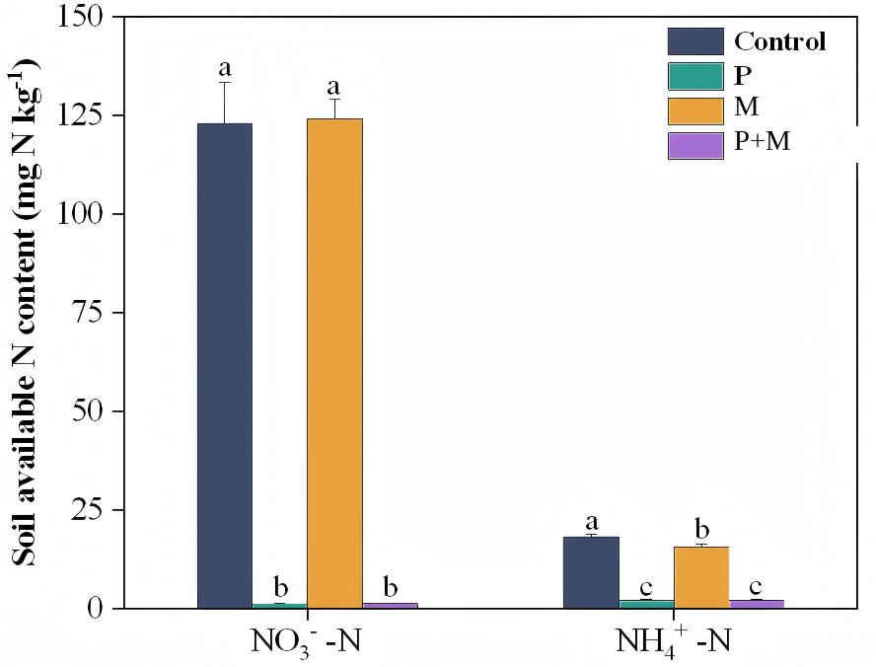
Fig. S8. Soil NO₃⁻–N and NH₄⁺–N concentrations on day 10. Control, P, S and SP correspond to CK, P, M and P+M, respectively. Values are means ± SD (n = 3); different lowercase letters denote p < 0.05.

Table S1. Factorial effects of PBAT, maize straw and their interaction on cumulative soil CO₂ emission during the 120-d incubation.
Impact factors | F | P
PBAT | 4570.900 | <0.001***
Straw | 359.288 | <0.001***
PBAT×Straw | 22.332 | <0.01**
Table S2. Descriptive molecular properties of day-10 soil DOM obtained by FT-ICR-MS.
Sample | Formula number | m/z₍w₎ | O/C₍w₎ | H/C₍w₎ | DBE₍w₎ | AI₍w₎ | NOSC₍w₎ | MLB
Control | 7800 | 375 | 0.419 | 1.196 | 8.491 | 0.313 | −0.269 | 0.127
P | 8598 | 392 | 0.430 | 1.178 | 8.963 | 0.317 | −0.219 | 0.101
M | 7974 | 378 | 0.423 | 1.218 | 8.278 | 0.295 | −0.286 | 0.147
P+M | 8520 | 380 | 0.437 | 1.177 | 8.706 | 0.314 | −0.207 | 0.116
Subscript w denotes peak-intensity-weighted values. MLB is the fraction of assigned formulae with H/C ≥ 1.5. Control, P, S and SP correspond to CK, P, M and P+M, respectively. One extract per treatment was analyzed; values are therefore descriptive.
Table S3. qPCR primer pairs for the bacterial 16S rRNA reference and genes involved in organic-carbon and organic-nitrogen degradation.
Gene name | Gene function | Encoded protein | Predicted  length (bp) | Forward sequence  (5′ → 3′) | Reverse sequence  (5′ → 3′)
16S | Reference gene | bacterial ribosomal RNA | 393 | GTGCCAGCMGCCGCGG | CCGTCAATTCMTTTRAGTTT
amyA | Starch hydrolysis | α-amylase | 316 | YGGTTTTCGTCTTGACGCSG | MGGCTGMGTRTCATGRTTK
amyX | Starch hydrolysis | pullulanase | 365 | TATAAYTGGGGMTATGAYCC | CCCATYAAATCAAAWCGRAA
apu | Starch hydrolysis | amylopullulanase | 287 | ACVTGGATAGGYGAGCCYCA | CCRTCSGGGAAGTAGTTKCC
sga | Starch hydrolysis | glucoamylase | 375 | CGSAACTGGGAYTACCGS | TCCCACAGSCCSKCGTC
ipu | Starch hydrolysis | isopullulanase | 540 | GTCATYTACTTYGGNCC | CGNGCSACATCNGCCCA
abfA | Hemicellulose hydrolysis | α-L-arabinofuranosidase | 349 | CGSTAYCCSGGCGGCAAYTT | TGCCASGGNCCGTCCATYTC
manB | Hemicellulose hydrolysis | β-mannanase | 323 | ATGCGCGGBGTCAACCA | TCGTTGSCGATGTTGABGA
xylA | Hemicellulose hydrolysis | xylose isomerase | 464 | TGGGGBGGTCGYGAAGG | ACTTTGGCRTCRAAGTT
cdh | Cellulose hydrolysis | cellobiose dehydrogenase | 130 | ATWRYCTWCCGMRTHGCCMT | GTKAGSGGRTTBYKGRYCAT
cex | Cellulose hydrolysis | exoglucanase | 380 | YSTACGGSATGCACTGGMT | TANCGCAGRTAGTCVCCCAT
glx | Lignin hydrolysis | glyoxal oxidase | 312 | AACCAGTCGATCATCTACGA | RTGSACGAGCTCDGGCATGG
lig | Lignin hydrolysis | lignin peroxidase | 243 | CCGCACACACTGTTGCTGC | CGAAGGATTGCCACTCGCA
mnp | Lignin hydrolysis | manganese peroxidase | 294 | MACRCCSTTCGACTCSACC | ACGTCSGAGCAGTCRAYGA
pox | Lignin hydrolysis | phenol oxidase | 155 | ACYAGTATCCATTGGCACGGT | AGATGVGARTGATACCARAA
chiA | Chitin hydrolysis | endochitinase | 300 | TSAAGAARTACGCSGACAACG | ASGTCATCAGRCCCTTSAG
exo-chi | Chitin hydrolysis | exochitinase | 400-430 | GATTGGTSVCAATATGAYRG | STCCARCCACCRAYRCTRAA
pgu | Pectin hydrolysis | pectinase/polygalacturonase | 380 | ANCATTGGTGGCCSTGGAA | TTRAYGGCRATRCARTCRTC
ureC | Urea hydrolysis | urease | 340 | AAGMTSCACGAGGACTGGGG | AGRTGGTGGCASACCATSAGCAT
naglu | Heparan sulfate hydrolysis | α-N-acetylglucosaminidase | 217 | TVAAYTGGTAYCTGAAATAY | CCRTGYAGVGCCATCCAGTC
Table S4. Soil hemicellulose concentration, degradation amount and degradation percentage during the PBAT–maize-straw incubation.
Incubation time | Sample | Content (g kg-1) | Degradation amount (g kg-1) | Degradation (%)
0 d | Control | 2.375±0.120 b | - | -
0 d | P | 2.580±0.065 b | - | -
0 d | M | 3.808±0.319 a | - | -
0 d | P+M | 4.021±0.308 a | - | -
60 d | Control | 1.891±0.079 c | 0.484±0.079 c | 20.39%
60 d | P | 1.634±0.056 c | 0.945±0.056 b | 36.65%
60 d | M | 2.812±0.145 a | 0.996±0.145 b | 26.17%
60 d | P+M | 2.534±0.018 b | 1.488±0.018 a | 36.99%
Values are means ± SD (n = 3). Different lowercase letters within an incubation time and column denote p < 0.05. Control, P, S and SP correspond to CK, P, M and P+M, respectively. Preliminary measurements indicated that the low hemicellulose concentration at day 120 could compromise quantitative accuracy; day-60 samples were therefore used for the endpoint analysis.

