Online Supplementary Material

Article: An Ecological Momentary Assessment of the Affective Experience of Music Listening, Exercise, and Eating

Journal: Scientific Reports

Authors: Sara MacPhailª, Dongyu Liuª, Margaret S. Osborne, & Sarah M. Tashjian^{a,*}
ªMelbourne School of Psychological Sciences, The University of Melbourne, Parkville, Victoria, Australia
* Corresponding author Sarah M. Tashjian (sarah.tashjian@unimelb.edu.au), School of Psychological Sciences, University of Melbourne, Parkville, VIC 3052, Australia
Supplementary Material 1
Results for Affective State and Additional Activity Categories
Included here are associations for the ancillary ‘other’ activity category (e.g., sleeping, working, drinking, smoking, etc.) and the concurrent multiple activity engagement, as supplementary points of reference rather than as part of the primary analysis. The ‘other’ category was excluded from the primary analysis due to its heterogeneity, with behaviors likely to have distinct affective correlates. Concurrent multiple activity engagement was also not a focus of the study due to its low engagement relative to single activity engagement, and because when it did occur it predominantly involved music paired with another activity. Note that affective state refers to shifts in valence and arousal, which is distinct from discrete affect (PANAS) outcomes.
Affective state change was negatively associated with prior affective state after engaging in ‘other’ activities (β = -0.62, SE = 0.04, z = -17.55, p < .001, 95% CI [-0.68, -0.55]) and multiple activities (β = -0.59, SE = 0.08, z = -7.49, p < .001, 95% CI [-0.58, 0.30]) (Figure S1).
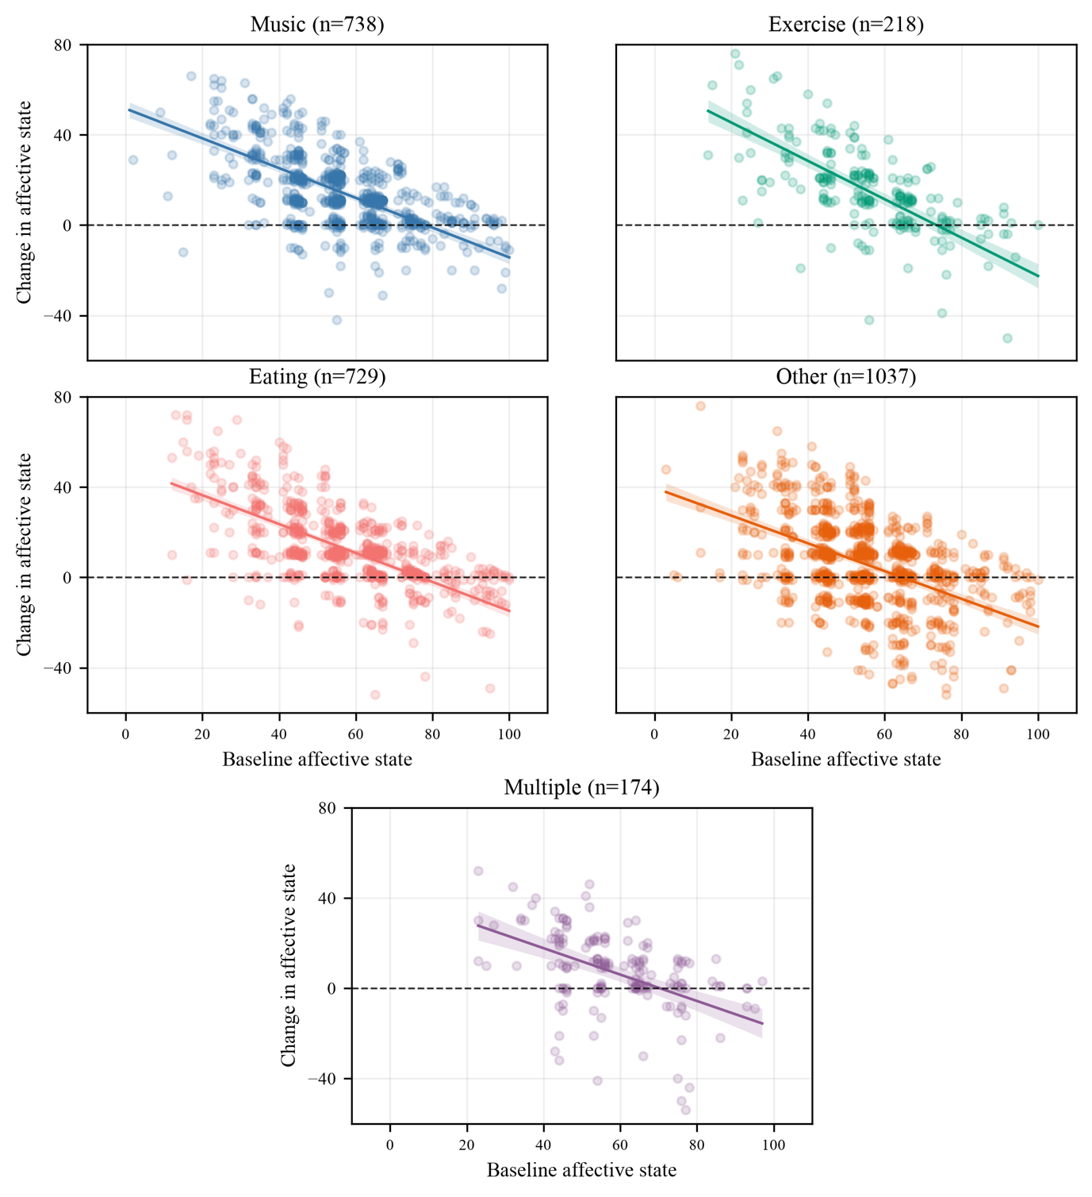
Fig. S1 Change in affective state outcomes by activity engagement in the previous hour. Y axis shows magnitude of change relative to baseline affective state. Dots represent instances of activity engagement for an individual.

Across all activity types, participants with lower baseline affect showed a greater magnitude of affective state change than those with higher baseline affect. This association was smaller for the ‘other’ and multiple (activity categories, than for music, exercise, and eating (Table S1).
Table. S1 Change in affective state by prior affect level (low vs high)
Activity Type | β | SE | t | p | CI 95%
Music | -16.29 | 1.05 | -14.67 | < .001 | [-18.35, -14.24]
Exercise | -22.45 | 2.30 | -9.76 | < .001 | [-26.96, -17.94]
Eating | -16.66 | 1.13 | -15.69 | < .001 | [-18.87, -14.24]
Other | -13.98 | 1.15 | -12.13 | < .001 | [-16.24, -11.72]
Multiple | -12.02 | 2.90 | -4.14 | < .001 | [-17.75, -6.29]

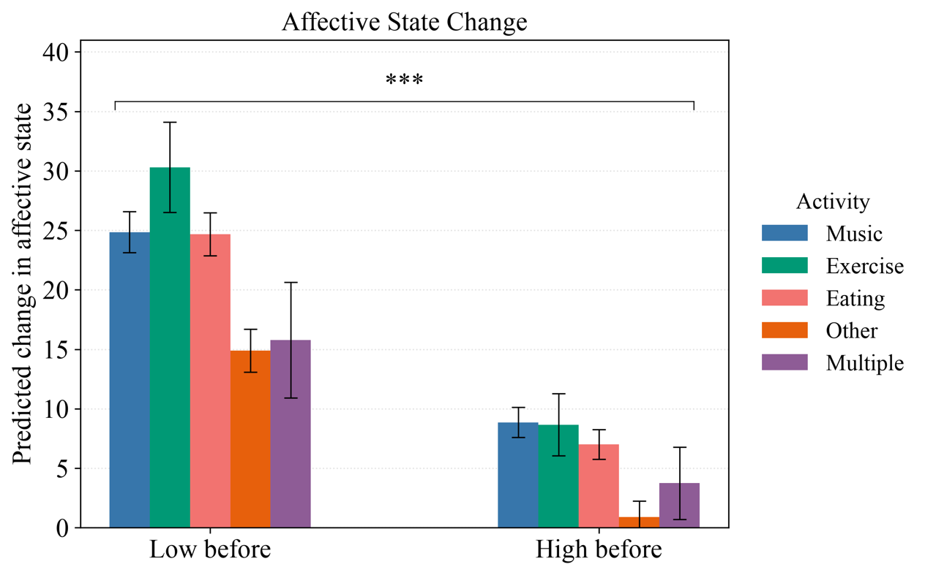

Results for Valence and Activity Engagement
Fig. S2 Affective state change as a function of prior affect level binarized subgroups (low <50, vs. high ≥50). Error bars represent standard deviation. Brackets and asterisks indicate statistically significant high vs low baseline group differences within each activity type. ***p<.001

In addition to the primary model of composite affective state (valence and arousal combined), we estimated separate models predicting valence and arousal alone. The magnitude of coefficients was consistently greater for valence change than for arousal across activity types, indicating that pre-activity state was associated with larger subsequent changes in valence than arousal.
Across all activities, more positive pre-activity valence was associated with smaller subsequent increases in valence, and more negative pre-activity valence was associated with larger subsequent increases (Table S2). This association was strongest for exercise, followed by music, eating, other activities, and engagement in multiple concurrent activities. Session number was not significantly associated with valence change.
Activity Type | β | SE | z | p | CI 95%
Music | -0.69 | 0.03 | -23.67 | < .001 | [-0.74, -0.63]
Exercise | -0.88 | 0.05 | -16.64 | < .001 | [-0.98, -0.77]
Eating | -0.66 | 0.03 | -23.56 | < .001 | [-0.71, -0.61]
Other | -0.62 | 0.04 | -17.98 | < .001 | [-0.69, 0.55]
Multiple | -0.58 | 0.08 | -7.49 | < .001 | [-0.73, -0.43]
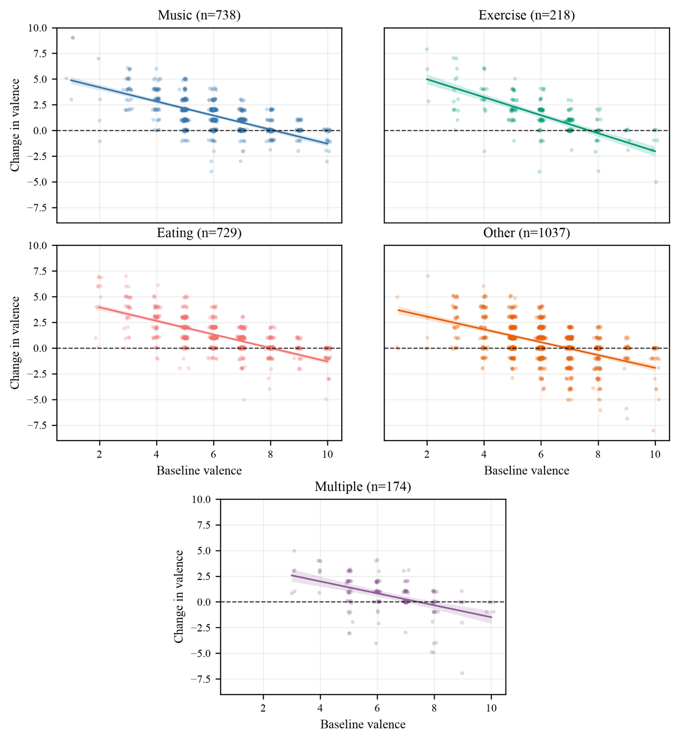
Table. S2 Change in valence
Fig. S3 Change in valence by activity engagement in the previous hour. Y axis shows magnitude of change relative to baseline affective state. Dots represent instances of activity engagement for an individual.
When pre-activity valence was binarized as negative versus positive (negative <50, vs. positive ≥50), participants who began in the positive valence group showed significantly less positive change in valence than those who began in the negative valence group for all activity types (Table. S3). The largest group difference was observed for exercise, followed by engagement in multiple concurrent activities, music, eating, and other activities.
Table. S3 Change in valence state by prior valence level (negative vs positive)
Activity Type | β | SE | t | p | CI 95%
Music | -2.40 | 0.15 | -16.19 | < .001 | [-2.69, -2.11]
Exercise | -2.59 | 0.31 | -8.43 | < .001 | [-3.19, -1.98]
Eating | -2.27 | 0.15 | -14.93 | < .001 | [-2.57, -1.97]
Other | -1.78 | 0.16 | -10.87 | < .001 | [-2.11, -1.46]
Multiple | -2.44 | 0.49 | -4.95 | < .001 | [-3.41, -1.47]
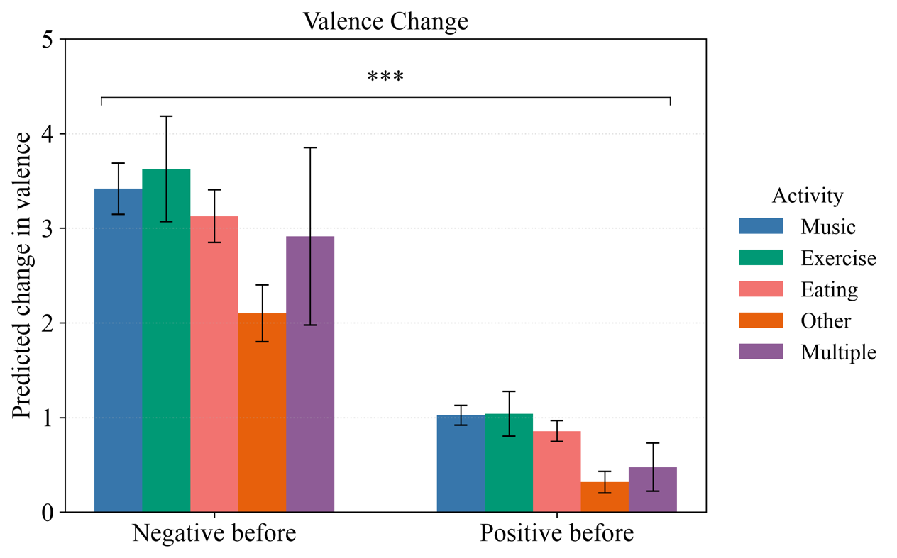
Fig. S4 Change in activity-related valence by prior valence level binarized subgroups (negative <50, vs. positive ≥50). Error bars represent standard deviation. Brackets and asterisks indicate statistically significant high vs low baseline group differences within each activity type. ***p<.001

Results for Arousal and Activity Engagement
In comparison to valence, arousal showed more modest regulation toward baseline but followed the same general pattern. Across all activity types, higher pre-activity arousal was associated with smaller subsequent increases, or greater decreases, in arousal, whereas lower pre-activity arousal was associated with larger subsequent increases. This association was strongest for eating, followed by engagement in multiple concurrent activities, exercise, other activities, and music. Session number was not significantly associated with arousal change (Table S4, Figure S5).
Table. S4 Change in arousal
Activity Type | β | SE | z | p | CI 95%
Music | -0.47 | 0.04 | -12.55 | < .001 | [0.54, -0.39]
Exercise | -0.53 | 0.07 | -7.85 | < .001 | [-0.66, -0.40]
Eating | -0.58 | 0.04 | -15.10 | < .001 | [-0.66, -0.51]
Other | -0.50 | 0.04 | -13.57 | < .001 | [-0.57, -0.43]
Multiple | -0.54 | 0.09 | -6.09 | < .001 | [0.71, -0.36]
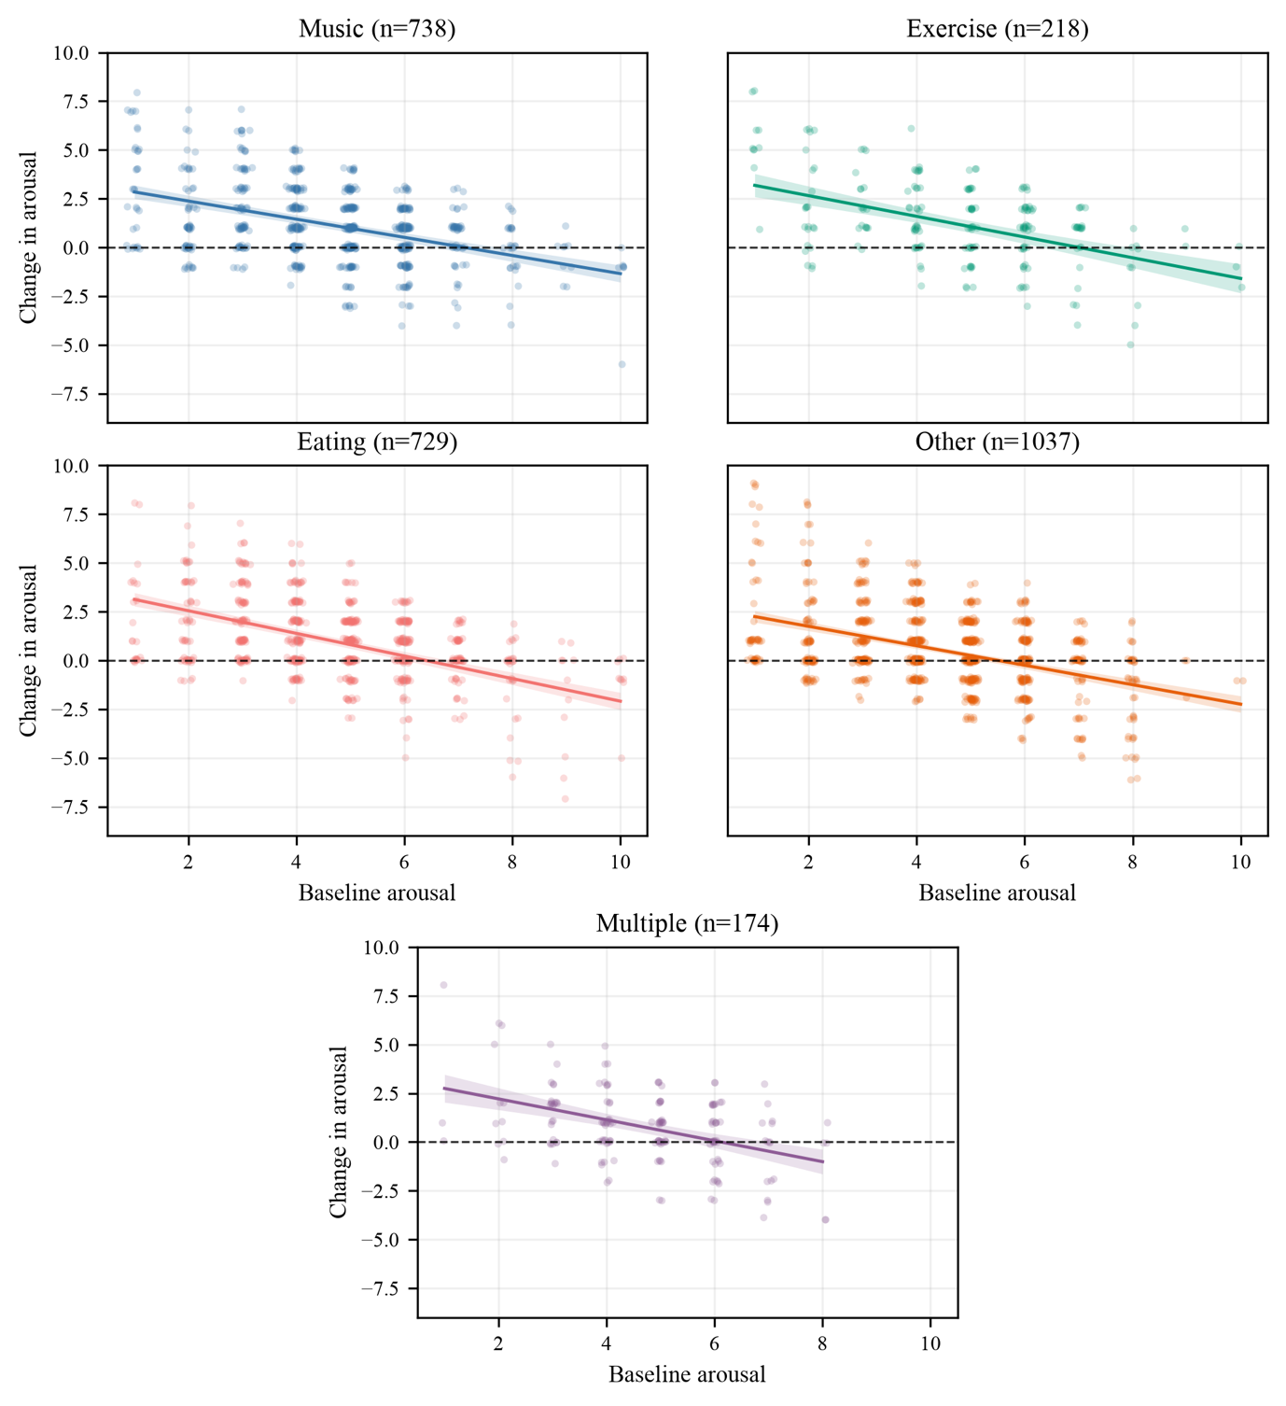
Fig. S5 Change in arousal by activity engagement in the previous hour. Y axis shows magnitude of change relative to baseline affective state. Dots represent instances of activity engagement for an individual.
When pre-activity arousal was binarized as low versus high, participants who began in the high arousal group showed significantly less change in arousal than those who began in the low arousal group after engagement in various activity types. The largest group difference was observed for exercise, followed by eating, music and other activities, and engagement in multiple concurrent activities (Table S5, Figure S6). There was not a significant relationship between session number and arousal change.
Table S5 Change in arousal state by arousal level (low vs high)
Activity Type | β | SE | t | p | CI 95%
Music | -1.31 | 0.13 | -10.0 | < .001 | [-1.57, -1.06]
Exercise | -1.74 | 0.27 | -6.50 | < .001 | [-2.27, -1.21]
Eating | -1.42 | 0.14 | -10.57 | < .001 | [-1.69, -1.16]
Other | -1.31 | 0.11 | -11.59 | < .001 | [-1.54, -1.09
Multiple | -1.25 | 0.27 | -4.54 | < .001 | [-1.79, 0.71]

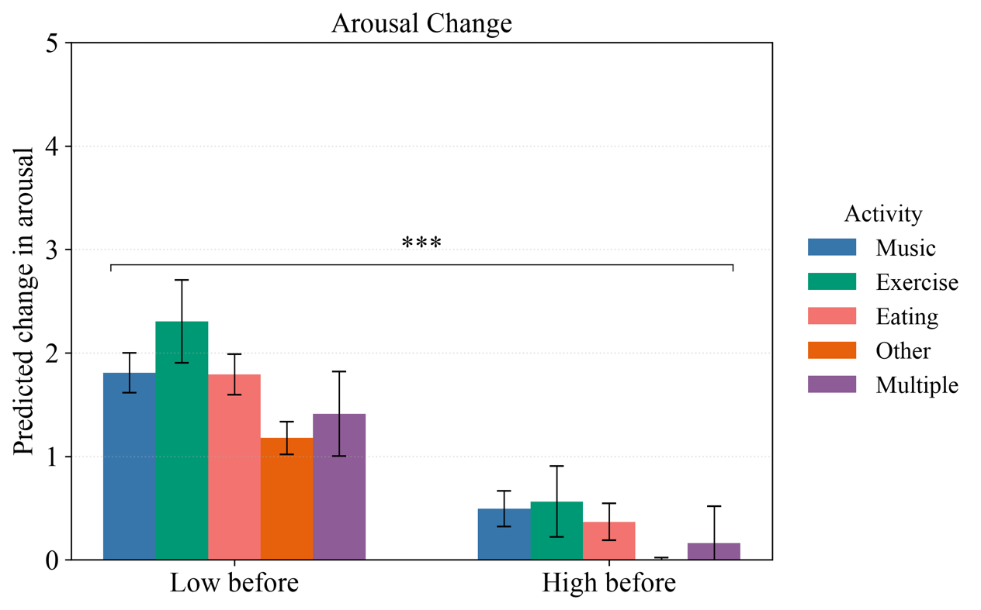

Fig. S6 Arousal change as a function of prior affect level binarized subgroups (negative <50, vs. positive ≥50). Error bars represent standard deviation. Brackets and asterisks indicate statistically significant high vs low baseline group differences within each activity type. ***p<.001

