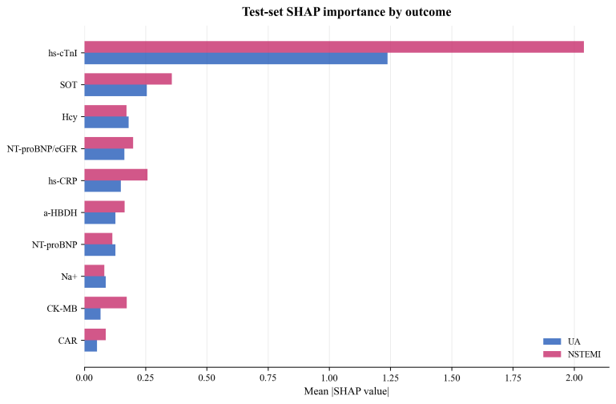

Supplementary Figure S1: Diagnosis-specific SHAP feature importance (UA vs. NSTEMI)

