Supplementary Figure S4. Stage-specific restricted cubic spline (RCS) curves and distributions of routine clinical predictors.

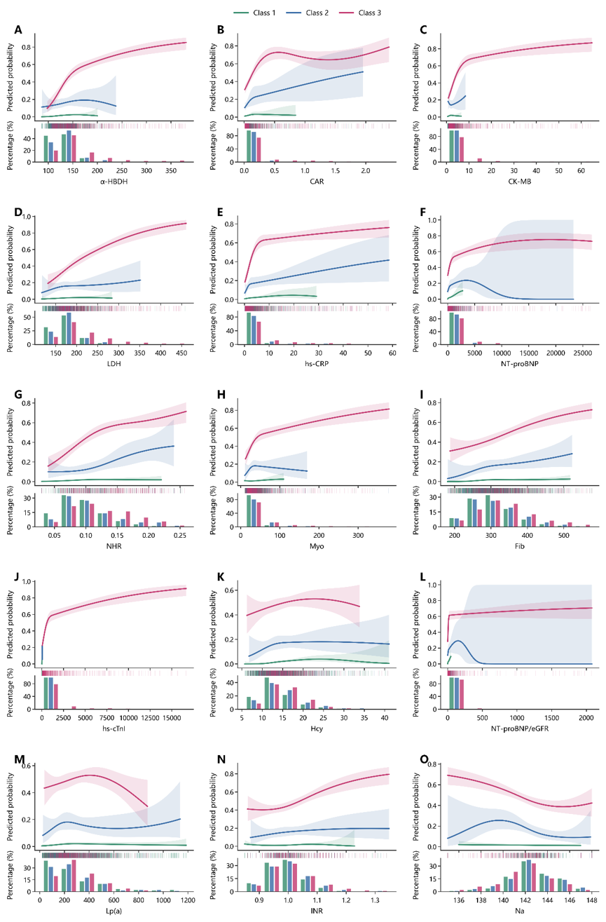
Supplementary Figure S4. Stage-specific restricted cubic spline (RCS) curves and distributions of routine clinical predictors. Restricted cubic spline (RCS) curves illustrate the associations between predictor values and NSTEMI risk across the three hs-cTnI-defined myocardial injury categories (Class 1: hs-cTnI < URL; Class 2: URL ≤ hs-cTnI < 3×URL; Class 3: hs-cTnI ≥ 3×URL). Shaded areas indicate 95% confidence intervals, and histograms below each curve show the distribution of observed values. Distinct stage-specific nonlinear risk–response patterns were observed for most predictors, indicating that the associations between routine clinical biomarkers and NSTEMI risk varied according to the background level of myocardial injury.

