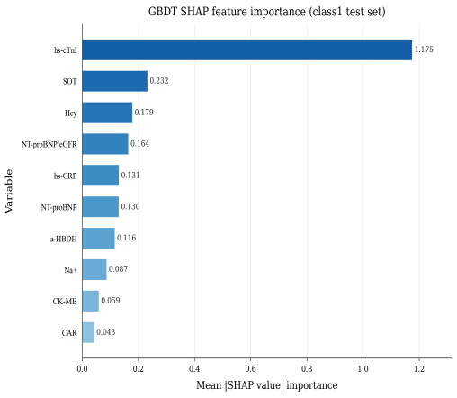
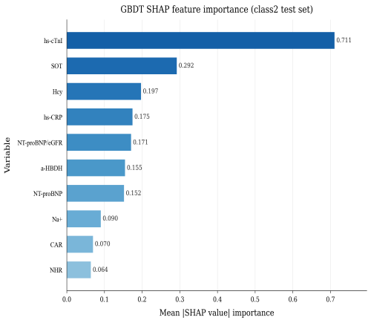
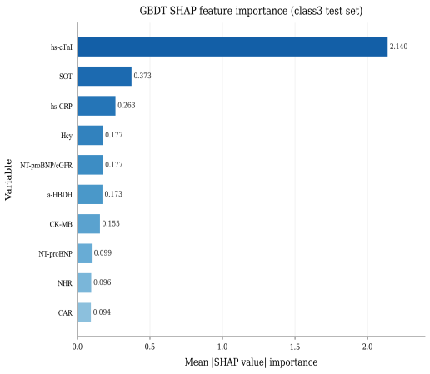
A
B
C

Supplementary Figure S3. Category-specific feature importance across hs-cTnI-defined categories. SHAP-based feature importance analysis was performed separately within the three hs-cTnI-defined categories to characterize how the contribution of individual predictors changed across different stages of myocardial injury in the final GBDT model. (A) Class 1: hs-cTnI below the upper reference limit (URL). (B) Class 2: URL ≤ hs-cTnI < 3×URL. (C) Class 3: hs-cTnI ≥ 3×URL. Mean absolute SHAP values represent the average contribution of each predictor to model output within each category. The results demonstrate dynamic stage-specific remodeling of diagnostic information, with the relative contribution of clinical and laboratory variables varying according to myocardial injury severity.

C

