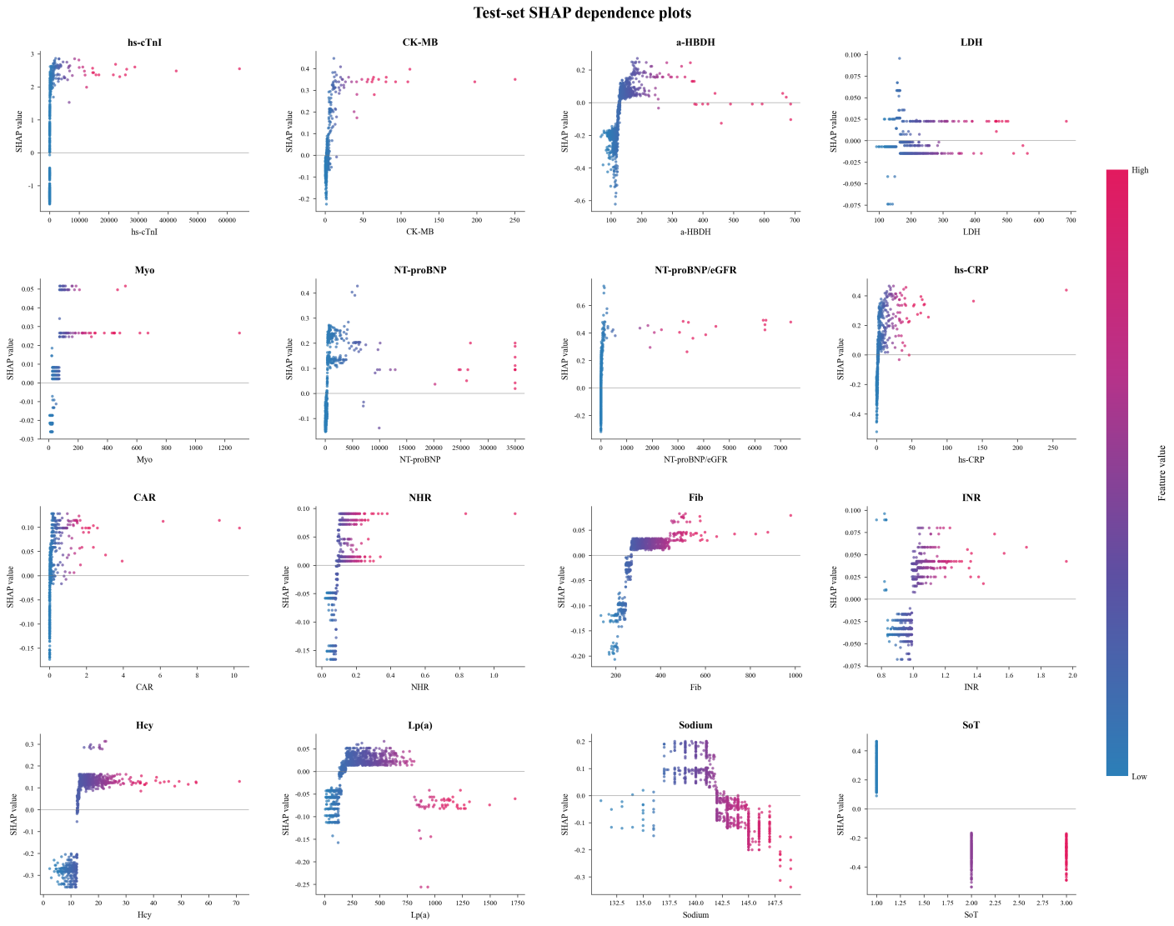
Supplementary Figure S2 SHAP dependence analysis of the 16 predictors in the final GBDT model. SHAP dependence plots demonstrate how individual predictor values influence the GBDT model output across the test cohort. The x-axis represents the original feature values, and the y-axis represents corresponding SHAP values. Each point corresponds to an individual patient, colored according to feature magnitude (blue indicates lower values and red indicates higher values). Positive SHAP values indicate increased contribution toward NSTEMI prediction, whereas negative SHAP values indicate decreased contribution. The dependence plots reveal nonlinear, threshold-dependent, and heterogeneous contribution patterns among the selected predictors. Detailed SHAP transition regions and inflection points for all predictors are provided in Supplementary Table S2

C

