Supplementary Information for

Interface-Specific In Situ Photoluminescence Resolves Depth-Dependent Crystallization in Solution-Processed Metal Halide Perovskites
Ziyao Yue (岳子尧)¹, Yuanhang Cheng (程远航)², Yunfan Wang (王云帆)^{1,*}, Sai-Wing Tsang (曾世榮)^{1,3,4,} *
¹Department of Materials Science and Engineering, City University of Hong Kong, Kowloon, Hong Kong SAR 999077, P.R. China
²School of New Energy, Nanjing University of Science and Technology, Jiangyin, Jiangsu 214443, P.R. China
³Hong Kong Institute for Clean Energy, City University of Hong Kong, Kowloon, Hong Kong SAR 999077, P.R. China
⁴Center of Super-Diamond and Advanced Films (COSDAF), City University of Hong Kong, Hong Kong SAR 999077, P.R. China
Email: ziyaoyue2-c@my.cityu.edu.hk (Z. Y.), yhcheng@njust.edu.cn (Y. C.), yunfawang2-c@my.cityu.edu.hk (Y. W.), saitsang@cityu.edu.hk (S-W. T.)
*Corresponding: yunfawang2-c@my.cityu.edu.hk, +86-15208414946 (Y. W.); saitsang@cityu.edu.hk, +852-34424618 (S-W. T.)

Supplementary Note 1
This note describes the interface-specific in-situ PL measurement platform used in this study, including its setup, design strategy, and validation.
In situ PL is a powerful and widely used technique for characterizing perovskite crystallization. In this study, we developed an in situ PL measurement platform to investigate perovskite crystallization near the top surface and buried interface of films during spin coating. The configuration of the platform is illustrated in Figure S1. Two Y-shaped optical fibers were employed to independently excite and collect PL signals from the top and bottom sides of the film. By selecting excitation lasers with different wavelengths, the penetration depth of the excitation light, and thus the effective probing region, can be adjusted, enabling depth-resolved PL detection with tunable probing depths.
After enabling PL excitation and collection from both sides of the film, a critical consideration is the effective detection depth. In situ absorption measurement was first conducted to compare the penetration depths of different laser probes (Figure S2). Taking 405 and 450 nm excitation as examples, the MAPbI₃ (DMF) perovskite wet film already exhibits strong absorption at 405 nm before nucleation, indicating that the incident light can be largely attenuated by precursor-derived species. As a result, only nucleation events occurring within a shallow near-surface region can be detected. In contrast, the 450 nm laser experiences negligible attenuation before nucleation, indicating that nuclei forming throughout the film can be excited and emit signals, thereby diminishing its spatial resolution. Therefore, 405 nm excitation can be used to selectively probe crystallization signals from the shallow region adjacent to the probe side, enabling interface-specific monitoring of nucleation near either the top surface or the buried interface. The penetration depth of the 405 nm excitation laser in the MAPbI₃ perovskite wet film, defined as the depth at which the light intensity decays to 1/e of its surface value, is further calculated to be approximately 100 nm.
To evaluate the spatial sensitivity of the measurement, we compared PL responses obtained under top-detected and bottom-detected excitation using 405 and 450 nm lasers (Figure S3). Interface-specific in situ PL measurements using 405 nm excitation reveal pronounced differences between top- and bottom-detected crystallization dynamics, confirming vertical heterogeneity in solution-processed perovskite films. The different PL onset times of the top- and bottom-detected signals indicate distinct nucleation onset times within the respective probing regions, confirming that the two detection configurations probe different spatial regions and thereby verifying the interface-specific probing capability of this platform, with 405 nm excitation primarily probing crystallization within a shallow region adjacent to the illuminated side. By contrast, in situ PL signals detected from the top and bottom sides under 450 nm excitation are nearly identical and exhibit similar onset times, consistent with a bulk-averaged response rather than interface-specific detection. Moreover, the bulk-averaged PL response obtained under 450 nm excitation closely resembles the bottom-side PL signal measured under 405 nm excitation, indicating that bulk nucleation in this system is dominated by buried-interface crystallization. Together, these results demonstrate that, using 405 nm excitation, our in-situ PL platform enables interface-specific monitoring of perovskite crystallization dynamics near both the top surface and buried interface during spin coating

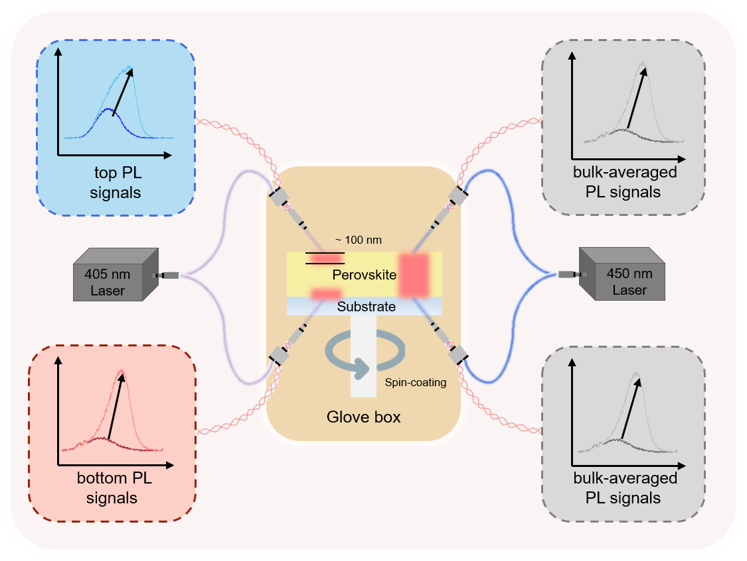
Figure S1. Schematic illustration of the in situ PL measurement platform. It can be readily switched between interface-specific and bulk-averaged detection modes by changing the excitation wavelength.

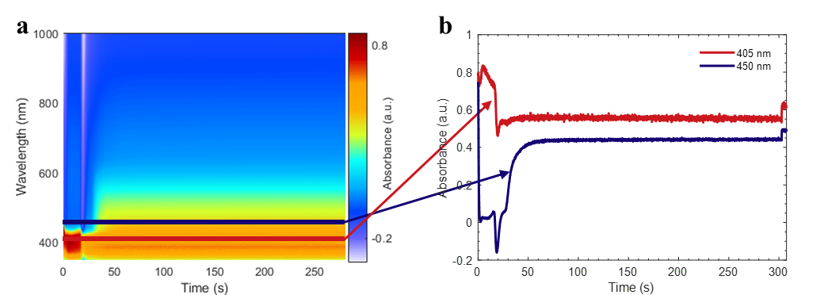
Figure S2. (a) In situ absorption spectra and (b) time-resolved absorbance at 405 nm and 450 nm for MAPbI₃ (DMF) wet film during spin coating. (a) Time-resolved absorption spectra of the MAPbI₃ wet film, showing the evolution of absorbance across a range of wavelengths during spin coating. (b) Extracted absorbance values at 405 nm and 450 nm as a function of time, highlighting distinct absorption changes at each wavelength. The differential evolution at these two wavelengths demonstrates the sensitivity of 405 nm excitation for probing interface-specific nucleation processes.

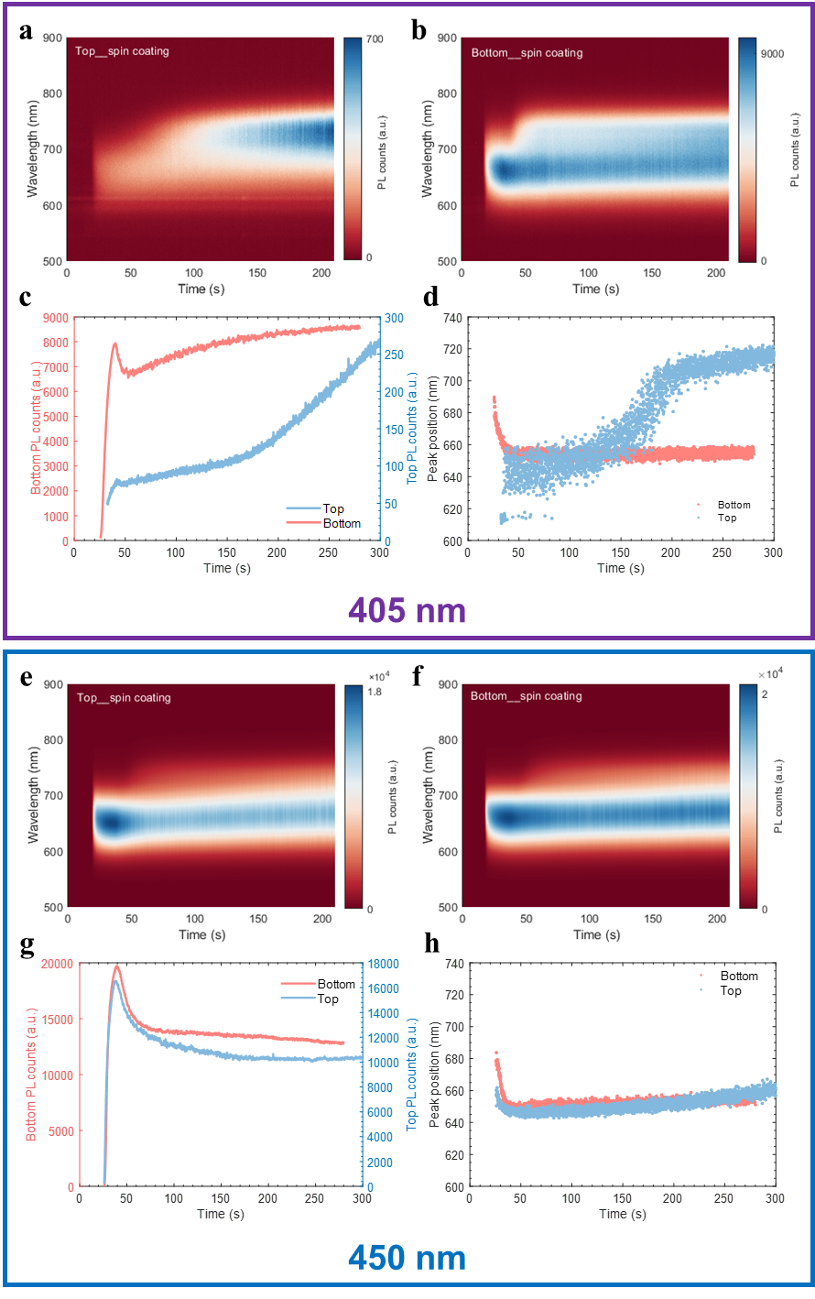
Figure S3. Comparison of in situ PL responses under 405 nm and 450 nm excitation during MAPbI₃ (DMF) spin coating. (a, b) Time-resolved PL spectra collected from the top and bottom sides of the MAPbI₃ wet film under 405 nm excitation. Temporal Evolution of (c) PL intensity and (d) PL peak position for top-detected and bottom-detected PL at 405 nm excitation. (e, f) Time-resolved PL spectra from top and bottom sides under 450 nm excitation. Temporal Evolution of (g) PL intensity and (h) PL peak position at 450 nm excitation. We can conclude that the 405 nm probe yields pronounced differences between the top and bottom signals, with early onset and strong PL emission from the bottom interface, indicating high interface sensitivity arising from its limited penetration depth. In contrast, the 450 nm probe produces comparable responses from both sides, reflecting bulk-averaged crystallization behavior. As the top PL signal is very weak, its crystallization dynamics are not readily resolved.

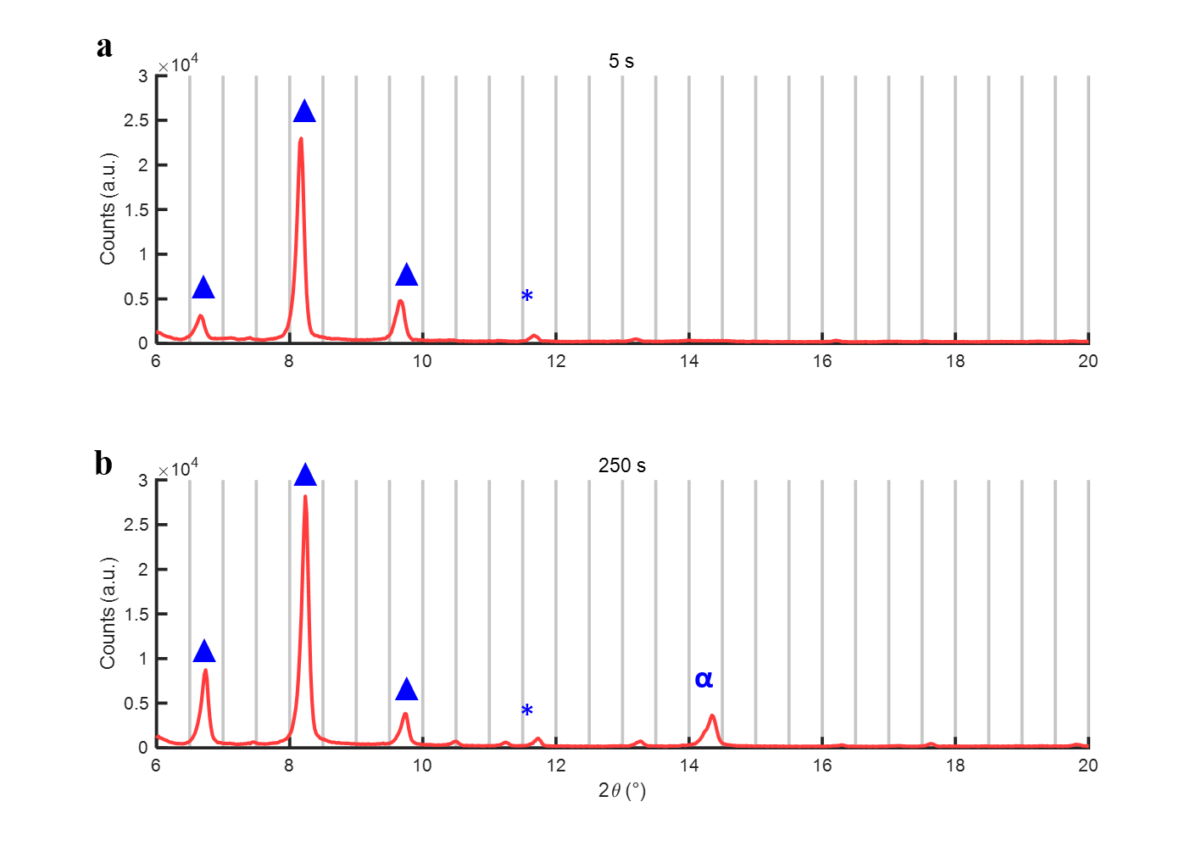
Figure S4. Quasi in situ XRD patterns of MAPbI₃ (DMF) as-cast films after (a) 5 s and (b) 250 s of spin coating. The intermediate phase, (MA)₂(DMF)₂Pb₂I₆, is marked by blue Δ, PbI₂ by blue *, and the perovskite phase by blue α. These results confirm that the intermediate phase forms earlier than the perovskite phase, appearing as soon as 5 s upon spin coating.

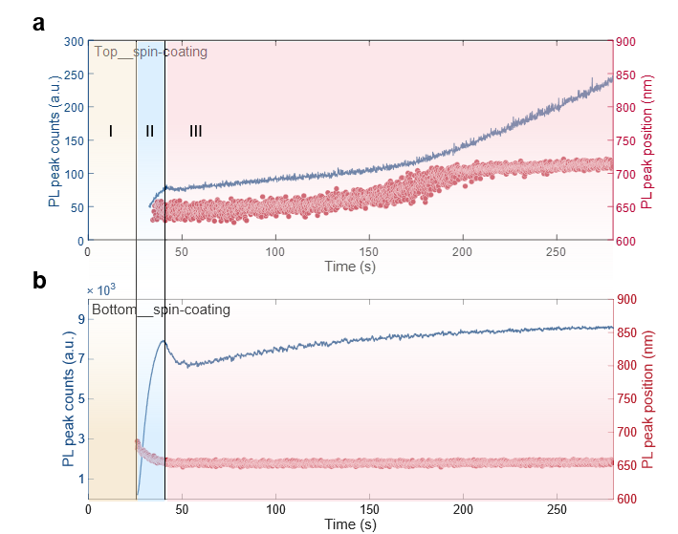
Figure S5. Evolution of PL peak intensity and peak wavelength extracted from the (a) top- and (b) bottom-detected in situ spectra of MAPbI₃ (DMF) wet film during spin coating.

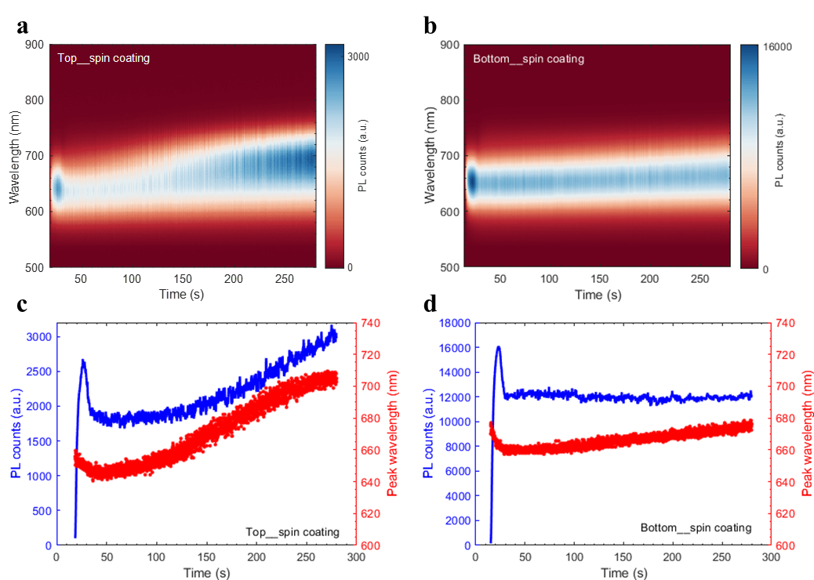
Figure S6. Interface-specific in situ PL results of MAPbI₃ (1.0 M, DMF) wet film during spin coating. (a) and (b) show the time-resolved PL spectra collected from the top and bottom sides, respectively. (c) and (d) present the evolution of PL peak counts (blue) and peak wavelength (red) extracted from the corresponding spectra in (a) and (b). Compared to the nucleation onset difference (7 s) for 1.7 M MAPbI₃, the difference is significantly reduced to 3.5 s (18.6 s for top and 15.1 s for bottom) at 1.0 M, confirming the upward nucleation event for MAPbI₃.

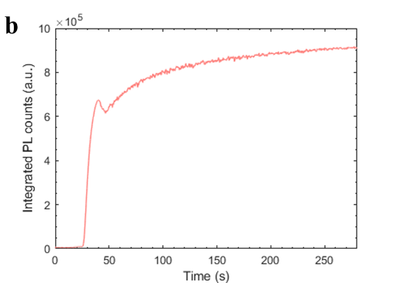
Figure S7. Time-resolved integrated PL counts from the bottom-detected in situ PL of MAPbI₃ (1.7 M, DMF) wet film during spin coating, integrated over 500-900 nm.

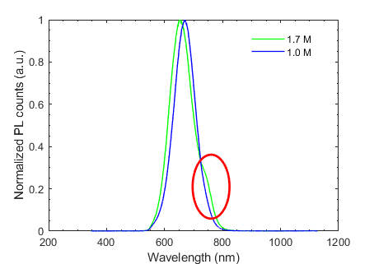

Figure S8. Comparison of the normalized PL spectra at Stage III for 1.7 M and the 1.0 M MAPbI₃ (DMF) wet films. The PL shoulder feature becomes negligible as the precursor concentration decreases, consistent with the formation chemistry of a colloidal soft framework.

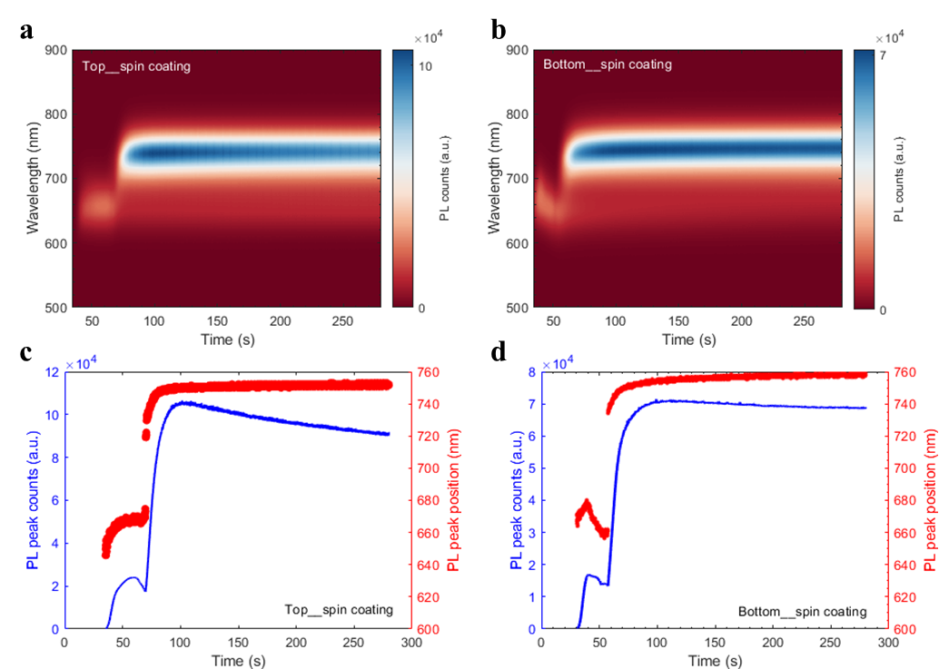
Figure S9. Interface-specific in situ PL results of MAPbI₃ (MAI: PbI₂ = 2:1, DMF) wet film during spin coating. (a) and (b) show the time-resolved PL spectra collected from the top and bottom sides, respectively. (c) and (d) present the evolution of PL peak counts (blue) and peak wavelength (red) extracted from the corresponding spectra in (a) and (b). A lower precursor concentration (1.2 M) is used here because pure DMF can not fully dissolve all the salts for 1.7 M. Compared to 1:1 recipes, a secondary nucleation event is observed after the initial nucleation, evidenced by the later increase in PL intensity and a shift in PL peak position from ~670 nm to ~730 nm. The nuclei formed during this secondary nucleation are more numerous, as indicated by the stronger PL intensity. This secondary nucleation is attributed to the colloidal soft frameworks in the precursor, consistent with the origin of the red-wavelength shoulder in 1:1 recipes, whose formation is enhanced in I-rich environments.

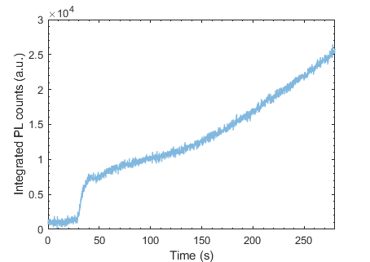
Figure S10. Time-resolved integrated PL counts from the top side in situ PL measurement of MAPbI₃ (DMF) wet film during spin coating, integrated over 500-900 nm. The initial rapid increase in PL counts (30-50 s) corresponds to the onset of nucleation, while the subsequent gradual increase indicates ongoing nucleation and the continued growth of nuclei formed during the initial event.

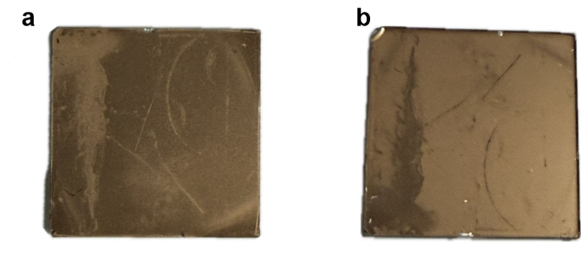
Figure S11. Optical photographs of the (a) top and (b) buried sides of the annealed MAPbI₃ (DMF) film using an anti-solvent-free deposition process.

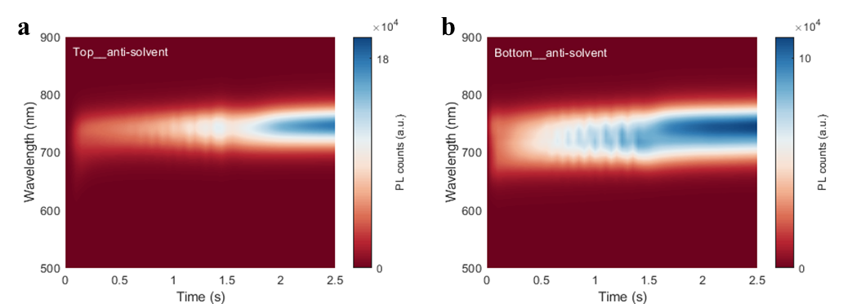
Figure S12. Interface-specific in situ PL results of MAPbI₃ (DMF) wet film during anti-solvent-assisted spin coating. (a) and (b) show the time-resolved PL spectra collected from the top and bottom sides, respectively. The CB induces nucleation uniformly across the wet film, as evidenced by the comparable PL intensities observed on both the top and bottom sides.

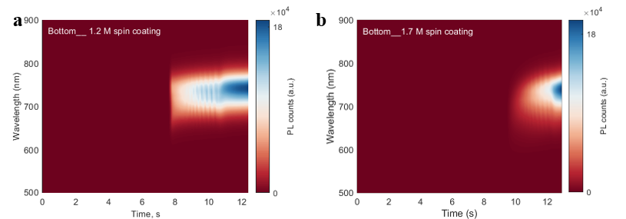
Figure S13. Time-resolved PL spectra collected from the bottom side of (a) 1.2 M and (b) 1.7 M MAPbI₃ (DMF) wet films during anti-solvent-assisted spin coating. The comparable PL intensity observed in the higher-thickness (high concentration) wet film confirms that the anti-solvent-induced nucleation event occurs throughout the MAPbI₃ (DMF) wet films.

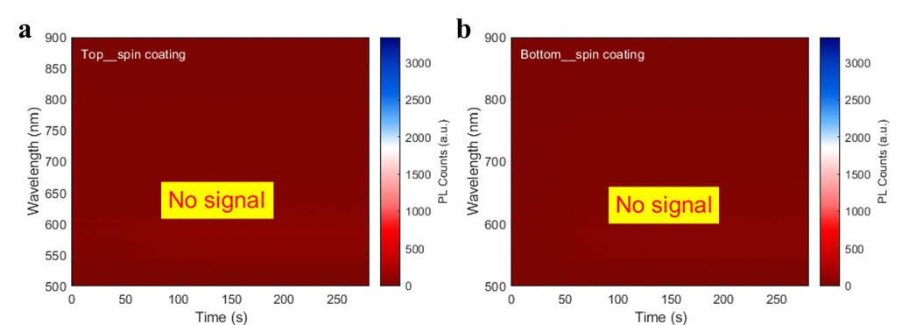
Figure S14. Interface-specific in situ PL results of MAPbI₃ (15% v DMSO) wet film during spin coating. (a) and (b) show the time-resolved PL spectra collected from the top and bottom sides, respectively. No PL signals are detected throughout the entire process, indicating that no perovskite phase is formed if no anti-solvent is used.

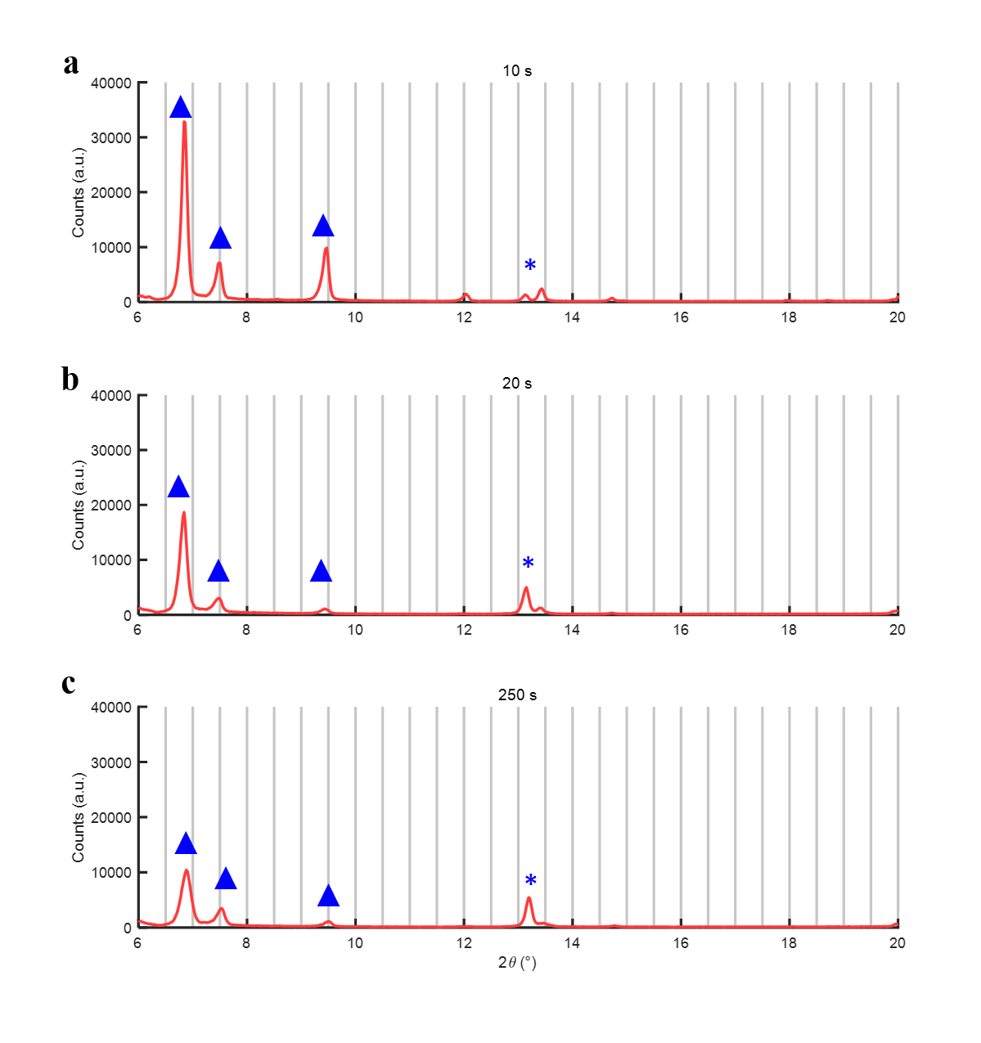
Figure S15. Quasi in situ XRD patterns of MAPbI₃ (DMSO) as-cast films after (a) 10 s, (b) 20 s, and (c) 250 s of spin coating. The MAPbI₃-DMSO intermediate phase is indicated by blue Δ, and PbI₂ is marked by blue *. No signals from the perovskite phase are detected at any stage; only the crystalline intermediate phase and PbI₂ are present in the wet films. These results confirm the formation of a stable intermediate phase in the wet film as early as 10 s into the spin-coating process.

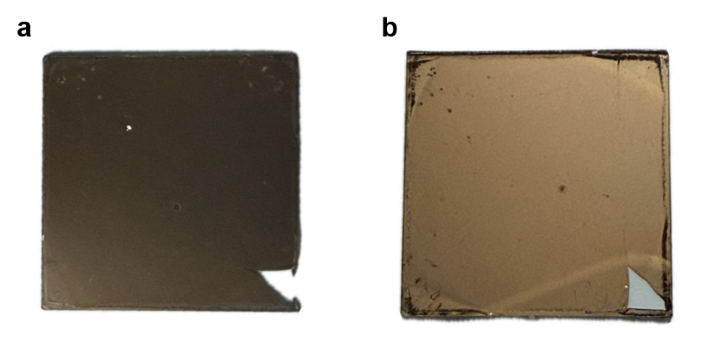
Figure S16. Optical photographs of the (a) top and (b) buried sides of the annealed MAPbI₃ (DMSO) film using an anti-solvent-free deposition process.

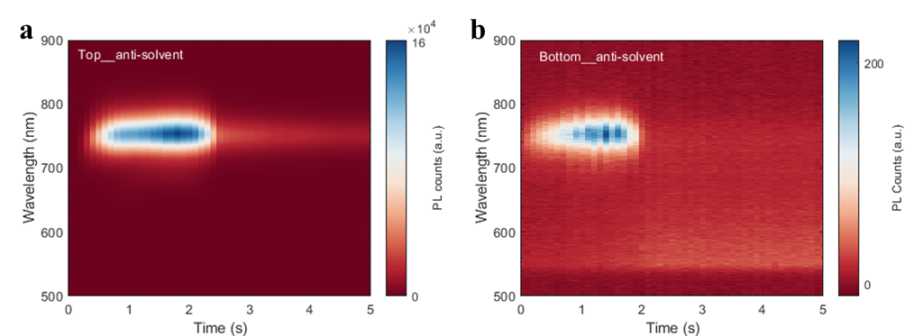
Figure S17. Interface-specific in situ PL results of MAPbI₃ (15% v DMSO) wet film during anti-solvent-assisted spin coating. Panels (a) and (b) show the time-resolved PL spectra collected from the top and bottom sides, respectively. The bottom PL intensity is significantly lower than that of the top, indicating fewer nuclei are formed at the bottom interface. This observation is consistent with the limited-thickness nucleation model, where CB anti-solvent confines nucleation primarily to the upper region of the film.
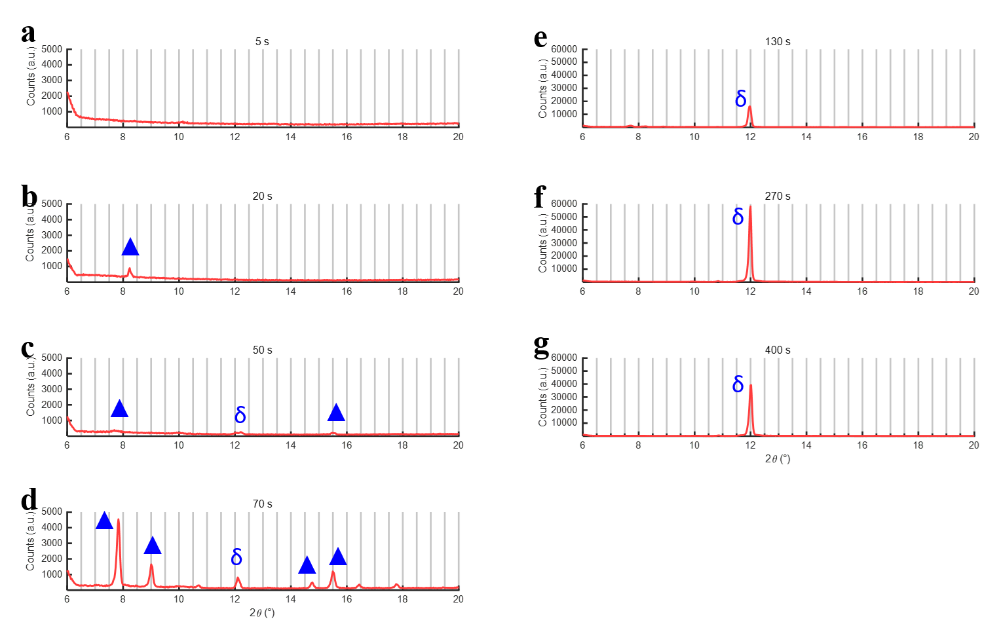
Figure S18. Quasi in situ XRD patterns of FA_{0.9}Cs_{0.1}PbI₃ as-cast film after (a) 5 s, (b) 20 s, (c) 50 s, (d) 70s, (e) 130 s, (f) 270 s, and (g) 400 s of spin coating. The intermediate phase is indicated by blue Δ, and the δ-phase perovskite by blue δ. By 50 s, the intermediate phase signal decreases while the δ-phase signal increases, indicating its transformation to the δ-phase. At later times, a new crystalline intermediate phase emerges, which similarly converts to the δ-phase between 70 s and 270 s. At 140s (the nucleation onset recovered by the in situ PL measurement), the wet film mainly consists of crystalline δ-phase and amorphous sol-gel phase. From 270 s to 400 s, the δ-phase intensity diminishes, suggesting its further transformation to other phases. No α-phase signal is detected throughout the process, despite its detection by in situ PL, highlighting the higher sensitivity of optical techniques for tracking perovskite crystallization.

Figure S19. Time-resolved PL peak intensity detected from the top (blue) and bottom (red) sides of FA_{0.9}Cs_{0.1}PbI₃ wet film during spin coating.

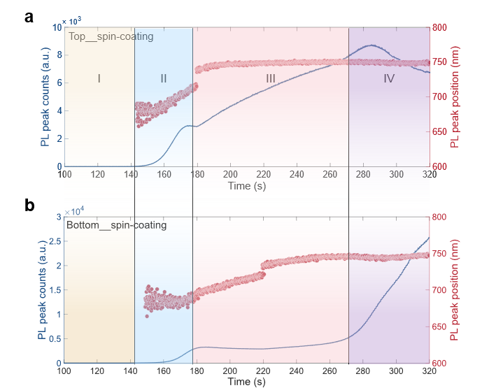
Figure S20. Evolution of PL peak intensity and peak wavelength extracted from the (a) top- and (b) bottom-detected in situ spectra of FA_{0.9}Cs_{0.1}PbI₃ wet film during spin coating.

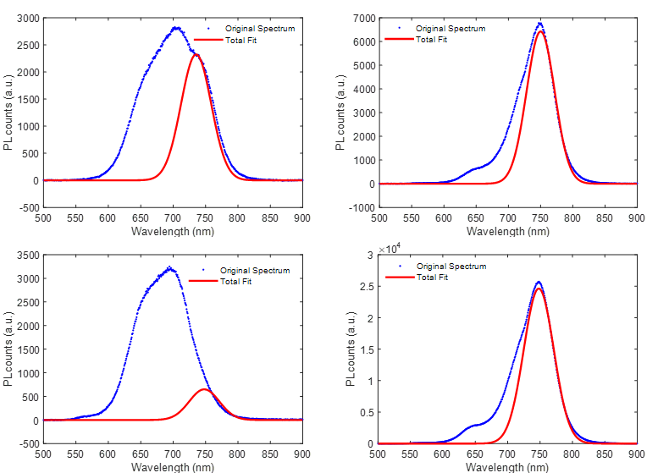
Figure S21. Representative deconvolution results of the in situ PL spectra of FA_{0.9}Cs_{0.1}PbI₃ wet film. These illustrate the method used to quantify the ratio of small nuclei to large crystals. The tail region of the original in-situ PL spectra was fitted using a Gaussian function with a fixed peak position, and the area under this Gaussian function was assigned to the contribution from large crystals. The contribution from small nuclei was then determined by subtracting the large-crystal Gaussian area from the total integrated PL spectral area.
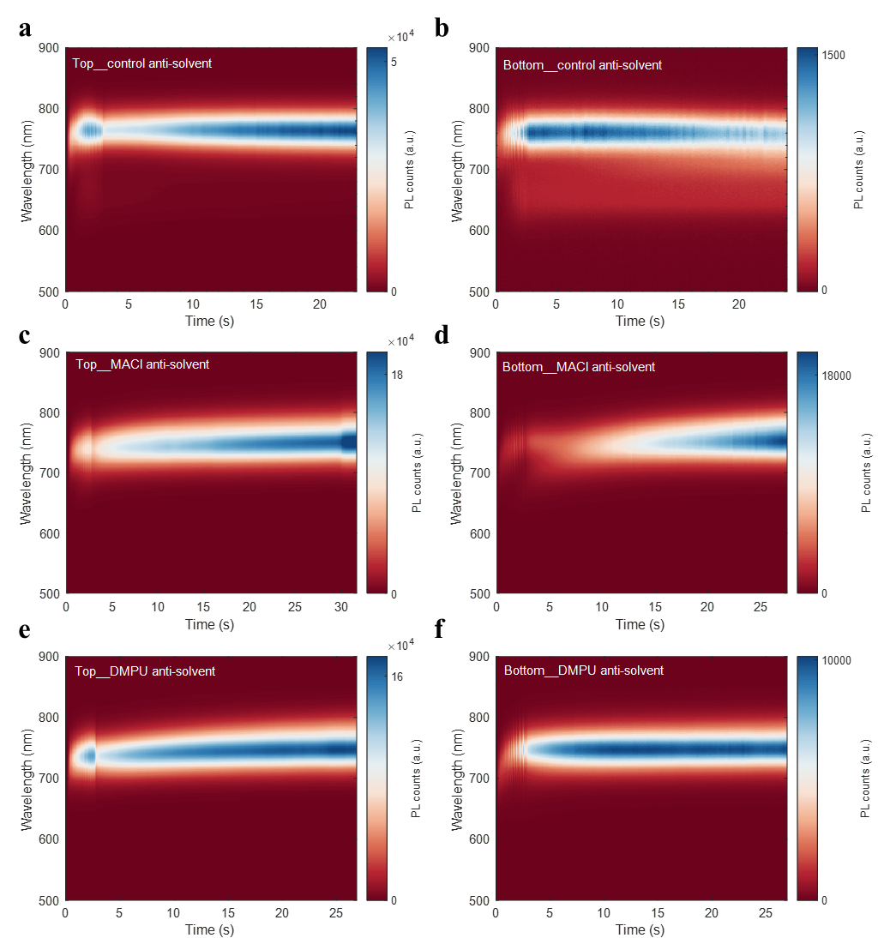
Figure S22. Interface-specific in situ PL results of (a-b) pristine, (c-d) MACl, and (e-f) DMPU FA_{0.9}Cs_{0.1}PbI₃ perovskite wet films during anti-solvent-assisted spin coating. Panels (a, c, e) show the time-resolved PL spectra collected from the top surface, while panels (b, d, f) present spectra from the bottom surface.

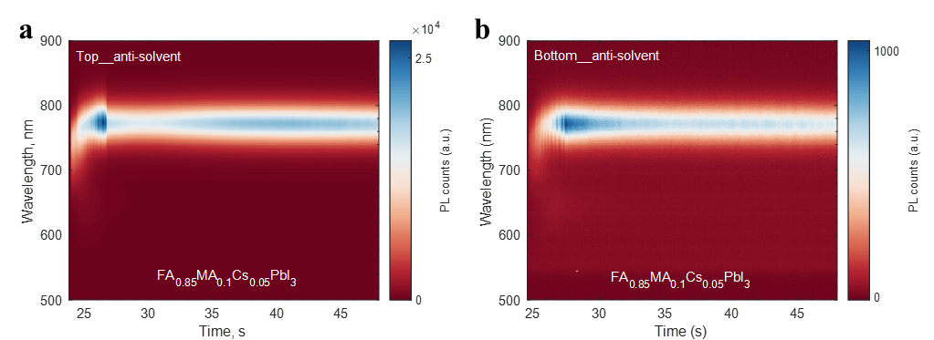
Figure S23. Interface-specific in situ PL results of FA_{0.85}MA_{0.1}Cs_{0.05}PbI₃ perovskite wet film during anti-solvent-assisted spin coating. Panels (a) and (b) show the time-resolved PL spectra collected from the top and bottom sides, respectively. The bottom PL response is significantly weaker than the top one, indicating the limited-thickness nucleation process induced by CB. These results demonstrate that the proposed nucleation model is also applicable to three-cation perovskite compositions.

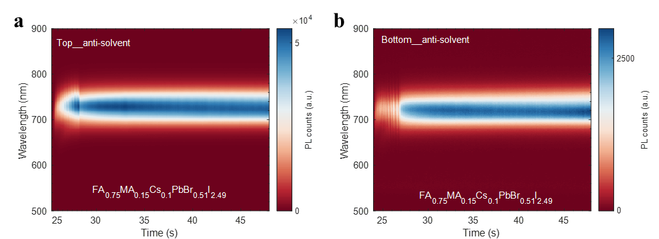
Figure S24. Interface-specific in situ PL results of FA_{0.75}MA_{0.159}Cs_{0.1}PbBr_{0.51}I_{2.49} perovskite wet film during anti-solvent-assisted spin coating. Panels (a) and (b) show the time-resolved PL spectra collected from the top and bottom sides, respectively. The bottom PL response is still significantly weaker than the top one, indicating the limited-thickness nucleation induced by CB. These results demonstrate that the proposed nucleation model is also applicable to low-Br mixed-halide perovskite compositions.

