Supporting Information for:
The 1994 Mw 7.8 Sanriku-Haruka-Oki Earthquake and Complex Recurrence on a Weakly Segmented Megathrust
Keisuke Yoshida¹, Takuya Nishimura², Ryota Hino¹, Yusaku Ohta¹, Naoki Uchida³

1: Research Center for Prediction of Earthquakes and Volcanic Eruptions, Graduate School of Science, Tohoku University, 6-6 Aza-Aoba, Aramaki, Aoba-ku, Sendai, 980-8578, Japan
2: Disaster Prevention Research Instiute,, Kyoto University, Gokasho, Uji, Kyoto, 611-0011, Japan
3: Earthquake Research Institute, The University of Tokyo, 1-1-1, Yayoi, Bunkyo ku, Tokyo, 113-0032, Japan.

Description of the Supplemental Material
This Supplemental Material includes additional figures supporting the analyses and interpretations presented in the main text. These figures present sensitivity tests of the source inversion to changes in the overall damping and smoothing strengths, enhanced damping on the shallow part of the fault, fault geometry, and GNSS data amplitudes.

List of Supplementary Figure Captions
- Figure S1. Sensitivity of the final-slip distribution to the regularization parameters.
- Figure S2. Results of the slip inversion using the plate-interface geometry of Zhao et al. (2020).
- Figure S3. Results of the slip inversion without the enhanced damping imposed on subfaults two or more grid intervals updip of the hypocenter.
- Figure S4. Results of the slip inversion with the GNSS displacement amplitudes reduced to 70% of their original values.
- Figure S5. Map and cross-sectional views of the relationships among coseismic slip distributions, seismicity, and subsurface structures.
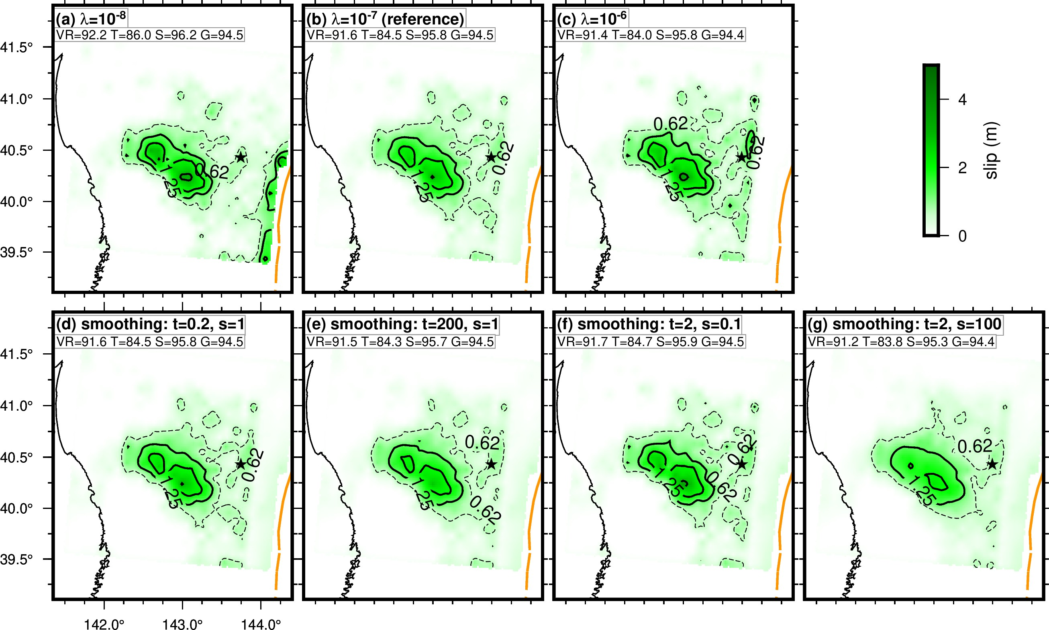
Figure S1. Sensitivity of the final-slip distribution to the regularization parameters. The temporal and spatial smoothing strengths are given by tλ and sλ, respectively. (a–c) Results for λ = 10⁻⁸, 10⁻⁷, and 10⁻⁶, respectively, with t = 2 and s = 1. (d, e) Results for t = 0.2 and 200, respectively, with λ = 10⁻⁷ and s = 1. (f, g) Results for s = 0.1 and 100, respectively, with λ = 10⁻⁷ and t = 2. All other settings are identical to those of the preferred model in Figure 2. Colors and contours show final slip. Black and red stars indicate the central subfault of the original model and the reference hypocentral subfault, respectively; the orange dashed line marks the Japan Trench. Values in each panel indicate variance reductions for all data (VR), teleseismic waveforms (T), strong-motion waveforms (S), and GNSS data (G).

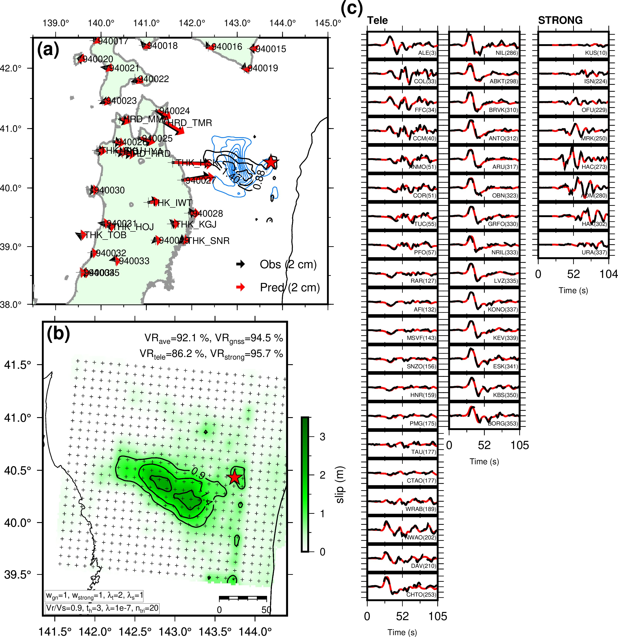
Figure S2. Results of the slip inversion using the plate-interface geometry of Zhao et al. (2020). (a) Estimated slip distribution and horizontal GNSS displacements. Black and red arrows indicate the observed and synthetic displacements, respectively. (b) Estimated slip distribution shown by colors and contours. The star marks the hypocenter, and the blue contours indicate the slip model of Nagai et al. (2001). (c) Fits to the teleseismic and strong-motion waveforms. The waveforms are arranged by station azimuth, with azimuths shown in parentheses. Black and red traces indicate the observed and synthetic waveforms, respectively.

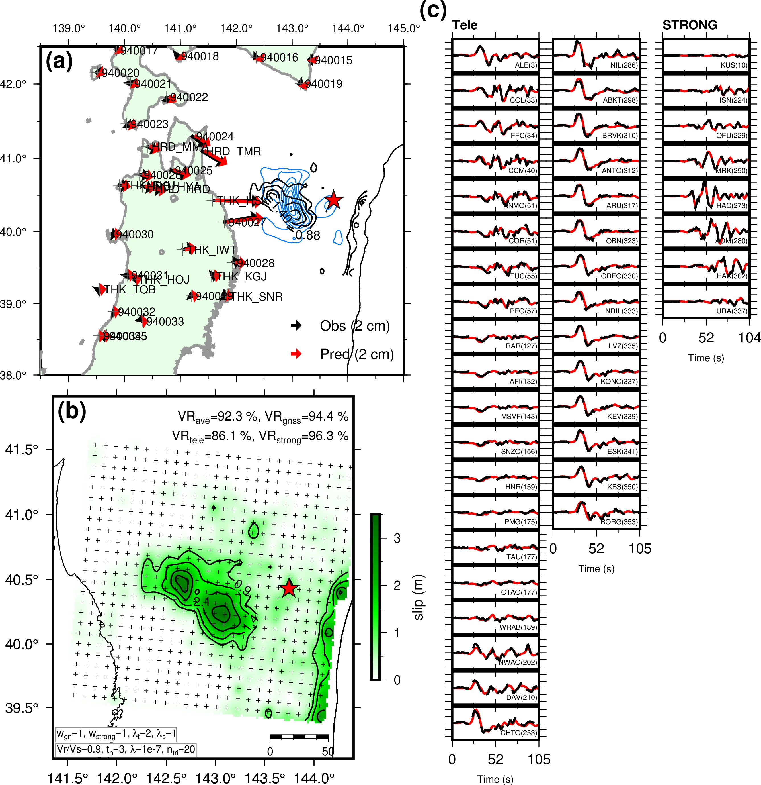
Figure S3. Results of the slip inversion without the enhanced damping imposed on subfaults two or more grid intervals updip of the hypocenter. (a) Estimated slip distribution and horizontal GNSS displacements. Black and red arrows indicate the observed and synthetic displacements, respectively. (b) Estimated slip distribution shown by colors and contours. The star marks the hypocenter, and the blue contours indicate the slip model of Nagai et al. (2001). (c) Fits to the teleseismic and strong-motion waveforms. The waveforms are arranged by station azimuth, with azimuths shown in parentheses. Black and red traces indicate the observed and synthetic waveforms, respectively.

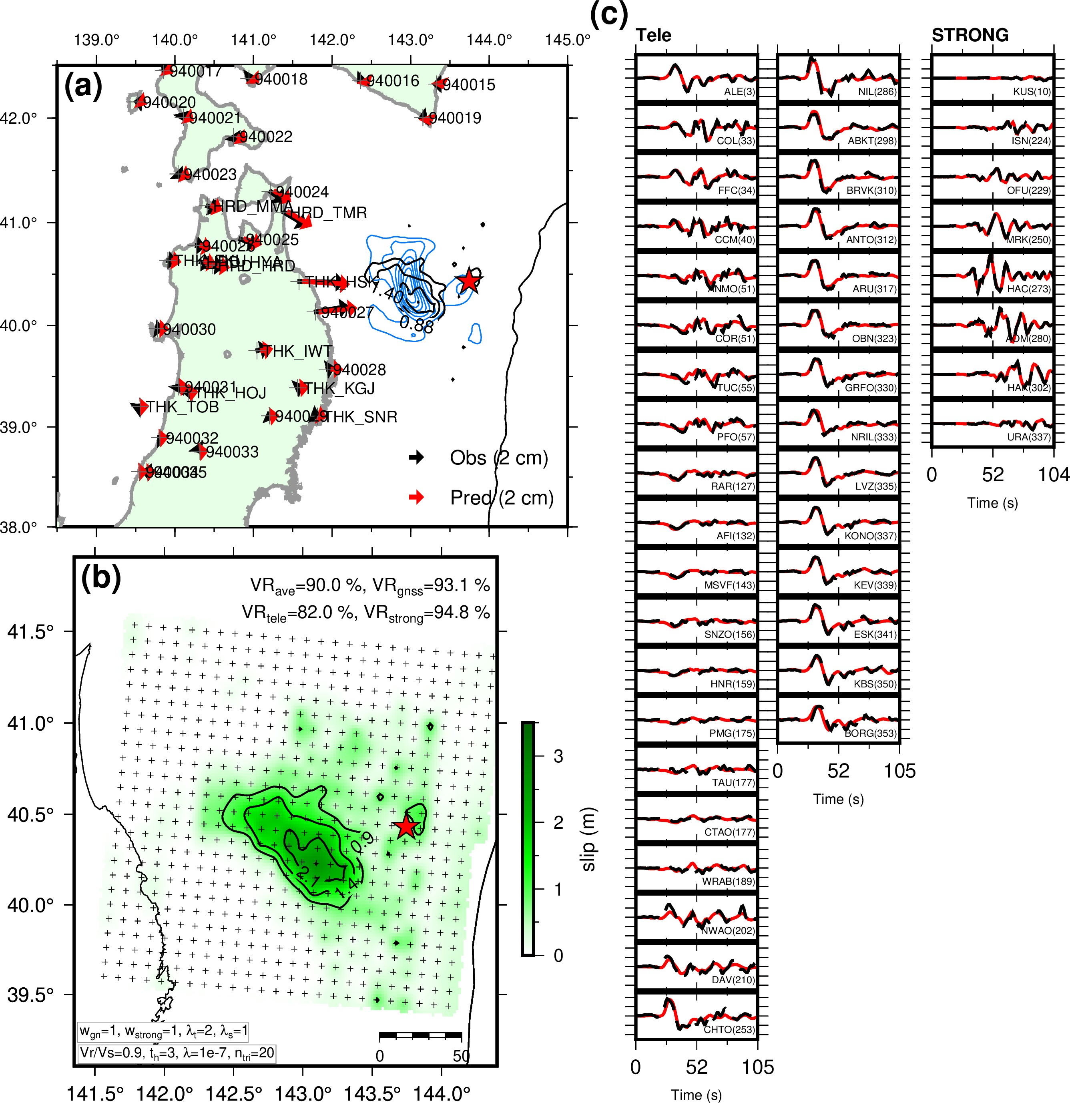
Figure S4. Results of the slip inversion with the GNSS displacement amplitudes reduced to 70% of their original values. (a) Estimated slip distribution and horizontal GNSS displacements. Black and red arrows indicate the observed and synthetic displacements, respectively. (b) Estimated slip distribution shown by colors and contours. The star marks the hypocenter, and the blue contours indicate the slip model of Nagai et al. (2001). (c) Fits to the teleseismic and strong-motion waveforms. The waveforms are arranged by station azimuth, with azimuths shown in parentheses. Black and red traces indicate the observed and synthetic waveforms, respectively.

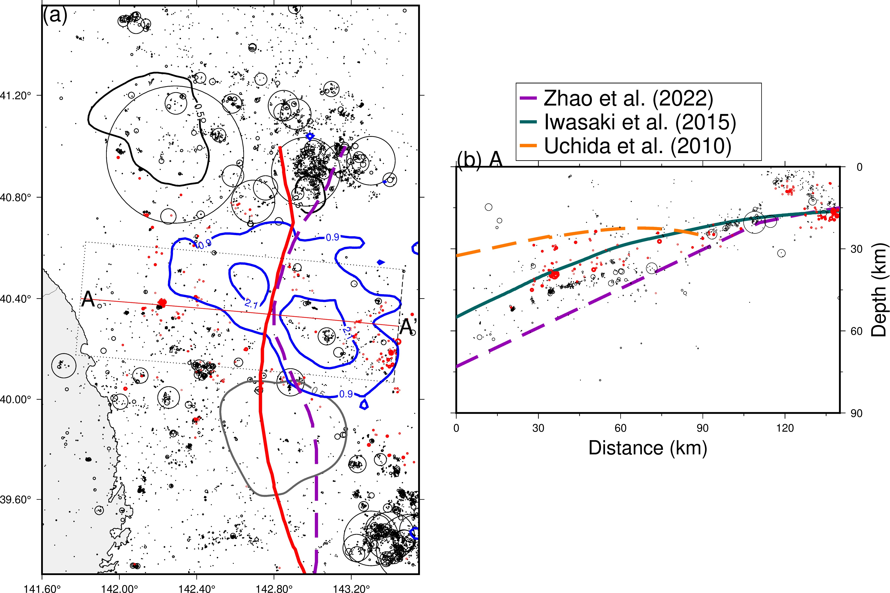
Figure S5. Map and cross-sectional views of the relationships among coseismic slip distributions, seismicity, and subsurface structures. Blue contours show the slip distribution of the 1994 earthquake; black and gray contours show those of the 2025 Mw 7.6 earthquake (Yoshida et al., 2025) and the 2011 Mw 7.4 earthquake (Kubo & Nishikawa, 2020), respectively. The blue star denotes the 1994 mainshock. Red circles show aftershocks relocated by Hino et al. (2000) for the period from 23 January to 26 February 1995. (a) Map view. The red line marks cross section A–A′, and the dotted rectangle indicates the 50-km-wide swath used to project the hypocenters onto the cross section. The red solid and purple dashed lines indicate the mantle-wedge corner (MWC) estimated using the plate-interface models of Iwasaki et al. (2015) and Zhao et al. (2022), respectively. For the Zhao et al. (2022) model, the −1-km contour of the Moho-minus-plate depth difference is shown because an exact zero contour is absent. (b) Depth cross section along A–A′. The purple dashed and dark-green solid lines show the Pacific plate interfaces of Zhao et al. (2022) and Iwasaki et al. (2015), respectively. The orange dashed line shows the Moho discontinuity of Uchida et al. (2010), plotted only to a distance of 90 km because of the limited reliable extent of the model. Symbol sizes are scaled according to earthquake magnitude.

