Comparison of rice-husk- and poplar-wood-shard derived biochars on the growth and physiological performance of two plant species for the ecological restoration of coal wastes
Plant and Soil
Nateq Lashkari Sanami, Jamshid Ghorbani*, Ghorban Vahabzadeh, Seyed Mohammad Hojjati, Babak Motesharezadeh, Rob H. Marrs
* Department of Rangeland Management, Faculty of Natural Resources, Sari Agricultural Sciences and Natural Resources University, Sari, Iran, j.ghorbani@Liverpool.ac.uk

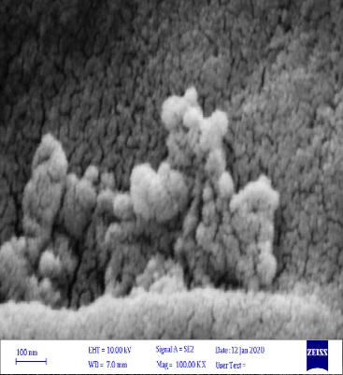
Figure S1.
a
b
c
d
e
f

Figure S2.

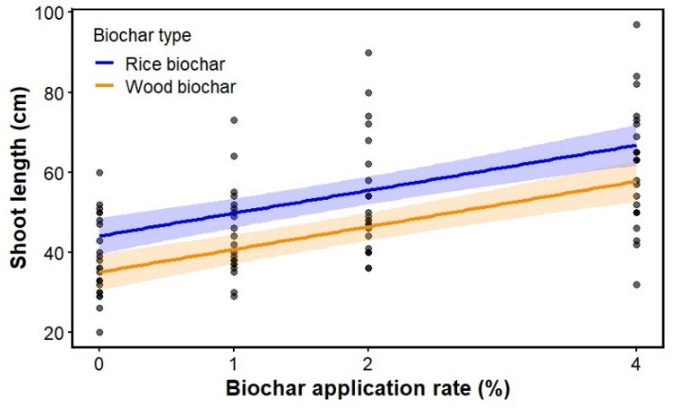
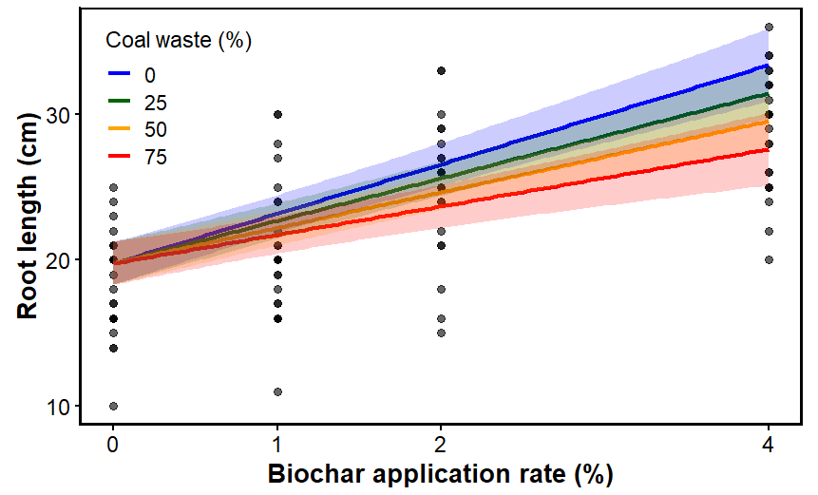
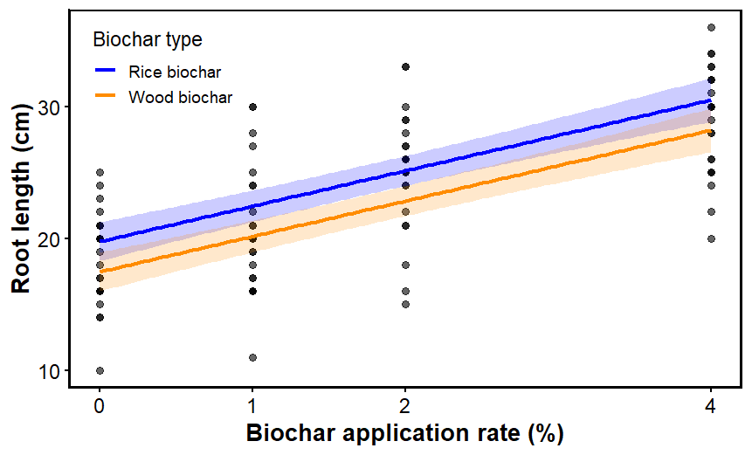
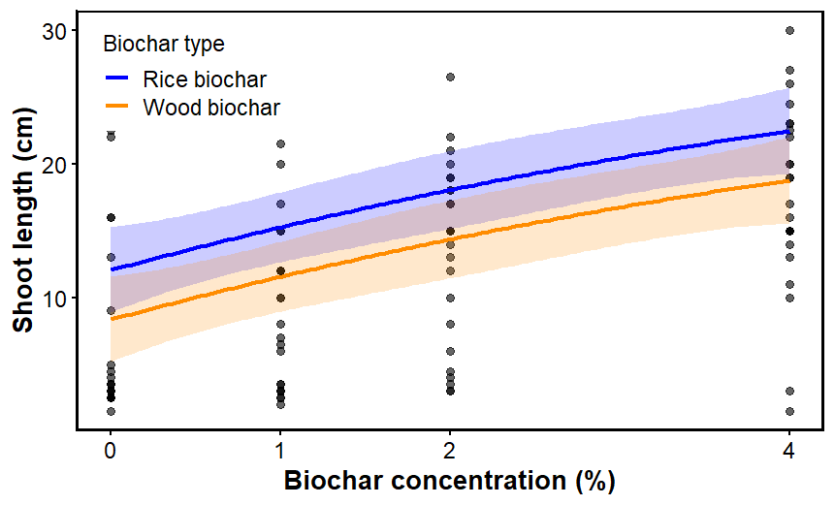
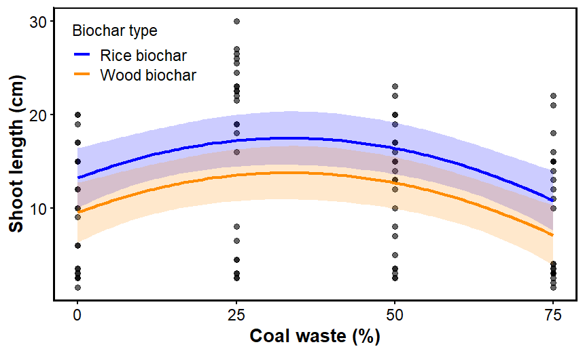
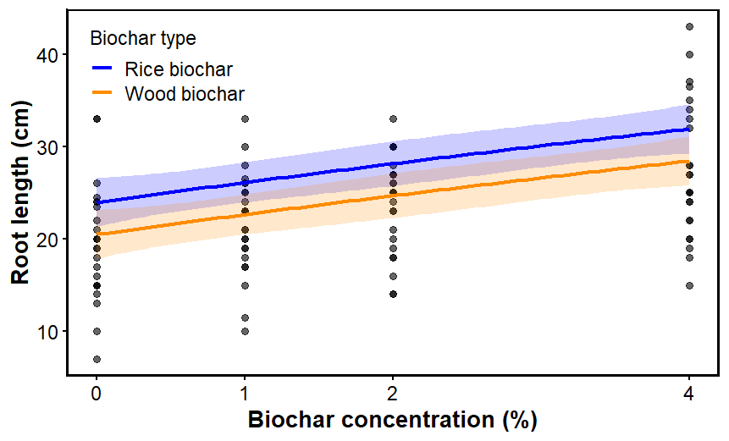
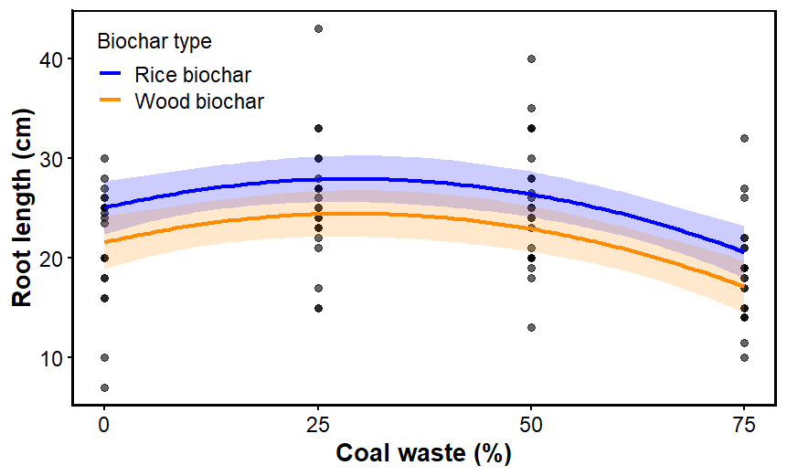
(a) Shoot length – A. absinthium
(b) Root length – A. absinthium
(c) Shoot length – S. marianum
(d) Root length – S. marianum

Figure S3.

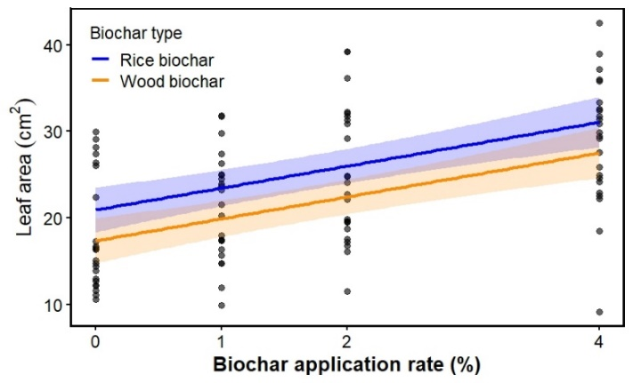
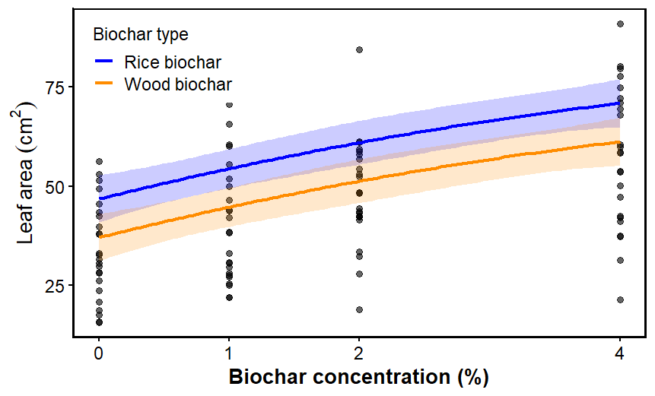
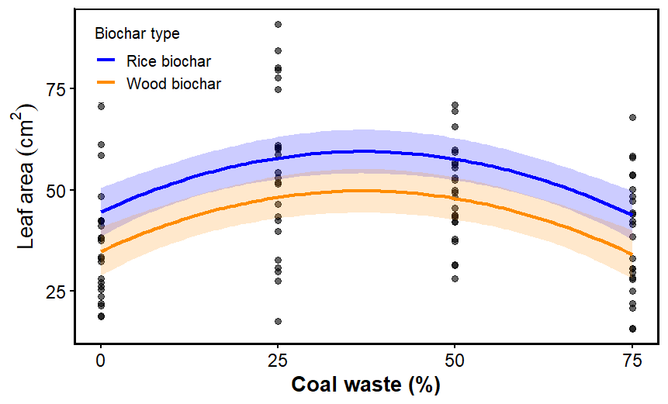
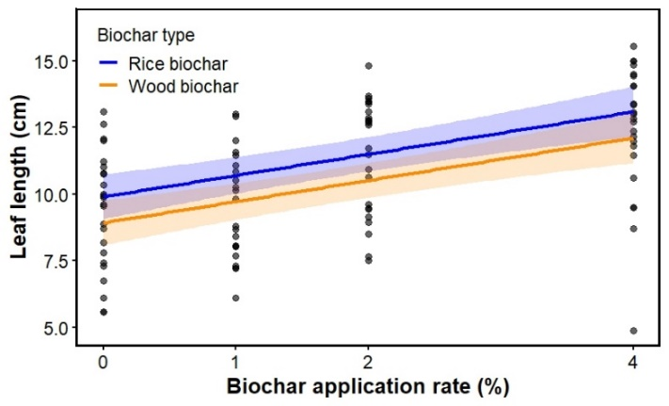
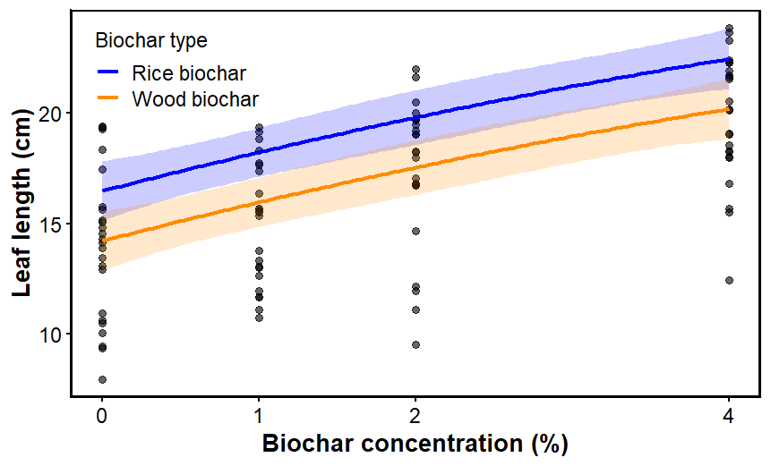
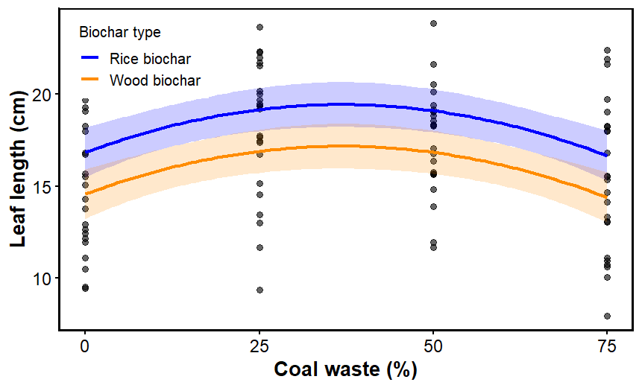
(a) Leaf area – A. absinthium
(c) Leaf area – S. marianum
(b) Leaf length – A. absinthium
(d) Leaf length – S. marianum

Figure S4.
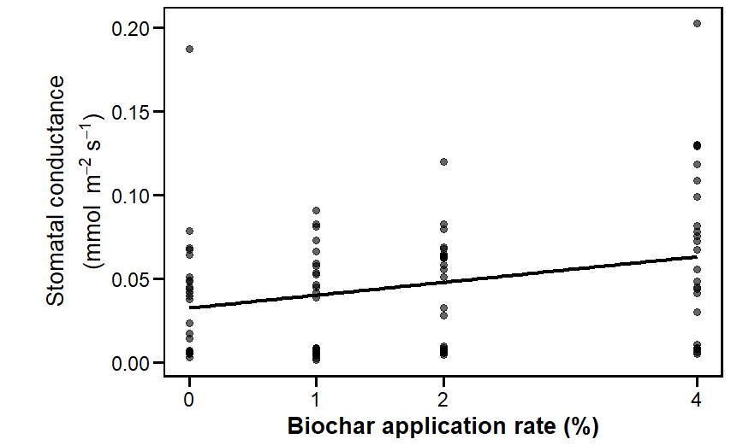
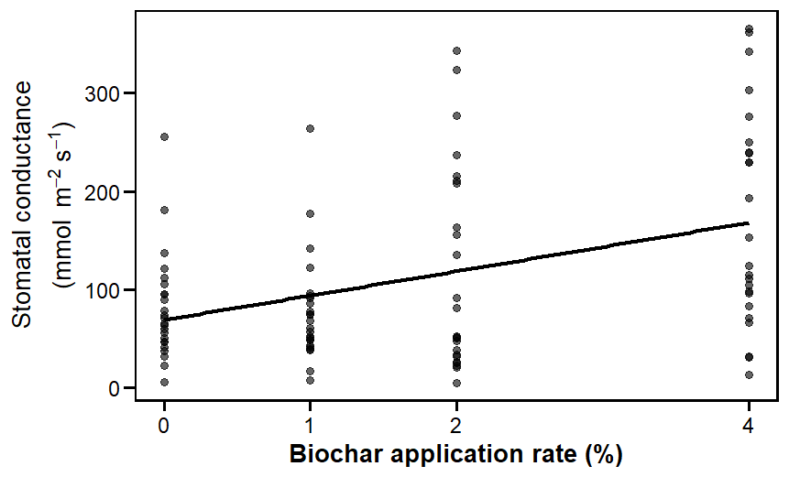
(b) Stomatal conductance – S. marianum
(a) Stomatal conductance – A. absinthium

