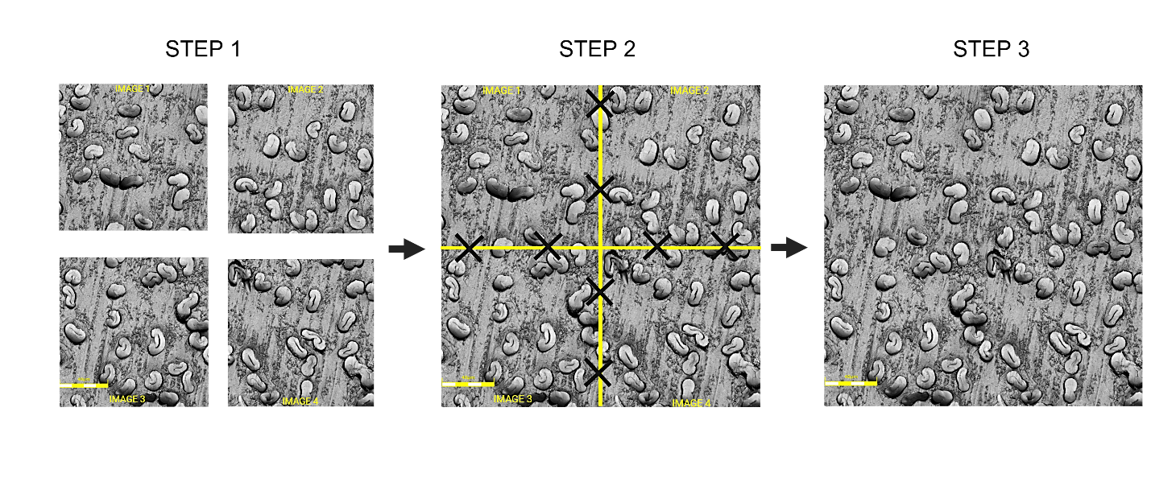
Supplementary Figure 1. Stitching of four light microscopy images into a single composite image to expand the field of view and increase imaging throughput. Images 1–4 are aligned using shared reference features (black X markers) along horizontal and vertical axes (yellow guidelines), producing a reconstructed high-resolution mosaic (right). Scale bar = 40 µm.

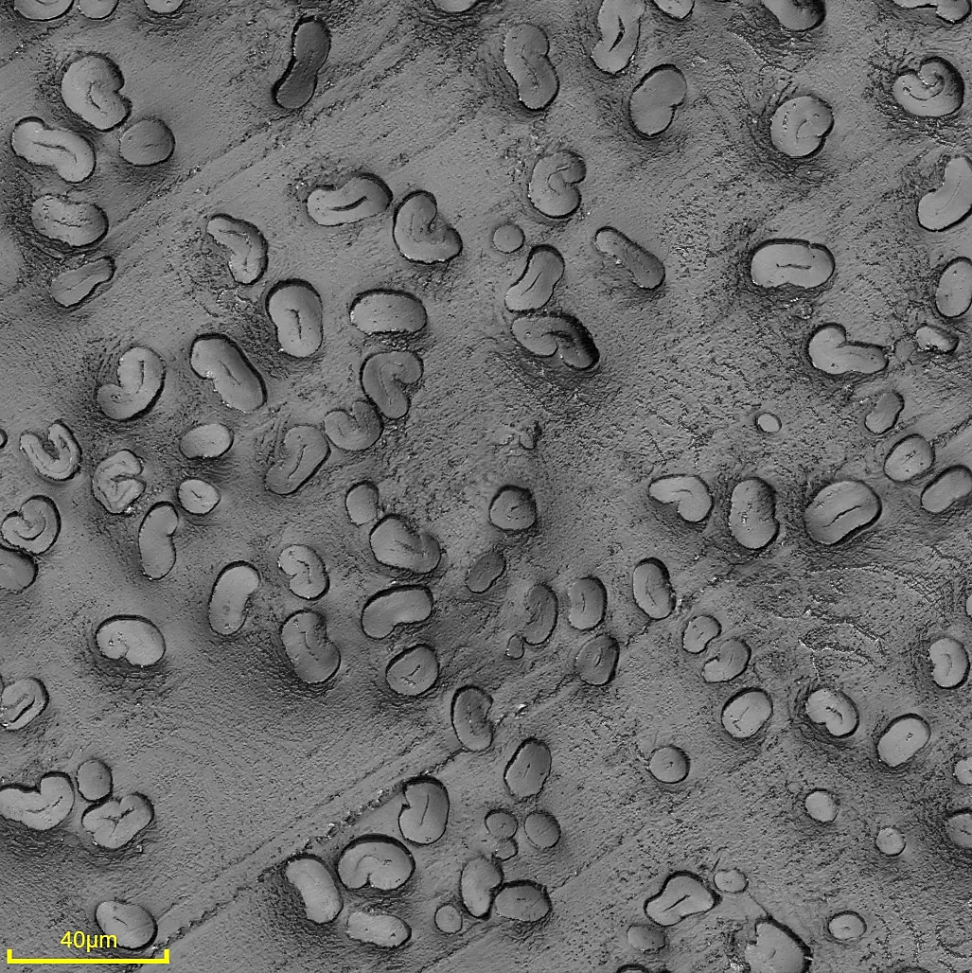
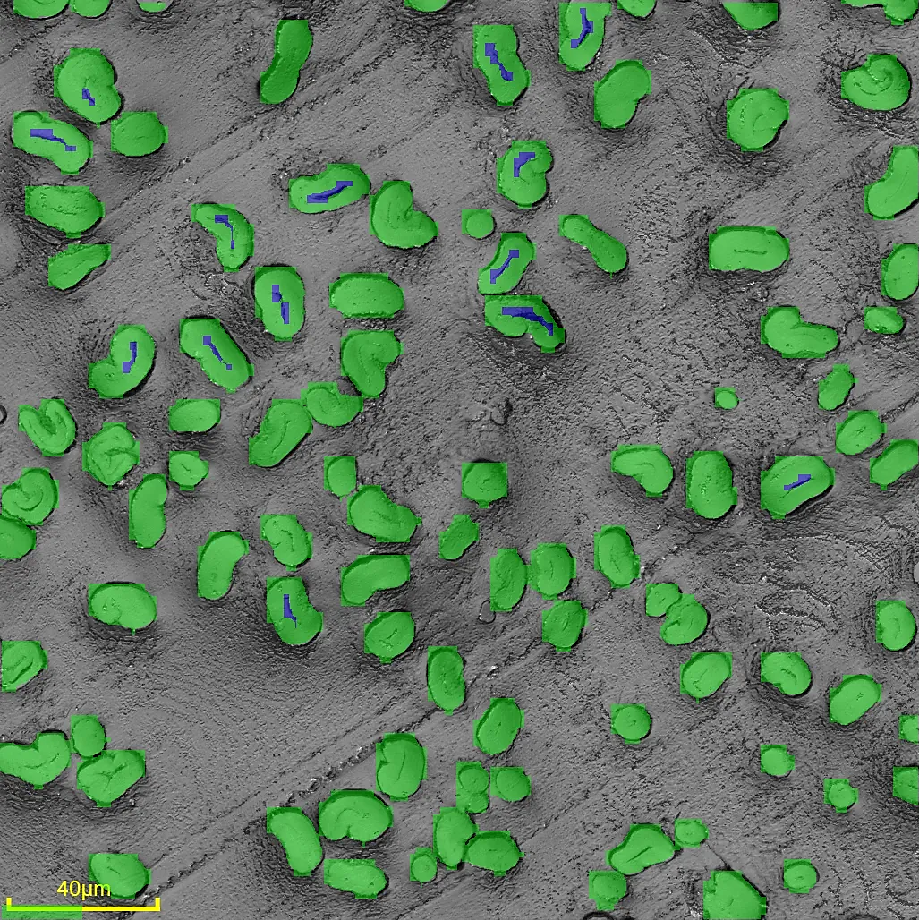
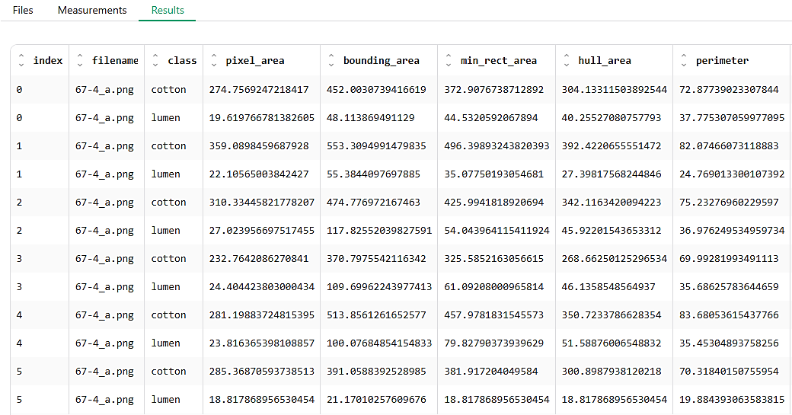
Supplementary Figure 2. Workflow demonstration of the cotton-lumen web application. (A) Uploading a light microscope image to the application. (B) Measuring cotton fiber and lumen regions. (C) Exporting measurement results as a CSV file.
Figure 3A
Figure 3B
Figure 3C

Supplementary Table 1. Descriptive statistics for cotton fiber cross-sectional traits derived from Adobe Photoshop and the automated YOLO11m workflow. Values are presented as mean ± standard deviation and median (Q1–Q3).
Trait | Genotype | Photoshop | Photoshop | Model | Model
 |  | Mean ± SD | Median (Q1–Q3) | Mean ± SD | Median (Q1–Q3)
Cotton Area (µm²) | Siokra-250 | 142.35 ± 37.22 | 140.61 (116.84–168.21) | 121.57 ± 55.98 | 129.80 (81.87–162.97)
Cotton Area (µm²) | U1 | 133.88 ± 31.22 | 133.05 (114.55–152.05) | 119.76 ± 52.46 | 129.42 (83.15–157.05)
Lumen Area (µm²) | Siokra-250 | 6.72 ± 4.37 | 5.84 (3.61–8.81) | 5.65 ± 5.57 | 4.79 (0.00–10.04)
Lumen Area (µm²) | U1 | 4.42 ± 2.62 | 3.70 (2.63–5.65) | 4.88 ± 4.61 | 4.53 (0.00–8.17)
Cotton Perimeter (µm) | Siokra-250 | 56.59 ± 9.13 | 56.86 (51.41–62.56) | 53.29 ± 19.75 | 54.60 (41.63–62.82)
Cotton Perimeter (µm) | U1 | 51.97 ± 6.78 | 51.86 (48.41–56.03) | 48.79 ± 15.07 | 51.27 (40.51–56.34)
True Fiber Area (µm²) | Siokra-250 | 135.64 ± 36.81 | 133.24 (110.31–162.53) | 115.92 ± 53.36 | 122.99 (78.19–153.87)
True Fiber Area (µm²) | U1 | 129.46 ± 31.10 | 129.09 (109.64–148.28) | 114.88 ± 50.14 | 123.26 (80.76–150.82)
Fiber Fineness (µm × g cm⁻³) | Siokra-250 | 206.17 ± 55.95 | 202.53 (167.67–247.04) | 176.20 ± 81.11 | 186.95 (118.85–233.88)
Fiber Fineness (µm × g cm⁻³) | U1 | 196.78 ± 47.27 | 196.22 (166.65–225.38) | 174.61 ± 76.21 | 187.35 (122.76–229.24)
Maturity Ratio | Siokra-250 | 0.94 ± 0.24 | 0.95 (0.77–1.11) | 0.92 ± 0.29 | 0.95 (0.72–1.16)
Maturity Ratio | U1 | 1.05 ± 0.19 | 1.07 (0.92–1.18) | 1.04 ± 0.26 | 1.11 (0.88–1.23)

Note: Adobe Photoshop measurements were obtained from representative manually measured subsets, whereas the automated workflow analyzed all detectable fibers from the same composite images. Consequently, the datasets are independent rather than paired, and the comparison is descriptive.

