Supplementary Data
Title: Differential Susceptibility of hiPSC-Derived Neural Progenitors and Neurons to Measles Virus Infection Reveals Unique Neuronal Budding and Viral Mutations
Authors’ names: Debora Santos, Davi G. S. Merighi, Ana K. A. Eisen, Paulo E. C. Leite, Cristiane R. Guzzo, Edison L. Durigon, Patricia C. B. Beltrão-Braga
Supplementary Figure S1
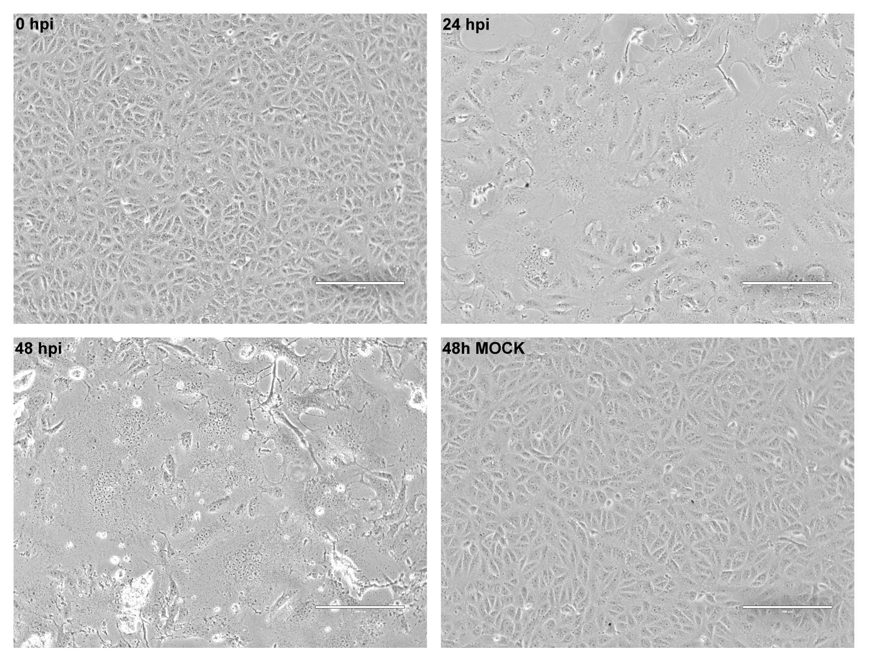
Supplementary Figure S1. Cytopathic effect (CPE) of MeV in Vero cells. Light microscopy images of Vero cells at 0, 24, and 48 h post-infection (hpi) and 48 h non-infected control (MOCK). Scale bars, 200 μm (20× magnification).
Supplementary Figure S2
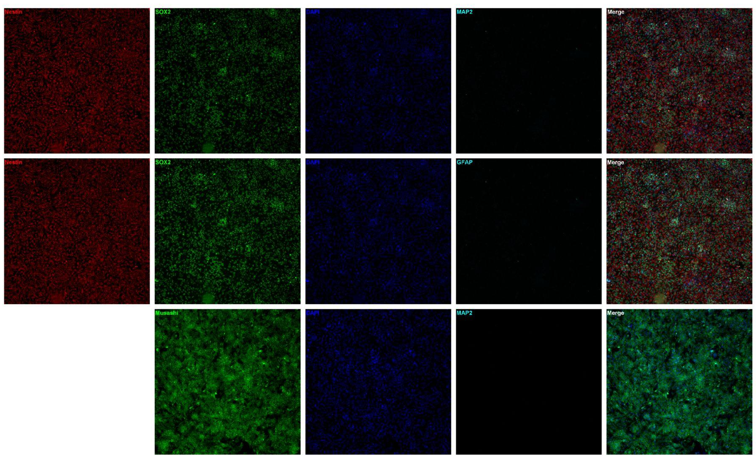
Supplementary Figure S2. Characterization of NPC and neurons. (A) NPC expressing neural progenitor markers Nestin, Sox2, and Musashi-1 (10x magnification). (B) Neurons expressing neural markers MAP2 and GFAP (20x magnification).
Supplementary Figure S3
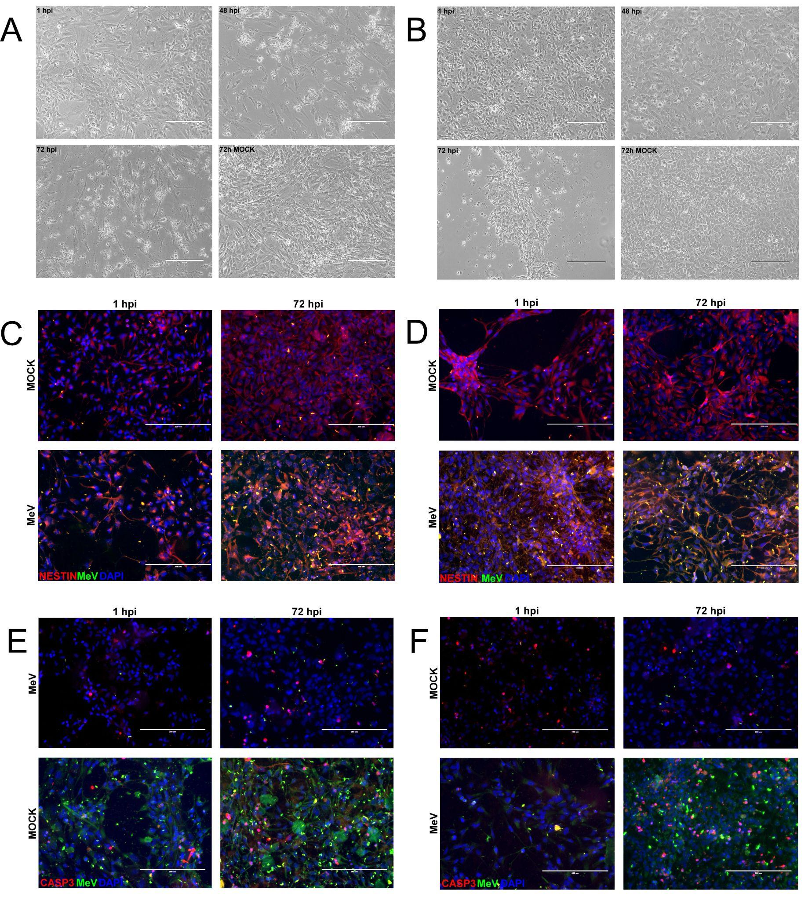
Supplementary Figure S3. NPC infected by MeV.
(A and B) Expanded light microscopy images of NPC at 1, 48, and 72 hpi and 72 h non-infected control (MOCK). Scale bars, 200 μm (20× magnification). (C and D) Expanded immunofluorescence images of infected (MeV) and non-infected (MOCK) NPC at 1 and 72 hpi, stained with DAPI (nuclei), Nestin (progenitor cytoskeleton), and MeV. Scale bars, 200 μm (20× magnification). (E and F) Expanded immunofluorescence images of infected (MeV) and non-infected (MOCK) NPC at 1 and 72 hpi, stained with DAPI (nuclei), cleaved caspase-3 (apoptosis), and MeV.
Supplementary Figure S4
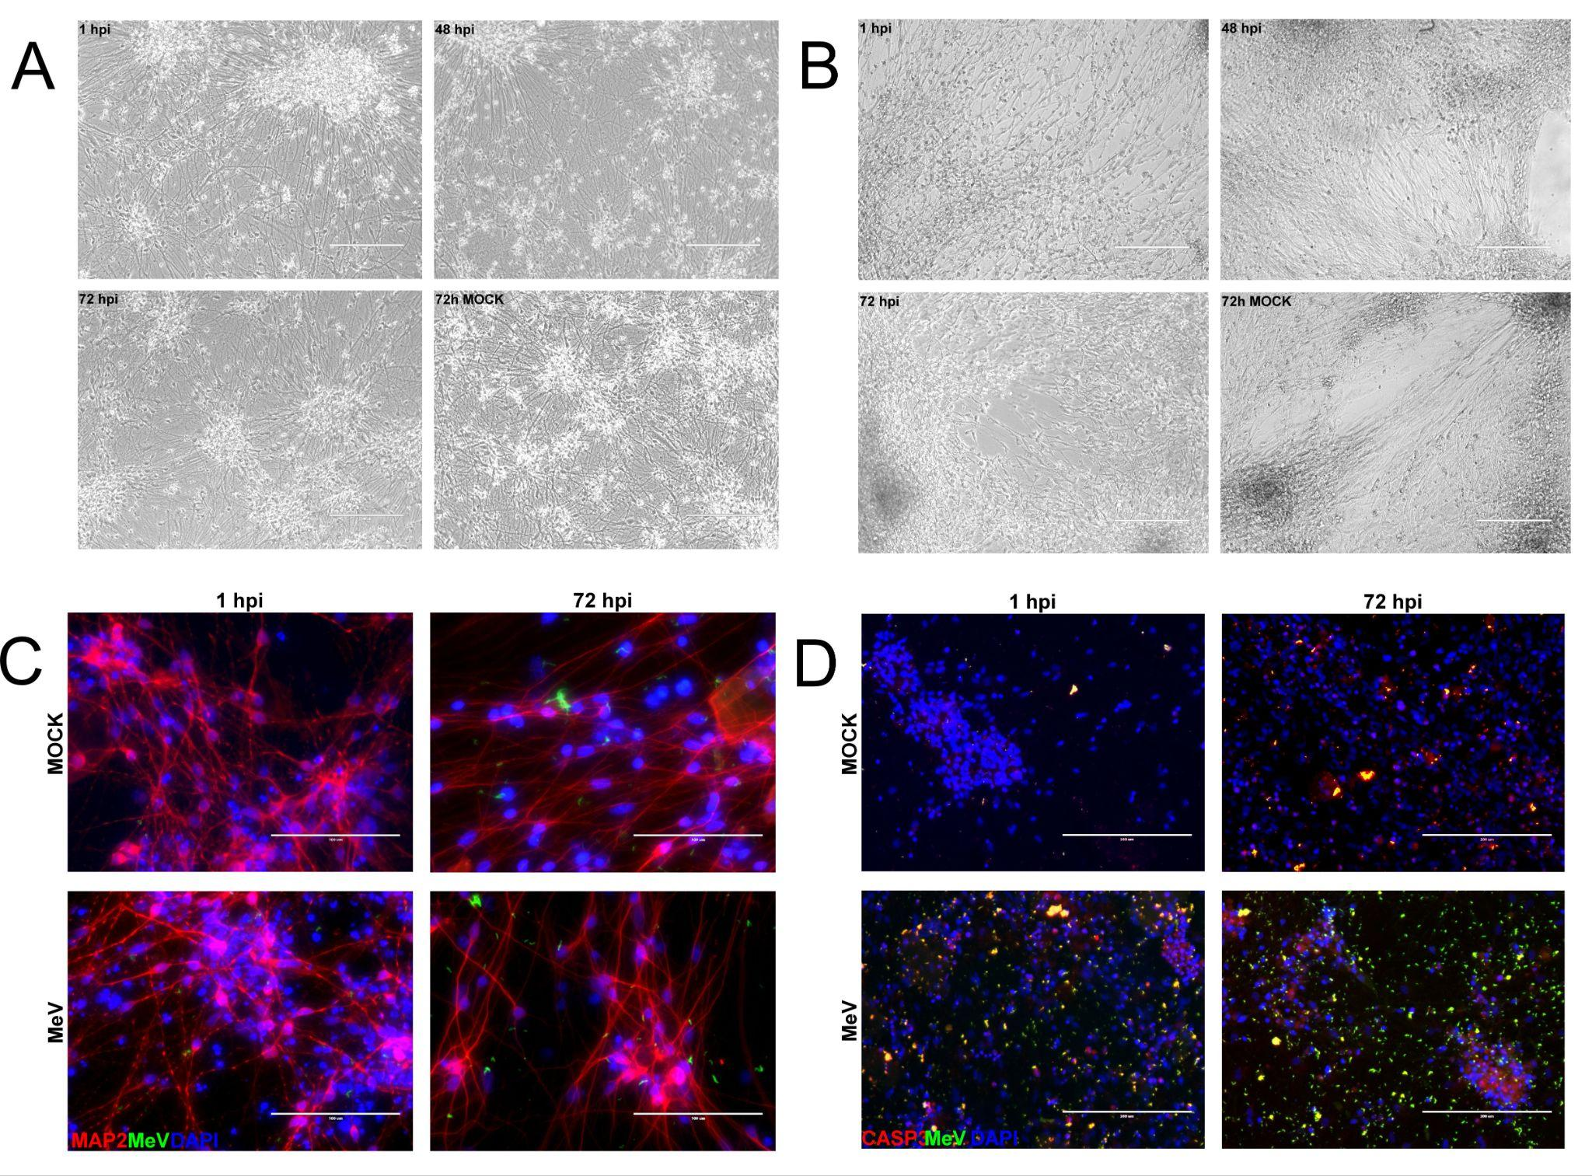
Supplementary Figure S4. Neurons infected by MeV.
(A and B) Expanded light microscopy images of neurons at 1, 48, and 72 hpi and 72 h non-infected control (MOCK). Scale bars, 200 μm (20× magnification). (C) Expanded immunofluorescence images of infected (MeV) and non-infected (MOCK) neurons at 1 and 72 hpi, stained with DAPI (nuclei), MAP2 (neuronal cytoskeleton), and MeV. Scale bars, 200 μm (20× magnification). (D) Expanded immunofluorescence images of infected (MeV) and non-infected (MOCK) neurons at 1 and 72 hpi, stained with DAPI (nuclei), cleaved caspase-3 (apoptosis), and MeV.
Supplementary Figure S5
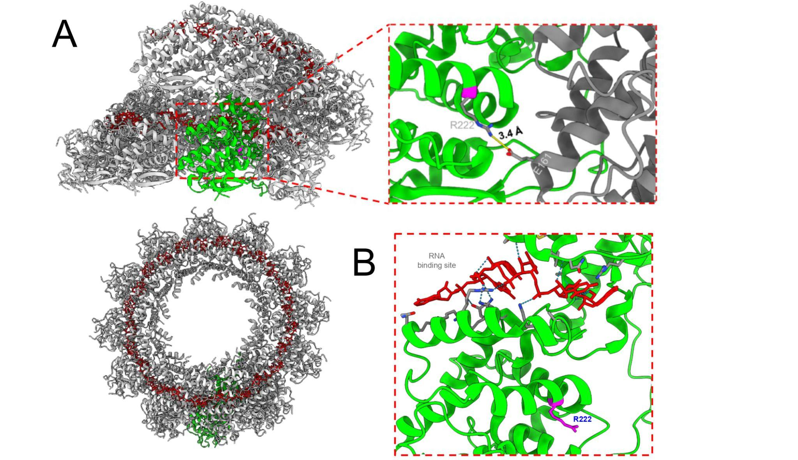
Supplementary Figure S5. Cryo-EM structure of the measles virus nucleocapsid protein at 3.3 Å resolution (PDB: 6H5S).
(A) Side and top views of the nucleocapsid oligomer solved by cryo-EM. One monomer is shown in green and the neighboring monomers in gray. Viral RNA is shown in red sticks. Detailed view of residue R222 (magenta), showing its interaction with E161 from the neighboring monomer (gray). (B) Detailed view of residue R222 (magenta) showing no interaction with viral RNA (red).
Supplementary Figure S6
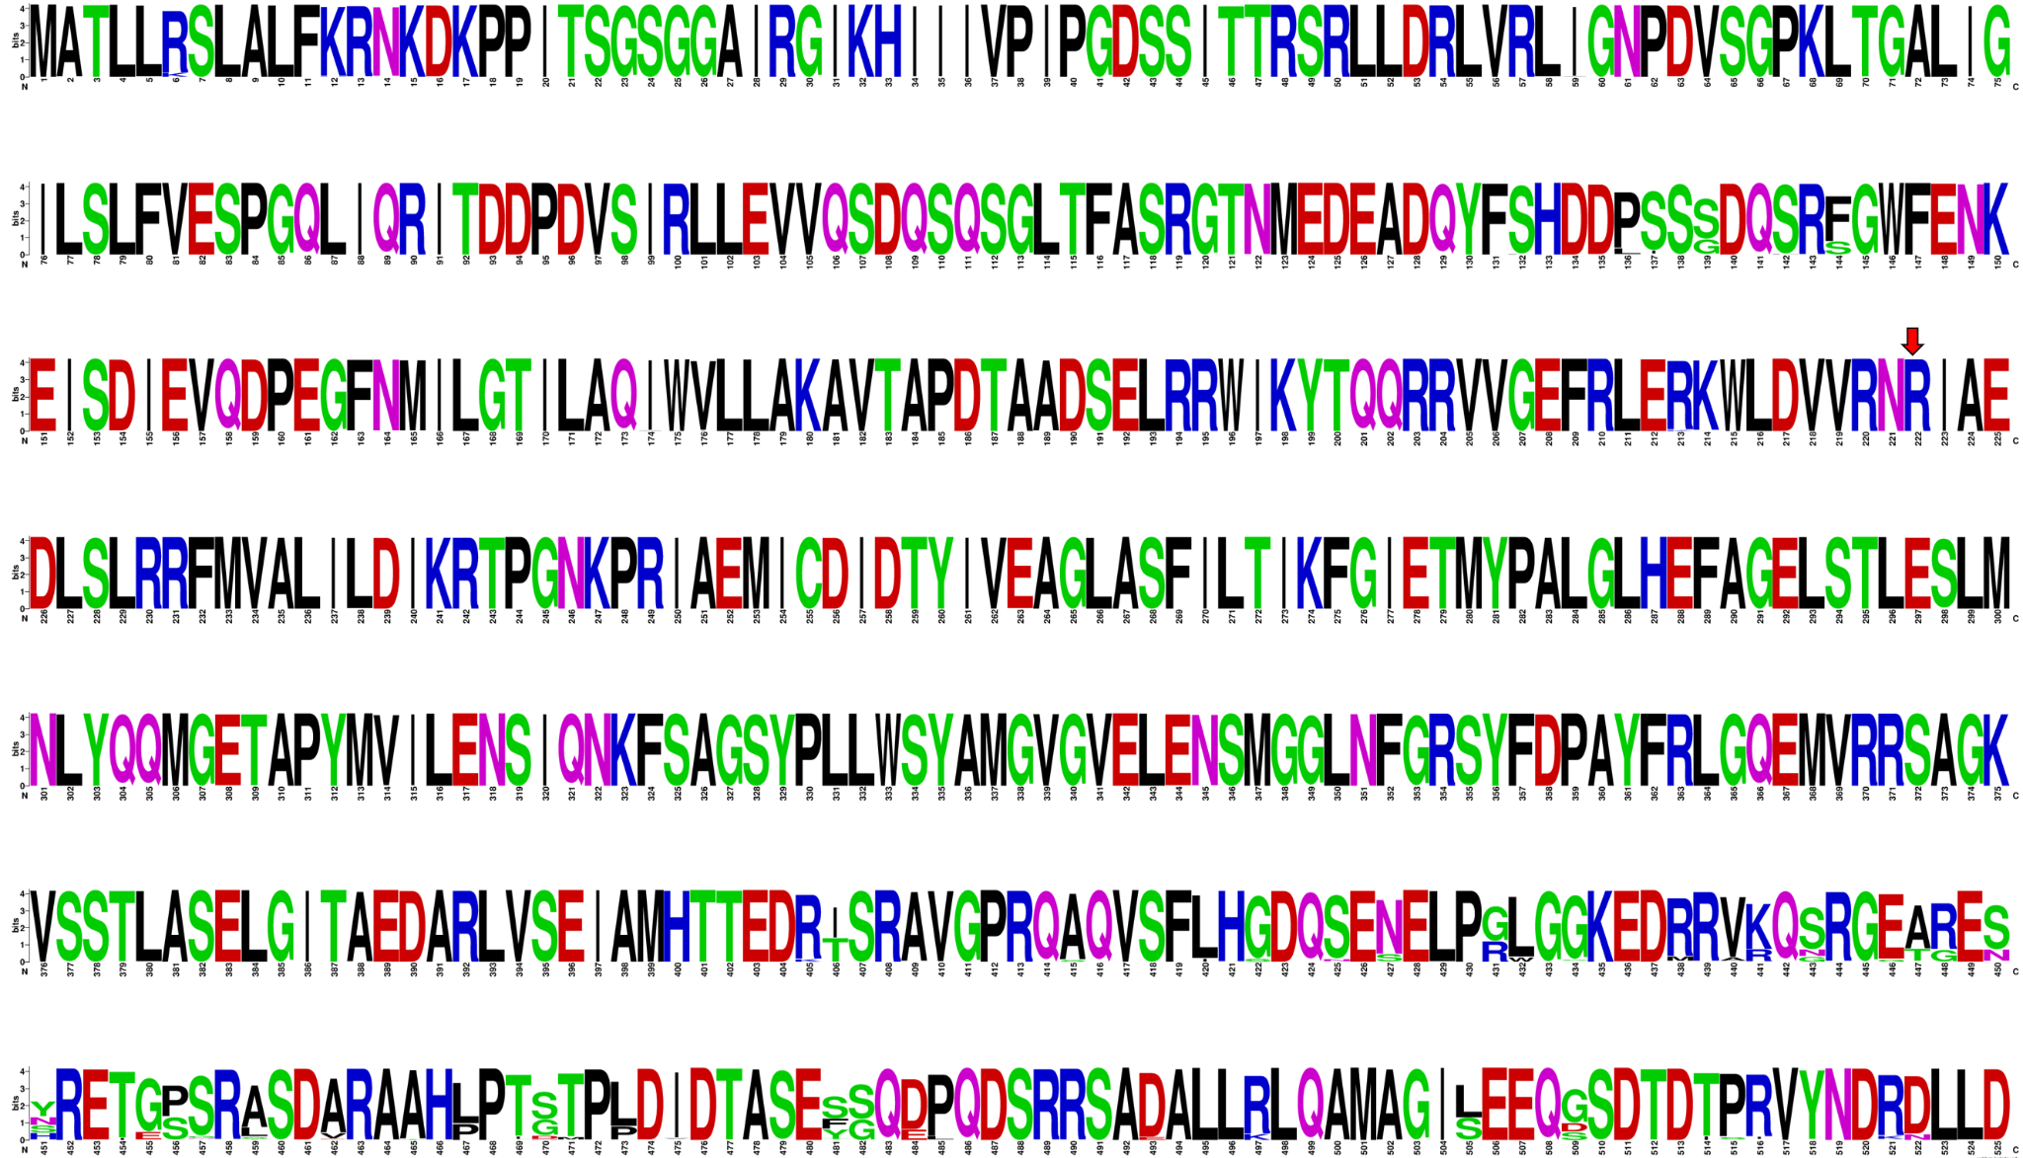
Supplementary Figure S6. Conservation profile of measles virus nucleocapsid proteins.
WebLogo representation generated from Clustal-aligned sequences (via Jalview) obtained from a BLAST search in the NCBI Virus database, using the studied MeV nucleocapsid protein (GenBank: ACN50047.1) as the query. Identical sequences (100% identity) were excluded, retaining sequences containing at least two mutations. Residue R222 is absolutely conserved.
Supplementary Figure S7
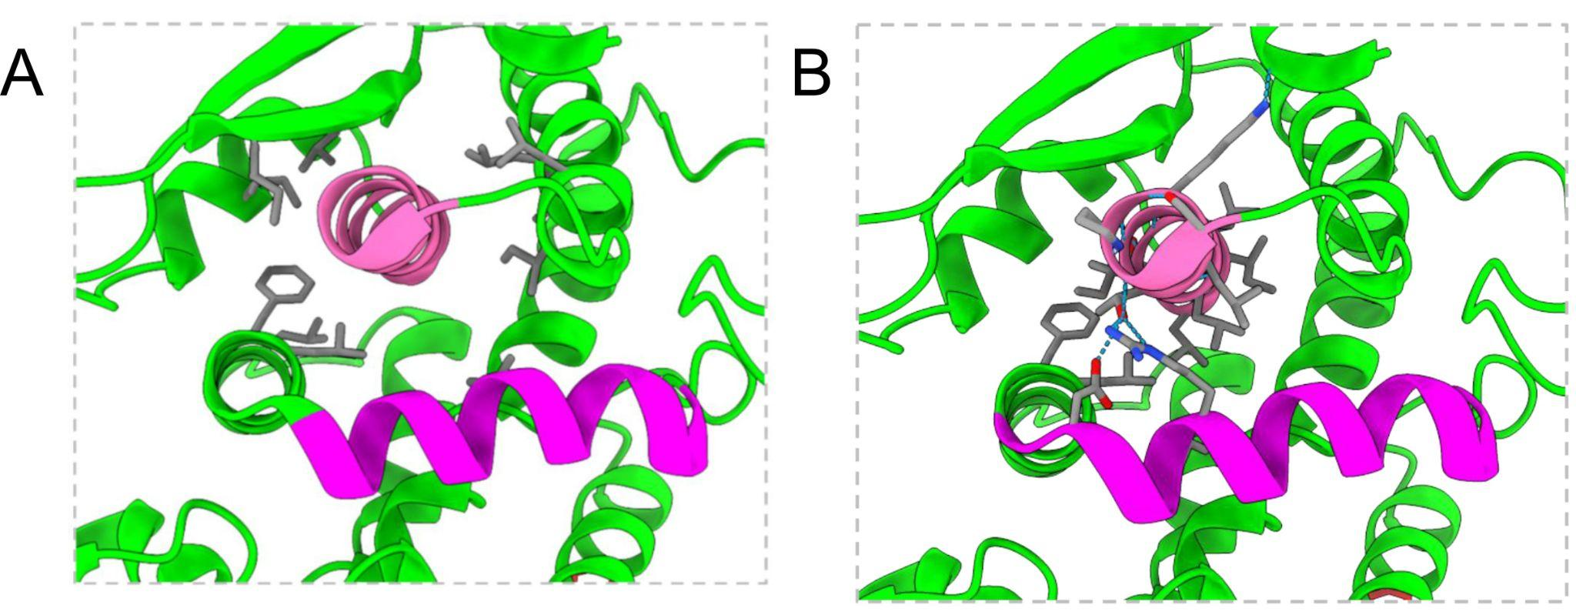
Supplementary Figure S7. Hydrophobic pocket of the α3 helix.
(A) The α3 helix is buried within a hydrophobic pocket formed by apolar residues from neighboring helices. (B) These interactions stabilize the apolar amino acids of α3, which are capable of polar interactions only at the N-terminal region. The nucleocapsid monomer is shown in green, α3 in hot pink, and α7 in magenta.
Supplementary Table 1. Primary antibodies used in this study
Antibody | Supplier | Cat No. | Concentration
Primary antibody
Nestin | Abcam | ab22035 | 1:100
SOX2 | Cell Signaling Technology | 2748 | 1:500
Musashi | Abcam | ab21628 | 1:1000
GFAP | Abcam | ab4674 | 1:1000
MAP2 | Abcam | Ab5392 | 1:500
NG2 | Millipore | AB5320 | 1:100
Cleaved caspase 3 | CellSignaling | 9664S | 1:200
MeV | - | - | 1:200

Supplementary Table 2. Descriptive and inferential statistical analysis of cytokine levels in supernatants measured by Luminex xMAP technology
Cell Model | Cytokine | Mock Mean | Mock SD | MeV Mean | Mev SD | P-Value
NPC | CCL2 (MCP-1) | 449.183333 | 219.497535 | 1629.53333 | 2539.129 | 0.0078
NPC | CCL3 (MIP-1α) | 0.693871 | 0.391528 | 2.840758 | 2.750784 | 0.0418
NPC | CCL4 (MIP-1β) | 0.315558 | 0.371321 | 10.080525 | 10.472952 | 0.0002
NPC | CCL5 (RANTES) | 8.722806 | 7.861430 | 398.899985 | 487.208498 | <0.0001
NPC | CCL7 (MCP-3) | 42.312953 | 40.055283 | 47.966194 | 52.584739 | 0.6048
NPC | CCL11 (Eotaxin) | 126.599948 | 145.910118 | 152.136125 | 203.926002 | 0.8167
NPC | CCL27 (CTACK) | 0.000000 | 0.000000 | 0.000000 | 0.000000 | NA
NPC | CXCL1 (GRO-α) | 241.283152 | 149.641307 | 1848.51817 | 1293.26974 | 0.0002
NPC | CXCL9 (MIG) | 25.580631 | 17.642256 | 28.792124 | 20.107198 | 0.6488
NPC | CXCL10 (IP-10) | 55.997031 | 74.186782 | 468.599124 | 668.404038 | 0.1903
NPC | CXCL12 (SDF-1α) | 135.556644 | 153.651132 | 150.092480 | 139.317023 | 0.4363
NPC | G-CSF | 0.000000 | 0.000000 | 0.050709 | 0.105310 | 0.0824
NPC | GM-CSF | 1.351774 | 1.259826 | 17.012960 | 21.373931 | 0.0199
NPC | HGF | 93.855549 | 75.105426 | 47.459584 | 25.565415 | 0.3865
NPC | IFN-α2 | 4.335008 | 4.046681 | 5.810814 | 4.540499 | 0.4483
NPC | IFN-γ | 9.811390 | 3.996982 | 12.793899 | 6.654232 | 0.2581
NPC | IL-1ra | 11.019327 | 21.835860 | 30.237799 | 27.669926 | 0.0771
NPC | IL-1α | 40.924954 | 29.344999 | 45.637217 | 48.476994 | >0.9999
NPC | IL-1β | 7.293757 | 6.202306 | 7.314953 | 7.117480 | >0.9999
NPC | IL-2 | 2.701665 | 2.435823 | 3.036012 | 2.909832 | 0.9292
NPC | IL-2ra (CD25) | 3.860997 | 2.942128 | 6.255755 | 5.875562 | 0.6229
NPC | IL-3 | 1.675478 | 1.107793 | 2.089935 | 1.766631 | 0.8148
NPC | IL-4 | 3.668388 | 1.751958 | 3.467197 | 2.002065 | 0.9591
NPC | IL-5 | 76.089585 | 25.009202 | 96.780010 | 49.761842 | 0.4894
NPC | IL-6 | 2.111692 | 1.423219 | 1114.56992 | 1682.28533 | <0.0001
NPC | IL-7 | 0.950048 | 2.687142 | 2.294543 | 4.537717 | 0.4529
NPC | IL-8 (CXCL8) | 387.325571 | 784.952413 | 3001.98761 | 4455.45556 | 0.0625
NPC | IL-9 | 1.241430 | 1.133958 | 9.148344 | 6.442150 | 0.0003
NPC | IL-10 | 0.000000 | 0.000000 | 0.050709 | 0.105310 | 0.4706
NPC | IL-12(p40) | 23.015156 | 19.037017 | 26.814574 | 23.156333 | 0.8633
NPC | IL-12(p70) | 0.189543 | 0.235314 | 0.198494 | 0.221358 | 0.9901
NPC | IL-13 | 1.170557 | 0.935308 | 2.328026 | 1.667044 | 0.1143
NPC | IL-15 | 13.670763 | 17.485804 | 24.145446 | 34.904180 | 0.7961
NPC | IL-16 | 3.737866 | 4.477729 | 3.885710 | 5.536380 | >0.9999
NPC | IL-17 | 8.732188 | 5.594093 | 8.126599 | 7.718689 | 0.7956
NPC | IL-18 | 2.159786 | 1.655199 | 20.101794 | 6.943713 | <0.0001
NPC | LIF | 158.185387 | 116.688666 | 379.543214 | 268.191046 | 0.1359
NPC | M-CSF | 1.351774 | 1.259826 | 17.012960 | 21.373931 | <0.0001
NPC | MIF | 859.716525 | 455.738529 | 9285.25460 | 12004.9078 | 0.0142
NPC | PDGF-BB | 6.024754 | 5.532046 | 8.298737 | 7.244360 | 0.6143
NPC | SCF | 23.788776 | 6.815938 | 24.926266 | 9.595309 | 0.7132
NPC | SCGF-β | 1316.51485 | 1576.04592 | 683.395490 | 796.804425 | 0.5567
NPC | TNF-α | 22.081217 | 16.234781 | 29.562844 | 20.162471 | 0.3853
NPC | TNF-β | 3.877672 | 4.488276 | 19.720669 | 16.598287 | 0.0027
NPC | TRAIL | 7.638271 | 5.099891 | 15.136999 | 8.343804 | 0.0625
NPC | VEGF | 88.854594 | 101.156822 | 1496.97985 | 1346.28912 | <0.0001
NPC | β-NGF | 3.610748 | 3.519131 | 3.393365 | 2.625959 | 0.9494
Neuron | CCL2 (MCP-1) | 683.617762 | 108.877752 | 1696.78777 | 2511.71616 | <0.0001
Neuron | CCL3 (MIP-1α) | 0.266852 | 0.218488 | 0.417210 | 0.236437 | 0.0070
Neuron | CCL4 (MIP-1β) | 0.681704 | 1.298875 | 1.637014 | 0.827742 | 0.9091
Neuron | CCL5 (RANTES) | 8.511457 | 7.160333 | 67.125436 | 21.187539 | <0.0001
Neuron | CCL7 (MCP-3) | 19.877184 | 20.841663 | 67.984557 | 102.551886 | 0.3865
Neuron | CCL11 (Eotaxin) | 129.600656 | 171.942111 | 277.983101 | 410.537646 | 0.5625
Neuron | CCL27 (CTACK) | 0.000000 | 0.000000 | 0.000000 | 0.000000 | NA
Neuron | CXCL1 (GRO-α) | 77.528356 | 109.761815 | 920.024832 | 1686.50901 | 0.0056
Neuron | CXCL9 (MIG) | 7.750272 | 6.140486 | 9.373689 | 9.627211 | 0.3853
Neuron | CXCL10 (IP-10) | 528.483482 | 361.905324 | 806.310331 | 526.632299 | 0.0078
Neuron | CXCL12 (SDF-1α) | 166.124608 | 134.595809 | 138.334359 | 117.942992 | 0.2961
Neuron | G-CSF | 0.000000 | 0.000000 | 1.487468 | 3.535107 | 0.4706
Neuron | GM-CSF | 0.465873 | 0.453481 | 0.882184 | 0.657659 | 0.0183
Neuron | HGF | 578.726266 | 727.751230 | 472.916819 | 546.244240 | 0.3401
Neuron | IFN-α2 | 0.989810 | 0.995577 | 1.731157 | 2.043280 | 0.2433
Neuron | IFN-γ | 11.449900 | 4.031035 | 11.308579 | 1.934129 | 0.0005
Neuron | IL-1ra | 1.877383 | 3.515558 | 4.345120 | 7.859501 | 0.5765
Neuron | IL-1α | 7.231591 | 6.243457 | 6.238270 | 9.979172 | 0.6441
Neuron | IL-1β | 1.353726 | 1.675836 | 1.541268 | 2.132359 | 0.5235
Neuron | IL-2 | 0.000000 | 0.000000 | 0.013633 | 0.038560 | >0.9999
Neuron | IL-2ra (CD25) | 1.351696 | 0.920081 | 2.132118 | 1.983418 | 0.1359
Neuron | IL-3 | 0.830823 | 0.514915 | 0.772702 | 0.789865 | 0.4807
Neuron | IL-4 | 1.280540 | 1.537041 | 1.889287 | 2.333548 | 0.4933
Neuron | IL-5 | 52.983369 | 15.697322 | 69.106849 | 41.900628 | 0.0056
Neuron | IL-6 | 70.399150 | 121.519213 | 183.825006 | 106.811403 | 0.0028
Neuron | IL-7 | 2.199251 | 6.220420 | 0.147019 | 0.415834 | >0.9999
Neuron | IL-8 (CXCL8) | 55.438979 | 47.650422 | 644.776834 | 674.026471 | 0.0005
Neuron | IL-9 | 0.851934 | 1.279293 | 2.157123 | 2.634058 | 0.0496
Neuron | IL-10 | 0.000000 | 0.000000 | 0.000000 | 0.000000 | NA
Neuron | IL-12(p40) | 44.312747 | 44.312747 | 33.056973 | 26.264670 | 0.2973
Neuron | IL-12(p70) | 0.036759 | 0.029502 | 0.038070 | 0.058580 | 0.6389
Neuron | IL-13 | 0.980263 | 1.038946 | 1.254649 | 1.329458 | 0.5188
Neuron | IL-15 | 0.000000 | 0.000000 | 1.698185 | 4.803193 | >0.9999
Neuron | IL-16 | 0.774115 | 2.189527 | 0.641852 | 1.815433 | >0.9999
Neuron | IL-17 | 1.668415 | 2.776910 | 2.874178 | 4.794574 | 0.5439
Neuron | IL-18 | 4.905283 | 2.793961 | 8.743483 | 3.482985 | 0.0003
Neuron | LIF | 125.276603 | 62.125545 | 125.423593 | 64.544769 | 0.0770
Neuron | M-CSF | 34.146568 | 20.095443 | 58.531578 | 16.222087 | 0.0002
Neuron | MIF | 791.407839 | 714.901939 | 878.038653 | 895.436843 | 0.0770
Neuron | PDGF-BB | 0.626525 | 1.772082 | 1.957542 | 3.742003 | 0.4706
Neuron | SCF | 6.839306 | 8.113780 | 8.700448 | 11.647832 | 0.3667
Neuron | SCGF-β | 2417.76717 | 4861.07533 | 4056.89929 | 6225.27662 | 0.0942
Neuron | TNF-α | 8.247055 | 12.450992 | 14.771584 | 15.785577 | 0.1682
Neuron | TNF-β | 2.617149 | 3.663580 | 7.039591 | 6.704984 | 0.0040
Neuron | TRAIL | 0.820042 | 1.568709 | 7.054980 | 8.502065 | 0.0016
Neuron | VEGF | 319.742340 | 470.098830 | 507.909484 | 396.255994 | 0.0222
Neuron | β-NGF | 3.189046 | 3.964256 | 2.848839 | 2.117719 | 0.2167

