Table 1. Baseline demographic and clinical characteristics of the study population. Distribution of age, sex, ECOG performance status, body mass index, comorbidities, concomitant medications, and other relevant clinical variables among patients with advanced cholangiocarcinoma included in the study.

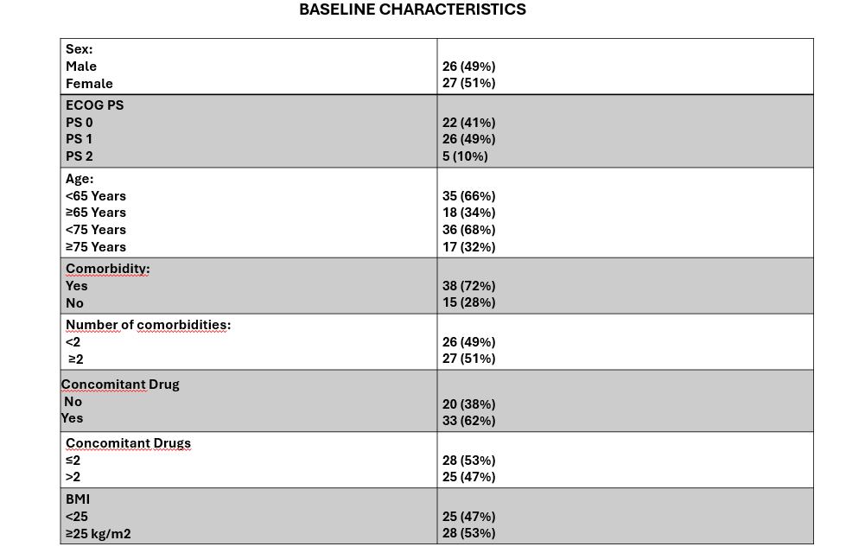

Table 2. Treatment characteristics of the study cohort. Distribution of systemic treatment strategies, including chemotherapy alone and durvalumab-based chemo-immunotherapy, according to treatment line and therapeutic regimen.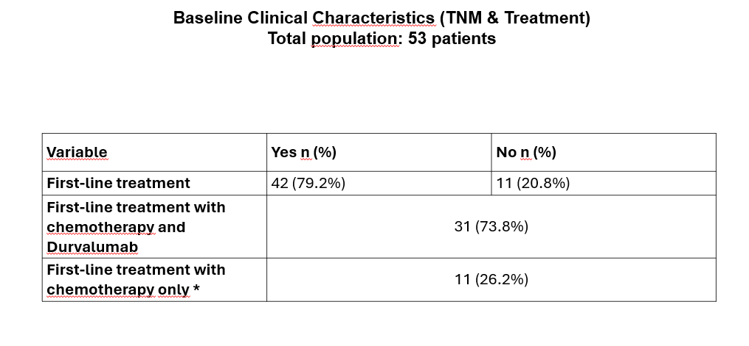
*Durvalumab was not prescribed due to comorbidities, contraindications, or because the diagnosis occurred prior to its approval.

Table 3. Association between baseline Drug-PIN risk categories and patient clinical characteristics. Comparative analysis of demographic, clinical, and pharmacological variables according to Drug-PIN classification (green vs. yellow/red categories).