Supporting Information

Ultrafast proton transport phosphate for protonic ceramic electrolysis cells oxygen electrodes

Chenhe Jia, Rongzheng Ren*, Cheng Zou, Yuanyuan Lei, Pengbo Guo, Linlin Song, Xiaodan Yu,Wang Sun, Jinshuo Qiao, Zhenhua Wang*, Kening Sun*

Table of Contents
Supplementary Notes 3
Supplementary Figures 4
Supplementary Tables 23
Supplementary Reference 29

Supplementary Notes

Supplementary Note 1 | Apparent activation energies from polarization resistance
The apparent activation energy was obtained from the temperature dependence of the area-specific polarization resistance¹. The data were fitted using the Arrhenius relation:
$R_{p}=R_{0}exp⁡\left(\frac{E_{a}}{RT}\right)$ (S1)
where Rₚ is the polarization resistance, R₀ is the pre-exponential factor, Eₐ is the apparent activation energy, R is the molar gas constant and T is the absolute temperature. Linearization gives:
$ln\left(R_{p}\right)=ln\left(R_{0}\right)+\frac{E_{a}}{RT}$ (S2)
Eₐ was calculated from the slope of ln(Rₚ) against 1/T. When the horizontal axis is 1,000/T, Eₐ = 1,000Rm. The result was converted from J mol⁻¹ to eV using 1 eV per particle = 96.485 kJ mol⁻¹. The fits give 1.01 eV for SFM and 0.854 eV for SFM-SPO.
Supplementary Note 2 | Hydrogen production and Faradaic efficiency of the electrolysis cells
For a protonic ceramic electrolysis cell, two electrons produce one H₂ molecule². The theoretical molar hydrogen production rate at current I is:
$n_{H_{2,theory}}=\frac{I}{2F}$ (S3)
where F is the Faraday constant. The corresponding standard volumetric rate is
$V_{H_{2,theory}}=\frac{V_{m}I}{2F}$ (S4)
where Vₘ = 22,400 ml mol⁻¹ at standard temperature and pressure. The measured molar rate was calculated from the dry H₂ mole fraction in the outlet and the standard gas flow. Q_{std} is expressed in ml s⁻¹; a flow recorded in ml min⁻¹ was divided by 60 before calculation:
$n_{H_{2,measured}}=\frac{y_{H_{2}}Q_{std}}{V_{m}}$ (S5)
The open circuit background was subtracted before calculation. If the flow was recorded outside standard conditions, $Q_{std}=Q_{measured}\left(\frac{P}{P_{std}}\right)\left(\frac{T_{std}}{T_{measured}}\right)$. Faradaic efficiency was then calculated as:
$FE=\frac{n_{H_{2},measured}}{n_{H_{2},theory}}×100\%=\frac{2Fn_{H_{2},measured}}{I}×100\%$ (S6)
The H₂ production rates and Faradaic efficiencies in Supplementary Figs. S4 and S5 were measured at 600 °C.

Supplementary Figures
Figure S1. Impedance spectra of SFM-SPO (a) and SFM (b) symmetric cells from 500 to 700 °C under pH₂O = 0.1 atm.
Figure S2. Cross-sectional SEM image of a single cell with an SFM-SPO oxygen electrode.
Figure S3. Potentiostatic electrolysis stability of the SFM-SPO cell at 600 °C and 1.3 V for 250 h.
Figure S4. H₂ production rates of cells with SFM and SFM-SPO oxygen electrodes at 600 °C.
Figure S5. Faradaic efficiencies of cells with SFM and SFM-SPO oxygen electrodes at 600 °C.
Figure S6. Powder X-ray diffraction patterns of SFN and SFN-SPO.
Figure S7. Impedance spectra of SFN-SPO (a) and SFN (b) symmetric cells from 500 to 700 °C under pH₂O = 0.1 atm.
Figure S8. Electrolysis polarization curves of cells with SFN-SPO (a) and SFN (b) oxygen electrodes from 500 to 700 °C.
Figure S9. Powder X-ray diffraction patterns of SCF and SCF-SPO.
Figure S10. Impedance spectra of SCF-SPO (a) and SCF (b) symmetric cells from 500 to 700 °C under pH₂O = 0.1 atm.
Figure S11. Electrolysis polarization curves of cells with SCF-SPO (a) and SCF (b) oxygen electrodes from 500 to 700 °C.
Figure S12. Powder X-ray diffraction patterns of SCN and SCN-SPO.
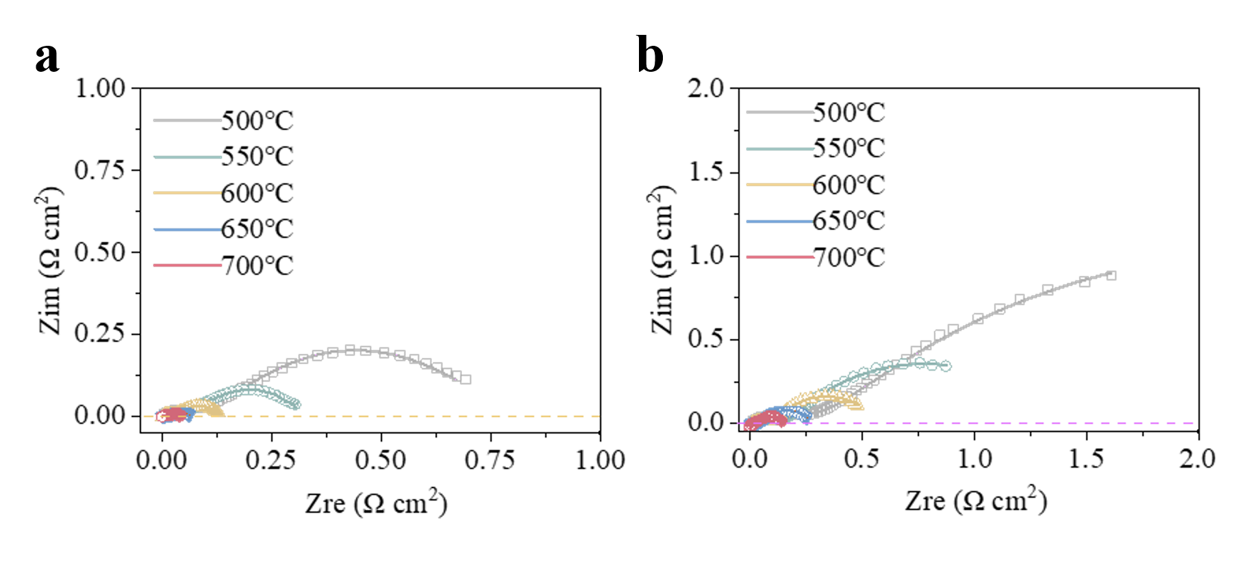
Figure S13. Impedance spectra of SCN-SPO (a) and SCN (b) symmetric cells from 500 to 700 °C under pH₂O = 0.1 atm.
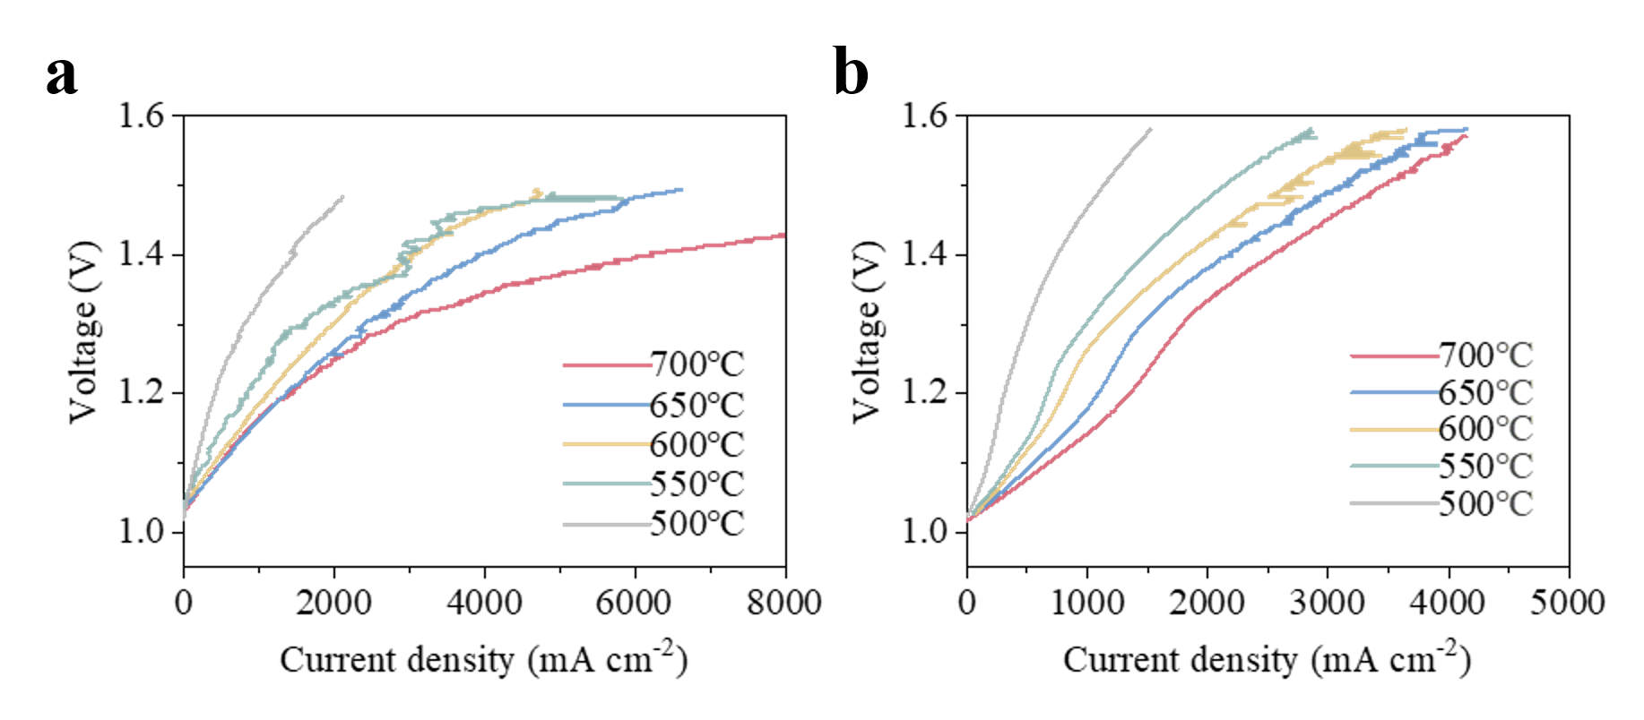
Figure S14. Electrolysis polarization curves of cells with SCN-SPO (a) and SCN (b) oxygen electrodes from 500 to 700 °C.
Figure S15. Thermogravimetric curves of SFM and SFM-SPO.
Figure S16. Wavelet transform contour plots of the Fe K-edge EXAFS signals of SFM-SPO (a), SFM (b), Fe foil (c), FeO (d), Fe₂O₃ (e) and Fe₃O₄ (f).
Figure S17. Solid-state ³¹P MAS NMR spectra of SPO before and after hydration.
Figure S18. Calculated intermediate structures along the proton migration pathway in BZCYYb.

Figure S19. Calculated intermediate structures along the proton migration pathway between neighboring PO₄ tetrahedra in SPO.

Supplementary Tables
Table S1. EXAFS fitting parameters at the Fe K-edge for various samples
Sample | Shell | Bond length (Å) | Coordination Number | σ² (Å²) | ΔE₀ shift (eV) | R-factor
SFM | Fe–O | 1.88±0.02 | 5.8±1.2 | 0.008±0.005 | -4.9±2.7 | 0.010
SFM | Fe–Sr | 3.33±0.03 | 6.5±1.8 | 0.010±0.002 | -4.9±2.7 | 0.010
SFM | Fe–O–Fe | 3.93±0.02 | 9.1±1.4 | 0.012±0.004 | -4.9±2.7 | 0.010
SFM-SPO | Fe–O | 1.90±0.02 | 6.1±1.1 | 0.004±0.004 | -4.8±3.0 | 0.014
SFM-SPO | Fe–Sr | 3.31±0.03 | 7.2±1.6 | 0.018±0.011 | -4.8±3.0 | 0.014
SFM-SPO | Fe–O–Fe | 3.91±0.01 | 8.3±1.3 | 0.011±0.007 | -4.8±3.0 | 0.014
σ²: Debye-Waller factor, ΔE₀: the shift in absorption edge energy, R-factor: Residual factor.
Table S2. Summary of D_{H} values for SFM-based oxygen electrodes in different configurations reported in recent years
References | D_{H} (cm² s⁻¹) | Temperature (℃)
³ | 1.84 × 10^{–6} | 700
³ | 1.16 × 10^{–6} | 650
³ | 8.49 × 10^{–7} | 600
³ | 4.95 × 10^{–7} | 550
⁴ | 2.86 × 10⁻⁵ | 750
⁴ | 1.62 × 10⁻⁵ | 700
⁴ | 9.16 × 10^{–6} | 650
⁴ | 5.30 × 10^{–6} | 600
⁵ | 1.71 × 10⁻⁵ | 750
⁵ | 1.35 × 10⁻⁵ | 700
⁵ | 7.88 × 10⁻⁶ | 650
⁵ | 3.92 × 10⁻⁶ | 600
This work (SFM-SPO) | 3.22 × 10⁻⁵ | 750
This work (SFM-SPO) | 2.12 × 10⁻⁵ | 700
This work (SFM-SPO) | 1.33 × 10⁻⁵ | 650
This work (SFM-SPO) | 7.47 × 10⁻⁶ | 600

Table S3. Area-specific resistances of reported SFM based oxygen electrodes and SPO modified perovskite oxygen electrodes
References | ASR(Ω cm²) | Temperature (℃)
⁶ | 0.13 | 700
⁶ | 0.28 | 650
⁶ | 0.58 | 600
⁶ | 1.20 | 550
⁷ | 0.09 | 750
⁷ | 0.14 | 700
⁷ | 0.29 | 650
⁷ | 0.63 | 600
¹ | 0.071 | 800
¹ | 0.10 | 750
¹ | 0.169 | 700
¹ | 0.260 | 650
⁸ | 0.074 | 750
⁸ | 0.178 | 700
⁸ | 0.314 | 650
⁸ | 0.772 | 600
⁹ | 0.058  0.08  0.2  0.57 | 650  600  550  500
¹⁰ | 0.148 | 600
¹¹ | 0.045  0.078  0.163  0.354  0.998 | 700  650  600  550  500
This work (SFM-SPO) | 0.079  0.144  0.279  0.575  1.22 | 700  650  600  550  500
This work (SCN-SPO) | 0.039  0.061  0.129  0.304  0.692 | 700  650  600  550  500
This work (SCF-SPO) | 0.054  0.091  0.188  0.304  1.05 | 700  650  600  550  500
This work (SFN-SPO) | 0.09  0.125  0.273  0.535  1.122 | 700  650  600  550  500

Table S4. Electrolysis performance of PCECs with reported SFM based oxygen electrodes and SPO modified perovskite oxygen electrodes
References | Current density (1.3 V, mA cm⁻²) | Temperature (℃)
⁴ | 1800 | 750
⁴ | 1400 | 700
⁴ | 950 | 650
⁴ | 720 | 600
⁶ | 950 | 700
⁶ | 640 | 650
⁶ | 400 | 600
⁶ | 220 | 550
⁵ | 1570 | 750
⁵ | 1235 | 700
⁵ | 827 | 650
⁵ | 516 | 600
⁵ | 247 | 550
⁸ | 1655 | 750
⁸ | 1053 | 700
⁸ | 625 | 650
⁸ | 295 | 600
⁹ | 2210  1490  1070  580 | 650  600  550  500
¹⁰ | 2400  1460  680  260 | 650  600  550  500
² | 1350  850  560 | 600  550  500
¹¹ | 2000  1500  1000 | 600  550  500
This work (SFM-SPO) | 1875  1549  1250  910  581 | 700  650  600  550  500
This work (SCN-SPO) | 2799  2400  2000  1649  800 | 700  650  600  550  500
This work (SCF-SPO) | 2545  2049  1694  1251  628 | 700  650  600  550  500
This work (SFN-SPO) | 2161  1991  1583  931  563 | 700  650  600  550  500

Supplementary Reference
1. Zheng H, Riegraf M, Sata N, Costa R. A double perovskite oxygen electrode in Zr-rich proton conducting ceramic cells for efficient electricity generation and hydrogen production. Journal of Materials Chemistry A 2023, 11(20): 10955-10970.

2. Zheng S, Wu W, Zhang Y, Zhao Z, Duan C, Karki S, et al. Enhancing surface activity and durability in triple conducting electrode for protonic ceramic electrochemical cells. Nature Communications 2025, 16(1): 4146.

3. Ren R, Wang Z, Meng X, Wang X, Xu C, Qiao J, et al. Tailoring the Oxygen Vacancy to Achieve Fast Intrinsic Proton Transport in a Perovskite Cathode for Protonic Ceramic Fuel Cells. ACS Applied Energy Materials 2020, 3(5): 4914-4922.

4. Song L, Qiao Y, Zhao Y, Ren R, Wang Z, Jia C, et al. Accelerating Bulk Proton Transfer in Sr₂Fe_{1.5}Mo_{0.5}O_{6–δ} Perovskite Oxide for Efficient Oxygen Electrode in Protonic Ceramic Electrolysis Cells. Ceramics International 2024, 50(14): 24987-24994.

5. Ren R, Sun J, Wang G, Xu C, Qiao J, Sun W, et al. Rational design of Sr₂Fe_{1.5}Mo_{0.4}Y_{0.1}O_{6-δ} oxygen electrode with triple conduction for hydrogen production in protonic ceramic electrolysis cell. Separation and Purification Technology 2022, 299: 121780.

6. Xiaojie C, Guangdong L, Rongzheng R, Chunming X, Jinshuo Q, Wang S, et al. Improving Performance of Proton Ceramic Electrolysis Cell Perovskite Anode by Zn Doping. Ceramics International 2023, 49(12): 19879-19884.

7. Song R, Jin W, Yuan J, Pang H, Zhang X, Zong W, et al. A Promising K‑Doped Sr₂Fe_{1.5}Mo_{0.5}O_{6‑δ} Nanofiber Oxygen Electrode Fabricated by Electrospinning as Proton-Conducting Solid Oxide Fuel Cells. ACS Applied Materials & Interfaces 2026, 18(6): 10035-10045.

8. Wang L, Huang F, Ling Y, Wang Y, Li T. Tuning Sr₂Fe_{1.5}Mo_{0.5}O_{6-δ} perovskites with Ni as an active and durable air electrode for reversible proton ceramic electrochemical cells. International Journal of Hydrogen Energy 2026, 200: 152920.

9. Liu Z, Qiao R, Feng D, Zhou J, Di H, Bai Y, et al. Strategic atomic trapping at heterointerfaces for protonic ceramic cells. Nature Communications 2025, 16(1): 10405.

10. Tian H, Li W, Lee Y-L, Zheng H, Li Q, Ma L, et al. Conformally coated scaffold design using water-tolerant Pr_{1.8}Ba_{0.2}NiO_{4.1} for protonic ceramic electrochemical cells with 5,000-h electrolysis stability. Nature Energy 2025, 10(7): 890-903.

11. Wang X, Cai Z, Chen Z, Liu D, Chen W, Zhu J, et al. Highly ionic-dispersed oxygen electrode for reversible proton ceramic electrochemical cells. Nature Communications 2026, 17(1): 3989.

