Supplemental Data
Supplemental Table 1. Annotations of Clones for all Subset Groups Identified in the Experiment.
Supplemental Table 2. Annotations via Public TCR Databases.
Supplemental Table 3. Annotations of HPV-Related Clones.
Supplemental Table 4. Patient Samples of Blood and Tumor.
Supplemental Table 5. Changes in Flow Markers and T-Cell Repertoire Over Time in Blood and Tumor Samples.
Supplemental Table 6. Comparison of Motif Characteristics in Tumor Samples.
Supplemental Table 7. Association of Flow and TCR Variables and Clones with Recurrence-Free and Overall Survival.
Supplemental Table 8. Association of Counts of TCR Motifs at Individual Time Points and Fold Changes with Recurrence-Free and Overall Survival.
Supplemental Table 9. Fold Changes of Flow Markers and T-Cell Repertoire in Blood vs Tumor.
Supplemental Table 10. Association of Blood Flow and TCR Variables with Patient Demographics and Tumor Characteristics.
Supplemental Table 11. Association of Tumor Flow and TCR Variables with Patient Demographics and Tumor Characteristics.

Supplemental Fig. 1. Abundances of clone-specific groups in the overall population.
a. Number of patients who had candidate HPV-specific clones in peripheral blood for the duration of the study.
b. Number of patients who had candidate HPV-specific clones in the TME for the duration of the study.
c. Maximum proportion of HPV-specific clones present in peripheral blood during the study.
d. Maximum proportion of HPV-specific clones present in the TME during the study.

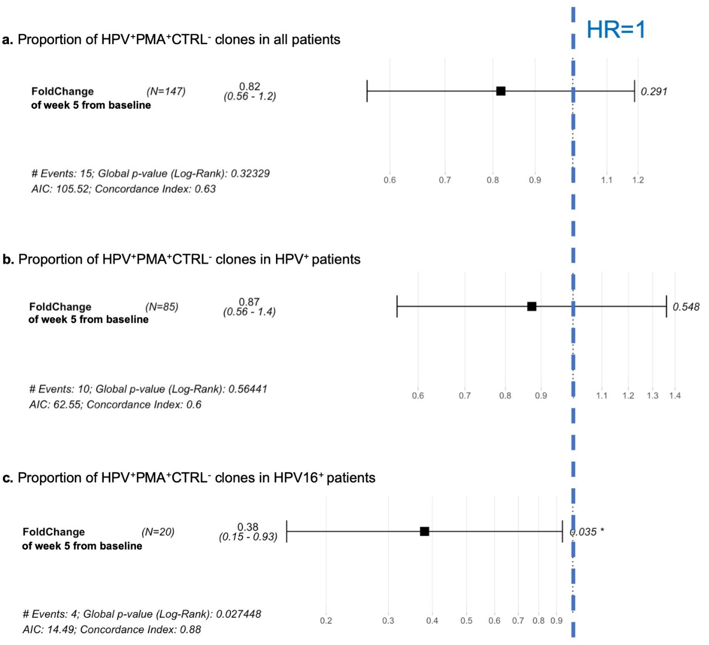
Supplementary Fig. 2. Forest plots for recurrence-free survival for patients with HPV-responsive clones. HR, hazard ratio.
a. Hazard ratio for recurrence-free survival for the fold change in the proportions of HPV⁺PMA⁺CTRL⁻ clones at week 5 from baseline in all patients.
b. Hazard ratio for recurrence-free survival for the fold change in the proportions of HPV⁺PMA⁺CTRL⁻ clones at week 5 from baseline in HPV⁺ patients.
c. Hazard ratio for recurrence-free survival for the fold change in the proportions of HPV⁺PMA⁺CTRL⁻ clones at week 5 from baseline in HPV16⁺ patients.

Supplemental Fig. 3. CD8⁺ cells in blood and tumor samples
Boxplots of percentages of live CD8⁺ cells in blood and tumor samples (data are from Supplemental Table 3).
a-g. Percentage of live CD8⁺ cells in blood samples, separated by marker subgroups: CD8⁺CD69⁺ (a), CD8⁺Ki67⁺ (b), CD8⁺IFNg (c), CD8⁺GranzB⁺ (d), CD8⁺PD1⁺ (e), CD8⁺CTLA4⁺ (f), CD8⁺ (g).
Baseline n = 30, week 1 n = 33, week 3 n = 27, week 5 n = 24, follow-up n = 11.
h-n. Percentage of live CD8⁺ cells in tumor samples, separated by marker subgroups: CD8⁺CD69⁺ (h), CD8⁺Ki67⁺ (i), CD8⁺IFNg (j), CD8⁺GranzB⁺ (k), CD8⁺PD1⁺ (l), CD8⁺CTLA4⁺ (m), CD8⁺ (n).
Baseline n = 63, week 1 n = 47, week 3 n = 42, week 5 n = 46, follow-up n = 19.
The thick middle line of each boxplot represents the median, and the lower and upper bounds of the box represent the first and third quartiles, respectively. Whiskers indicate the range. Timepoints were compared using a paired t-test. NS = not significant, *P < 0.05, **P < 0.01.

Supplemental Fig. 4. CD4⁺ and CD3⁺ cells in blood and tumor samples
Boxplots of percentages of live CD4⁺ and CD3⁺ cells (data are from Supplemental Table 3).
a-g. CD4⁺ cells in blood samples, separated by marker subgroups:
CD4 (a) CD4⁺FoxP3⁺ (b) CD4⁺CTLA4⁺ (c) CD4⁺CD69⁺ (d) CD4⁺Ki67⁺ (e) CD4⁺IFNg (f) CD4⁺PD1⁺ (g).
Baseline n = 30, week 1 n = 33, week 3 n = 27, week 5 n = 24, follow-up n = 11.
h-n. CD4⁺ cells in tumor samples, separated by marker subgroups: CD4⁺ (h) CD4⁺FoxP3 (i) CD4⁺CTLA4⁺ (j) CD4⁺CD69⁺ (k) CD4⁺Ki67⁺ (l) CD4⁺IFNg (m) CD4⁺PD1⁺ (n). o. CD3⁺ cells in blood samples. p. CD3⁺ cells in tumor samples.
Baseline n = 63, week 1 n = 47, week 3 n = 42, week 5 n = 46, follow-up n = 19.
The thick middle line of each boxplot represents the median, and the lower and upper bounds of the box represent the first and third quartiles, respectively. Whiskers indicate the range. Timepoints were compared using a paired t-test. NS = not significant, *P < 0.05, **P < 0.01.

Supplementary Fig. 5. Clusters of clinical characteristics and CD8 and CD4.
Unsupervised hierarchical clustering of CD4⁺ and CD8⁺ markers
a-b CD4⁺ markers in (a) tumor and (b) blood samples before during and after CRT with clinical characteristics.
c-d CD8⁺ markers in (c) tumor and (d) blood samples before during and after CRT with clinical characteristics.

