Mapping knowledge user participation approaches in infectious disease transmission modeling (participatory modeling): a scoping review
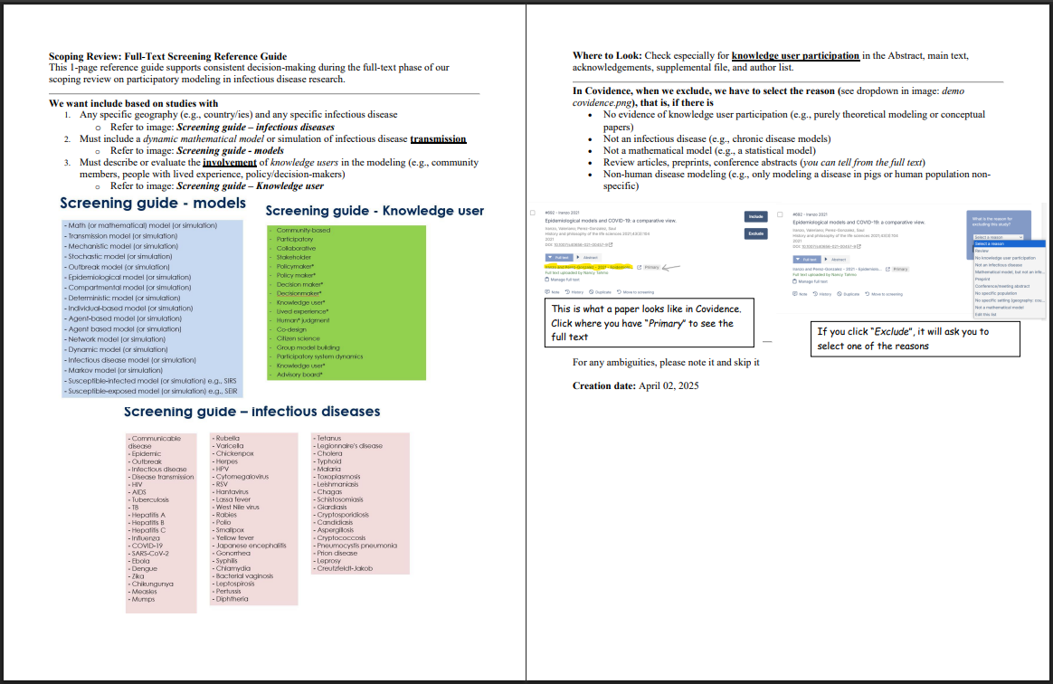
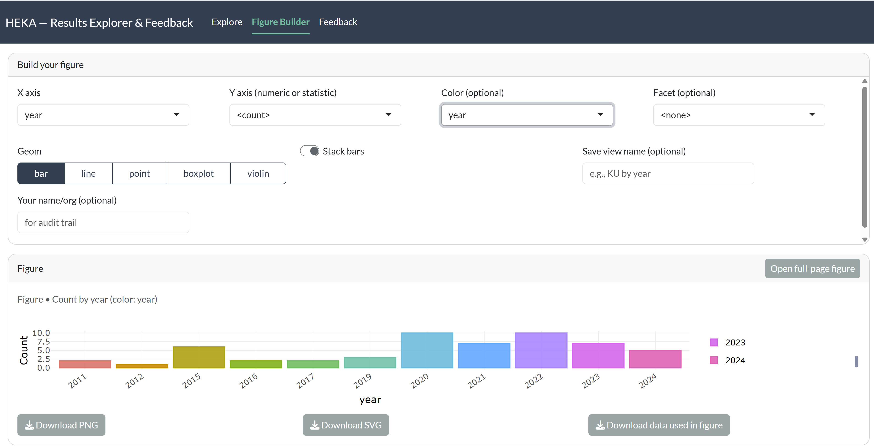
Supplementary Figure 1. Tools used to support community scholar participation in data screening and analysis. Left: Full-text screening reference guide used by academic and community reviewers to support consistent screening decisions, including definitions of infectious diseases, model types, and knowledge user categories, as well as exclusion criteria applied in Covidence. Bottom: Interactive R Shiny application developed for exploratory data analysis, preloaded with the extraction dataset and enabling community scholars to generate descriptive figures, explore patterns, and support independent interpretation of findings.

