Table A1. Attrition by Treatment Status Across Survey Intervals
Interval | Group | Stayed | Dropped | Total | Dropout rate (%)
7 → 9 | Unaffected | 1,142 | 53 | 1,195 | 4.44
 | Affected | 340 | 20 | 360 | 5.56
9 → 11 | Unaffected | 1,143 | 47 | 1,190 | 3.95
 | Affected | 333 | 14 | 347 | 4.03
11 → 13 | Unaffected | 1,060 | 124 | 1,184 | 10.47
 | Affected | 300 | 48 | 348 | 13.79
Notes: Each row reports the number and share of respondents interviewed in round t who were not re-interviewed in round t+2. Pearson chi-squared tests: 7→9, χ²(1)=0.776 (p=0.378); 9→11, χ²(1)=0.005 (p=0.943); 11→13, χ²(1)=2.975 (p=0.085).

Table A2. Construction and Composition of the Round-14 Estimation Samples
 | Worse now | Worse in a year | Climate risk
Panel A: sample construction
Round-14 respondents | 1,403 | 1,403 | 1,403
Answered the question | 1,401 | 1,244 | 1,377
Non-missing controls: exposure models (Table 7) | 1,255 | 1,109 | 1,231
Observed in round 13: loss models (Tables 8–9) | 1,212 | 1,069 | 1,188
Retained share of those answering (%) | 89.6 | 89.1 | 89.4
Panel B: retained vs excluded, current assessment | Retained | Excluded | p-value
Affected district (≥40,000) | 0.222 | 0.281 | 0.111
Female head (no spouse) | 0.187 | 0.205 | 0.595
Rural | 0.608 | 0.719 | 0.009
Education | 1.086 | 0.804 | 0.008
Age | 44.28 | 44.30 | 0.985
Employed (round 12) | 0.795 | 0.810 | 0.750
Household size (round 12) | 5.07 | 4.75 | 0.203
Observations | 1,255 | 146
Notes: Panel A reports the construction of each estimation sample. Panel B compares the retained sample for the current-assessment outcome with the round-14 respondents excluded from it, with p-values from two-sample t-tests.

Table A3. Overlap of Farm and Business Income Sources
 | No business income | Has business income | Total
No farm income | 1,071 (17.7%) | 1,146 (18.9%) | 2,217 (36.6%)
Has farm income | 2,191 (36.2%) | 1,646 (27.2%) | 3,837 (63.4%)
Total | 3,262 (53.9%) | 2,792 (46.1%) | 6,054 (100.0%)
Notes: Person-round observations, with cell percentages of the total (6,054) in parentheses. The 1,646 observations reporting both sources correspond to 774 households.

Table A4. Composition of Farm-Only and Business-Only Households
 | Farm-only | Business-only | Difference | t-stat
Affected district (≥40,000) | 0.297 | 0.120 | 0.178*** | 11.70
Age | 44.78 | 39.80 | 4.98*** | 9.69
Female head (no spouse) | 0.231 | 0.161 | 0.070*** | 4.78
Education | 0.749 | 1.394 | -0.644*** | -16.03
Household size | 5.41 | 4.88 | 0.525*** | 6.16
Rural | 0.839 | 0.349 | 0.490*** | 32.89
Agriculture | 0.594 | 0.114 | 0.480*** | 25.79
Employment | 0.862 | 0.844 | 0.018 | 1.43
Observations | 2,191 | 1,146
Notes: Means over person-round observations from households reporting only farm income and only business income, excluding the 1,646 observations reporting both. The difference column is farm-only minus business-only and the t-statistic follows the same convention. *** p<0.01, ** p<0.05, * p<0.10.

Table A5. Heterogeneous Effects of Cyclone Exposure on Farming Income Loss
 | Female head (no spouse) | Bottom three wealth quintiles | Head under 30
Exposure × post-Ana × moderator | 0.074 | -0.002 | 0.074
 | (0.143) | (0.076) | (0.128)
Observations | 3,837 | 3,837 | 3,837
Notes: Coefficients on the triple interaction (exposure × round 13 × moderator) from fixed-effects regressions with district-clustered HC2 (Bell–McCaffrey) standard errors in parentheses. *** p<0.01, ** p<0.05, * p<0.10.

Table A6. Effect of Cyclone Exposure on Holding Each Income Source
 | Farm source | Business source | Wage source
Affected district (≥40,000) × post-Ana | -0.037 | 0.026 | 0.076**
 | (0.027) | (0.034) | (0.027)
Observations | 6,054 | 6,054 | 6,054
Notes: District-clustered HC2 (Bell–McCaffrey) standard errors in parentheses. * p<0.10, ** p<0.05, *** p<0.01

Table A7. Difference-in-Differences on Time-Varying Household Characteristics
 | Household size | Children | Employment
Affected district (≥40,000) × post-Ana | 0.080 | 0.026 | -0.040
 | (0.054) | (0.041) | (0.028)
Observations | 6,054 | 6,054 | 6,054
Notes: Each column re-estimates equation (1) with the household characteristic as the outcome. District-clustered HC2 (Bell–McCaffrey) standard errors in parentheses. *** p<0.01, ** p<0.05, * p<0.10.

Table A8. Subjective Outcomes: Partialling-Out LASSO Robustness
 | Worse now | Worse in a year | Climate risk likely
Panel A: cyclone exposure
Affected district (≥40,000) | 0.050 | 0.054 | 0.019
 | (0.032) | (0.043) | (0.035)
Observations | 1,227 | 1,081 | 1,203
Panel B: realised income losses
Farming income loss, R13 | 0.097*** | 0.002 | 0.047
 | (0.035) | (0.042) | (0.033)
Business income loss, R13 | 0.060 | 0.050 | -0.005
 | (0.040) | (0.047) | (0.039)
Has farm income source, R13 | -0.0385 | -0.044 | 0.067**
 | (0.034) | (0.042) | (0.034)
Has business income source, R13 | -0.049 | -0.083* | 0.005
 | (0.038) | (0.044) | (0.037)
Observations | 1,184 | 1,041 | 1,160
Notes: Partialling-out LASSO with a cross-validated penalty and a high-dimensional control set adding health, food-security, mental-health, employment, income-variation, credit and safety-net variables; region fixed effects and district-clustered standard errors. * p<0.10, ** p<0.05, *** p<0.01.

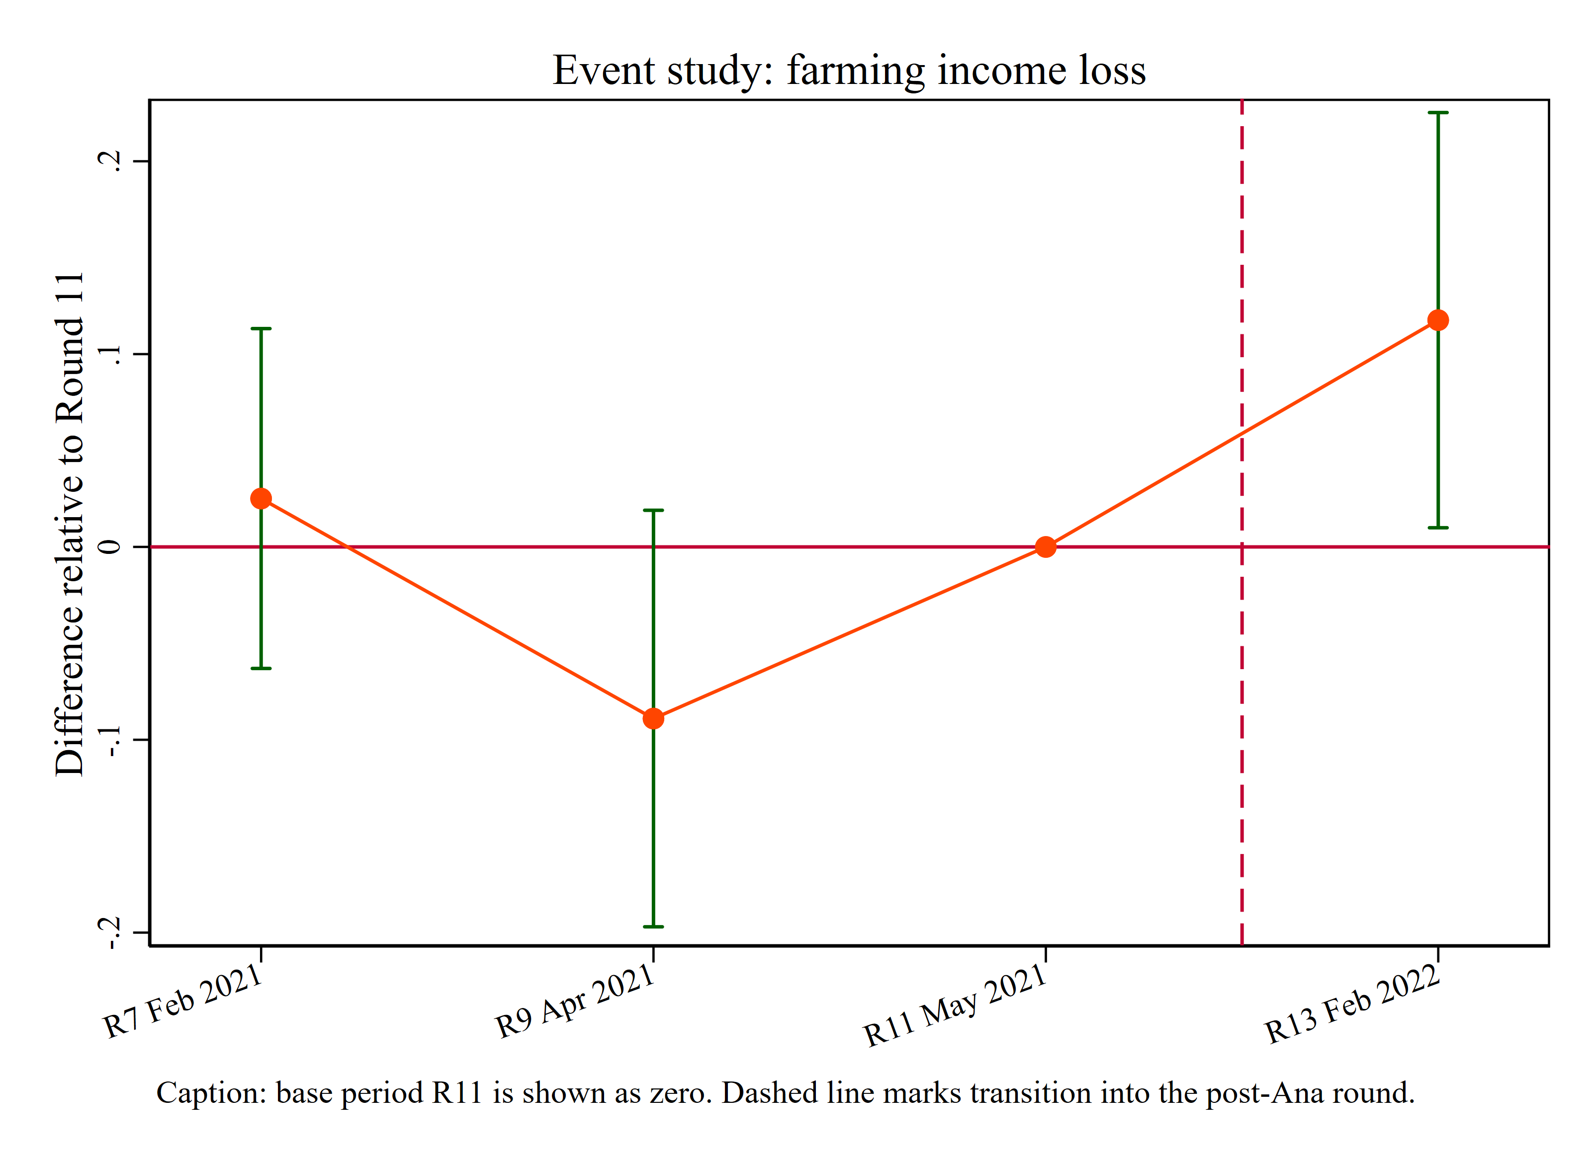
Figure B1. Event-study estimates for farming income loss, round 11 omitted as the base period.

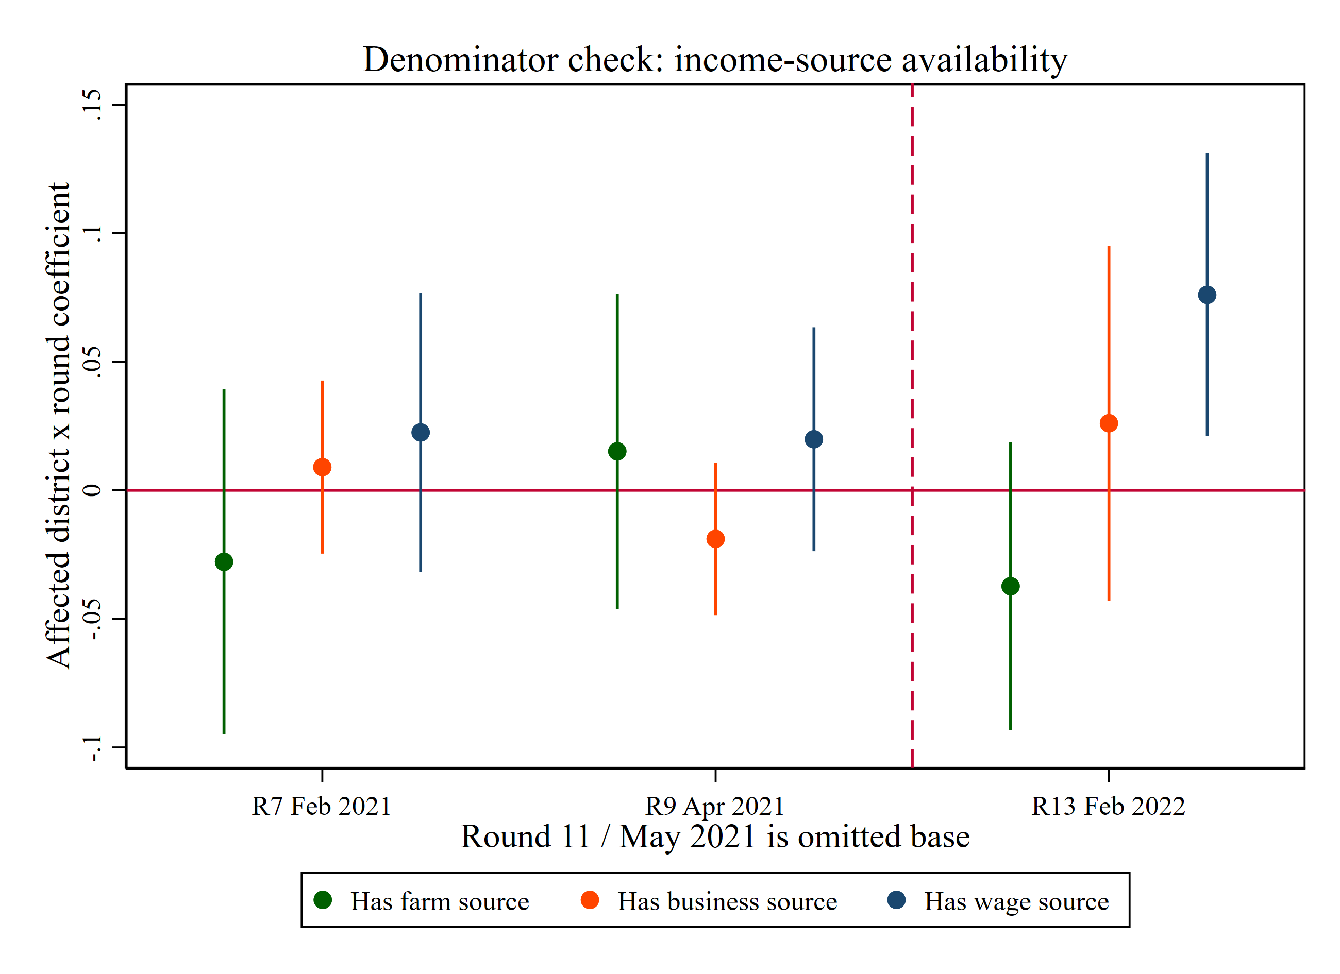
Figure B2. Event-study estimates for holding each income source (farm, business). Post-Ana coefficients are small and insignificant.

