Table 1. Pairwise comparisons of tumor growth slopes from a linear mixed-effects model of square root-transformed tumor volumes. Holm’s procedure was used to correct for multiple comparisons.
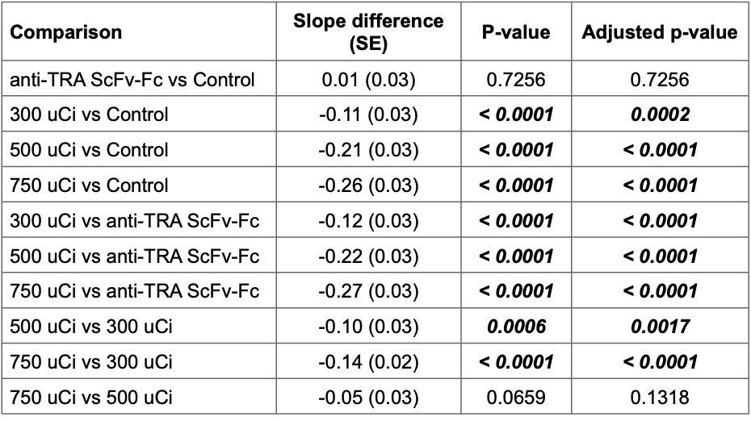

Table 2. Pairwise comparisons of tumor latency from the Firth Cox model. Holm’s procedure was used to correct for multiple comparisons.
