Supplementary information for:
Integrating multi-trait selection and climate associations to identify climate-resilient seed sources: insights from a beech provenance trial over four decades
Mehdi Ben-Targem*, Mirko Liesebach, Marie-Fee August, Katharina J. Liepe
Thünen Institute of Forest Genetics, Sieker Landstrasse 2, 22926 Grosshansdorf, Germany
* Corresponding author: mehdi.ben-targem@thuenen.de

Table S1. Geographic origin of provenances planted in the trial
.
Species | Country | HK | Provenance | Provenance region | Latitude (°) | Longitude (°) | Altitude (m)
FS | DE | 1 | Paderborn 2 | 810 07 | 51.5 | 8.67 | 260
FS | DE | 2 | Reinfeld | 810 02 | 53.77 | 10.37 | 35
FS | DE | 3 | Eutin 4 | 810 02 | 54.18 | 10.65 | 35
FS | DE | 4 | Eutin 2 | 810 02 | 54.13 | 10.57 | 35
FS | DE | 5 | Morschen 2 | 810 09 | 51.15 | 9.63 | 358
FS | DE | 6 | Farchau 1 | 810 02 | 53.6 | 10.67 | 25
FS | DE | 7 | Paderborn 3 | 810 07 | 51.5 | 8.67 | 260
FS | DE | 8 | Hasbruch 2 | 810 01 | 53.13 | 8.43 | 35
FS | DE | 9 | Seesen 1 | 810 09 | 51.83 | 10.17 | 330
FS | DE | 10 | Stauffenburg | 810 09 | 51.82 | 10.15 | 315
FS | DE | 11 | Medingen | 810 03 | 53.05 | 10.57 | 75
FS | DE | 12 | Seelzerthurm 1 | 810 09 | 51.8 | 9.7 | 360
FS | DE | 13 | Walkenried 3 | 810 06 | 51.6 | 10.63 | 305
FS | DE | 14 | Ebrach 4 | 810 17 | 49.83 | 10.58 | 400
FS | DE | 15 | Lensahn 2 | 810 02 | 54.2 | 10.77 | 20
FS | DE | 16 | Glindfeld 1 | 810 08 | 51.2 | 8.67 | 490
FS | DE | 17 | Schmallenberg 1 | 810 08 | 51.2 | 8.42 | 620
FO | TR | 18 | Eregli |  | 41.05 | 31.28 | 900
FO | TR | 19 | Duezce |  | 40.85 | 31.15 | 1050
FO | TR | 20 | Akkus |  | 40.83 | 37.08 | 1250
FO | TR | 21 | Catalca |  | 41.47 | 28.35 | 350
FO | TR | 22 | Inegoel |  | 39.88 | 29.6 | 1300
FO | TR | 23 | Izmit |  | 40.57 | 29.95 | 1250
FO | TR | 24 | Karabuek |  | 41.28 | 32.53 | 900
FO | TR | 25 | Devrek |  | 41.27 | 32.28 | 950
FS | DE | 26 | Fischbach 3 | 810 07 | 49.3 | 7.07 | 315
FS | DE | 27 | Saarbruecken | 810 07 | 49.3 | 7.02 | 305
FS | DE | 28 | Neunkirchen/S.1 | 810 07 | 49.33 | 7.17 | 340
FS | DE | 29 | Blieskastel 6 | 810 07 | 49.3 | 7.1 | 265
FS | DE | 30 | Hilchenbach | 810 08 | 51 | 8.2 | 585
FS | DE | 31 | Reichensachsen | 810 09 | 51.17 | 10 | 343
FS | DK | 32 | Grasten |  | 54.92 | 9.67 | 1
FS | DK | 33 | Sovaenger (2) |  | 54.83 | 11.5 | 25
FS | DE | 34 | Fuerstenberg | 810 02 | 54.13 | 10.5 | 45
FS | DE | 35 | Elmstein 1 | 810 07 | 49.37 | 7.95 | 440
FS | DE | 36 | Dierdorf 2 | 810 07 | 50.55 | 7.67 | 320
FS | F | 37 | 02 Eawy 2 |  | 49.77 | 1.27 | 155
FS | DE | 39 | Homberg/Ohm | 810 10 | 50.73 | 9 | .
FS | DE | 40 | Schotten | 810 10 | 50.5 | 9.12 | 580
FS | NL | 41 | Ellecom-Dieren |  | 52.03 | 6.08 | 1
FS | NL | 42 | Apeldoorn 1 |  | 52.23 | 5.93 | 1
FS | NL | 43 | Apeldoorn 2 |  | 52.22 | 5.93 | 1
FS | NL | 44 | Edese Bos |  | 52.05 | 5.68 | 1
FS | F | 45 | 01 Belleme 3 |  | 48.53 | 0.53 | 205
FS | F | 46 | 02 Arques |  | 49.9 | 1.17 | 105
FS | F | 47 | 03 Halatte |  | 49.28 | 2.6 | 160
FS | F | 48 | 04 Beaumont |  | 48.02 | 4.67 | 300
FS | F | 49 | 08 Beffou |  | 48.48 | -2.48 | 253
FS | F | 50 | 02 Eu |  | 49.87 | 1.62 | 190
The table lists all provenances included in the trial. Columns provide country of origin, provenance ID (HK), provenance name, provenance region code (for German sites only), and geographic coordinates (latitude and longitude in decimal degrees) as well as altitude (m above sea level).

Table S2. Relationships between performance traits and climatic variables based on linear regressions

Trait | Climatic Variables | Intercept | Slope | R² | P value
MGIDI | MCMT | 2.57 | 0.498 | 0.64 | 1.80 e-07 ***
MGIDI | GDD5 | -3.38 | 2.98 e-03 | 0.40 | 2.59 e-04 ***
MGIDI | TD | 9.47 | -0.412 | 0.38 | 3.66 e-04 ***
MGIDI | MWMT | -4.70 | -6.48 e-03 | 0.15 | 0.040 *
MGIDI | PGS | 4.21 | 0.400 | 0.14 | 0.047 *
MGIDI | AHM | -0.79 | 0.113 | 0.14 | 0.047 *
MGIDI | CMD | 1.38 | 4.08 e-03 | 0.11 | 0.080 .
MGIDI | MAP | 3.31 | -1.63 e-03 | 0.03 | 0.344
Basal area | MCMT | 31.49 | -3.127 | 0.56 | 3.07 e-06 ***
Basal area | GDD5 | 73.28 | -0.021 | 0.44 | 9.07 e-05 ***
Basal area | AHM | 62.01 | -1.083 | 0.28 | 3.28 e-03 **
Basal area | TD | -6.50 | 2.293 | 0.26 | 4.69 e-03 **
Basal area | PGS | 15.17 | 0.059 | 0.26 | 5.63 e-03 **
Basal area | CMD | 41.24 | -0.039 | 0.22 | 0.011 *
Basal area | MWMT | 89.48 | -3.238 | 0.21 | 0.012 *
Basal area | MAP | 20.43 | 0.019 | 0.10 | 0.094 .
Survival | MCMT | 0.23 | -0.019 | 0.63 | 3.32 e-07 ***
Survival | TD | -0.05 | 0.017 | 0.43 | 1.26 e-04 ***
Survival | GDD5 | 0.45 | -1.07 e-04 | 0.34 | 9.41 e-04 ***
Survival | MWMT | 0.47 | -0.013 | 0.10 | 0.102
Survival | PGS | 0.19 | 1.83 e-04 | 0.07 | 0.156
Survival | AHM | 0.33 | -3.18 e-03 | 0.07 | 0.158
Survival | CMD | 0.27 | -1.25 e-04 | 0.07 | 0.171
Survival | MAP | 0.24 | 2.05 e-05 | 0.00 | 0.762
Stem form | MCMT | 0.37 | -0.016 | 0.18 | 0.021 *
Stem form | TD | 0.13 | 0.014 | 0.12 | 0.060 .
Stem form | GDD5 | 0.54 | -8.59 e-05 | 0.09 | 0.121
Stem form | MWMT | 0.57 | -0.011 | 0.03 | 0.384
Stem form | PGS | 0.34 | 1.45 e-04 | 0.02 | 0.486
Stem form | AHM | 0.43 | -1.92 e-03 | 0.01 | 0.599
Stem form | MAP | 0.35 | 4.97 e-05 | 0.01 | 0.641
Stem form | CMD | 0.39 | -5.13 e-05 | 0.01 | 0.728
Linear regression results between performance traits (MGIDI, basal area, survival, and stem form) and climatic variables. For each trait-climate combination, intercept, slope, coefficient of determination (R²), and significance level are reported. Climatic variables include mean coldest month temperature (MCMT), growing degree days above 5°C (GDD5), temperature difference (TD), potential growing season (PGS), mean warmest month temperature (MWMT), annual heat-moisture index (AHM), climatic moisture deficit (CMD), and mean annual precipitation (MAP). Significance levels are indicated as *** p < 0.001, ** p < 0.01, * p < 0.05, and . p < 0.1.

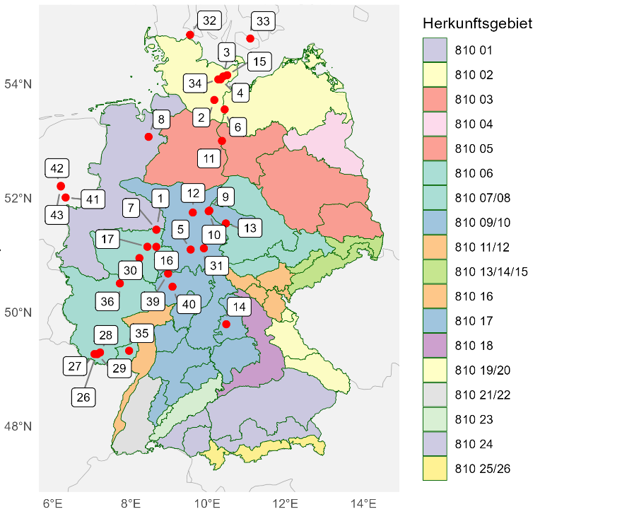
Figure S1. Geographic distribution of European beech provenances included in the Malente trial. Red dots indicate provenance locations, and numbered labels correspond to provenance identifiers used throughout the study. Colored polygons represent German provenance regions (Herkunftsgebiete) for European beech.
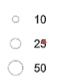
DBH (cm)
Figure S2. Spatial layout of the Malente provenance trial. Each point represents an individual tree, with point size scaled according to DBH as indicated in the scale. Numbers displayed within experimental units denote provenance identifiers, and colors distinguish provenance origins. The figure illustrates the replicated block design and the spatial distribution of tree growth across the site prior to the subsequent thinning intervention.

Figure S3. Provenance performance mapped onto geographic origin. Points represent the geographic origin of European and Oriental beech provenances. Colors represent mean provenance performance measured in our trial in Malente. Performance is shown for: MGIDI (score), basal area (m² ha⁻¹), survival (%), and acceptable stem form (%).

