Supplementary Information

Is the Onset-Based STEARC Effect Culturally Generalizable? Evidence from a Turkish Sample

Correspondence concerning this article should be addressed to Ezgi Gür, Department of Psychology, Izmir University of Economics, 35330 Balçova, Izmir, Turkey.
Email: ezgi.gur@izmirekonomi.edu.tr

Table S1
Descriptive Statistics for Reaction Times and Accuracy Rates Across Mapping Order Groups
Group |  | Reaction Times |  | Accuracy Rates
 | Condition | Mean (ms) | SD | Mean (%) | SD
 | Early-Left | 573.98 | 159.93 | 98.21 | 2.93
 | Early-Right | 503.76 | 122.78 | 97.94 | 3.31
MTL-Congruent First | Late-Left | 449.59 | 150.25 | 94.84 | 6.57
 | Late-Right | 520.56 | 152.04 | 97.84 | 3.24
 | Early-Left | 532.44 | 161.98 | 97.53 | 6.06
 | Early-Right | 540.08 | 160.31 | 98.71 | 1.7
MTL-Incongruent First | Late-Left | 567.45 | 145.31 | 97.83 | 3.84
 | Late-Right | 490.75 | 150.23 | 94.85 | 6.16
Note. Reaction times are reported in milliseconds (ms). All values are based on the final sample (N = 61). Descriptive statistics reported in this table were calculated directly from the long-format dataset across conditions and mapping order groups. These condition-level values are not intended to replace the participant-level descriptive statistics reported in the main text.

Table S2
Main Effects and Interactions for Reaction Time by Onset Timing and Response Side
Effect | F | df | p | η_{p}²
Onset Timing | 8.91 | 1, 60 | .004** | .13
Response Side | 5.81 | 1, 60 | .019* | .09
Onset Timing × Response Side | 1.48 | 1, 60 | .228 | .02
η_{p}² = partial eta squared. *p < .05. **p < .01. ***p < .001.

Table S3
Main Effects and Interactions for Reaction Time by Mapping Order, Onset Timing, and Response Side
Effect | F | df | p | η_{p}²
Mapping Order | 0.36 | 1, 59 | .552 | .01
Onset Timing | 8.83 | 1, 59 | .004** | .13
Response Side | 7.12 | 1, 59 | .010* | .11
Onset Timing × Response Side | 1.40 | 1, 59 | .242 | .02
Mapping Order × Onset Timing | 5.17 | 1, 59 | .027* | .08
Mapping Order × Response Side | 7.43 | 1, 59 | .008** | .11
Mapping Order × Onset Timing × Response Side | 21.98 | 1, 59 | < .001*** | .27
η_{p}² = partial eta squared. *p < .05. **p < .01. ***p < .001.

Figure S1
Mean dRT values as a function of onset timing for MTL-Congruent First (upper panel) and MTL-Incongruent First (lower panel) groups. Positive slopes indicate a reverse STEARC pattern, whereas negative slopes indicate a regular STEARC pattern.
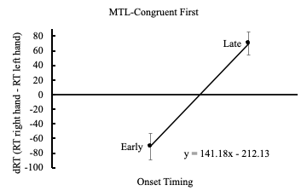
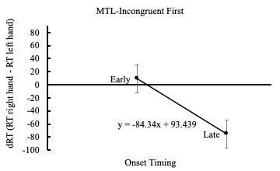
Note: Error bars represent standard error.

