Supplementary Information (SI)
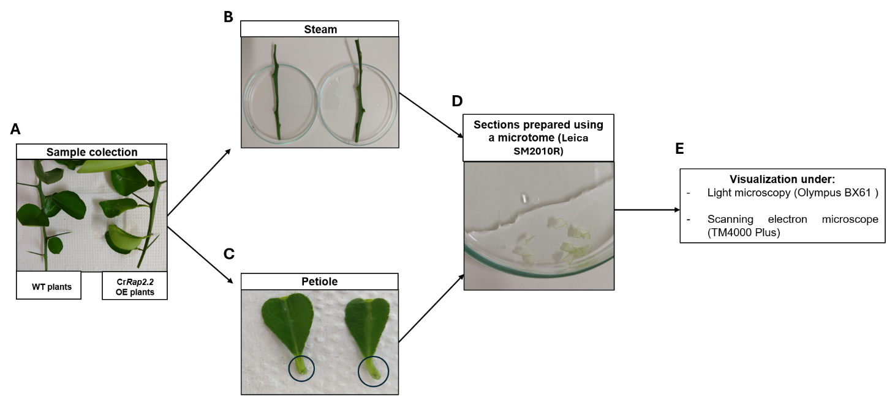
Supplementary Fig. 1 Schematic representation of the workflow used for the preparation of plant tissues for microscopy analyses. (A) Branches collected from transgenic citrus plants overexpressing CrRAP2.2 (CrRAP2.2-OE) and non-transgenic wild-type (WT) plants. (B) Stem segments and (C) petioles were excised, and (D) transverse sections were prepared using a microtome (Leica SM2010R). (E) Tissue sections were subsequently examined by light microscopy (Olympus BX61) and scanning electron microscopy (SEM) (TM4000 Plus).
.

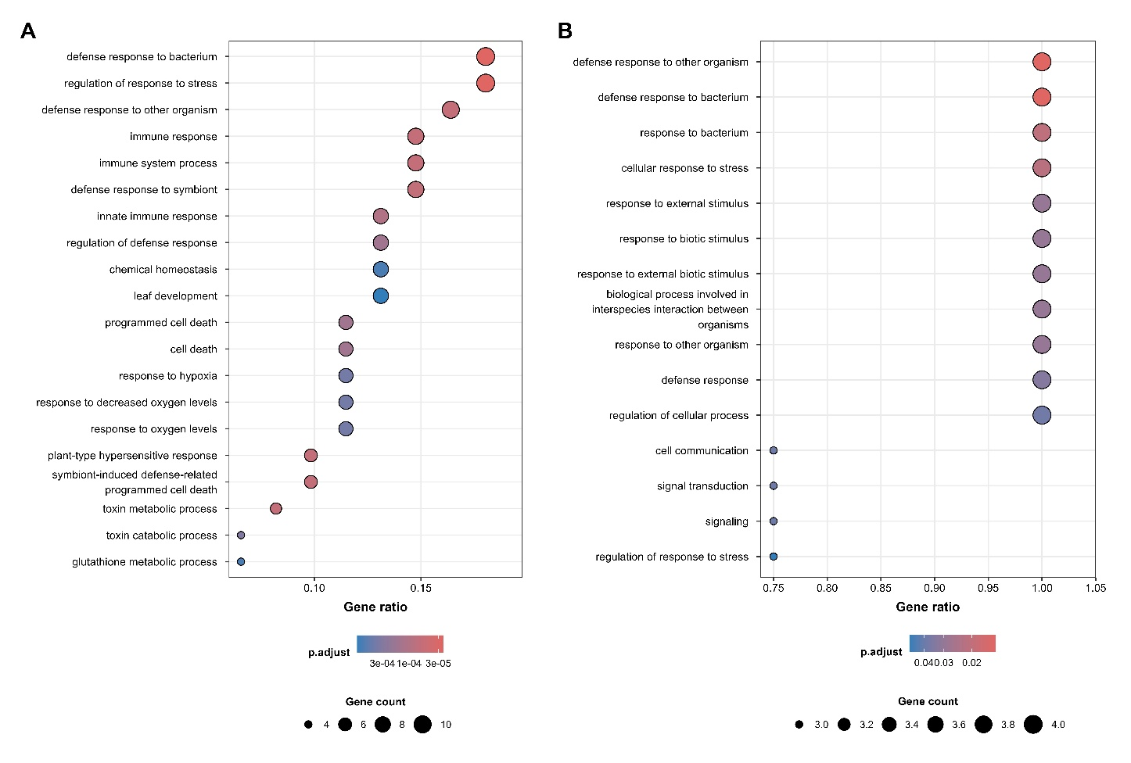
Supplementary Fig. 2 Gene Ontology (GO) Biological Process enrichment analysis of the protein–protein interaction (PPI) network. (A) GO enrichment analysis performed using all genes present in the PPI network. (B) GO enrichment analysis of the EDS1 module. Only significantly enriched GO terms (p.adjust ≤ 0.05) are shown.

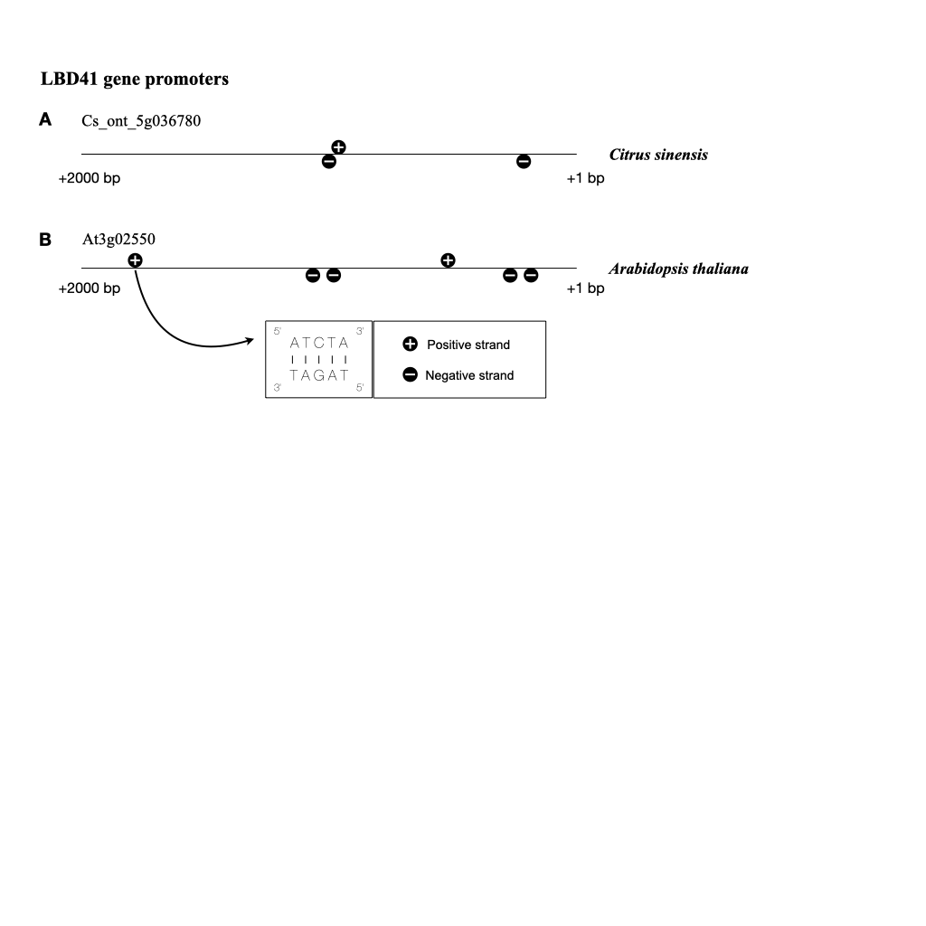
Supplementary Fig. 3 Distribution of CrRAP2.2-binding motifs within the promoter regions of LBD41 genes from (A) Citrus sinensis and (B) Arabidopsis thaliana.

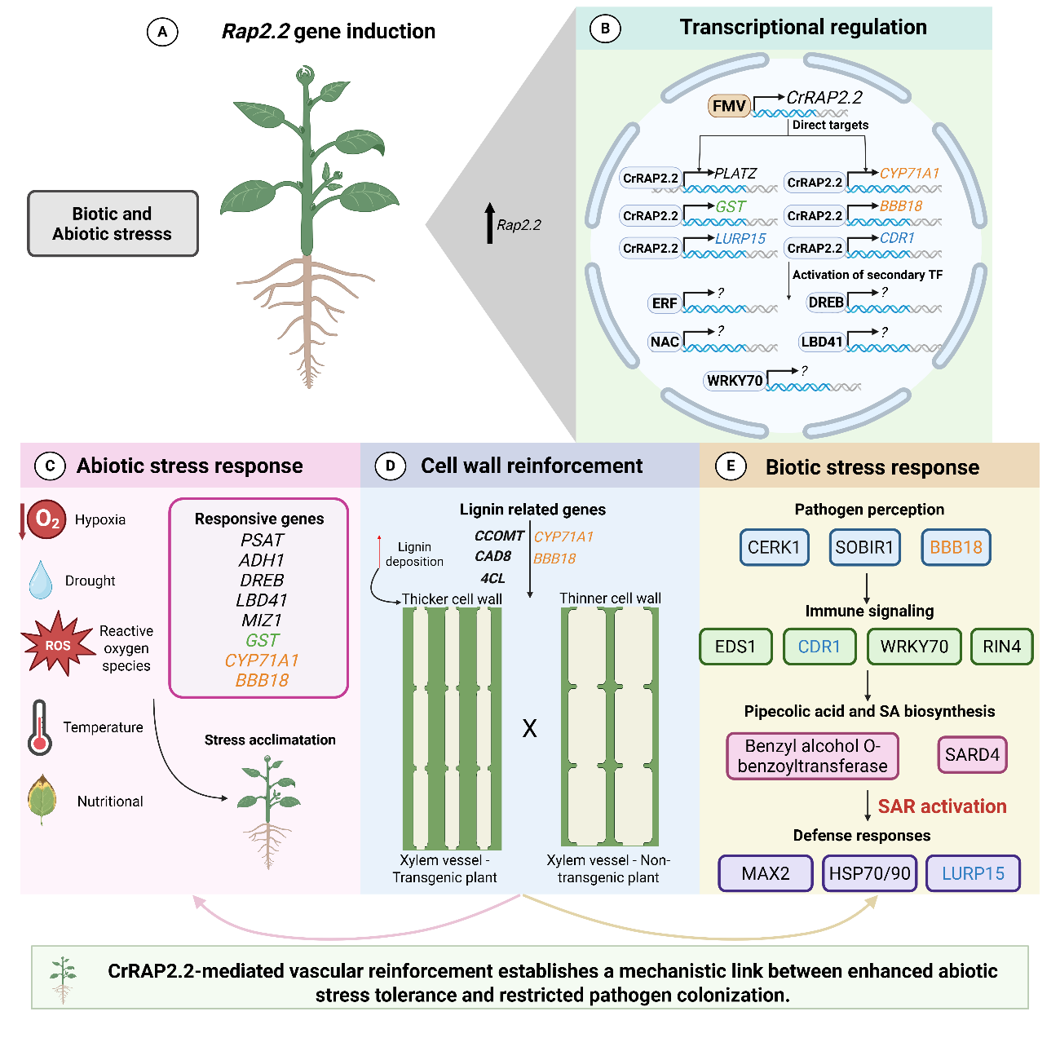
Supplementary Fig. 4 Hypothetical model of CrRAP2.2-mediated responses in plants. (A) RAP2.2 is known to be induced in response to biotic and abiotic stress. (B) Constitutive overexpression of CrRap2.2 in Citrus sinensis is predicted to directly regulate the expression of PLATZ, GST, LURP15, CYP71A1, BBE18, and CDR1, while indirectly modulating the activity of additional transcription factors, including ERF, NAC, DREB, LBD41, and WRKY70. The transcriptional reprogramming mediated by CrRAP2.2 promotes the activation of genes associated with (C) abiotic stress responses, (D) vascular cell wall reinforcement, and (E) biotic stress responses, mainly through modulation of salicylic acid-related genes and systemic acquired resistance (SAR). Collectively, these findings indicate that CrRAP2.2 establishes a mechanistic link between the genetic responses underlying abiotic and biotic stress tolerance.

