Boswellic acid and myrrh sesquiterpene alleviate hypoxic-ischemic brain injury via regulating TLR4/NF-κB and Ang Ⅰ/Ang Ⅱ/Tie signaling pathway on MCAO rats
Xiao Dong Miao^{1,2,3,a}, Zi Zhang Zhao ^{1,2,a}, Zhuo Xu ^{1,2,a}, Shu Lan Su^{1,2,*}, Bao Ping Jiang², Er-Xin Shang^{1,2}, Jia Shang Li^{1,2}, Yue Zhu^{1,2}, Jian Ming Guo^{1,2}, Li Yu², Da Wei Qian^{1,2}, Jin-Ao Duan^{1,2,*}
(¹ Jiangsu Key Laboratory for High Technology Research of TCM Formulae and Jiangsu Collaborative Innovation Center of Chinese Medicinal Resources Industrialization, Nanjing 210023, China; ² Nanjing University of Chinese Medicine, Nanjing 210023, China; ³ Jiangxi Academy of Traditional Chinese Medicine, Jiangxi 330077, China)
*Corresponding authors at: Jiangsu Collaborative Innovation Center of Chinese Medicinal Resources Industrialization, Nanjing University of Chinese Medicine, Nanjing 210023, PR China
E-mail addresses: sushulan1974@163.com (S.L. Su); duanja@163.com (J.A. Duan)
Tel. / fax: +86 25 85811917 (S.L. Su); +86 25 85811291 (J.A. Duan)
a: These authors contributed equally to this work.
1. Materials
Frankincense is a resin that exudes from Bowiellia carteri Birdw and myrrh is a dried resin of Commiphora myrrh Engl. They were identified by Professor Duan Jin-ao of Nanjing University of Traditional Chinese Medicine. Nimodipine was purchased from Shandong Xinhua Pharmaceutical Company Limited (lot number: 1810243). SPF-grade SD rats (male, 6-7 weeks) were procured from Shanghai slack laboratory animal co. LTD (License No: SCXK（Hu）2017-0005).Small vertical electrophoresis tank (Bio-Rad), small Trans-Blot transfer tank (Bio-Rad), basic power supply (Bio-Rad). Anke LXJ-IIB type and TDL-240B centrifuge was purchased from Shanghai Anting Scientific Instrument Factory (China, Shanghai); EPED ultra-pure water machine was purchased from Nanjing Yeap Esselte Technology Development Co., Ltd (China, Nanjing).
2. Preparation of drug solution
BA preparation: Frankincense were extracted four times with 20 times amount of 95 % ethanol, 1 h each time. Supernatants combined and evaporated to obtain dry extracts. Then BA was obtained by alkali-soluble acid precipitation, and 0.2 g of BA can be obtained with 1 g of frankincense. The BA content was 73.87%. BA mainly contains 3-oxotirucall-8,24-dien-21-oic acid, 3α-acetoxy-tirucall-7, 24-dien-21-oic acid, 3-hydroxytirucall-8,24-dien-21-oic acid, acetyl 11α-methoxy-β-boswellic acid, 3α-hydroxy tirucall-7,24-dien-21- oic acid, 11-keto-boswellic acid, 3-O-acetyl-α-boswellic acid, 3α-acetyloxylanosta -8,24-dien-21-oic acid, 3β-acetoxy-5α-lanosta-8,24- dien-21-oic acid, 3-acetyl-11-keto-β-boswellic acid, 3-acetyloxy-tirucall-8,24-dien-21-oic acid, α-boswellic acid, β-boswellic acid.
MS preparation: Myrrh were extracted twice with 7 times amount of 92 % ethanol, 2.5 h each time. Supernatants combined and evaporated to obtain dry extracts. Then the ethyl acetate extract was purified by silica gel column chromatography to obtain MS, and about 0.2 g of MS can be obtained with 1 g of myrrh. The content of MS is about 61%, mainly including 2-methoxy-8, 12-epoxygermacra-1(10), 7, 11-trien-6-one, 2-methoxy-5-acetoxy- fruranogermacr -1(10) -en-6-one, etc.
3.Animal experiment
Scoring criteria: 0 score: no symptoms; 1 score: the forelimb of the injured brains contralateral side cannot be straightened when lifting the tail; 2 score: rotating to the damage side; 3 score: tip to the opposite side; 4 score: can not walk spontaneously and consciousness is not clear; 5 score: death.
4. Metabolomics study on plasma and urine
An equal amount of plasma/urine from each sample were mixed together as a quality control (QC) sample. QC samples are continuously injected for 6 times to adjust the system balance before sampling, and injected once again between the two groups to monitor the stability of analysis.
The separation was performed on an ACQUITY UPLC BEH C₁₈ column (2.1 mm × 100 mm, 1.7 μm) which was maintained at 35 °C, and mobile phase was composed of 0.1% formic acid solution (A) and acetonitrile (B) at a flow rate of 0.4 mL/min. For plasma analysis, the gradient elution conditions were as follows:0-3 min, 5-50 % B; 3-7 min, 50-60 % B; 7-10 min, 60-70 % B; 10-14 min, 70-95 % B; 14-16.5 min, 95 % B; 16.5-20 min, 95-5 % B. For urine analysis, the gradient elution conditions were as follows: 0.0~8.0 min, 5~30% B; 8.0~11.0 min, 30~70% B; 11.0~13.0 min, 70%~95% B; 13.0~14.0 min, 95% B; 14.0~15.0 min, 95%~5% B.
ESI mass spectra were acquired in both positive and negative ionization modes by scanning over the m/z range 100~1000 Da. The conditions were as follows: extraction voltage: 2.0 V, cone voltage: 30 V, capillary voltage: 3.0 kV, collision energy: 20~50 eV, ion source temperature: 120 °C, desolvation temperature: 350 °C, cone gas flow rate: 50 L/h, and desolvation gas flow rate: 600 L/h. High purity nitrogen and leucine-enkephalin (ESI⁺: 556.2771 m/z, ESI⁻: 555.2615 m/z) were gas collision and locked mass solution, respectively.
5. Metabolites of intestinal flora analysis
Gas chromatographic condition: gas chromatograph (perkinelmer clams⑥ 680)- correlation Flame Ionization Detector (FID), Hp-5 capillary column（30m×0.25mm ×0.25 μm; number: 19091S-433; Agilent Technologies), a channels sampling rate 12.5 pts/s, injection volume: 2 μL, Carrier gas is helium, the shunt ratio was 10:1, the air flow rate was 400 mL/min and H2 flow rate was 40 mL/min, injector temperature at 250 °C, FID detector temperature at 250 °C, temperature programming: start temperature at 100 °C and keep for 2.5 min, then heat up to 230 °C at 50 °C/ min and hold for 2 min.

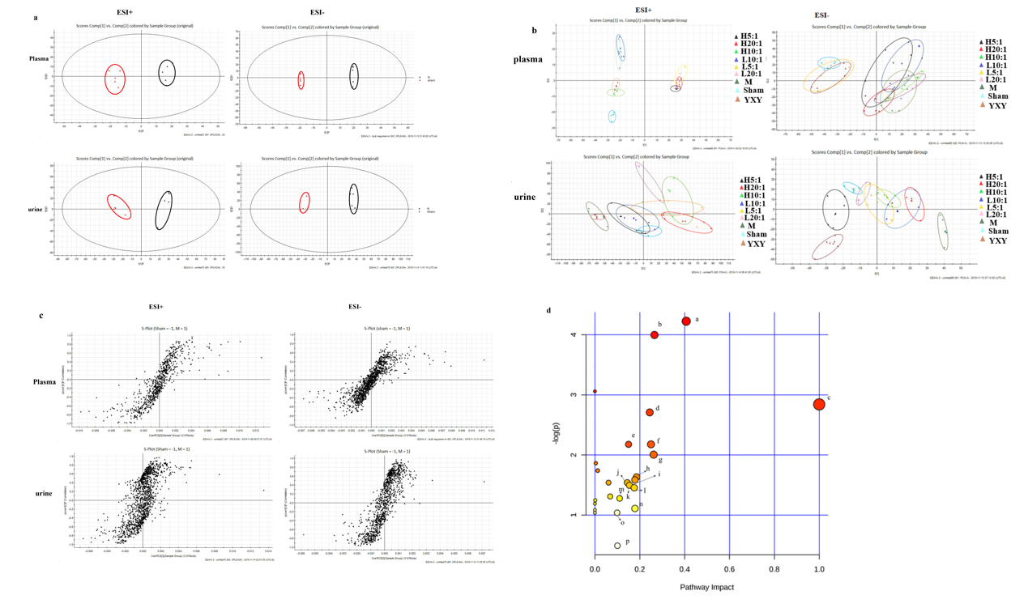Figure Ⅰ OPLS-DA model between sham and M rats in positive mode and negative mode (a); PCA model results sham group, model group and drug groups rats in positive mode and negative mode (b). S-plot polt for M vs. sham group in positive mode and negative mode(c). Metabolic pathways involved in all markers in plasma and urine (a. Retinol metabolism, b. Pentose and glucuronate interconversions, c. Linoleic acid metabolism, d. Glycerophospholipid metabolism, e. Biotin metabolism, f. Ascorbate and aldarate metabolism, g. Phenylalanine metabolism, h. Terpenoid backbone biosynthesis, i. Pantothenate and CoA biosynthesis, j. Ether lipid metabolism, k. Sphingolipid metabolism, l. Pyruvate metabolism, m. Galactose metabolism, n. Cysteine and methionine metabolism, o. Arachidonic acid metabolism, p. Steroid hormone biosynthesis) (d).

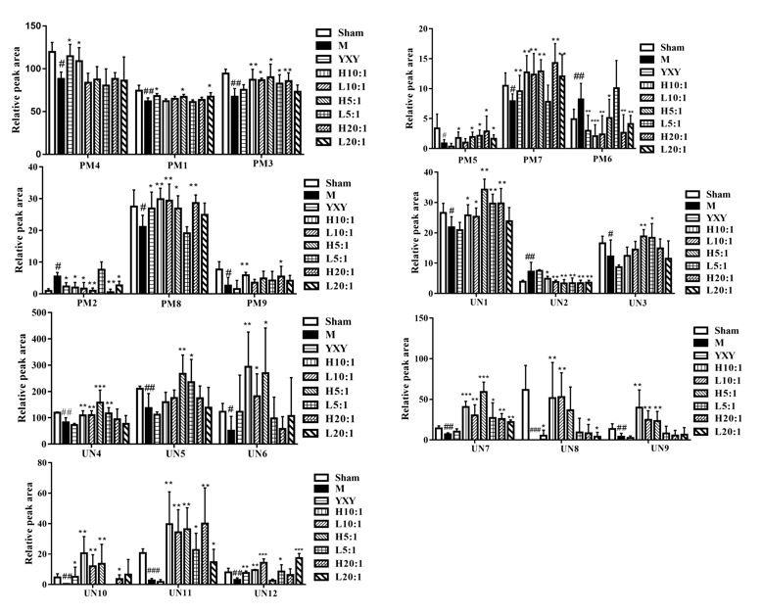
Figure ⅠI Relative peak area of potential biomarkers identified in plasma and urine in positive and negative ion mode by UPLC-QTOF/MS(d). (#P< 0.05, ##P< 0.01, ###P< 0.001: model group vs control group; *P< 0.05; **P< 0.01, ***P< 0.001: administration groups vs model group. PM1: Sphinganine; PM2: Prostaglandin H2; PM3: LysoPC(O-18:0/0:0); PM4: Linoleic acid; PM5: 4'-Phosphopantothenoylcysteine; PM6: LysoPA(18:0/0:0); PM7: 17-Hydroxyprogesterone; PM8: Retinal; PM9: Retinyl ester; UN1: PE(18:4(6Z,9Z,12Z,15Z)/22:6(4Z,7Z,10Z,13Z,16Z,19Z)); UN2: LysoPA(16:0/0:0); UN3: Biocytin; UN4: LysoPA(0:0/18:1(9Z)); UN5: Deoxycholic acid 3-glucuronide; UN6: Isopentenyl pyrophosphate; UN7: L-Cystathionine; UN8: 2-Phenylethanol glucuronide; UN9: Alpha-Lactose; UN10: Phenylpyruvic acid; UN11: D-Glucuronic acid; UN12: S-Acetyldihydrolipoamide-E).
Figure III High quality distribution of the sample sequence length

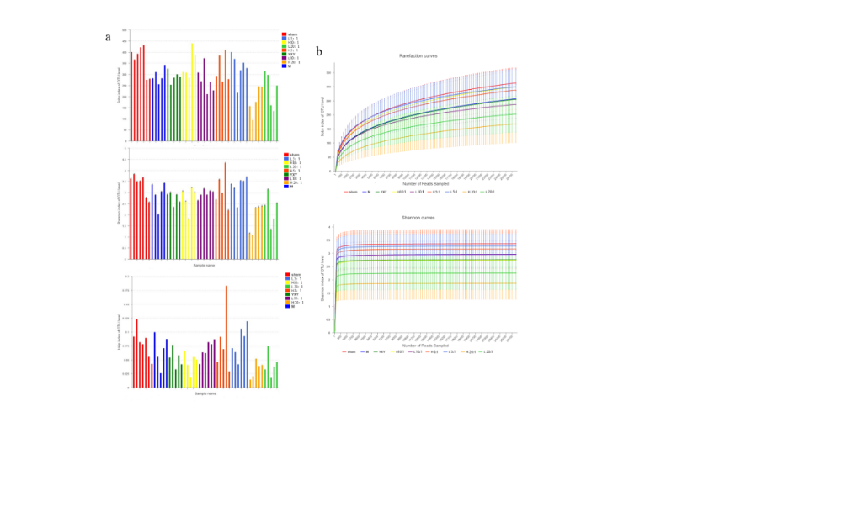
Figure IV Diversity index (Sobs, Heip and Shannon index) (a); rarefaction curve (Sobs and Shannon index) of each group (b)

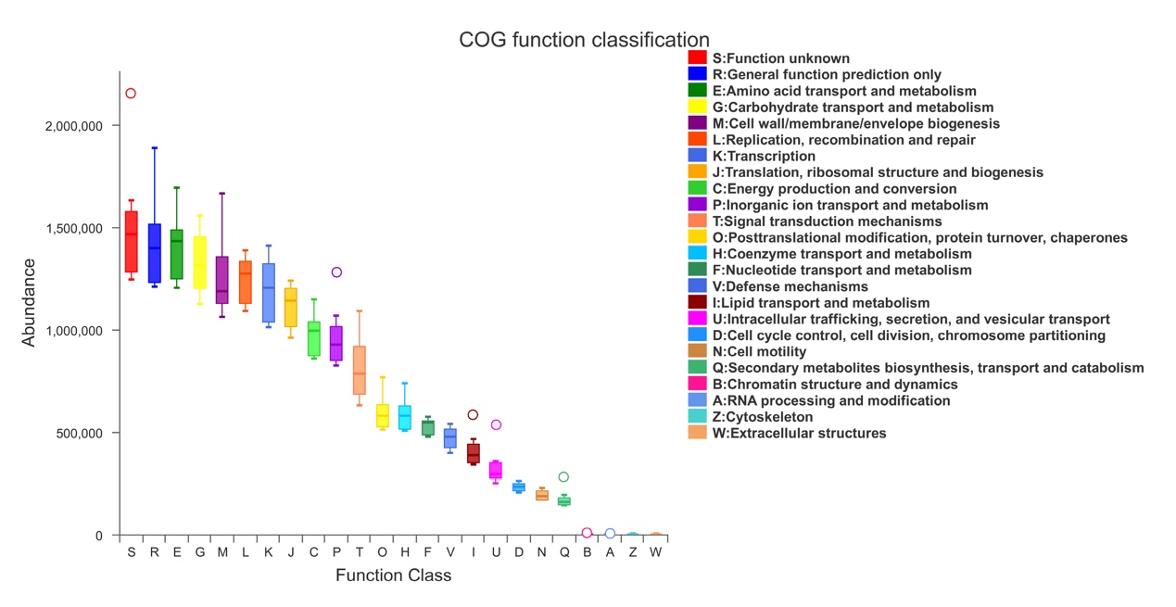
Figure V Function prediction of metabolites in intestinal flora

Figure VI The chromatogram of SCFAs (a: the mixed reference substances, b: Sham group, c: M group)

Table Ⅰ Potential metabolites selected and identified in plasma and urine
 | tR/min | HMDB | Metabolite | molecular formula | M/Z | Trend | Ion mode | PubChem | KEGG | pathway name | impact
PM1 | 7.04 | HMDB0000269 | Sphinganine | C₁₈H₃₉NO₂ | 302.31 | ↓ | [M+H]+ | 91486 | C00836 | Sphingolipid metabolism | 0.15
PM2 | 3.74 | HMDB0001381 | Prostaglandin H2 | C₂₀H₃₂O₅ | 353.23 | ↑ | [M+H]+ | 445049 | C00427 | Arachidonic acid metabolism | 0.10
PM3 | 9.57 | HMDB0011149 | LysoPC(O-18:0/0:0) | C₂₆H₅₆NO₆P | 510.39 | ↓ | [M+H]+ | 2733532 | C04317 | Ether lipid metabolism | 0.14
PM4 | 12.88 | HMDB0000673 | Linoleic acid | C₁₈H₃₂O₂ | 279.23 | ↓ | [M-H]- | 5280450 | C01595 | Linoleic acid metabolism | 1.00
PM5 | 3.57 | HMDB0001117 | 4'-Phosphopantothenoylcysteine | C₁₂H₂₃N₂O₉PS | 401.08 | ↓ | [M-H]- | 440304 | C04352 | Pantothenate and CoA biosynthesis | 0.18
PM6 | 5.57 | HMDB0007854 | LysoPA(18:0/0:0) | C₂₁H₄₃O₇P | 437.27 | ↑ | [M-H]- | 9547179 | C00416 | Glycerophospholipid metabolism | 0.14
PM7 | 13.29 | HMDB0000374 | 17-Hydroxyprogesterone | C₂₁H₃₀O₃ | 329.21 | ↓ | [M-H]- | 6238 | C01176 | Steroid hormone biosynthesis | 0.10
PM8 | 12.33 | HMDB0001358 | Retinal | C₂₀H₂₈O | 283.21 | ↓ | [M-H]- | 638015 | C00376 | Retinol metabolism | 0.25
PM9 | 11.5 | HMDB0003598 | Retinyl ester | C₂₀H₃0O₂ | 301.22 | ↓ | [M-H]- | 5460164 | C02075 | Retinol metabolism | 0.16
UN1 | 6.38 | HMDB0009210 | PE(18:4(6Z,9Z,12Z,15Z)/22:6(4Z,7Z,10Z,13Z,16Z,19Z)) | C₄₅H₇₀NO₈P | 784.49 | ↓ | M+H | 52924469 | C00350 | Glycerophospholipid metabolism | 0.10
UN2 | 3.5 | HMDB0007853 | LysoPA(16:0/0:0) | C₁₉H₃₉O₇P | 411.25 | ↑ | M+H | 6419701 | C00416 | Glycerophospholipid metabolism | 0.14
UN3 | 6.15 | HMDB0003134 | Biocytin | C₁₆H₂₈N₄O₄S | 373.19 | ↓ | M+H | 83814 | C05552 | Biotin metabolism | 0.15
UN4 | 4.06 | HMDB0007851 | LysoPA(0:0/18:1(9Z)) | C₂₁H₄₁O₇P | 437.27 | ↓ | M+H | 52929749 | C00416 | Glycerophospholipid metabolism | 0.14
UN5 | 5.11 | HMDB0002596 | Deoxycholic acid 3-glucuronide | C₃₀H₄₈O₁₀ | 569.33 | ↓ | M+H | 53477755 | C03033 | Pentose and glucuronate interconversions | 0.14
UN6 | 3.15 | HMDB0001347 | Isopentenyl pyrophosphate | C₅H₁₂O₇P₂ | 245.00 | ↓ | M-H | 1195 | C00129 | Terpenoid backbone biosynthesis | 0.19
UN7 | 9.95 | HMDB0000099 | L-Cystathionine | C₇H₁₄N₂O₄S | 221.06 | ↓ | M-H | 439258 | C02291 | Cysteine and methionine metabolism | 0.18
UN8 | 6.29 | HMDB0010350 | 2-Phenylethanol glucuronide | C₁₄H₁₈O₇ | 297.10 | ↓ | M-H | 24862077 | C03033 | Pentose and glucuronate interconversions | 0.14
UN9 | 3.22 | HMDB0000186 | Alpha-Lactose | C₁₂H₂₂O₁₁ | 341.11 | ↓ | M-H | 84571 | C00243 | Galactose metabolism | 0.11
UN10 | 3.34 | HMDB0000205 | Phenylpyruvic acid | C₉H₈O₃ | 163.04 | ↓ | M-H | 997 | C00166 | Phenylalanine metabolism | 0.26
UN11 | 2.96 | HMDB0000127 | D-Glucuronic acid | C₆H₁₀O₇ | 193.04 | ↓ | M-H | 444791 | C00191 | Ascorbate and aldarate metabolism | 0.25
UN12 | 5.4 | HMDB0006878 | S-Acetyldihydrolipoamide-E | C₁₀H₁₉NO₂S₂ | 248.08 | ↓ | M-H | 24906332 | C16255 | Pyruvate metabolism | 0.18

Table Ⅱ the metabolic pathways in the top 20 of abundance values
No | metabolic pathway | Abundance value
1 | Membrane Transport | 105692924
2 | Carbohydrate Metabolism | 88022887
3 | Amino Acid Metabolism | 80683073
4 | Replication and Repair | 75058735
5 | Energy Metabolism | 48214007
6 | Translation | 47475810
7 | Poorly Characterized | 44560931
8 | Cellular Processes and Signaling | 35077486
9 | Metabolism of Cofactors and Vitamins | 35035184
10 | Nucleotide Metabolism | 33769103
11 | Genetic Information Processing | 24154934
12 | Lipid Metabolism | 23596902
13 | Transcription | 22549380
14 | Metabolism | 22286325
15 | Glycan Biosynthesis and Metabolism | 20887654
16 | Folding, Sorting and Degradation | 20818946
17 | Enzyme Families | 18882988
18 | Cell Motility | 17376939
19 | Signal Transduction | 15725330
20 | Metabolism of Terpenoids and Polyketides | 14101934

Table Ⅲ The precision, stability, repeatability, average recovery and linear relation of six SCFAs components
compound | RSD/%(n=6) |  |  | average recovery (%) | regression equation | R²
compound | precision | stability | repeatability | average recovery (%) | regression equation | R²
Acetic acid | 5.36 | 6.18 | 9.98 | 110.65 | y=33180x-8660.3 | 0.9994
Propionic acid | 6.68 | 4.01 | 9.03 | 106.00 | y=58215x-3212.5 | 0.9991
Isobutyric acid | 6.61 | 3.38 | 9.04 | 108.37 | y=68937x+5402.8 | 0.9994
Butyric acid | 7.53 | 9.04 | 8.70 | 113.33 | y=78466x-26242 | 0.9997
Isovaleric acid | 6.75 | 6.33 | 9.48 | 108.15 | y=90551x-14885 | 0.9997
Valeric acid | 7.41 | 2.64 | 2.80 | 116.39 | y=96891x-83710 | 0.9992

