Appendix A
In this section, beyond the metric‑based quantitative analysis, we present explanation results for four representative cases, including their top‑k segments and the final SPS‑LIME heatmaps highlighting the most influential text for the model’s predictions. The first two examples are drawn from the SCOTUS dataset and the latter two from the ECtHR dataset, and together they cover both correctly and incorrectly classified decisions, allowing us to examine how well the explanations align with the underlying legal reasoning. For visualisation purposes, background details in the heatmap excerpts (such as dates, locations, and personal names) have been slightly generalised or replaced with pseudonyms and are visually underlined, in order to reduce identifiability while preserving the legal reasoning context.

Case Study 1: Correct Classification on SCOTUS
In the first example, our model correctly classified a judicial decision into the Federal Taxation category. The case concerns the income tax obligations associated with the administration of a liquidation plan in insolvency proceedings. The court held that the responsible party was required to file income tax returns and pay taxes on income attributable to the property being administered. The decision is therefore a clear example of a federal tax case, even though the underlying proceedings arise in a bankruptcy-related context. The top-k segments selected by SPS-LIME based on their attribution scores are presented in Table 11.
Table 11 Top-k segments classified as "Federal Taxation" in the first insolvency-related tax case.
Rhetorical Role | Segment Text | Support Class | Strength
Fact | Over the objections of the United States and the debtors, the Bankruptcy Court granted Smith's request for a declaratory judgment that he had no duty under the Internal Revenue Code (Code) to file income tax returns or pay income taxes. | Yes | Strong
Fact | II 9 The Internal Revenue Code ties the duty to pay federal income taxes to the duty to make an income tax return. | Yes | Strong
Fact | 1 These cases require us to decide whether a trustee appointed to liquidate and distribute property as part of a Chapter 11 bankruptcy plan must file income tax returns and pay income tax under the Internal Revenue Code. | Yes | Strong
Fact | First, they argue that Gould must pay the Miami Center Liquidating Trust's income taxes under the so-called "grantor trust" rules in the Internal Revenue Code. | Yes | Strong
Argument | Because the liquidating trust is a trust under the Internal Revenue Code and because respondent Smith's duties under the plan satisfy the description of a fiduciary in the regulations, the restrictions on the trustee's discretion do not remove him fr | Yes | Strong
Precedent | The plan did not simply substitute the trustee for Gould as the fiduciary of the estate. | No | Strong
Precedent | A Treasury Regulation states: 23 "Certain organizations which are commonly known as liquidating trusts are treated as trusts for purposes of the Internal Revenue Code. | Yes | Strong
Argument | (c) Respondents also err in asserting that Smith may ignore the duties imposed by the Code because the plan does not require him to pay taxes. | Yes | Strong
In Table 11, the selected segments at the segment-level top-k stage are clearly related to the Federal Taxation classification, and many of them contain explicit references to statutory tax provisions and income tax obligations. Most segments are marked as supporting the prediction, and their support strengths are strong. However, the rhetorical roles of these segments are primarily labeled as Fact, Argument, and Precedent, with Fact appearing most frequently, while Ruling by Present Court (RPC), Ruling by Lower Court (RLC), and Ratio of the Decision (ROD) are absent. This pattern suggests a limitation in how well the explanation aligns with the court’s formal reasoning structure, even though it captures tax-related content. The corresponding SPS-LIME explanation heatmap for this case is shown in Fig. 8.
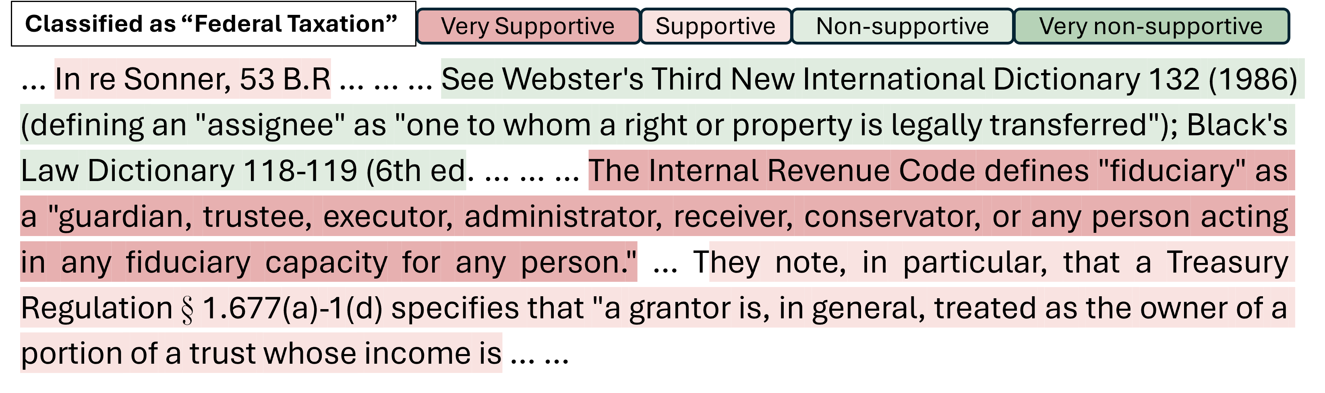
Fig. 8 SPS-LIME explanation heatmap for the correctly classified Federal Taxation case, showing the textual regions that most strongly support the tax-related prediction.
As shown in the heatmap, SPS-LIME assigns strong or moderate positive importance to segments that discuss insolvency-related case law and the meaning of fiduciary roles, as well as passages explaining statutory provisions concerning trustees and regulations that treat certain parties as owners of trust income. These segments provide evidence supporting the Federal Taxation prediction because they directly connect legal status and trust income to tax obligations. By contrast, more general references to legal authorities or dictionary definitions receive negative or weak attribution scores. This pattern suggests that the classifier relies primarily on passages that express fiduciary status, ownership, and income in tax-specific terms, while broader doctrinal or definitional material contributes less directly to the prediction.

Case Study 2: Incorrect Classification on SCOTUS
The second example is a failure case where the true label is Judicial Power, whereas the model predicted Economic Activity. The decision involves a statutory scheme governing civil remedies in the context of financial-market regulation. The court considered whether an investor-protection entity could bring a civil action to recover multiple damages for losses incurred after intermediaries became insolvent.
This case concerns the scope of judicial authority over statutory civil remedies and standing. The court held that the claimant’s injury was too remote to satisfy the proximate-cause requirement in the relevant remedial provision, and that the claimant therefore had no right to sue for enhanced damages. The decision is therefore useful for examining whether the model can correctly identify issues of standing and remedial authority, rather than being misled by language about economic harm. The top-k segments selected by SPS-LIME based on their attribution scores are shown in Table 12.
Table 12 Top-k segments classified as "Economic Activity" in the judicial-power case misclassified as economic activity.
Rhetorical Role | Segment Text | Support Class | Strength
Precedent | This analysis is not deflected by the congressional admonition that RICO be liberally construed to effectuate its remedial purposes, since allowing suits by those injured only indirectly would open the door to massive and complex damages litigation, | Yes | Strong
Fact | 53 Section 1961(1)'s list of racketeering offenses provides the RICO predicates for both criminal prosecutions and civil actions. | No | Strong
Ruling by Present Court | It is required in RICO not so much because RICO has language similar to that of the Clayton Act, which in turn has language similar to that of the Sherman Act, which, by the time the Clayton Act had been passed, had been interpreted to include a prox... | Yes | Strong
Ruling by Present Court | What is more, SIPC briefed the proximate-cause issue, see Brief for Respondent 34-36, 38-39, and announced at oral argument that it recognized the Court might reach it, see Tr. | No | Strong
Fact | The great majority of acts listed in § 1961(1) are criminal offenses for which only a State or the Federal Government is the proper party to bring suit. | No | Strong
Fact | 459 U.S., at 543-544, 103 S.Ct., at 911-912; McCready, supra, 457 U.S., at 473-475, 102 S.Ct., at 2545-2546; Hawaii v. Standard Oil Co. of Calif., 405 U.S. 251, 264, 92 S.Ct. | Yes | Strong
Precedent | 451 (1918)),19 and the reasons that supported conforming Clayton Act causation to the general tendency apply just as readily to the present facts, underscoring the obvious congressional adoption of the Clayton Act direct-injury limitation among the r | Yes | Strong
In Table 12, we examine the segment-level top-k for this case, where the true label is Judicial Power but our model predicted Economic Activity. The selected segments include Precedent, Fact, and Ruling by Present Court (RPC) roles, and most are marked as supporting the predicted label with strong strength values. However, their content primarily discusses the civil-action provision in parallel with general competition-law concepts, the list of predicate offenses, and reasoning about proximate cause and injuries to business or property, rather than focusing on who has the right to sue under the statute or on the institutional allocation of remedial authority. This pattern shows that SPS-LIME faithfully surfaces the economic-harm vocabulary that drove the erroneous Economic Activity prediction, while the presence of RPC segments does not fully compensate for the explanation’s weak alignment with the underlying judicial-power issue. The corresponding SPS-LIME explanation heatmap for this failure case is shown in Fig. 9.
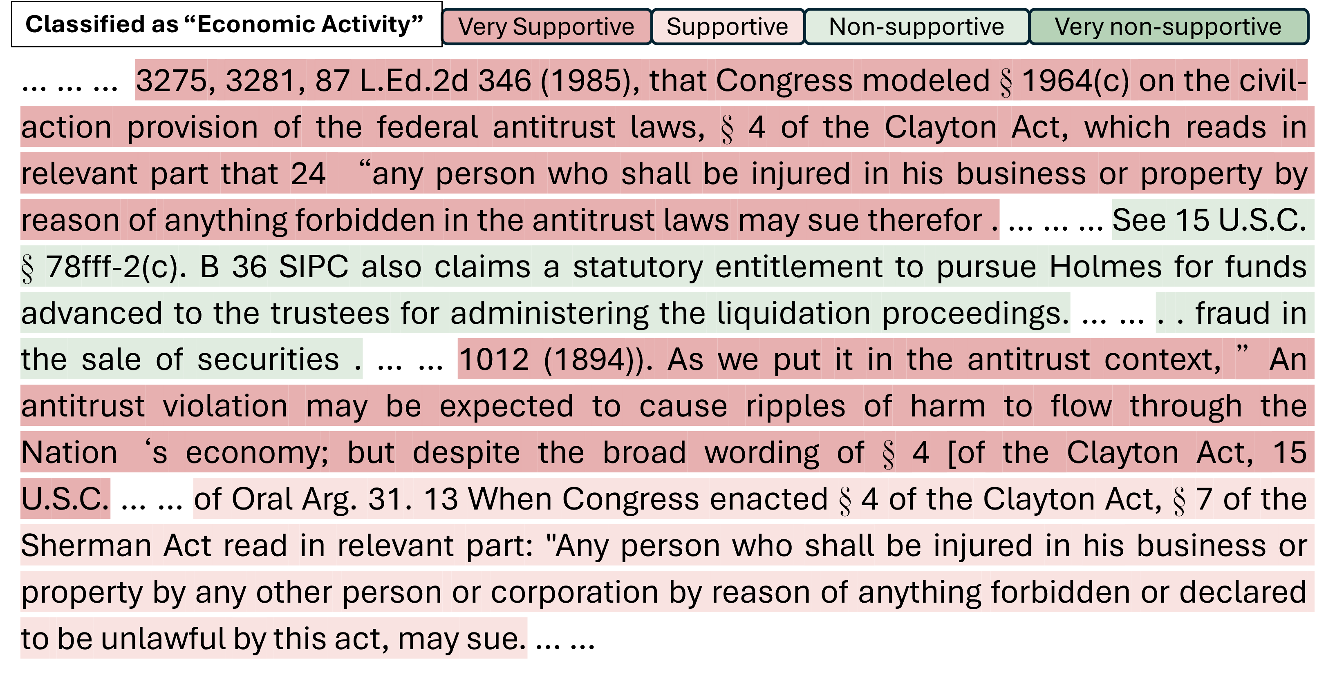
Fig. 9 SPS-LIME explanation heatmap for the judicial-power case misclassified as "Economic Activity", highlighting the textual regions that drove the erroneous economic-activity prediction.
As shown in Fig. 9, phrases that invoke competition-law style remedies, such as references to civil-action provisions, injuries to business or property, and broad “ripples of harm” in the economy, are highlighted as very or moderately supportive for the Economic Activity classification. By contrast, portions of the opinion that bear more directly on who is entitled to sue and on the court’s allocation of remedial authority are either weakly supportive or not highlighted at all, indicating that the model’s explanation prioritizes economic-harm vocabulary over the judicial-power dimension of the case.

Case Study 3: Correct Classification on ECtHR
The third case is an example involving the protection of reputation and private life that the model correctly classified as violation. The decision addresses a dispute concerning offensive online expression on a social-media platform. In particular, the domestic courts had to assess the impact of an altered image of the applicant accompanied by a caption using highly abusive language which explicitly portrayed him as a rapist.
This case concerns the conflict between freedom of expression and the protection of reputation and private life. The court found a violation of the right to respect for private life because the domestic authorities failed to provide sufficient protection for the applicant’s reputation, allowing him to be publicly portrayed as a rapist despite the dismissal of all criminal accusations and the absence of any conviction. The abusive caption was treated not merely as a value judgment but as a statement implying that the applicant had committed a serious criminal offence, and this assessment played a central role in the court’s reasoning on reputational harm. The case therefore illustrates how the model handles privacy-related claims involving online speech and evaluates whether domestic courts have struck a fair balance between expressive freedom and the right to respect for private life. The top-k segments identified by SPS-LIME are shown in Table 13.
Table 13 Top-k segments for the privacy-and-reputation case involving offensive online expression, correctly classified as "violation".
Rhetorical Role | Segment Text | Support  Class | Strength
Fact | 11. On 26 November 2012 the applicant’s lawyer sent a letter to X requesting that he withdraw his statement, apologise in the media and pay the applicant punitive damages. | Yes | Strong
Precedent | In this context, it makes a difference, even though this alone is not decisive for the conclusion, that [X] did not maintain that the [applicant] had thus committed a criminal offence against someone else, named or unnamed. | No | Strong
Argument | The documents of the case reveal that there were instances when his criticism had been directed towards named individuals, often women, and in some cases his words could be construed to mean that he was in fact recommending that they should be subjec... | Yes | Medium
Argument | Before the Supreme Court the applicant reiterated his argument that X’s Instagram account had been an “open” account, meaning that the picture had been accessible not only to his followers but to all Instagram users, over 100,000,000 people at the ma... | No | Medium
Argument | In the same manner, he must take responsibility for the material he produces, irrespective of what name he chooses to use. | No | Weak
Fact | He submitted further documents to support his argument. | No | Weak
Fact | Article 166 of Act No 91/1991 on Civil Procedure, legal costs before both court instances will be cancelled.” 17. | Yes | Weak
Fact | The Supreme Court agrees with the District Court that the [applicant] enjoys the personal protection provided for by law, under Article 71 of the Constitution and Article 8(1) of the European Convention of Human Rights, cf. | No | Weak
In Table 13, we present the segment-level top-k SPS-LIME explanation for this correctly classified violation case. The selected segments are predominantly labeled as Fact and Argument, with one Precedent segment, and most of them either support or do not support the violation classification with medium or weak strength values. These passages focus on the applicant’s request for withdrawal of the statement and apology, his claim for damages, the description of the social-media account as publicly accessible to a very large number of users, and the courts’ treatment of legal costs and the applicant’s personal protection under domestic law and fundamental-rights provisions. This pattern suggests that SPS-LIME builds its explanation by highlighting factual and argumentative material about the public nature and impact of the impugned expression, rather than by relying on abstract doctrinal formulations of proportionality analysis, thereby aligning the explanation with the case outcome while still privileging narrative over formal legal reasoning. The corresponding SPS-LIME explanation heatmap for this case is shown in Fig. 10.
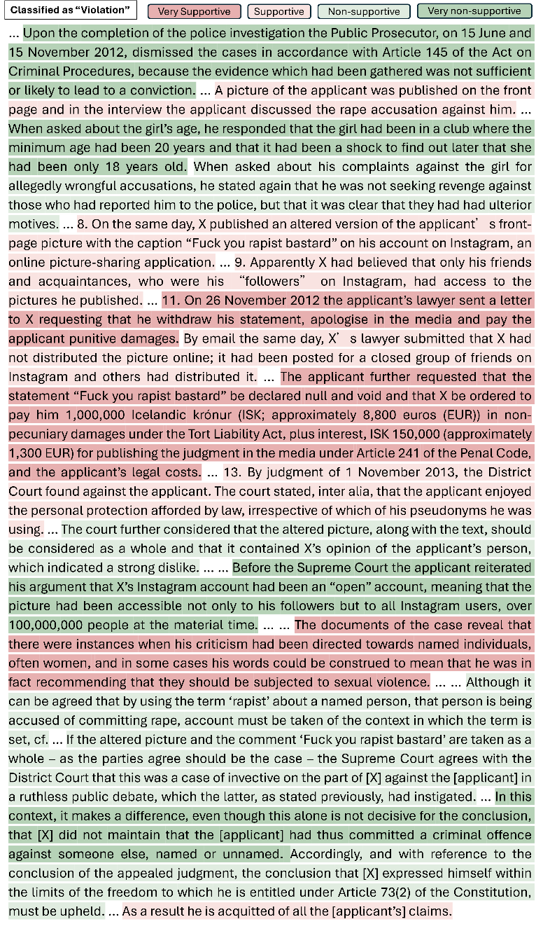
Fig. 10. SPS-LIME explanation heatmap for the correctly classified privacy-and-reputation case, illustrating the textual regions that most strongly support the finding of a violation of the right to respect for private life.
In Fig. 10, the SPS-LIME heatmap highlights as very supportive the passages describing the insulting description of the applicant as a rapist, the applicant’s request for damages, and the wide dissemination of the altered picture via an open social-media account, all of which underpin the court’s finding of a violation of privacy and reputation. By marking entire, semantically coherent segments rather than isolated words, SPS-LIME preserves the narrative context of the impugned conduct and the concrete forms of reputational and personal harm, which is crucial for assessing violations and is consistent with the high LRA score reported earlier.

Case Study 4: Incorrect Classification on ECtHR
The fourth case is a failure example involving fair-trial guarantees in judicial disciplinary proceedings, where the true label is violation but the model predicted non-violation. The decision examines whether disciplinary proceedings against a judge complied with fundamental procedural-fairness standards.
This case focuses on the impartiality and fairness of judicial disciplinary proceedings. The court found a violation of fair-trial rights because the same judicial body had participated in both drafting the disciplinary charges and later adjudicating them, and its decision was final with no further judicial review available. The case is therefore useful for examining whether the model can identify procedural-fairness issues and distinguish genuinely impartial disciplinary structures from those where the concentration of functions undermines the right to a fair hearing. The top-k segments identified by SPS-LIME are shown in Table 14.
Table 14 Top-k segments for the judicial-disciplinary fair-trial case, misclassified as "non-violation".
Rhetorical Role | Segment Text | Support Class | Strength
Fact | He informed the applicant that the proceedings would not be held in public unless he so wished and that, pending the proceedings, he would have to refrain from carrying out his duties. | No | Strong
Precedent | Furthermore, with regard to the investigation and the object of the hearing, he observed: “A judicial official with the duties of prosecutor was not appointed, a possibility which is referred to in Rule 16, and we adopted the following approach: ever... | Yes | Strong
Ratio of the Decision | He was paid a retirement lump sum and started receiving his pension. | Yes | Strong
Fact | He argued that that was contrary to the rules of natural justice and the right to a fair trial. | Yes | Medium
Argument | In brief, Mr Efstathiou not only accepted but also praised as correct the competence, arising from the Constitution, of the Supreme Council of Judicature, which is made up of the full bench of the Members of the Supreme Court, the highest judicial au... | Yes | Medium
Fact | That constitutional provision secures the well-known rights that an accused has in a criminal trial and are identical to those secured under Articles 6 §§ 2 and 3 of the European Convention on Human Rights, which was ratified by the House of Represen... | No | Medium
Ruling by Present Court | It therefore called the applicant to put forward his defence. | No | Weak
Ruling by Present Court | Clarifying his position, he said that that is inferred from the fact that the President and Members of the Supreme Council of Judicature put questions to the witnesses. | Yes | Weak
In Table 14, we show the segment-level top-k SPS-LIME explanation for this fair-trial case, which our model incorrectly classified as non-violation. The selected segments span Fact, Precedent, Ratio of the Decision, Argument, and Ruling by Present Court (RPC) roles, and most are marked as supporting the predicted label with strong or medium strength values. These passages describe the applicant’s removal from judicial duties, his complaint that the proceedings were contrary to natural justice and the right to a fair trial, the constitutional and fundamental-rights provisions securing fair-trial guarantees, and the court’s reasoning on competence and institutional structure, indicating that SPS-LIME successfully surfaces the doctrinal and institutional context of the case even though the model’s final classification is wrong. The corresponding explanation heatmap for this case is shown in Fig. 11.
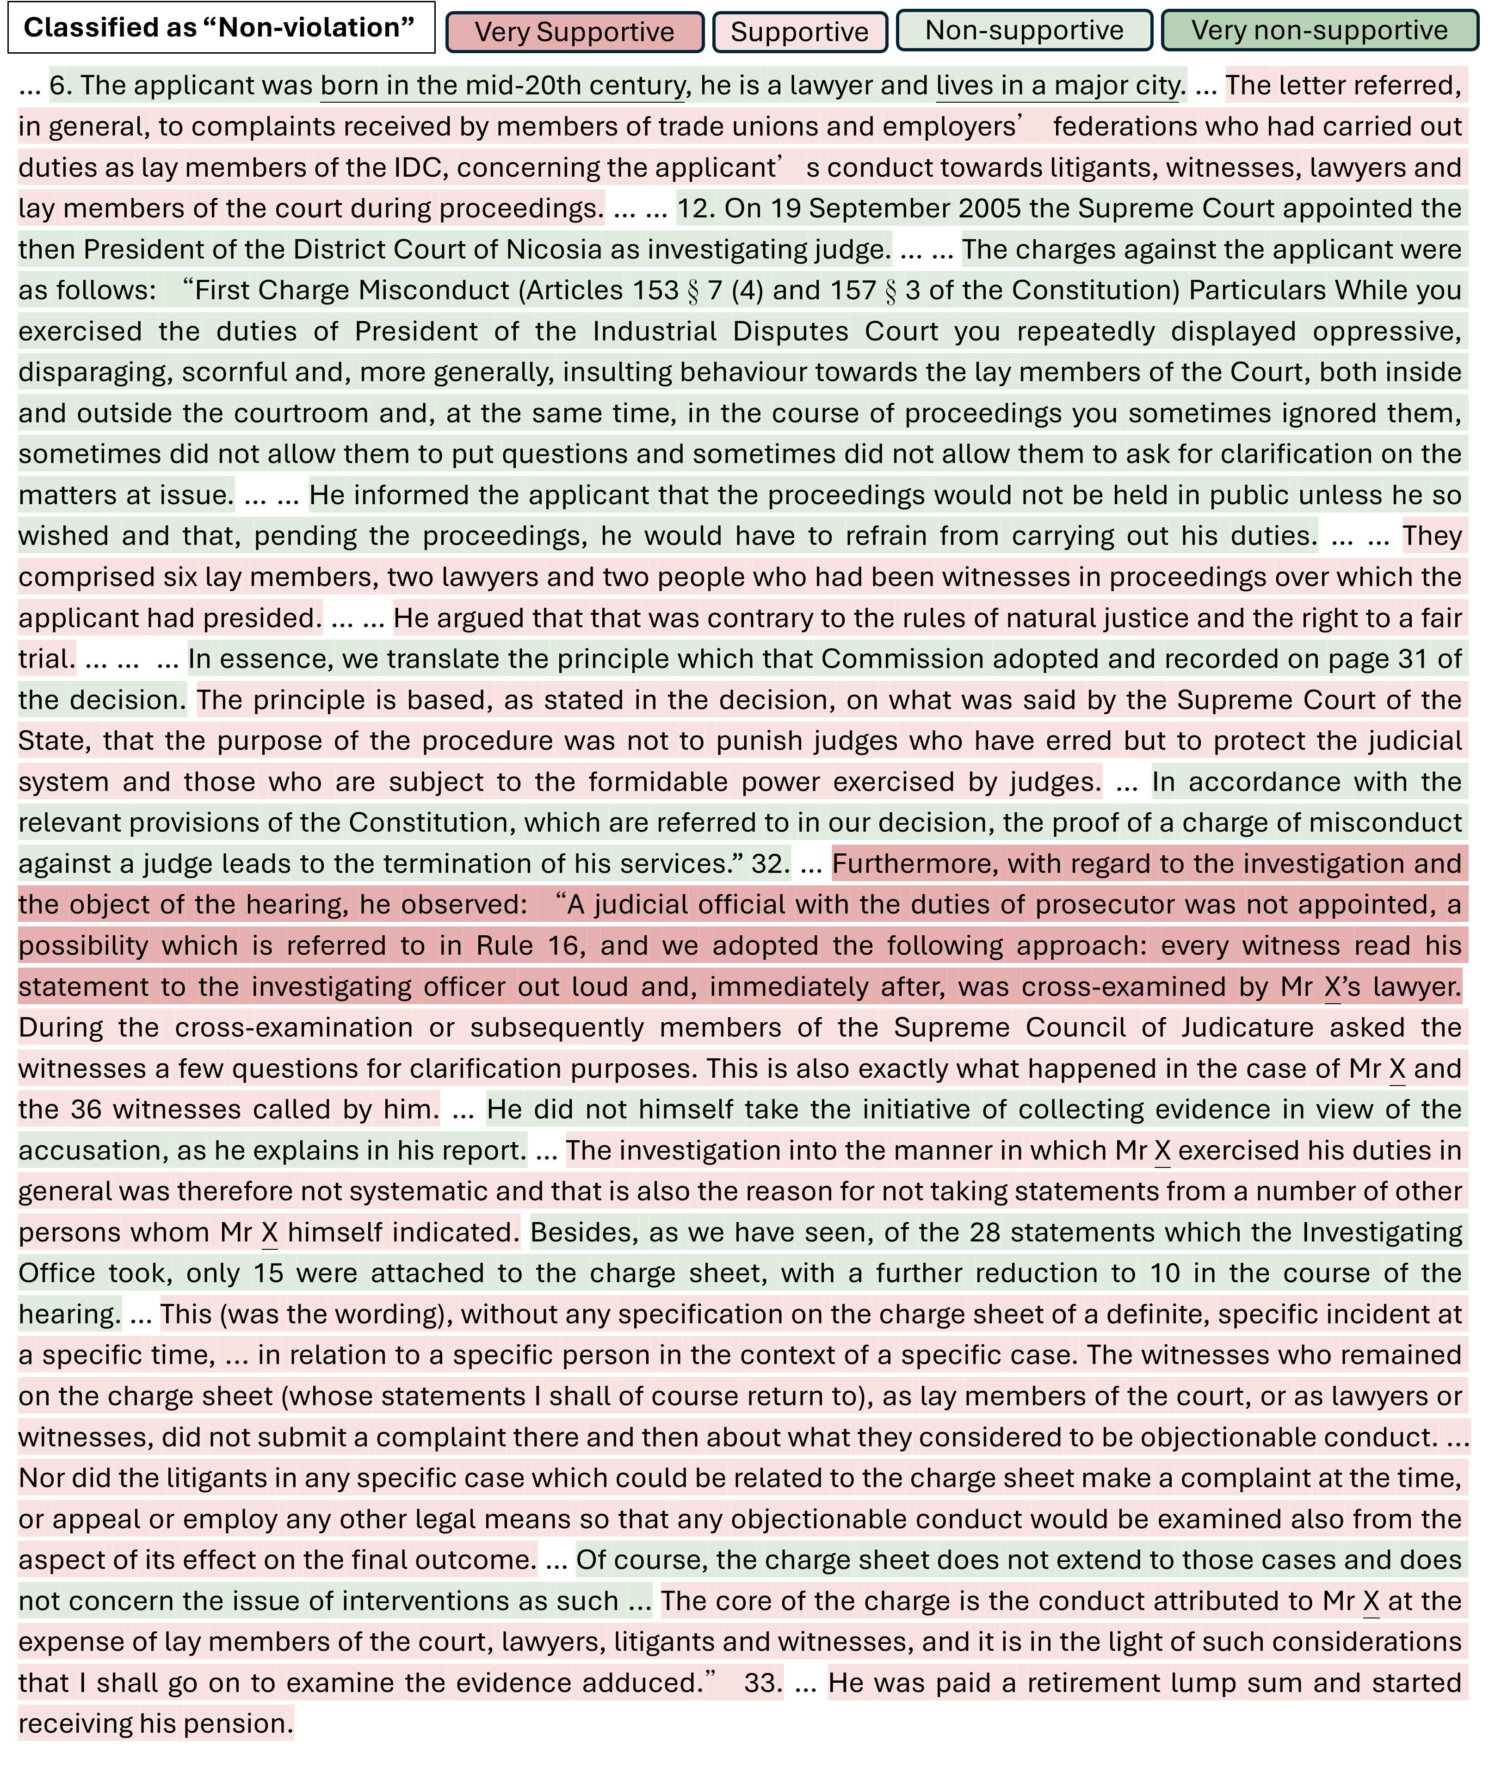
Fig. 11. SPS-LIME explanation heatmap for the fair-trial judicial-disciplinary case misclassified as "non-violation", showing the influential textual regions underlying the erroneous decision.
In Fig. 11, the SPS-LIME heatmap highlights as supportive extended passages that list the misconduct charges, refer to fair-trial rights under domestic constitutional law and international human-rights standards, and describe the institutional safeguards of the courts. The classifier thus reacts strongly to rights-related keywords and formal guarantees, but fails to register that the court’s overall assessment of these guarantees is critical and leads to a finding of violation, illustrating its difficulty with semantic reversal and multiple strands of reasoning in complex fair-trial cases. SPS-LIME makes this limitation visible by faithfully reflecting the model’s reliance on surface rights vocabulary while revealing its misreading of the judgment’s negative and dismissive context.

