SUPPLEMENTARY MATERIAL

SUPPLEMENTARY MATERIAL – Section 1

Table S1. Confidence range assign to fire pixels - MOD14A1 fire mask (Giglio and al. 2021)
Range | Confidence class
0 % ≤ C < 30 % | Low-confidence fire
30 % ≤ C < 80 % | Nominal-confidence fire
80 % ≤ C ≤ 100 % | High-confidence fire

Normality and collinearity diagnostics

We conducted a comprehensive evaluation of distributional assumptions and predictor redundancy to ensure statistical robustness and prevent biased inference. Multivariate normality was tested using Henze–Zirkler, Royston, Doornik–Hansen, Energy, and Mardia procedures, all of which consistently rejected the null hypothesis of multivariate normality (p = 0). These complementary tests are widely recommended for assessing joint distributional structure because they capture skewness, kurtosis, and higher-order moment departures from Gaussian assumptions (Doornik and Hansen 2008; Henze and Zirkler 1990; Mardia 1970). Univariate Anderson–Darling and Shapiro–Wilk tests further confirmed that each variable significantly deviated from normality (p < 0.001), a result consistent with the strong skewness and leptokurtosis observed in rainfall, fire_count, and burn_area distributions (Supp. Material 1, Table S2). These findings justified the adoption of non-parametric trend tests (Mann–Kendall, Sen’s slope) and semi-parametric Generalized Additive Models (GAMs) (Zuur et al. 2009).
Table S2. Assessment of univariate and multivariate distributional assumptions and collinearity among wildfire response and predictor variables used in model development.
Variable | Shapiro–Wilk W | Shapiro p-value | Anderson–Darling Statistic | AD p-value | Skewness | Kurtosis | Multivariate Normality (Overall) | Strong Collinearity Detected | Retained in Final Models
Rainfall | 0.565 | < 2.2e-16 | 42.76 | <0.001 | 2.51 | 6.08 | Rejected (all tests p = 0) | No | Yes
MSAVI | 0.689 | < 2.2e-16 | 20.33 | <0.001 | 3.13 | 13.37 | Rejected | No | Yes
Fire Count | 0.394 | < 2.2e-16 | 52.17 | <0.001 | 4.85 | 28.77 | Rejected | — (response variable) | Yes (response)
Burn Area | 0.386 | < 2.2e-16 | 56.44 | <0.001 | 4.32 | 20.58 | Rejected | — (response variable) | Yes (response)
Median Temp | 0.938 | 1.60e-08 | 5.07 | <0.001 | -0.67 | -0.50 | Rejected | Yes (with max_temp) | Yes
Wind Speed | 0.963 | 7.49e-06 | 3.21 | <0.001 | 0.03 | -1.09 | Rejected | Yes (with temperature vars) | No (excluded)
Shapiro–Wilk and Anderson–Darling tests, together with skewness and kurtosis statistics, were used to evaluate departures from normality for climatic, vegetation, and fire variables. All variables showed significant deviations from normality (all p < 0.001), indicating strongly non-Gaussian distributions characterized by varying degrees of asymmetry and heavy tails, particularly for fire count and burned area. Multivariate normality was likewise rejected across all tests. Collinearity diagnostics were applied to identify highly correlated predictors prior to model fitting. Rainfall and MSAVI showed no evidence of problematic collinearity and were retained. Median temperature exhibited strong collinearity with maximum temperature but was retained based on model performance and ecological interpretability. Wind speed showed collinearity with temperature variables and was excluded from final models. Fire count and burned area were retained as response variables and were not subjected to predictor selection.
Collinearity diagnostics were conducted using correlation matrices (Supp. material 1, Fig. S1) to identify redundant predictors and avoid inflated variance, unstable smooth functions, and misleading inference. High pairwise correlations (|r| ≥ 0.7) were considered indicative of problematic multicollinearity (Dormann et al. 2013). Strong collinearity was detected between median temperature and maximum temperature, as well as between wind_speed and temperature-related metrics. Because median temperature provided a robust representation of central thermal conditions and was ecologically consistent with compound climate–fuel interaction theory in drylands (Abatzoglou and Kolden 2013), maximum temperature was excluded to prevent redundancy. Wind speed, although theoretically relevant for fire behavior, showed strong statistical dependence with temperature variables. Our approach of non-normality and multicollinearity assessment aimed to ensure that subsequent ignition and fire spread models were statistically defensible and ecologically interpretable.

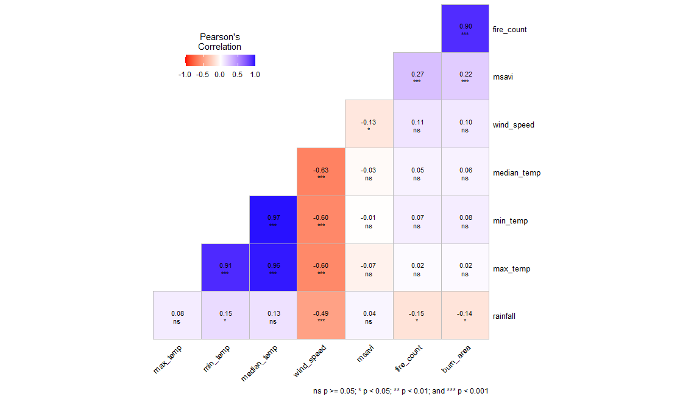
Figure S1. Pearson’s correlation test of candidate variables
- Predictor definitions and summary statistics used in GAMs models.
Table 3.1 summarizes the structure of the pre- and post-firebreak GAMs, the ecological meaning of each predictor, and the distribution of predictor values across both study periods. In both models, fire presence was related to a common set of climatic, vegetation, topographic, and anthropogenic variables, allowing direct comparison before and after firebreak implementation. Vegetation productivity (msavi), temperature (temp), rainfall (rain), elevation (elev), topographic convergence index (TCI), and distances to high-traffic areas and settlements were retained in both periods, whereas distance to firebreak (log_firebreak) was included only in the post-2016 model, reflecting the introduction of the firebreak network. Presenting the variables alongside their full names and pre/post-descriptive values helps clarify both the ecological role of each predictor and the comparability of environmental conditions between temporal regimes. This makes the table useful not only for documenting model structure, but also for showing that the post-firebreak analysis was built on the same environmental framework, with the addition of the management variable needed to test firebreak influence.
Table 3.1. Structure and predictor variables of generalized additive models (GAMs) for fire presence during pre- (2005–2015) and post-firebreak (2016–2024) periods.
Model period | Model formula | Variable | Full variable name | Ecological meaning | Pre-firebreak (2005–2015) | Post-firebreak (2016–2024)
Pre-firebreak | fire_presence ~ s(lon, lat) + s(msavi) + s(temp) + s(elev) + s(TCI) + s(dist_hightraf) + s(dist_settlement) + s(rain) | fire_presence | Fire presence | Binary response indicating fire occurrence (0 = absence, 1 = presence) | Binary | Binary
 |  | lon / lat | Longitude / Latitude | Easting coordinate of pixel location / Northing coordinate of pixel location | Spatial coordinate | Spatial coordinate
 |  | msavi | Modified Soil-Adjusted Vegetation Index | Proxy for vegetation productivity / fuel load | Mean visible in dataset; values around 0.16–0.17 in sample shown | Mean visible in dataset; values around 0.16–0.17 in sample shown
 |  | temp | Median daily temperature (°C) | Thermal control on fuel drying and flammability | Sample values around 40.9–41.0 °C | Sample values around 41.6–41.8 °C
 |  | elev | Elevation (m) | Topographic control on fire distribution | Sample values around 299–320 m | Sample values around 299–320 m
 |  | TCI | Topographic Convergence Index | Proxy for moisture redistribution and local water accumulation | Sample values around 6.5–7.0 | Sample values around 6.5–7.0
 |  | dist_hightraf | Distance to high-traffic areas (m) | Proxy for anthropogenic accessibility and ignition pressure | Sample values around 249,000–250,000 m | Sample values around 249,000–250,000 m
 |  | dist_settlement | Distance to settlements (m) | Proxy for settlement-related human influence | Sample values around 168,000–169,000 m | Sample values around 168,000–169,000 m
 |  | rain | Median monthly precipitation (mm) | Climatic control on biomass production and fuel accumulation | Sample shown = 0 mm for displayed rows | Sample shown = 0 mm for displayed rows
Post-firebreak | fire_presence ~ s(lon, lat) + s(msavi) + s(temp) + s(elev) + s(TCI) + s(dist_hightraf) + s(dist_settlement) + s(rain) + s(log_firebreak) | fire_presence | Fire presence | Binary response indicating fire occurrence (0 = absence, 1 = presence) | Binary | Binary
 |  | log_firebreak | Log-transformed distance to firebreak | Management/infrastructure proximity effect | Not applicable before 2016 in the model | Sample values around 12.49 in displayed rows

Two Generalized Additive Models were fitted separately for the pre- (2005–2015) and post-firebreak (2016–2024) periods. Both model periods share eight environmental and anthropogenic smooth terms. The post-firebreak model includes an additional predictor — log-transformed distance to firebreak infrastructure — to account for the spatial influence of management intervention on fire occurrence probability.

Table 3.2. Conditional effects of environmental, topographic, and anthropogenic predictors on fire occurrence probability across pre- (2005–2015) and post-firebreak (2016–2024) periods.
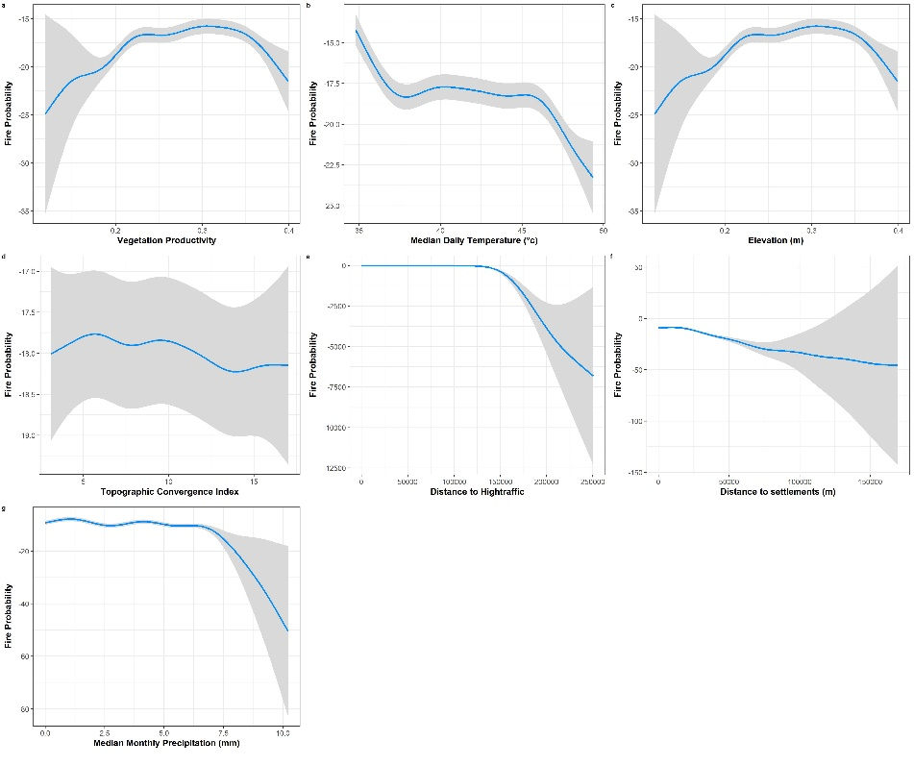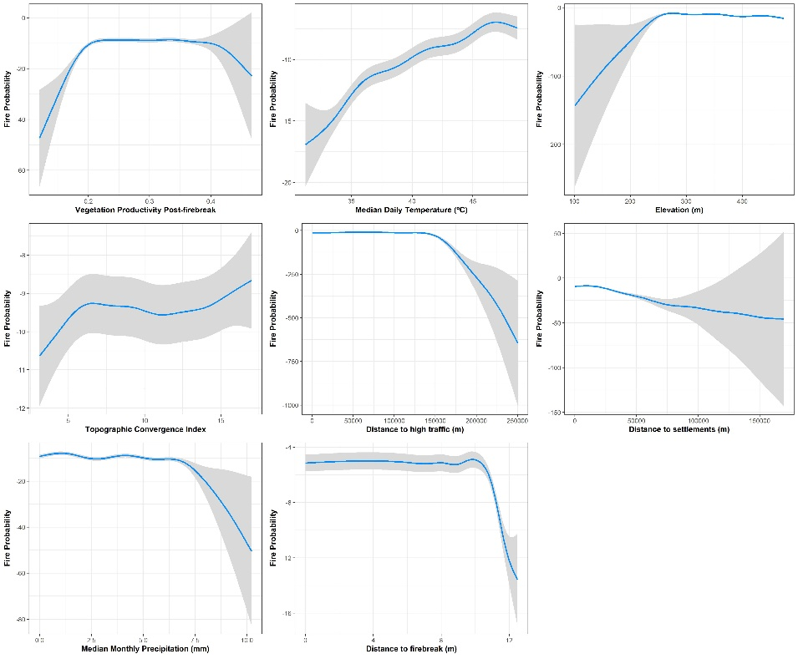
Partial dependence plots from binomial generalized additive models (GAMs) illustrating the conditional smooth-term effects of each predictor on fire occurrence probability for the pre-firebreak (2005–2015, left panels) and post-firebreak (2016–2024, right panels) periods. Predictors common to both periods include vegetation productivity (MSAVI), median daily temperature, elevation, Topographic Convergence Index (TCI), distance to high-traffic areas, distance to settlements, and median monthly precipitation. The post-firebreak model additionally incorporates log-transformed distance to firebreak infrastructure as a management-related predictor. All smooth terms were statistically significant (p < 0.001); deviance explained was 26.3% and 28.6% for the pre- and post-firebreak models, respectively.

- Analytical framework

Wildfire trend analysis
The Mann-Kendall non-parametric trend test was used to analyze the trend of wildfires metrics over the 20 years (Naawa et al. 2025; da Silva Araújo et al. 2023; Gocic and Trajkovic 2013). The test was used for increasing monotonic upward or downward trends in annual time series of active fire density (fire_count) and burned area for each grid cell of the OROAFR by land cover units (Dwomoh and Wimberly 2017). Based on Kendall’s t-rank correlation statistic, it was also used to show the degree of significance of the trend and to determine the direction of the trend in the time series (Naawa et al. 2025).
The amplitude of the trend was calculated using the Sen’s slope estimator (Gocic and Trajkovic 2013). It is also a non-parametric method used to estimate the statistical significance of the slope of the time series data through the Z-statistic values (Kouassi et al. 2022). It is expressed as the change in the response variable per unit change in time. The unit of Sen’s slope depends on the unit of the response variable and the time unit used. For example, if the response variable is rainfall and the time unit is month, then the unit of Sen’s slope would be mm/month (Naawa et al. 2025).
Both Mann-Kandall's and Sen's slope statistical estimators were determined using the package trend in R (R Core Team 2025). The Mann-Kendall test was performed using the function mk.test() and the Sen’s slope estimator using the sens.slope() function on the aggregated monthly median values of pixel wise burn area (period 2005 - 2022) and active fires or fire count (period 2005 - 2024) detected within the entire reserve’s limits.

Spatial fire hotspots distribution analysis
The Getis-Ord Gi statistic* was used to determine statistically significant spatial hotspots and coldspots of wildfire activity (Naawa et al. 2025). It includes a Global G.test and a local Gi test (Gajović and Todorović 2013). The Global G.test computes a global test for spatial autocorrelation using a Monte Carlo simulation approach (simulated spatial datasets that have the same spatial structure as the original data but are randomly permuted). It tests the null hypothesis of no spatial autocorrelation against the alternative hypothesis of positive spatial autocorrelation. Binary weighting is used to assess the overall spatial distribution using the function nb2listw( ) (Gajović and Todorović 2013). Binary weighting assigns a weight of 1 to all neighboring features (ignoring relative size or extent) and a weight of 0 to all other features. The Hot Spot analysis using Getis-Ord Gi* statistics has been performed on MODIS active fire data, with fire radiative power (FRP) as weight attribute (Supp. Material 3, Section F). The active fire raster containing pixel-wised fire count value from 2005 – 2024 was converted to a vector feature to allow the calculation of neighbors for each polygon within the global dataset. This analysis tells if features with either high or low values are clustered spatially (Naawa et al. 2025). A positive Gi value indicates that a feature and its neighbors share a boundary, while a negative Gi value indicates that they have no common boundary. The magnitude of the Gi value indicates the strength of the clustering.
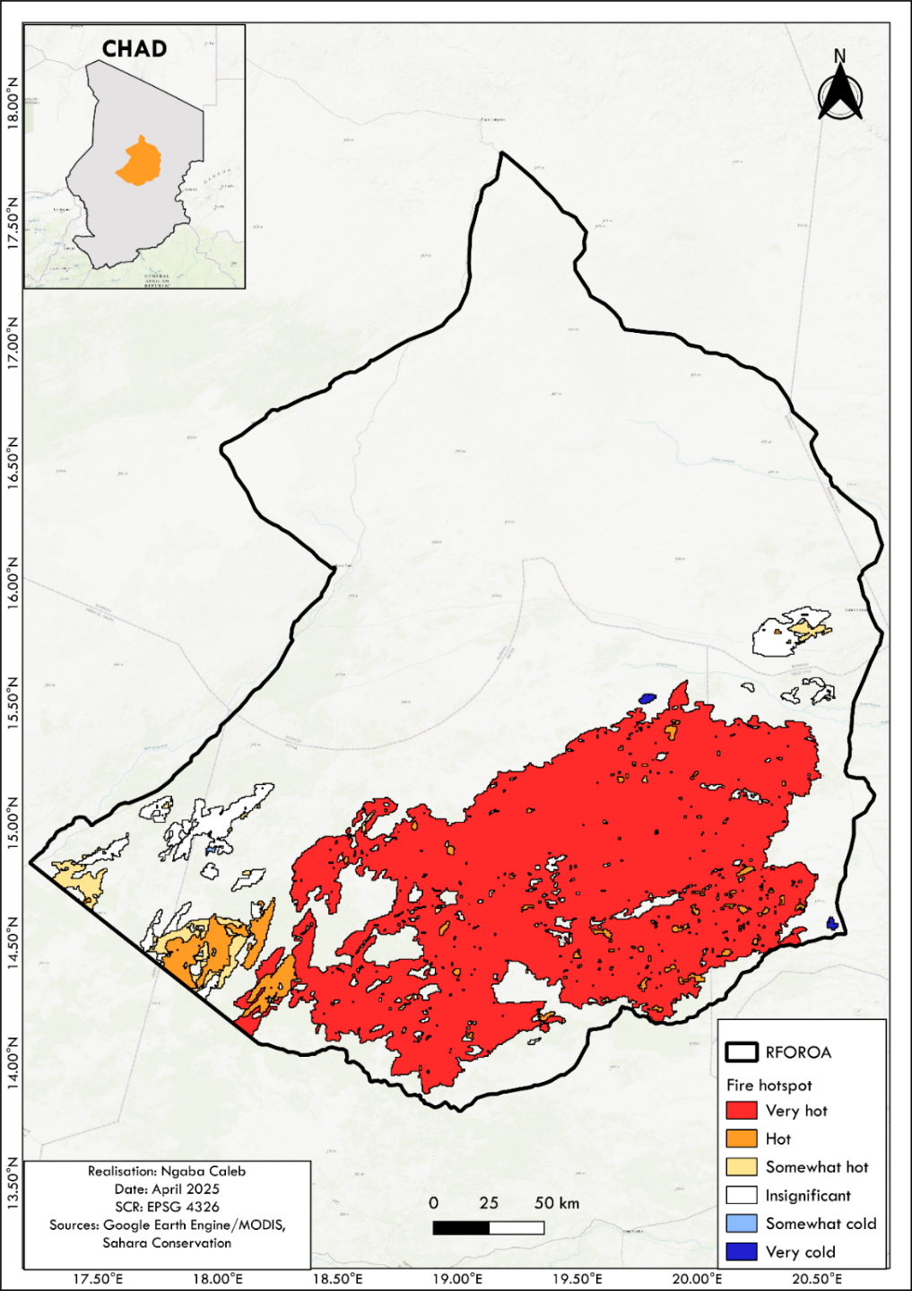
Figure S2. Fire hotspot classification for the 2005 – 2022 time series in OROAFR
Wildfire Spatiotemporal Hot & Cold spots
The results of Getis-ord GI*statistic (used to analyze the spatiotemporal hotspots distribution) revealed the existence of several clustered wildfire hotspots (Fig. S2). The wildfire hotspots were spatially occurring from the south-west to the southeast of the reserve, zone with an extended patch observed in the middle south. The high concentrations of wildfire hotspots include Batha administrative province and the west part of Wadi-Fira administrative province. Some isolated fire hotspots were observed in the northeast side of the Barh-El-Ghazel administrative province and southeast of Borkou administrative province (Fig. S2). Contrarily, wildfire cold spots were predominantly observed in Upper Northwest side of Batha, in Northeast of Barh-El-Ghazel, upper Northwest of the Wadi-Fira part within the reserve and in the lower Southeast side of Borkou between the wadis Kharma and Hawach area (middle Northeast of the OROAFR).

Spatial probabilistic modeling
We further examined the influence of human activities, environmental conditions (precipitation, vegetation productivity, temperature), and topography (elevation and topographic convergence index) on ignition, spread, and intensity before and after firebreak implementation. A before–after design was used to compare fire dynamics across periods.
All analyses were conducted in R (R Core Team 2025). The spatial data were processed using the terra package (Hijmans et al. 2023), a standard tool for large-scale ecological raster analyses and wildfire modeling (Parisien et al. 2019; Syphard et al. 2017). Vector operations were performed with sf (Pebesma et al. 2018), enabling geometrically robust spatial overlays. Masking operations (mask()) limit the analyses to the ecological boundaries of the study area.
Wildfire probability was modelled using a binomial GAM implemented with mgcv (Wood 2017). Ignition probability for pixel i was modeled as:
$logit(p_{i})=β_{0 }+s(x_{i} , y_{i}) + s(logD_{firebreak,i})+s(D_{settlement,i})+s(D_{traffic,i})+s(MSAVI_{lag,i})+ti(T_{i},R_{i})+s(TCI_{i}{)+s(Elevation_{i})}_{}$ (1)
Where s (⋅) denotes thin-plate regression splines and ti (⋅) represents tensor-product interactions capturing coupled climate effects, (x, y) pixel i coordinates.
Thin-plate regression splines were used to minimize boundary artifacts while allowing flexible curvature (Benini and Ponza 2010; Wood 2003). Tensor-product smooths capture nonlinear climate coupling (temperature and rain). We used it as a critical feature given that biomass accumulation and flammability often arise from rainfall–temperature interactions rather than independent effects (Khanal et al. 2025; Koslik 2025; Lenzen and McBain 2012). Smoothing penalties were estimated via restricted maximum likelihood (fREML), which provides stable inference and guards against overfitting (Koslik 2024; Boer 2024, 2023). Model adequacy was evaluated through gradient convergence, Hessian positivity, basis-dimension diagnostics, deviance explained, and adjusted R².
Environmental predictors
Predictor stacks included annual fire counts, vegetation productivity represented using the MSAVI, rainfall, monthly median temperature, elevation derived from SRTM, topographic convergence index (TCI), and distances to settlements, high-traffic corridors, and firebreak network (fbn). Distances were derived using Euclidean metrics:
$D_{fi} = \sqrt{({x_{i}}_{}- x_{f})^{2}+ (y_{i} - y_{f})^{2}}$ (2)
Where 𝐷_{f𝑖} represents the distance from pixel 𝑖 to the nearest feature 𝑓.

Lagged MSAVI (shift() from data.table) was used to incorporate ecological memory effects, reflecting the influence of prior-year fuel accumulation on ignition probability — an approach increasingly relevant in fire occurrence modelling (Abatzoglou et al. 2019). Rainfall and median temperature rasters were incorporated as continuous climatic predictors within the modeling framework. Their joint influence was modeled using tensor-product smooth interactions (ti()) within generalized additive models implemented in the mgcv package in R. This method allows flexible estimation of nonlinear response surfaces describing how combinations of rainfall and temperature influence wildfire dynamics without imposing rigid parametric assumptions (Wood 2017; Hastie and Tibshirani 1990a). That semiparametric approaches was used to capture nonlinear environmental controls on disturbance processes, including wildfire regimes (Parisien et al. 2019; Syphard et al. 2017).

Anthropogenic metrics derived
Anthropogenic pressure was captured through distance to settlements and high-traffic corridors (concentrated in central and southern parts of the OROAFR) computed using distance() in terra, consistent with established evidence that human accessibility strongly predicts ignition locations (Balch et al. 2017). Firebreak influence was represented as distance to the firebreak network (fbn) and subsequently log-transformed (Syphard et al. 2017).
$log_firebreak = log(1+ D_{firebreak })$ (3)
Logarithmic transformations were done for modelling distance-decay ecological processes because fire suppression effectiveness typically declines nonlinearly with distance (Bates et al. 2015). This transformation stabilizes variance and approximates diminishing marginal protection with increasing distance (Hastie and Tibshirani 1990b; Syphard et al. 2017).

Rare-event treatment
Predictors and response (fire_count) variables annual raster stacks (2005–2024) were converted to a long-format panel dataset using as.data.frame() and concatenated with rbindlist() from data.table (Dowle and Srinivasan 2021). Fire occurrence was converted into a binary response variable (fire presence/absence, 1/0) following standard ignition modelling approaches (Preisler et al. 2004). A stratified sampling approach was carried out, to retain all fire pixels while subsampling non-fire observations at a 1:6 ratio. That approach aims to capture wildfire ignitions that are supposed to represent rare events in function of the study area extent. We corrected the rare-event imbalance to avoid any bias logistic estimators (King and Zeng 2001). Predicted probabilities were subsequently corrected using an offset:
$δ= log(\frac{π}{1 - π})- log(\frac{\hat{π}}{1 - \hat{π}})$ (4)
Where 𝜋 is the true fire occurence and $\hat{π}$ is the sampled prevalence.
Temporal autocorrelation within pixels was also addressed by specifying an AR(1) structure (ρ = 0,25) and defining sequence starts (AR.start) within the bam() function (Lanorte et al. 2013).
Counterfactual firebreak effect estimation
A counterfactual landscape was simulated to isolate the causal contribution of the firebreak network. The operation was done by assigning all pixels an extreme distance value, effectively representing a scenario without firebreak protection. Ignition probabilities were computed under both observed and counterfactual conditions (Morgan and Winship 2014; Pearl 2009). Firebreak effectiveness was quantified as:
$Δp=P_{observed}-P_{no-firebreak}$ (5)
Positive values indicate risk reduction attributable to the firebreak network (see Supp. Material I, Section 5).

Effective Protection Distance
The marginal effect of firebreak proximity was evaluated in the GAM model using first derivatives of the smooth function gratia (Simpson 2024). The effective protection distance was defined as the point at which the derivative approached zero:
$\frac{d}{dD}s(logD_{firebreak})≈0$ (1)
This represents the distance beyond which additional separation from a firebreak yields negligible changes in ignition probability. The effective protection distance corresponds to the range where the marginal effect of firebreak proximity approaches zero, indicating a plateau in ignition response. The distribution of near-zero derivative values reveals that this threshold is not a fixed point but a range, reflecting ecological variability in fire spread limitation.
Operational management footprints
Cumulative fire occurrences (2016–2024) were intersected with an empirically derived protection buffer to delineate the operational management area influenced by the firebreak network (Supp. Material I, Section 2E). The buffer distance corresponds to the effective influence threshold estimated from the fire-size GAM, defined as the distance at which the marginal effect of firebreak proximity on fire spread approached zero. This threshold was applied as a uniform buffer around firebreak segments to represent the spatial extent of their functional containment effect. Pixels located within this distance were classified as effectively managed areas, where fire spread and intensity are likely constrained by firebreak infrastructure. The buffered raster was converted to vector polygons using as.polygons() to facilitate spatial analysis and mapping. Spatial visualization was produced using layered spatial overlay maps generated with the ggplot2 and sf packages, allowing simultaneous representation of fire intensity patterns, protected zones, and anthropogenic influence areas (Restas 2023; Wang et al. 2021).
Spatial cross-validation and model evaluation
Spatial predictive skill was assessed through block cross-validation using blockCV package in R (Valavi et al. 2019). Partitioning data into geographically structured folds that reduces overly optimistic accuracy estimates caused by spatial autocorrelation. Receiver operating characteristic curves were computed with pROC (Robin et al. 2011). Model discrimination was quantified with the area under the ROC curve (AUC) using pROC. Values above 0.7 were considered acceptable, while values exceeding 0.8 indicate strong predictive performance in fire occurrence models.
SUPPLEMENTARY MATERIAL – Section 2
- Post firebreak GAMs Comparison for fire ignition assessment
The GAMs comparison explains wildfire ignition probability in OROAFR after the implementation of the firebreak network (2016–2024). Models include combinations of climatic predictors (temperature and rainfall interaction), fuel productivity (lagged MSAVI), anthropogenic accessibility (log distance to anthropogenic features), and firebreak proximity. Model support was evaluated using Akaike’s Information Criterion (AIC).
Table S4. AIC-based comparison of competing post-firebreak GAM structures for fire occurrence modelling (2016–2024).
Model | Predictors Included in Model | Firebreak Predictor | Anthropogenic Predictor | Deviance Explained | Adj. R² | AIC | ΔAIC | Model Support
gam_post1 | s(MSAVI_lag) + ti(temp, rain) + s(log_dist_anthro) | No | Yes | 47.3% | 0.422 | 130,437.7 | 0.0 | Strongest
gam_post3 | s(MSAVI_lag) + ti(temp, rain) + s(log_dist_firebreak) | Yes | No | 47.3% | 0.422 | 130,440.9 | 3.2 | Moderate
gam_post2 | s(MSAVI_lag) + ti(temp, rain) | No | No | 47.2% | 0.421 | – | – | Not evaluated
gam_post | s(MSAVI_lag) + ti(temp, rain) + s(log_dist_firebreak) + s(log_dist_anthro) | Yes | Yes | 47.2% | 0.422 | 130,638.2 | 200.6 | None
Comparison of four binomial generalized additive models (GAMs) fitted for the post-firebreak period (2016–2024), evaluated by deviance explained, adjusted R², Akaike Information Criterion (AIC), and ΔAIC. All candidate models include lagged vegetation productivity (MSAVI_lag) and a tensor product interaction of temperature and precipitation (ti(temp, rain)) as shared ecological predictors. The best-supported model (gam_post1, ΔAIC = 0.0) retained log-transformed distance to anthropogenic areas as the sole management predictor, while the firebreak-only model (gam_post3) received moderate support (ΔAIC = 3.2). The full model incorporating both management predictors was not supported (ΔAIC = 200.6), suggesting no additive benefit of combining firebreak proximity and anthropogenic distance in explaining post-firebreak fire occurrence.

- GAM Models’ diagnostics
- Fire ignition models (diagnostics and interpretation).
The pre-firebreak ignition model shows relatively low explanatory power (adjusted R² ≈ 0.08; deviance explained ≈ 31.6%), despite all predictors being highly significant, indicating that ignition is influenced by many weak and spatially diffuse drivers. Diagnostic checks (gam.check) suggest generally adequate smoothing, although some terms (e.g., spatial smooth and vegetation) show k-index issues, implying potential underfitting in complex patterns. In contrast, post-firebreak models substantially improve fit (adjusted R² ≈ 0.42; deviance explained ≈ 47%), highlighting stronger structure after intervention, but the firebreak variable itself is not consistently significant and contributes little to model performance based on AIC comparisons.
- Fire spread models (diagnostics and interpretation).
Fire spread models show a marked improvement over ignition models, with consistent explanatory power (adjusted R² ≈ 0.43; deviance explained ≈ 48%), indicating that spread processes are more predictable and driven by environmental gradients. The interaction between temperature and rainfall is highly significant across all models, confirming its dominant control on fire propagation, while anthropogenic variables (traffic, settlements) have weaker or inconsistent effects. Model comparison suggests minimal differences among post-firebreak specifications, although inclusion of firebreak distance improves interpretability rather than predictive performance.
- Fire intensity models (diagnostics and interpretation).
Fire intensity models perform best overall (adjusted R² ≈ 0.48; deviance explained ≈ 48.4%), indicating strong explanatory capacity for fire severity dynamics. The BACI framework reveals a significant negative post-firebreak effect (p < 0.01), demonstrating that firebreaks are associated with reduced fire intensity, supported by lower mean fire size and intensity in the post period. Smooth terms for firebreak distance, vegetation, and climate interactions are all significant, confirming that intensity is driven by both management interventions and biophysical conditions.
Figure S3. Fire intensity before and after intervention. Mean standardized Fire Intensity Index (± 95% CI; circles) and median (triangles) for pre- and post-intervention periods. The intervention significantly reduced fire intensity (Δ = −0.321, p = 0.000557). The dashed line indicates the long-term mean. Values above and below zero represent above- and below-average fire intensity, respectively.

Table S5. Model comparison table (diagnostics, metrics, tests, and goals)
Model Goal | Model Type | Adj. R² | Deviance Explained | Key Significant Predictors | Firebreak Effect | Diagnostics (gam.check) | Model Selection (AIC)
Ignition | Pre-firebreak (full) | 0.08 | 31.6% | All predictors (climate, vegetation, spatial) | Not included | Minor k issues (spatial, vegetation) | Baseline
 | Post-firebreak (full) | 0.42 | 47.2% | Climate interaction, vegetation, spatial | Weak / non-significant | Good overall fit | Poor (ΔAIC ≈ 200)
 | Post (no firebreak) | 0.42 | 47.3% | Same as above | Not included | Stable | Best (AIC weight ≈ 0.83)
 | Post (reduced predictors) | 0.42 | 47.2% | Climate + vegetation | Weak | Slight k issues | Low support
 | Post (firebreak only) | 0.42 | 47.3% | Climate + vegetation | Weak | Acceptable | Moderate (AIC weight ≈ 0.17)
Spread | Pre-firebreak | 0.08 | 33.9% | Climate, vegetation, spatial | Not included | Not assessed | Baseline
 | Post-firebreak (full) | 0.43 | 48.2% | Temp–rain interaction, vegetation | Significant | Stable | Comparable across models
 | Post (no firebreak) | 0.43 | 48.1% | Same drivers | Not included | Stable | Similar performance
 | Reduced models | 0.43 | ~48% | Climate + vegetation dominate | Minor contribution | Stable | Minimal differences
Intensity | BACI GAM | 0.48 | 48.4% | Firebreak, vegetation, climate interaction | Significant reduction | Good fit | Not compared via AIC
 | Summary stats (pre/post) | — | — | — | Lower size & intensity post | — | —

SUPPLEMENTARY MATERIAL - Section 3
- Effective firebreak management footprint visualization
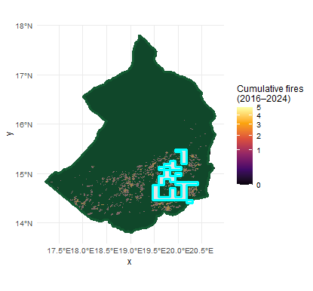
Figure S4. Effective firebreak management footprint in white, blue (Empirical protection distance: 1,723 m).

- Evaluation of climate–fuel coupling between antecedent vegetation productivity and annual fire activity
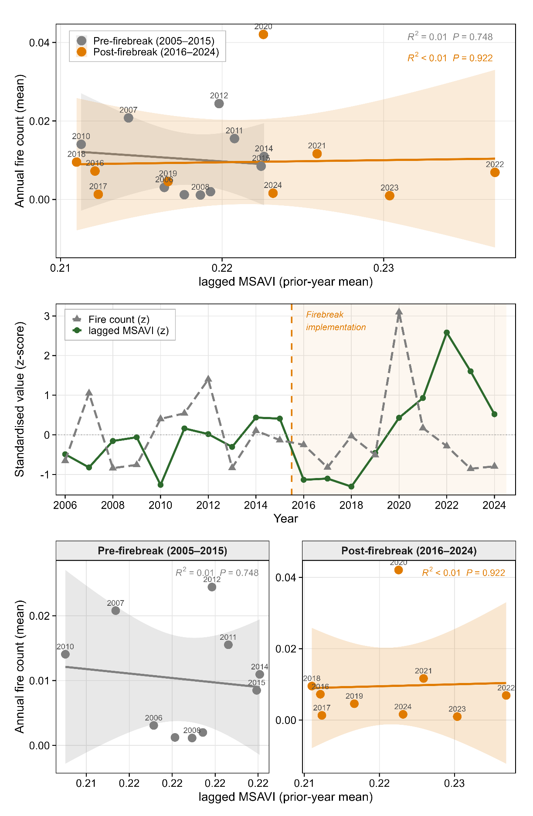
Figure S5. Multi-panel evaluation of climate–fuel coupling between antecedent vegetation productivity and annual fire activity in the OROAFR, Chad, during the pre-firebreak (2005–2015) and post-firebreak (2016–2024) periods.
Antecedent vegetation productivity was represented by the lagged MSAVI, calculated as the reserve-wide annual mean from the previous year to represent fuel conditions available during the subsequent fire season. Fire activity was expressed as the annual mean fire count across the reserve, derived from monthly burned-area products aggregated to annual values.
(A) Scatterplot illustrating the relationship between lagged MSAVI and annual fire activity across the full study period. Individual points represent years (labels indicate observation year), grouped into pre-firebreak (grey) and post-firebreak (orange) periods. Solid lines show period-specific linear regressions and shaded bands represent 95% confidence intervals. Regression statistics indicate weak and non-significant associations in both periods (pre-firebreak: R² = 0.01, P = 0.748; post-firebreak: R² < 0.01, P = 0.922), suggesting that antecedent vegetation productivity alone did not explain interannual variation in reserve-wide fire activity.
(B) Standardised temporal trajectories (z-scores) of lagged MSAVI (green solid line) and annual fire count (grey dashed line), showing interannual co-variation and temporal shifts before and after firebreak implementation in 2016 (vertical dashed line; shaded background indicates the post-firebreak period). This panel highlights periods of decoupling between vegetation productivity and fire occurrence, including elevated antecedent productivity after 2019 without a proportional increase in annual fire counts.
(C) Period-stratified scatterplots with independent axis scaling to facilitate within-period comparison of vegetation–fire relationships. The faceted view confirms that the slope of the relationship remained weak before and after firebreak establishment despite differences in variability and the occurrence of isolated high-fire years (e.g., 2020). Collectively, these panels support the interpretation that broad-scale fire occurrence in OROAFR is only partially linked to antecedent vegetation conditions and is likely influenced by additional climatic, spatial, and management-related controls.

SUPPLEMENTARY MATERIAL – Section 4
4.1. Counterfactual firebreak effect estimation (scenario details)
The counterfactual analysis was designed to estimate the causal contribution of the firebreak network to wildfire ignition probability while holding other environmental conditions constant. In this framework, an “extreme distance value” refers to assigning all pixels a very large distance from firebreaks (upper bound of the observed distance distribution) so that no location is considered influenced by the network. This effectively represents a landscape without functional firebreak protection. Importantly, all other predictors used in the model (climatic variables, vegetation productivity, and topographic factors) were kept identical to the observed conditions. Consequently, the counterfactual and observed predictions share the same climatic and environmental context, differing only in the firebreak proximity variable. This allows the estimated difference in ignition probability to be interpreted as the marginal contribution of the firebreak network. The procedure follows a model-based counterfactual prediction approach commonly used in ecological impact assessment and causal inference (Morgan and Winship 2014; Pearl 2009). Predictions were generated from the fitted generalized additive model (GAM) by altering the firebreak-distance predictor while keeping all other variables unchanged. This approach is consistent with simulation-based evaluations of landscape management interventions in fire ecology (Finney 2001; Parisien et al. 2019). Firebreak effectiveness was then quantified as the difference between ignition probabilities predicted under observed conditions and those predicted under the counterfactual no-firebreak scenario.
4.2. Fire event reconstruction and spread quantification (spatial aggregation details)
Event reconstruction and spatial aggregation were implemented in R using the packages terra, data.table, and mgcv. Monthly burned-area rasters were converted to binary burn masks with terra::classify(). Contiguous burned patches were then delineated using terra::patches (directions = 8), which applies an 8-neighbour connectivity rule to identify spatially coherent fire events, including diagonally adjacent cells. Each patch was assigned a unique identifier combining year, month, and patch index to ensure temporal uniqueness.
Event-level metrics were derived by linking reconstructed fire patches with pixel-level predictor variables. Raster predictors (e.g., lagged MSAVI, rainfall, temperature, and log-distance to firebreaks) were extracted using terra::extract() and joined to the fire patch dataset using data.table::merge(). Spatial aggregation to the event scale was then performed with grouped summaries in data.table, computing within-patch means of environmental predictors and total burned area (.N pixels). Fire size was converted to hectares using the raster cell resolution (terra::res()), producing an event-level dataset used to model fire spread with mgcv::gam().
Burned-area monthly rasters (MODIS)
Binary burn mask (terra::classify)
Patch ID assignment (year_month_patch)
Patch detection (8 – neighbor, terra::patches)
Fire spread modeling (mgcv::gam)
Event-level aggregation (mean predictors, fire_size)
(data.table
Pixel predictors join (data.table::merge / terra::extract)

Figure 10. Fire event reconstruction and spread quantification pipeline

SUPPLEMENTARY MATERIAL - Section 5: FIELD BASED EVIDENCES.
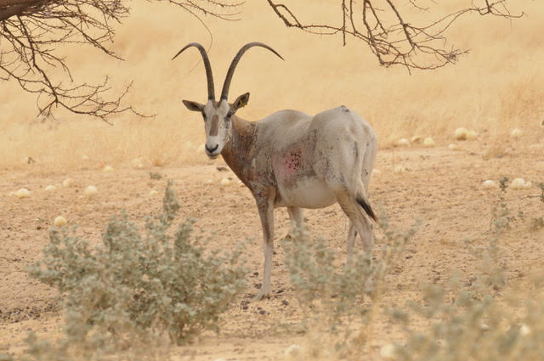
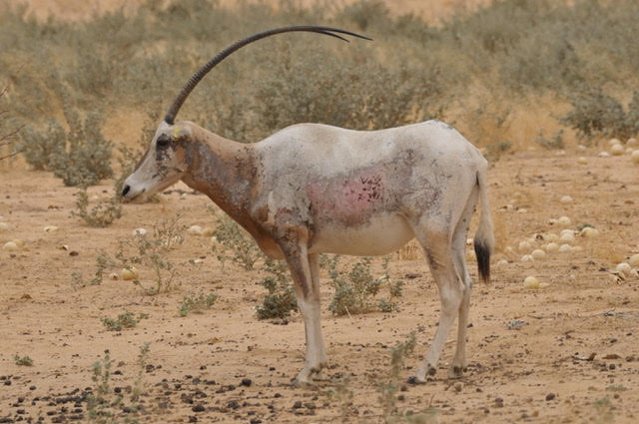
Plate S5.1. An adult female scimitar-horned oryx highly injured after an episode of fire in the western part of the OROAFR (May 28, 2019). Photos by Krazidi Abeye. © Sahara Conservation, 2019.
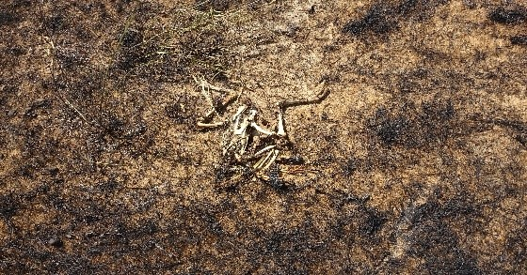
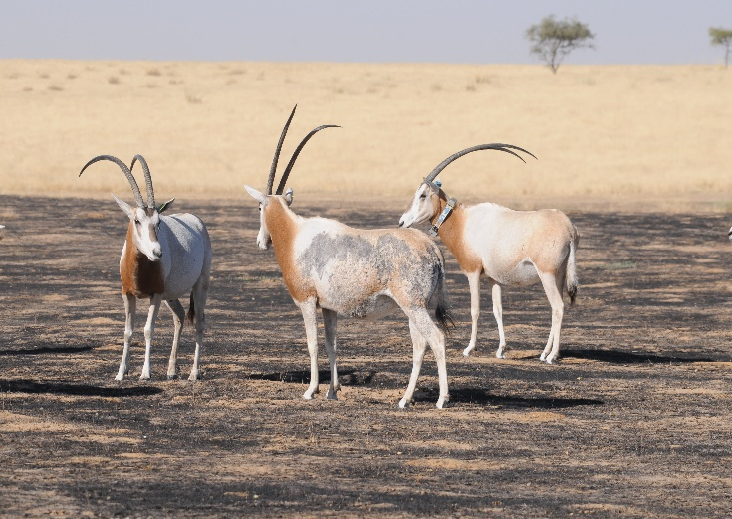
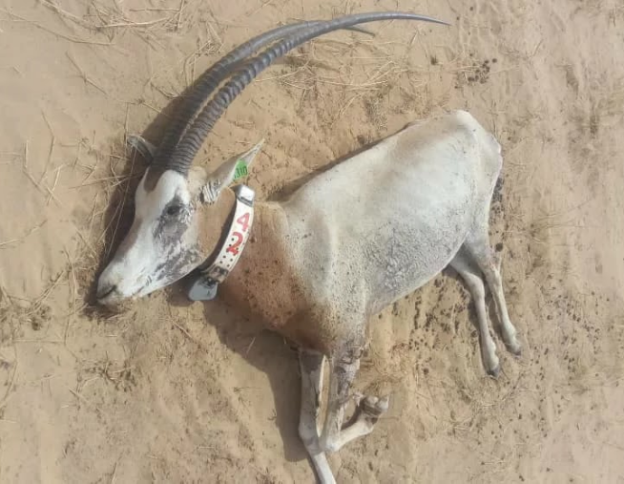
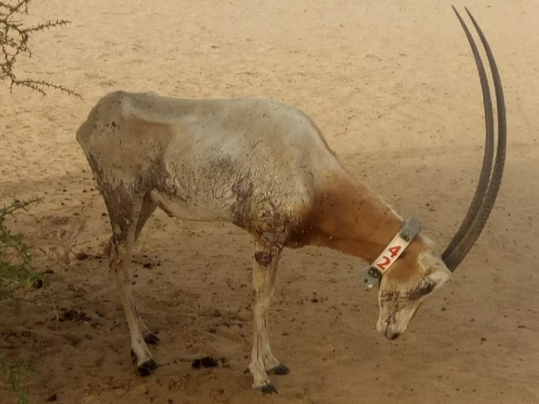
A

B

C

D

Plate S5.2. A. Herd of wild scimitar-horned oryx exposed to fire (eastern OROAFR), with the juvenile male at the front injured after an episode of fire (September 19, 2020). B. Bones of an adult Arabian bustard (Ardeotis arabs) burned after a large fire in the north-western part of the OROAFR (September 19, 2020). C. Female burned following a fire on April 24, 2019, south of the OROAFR (profile photo taken on May 28, 2019). D. Female burned, found dead on June 7, 2019, approximately 40 days after the fire. Photos by Ngaba Waye Taroum Caleb (A&B) and Krazidi Abeye (C&D). © Sahara Conservation, 2019, 2020 & 2021.

  - OROAFR wooded grassland composition overview
The wooded grasslands, the wadis as well as the groves, are composed of Balanites aegyptiaca (Dany et al. 2025), Vachellia tortilis, Capparis decidua, Boscia senegalensis, Maerua crassifolia and Zizyphus spp. The shrub layer is composed of Chrozophora brocchiana, Caccia italica (widespread in the depression areas around the wadis), Leptadenia pyrotechnica, (Wacher et al. 2011; Newby 1978; Gillet 1965). The lower vegetation is composed of annual herbaceous plants within which the most widespread are Aristida mutabilis, Aristida funiculata, Dactyloctenium aegyptium, Schoenefeldia gracilis, Cenchrus biflorus, Brachiaria spp., Tribulus spp., Stipagrostis spp., Cornulaca monacantha, etc (Lox, 2020). Some of the represented perennial herbaceous (Panicum turgidum, Indigofera colutea and Citrullus colocynthis) are historically known to have a significant contribution to water intake principally for the oryx and addax (Lox, 2020).

References
Abatzoglou, John T., and Crystal A. Kolden. 2013. “Relationships between Climate and Macroscale Area Burned in the Western United States.” International Journal of Wildland Fire 22 (7): 1003–20. https://doi.org/10.1071/WF13019.
Abatzoglou, John T., A. Park Williams, and Renaud Barbero. 2019. “Global Emergence of Anthropogenic Climate Change in Fire Weather Indices.” Geophysical Research Letters 46 (1): 326–36. https://doi.org/10.1029/2018GL080959.
Balch, Jennifer K., Bethany A. Bradley, John T. Abatzoglou, R. Chelsea Nagy, Emily J. Fusco, and Adam L. Mahood. 2017. “Human-Started Wildfires Expand the Fire Niche across the United States.” Proceedings of the National Academy of Sciences 114 (11): 2946–51. https://doi.org/10.1073/pnas.1617394114.
Bates, Douglas, Martin Mächler, Ben Bolker, and Steve Walker. 2015. “Fitting Linear Mixed-Effects Models Using Lme4.” Journal of Statistical Software 67 (October): 1–48. https://doi.org/10.18637/jss.v067.i01.
Benini, Ernesto, and Rita Ponza. 2010. “Nonparametric Fitting of Aerodynamic Data Using Smoothing Thin-Plate Splines.” AIAA Journal 48 (7): 1403–19. https://doi.org/10.2514/1.J050028.
Boer, Martin P. 2023. “Tensor Product P-Splines Using a Sparse Mixed Model Formulation.” Statistical Modelling 23 (5–6): 465–79. https://doi.org/10.1177/1471082X231178591.
Boer, Martin P. 2024. “REML for Two-Dimensional P-Splines.” In Developments in Statistical Modelling, edited by Jochen Einbeck, Hyeyoung Maeng, Emmanuel Ogundimu, and Konstantinos Perrakis. Springer Nature Switzerland. https://doi.org/10.1007/978-3-031-65723-8_1.
Dany, Oumar, Balamon Reine, Elisée Mbayngone, et al. 2025. “Floristic Characteristics, Diversity and Population Structure of Balanites Aegyptiaca (L.) Del (Zygophyllaceae) in the Ouadi Rimé-Ouadi Achim Wildlife Reserve in Chad.” International Journal of Plant & Soil Science 37 (October): 217–27. https://doi.org/10.9734/ijpss/2025/v37i105777.
Doornik, Jurgen A., and Henrik Hansen. 2008. “An Omnibus Test for Univariate and Multivariate Normality.” Oxford Bulletin of Economics and Statistics 70 (s1): 927–39. https://doi.org/10.1111/j.1468-0084.2008.00537.x.
Dormann, Carsten F., Jane Elith, Sven Bacher, et al. 2013. “Collinearity: A Review of Methods to Deal with It and a Simulation Study Evaluating Their Performance.” Ecography 36 (1): 27–46. https://doi.org/10.1111/j.1600-0587.2012.07348.x.
Dowle, M., and A. Srinivasan. 2021. “Data. Table: Extension of ‘Data. Frame’. R Package Version 1.14. 2. 2021.”
Dwomoh, Francis K., and Michael C. Wimberly. 2017. “Fire Regimes and Their Drivers in the Upper Guinean Region of West Africa.” Remote Sensing 9 (11): 1117. https://doi.org/10.3390/rs9111117.
Finney, Mark A. 2001. “Design of Regular Landscape Fuel Treatment Patterns for Modifying Fire Growth and Behavior.” Forest Science 47 (2): 219–28. https://doi.org/10.1093/forestscience/47.2.219.
Gajović, Vojkan, and Bojana Todorović. 2013. “Spatial and Temporal Analysis of Fires in Serbia for Period 2000-2013.” Journal of the Geographical Institute" Jovan Cvijic", SASA 63 (3 Conference Issue): 297–312.
Gillet, Hubert. 1965. “L’Oryx Algazelle et l’Addax Au Tchad.” Revue d’écologie, no. 3: 257–72.
Gocic, Milan, and Slavisa Trajkovic. 2013. “Analysis of Changes in Meteorological Variables Using Mann-Kendall and Sen’s Slope Estimator Statistical Tests in Serbia.” Global and Planetary Change 100 (January): 172–82. https://doi.org/10.1016/j.gloplacha.2012.10.014.
Hastie, Trevor, and Robert Tibshirani. 1990a. “Exploring the Nature of Covariate Effects in the Proportional Hazards Model.” Biometrics 46 (4): 1005–16. https://doi.org/10.2307/2532444.
Hastie, Trevor, and Robert Tibshirani. 1990b. “Exploring the Nature of Covariate Effects in the Proportional Hazards Model.” Biometrics 46 (4): 1005–16. https://doi.org/10.2307/2532444.
Henze, N., and B. Zirkler. 1990. “A Class of Invariant Consistent Tests for Multivariate Normality.” Communications in Statistics - Theory and Methods 19 (10): 3595–617. https://doi.org/10.1080/03610929008830400.
Hijmans, Robert J., R. Bivand, K. Dyba, E. Pebesma, and M. Sumner. 2023. “Terra [R Package].” R Programming Language. https://rspatial.org/pkg/terraPackage.pdf.
Khanal, Shiva, Rachael H. Nolan, Belinda E. Medlyn, and Matthias M. Boer. 2025. “Topoclimatic Factors Create Favourable Conditions for Carbon-Dense Forests in the Central Himalayas.” Scientific Reports 15 (1): 35134. https://doi.org/10.1038/s41598-025-19127-y.
King, Gary, and Langche Zeng. 2001. “Logistic Regression in Rare Events Data.” Political Analysis 9 (2): 137–63. https://doi.org/10.1093/oxfordjournals.pan.a004868.
Koslik, Jan-Ole. 2024. “Efficient Smoothness Selection for Nonparametric Markov-Switching Models via Quasi Restricted Maximum Likelihood.” arXiv:2411.11498. Preprint, arXiv, November 18. https://doi.org/10.48550/arXiv.2411.11498.
Koslik, Jan-Ole. 2025. “Tensor-Product Interactions in Markov-Switching Models.” arXiv:2507.01555. Preprint, arXiv, August 25. https://doi.org/10.48550/arXiv.2507.01555.
Kouassi, Jean-Luc, Narcisse Wandan, and Cheikh Mbow. 2022. “Exploring Spatio-Temporal Trends and Environmental Drivers of Wildfire Occurrence and Impacts in Côte d’Ivoire, West Africa.” African Journal of Ecology 60 (4): 1218–36. https://doi.org/10.1111/aje.13066.
Lanorte, A., M. Danese, R. Lasaponara, and B. Murgante. 2013. “Multiscale Mapping of Burn Area and Severity Using Multisensor Satellite Data and Spatial Autocorrelation Analysis.” International Journal of Applied Earth Observation and Geoinformation, Earth Observation and Geoinformation for Environmental Monitoring, vol. 20 (February): 42–51. https://doi.org/10.1016/j.jag.2011.09.005.
Lenzen, Manfred, and Bonnie McBain. 2012. “Using Tensor Calculus for Scenario Modelling.” Environmental Modelling & Software 37 (November): 41–54. https://doi.org/10.1016/j.envsoft.2012.02.020.
Lox, Sophie. 2020. INFLUENCE DES REGIMES DE FEUX SUR LES PATURAGES DE L’ORYX ALGAZELLE A L’AIDE DE LA TELEDETECTION : CAS DE LA RESERVE DE FAUNE DE OUADI RIME – OUADI ACHIM (TCHAD).
Mardia, Kanti V. 1970. “Measures of Multivariate Skewness and Kurtosis with Applications.” Biometrika 57 (3): 519–30.
Morgan, Stephen L., and Christopher Winship. 2014. Counterfactuals and Causal Inference: Methods and Principles for Social Research. Cambridge University Press.
Naawa, Aline Mwintome, Fousseni Folega, Amos Kobo-bah, Yvonne Walz, Kperkouma Wala, and Amos Amponsah. 2025. “Spatio-Temporal Dynamics, Drivers of Wildfire Occurrence and Distribution in the Northern Savannah Ecological Zone of Ghana.” Scientific African 27 (March): e02580. https://doi.org/10.1016/j.sciaf.2025.e02580.
Newby, J. E. 1978. “Scimitar-Horned Oryx–the End of the Line?” Oryx 14 (3): 219–21. https://doi.org/10.1017/S0030605300015520.
Parisien, Marc-André, Denyse A. Dawe, Carol Miller, Christopher A. Stockdale, and O. Bradley Armitage. 2019. “Applications of Simulation-Based Burn Probability Modelling: A Review.” International Journal of Wildland Fire 28 (12): 913–26. https://doi.org/10.1071/WF19069.
Pearl, Judea. 2009. “Causal Inference in Statistics: An Overview.” Statistics Surveys 3 (none): 96–146. https://doi.org/10.1214/09-SS057.
Pebesma, Edzer, Roger Bivand, Etienne Racine, et al. 2018. “Sf: Simple Features for R.” R Package Version 0.6 1.
Preisler, Haiganoush K., David R. Brillinger, Robert E. Burgan, and J. W. Benoit. 2004. “Probability Based Models for Estimation of Wildfire Risk*.” International Journal of Wildland Fire 13 (2): 133–42. https://doi.org/10.1071/WF02061.
R Core Team. 2025. “R: A Language and Environment for Statistical Computing. R Foundation for Statistical Computing, Vienna, Austria.” Http://Www. R-Project. Org/. https://cir.nii.ac.jp/crid/1574231874043578752.
Robin, Xavier, Natacha Turck, Alexandre Hainard, et al. 2011. “pROC: An Open-Source Package for R and S+ to Analyze and Compare ROC Curves.” BMC Bioinformatics 12 (1): 77. https://doi.org/10.1186/1471-2105-12-77.
Silva Araújo, Lidiane da, Antonio Samuel Alves da Silva, Rômulo Simões Cezar Menezes, Borko Stosic, and Tatijana Stosic. 2023. “Analysis of Rainfall Seasonality in Pernambuco, Brazil.” Theoretical and Applied Climatology 153 (1): 137–54. https://doi.org/10.1007/s00704-023-04462-9.
Syphard, Alexandra D., Jon E. Keeley, Anne H. Pfaff, and Ken Ferschweiler. 2017. “Human Presence Diminishes the Importance of Climate in Driving Fire Activity across the United States.” Proceedings of the National Academy of Sciences 114 (52): 13750–55. https://doi.org/10.1073/pnas.1713885114.
Valavi, Roozbeh, Jane Elith, José J. Lahoz-Monfort, and Gurutzeta Guillera-Arroita. 2019. “blockCV: An r Package for Generating Spatially or Environmentally Separated Folds for k-Fold Cross-Validation of Species Distribution Models.” Methods in Ecology and Evolution 10 (2): 225–32. https://doi.org/10.1111/2041-210X.13107.
Wacher, T., J. Newby, S. Bourtchiakbe, and F. Banlongar. 2011. “Wildlife Survey of the Ouadi Rimé-Ouadi Achim Game Reserve, Chad (Part I).” SCF/Pan Saharan Wildlife Survey. Technical Report.
Wood, Simon N. 2003. “Thin Plate Regression Splines.” Journal of the Royal Statistical Society Series B: Statistical Methodology 65 (1): 95–114. https://doi.org/10.1111/1467-9868.00374.
Wood, Simon N. 2017. Generalized Additive Models: An Introduction with R, Second Edition. 2nd ed. Chapman and Hall/CRC. https://doi.org/10.1201/9781315370279.
Zuur, Alain F., Elena N. Ieno, Neil J. Walker, Anatoly A. Saveliev, and Graham M. Smith. 2009. “Zero-Truncated and Zero-Inflated Models for Count Data.” In Mixed Effects Models and Extensions in Ecology with R, edited by Alain F. Zuur, Elena N. Ieno, Neil Walker, Anatoly A. Saveliev, and Graham M. Smith. Springer. https://doi.org/10.1007/978-0-387-87458-6_11.

