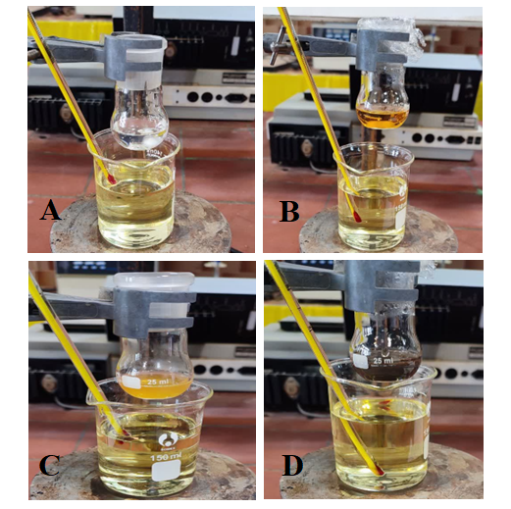

Fig. S1. Control experiments for evaluating the roles of different components in silver nanoparticle synthesis. (a) Dex solution, (b) AgNPs synthesized using Dex, (c) quince peel extract, and (d) green-synthesized AgNPs using quince peel extract (Ag NPs–QPE). The pronounced color change in the presence of the peel extract confirms its role as the main reducing agent, whereas Dex acts primarily as a stabilizing/capping agent, while the slight color change observed in the Dex-containing system indicates limited reduction of Ag⁺ ions under the applied conditions. The experiments were performed under stirring at 45 °C followed by heating at 75–80 °C for 2 h to ensure complete reduction of Ag⁺ ions.

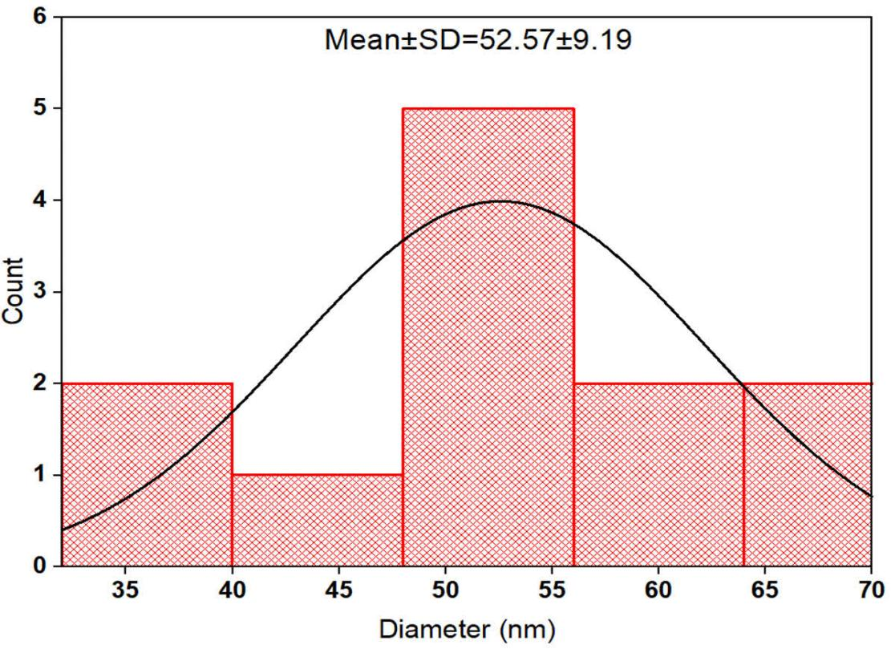
Fig. S2. Histogram of particle diameter (nm) with a fitted normal distribution curve. The mean ± standard deviation is 52.57 ± 9.19 nm.

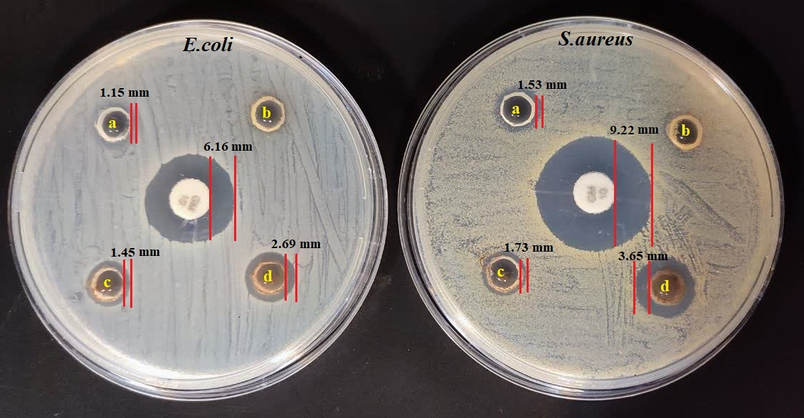
Fig. S3. Antibacterial activity of (a=Dex, b=quince peel extract, c=Ag NPs synthesized using quince peel extract (Ag NPs-QPE) and d=silver–Dex nanocomposite (Ag–Dex NC) against S. aureus and E. coli assessed by the agar diffusion method. The central well contains gentamicin (positive control), which produced the highest inhibition zone in both bacterial strains.

