Supplementary

Experiment 2. Pilot Study.
Participants. One hundred two participants were recruited via Prolific Academic using the same eligibility criteria as Experiments 2A and 2B. The study was preregistered prior to data collection.
Stimuli, apparatus, and procedure. The task was identical to Experiments 2A and 2B, with two exceptions: no response deadline was imposed on individual trials, and no awareness assessment was administered following the critical trial.
Results. Performance on the critical irrelevant object-part did not differ from chance (M = 38%, BF = 0.17), with the Bayesian analysis providing evidence against the hypothesis that unreportable features would guide behavior (Fig. S1). A Spearman correlation between total task completion time and critical trial performance revealed a significant negative relationship (ρ = −0.295, p = 0.003), indicating that slower participants performed worse. Together, these findings suggest that without time pressure, participants engaged in deliberate post-perceptual processing rather than relying on awareness, and that such deliberate processing is ineffective for irrelevant features by definition. This interpretation is consistent with classic evidence that visual information is briefly available in a high-capacity sensory store but rapidly becomes unavailable for report unless sampled soon after stimulus offset (30). These results motivated two modifications in Experiments 2A and 2B: the introduction of a 2-second per-trial response deadline to push participants toward using a perceptual icon rather than their awareness of it, and the addition of an awareness assessment of the critical change.

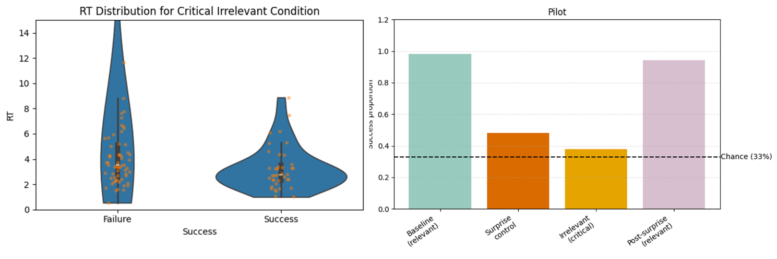
Figure S1. Pilot study results for Experiment 2. Left: Response-time distributions on the critical-irrelevant object-part trial, separated by accuracy. Right: Mean success rates across baseline, surprise-control, critical irrelevant-feature, and post-surprise relevant trials. Performance on the critical irrelevant-feature trial did not differ from chance, whereas slower task completion was associated with poorer critical-trial performance. The dashed line indicates chance performance (33%).

Exploratory Metacognitive Analysis (Experiments 1A and 1B)
In Experiments 1A and 1B, participants reported the basis of their responses at strategically selected intervals using a four-category system: memory, intuition, guess, or other (based on (31 )). For relevant trials, prompts occurred after trials 1, 4, 7, 13, 21, 24, 27, 34, and 38, selected to maintain unpredictability and prevent anticipatory introspection. Participants also reported their reasoning following each of the four surprise trials. These measures were intentionally exploratory and hence were not preregistered.

Results. Across both experiments, intuition and other responses were rare, together comprising approximately 7% of all responses (91/1300 overall; Experiment 1A: 39/741 ≈ 5%; Experiment 1B: 52/559 ≈ 9%). These categories were therefore combined with guess into a single not-memory category for analysis.

Memory reports were strongly associated with accuracy on relevant trials in both experiments (Experiment 1A: OR = 19.07, 95% CI [7.78, 46.74], indicating that the odds of a 'remembered' response being correct on the relevant dimension were 19.07 times higher than the odds of a ‘guess’ response being correct; Experiment 1B: OR = 14.67, 95% CI [6.87, 31.31]) and on subsequent non-surprise trials (Experiment 1A: OR = 9.56, 95% CI [5.11, 17.88]; Experiment 1B: OR = 5.58, 95% CI [2.91, 10.70]). The odds ratios did not differ reliably between relevant and irrelevant non-surprise trials in either experiment (Experiment 1A: Woolf z = 1.24, p = .216; Experiment 1B: Woolf z = 1.90, p = .058); in essence, these are the same type of (relevant) trial.
A notable exception emerged on the first (critical) surprise-irrelevant trial, where memory reports showed no association with accuracy (OR = 0.88, 95% CI [0.31, 2.51]), in sharp contrast to all other trial types (OR = 12.74, 95% CI [8.43, 19.26]). This difference was large and reliable (Woolf z = −4.66, p = 3.16 × 10⁻⁶).

Interpretation. Self-reported metacognitive basis of responding tracked objective accuracy, but only when judgments targeted the task-relevant feature under expected conditions. The collapse of this relationship on the first surprise trial, where an unexpected query targeted a feature participants had no reason to monitor, is consistent with the broader finding that metacognitive access/awareness is relevance-gated. When task expectations are violated, the link between introspective report and actual performance weakens or disappears entirely.
Yet these results should be interpreted cautiously. Performance on relevant trials was near ceiling while performance on irrelevant trials hovered near chance, restricting variance and inflating uncertainty of effect-size estimates. Additionally, the apparent success of memory reports on relevant trials may partly reflect post-hoc performance tracking rather than genuine meta-mnemonic access. Similarly, the low base rate of intuition and other responses, while justifying their combination with guessing, limits the granularity of the non-memory category.

Exploratory response-time analysis. We conducted an exploratory analysis to test whether the inverse relationship between awareness and performance could be explained by response time (RT). The analysis was restricted to the critical irrelevant-probe trial in Experiment 2B. Accuracy on this trial was entered into a logistic regression as the binary outcome variable, with binary awareness report (“aware” vs. “unaware”) and z-scored RT as predictors.
We first fitted an additive model including awareness and RT. We then fitted a second model that added the RT × awareness interaction. The interaction model tested whether RT predicted performance differently for participants who reported awareness of the critical change than for those who did not. This is the pattern expected if poorer performance among aware participants reflected a deliberative strategy shift.
Model comparison was conducted in two ways. First, we assessed the interaction term using conventional logistic-regression inference. Second, we compared the additive and interaction models using a BIC-based approximation to the Bayes factor. In this comparison, the additive model served as the null model and the interaction model served as the alternative model. Bayes factors were computed as (BF_{10} ~ \exp[(BIC_0 - BIC_1)/2]), where (BIC_0) is the BIC of the additive model and (BIC_1) is the BIC of the interaction model. This approximation corresponds to Bayesian model comparison under a unit-information prior. For completeness, we also compared the awareness-only, RT-only, additive, and interaction models against an intercept-only null model.
As in the pilot experiment, RT was still overall negatively associated with performance on the irrelevant object-part probe (coef = −0.50, p = .004), such that slower responses predicted lower success rates. Critically, however, awareness remained predictive of performance even after controlling for RT. Participants reporting no awareness of change on the last trial (unaware) had higher odds of success than participants reporting awareness (aware; coef = 0.46, p = .041) across the RT range (Figure S2), indicating that response time differences alone cannot account for the inverse awareness–performance relationship.
The RT × awareness interaction was not statistically reliable (coef = −0.66, p = .135). Bayesian model comparison (with the null being the additive model) further favored the additive model over the interaction model (BF₀₁ = 6.49), providing moderate evidence against the hypothesis that RT affected performance differently across awareness groups. Thus, although slower responses were associated with poorer performance overall, the data provided moderate evidence that this relationship did not differ across awareness groups. The persistence of the awareness effect after accounting for RT argues against a simple strategy-shift explanation (or a less defined effect of ‘surprise’) in which the superior performance of unaware participants is attributable solely to differences in response timing.
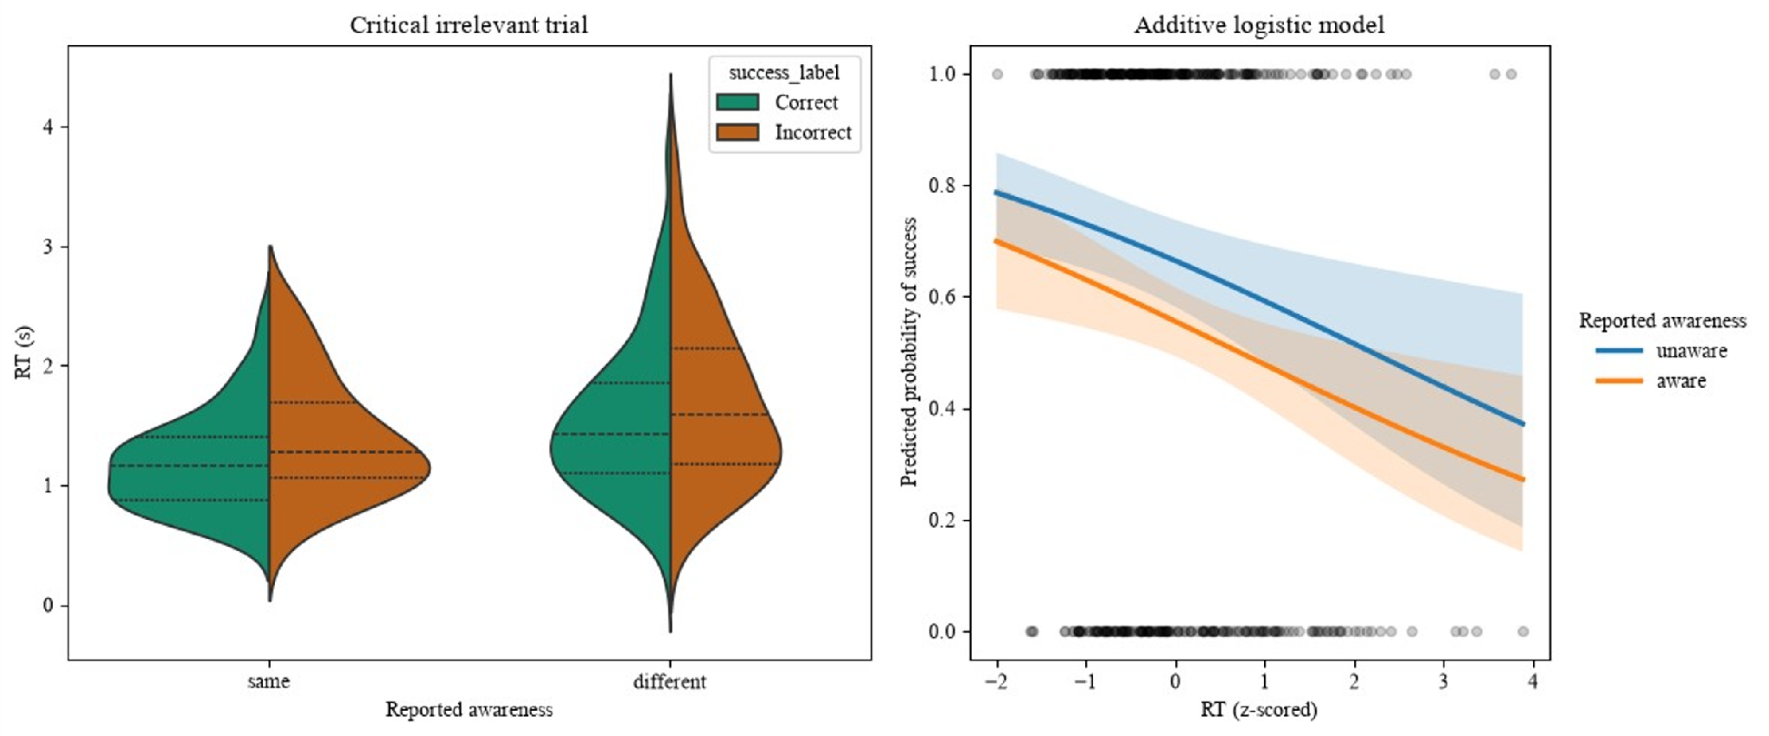
Figure S2. Response time and success on the critical irrelevant-feature trial in Experiment 2B. Left: RT distributions by the response to the binary awareness probe (unaware vs. aware), separated by trial success. Right: Predicted probability of success as a function of RT and awareness (binary). Curves show predictions from an additive logistic regression model including RT and awareness as predictors; shaded areas indicate 95% confidence intervals.

Fig. S3.
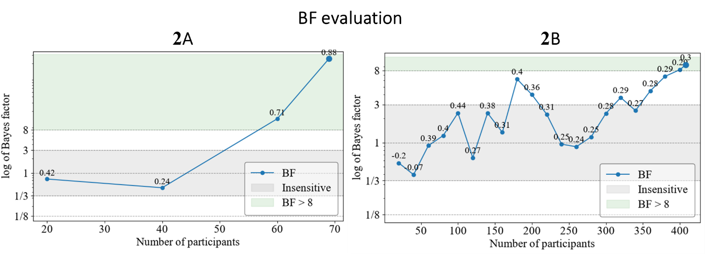
Fig. S3. Sequential Bayes factor evolution for Experiments 2A and 2B.
Bayes factor (BF) plotted sequentially as a function of cumulative sample size for Experiment 2A (left) and Experiment 2B (right). The dashed horizontal line indicates the preregistered stopping criterion (BF = 8). Data collection continued in batches of 20 participants until this threshold was reached (no new batches were needed for 2A). Final samples were N = 69 (BF = 250.78) and N = 408 (BF = 9.49) respectively. Numerical labels at each data point indicate the difference of differences between the binary metacognitive judgment groups: [(Unaware: correct − incorrect) − (Aware: correct − incorrect)], reflecting the evolving gap in performance between participants reporting no awareness of a change and those reporting awareness. Positive values indicate higher performance among participants unaware of the change in the final (critical) probe trial. The awareness-performance gap was positive across both experiments in all but a single data point; in Experiment 2A it increased sharply as the sample grew, while in Experiment 2B it remained stable across a substantially larger sample. Point labels represent the difference of differences [(Unaware: correct − incorrect) − (Aware: correct − incorrect)].

Experiment 2 Method Control
To verify that the changes in methodology between Experiments 1 and 2, apart from the shift from color report to match-to-sample, i.e., a shorter time window for reporting and the addition of a reward for success did not affect the results, we conducted a pre-registered experiment (https://osf.io/32awu/overview) in which we used the exact same parameters as in Experiment 2, but with the explicit color patch report (and no metacognition). Overall, we ran 110 participants on Prolific; 5 failed the attention check, leaving a final N of 105. At the end of the study, we repeated the probe of the irrelevant color four times to judge recovery.
Results paragraph:
Success proportions in the fast-abstract condition of the IIA task differed systematically across probe types (Fig. S4). Performance in the baseline (relevant) condition was near ceiling (97.3%, 4146/4260), with very strong evidence for above-chance performance (BF = inf). Performance in the surprise control condition was also well above chance (62.3%, 66/106; BF = 1.96 × 10^13). In contrast, performance on critical-irrelevant trials did not exceed chance (20.8%, 22/106; BF = 0.167 against the above-chance hypothesis), constituting moderate evidence for chance-level performance rather than merely an absence of evidence for above-chance performance. Performance recovered on post-critical irrelevant trials (75.2%, 239/318), again with very strong evidence for above-chance performance (BF = 1.327 × 10^75). Direct comparisons confirmed that the drop on critical-irrelevant trials was reliable: critical-irrelevant performance was lower than surprise-control performance (BF = 3.969 × 10^7) and lower than post-critical irrelevant performance (BF = 5.553 × 10^20), indicating genuine, recoverable reportability once the feature became relevant once more.repeated the probe of the irrelevant color four times to judge recovery.

Fig. S4.
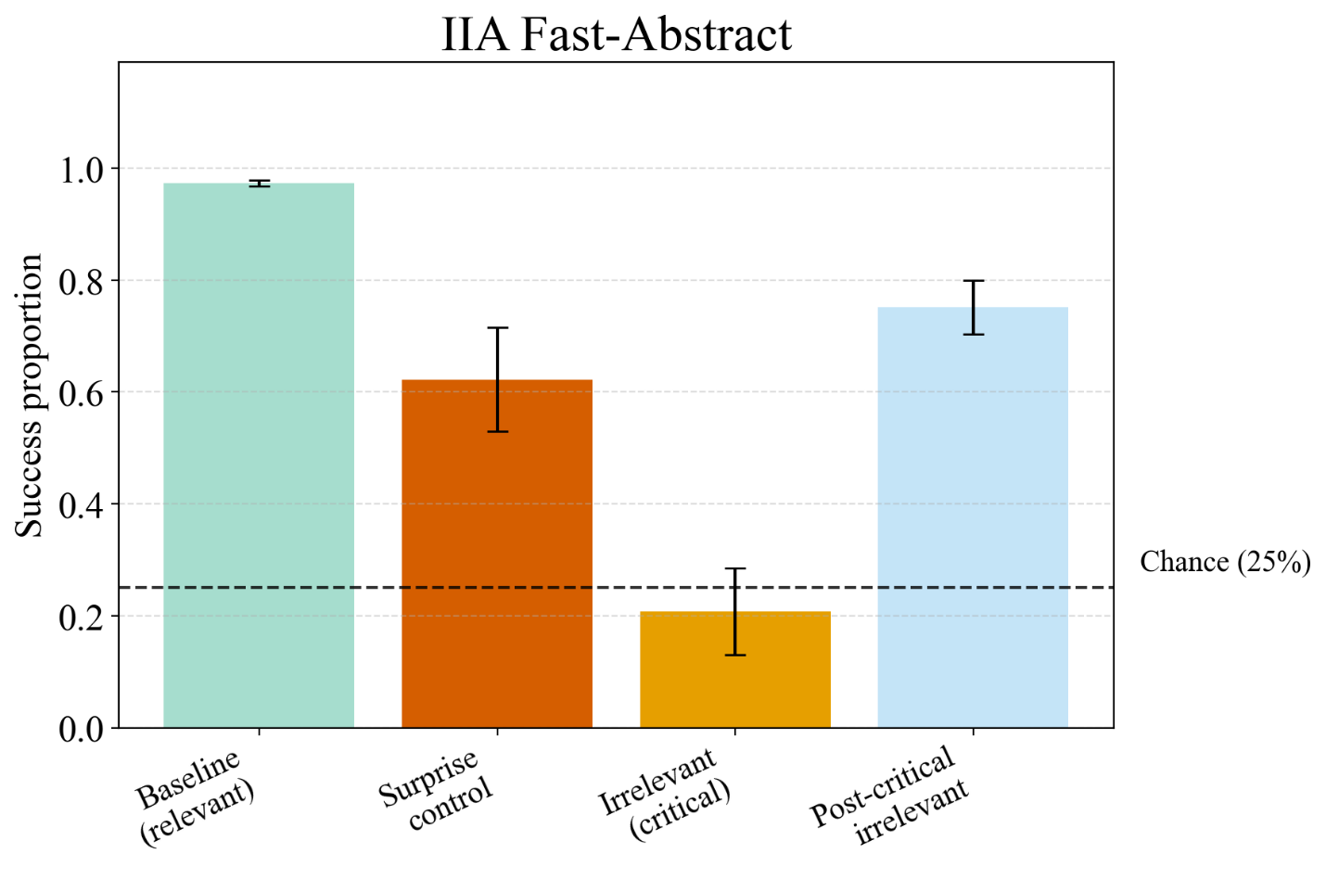
Fig. S4. Success proportion by probe type in the Experiment 2 Method Control. Success proportion by probe type in the Experiment 2 Method Control. Bars show mean success proportion for four probe conditions: baseline (relevant), surprise control, irrelevant (critical), and post-critical irrelevant. Error bars represent 95% CI. The dashed line marks chance performance (25%).
Fig. S5.













Fig. S5, Stimuli used. All flower and pot combinations that were used in experiments 1-2 A&B.

Fig. S7.
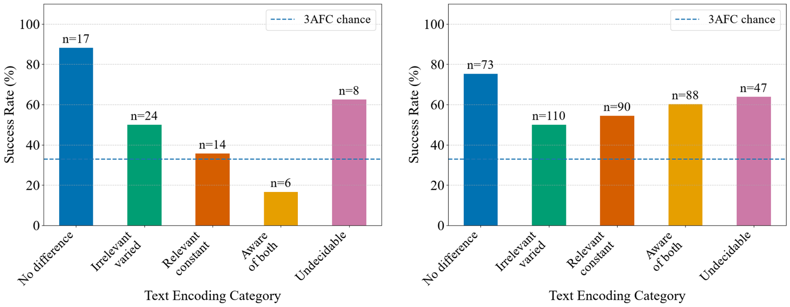
Figure S7. Detailed accuracy on the critical trial as a function of participants' free-text reports. In Experiment 2A (left; N = 69) and Experiment 2B (right; N = 408). Responses were categorized as: No difference (participants reported no change between the critical trial and previous trials), Irrelevant varied (participants reported that the previously irrelevant feature varied), Relevant constant (participants reported that the previously relevant feature was constant), Aware of both (participants reported both changes), and Undecidable (responses that could not be unambiguously classified). Numbers above the bars indicate the number of participants in each category. The dashed line indicates chance performance (33%).
Examples of the undecidable category include quotes from the free-text responses: 1) “it had a little change,” 2) “ ”, 3) “the 3 options,” and 4) “I did not have to click on a number.”

