Synergistic Convergence of Multiple Environmental Drivers Triggered a Multi‑taxa Regime Shift in the Yangtze Estuary

Danyun Ou, Yue Ni, Xiangwen Bao, Ming Chen, Weiwen Li, Lei Wang, Hao Huang*

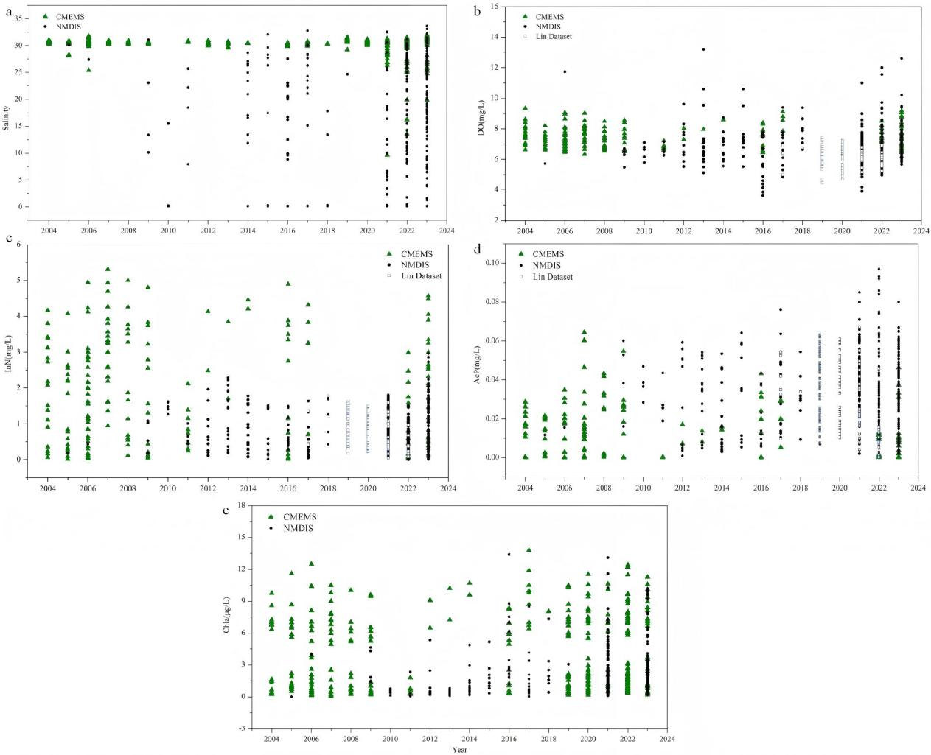
Fig. S1 | Inter-annual consistency of summer environmental variables derived from multiple data sources in the surface water of the Yangtze Estuary from 2004 to 2023.
a Salinity from CMEMS and NMDIS, showing comparable inter-annual patterns. b Dissolved oxygen (DO) concentration from CMEMS, NMDIS, and the Lin dataset, showing comparable inter-annual patterns. c Dissolved inorganic nitrogen (DIN) concentration from CMEMS, NMDIS, and the Lin dataset, showing comparable inter-annual patterns. d Phosphate concentration from CMEMS, NMDIS, and the Lin dataset, showing comparable inter-annual patterns. e Chlorophyll a (Chl a) from CMEMS and NMDIS, showing comparable inter-annual patterns.

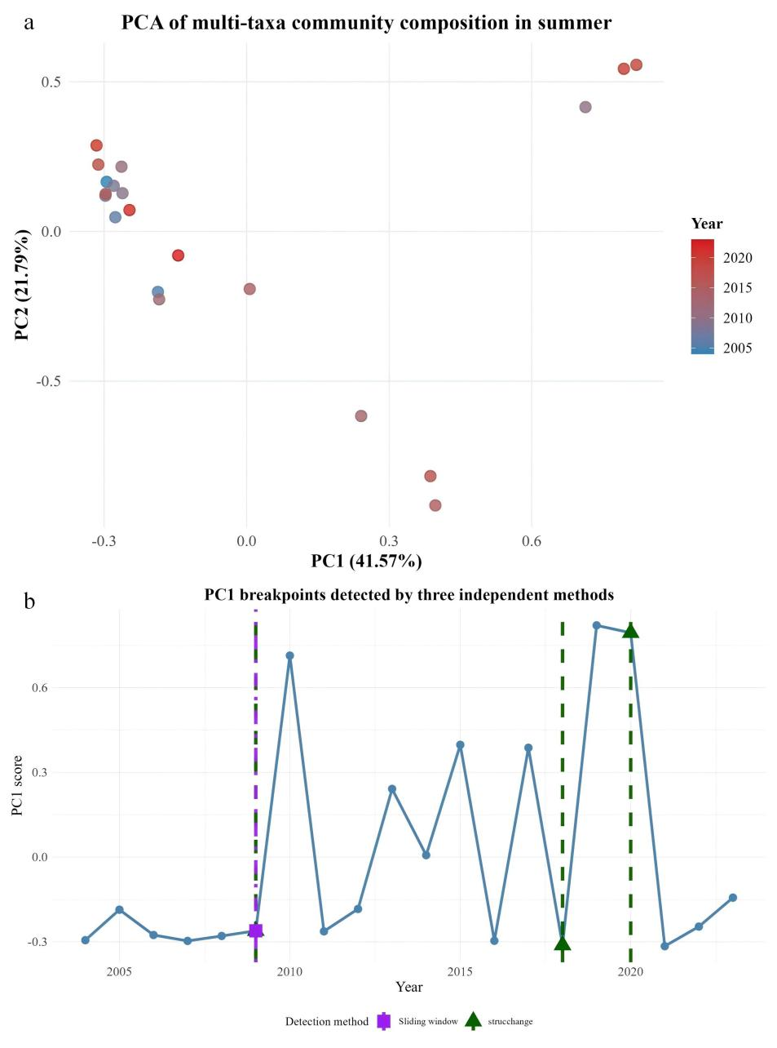
Fig. S2 | PCA summary of multi-taxa community composition and PC1 breakpoint detection results.
a PCA biplot of the multi-taxa community matrix showing the first two principal components. b PC1 time series from 2004 to 2023 with breakpoints detected by three independent methods.

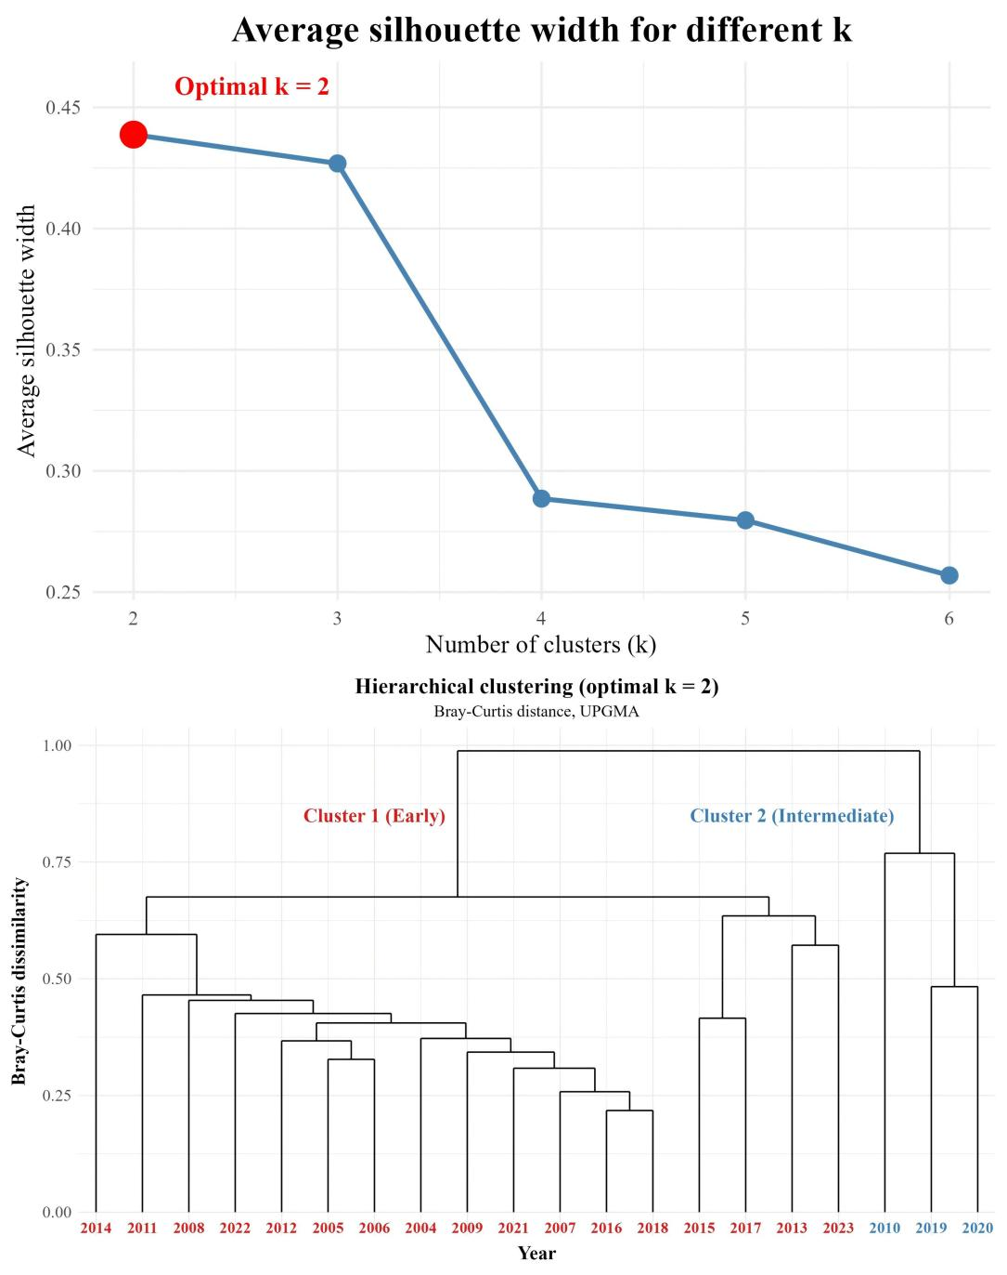
Fig. S3 | Hierarchical clustering validation of the multi‑taxa community matrix using Bray-Curtis distance and UPGMA.
a Average silhouette width for different cluster numbers, with the optimal number identified as k = 2. b Temporal trajectory of cluster membership from 2004 to 2023, showing multiple shifts between Cluster 1 and Cluster 2.

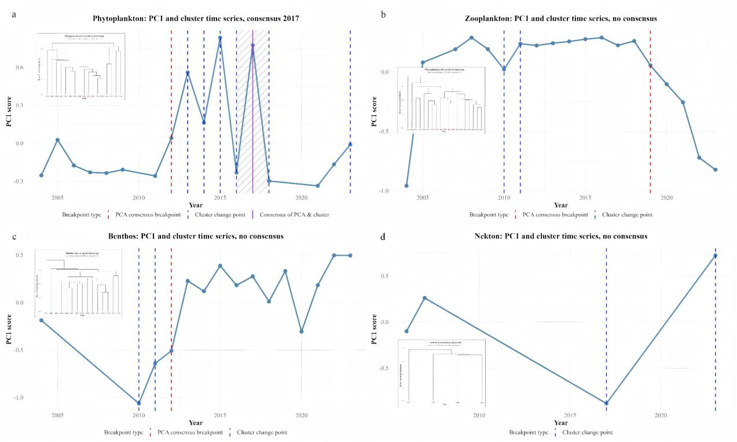
Fig. S4 | Comparison of PCA-derived breakpoints and cluster-based change points for individual biotic groups.
a Phytoplankton, with a consensus breakpoint identified in 2017 from the overlap of PCA-derived breakpoints and cluster-based change points. b Zooplankton, with no consensus between tow methods. c Nekton, with no consensus between two methods. d Benthos, with no PC1 breakpoints detected.

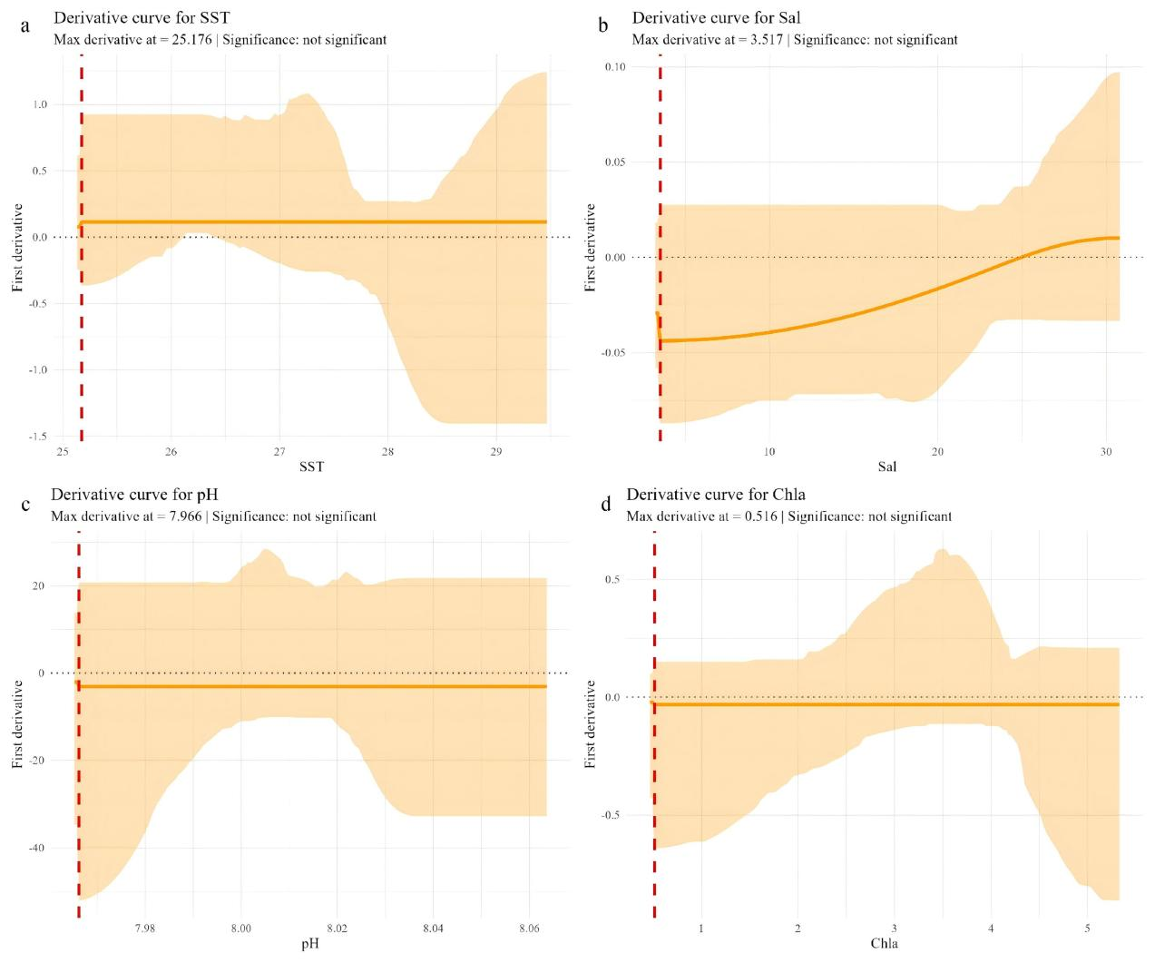
Fig. S5 | Environmental variables with no significant thresholds detected by the derivative method.
For each variables, the bootstrap confidence intervals of the derivatives contained zero and no significant curvature was detected in the response curves of SST (a), Salinity (b), pH (c), and Chla (d), respectively.

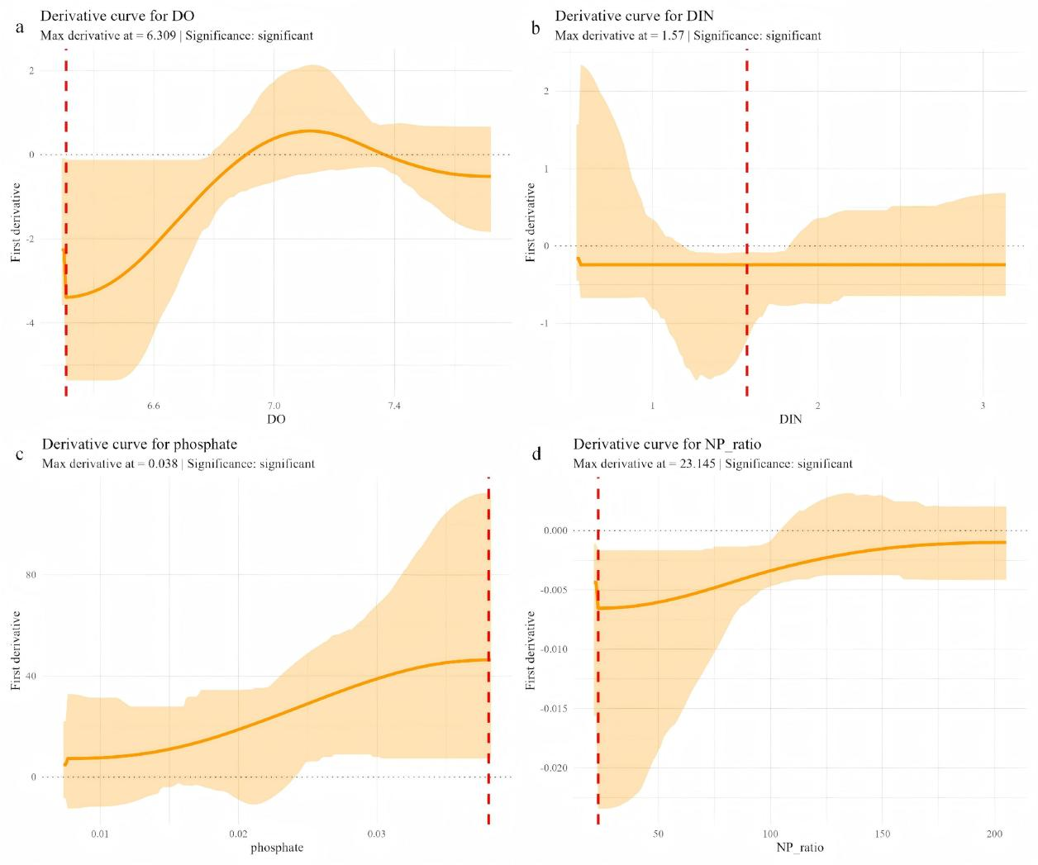
Fig. S6 | Derivative method results for the four significant environmental drivers with significant thresholds. For each variable, the red dashed vertical line indicates the threshold identified by the derivative method, and the shaded areas represent the 95% bootstrap confidence intervals of the derivatives, which did not contain zero for any of the four thresholds, confirming their statistical significance at the α = 0.05 level.
a DO with a negative slope and a significant threshold of 6.309 mg/L. b DIN with a negative slope and a significant threshold of 1.57 mg/L. c phosphate with a negative slope and a significant threshold of 0.038 mg/L. d N/P ratio with a negative slope and a significant threshold of 23.145.

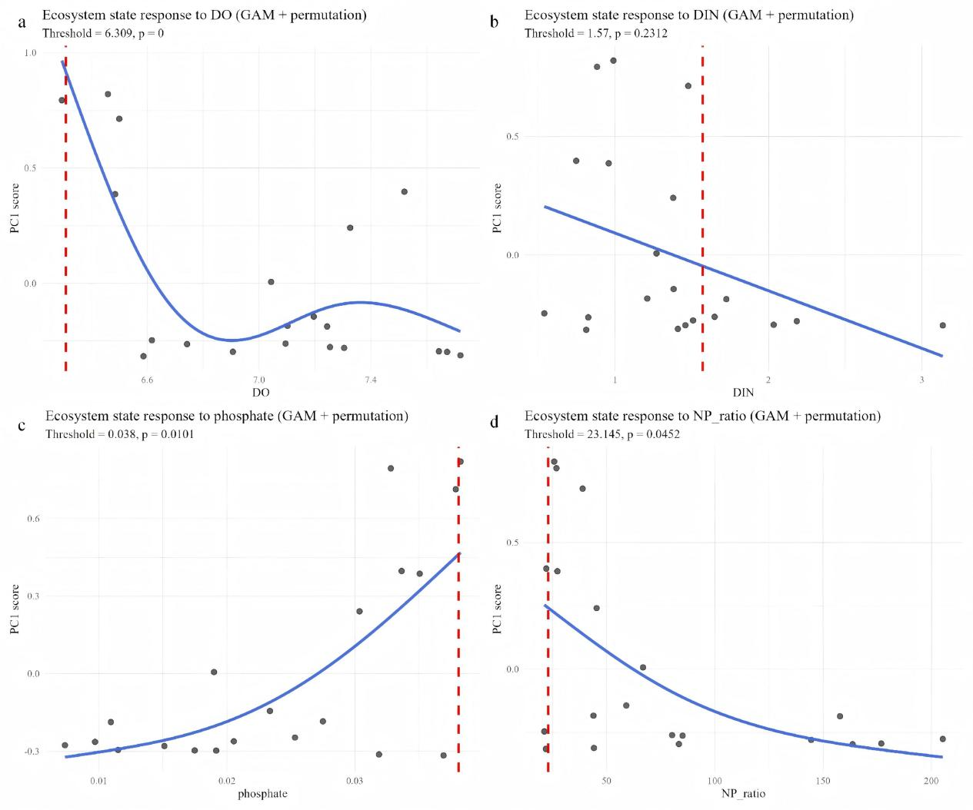

Fig. S7 | GAM-based permutation test results for the four environmental drivers that exhibited significant thresholds in the derivative method. For each variable, the red dashed line indicates the observed deviance, and p values were calculated as the proportion of permuted deviances exceeding the observed deviance.Thresholds with p < 0.05 were considered statistically significant.
a DO with a significant threshold of 6.309 mg/L confirmed by GAM permutation (p = 0). b DIN with a threshold of 1.57 mg/L consistent with the derivative method, though the GAM p value was non-significant (p = 0.231). c Phosphate with a nearly identical threshold of 0.0383 mg/L confirmed by GAM permutation (p = 0.010). d N/P ratio with a threshold of 23.14 consistent with the derivative method, confirmed by GAM permutation as significant (p = 0.045).

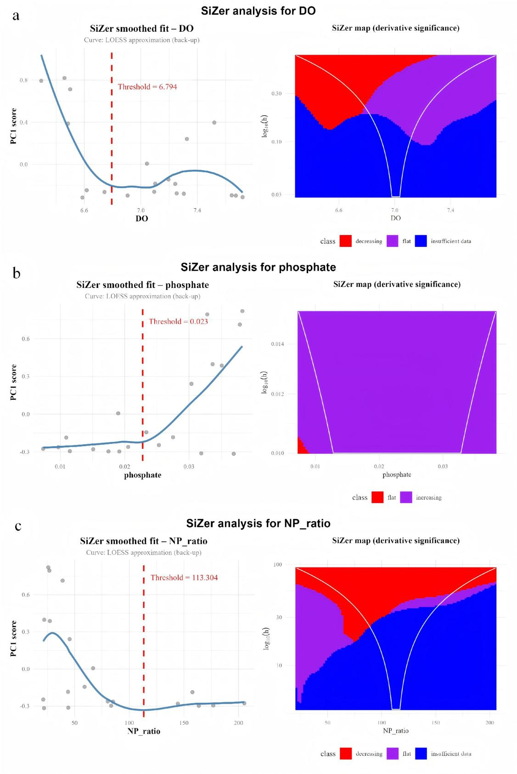
Fig. S8 | SiZer analysis results for three environmental drivers with candidate thresholds detected. SiZer provides graphical derivative significance across smoothing scales without p values or confidence intervals. These thresholds are therefore exploratory and used solely for corroboration. SiZer detected no threshold for DIN.
a DO with a SiZer-detected threshold of 6.794 mg/L. b Phosphate with a SiZer-detected threshold of 0.023 mg/L. c N/P ratio with a SiZer-detected threshold of 113.30.
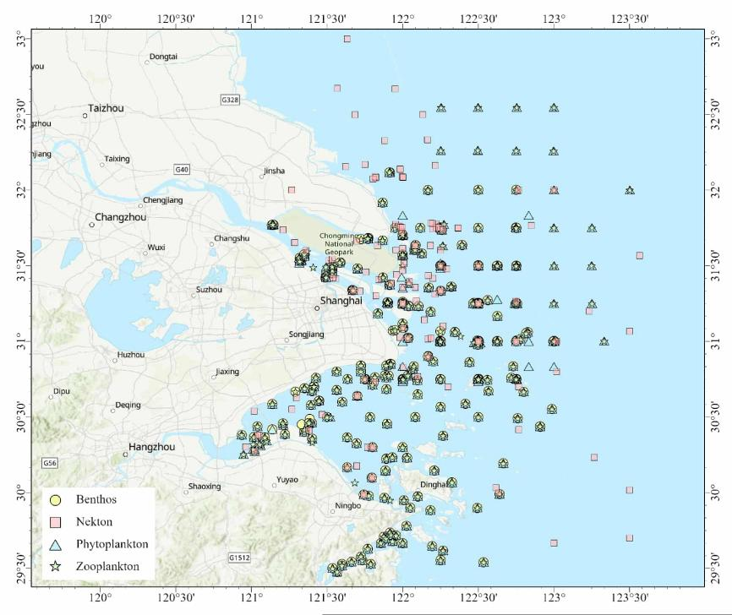
a
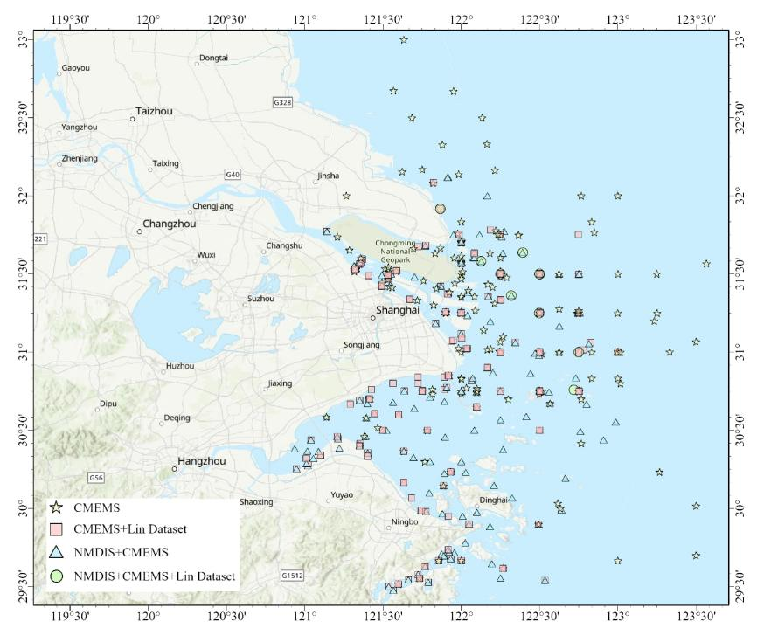
b
Fig. S9 | Locations of biological (a) and environmental (b) data stations in the Yangtze Estuary. a. Sampling sites of phytoplankton, zooplankton, necton, and benthos. b. Environmental data sources included in-situ measurements (NMDIS) and gridded datasets originated from Lin et al. (2023) and CMEMS, from which values were extracted for the grid cells nearest to each biological sampling station.

